DB Project 2 – Healthcare Screenshots

# Home Page



# Second page – Select options for displaying survey data

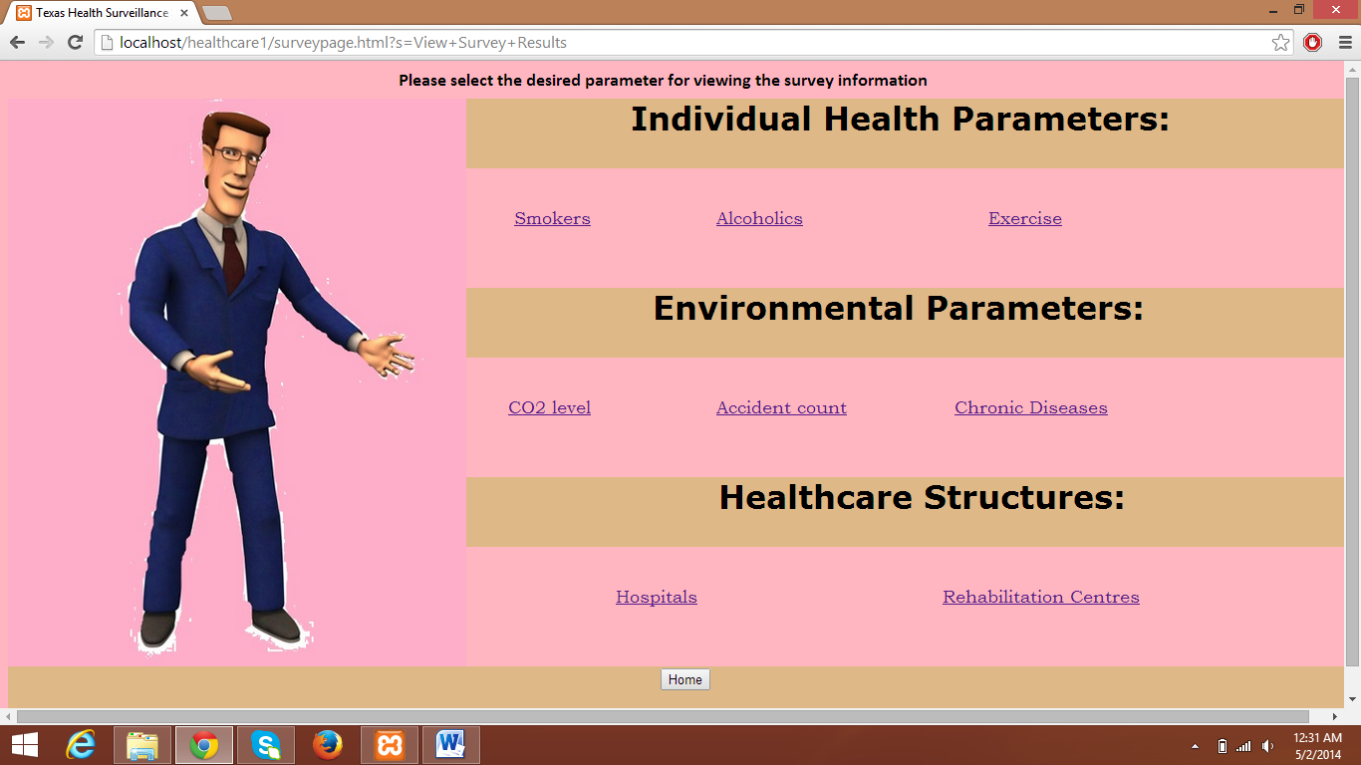

# Data displayed after clicking on Smokers

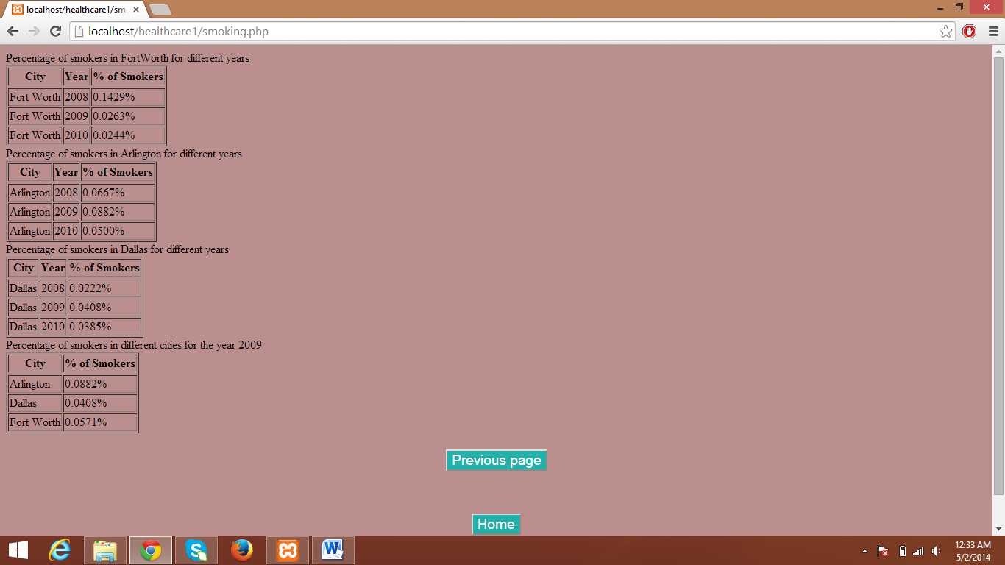

# Data displayed after clicking on Alcoholics

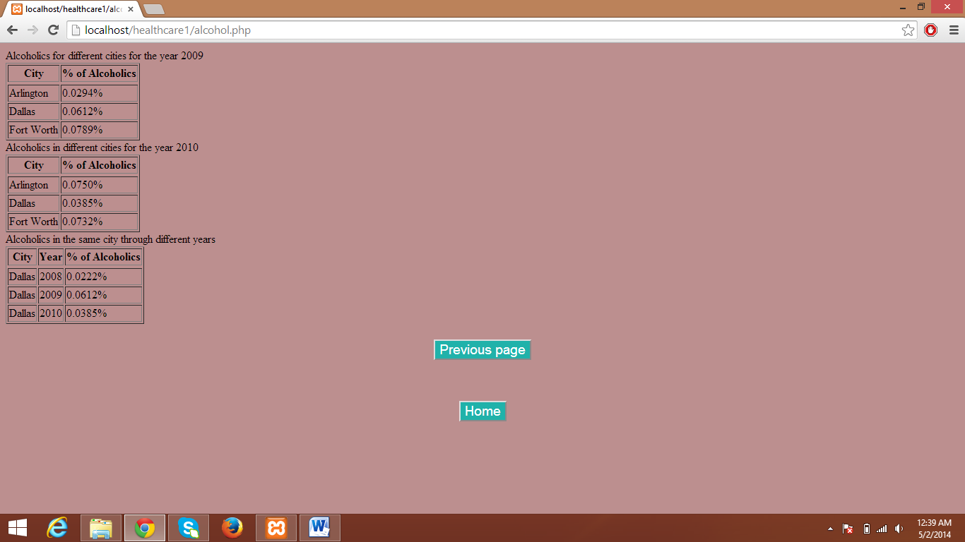

# Data displayed after clicking on Exercise link

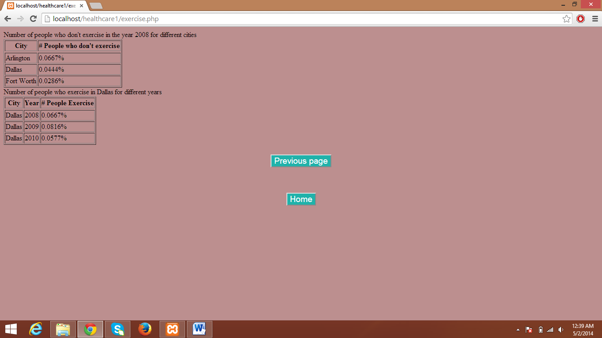

# Data displayed after clicking on CO2 level

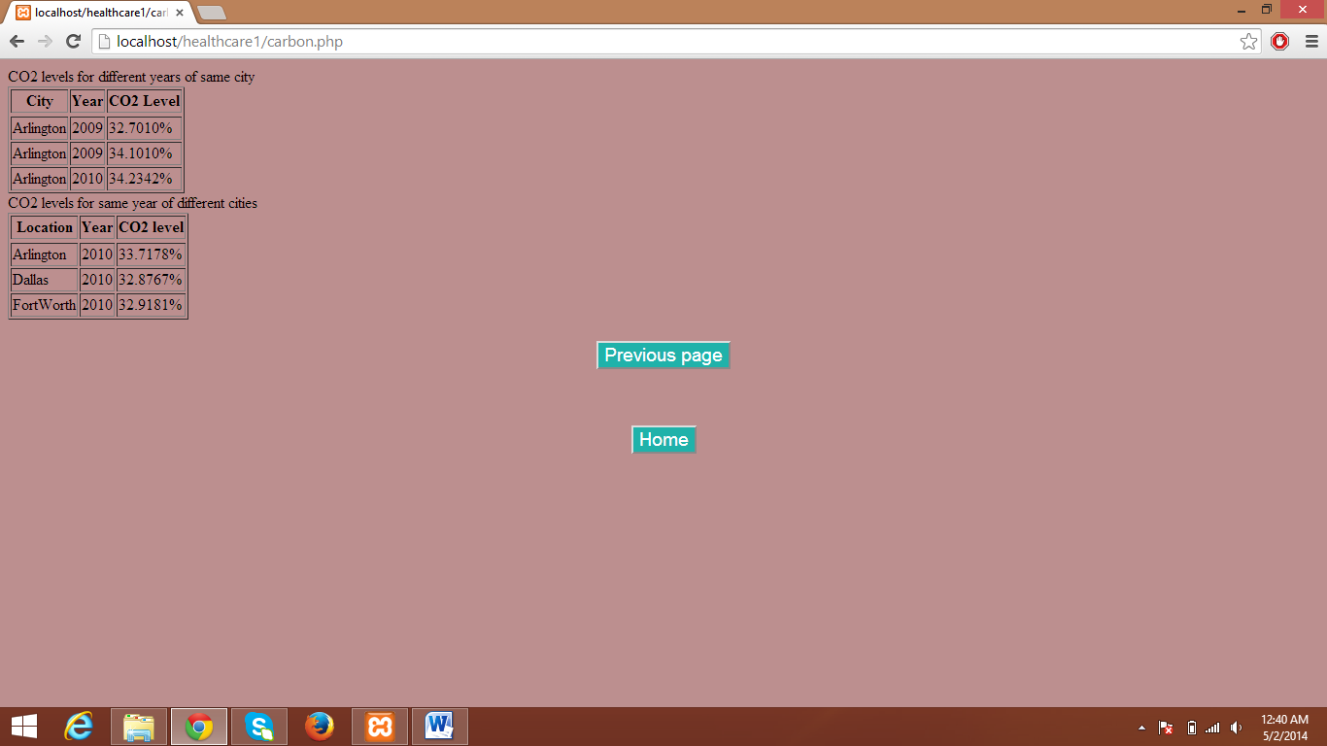

# Data displayed after clicking on Accident count

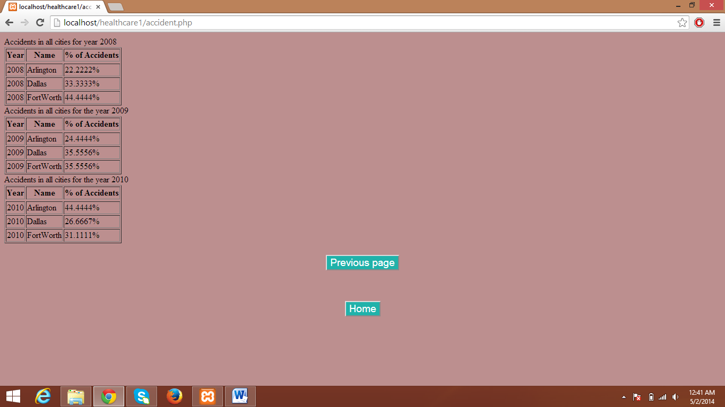

# Data displayed after clicking on Chronic diseases

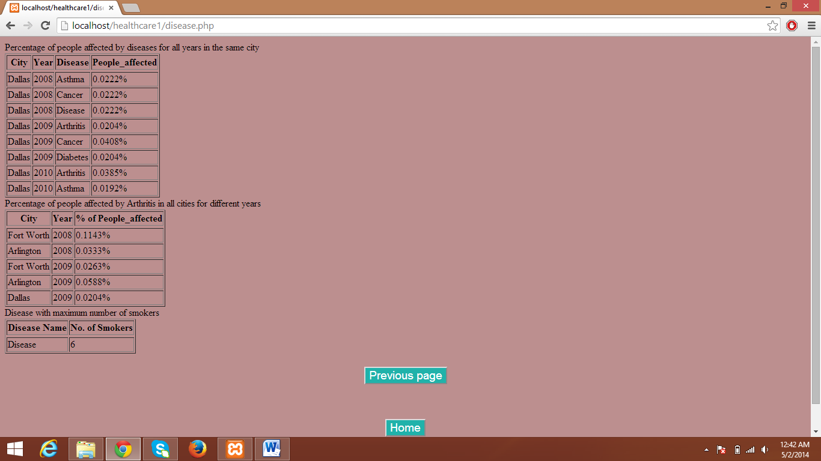

# Data displayed after clicking on Hospitals

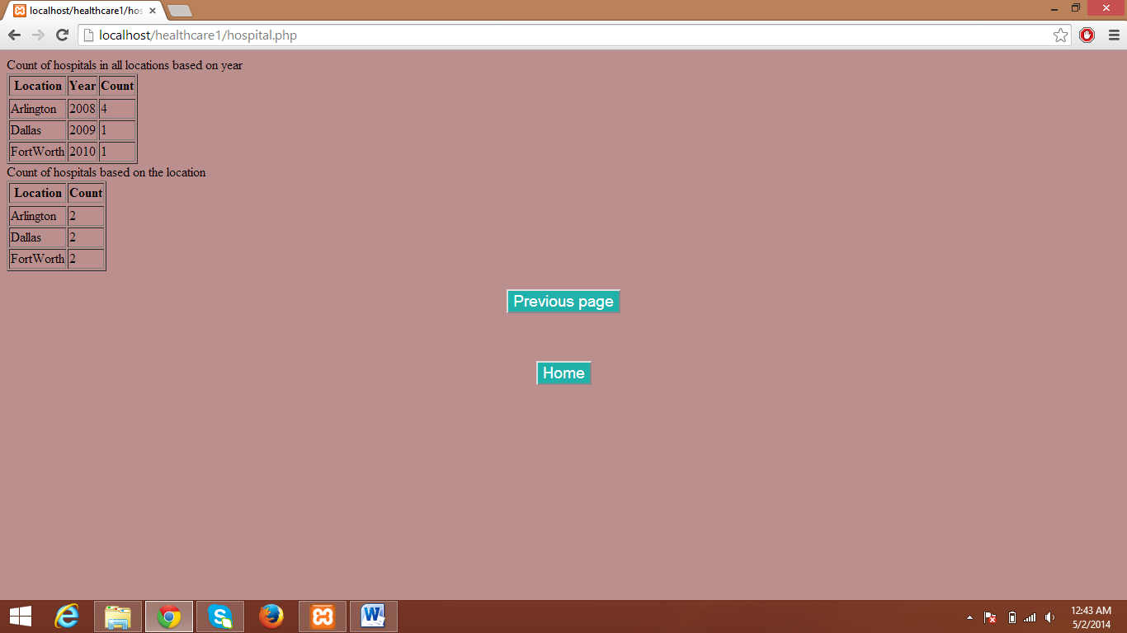

# Data displayed after clicking on Rehabilitation Centres

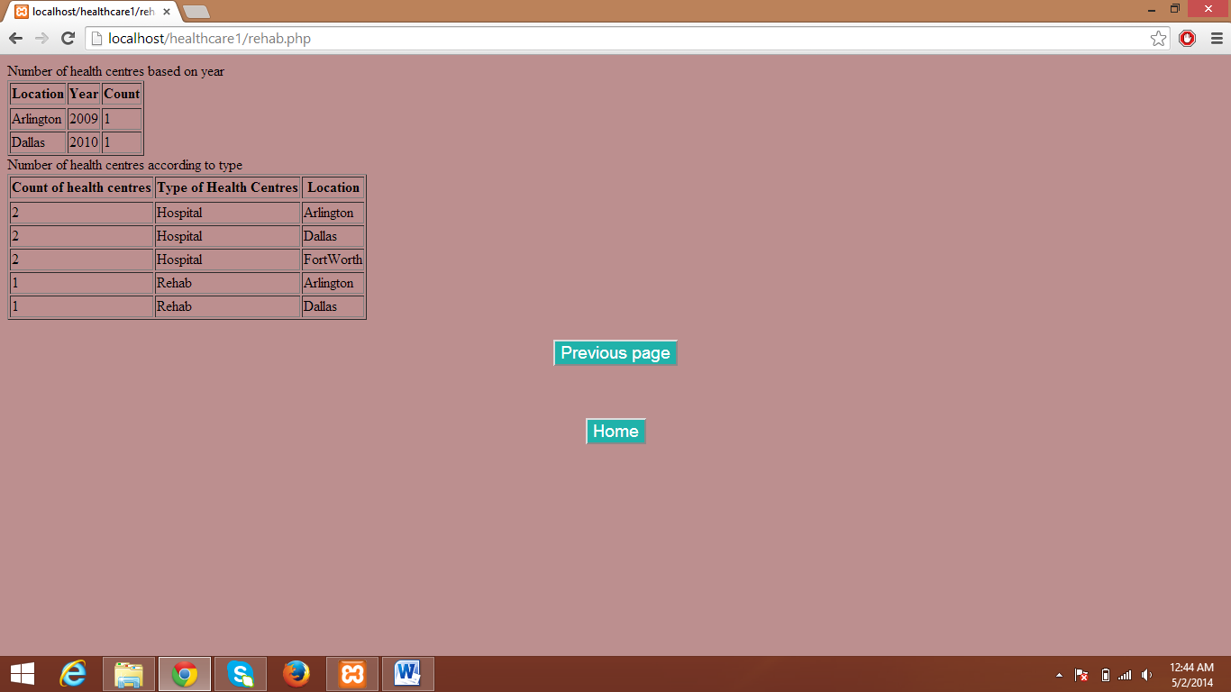

# Page shows options for entering data

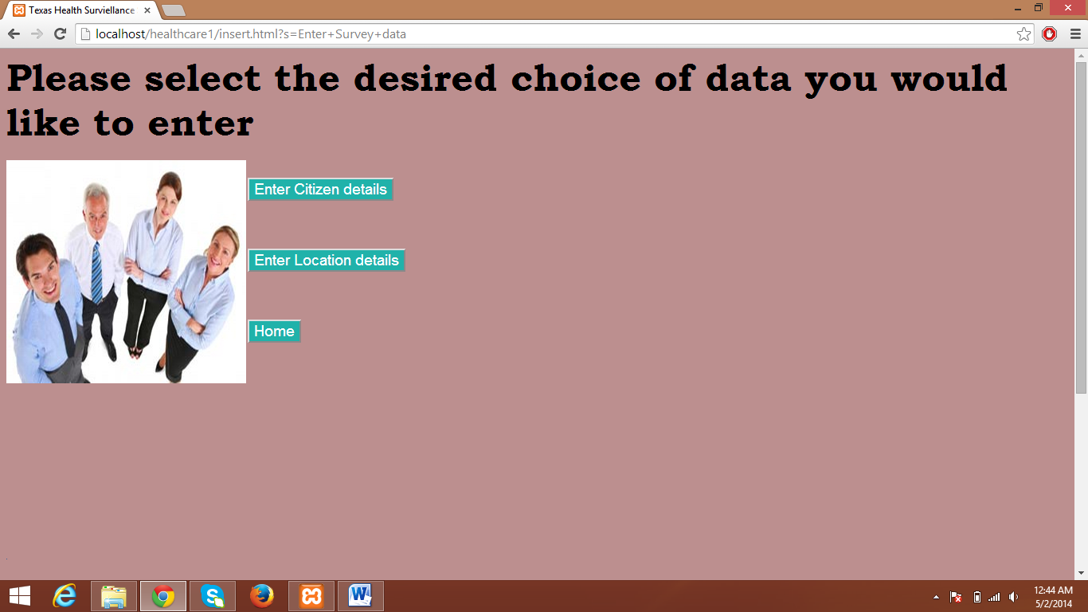

# Form displayed for entering Citizen Information for each city

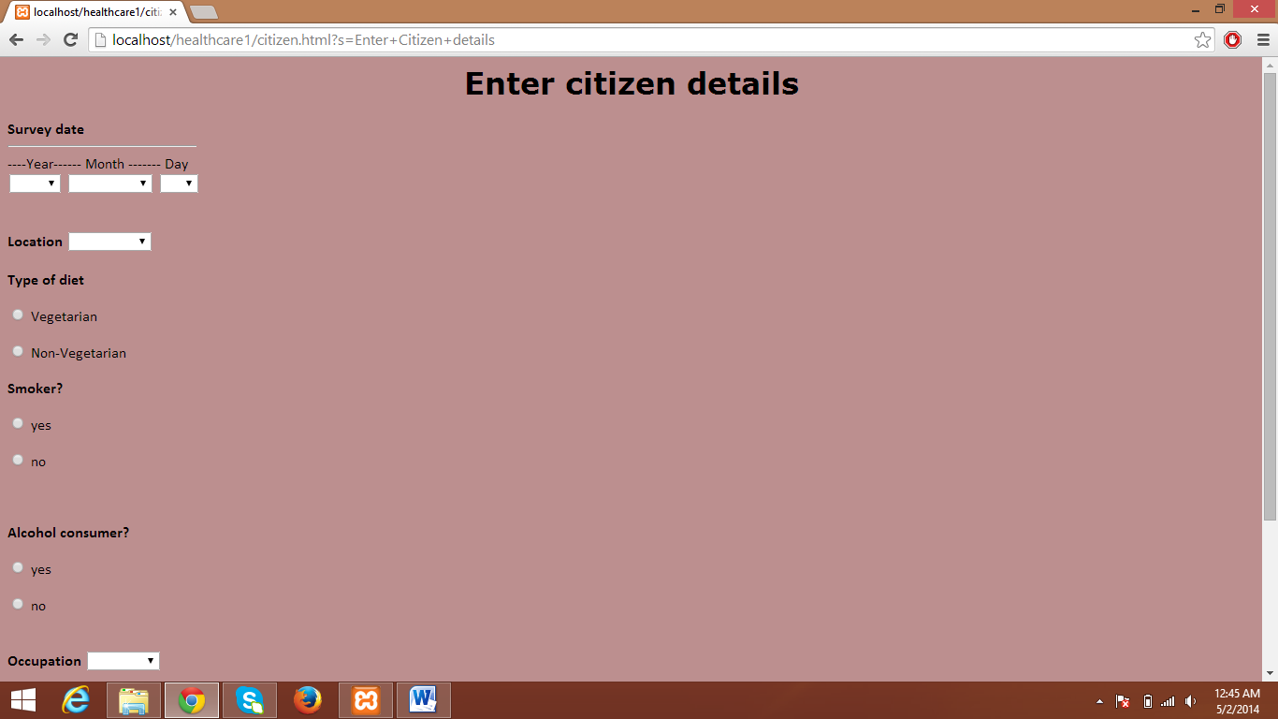

# Form displayed for entering Location Information

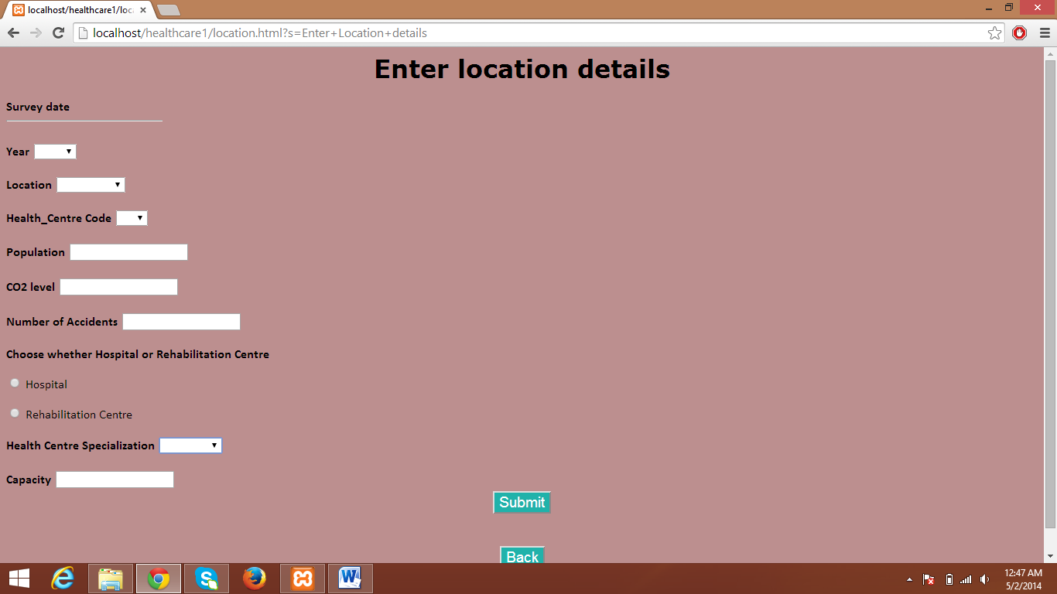

Front End code

# hshome.html

<html>

<head>

<title> Healthcare Surviellance </title>

</head>

<h1 align="center"><font face="Bookman Old style" size="15" color="black"><b>WELCOME TO TEXAS HEALTH SURVEILLANCE</b></font></h1>

<body bgcolor ="rosybrown" body>

<marquee behavior="alternate" alternateamount="12"><font size="3" face = "Verdana" color = "black"> Survey results available for 2008,2009 and 2010 </font></marquee>

<br><br><br><img src = "homepage.jpg" style="height:60%;width:100%" alt = "The Health Surviellance cyle"></br></br></br>

<form action="surveypage.html" method="link"><input type="submit" style="font-face: 'Comic Sans MS'; font-size: larger; color: white; background-color: #20B2AA;margin-left:auto;margin-right:auto;display:block;" name="s" value="View Survey Results"></form>

<form action="insert.html" method="link"><input type="submit" style="font-face: 'Comic Sans MS'; font-size: larger; color: white; background-color: #20B2AA;margin-left:auto;margin-right:auto;display:block;" name="s" value="Enter Survey data"></form>

</body>

</html>

# Surveypage.html

<html>

<title>Texas Health Surveillance System</title>

<body bgcolor="Lightpink">

<div id="container" style="width:1360px;height=500;">

<div id="header" style="background-color:Lightpink;height:30px;">

<h1 style="margin-bottom:0;">

<font face="Calibri" size="4" color="black">&nbsp&nbsp&nbsp&nbsp&nbsp&nbsp&nbsp&nbsp&nbsp&nbsp&nbsp&nbsp&nbsp&nbsp&nbsp&nbsp&nbsp&nbsp&nbsp&nbsp&nbsp&nbsp&nbsp&nbsp&nbsp&nbsp&nbsp&nbsp&nbsp&nbsp&nbsp&nbsp&nbsp&nbsp&nbsp&nbsp&nbsp&nbsp&nbsp&nbsp&nbsp&nbsp&nbsp&nbsp&nbsp&nbsp&nbsp&nbsp&nbsp&nbsp&nbsp&nbsp&nbsp&nbsp&nbsp&nbsp&nbsp&nbsp&nbsp&nbsp&nbsp&nbsp&nbsp&nbsp&nbsp&nbsp&nbsp&nbsp&nbsp&nbsp&nbsp&nbsp&nbsp&nbsp&nbsp

&nbsp&nbsp&nbsp&nbsp&nbsp&nbsp&nbsp&nbsp&nbsp&nbsp&nbsp&nbsp&nbsp&nbsp&nbsp&nbsp&nbsp&nbsp&nbsp&nbsp&nbsp Please select the desired parameter for viewing the survey information</font>

</div></h1>

<div id="content" style="height:570px;width:460px;float:left;align:right;">

<img src="Ralph_Pose1_Final.jpg" height="100%" width="100%">

</div>

<div id="menu" style="background-color:Burlywood;height:70px;width:auto;float:down;">

<font face="Verdana" size="6" color="black"><b>&nbsp&nbsp&nbsp&nbsp&nbsp&nbsp&nbsp&nbsp&nbsp&nbsp&nbsp&nbsp&nbsp&nbsp&nbspIndividual Health Parameters:</b></font>

</div>

<div id="menu2" style="background-color:Lightpink;height:120px;width:auto;float:down;">

<br></br><font face = "Bookman Old Style" size="4">&nbsp&nbsp&nbsp&nbsp&nbsp&nbsp&nbsp&nbsp<a href = "smoking.php">Smokers</a>&nbsp&nbsp&nbsp&nbsp&nbsp&nbsp&nbsp&nbsp&nbsp&nbsp&nbsp&nbsp&nbsp&nbsp&nbsp&nbsp&nbsp&nbsp&nbsp&nbsp

<a href = "alcohol.php">Alcoholics</a>&nbsp&nbsp&nbsp&nbsp&nbsp&nbsp&nbsp&nbsp&nbsp&nbsp&nbsp&nbsp&nbsp&nbsp&nbsp&nbsp&nbsp&nbsp&nbsp&nbsp&nbsp&nbsp&nbsp&nbsp&nbsp&nbsp&nbsp&nbsp&nbsp&nbsp

<a href = "exercise.php">Exercise</a> </font>

</div>

<div id="menu3" style="background-color:Burlywood;height:70px;width:auto;float:down;">

<font face="Verdana" size="6" color="black"><b>&nbsp&nbsp&nbsp&nbsp&nbsp&nbsp&nbsp&nbsp&nbsp&nbsp&nbsp&nbsp&nbsp&nbsp&nbsp&nbsp&nbspEnvironmental Parameters:</b></font>&nbsp&nbsp</div>

<div id="menu4" style="background-color:Lightpink;height:120px;width:auto;float:down;">

<br></br><font face = "Bookman Old Style" size="4">&nbsp&nbsp&nbsp&nbsp&nbsp&nbsp&nbsp<a href = "carbon.php">CO2 level</a>&nbsp&nbsp&nbsp&nbsp&nbsp&nbsp&nbsp&nbsp&nbsp&nbsp&nbsp&nbsp&nbsp&nbsp&nbsp&nbsp&nbsp&nbsp&nbsp&nbsp

<a href = "accident.php">Accident count</a>&nbsp&nbsp&nbsp&nbsp&nbsp&nbsp&nbsp&nbsp&nbsp&nbsp&nbsp&nbsp&nbsp&nbsp&nbsp&nbsp&nbsp

<a href = "disease.php">Chronic Diseases</a></font>

</div>

<div id="menu5" style="background-color:Burlywood;height:70px;width:auto;float:down;">

<font face="Verdana" size="6" color="black"><b>&nbsp&nbsp&nbsp&nbsp&nbsp&nbsp&nbsp&nbsp&nbsp&nbsp&nbsp&nbsp&nbsp&nbsp&nbsp&nbsp&nbsp&nbsp&nbsp&nbsp&nbsp&nbsp&nbspHealthcare Structures:</b></font>&nbsp&nbsp</div>

<div id="menu6" style="background-color:Lightpink;height:120px;width:auto;float:down;">

<br></br><font face = "Bookman Old Style" size="4">&nbsp&nbsp&nbsp&nbsp&nbsp&nbsp&nbsp&nbsp&nbsp&nbsp&nbsp&nbsp&nbsp&nbsp&nbsp&nbsp&nbsp&nbsp&nbsp&nbsp&nbsp&nbsp&nbsp&nbsp

<a href = "hospital.php">Hospitals</a>&nbsp&nbsp&nbsp&nbsp&nbsp&nbsp&nbsp&nbsp&nbsp&nbsp&nbsp&nbsp&nbsp&nbsp&nbsp&nbsp&nbsp&nbsp&nbsp&nbsp&nbsp&nbsp&nbsp&nbsp&nbsp&nbsp&nbsp&nbsp&nbsp&nbsp&nbsp&nbsp&nbsp&nbsp&nbsp&nbsp&nbsp&nbsp&nbsp&nbsp

<a href = "rehab.php">Rehabilitation Centres</a></font>

</div>

<div id="footer" style="background-color:Burlywood;clear:both;text-align:center;">

<form action="hshome.php" method="link"><input type="submit" name="s" value="Home"></form>&nbspCopyrights @ UTA Health Surviellance

</div>

</div>

</body>

</html>

# smoking.php

<html>

<body bgcolor="Rosybrown">

<?php

$con=mysqli_connect("localhost","root","adithya","healthcare"); //$db_con = new mysqli(DB_SERVER,DB_USERNAME,DB_PASSWORD,DB_DATABASE);

// Check connection

if (mysqli_connect_errno()) {

echo "Failed to connect to MySQL: " . mysqli_connect_error();

}

echo "Percentage of smokers in FortWorth for different years";

$sql1= mysqli_query($con,"select city, b.year as year,concat((count(a.smoking)/b.population * 100),'%') AS Smokers

from location b, survey_details a

where a.l_id = b.l_id

and b.name = 'FortWorth'

and smoking like 'yes'

group by b.year;");

echo "<table border='1'>

<tr>

<th>City</th>

<th>Year</th>

<th>% of Smokers</th>

<tr>";

while($row = mysqli_fetch_array($sql1)){

echo "<tr>";

echo "<td>" . $row['city'] . "</td>";

echo "<td>" . $row['year'] . "</td>";

echo "<td>" . $row['Smokers'] . "</td>";

echo "</tr>";

}

echo"</table>";

echo "Percentage of smokers in Arlington for different years";

$sql2= mysqli_query($con,"select city, b.year as year,concat((count(a.smoking)/b.population * 100),'%') AS Smokers

from location b, survey_details a

where a.l_id = b.l_id

and b.name = 'Arlington'

and smoking like 'yes'

group by b.year;");

echo "<table border='1'>

<tr>

<th>City</th>

<th>Year</th>

<th>% of Smokers</th>

<tr>";

while($row = mysqli_fetch_array($sql2)){

echo "<tr>";

echo "<td>" . $row['city'] . "</td>";

echo "<td>" . $row['year'] . "</td>";

echo "<td>" . $row['Smokers'] . "</td>";

echo "</tr>";

}

echo "</table>";

echo "Percentage of smokers in Dallas for different years";

$sql3= mysqli_query($con,"select city, b.year as year,concat((count(a.smoking)/b.population * 100),'%') AS Smokers

from location b, survey_details a

where a.l_id = b.l_id

and b.name = 'Dallas'

and smoking like 'yes'

group by b.year;");

echo "<table border='1'>

<tr>

<th>City</th>

<th>Year</th>

<th>% of Smokers</th>

<tr>";

while($row = mysqli_fetch_array($sql3)){

echo "<tr>";

echo "<td>" . $row['city'] . "</td>";

echo "<td>" . $row['year'] . "</td>";

echo "<td>" . $row['Smokers'] . "</td>";

echo "</tr>";

}

echo "</table>";

echo "Percentage of smokers in different cities for the year 2009";

$sql4= mysqli_query($con,"select city, concat((count(a.smoking)/b.population * 100),'%') AS Smokers

from survey_details a, location b

where a. l_id = b.l_id

and smoking like 'yes'

and

date like '2009%'

group by city;");

echo "<table border='1'>

<tr>

<th>City</th>

<th>% of Smokers</th>

<tr>";

while($row = mysqli_fetch_array($sql4)){

echo "<tr>";

echo "<td>" . $row['city'] . "</td>";

echo "<td>" . $row['Smokers'] . "</td>";

echo "</tr>";

}

echo "</table>";

mysqli_close($con);

?>

<br><form action="surveypage.html" method="link"><input type="submit" style="font-face: 'Comic Sans Ms'; font-size: larger; color:white;background-color:#20B2AA;margin-left:auto;margin-right:auto;display:block;" name="s" value="Previous page"></form></br>

<br><form action="hshome.php" method="link"><input type="submit" style="font-face: 'Comic Sans Ms'; font-size: larger; color:white;background-color:#20B2AA;margin-left:auto;margin-right:auto;display:block;" name="h" value="Home"></form></br>

</body>

</html>

# alcohol.php

<html>

<body bgcolor="Rosybrown">

<?php

$con=mysqli_connect("localhost","root","adithya","healthcare"); //$db_con = new mysqli(DB_SERVER,DB_USERNAME,DB_PASSWORD,DB_DATABASE);

// Check connection

if (mysqli_connect_errno()) {

echo "Failed to connect to MySQL: " . mysqli_connect_error();

}

echo "Alcoholics for different cities for the year 2009";

$sql1= mysqli_query($con,"select city, concat((count(a.alcohol)/b.population * 100) , '%') AS Alcoholics_2009

from survey_details a, location b

where a. l_id = b.l_id

and alcohol like 'yes'

and

date like '2009%'

group by city;");

echo "<table border='1'>

<tr>

<th>City</th>

<th>% of Alcoholics</th>

<tr>";

while($row = mysqli_fetch_array($sql1)){

echo "<tr>";

echo "<td>" . $row['city'] . "</td>";

echo "<td>" . $row['Alcoholics_2009'] . "</td>";

echo "</tr>";

}

echo "</table>";

echo "Alcoholics in different cities for the year 2010";

$sql2= mysqli_query($con,"select city, concat((count(a.alcohol)/b.population * 100) , '%') AS Alcoholics_2010

from survey_details a, location b

where a. l_id = b.l_id

and alcohol like 'yes'

and

date like '2010%'

group by city;");

echo "<table border='1'>

<tr>

<th>City</th>

<th>% of Alcoholics</th>

<tr>";

while($row = mysqli_fetch_array($sql2)){

echo "<tr>";

echo "<td>" . $row['city'] . "</td>";

echo "<td>" . $row['Alcoholics_2010'] . "</td>";

echo "</tr>";

}

echo "</table>";

echo "Alcoholics in the same city through different years";

$sql3= mysqli_query($con,"select city,year,concat((count(a.alcohol)/b.population * 100),'%') AS Alcoholics

from location b, survey_details a

where a.l_id = b.l_id

and b.name = 'Dallas'

and alcohol like 'yes'

group by b.year;");

echo "<table border='1'>

<tr>

<th>City</th>

<th>Year</th>

<th>% of Alcoholics</th>

<tr>";

while($row = mysqli_fetch_array($sql3)){

echo "<tr>";

echo "<td>" . $row['city'] . "</td>";

echo "<td>" . $row['year'] . "</td>";

echo "<td>" . $row['Alcoholics'] . "</td>";

echo "</tr>";

}

echo "</table>";

mysqli_close($con);

?>

<br><form action="surveypage.html" method="link"><input type="submit" style="font-face: 'Comic Sans Ms'; font-size: larger; color:white;background-color:#20B2AA;margin-left:auto;margin-right:auto;display:block;" name="s" value="Previous page"></form></br>

<br><form action="hshome.php" method="link"><input type="submit" style="font-face: 'Comic Sans Ms'; font-size: larger; color:white;background-color:#20B2AA;margin-left:auto;margin-right:auto;display:block;" name="h" value="Home"></form></br>

</body>

</html>

# exercise.php

<html>

<body bgcolor="Rosybrown">

<?php

$con=mysqli_connect("localhost","root","adithya","healthcare"); //$db_con = new mysqli(DB_SERVER,DB_USERNAME,DB_PASSWORD,DB_DATABASE);

// Check connection

if (mysqli_connect_errno()) {

echo "Failed to connect to MySQL: " . mysqli_connect_error();

}

echo "Number of people who don't exercise in the year 2008 for different cities";

$sql1= mysqli_query($con,"select city, concat((count(a.nutrition)/b.population * 100),'%') as Do_Not_Exercise

from survey_details a, location b

where a. l_id = b.l_id

and nutrition like 'No%'

and

date like '2008%'

group by city;");

echo "<table border='1'>

<tr>

<th>City</th>

<th># People who don't exercise</th>

<tr>";

while($row = mysqli_fetch_array($sql1)){

echo "<tr>";

echo "<td>" . $row['city'] . "</td>";

echo "<td>" . $row['Do_Not_Exercise'] . "</td>";

echo "</tr>";

}

echo"</table>";

echo "Number of people who exercise in Dallas for different years";

$sql2= mysqli_query($con,"select city, b.year as year,concat((count(a.nutrition)/b.population * 100),'%') Ppl_Exercise

from location b, survey_details a

where a.l_id = b.l_id

and b.name = 'Dallas'

and nutrition like '%exercise%'

group by b.year;

");

echo "<table border='1'>

<tr>

<th>City</th>

<th>Year</th>

<th># People Exercise</th>

<tr>";

while($row = mysqli_fetch_array($sql2)){

echo "<tr>";

echo "<td>" . $row['city'] . "</td>";

echo "<td>" . $row['year'] . "</td>";

echo "<td>" . $row['Ppl_Exercise'] . "</td>";

echo "</tr>";

}

echo "</table>";

mysqli_close($con);

?>

<br><form action="surveypage.html" method="link"><input type="submit" style="font-face: 'Comic Sans Ms'; font-size: larger; color:white;background-color:#20B2AA;margin-left:auto;margin-right:auto;display:block;" name="s" value="Previous page"></form></br>

<br><form action="hshome.php" method="link"><input type="submit" style="font-face: 'Comic Sans Ms'; font-size: larger; color:white;background-color:#20B2AA;margin-left:auto;margin-right:auto;display:block;" name="h" value="Home"></form></br>

</body>

</html>

# carbon.php

<html>

<body bgcolor="Rosybrown">

<?php

$con=mysqli_connect("localhost","root","adithya","healthcare"); //$db_con = new mysqli(DB_SERVER,DB_USERNAME,DB_PASSWORD,DB_DATABASE);

// Check connection

if (mysqli_connect_errno()) {

echo "Failed to connect to MySQL: " . mysqli_connect_error();

}

echo "CO2 levels for different years of same city";

$sql1= mysqli_query($con,"select a.name AS city, b.year AS year, concat((level/sum(level)*100),'%') AS carbon_dioxide

from location AS a, co2_level AS b

where a.l_id = b.l_id

group by a.year");

echo "<table border='1'>

<tr>

<th>City</th>

<th>Year</th>

<th>CO2 Level</th>

<tr>";

while($row = mysqli_fetch_array($sql1)){

echo "<tr>";

echo "<td>" . $row['city'] . "</td>";

echo "<td>" . $row['year'] . "</td>";

echo "<td>" . $row['carbon_dioxide'] . "</td>";

echo "</tr>";

}

echo "</table>";

echo "CO2 levels for same year of different cities";

$sql2= mysqli_query($con,"SELECT b.name AS city,a.year AS year, concat((level/sum(level)*100),'%') AS carbon_dioxide

FROM co2_level AS a, location AS b

WHERE a.l_id=b.l_id

GROUP BY b.name");

echo "<table border='1'>

<tr>

<th>Location</th>

<th>Year</th>

<th>CO2 level</th>

<tr>";

while($row = mysqli_fetch_array($sql2)){

echo "<tr>";

echo "<td>" . $row['city'] . "</td>";

echo "<td>" . $row['year'] . "</td>";

echo "<td>" . $row['carbon_dioxide'] . "</td>";

echo "</tr>";

}

echo "</table>";

mysqli_close($con);

?>

<br><form action="surveypage.html" method="link"><input type="submit" style="font-face: 'Comic Sans Ms'; font-size: larger; color:white;background-color:#20B2AA;margin-left:auto;margin-right:auto;display:block;" name="s" value="Previous page"></form></br>

<br><form action="hshome.php" method="link"><input type="submit" style="font-face: 'Comic Sans Ms'; font-size: larger; color:white;background-color:#20B2AA;margin-left:auto;margin-right:auto;display:block;" name="h" value="Home"></form></br>

</body>

</html>

# accident.php

<html>

<body bgcolor="Rosybrown">

<?php

$con=mysqli_connect("localhost","root","adithya","healthcare"); //$db_con = new mysqli(DB_SERVER,DB_USERNAME,DB_PASSWORD,DB_DATABASE);

// Check connection

if (mysqli_connect_errno()) {

echo "Failed to connect to MySQL: " . mysqli_connect_error();

}

echo "Accidents in all cities for year 2008";

$sql=mysqli_query($con,"select @total := sum(no_of_accidents) from accidents where year=2008;");

$sql1= mysqli_query($con,"select a.year AS year, b.name AS name , concat((no_of_accidents/@total)*100,'%') AS Accidents

from accidents AS a, location AS b

where a.L_ID=b.L_ID

and a.year=2008

group by b.name;");

echo "<table border='1'>

<tr>

<th>Year</th>

<th>Name</th>

<th>% of Accidents</th>

<tr>";

while($row = mysqli_fetch_array($sql1)){

echo "<tr>";

echo "<td>" . $row['year'] . "</td>";

echo "<td>" . $row['name'] . "</td>";

echo "<td>" . $row['Accidents'] . "</td>";

echo "</tr>";

}

echo "</table>";

echo "Accidents in all cities for the year 2009";

$sql2= mysqli_query($con,"select a.year AS year, b.name AS name , concat((no_of_accidents/@total)*100,'%') AS Accidents

from accidents AS a, location AS b

where a.L_ID=b.L_ID

and a.year=2009

group by b.name;");

echo "<table border='1'>

<tr>

<th>Year</th>

<th>Name</th>

<th>% of Accidents</th>

<tr>";

while($row = mysqli_fetch_array($sql2)){

echo "<tr>";

echo "<td>" . $row['year'] . "</td>";

echo "<td>" . $row['name'] . "</td>";

echo "<td>" . $row['Accidents'] . "</td>";

echo "</tr>";

}

echo "</table>";

echo "Accidents in all cities for the year 2010";

$sql3= mysqli_query($con,"select a.year AS year, b.name AS name , concat((no_of_accidents/@total)*100,'%') AS Accidents

from accidents AS a, location AS b

where a.L_ID=b.L_ID

and a.year=2010

group by b.name;");

echo "<table border='1'>

<tr>

<th>Year</th>

<th>Name</th>

<th>% of Accidents</th>

<tr>";

while($row = mysqli_fetch_array($sql3)){

echo "<tr>";

echo "<td>" . $row['year'] . "</td>";

echo "<td>" . $row['name'] . "</td>";

echo "<td>" . $row['Accidents'] . "</td>";

echo "</tr>";

}

echo "</table>";

mysqli_close($con);

?>

<br><form action="surveypage.html" method="link"><input type="submit" style="font-face: 'Comic Sans Ms'; font-size: larger; color:white;background-color:#20B2AA;margin-left:auto;margin-right:auto;display:block;" name="s" value="Previous page"></form></br>

<br><form action="hshome.php" method="link"><input type="submit" style="font-face: 'Comic Sans Ms'; font-size: larger; color:white;background-color:#20B2AA;margin-left:auto;margin-right:auto;display:block;" name="h" value="Home"></form></br>

</body>

</html>

# hospital.php

<html>

<body bgcolor="Rosybrown">

<?php

$con=mysqli_connect("localhost","root","adithya","healthcare"); //$db_con = new mysqli(DB_SERVER,DB_USERNAME,DB_PASSWORD,DB_DATABASE);

// Check connection

if (mysqli_connect_errno()) {

echo "Failed to connect to MySQL: " . mysqli_connect_error();

}

echo "Count of hospitals in all locations based on year";

$sql1= mysqli_query($con,"SELECT location,year, count(type) FROM health_centers WHERE type LIKE 'Hospital'

GROUP BY year");

echo "<table border='1'>

<tr>

<th>Location</th>

<th>Year</th>

<th>Count</th>

<tr>";

while($row = mysqli_fetch_array($sql1)){

echo "<tr>";

echo "<td>" . $row['location'] . "</td>";

echo "<td>" . $row['year'] . "</td>";

echo "<td>" . $row['count(type)'] . "</td>";

echo "</tr>";

}

echo "</table>";

echo "Count of hospitals based on the location";

$sql2= mysqli_query($con,"SELECT location, count(type) FROM health_centers WHERE type LIKE 'Hospital'

GROUP BY location");

echo "<table border='1'>

<tr>

<th>Location</th>

<th>Count</th>

<tr>";

while($row = mysqli_fetch_array($sql2)){

echo "<tr>";

echo "<td>" . $row['location'] . "</td>";

echo "<td>" . $row['count(type)'] . "</td>";

echo "</tr>";

}

echo "</table>";

mysqli_close($con);

?>

<br><form action="surveypage.html" method="link"><input type="submit" style="font-face: 'Comic Sans Ms'; font-size: larger; color:white;background-color:#20B2AA;margin-left:auto;margin-right:auto;display:block;" name="s" value="Previous page"></form></br>

<br><form action="hshome.php" method="link"><input type="submit" style="font-face: 'Comic Sans Ms'; font-size: larger; color:white;background-color:#20B2AA;margin-left:auto;margin-right:auto;display:block;" name="h" value="Home"></form></br>

</body>

</html>

# rehab.php

<html>

<body bgcolor="Rosybrown">

<?php

$con=mysqli_connect("localhost","root","adithya","healthcare"); //$db_con = new mysqli(DB_SERVER,DB_USERNAME,DB_PASSWORD,DB_DATABASE);

// Check connection

if (mysqli_connect_errno()) {

echo "Failed to connect to MySQL: " . mysqli_connect_error();

}

echo "Number of health centres based on year";

$sql1= mysqli_query($con,"SELECT location,year, count(type) FROM health_centers WHERE type LIKE 'Rehab'

GROUP BY location");

echo "<table border='1'>

<tr>

<th>Location</th>

<th>Year</th>

<th>Count</th>

<tr>";

while($row = mysqli_fetch_array($sql1)){

echo "<tr>";

echo "<td>" . $row['location'] . "</td>";

echo "<td>" . $row['year'] . "</td>";

echo "<td>" . $row['count(type)'] . "</td>";

echo "</tr>";

}

echo "</table>";

echo "Number of health centres according to type";

$sql2= mysqli_query($con,"SELECT distinct count(b.type) AS count,b.type AS type,b.location AS location FROM location AS a,health_centers AS b

WHERE a.l_id=b.l_id

GROUP BY b.type,b.location");

echo "<table border='1'>

<tr>

<th>Count of health centres</th>

<th>Type of Health Centres</th>

<th>Location</th>

<tr>";

while($row = mysqli_fetch_array($sql2)){

echo "<tr>";

echo "<td>" . $row['count'] . "</td>";

echo "<td>" . $row['type'] . "</td>";

echo "<td>" . $row['location'] . "</td>";

echo "</tr>";

}

echo "</table>";

mysqli_close($con);

?>

<br><form action="surveypage.html" method="link"><input type="submit" style="font-face: 'Comic Sans Ms'; font-size: larger; color:white;background-color:#20B2AA;margin-left:auto;margin-right:auto;display:block;" name="s" value="Previous page"></form></br>

<br><form action="hshome.php" method="link"><input type="submit" style="font-face: 'Comic Sans Ms'; font-size: larger; color:white;background-color:#20B2AA;margin-left:auto;margin-right:auto;display:block;" name="h" value="Home"></form></br>

</body>

</html>

# citizen.html

<html>

<head>

</head>

<h1><font face = "Verdana" align="center" color="black" style="margin-left:auto;margin-right:auto;display:block;"> Enter citizen details </font></h1>

<body bgcolor ="rosybrown" body>

<form action="citizen.php" method="POST">

<font face = "Calibri"><b> Survey date </b><hr align="left" width="200px"/>

----Year------ Month ------- Day <br>

<select name="year">

<option value="default"></option>

<option value="2008">2008</option>

<option value="2009">2009</option>

<option value="2010">2010</option>

</select>

<select name="month">

<option id="defaultm" value="defaultm"></option>

<option id="January" value="January" >January</option>

<option id="February" value="February" >February</option>

<option id="March" value="March" >March</option>

<option id="April" value="April" >April</option>

<option id="May" value="May" >May</option>

<option id="June" value="June" ">June</option>

<option id="July" value="July" >July</option>

<option id="August" value="August">August</option>

<option id="September" value="September">September</option>

<option id="October" value="October">October</option>

<option id="November" value="November">November</option>

<option id="December" value="December">December</option>

</select>

<select name="day">

<option id="defaultd" value="defaultd"></option>

<option id="one" value="one" >1</option>

<option id="two" value="two" >2</option>

<option id="three" value="three" >3</option>

<option id="four" value="four" >4</option>

<option id="five" value="five" >5</option>

<option id="six" value="six" >6</option>

<option id="seven" value="seven" >7</option>

<option id="eight" value="eight" >8</option>

<option id="nine" value="nine" >9</option>

<option id="ten" value="ten" >10</option>

<option id="eleven" value="eleven" >11</option>

<option id="twelve" value="twelve" >12</option>

<option id="thirteen" value="thirteen" >13</option>

<option id="fourteen" value="fourteen" >14</option>

<option id="fifteen" value="fifteen" >15</option>

<option id="sixteen" value="sixteen" >16</option>

<option id="seventeen" value="seventeen" >17</option>

<option id="eighteen" value="eighteen" >18</option>

<option id="nineteen" value="nineteen" >19</option>

<option id="twenty" value="twenty" >20</option>

<option id="twentyone" value="twentyone" >21</option>

<option id="twentytwo" value="twentytwo" >22</option>

<option id="twentythree" value="twentythree" >23</option>

<option id="twentyfour" value="twentyfour" >24</option>

<option id="twentyfive" value="twentyfive" >25</option>

<option id="twentysix" value="twentysix" >26</option>

<option id="twentyseven" value="twentyseven" >27</option>

<option id="twentyeight" value="twentyeight" >28</option>

<option id="twentynine" value="twentynine" >29</option>

<option id="thirty" value="thirty" >30</option>

<option id="thirtyone" value="thirtyone" >31</option>

</select>

<br></br><br><font face = "Calibri"><b>Location</b>

<select name="city">

<option value=NULL></option>

<option value="Dallas">Dallas</option>

<option value="Fort Worth">Fort Worth</option>

<option value="Arlington">Arlington</option>

</select></br>

<br><b><font face = "Calibri"> Type of diet </font></b></br>

<br><input type="radio" name="nutrition" value="r1"> Vegetarian </br>

<br><input type="radio" name="nutrition" value="r2"> Non-Vegetarian </br>

<br><b><font face = "Calibri">Smoker?</font></b></br>

<br><input type="radio" name="smoke" value="r1"> yes </br>

<br><input type="radio" name="smoke" value="r2"> no </br>

<br></br><br><b><font face = "Calibri">Alcohol consumer?</font></b></br>

<br><input type="radio" name="alc" value="r3"> yes </br>

<br><input type="radio" name="alc" value="r4"> no </br>

</br><br><font face = "Calibri"><b> Occupation</font></b>

<select name ="job">

<option value=NULL></option>

<option value="Miner">Miner</option>

<option value="Farmer">Farmer</option>

<option value="Engineer">Engineer</option>

<option value="Doctor">Doctor</option>

</select><br></br>

<br><font face = "Calibri"><b>Chronic Disease</font></b>

<select name ="disease">

<option value=NULL></option>

<option value="1001">Cancer</option>

<option value="1002">Asthma</option>

<option value="1003">Arthritis</option>

<option value="1004">Diabetes</option>

</select></br><br></br>

<input type="submit" style="font-face: 'Comic Sans MS'; font-size: larger; color: white; background-color: #20B2AA;margin-left:auto;margin-right:auto;display:block;" name="s" value="Submit">

</form>

<br></br><form action="insert.html" method="link"><input type="submit" style="font-face: 'Comic Sans MS'; font-size: larger; color: white; background-color: #20B2AA;margin-left:auto;margin-right:auto;display:block;" name="h" value="Back"></form>

</body>

</html>

# citizen.php

<html>

<head></head>

<?php

$con=mysqli_connect("localhost","root","adithya","healthcare"); //$db_con = new mysqli(DB_SERVER,DB_USERNAME,DB_PASSWORD,DB_DATABASE);

// Check connection

if (mysqli_connect_errno()) {

echo "Failed to connect to MySQL: " . mysqli_connect_error();

}

$sid= rand();

$city=mysqli_real_escape_string($con,$_POST['city']);

$year=mysqli_real_escape_string($con,$_POST['year']);

$date=mysqli_real_escape_string($con,$_POST['year']."-". $_POST['month']."-".$_POST['day']);

$nutrition=mysqli_real_escape_string($con, $_POST['nutrition'].",".$_POST['nutrition1']);

$smoke=mysqli_real_escape_string($con,$_POST['smoke']);

$alc=mysqli_real_escape_string($con,$_POST['alc']);

$job=mysqli_real_escape_string($con,$_POST['job']);

$d_id=mysqli_real_escape_string($con,$_POST['disease']);

if($d_id=="1001"){

$d_name="Cancer";}

else if($d_id=="1002"){

$d_name="Asthma";}

else if($d_id=="1003"){

$d_name="Arthritis";}

else

$d_name="Diabetes";

if(($city=="Arlington")&&($year=="2008")){

$l_id="108";}

else if(($city=="Arlington")&&($year=="2009")){

$l_id="109";}

else if(($city=="Arlington")&&($year=="2010")){

$l_id="110";}

else if(($city=="Dallas")&&($year=="2008")){

$l_id="208";}

else if(($city=="Dallas")&&($year=="2009")){

$l_id="209";}

else if(($city=="Dallas")&&($year=="2010")){

$l_id="210";}

else if(($city=="Fort Worth")&&($year=="2008")){

$l_id="308";}

else if(($city=="Fort Worth")&&($year=="2009")){

$l_id="309";}

else if(($city=="Fort Worth")&&($year=="2010")){

$l_id="308";}

$sql= mysqli_query($con,"INSERT INTO survey_details(S_Id,city,date,chronic_disease,occupation,nutrition,smoking,alcohol,L_ID,D_ID) VALUES ('$sid','$city','$date','$d_name','$job','$nutrition','$smoke','$alc','$l_id','$d_id')");

mysqli_close($con);

?>

<body bgcolor="red">

<p><img src="health_survey.jpg" style="text-align:center;"></p>

<p><font face = "Tahoma" size="10"><b>Data entered into survey table successfully</b></font></p>

<form action="insert.html" method="link"><input type="submit" style="margin-left:auto;margin-right:auto;display:block;" name="s" value="Go to previous page"></form>

<p><form action="hshome.php" method="link"><input type="submit" style="margin-left:auto;margin-right:auto;display:block;" name="s" value="Home"></form>

</body>

</html>

# location.html

<html>

<head>

</head>

<h1><font face = "Verdana" align="center" color="black" style="margin-left:auto;margin-right:auto;display:block;"> Enter location details </font></h1>

<body>

<form action="location.php" method="POST">

<body bgcolor ="rosybrown" body>

<font face = "Calibri"><b> Survey date </b><hr align="left" width="200px"/>

<br><font face = "Calibri"><b> Year</b>

<select name="year">

<option value="default"></option>

<option value="2008">2008</option>

<option value="2009">2009</option>

<option value="2010">2010</option>

</select>

</br><br><font face = "Calibri"><b> Location</b>

<select name="city">

<option value=NULL></option>

<option value="Dallas">Dallas</option>

<option value="Fort Worth">Fort Worth</option>

<option value="Arlington">Arlington</option>

</select></br>

<br><font face = "Calibri"><b>Health_Centre Code</b>

<select name="hid">

<option value=NULL></option>

<option value="11">11</option>

<option value="12">12</option>

<option value="13">13</option>

<option value="21">21</option>

<option value="22">22</option>

<option value="23">23</option>

<option value="31">31</option>

<option value="32">32</option>

<option value="33">33</option>

</select></br>

<br><font face = "Calibri"><b> Population </b><input type = "text" name="pop"></br>

<br><font face = "Calibri"><b> CO2 level </b><input type = "text" name="co2"></br>

<br><font face = "Calibri"><b> Number of Accidents </b><input type = "text" name="acc"></br>

<br><b><font face = "Calibri">Choose whether Hospital or Rehabilitation Centre</font></b></br>

<br><input type="radio" name="type" value="Hospital"> Hospital </br>

<br><input type="radio" name="type" value="Rehabilitation_centre"> Rehabilitation Centre </br>

<br><b><font face = "Calibri">Health Centre Specialization</font></b>

<select name="specialization">

<option value=NULL></option>

<option value="Cancer">Cancer</option>

<option value="General">General</option>

<option value="Addiction">Addiction</option>

</select></br>

<br><font face = "Calibri"><b>Capacity </b><input type = "text" name="capacity"></br>

<input type="submit"style="font-face: 'Comic Sans MS'; font-size: larger; color: white; background-color: #20B2AA;margin-left:auto;margin-right:auto;display:block;" name="s" value="Submit">

</form>

<br></br><form action="insert.html" method="link"><input type="submit" style="font-face: 'Comic Sans MS'; font-size: larger; color: white; background-color: #20B2AA;margin-left:auto;margin-right:auto;display:block;" name="h" value="Back"></form>

</body>

</html>

# location.php

<html>

<title>Texas Health Surveillance System</title>

<head></head>

<?php

$con=mysqli_connect("localhost","root","adithya","healthcare"); //$db_con = new mysqli(DB_SERVER,DB_USERNAME,DB_PASSWORD,DB_DATABASE);

// Check connection

if (mysqli_connect_errno()) {

echo "Failed to connect to MySQL: " . mysqli_connect_error();

}

$year=mysqli_real_escape_string($con,$_POST['year']);

$type=mysqli_real_escape_string($con,$_POST['type']);

$city=mysqli_real_escape_string($con,$_POST['city']);

$capacity=mysqli_real_escape_string($con,$_POST['capacity']);

$specialization=mysqli_real_escape_string($con,$_POST['specialization']);

if(($city=="Arlington")&&($year=="2008")){

$l_id="108";}

else if(($city=="Arlington")&&($year=="2009")){

$l_id="109";}

else if(($city=="Arlington")&&($year=="2010")){

$l_id="110";}

else if(($city=="Dallas")&&($year=="2008")){

$l_id="208";}

else if(($city=="Dallas")&&($year=="2009")){

$l_id="209";}

else if(($city=="Dallas")&&($year=="2010")){

$l_id="210";}

else if(($city=="Fort Worth")&&($year=="2008")){

$l_id="308";}

else if(($city=="Fort Worth")&&($year=="2009")){

$l_id="309";}

else if(($city=="Fort Worth")&&($year=="2010")){

$l_id="308";}

if($l_id=="108"){

$c_id="1188";}

else if($l_id=="208"){

$c_id="2288";}

else if($l_id=="308"){

$c_id="3388";}

else if($l_id=="109"){

$c_id="1199";}

else if($l_id=="209"){

$c_id="2299";}

else if($l_id=="309"){

$c_id="3399";}

else if($l_id=="110"){

$c_id="1110";}

else if($l_id=="210"){

$c_id="2210";}

else

$c_id="3310";

if($l_id=="108"){

$a_id="11188";}

else if($l_id=="208"){

$a_id="22288";}

else if($l_id=="308"){

$a_id="33388";}

else if($l_id=="109"){

$a_id="11199";}

else if($l_id=="209"){

$a_id="22299";}

else if($l_id=="309"){

$a_id="33399";}

else if($l_id=="110"){

$a_id="11110";}

else if($l_id=="210"){

$a_id="22210";}

else

$a_id="33310";

if($l_id=="108"){

$h_id="11";}

else if($l_id=="208"){

$h_id="12";}

else if($l_id=="308"){

$h_id="13";}

else if($l_id=="109"){

$h_id="21";}

else if($l_id=="209"){

$h_id="22";}

else if($l_id=="309"){

$h_id="23";}

else if($l_id=="110"){

$h_id="31";}

else if($l_id=="210"){

$h_id="32";}

else

$h_id="33";

$carbon_dioxide=mysqli_real_escape_string($con,$_POST['co2']);

$accident=mysqli_real_escape_string($con,$_POST['acc']);

$type=mysqli_real_escape_string($con,$_POST['type']);

$population=mysqli_real_escape_string($con, $_POST['pop']);

$sql1= mysqli_query($con,"INSERT INTO health_centers(H_ID,year,type,location,capacity,specialization,L_ID) VALUES ('$h_id','$year','$type','$city','$capacity,'$specialization','$l_id')");

$sql2= mysqli_query($con,"INSERT INTO co2_level(C_ID,year,level,L_ID) VALUES ('$c_id','$year','$carbon_dioxide','$l_id')");

$sql3= mysqli_query($con,"INSERT INTO accidents(A_ID,year,no_of_accidents,L_ID) VALUES ('$a_id','$year','$accident','$l_id')");

mysqli_close($con);

?>

<body bgcolor="Rosybrown">

<p><img src="occpest_banner.jpg" style="margin-left:auto;margin-right:auto;display:block;"></p>

<p><font face = "Tahoma" size="10"><b>Data entered into survey table successfully</b></font></p>

<form action="insert.html" method="link"><input type="submit" style="margin-left:auto;margin-right:auto;display:block;" name="s" value="Go to previous page"></form>

<p><form action="hshome.php" method="link"><input type="submit" style="margin-left:auto;margin-right:auto;display:block;" name="s" value="Home"></form>

</body>

</html>