**Ministry of Science and Education of the Republic of Azerbaijan**

**Baku Engineering University**

**Computer Engineering 1200i**

**Database Systems**

**Anar Dashdamirli**

**Academic year: 2022-2023**

**Term: Fall**

**Teacher: Hüsniyyə Rzayeva**

**Baku – 2022**

**Multiple-Row Subqueries**

**Multiple-row subqueries** are nested queries that can return more than one row of results to the parent query. Multiple-row subqueries are used most commonly in WHERE and HAVING clauses. Since it returns multiple rows, it must be handled by set comparison **operators (IN, ALL, ANY)**. While IN operator holds the same meaning as discussed in the earlier chapter, ANY operator compares a specified value to each value returned by the subquery while ALL compares a value to every value returned by a subquery.

**ANY** - The ANY comparison condition is used to compare a value to a list or subquery. It must be preceded by =, !=, >, <, <=, >= and followed by a list or subquery. When the ANY condition is followed by a list, the optimizer expands the initial condition to all elements of the list and strings them together with OR operators, as shown below.

**Example:**

Display all cars, which price is more than any “Mercedes” price?

SELECT MARKA, MODEL, BAXISH_SAYI, BAN_NOVU, MUHERRIK, YURUSH, QIYMET_AZN  
FROM TURBO_AZ_NEW  
WHERE QIYMET_AZN > ANY (SELECT QIYMET_AZN FROM TURBO_AZ_NEW WHERE MARKA = 'Mercedes');

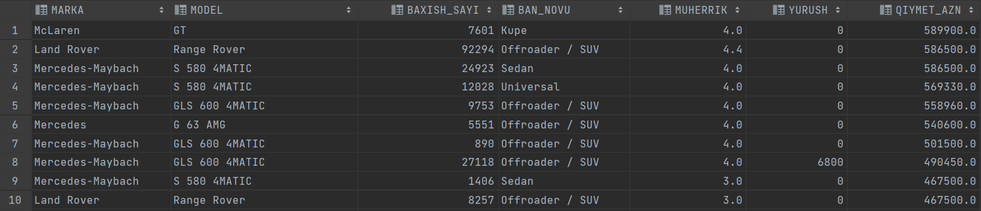

**ALL -** The ALL comparison condition is used to compare a value to a list or subquery. It must be preceded by =, !=, >, <, <=, >= and followed by a list or subquery. When the ALL condition is followed by a list, the optimizer expands the initial condition to all elements of the list and strings them together with AND operators, as shown below.

**Example:**

Display all cars, which price is more than all “Mercedes” price?

SELECT MARKA, MODEL, BAXISH_SAYI, BAN_NOVU, MUHERRIK, YURUSH, QIYMET_AZN  
FROM TURBO_AZ_NEW  
WHERE QIYMET_AZN > ALL (SELECT QIYMET_AZN FROM TURBO_AZ_NEW WHERE MARKA = 'Mercedes');

**Output:**

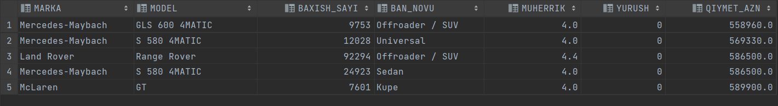

**IN -** The IN operator returns true if the value of expression equals to any value in the list of values or the result set returned by the subquery. Otherwise, it returns false. The NOT operator negates the result of the IN operator.

**Example:**

Display all car models, which also have “Off Roader / SUV” category

SELECT MARKA, MODEL, BAXISH_SAYI, BAN_NOVU, MUHERRIK, YURUSH, QIYMET_AZN  
FROM TURBO_AZ_NEW  
WHERE MODEL IN (SELECT MODEL FROM TURBO_AZ_NEW WHERE BAN_NOVU = 'Offroader / SUV');

**Output:**

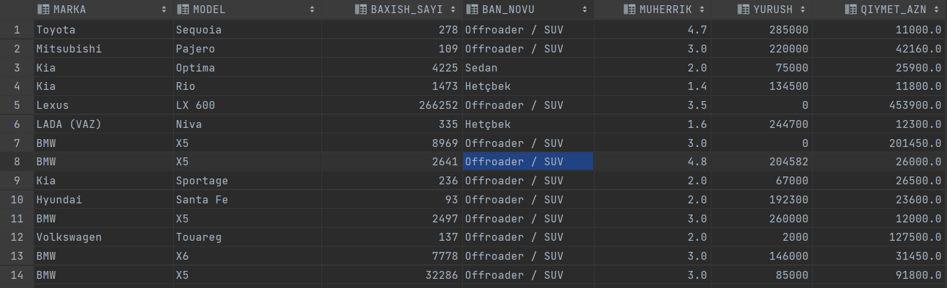

If we use “NOT IN”: Displaying all car models, which don't have “Off Roader / SUV” category

SELECT MARKA, MODEL, BAXISH_SAYI, BAN_NOVU, MUHERRIK, YURUSH, QIYMET_AZN  
FROM TURBO_AZ_NEW  
WHERE MODEL NOT IN (SELECT MODEL FROM TURBO_AZ_NEW WHERE BAN_NOVU = 'Offroader / SUV');

**Output:**

