**JENKINS**

* **Jenkins war file**

**Go to this link**

[**https://updates.jenkins-ci.org/download/war/**](https://updates.jenkins-ci.org/download/war/)

**click on permalink to the latest**

**It will download the latest**

**Copy the downloaded file and paste in E drive**

* **We need to run Jenkins.war in command prompt.**
* **Open command promp**
* **Go to e: where Jenkins is saved**
* **Run the command java –jar jenkins.war**
* **You will get a message Jenkins initial set up is required . An admin user has been created and password generated.**

**jenkins secret key**

**67e11d326402450784721466d7102408**

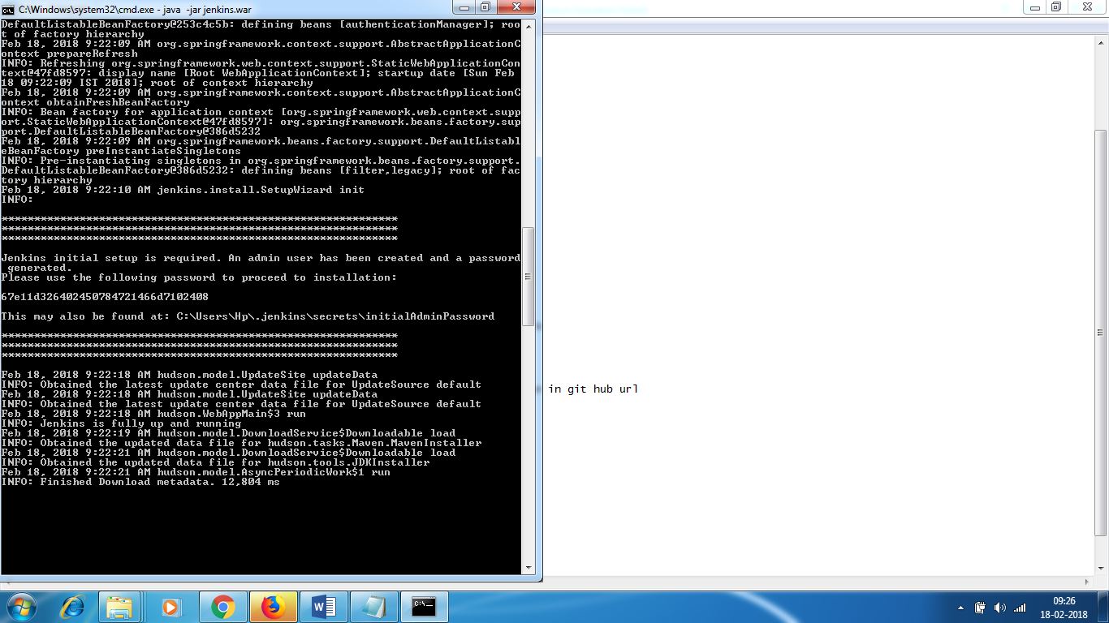

* **Goto localhost:8080**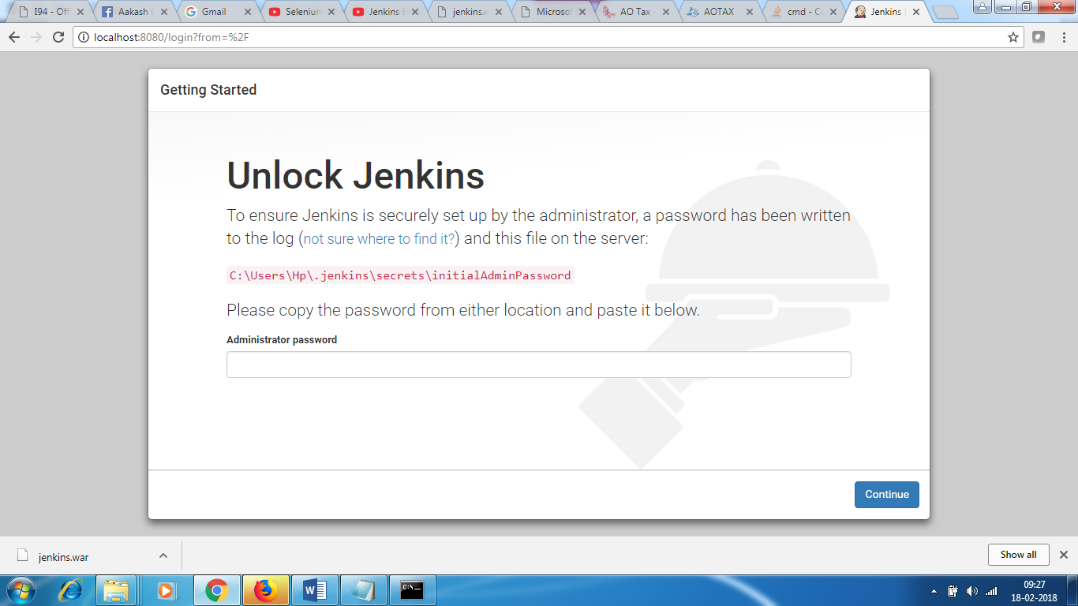

* **Give the password here and continue**
* **Install suggested plugin**

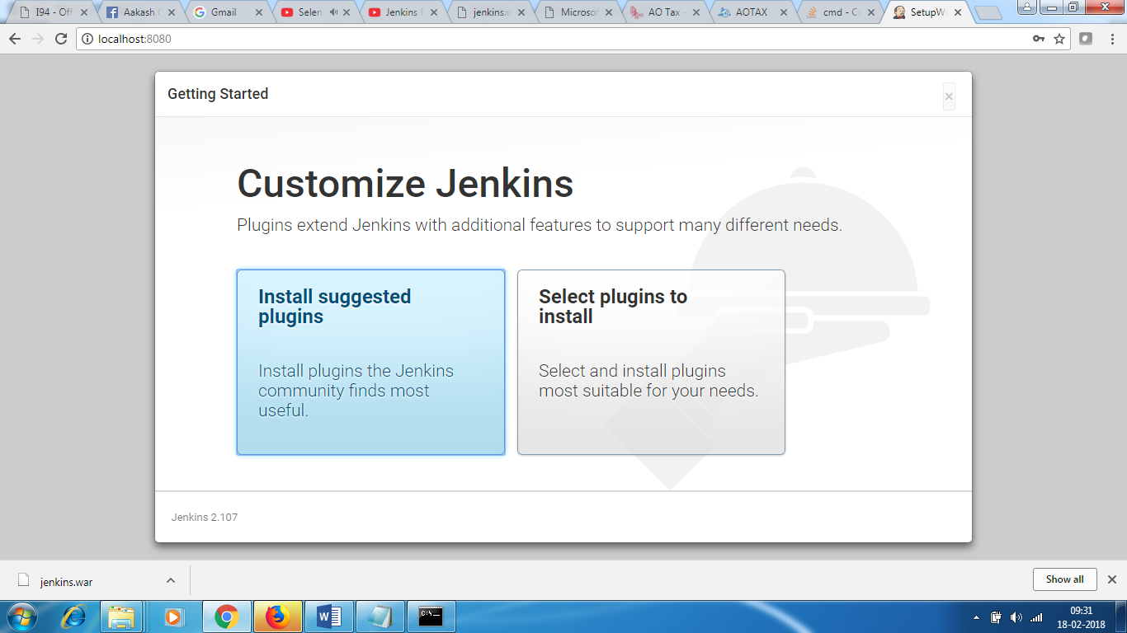

**It will install suggested plugins.**

**It will ask to set up an account**

**username : anariky1**

**usual password**

**ananthgithub@gmail.com**

**FULL NAME :Ananth Kumar Babu**

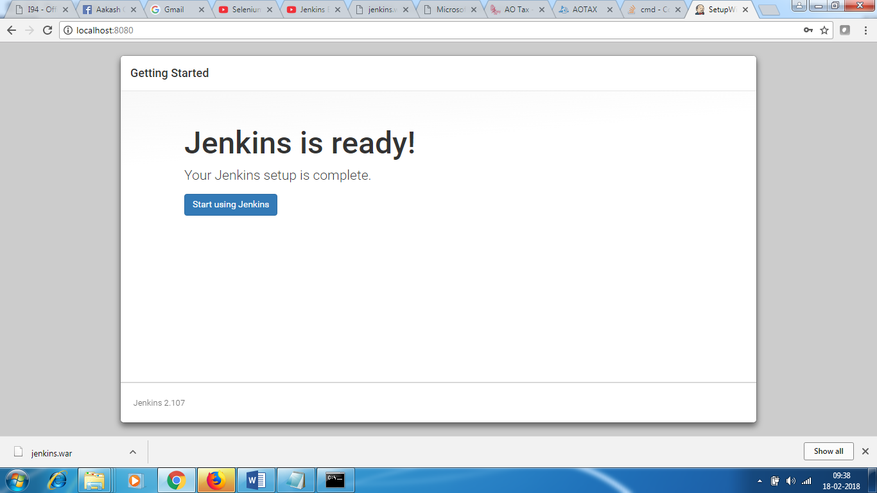

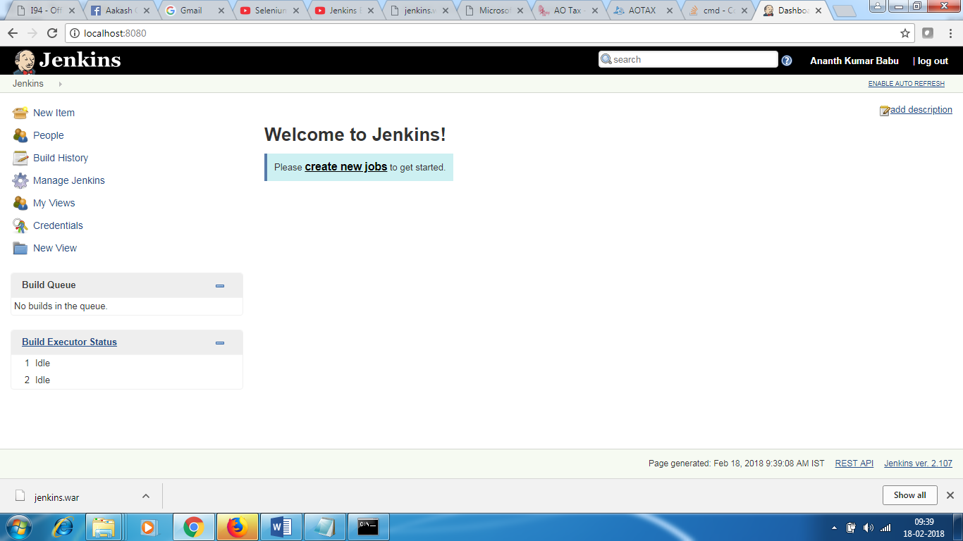

* Click on New item
* You don’t see Mave plugin , you need to add maven plugin

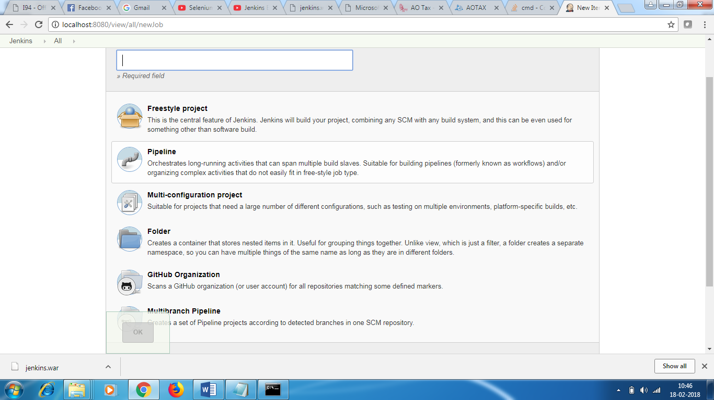

* Goto Jenkins -> Manage Jenkins -> Manage Plugins ->Goto available ->Enter maven in filter section

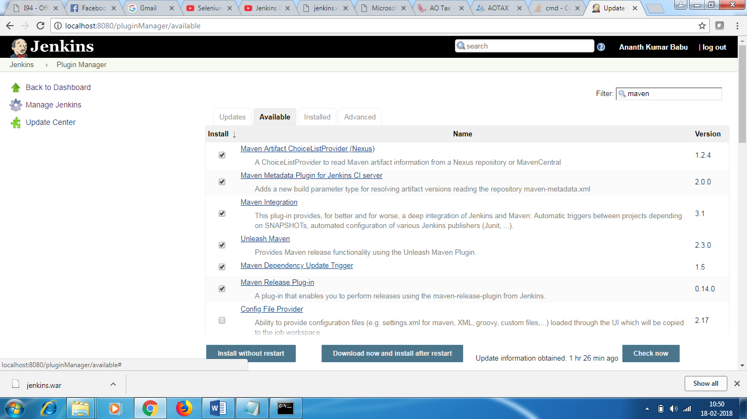

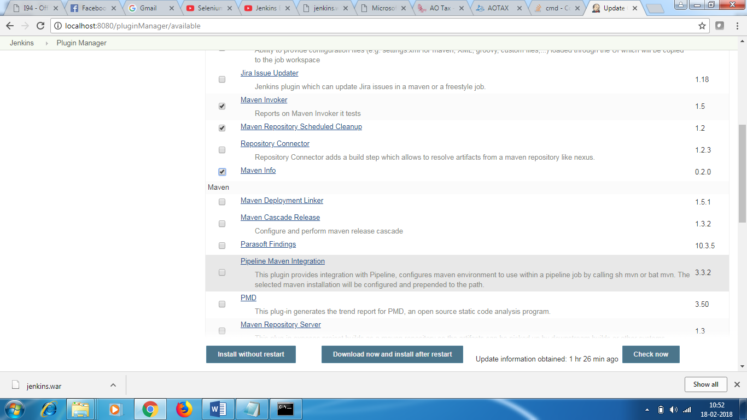

* Click download and install
* Do not close the command prompt – Jenkins should be started with command prompt
* If it doesn’t restart on its own,and maven plugin doesn’t show up , close the command prompt and restart Jenkins .

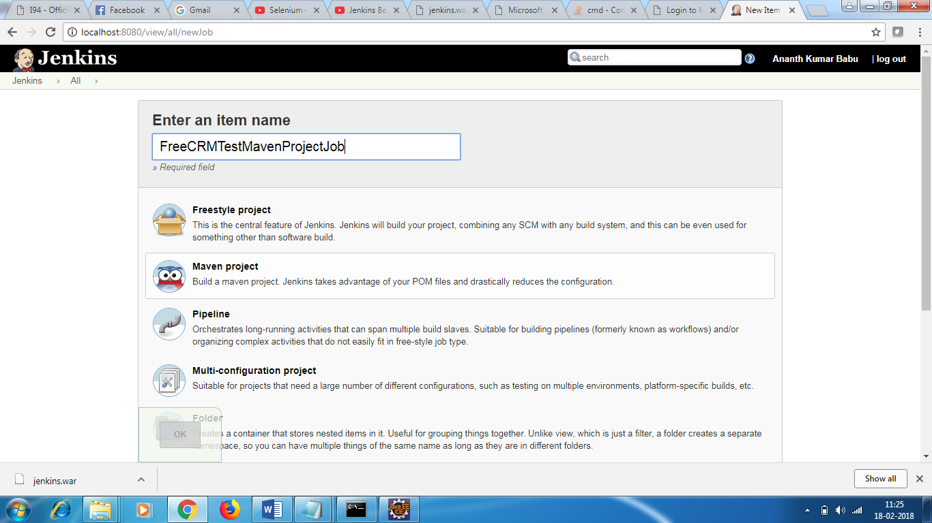

* Select MAVEN Project
* In DESCRIPTION –

FreeCRMTestMavenProjectJob

TestAutomationSuiteforFreeCRMApp

* Source code Management – None
* In Builds section , Jenkins needs to know **Jenkins needs to know where your Maven is installed.**

Click on tool configuration

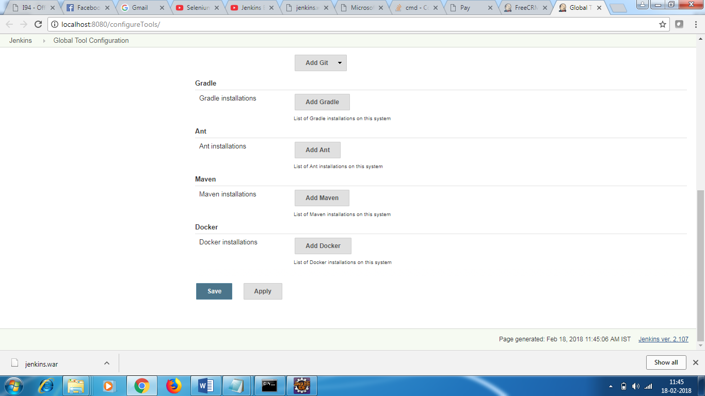

Click Add Maven

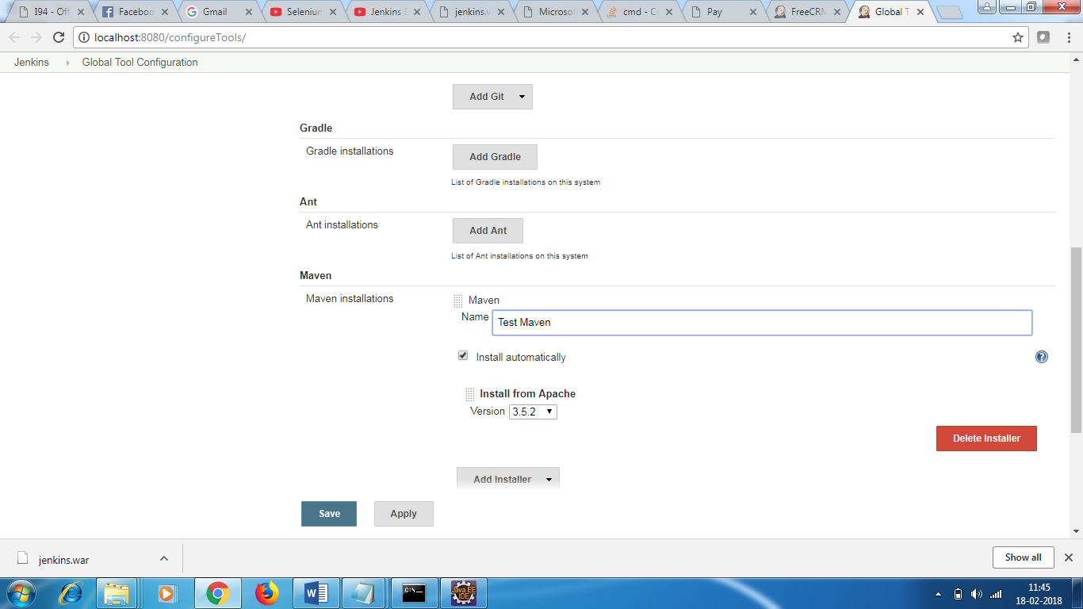

Click save.

[Optional step –

Give the git hub url if the source code is in git hub -

<https://github.com/anariky1/FreeCRM-PageObjectModelFramework>

pom – give pom.xml

]

Enter the pom.xml path

In golas – enter clean install , it will clean , install and then run

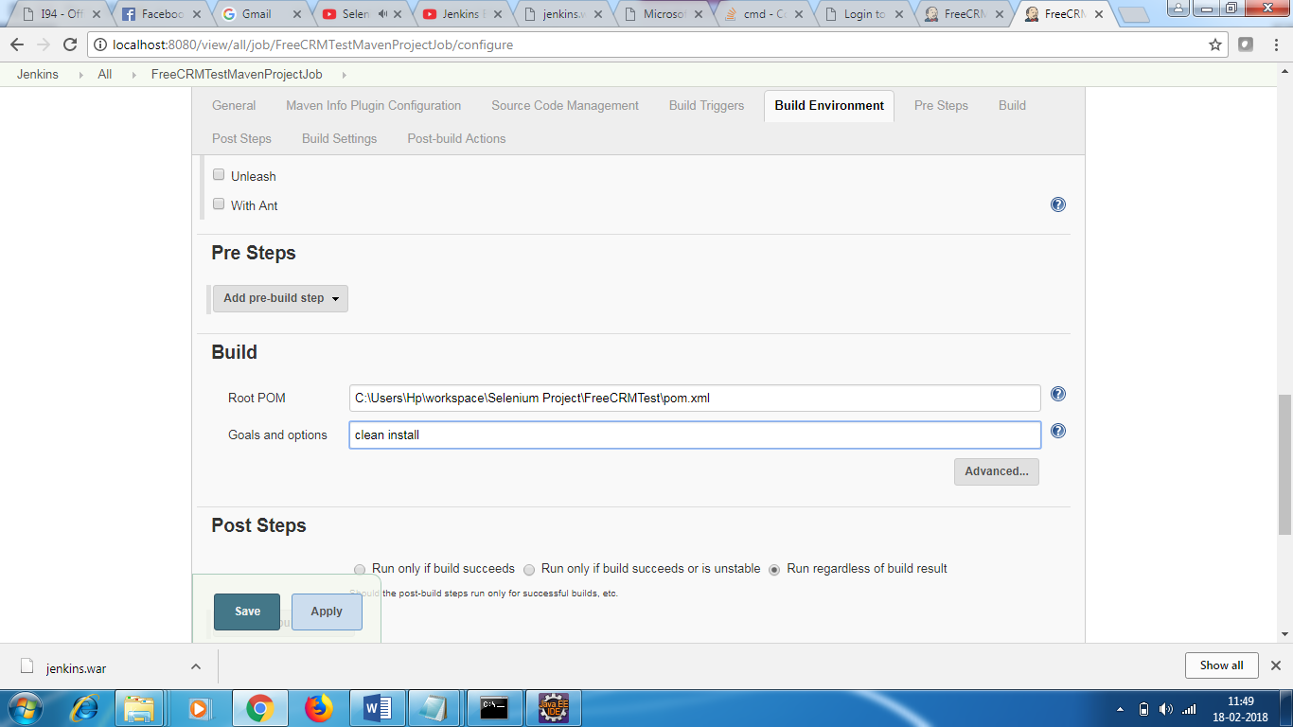

Post step:

Run regardless of build result.

In post build action , there is no testNG report. We need to install the TestNg plugin.

IN plugin section , add TestNG plugin in the available section.

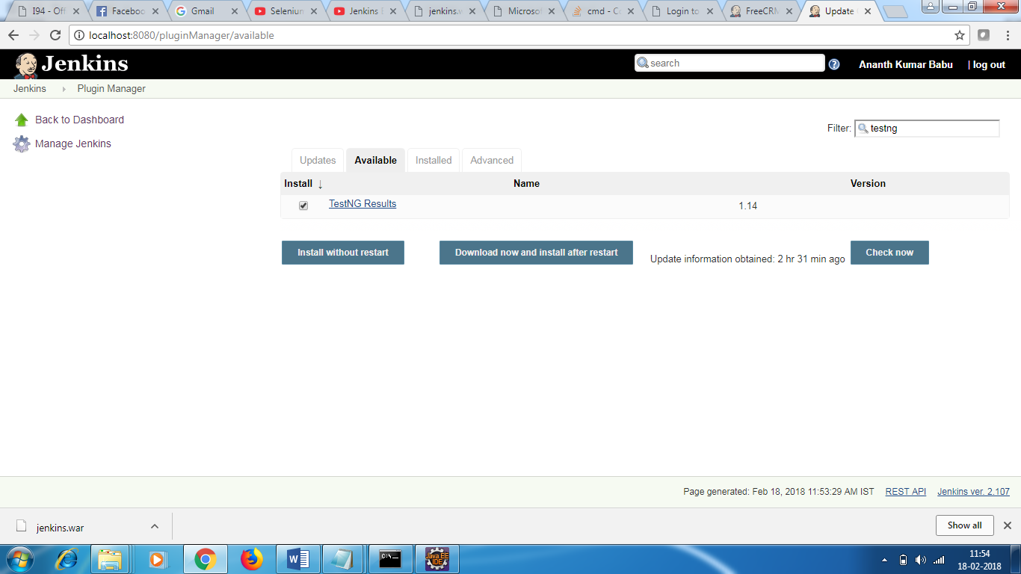

In Post build actions select Publish TestNG results

Give the path **/testng-results.xml - so that Jenkins will pick the results from this location and publish it.

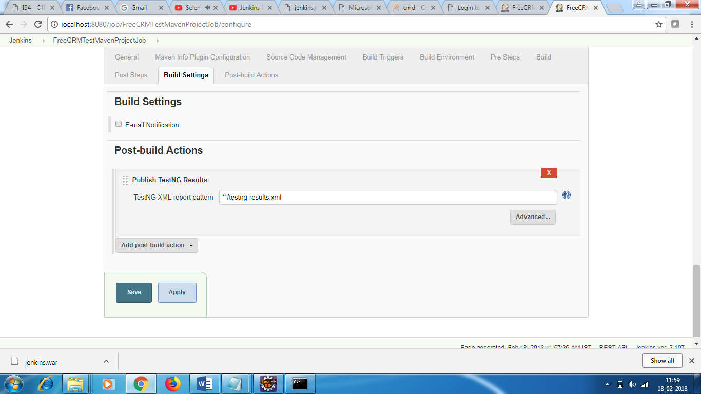

For Extent Report – add the plugin html report – publish html report plugin

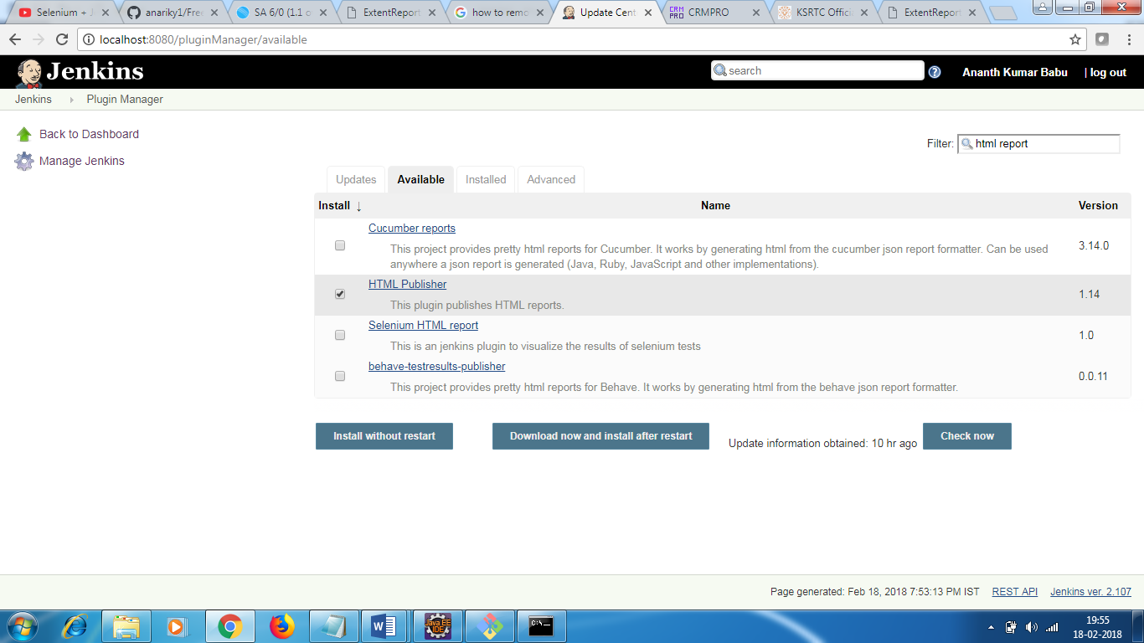

Exent html report is shown now

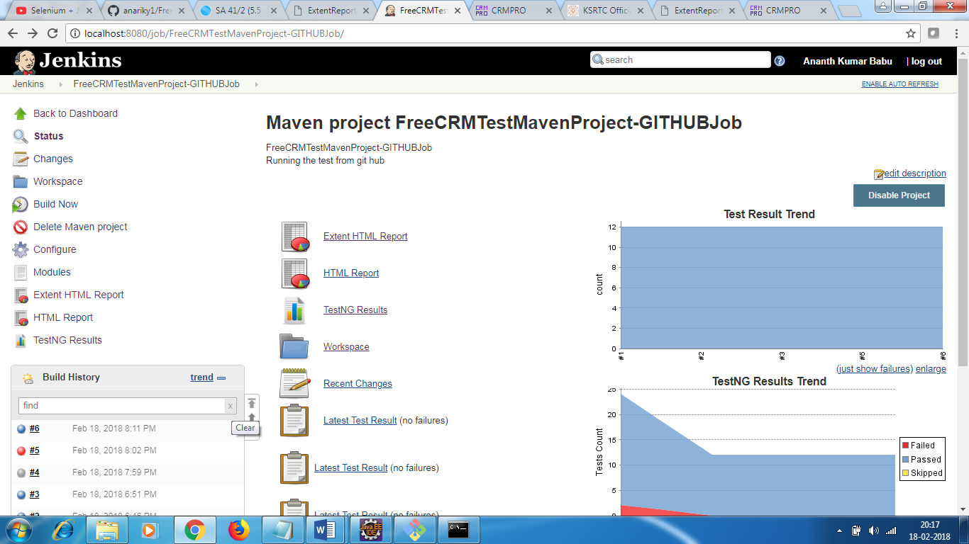

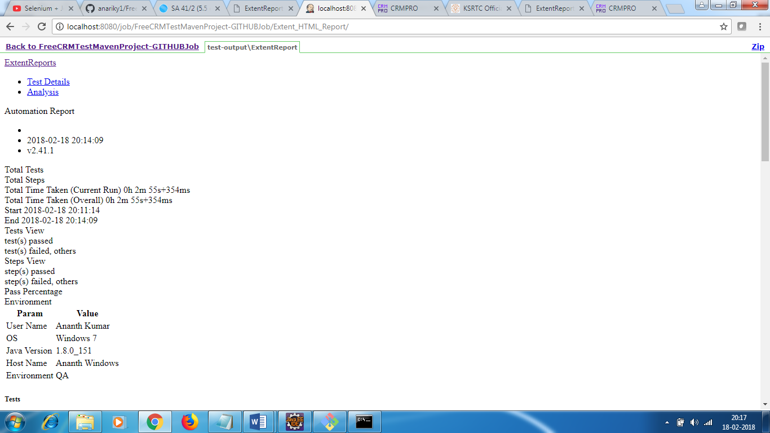

But the layout is not good.

Go to Manage Jenkins - > Click script console ->

Set the property

System.setProperty("hudson.model.DirectoryBrowserSupport.CSP", "")

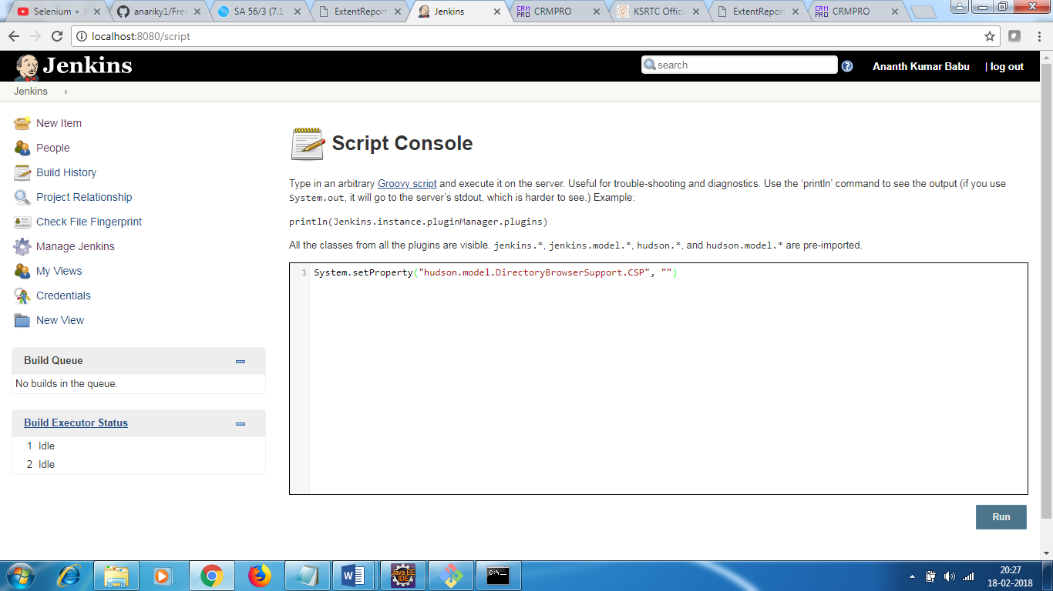

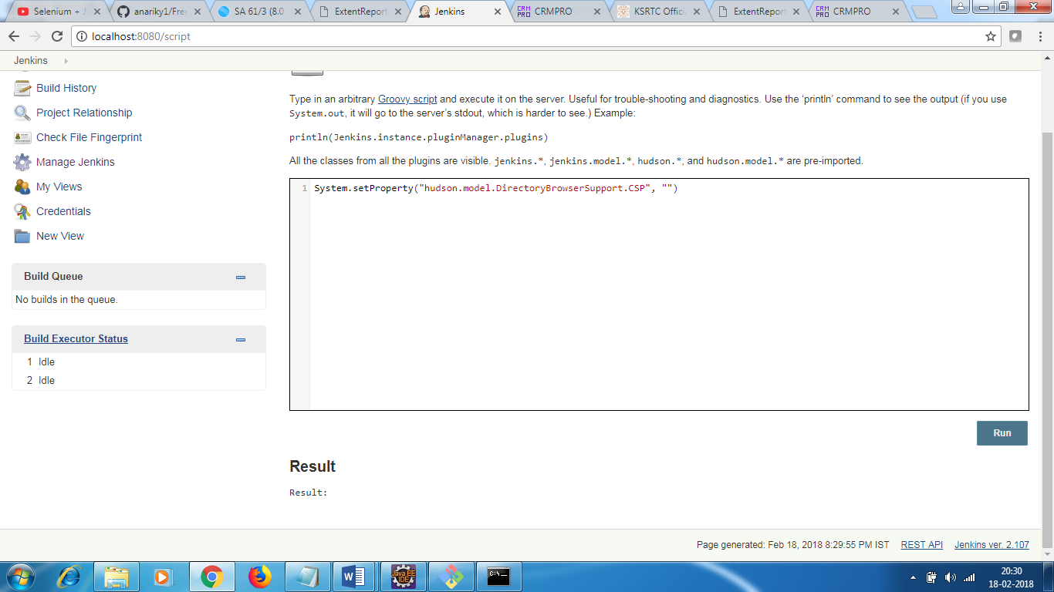

Make sure once you click on Run button , you get Result: text as in the above screenshot.

Jenkins screenshot

