Right click on project folder and create source folder

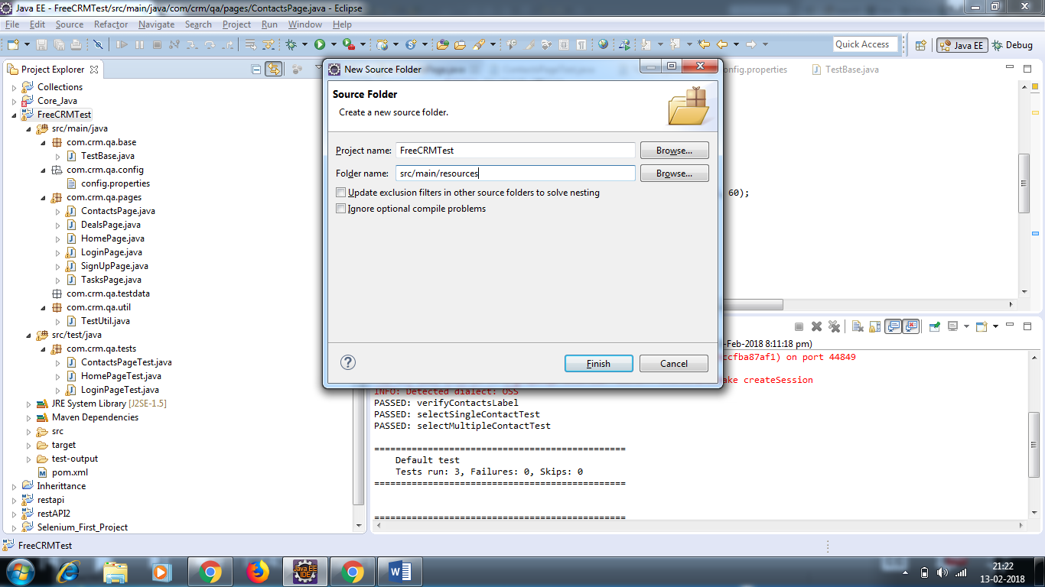

Right click on src/main/resources/ and add testng.xml

Email able report is also there in test output folder. Go to report path and open in browser

