API – Rest API – mostly we will cover Rest API –

* Soap based API is gone from the market.
* What is API?
* What is web service?
* What is Rest API
* What is Soap based API?

What are the different clients to be used?

How to do manual testing for API level point of view

API – means Application programing interface. API means JAR file.

In one class – Calculator class – I have sum method , mul method , div method and sub method

Next to calculator class , I have helper class –

I combine both these classes , and give as a form of Jar file - >**CALCULATOR JAR FILE.**

**Selenium Jar file is also available in form of API’s**

**To test these API , we have to write some code , we use TestNG**

**All the test inputs I am calling from TestNG. We call the methods available in CALCULATOR JAR FILE from TestNG class .**

**We create the object of calculator class and use the methods.**

**Some ABC company has created the JAR file and given us the utility to use it. In ABC company , there is a testing team who are doing this API level testing.**

**ABC company have given an interface ,some UI portal ,to test the calculator application . 2 input boxes and 1 output box . 2 +3 , your put is getting 5.**

**UI interface will be tested by selenium tool.**

**To test methods (sum , mul,div,sub) in JAR file , we need backend testing. This is called API testing.**

**Some applications don’t have UI , they just have JAR file and give to us. Selenium company – Thought Works they test if send keys , get method , driver.findelement method is working fine**

**Or not.These are called API testing / backend testing. We call selenium API jar files and use their method.**

**S1 will send request to B and B will send response to S2,**

**The communication b/w S1 and S2 happens in some format - > JSON format /XML format**

**Lets says S1 is written in JAVA and S2 is written in python , both the technologies are totally different and there is a security concern , S2 says we will give our API ‘s to you , you just call our API and use our methods.**

**S2 says I wont show my business logic , what is the business logic written in findelement method ,but we will give API, and you can call Sum () method.**

**We will give you the API name and the format , we will give you some authentication.**

**ABC will create some authentication so that S1 can access S2 API. S1 and S2 are independent to each other.**

**ABC will sell their products to different clients. Amazon , flipkart and ebay will call API . Every client will have one authentication key. This is the concept of token key , this**

**Is unique.**

**ABC company will decide how exactly they want to communicate using json /xml.**

**S1 will send request and will receive response from S2. Request JSON and Response JSON.**

**Why JSON/XML file ? – These are data collector .Informtion is stored here . These are very light weight. This the standard way to communicate between 2 different systems.**

**On,da**

**API is used when 2 systems wants to interact with each other.**

**Webservice**

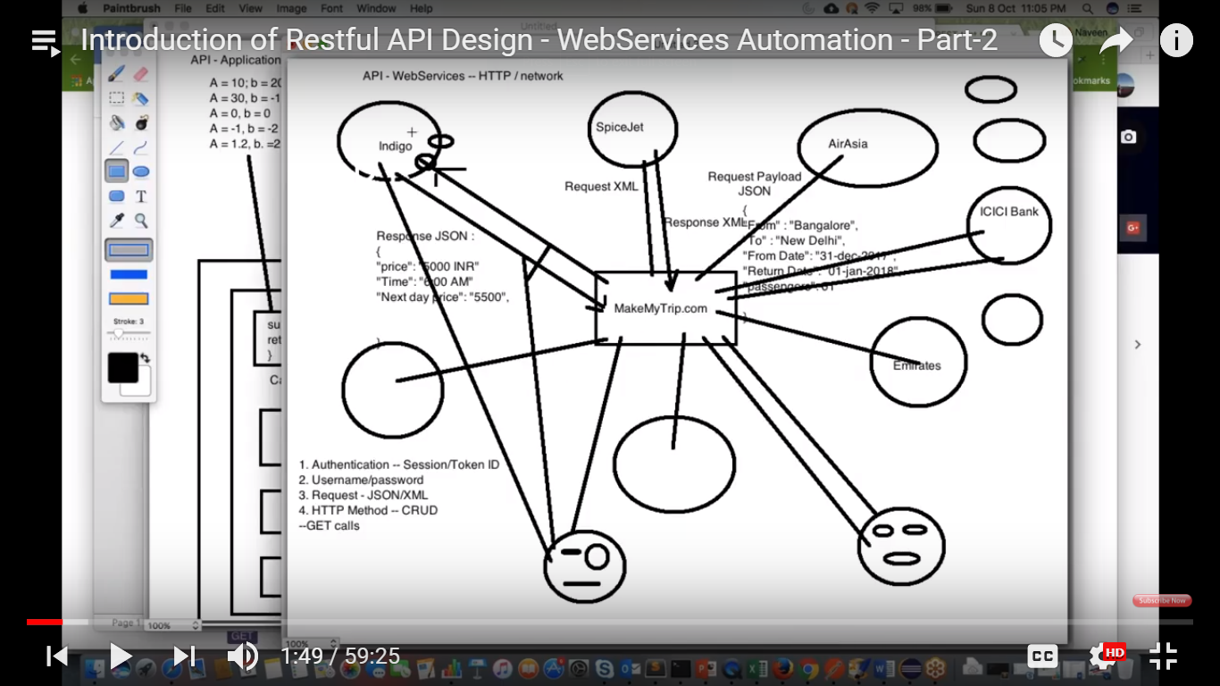

**We have makemytrip.com ,- indigo ,emirates , AirAsia**

**Customer wants to book a flight. Instead of going to individual flights .If they have to see 100 different flights , it becomes difficult for them to see the price.**

**So, these vendors are available in the market to make easy comparison.**

**I will go to makemytrip.com , I will fill a form may be json form or in UI itself.**

**We enter from - banglore , to destination – delhi , from date – 31 dec 2017 ,return date – 1 jan 2018. No of passengers – 01**

**MakeMyTrip converts to JSON / XML form**

**JSON – Request PayLoad ,**

**MakeMyTrip sends the information to indigo,emirates , AirAsia etc .**

**Indigo says to MakeMyTrip that you should not access my system . We have some API’s for MakeMyTrip . MakeMyTrip can call API’s from Indigro**

**Indigo sends one Json file to MakeMyTrip.com .This is called response.**

**{**

**“Price”:5000 INR**

**“Time” : 6:00 AM**

**PrevDayPrice:**

**NextDayPrice**

**}**

**MakeMyTrip collects information from different airlines . The UI developer will collect the data and display . This type of communication**

**Happens through API. These API are called webservices . They are not providing Jaoile . I don’t have Jar file locally . Here we are communicating**

**Over HTTP call . Through HTTP protocol we are communicating.**

**Through HTTP protocol we are sending the request and getting the response.**

**Factors required**

**->Authentication – Session/ Token should be there. Username/Pwd to access API’s.**

**-> What kind of request you want to fetch – send me req in the form of JSON / xml file and you will get response**

**- > What type of method ? HTTP method – CRUP – Create , Retrieve , Update and delete**

**I cannot create anything in Indigo**

**I can only do Retreive. – GET API calls**

**->Security – Hacker – Whatever request you are sending and whatever response you are getting he will attack in between.**

**He will attack MakeMyTrip.com(when passing credit card) . That is security concern with MakeMyTrip.com**

**Hacker may attack Indigo or at the nework layer in between request and response .**

**Indigo and MakeMyTrip they have to prevent hacking which is done by each of them separately.T . This is not a part of web service security .**

**This is system security.**

**Now ICICI bank is there , Customer says am ok with option and lets do the payment .**

**MakeMyTrip will redirect to ICICI bank . MakeMyTrip will send a request to ICICI and will get response from ICICI.**

**They will know if transaction is successful or not. If you are entering wrong u sername/pwd , ICICI will deny the permission.**

**MakeMyTrip will send credit cardno , cvv , expiry no to ICICI and please deduct 5000 RS.**

**Once amout is deducted , they will send invoice to customer that ticket has been booked .**

**All is happen through webservice. Security is most important.**

**ICICI , MakeMyTrip and Indigo have their own testing team.**

**Rest API provides some security.**

**If you are passing XML/JSON file – that is called REST API call**

**SOAP API – totally gone from market .**

**REST is light weight.**

**If you are calling API over network – Webservices**

**I have downloaded selenium 3.6.0 .JAR file .**

**I want to customize their code .I will create my own Customize JAR .This is open source. There is no licensing.**

**2 Types of Web service:**

**SOAP based (SIMPLE OBJECT ACCESS PROTOCOL)**

**REST based.**

**SOAP and REST –**

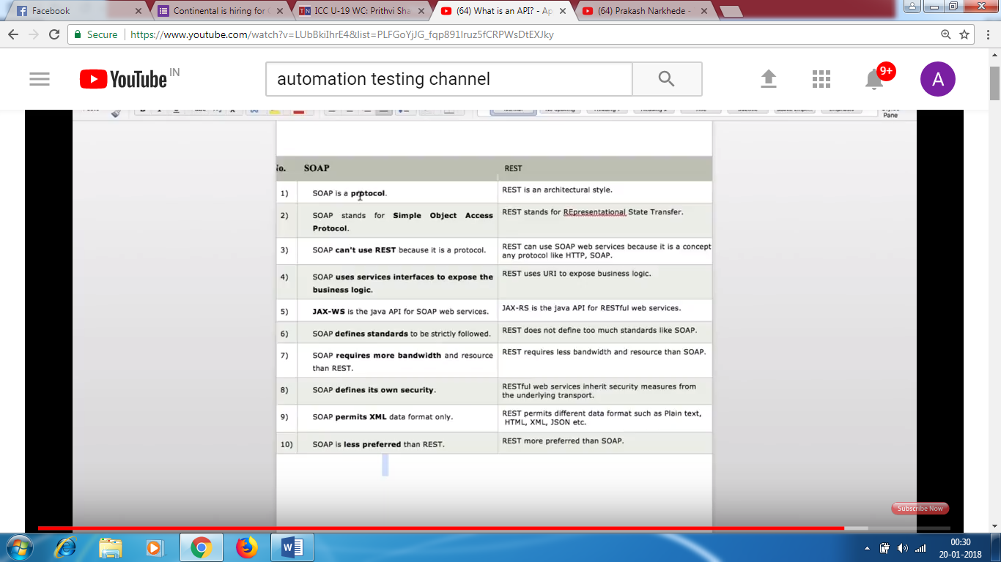

**URI – kind of URL – If you want to access my system , I will give one URL**

**JAX-WS – security based system for SOAP**

**JXA-RS – security based system for REST**

**REST – less weight , uses less number of resources.**

**SOAP – requires more internet bandwidth.**

**SOAP – defines its own security**

**REST – inherits security measres from underlying transport.**

**SOAP – XML**

**REST – HTML,XML,JSON,plain text.**

**SOAP – protocol; SIMPLE OBJECT ACCESS PROTOCOL**

**REST – representational state transfer.**