* Automate GET API’s with Headers
* How to Parse API Response Object
* Validate Response by using TestNG Assertion.

JSON Object and JSON Array.

How to add Headers?

Click Headers

Click Bulk Edit

Content-Type:application/json

UserName:test

Password:test123

Auth Token:1234

Then Click Key value edit

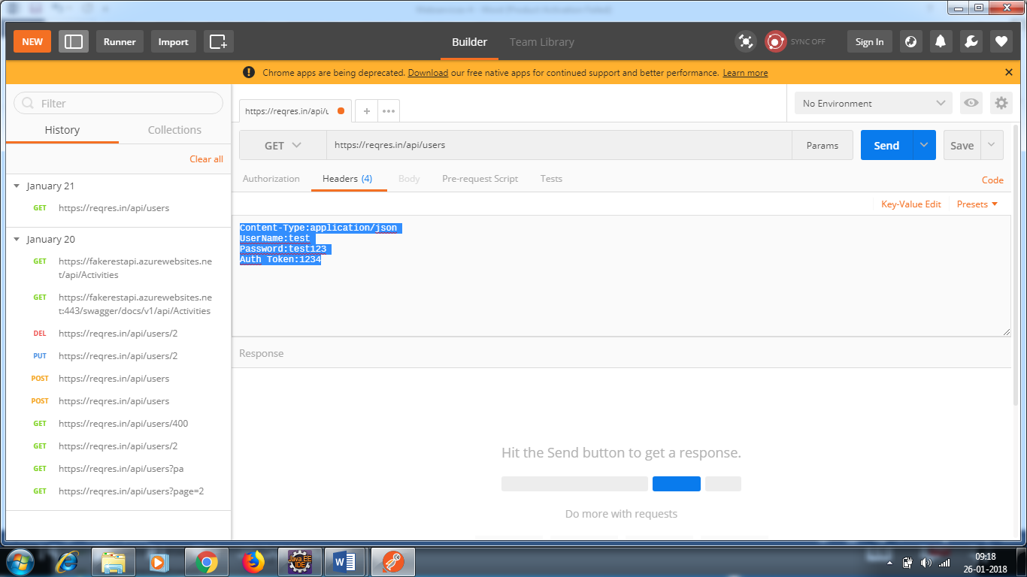

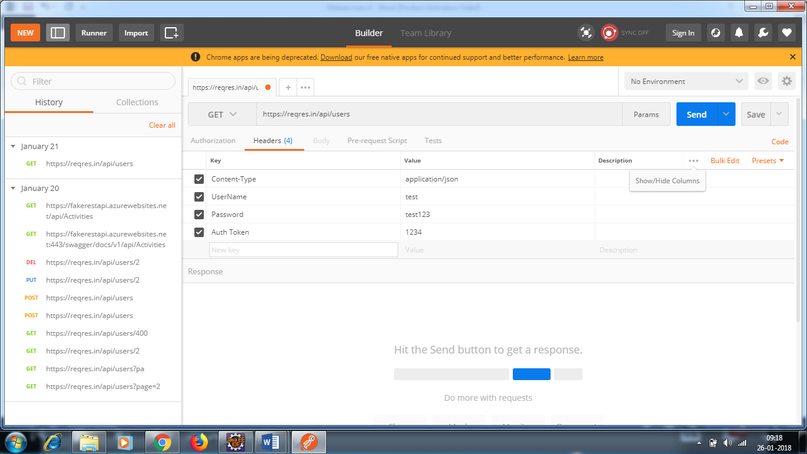

The developers will give header information.