Webservices – 3

Automate GET call

We wil see by calling JAVA API , how to call GET API

* Add HTTP Client JSON Parser libs dependency
* Automate GET APIs with headers
* Automate GET APIs without headers
* How to parse JSON objects

You need to hit the API through POSTMAN and automate it

You wont have any UI where you click on GET button like we did in earlier session.

Create Maven Project.

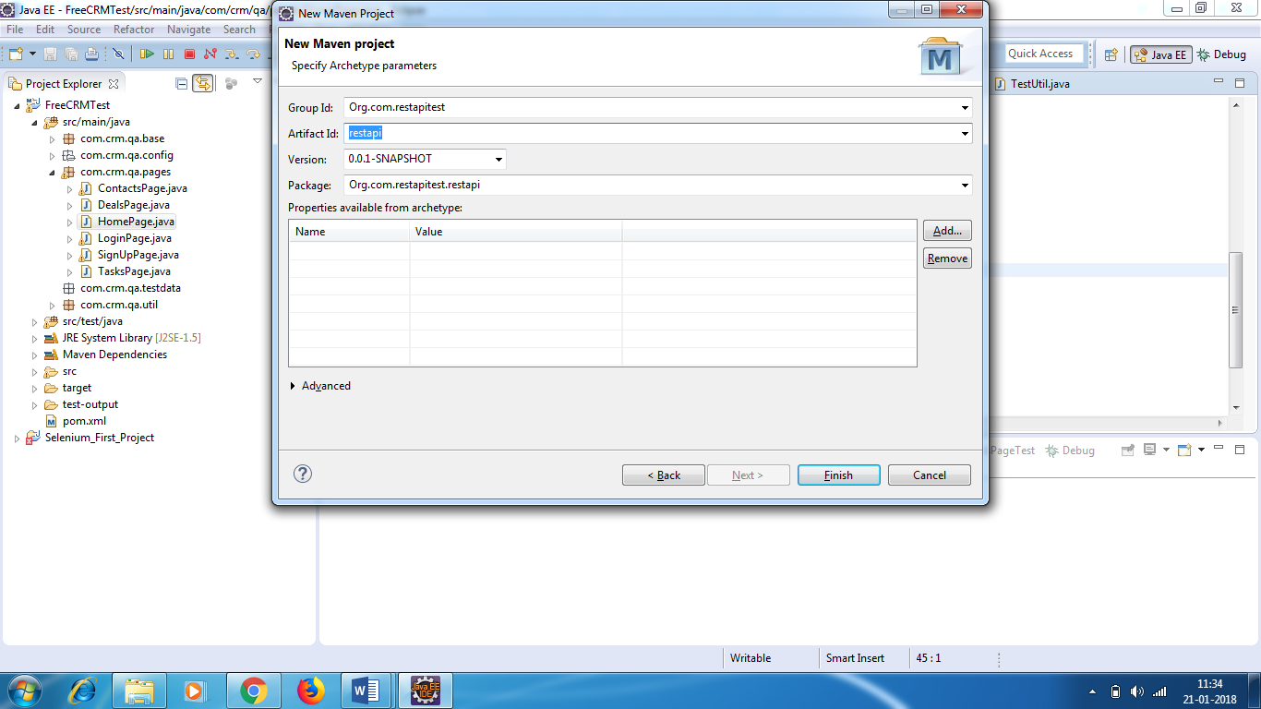

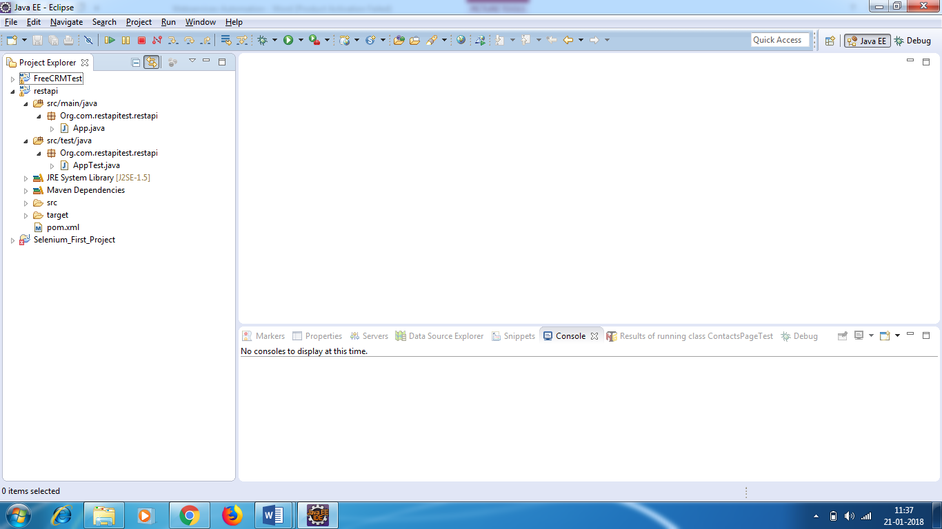

Delete the dummy packages – org.com.restAPI.restapi

You have pom.xml

We need to add 2 dependency (API’s)

* HTTP Client library.
* HTTP Core library.
* JSON Parser library.
* TESTNG Library

The response we get is JSON response. We need to parse JSON response.

We are not adding any selenium dependency.