
Label Switch Router (LSR) for NetFPGA
User Manual, Version 1.5
May 10, 2012
Developed by Algo-Logic Systems for Google
http://Algo-Logic.com

Contents
1. Introduction 2
2. MPLS Operation Commands 2
3. Label spaces and partitions in SRAM 4
4. SRAM Lookup 5
5. BRAM Lookup 6
6. Packet flow through the NetFPGA hardware pipeline 6
7. Register Interface 8
8. Software 9
9. Implementation and testing 13
10. Results : 15
11. Errata 23
12. For Additional help and assistance: 23

Introduction
Multiprotocol Label Switching (MPLS) is a mechanism that allows networks to carry data from one network node to the next with the help of short labels. MPLS enables the creation of virtual links between distant nodes and can readily forward packets between data centers by encapsulating packets of multiple network protocols.
The MPLS Label Switch Router (LSR) is a hardware-accelerated LSR implemented built by Algo-Logic Systems for Google that adds MPLS label switching functionality over and beyond the default NetFPGA reference switch.
The structure of an MPLS frame with four MPLS tags is shown below.
IPv4 or V6 Header
ENet
MPLS
Tag 1
MPLS
Tag 2
MPLS
Tag 4
Packet Payload
..

MPLS headers can be seen immediately after the EtherType field in the Ethernet Header. Each MPLS header is 32-bits long with the following format:
TTL (8)
EXP (3)
S (1)
Label (20 bit)

“Label” is a 20-bit field used as a label for switching operations.
“EXP” is the 3-bit experimental bits field. This implementation does not use it.
“S” is the Bottom of Stack bit. If S is “1” it indicates this header is the last one in the MPLS stack.
“TTL” is an 8-bit Time-To-Live field used to detect forwarding loops.

MPLS Operation Commands
The MPLS operations implemented are:
- Swap
- Push
- Swap+Push
- Pop
- Pop+Swap
The operation to be performed on the received MPLS frame is determined by a 72-bit word stored in the SRAM of the 1G NetFPGA card. Whenever a frame enters the NetFPGA hardware pipeline, the 20 bit label is extracted from the top-most MPLS header and used as an address for a lookup operation into the corresponding 72-bit word in SRAM. The format of the 72-bit word stored in SRAM is shown below:
LD
[4]
Cmd
[4]
Dest Port
[6]
Next Label
[20]
Push Label –or/- Distribution Offset
[20]
Parity
Chk
[8]
Dest MAC
[8]
2 Bits
(Unu (Not
Used)
Each field of the 72-bit word is explained below:
Cmd – MPLS Operation Commands: 4 bits, representing:
0 – No Op
1 – Swap
2 – Push
3 – Swap & Push
4 – Pop
5 – Pop & Swap
LD - Load Distribution Count: 4 bits
The number of load distribution entries starting from the Load distribution offset. Default value is 0, up to 4 entries are supported.
Dest Port - 6 bits
Address of the physical output port (nf2c0, nf2c1 … )
nf2c0 = port 0
nf2c1 = port 2
nf2c2 = port 4
nf2c3 = port 6

Dest MAC - 8 bits
An index into a 256-entry table of next-hop MAC addresses stored in on-chip BRAM

Next Label
A 20-bit MPLS label used as a lookup address into the SRAM table, to determine the label to swap in the first MPLS header.

Push Label / Distribution offset
For commands that push additional MPLS headers, these 20 bits define the MPLS label to be pushed onto the top of the stack. If the LD field > 0 these 20 bits will be the starting address of the load distribution entries.

Parity/Checksum
8-bit check of bits.

Label spaces and partitions in SRAM
The SRAM in a 1G NetFPGA board can store 256k words with a width of 72 bits. The total label space (not the total SRAM space) is first divided into two equal halves, one for input label spaces and one for load distribution. The input label spaces are further divided in to four equal-sized spaces and each space is assigned to an input port (LS1, LS2, LS3 and LS4). The load distribution entries have their own space named LD space. Each entry in both the LS space and the LD space has two counters. The first counter indicates the total number of input frames hitting that particular entry and the second counter indicates the total byte count of those frames. Each of these counters takes 1/3 of the total SRAM space. The whole SRAM space allotted for these spaces is shown below.

LS 1 : MPLS Table
LS 2 : MPLS Table
LS 3 : MPLS Table
LS 4 : MPLS Table

LD : MPLS Table
Packet Counter entries

Packet Byte Counter entries

SRAM Lookup
If the Ethernet parser finds an MPLS unicast packet, the first 20 bits from the top-most MPLS header are extracted and added to a constant value (software offset) to determine the lookup address. After the 72-bit SRAM word lookup is performed using that value, the Ethernet parser module will check the 4-bit LD value in the retrieved entry. If the LD value is zero, the received SRAM word is latched and the corresponding packet counter and packet byte counter is incremented. If the LD value is not equal to zero the 20-bit LD offset value is then latched. Let’s suppose n is the LD value. This indicates there are n valid LD entries starting from the address ‘LD offset’, and from these n entries one is to be selected for later MPLS operations. To make this selection, a hash value is generated by making use of the following parameters:
- Source IP address (32 bits) of the frame.
- Destination IP address (32 bits) of the frame.
- TCP source port (16 bits) if the packet is a TCP packet (or UDP source port if the packet is a UDP packet)
- TCP destination port (16 bits) if the packet is a TCP packet (or UDP destination port if the packet is a UDP packet)
- Let k is the hash value, then (k modulo n) will give a number p whose value will be in between 0 and n-1.
- The SRAM address of the LD entry selected = (LD offset + p)
A second SRAM look up operation is performed for this selected address. After latching, the corresponding 72-bit SRAM word packet counter and 72-bit SRAM word packet byte counter is incremented. Because this second lookup is required, LD is not supported with the Pop&Swap opcode as it exceeds available memory bandwidth.
Read Request for MPLS word
Read Request for counter1
Read Request for counter2
Waiting time (3 clk)
MPLS word, LD>0 ?
Read Request for LD counter1
Read Request for LD counter2
Write Request counter/ LD counter 1
MPLD word read done
Waiting time (3 clk)
Write Request counter/LD counter 2
Yes => Find LD offset and Request LD word
No
MPLS word, LD>0 ?
Yes => Error
No

BRAM Lookup
The dest MAC field (8 bits) of the latched 72-bit SRAM word is used as an index into a BRAM lookup, to get the destination MAC address of the outgoing frame. A maximum of 256 MAC addresses can be stored in the BRAM.

Packet flow through the NetFPGA hardware pipeline
As a frame is delivered to a NetFPGA port, the MAC receiver unit accepts and directs it to the output look-up module via the input arbiter.
In the output look-up module, the header of the frame is parsed by the header parser module. It latches all the header information in a status FIFO. The frames are stored in a FIFO in the look-up module.
The actions in the output look-up module place in the following order:
- If the packet is MPLS multicast it is forwarded to the host CPU.
- If the MAC multicast bit is not set and the destination MAC address is not matching, the frame is dropped and the corresponding counter (the not for us counter) is incremented.
- If the frame is MPLS unicast and the SRAM lookup address derived from its top-most 20-bit MPLS header is outside of the expected label space, the packet is dropped and the corresponding counter (LS error counter) is incremented.
- If the frame is not MPLS unicast it is forwarded to the host CPU.
- If the frame is MPLS unicast, it waits for the MPLS look-up action to complete.
- After getting the 72-bit word from SRAM, the corresponding packet counter and packet byte counter in SRAM is incremented.
- The index for the destination MAC address is latched from the 72-bit SRAM word and a BRAM lookup is performed.
- If there a parity error in the look-up SRAM word it is dropped and the corresponding counter is incremented.
- If there is no error, the MPLS unicast packet with the modified destination MAC and output port are passed to the MPLS processing unit along with the 72-bit look-up word from SRAM.
- The MPLS processing unit check the TTL and if it is expired forwards the frame to the host CPU and the corresponding counter is incremented, otherwise it modifies the frame header according to the “cmd” field in the SRAM word. The frame is then passed to the output queue module.
- The output queue module checks the output port address and forwards the frame to the corresponding DRAM queue and then it is forwarded to the corresponding MAC transmitting unit.

Register Interface
The 72-bit word entry in SRAM and the output MAC address entry in BRAM are populated using the register interface. The addresses of all registers, the SRAM base and the BRAM base are defined in ~/netfpga/projects/mpls_switch/lib/C/reg_defines_mpls_switch.h
The NetFPGA register interface supports the reading and writing of 32-bit wide words. In order to write a single 72-bit SRAM entry we make use of SRAM address locations between “0Xxxxxxx0” and “0Xxxxxxxf” as follows. The 32 bits of SRAM entry in the LSB side are buffered if we use the address location 0XxxxxxxC, the next 32 bits (middle of the SRAM entry) are buffered for the address location 0Xxxxxxx8 and the next 8 bits (MSB side) are buffered for the address location 0Xxxxxxx4. These buffered 72 bits are written to SRAM when we write a trigger value of “0xffffffff” to the address location “0Xxxxxxx0”. The following example illustrates the procedure to write a 72-bit SRAM entry “0X12345678ABCDFFFF98” to the SRAM locations from address 0X1000000 to 0X100000f.
writeReg(&nf2, 0x100000C, 0xCDFFFF98);
writeReg(&nf2, 0x1000008, 0x345678AB);
writeReg(&nf2, 0x1000004, 0x00000012);
writeReg(&nf2, 0x1000000, 0xffffffff);

Writing a MAC address in BRAM follows the same procedure. The following example illustrates how we write MAC address “12345678ABCD” to the BRAM region spanned between “0x2002030” and “0x200203f”.

writeReg(&nf2, 0x100000C, 0x5678ABCD);
writeReg(&nf2, 0x1000008, 0x00001234);
writeReg(&nf2, 0x1000000, 0xffffffff);

Other important registers needed for proper MPLS operations are detailed below:

#define SWITCH_OP_LUT_MAC0_HI_REG 0x2000100
#define SWITCH_OP_LUT_MAC0_LO_REG 0x2000104
#define SWITCH_OP_LUT_MAC1_HI_REG 0x2000108
#define SWITCH_OP_LUT_MAC1_LO_REG 0x200010c
#define SWITCH_OP_LUT_MAC2_HI_REG 0x2000110
#define SWITCH_OP_LUT_MAC2_LO_REG 0x2000114
#define SWITCH_OP_LUT_MAC3_HI_REG 0x2000118
#define SWITCH_OP_LUT_MAC3_LO_REG 0x200011c
The above registers are used for storing the MAC addresses of the NetFPGA ports.
This MAC address is used for matching with the destination MAC address of the incoming packets.

#define SWITCH_OP_LUT_LS1_BASE_REG 0x2000120
#define SWITCH_OP_LUT_LS1_BOUND_REG 0x2000124
#define SWITCH_OP_LUT_LS2_BASE_REG 0x2000128
#define SWITCH_OP_LUT_LS2_BOUND_REG 0x200012c
#define SWITCH_OP_LUT_LS3_BASE_REG 0x2000130
#define SWITCH_OP_LUT_LS3_BOUND_REG 0x2000134
#define SWITCH_OP_LUT_LS4_BASE_REG 0x2000138
#define SWITCH_OP_LUT_LS4_BOUND_REG 0x200013c
#define SWITCH_OP_LUT_LD_BASE_REG 0x2000140
#define SWITCH_OP_LUT_LD_BOUND_REG 0x2000144
The above registers are used for storing the base addresses and bound sizes for the four label spaces and one LD space.

#define SWITCH_OP_LUT_SOFT_OFFSET_REG 0x2000150
This register is used to load the software offset. The content of this register is added to the 20 bit MPLS label of the topmost MPLS header in the incoming frame to determine the SRAM lookup address.

#define SWITCH_OP_LUT_NOT_FOR_US_REG 0x2000154
The content of this register counts the number frames dropped due to mismatching destination MAC address errors.

#define SWITCH_OP_LUT_PARITY_ERROR_REG 0x2000158
The content of this register counts the number of times a parity error was found doing an SRAM word lookup.

#define SWITCH_OP_LUT_TTL_ERROR_REG 0x200015c
The content of this register gives the TTL error count.

#define SWITCH_OP_LUT_LS_ERROR_REG 0x2000160
This counter is incremented if the index for the SRAM lookup is not contained within the assigned label space for the incoming frame’s port.

#define SWITCH_OP_LUT_LD_ERROR_REG 0x2000164
This counter is incremented if the index for the SRAM lookup is no contained within the LD label space during an LD indexing.

Software
Software programs to help populate SRAM, BRAM, and other register entries are provided in ~/netfpga/projects/mpls_switch/sw
swap is the command for creating a swap entry in SRAM with LD value zero, using the following parameters:
- Destination port number
- SRAM entry number
- BRAM MAC entry number to rewrite the destination MAC address with
- The MPLS label to swap into the topmost MPLS header

push is the command for creating a push entry in SRAM with LD value zero, using the following parameters:
- Destination port number
- SRAM entry number
- BRAM MAC entry number to rewrite the destination MAC address with
- The MPLS label to push onto the existing MPLS stack

pop is the command for creating a pop entry in SRAM with LD value zero, using the following parameters:
- Destination port number
- SRAM entry number
- BRAM MAC entry number to rewrite the destination MAC address with

spush is the command for creating a swap+push entry in SRAM with LD value zero, using the following parameters:
- Destination port number
- SRAM entry number
- BRAM MAC entry number to rewrite the destination MAC address with
- The MPLS label to swap into the existing topmost MPLS header
- The MPLS label to push underneath the swap label

pswap is the command for creating a pop+swap entry in SRAM with LD value zero, using the following parameter:
- SRAM entry number

ld is the command for creating an entry in SRAM with a nonzero LD, using the following parameters:
- LD value
- SRAM entry number
- Distribution offset

mac_out is the command for creating a MAC entry in BRAM, using the following parameters:
- The MAC address to be added, without colon or space in between
- BRAM entry number

lsld_init is the command for creating the label spaces, ld space, and packet counter base and bound, and it should be followed by
- Label space 1 base address
- Label space 1 bound (number of entries)
- Label space 2 base address
- Label space 2 bound (number of entries)
- Label space 3 base address
- Label space 3 bound (number of entries)
- Label space 4 base address
- Label space 4 bound (number of entries)
- LD space base address
- LD space bound (number of entries)
- Packet counter space base address
- Packet byte counter space base address

mac0_add, mac1_add, mac2_add, mac3_add are the commands for creating MAC addresses of the corresponding MAC ports and these should be followed by
- MAC address without colon or space in between

lsr_init is the command for initializing the label space registers, LD space registers, software offset register, MAC address registers, and error count registers with default values.

Following are some underlying C functions which can be used to perform MPLS operations.
lsr_fn is a function which can be used to enter a 72-bit SRAM entry.
int lsr_fn(int dest_port,int ld_entry, int mac_bram_entry, int next_label, int next_label2,int op, int entry_num)
- dest_port – Destination port
- ld_entry - Load distribution entry
- int mac_bram_entry – Index of BRAM to read the output MAC Address
- next_label – Label used for the swap operation (input any value if it is not used)
- next_label2 - load distribution offset or push value (input any value if it is not used)
- op – MPLS cmd (value between 0 to 5)
- entry_num – Index of SRAM to write the MPLS word

mac_out is the function to write a MAC address entry to the BRAM lookup Table.

int mac_out(int mac_oh, int mac_ol, int entry_num)
- mac_oh - value for 16 bits on the MSB side of the MAC address
- mac_ol – value for 32 bits on the LSB side of the MAC address
- entry_num - Index of BRAM to write the MAC address

lsr1_init is the function to write Label space 1’s starting index and bound (number of entries in SRAM) to the corresponding registers.

int lsr1_init(int base_address, int bound)
- base_address – Starting address of label space 1 in SRAM
- bound - Number of entries for tlabel space 1 in SRAM

Similarly lsr2_init, lsr3_init, lsr4_init can be used to enter base and bound values for other label spaces.

lsr_ld_init is the function to write the LD space’s starting index and bound to the corresponding registers.

int lsr_ld_init(int base_addr, int bound)
- base_addr – Starting address of LD space in SRAM
- bound - Number of entries for the LD space in SRAM

cnt_base_init is the function to write the packet counter base address and packet byte counter base address to the corresponding registers.

int cnt_base_init(int packet_counter_base_addr, int byte_counter_base_addr)
- packet_counter_base_addr – Starting address of the packet counter block in SRAM
- byte_counter_base_addr - Starting address of the packet byte counter block in SRAM

soft_offset_init is the function to write the software offset value to corresponding register.

int soft_offset_init(int soft_offset)
- soft_offset – software offset value

mac0_init is the function to enter the MAC address of Port 0 of the NetFPGA board

int mac0_init(int mac0_hi, int mac0_lo)
- mac0_hi – value for 16 bits of the MSB side of the MAC address
- mac0_lo - value for 32 bits of the LSB side of the MAC address

Similarly mac1_init, mac2_init, mac3_init can be used to enter the MAC addresses for the other three ports.

lsr_init is the function which set up default values in different registers

int lsr_init()
This function initializes the following default parameters:
- Label space and LD space base and bound values. Equally distributed entries for all the four label spaces (corresponds to each port) and LD space. default is to assign each port N=8888 h=34,952d entries of the total of 512k entries 3 table regions
- The packet counter and packet byte counter base addresses
- The offset value to be added to input label value (-1,000,000 in 2's complement; this default is useful when interoperating with Junos as its static label range starts at 1,000,000)
- The MAC address of nf2c0: MSB,LSB = 00:90:69:B1:D0:7E
- Resets the packets arriving with MAC != self counter
- Resets the Parity errors in SRAM lookups counter
- Resets the TTL expirations counter
- Resets the Label Space out-of-bound error counter
- Resets the Load Distribution error counter

User can also read and write any registers using the regread and regwrite commands found in ~/netfpga/lib/C/reg_access. For example, one can use regread 0x0600028 to read the number of packets transmitted through the MAC-0 port.

Implementation and testing
Step 1. Starting at the top-level of a NetFPGA base distribution (typically /home/user/netfpga), extract the tarball file to Populate the lib and project/mpls-switch sub-directories.
eg:
cd ~/netfpga
tar xvf lsr-netFPGA.tar

Step 2. Download the LSR bitfile to the NetFPGA:
nf_download ./bitfiles/mpls_switch.bit

Step 3. Compile the MPLS control and configuration software
cd ./projects/mpls_switch/sw
./make

Step 4. Run the command-line program to initialize the LSR switch
./lsr lsr_init
This will initialize the tables and counters with default values as documented earlier.

Step 5. For testing:
* Connect eth1 (NIC) to nf2c0 (Port 0 of NetFPGA) with a short cat5e cable,
* Connect eth2 (NIC) to nf2c1 (Port 1 of NetFPGA) with a short cat5e cable,
* Run wireshark on eth2 to monitor output packets
* Run command like:
cd /../pcap_files
tcpreplay intf1=eth1 preswap.cap
to verify the operation of the LSR switch with sample packets

The cable connections between the Host machine and the NetFPGA board are shown below:
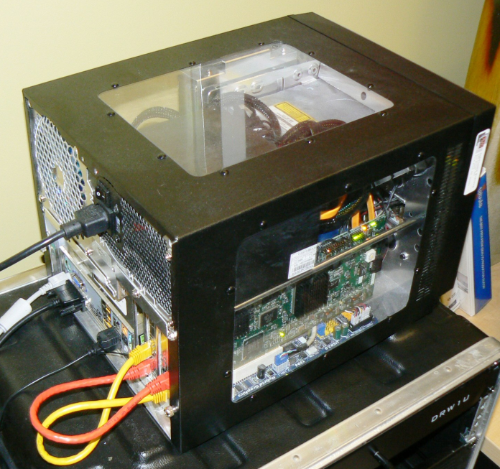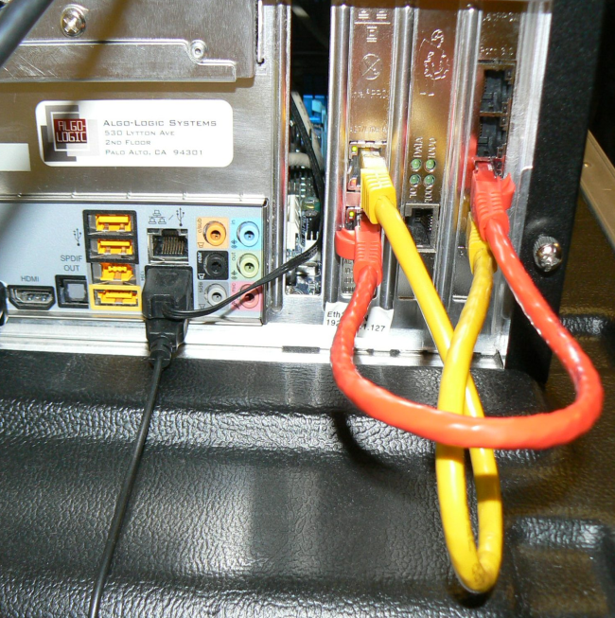

Step 6. To add entries to SRAM to perform specific swap, pop, push, swap+push, and pop+swap operations, use the command syntax documented above by running
./lsr

Results :
A wireshark capture of the packets sent to the NetFPGA port 0, and the packet output from NetFPGA port 1 is shown below.
Swap operation
The following commands are used for setup (see earlier sections for parameter explanations):
./lsr lsr_init
./lsr swap 2 0 3 3
./lsr mac_out 13a9278bd2 3
Then using the tcpreplay utility, run the following command to transmit the captured packets:
tcpreplay intf1=eth1 preswap.cap

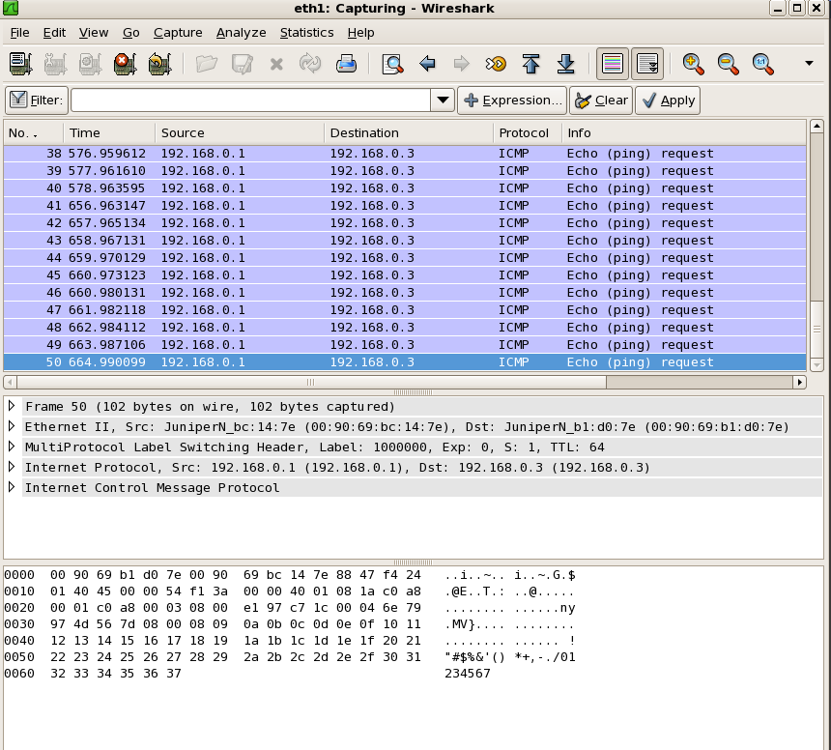
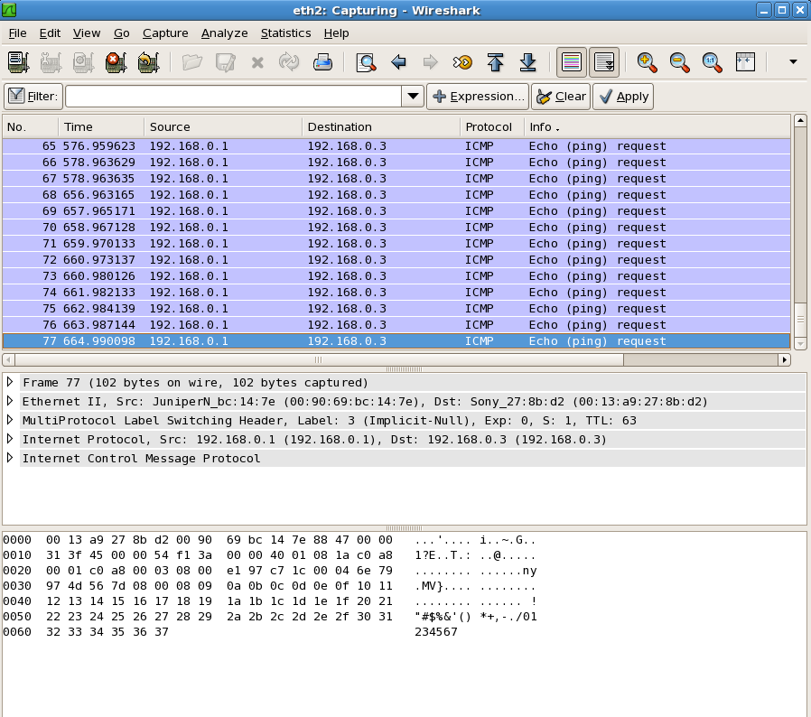

Push operation
The following commands are used for setup:
./lsr lsr_init
./lsr push 2 0 3 786432
./lsr mac_out 13a9278bd2 3
Then using the tcpreplay utility, run the following command to transmit the captured packets:
tcpreplay intf1=eth1 preswap.cap
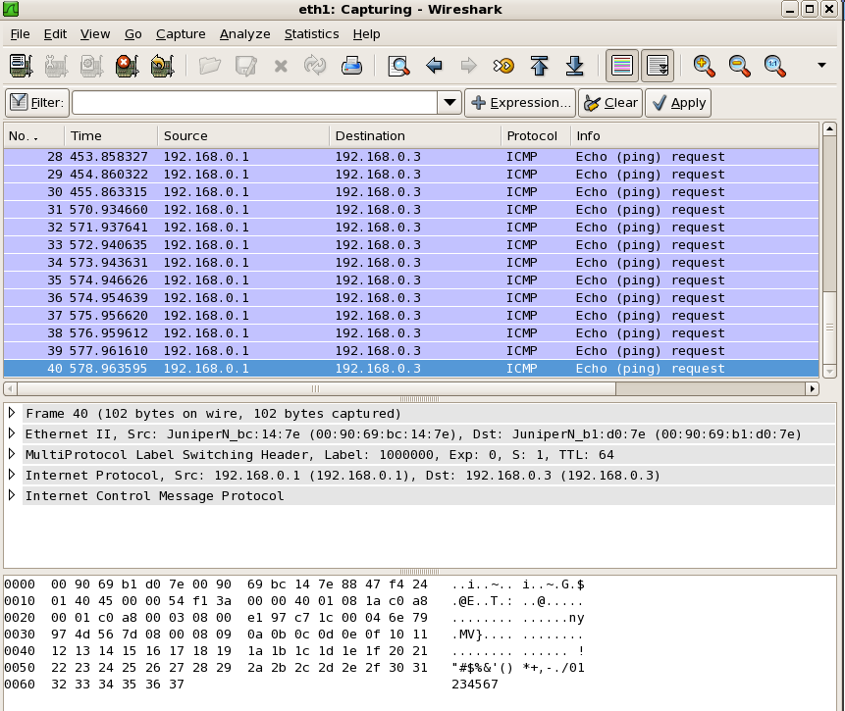
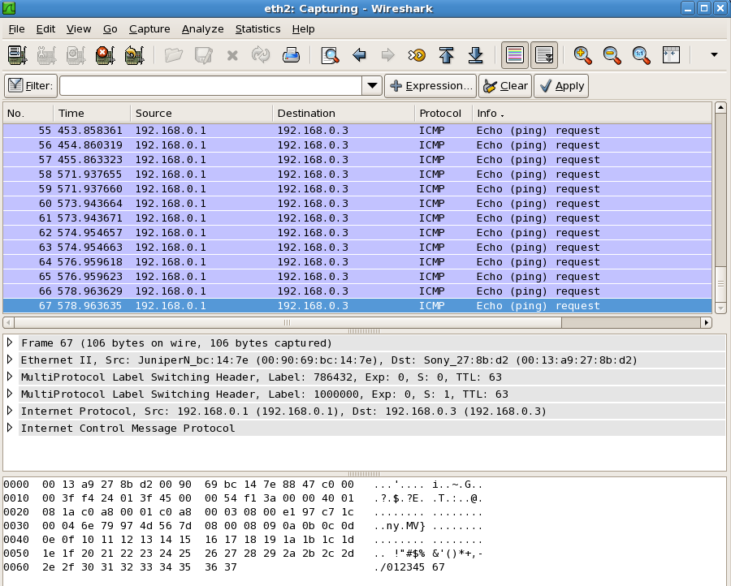
Pop operation
The following commands are used for setup
./lsr lsr_init
./lsr pop 2 0 3
./lsr mac_out 13a9278bd2 3
Then using the tcpreplay utility, run the following command to transmit the captured packets:
tcpreplay intf1=eth1 predoublepop.cap

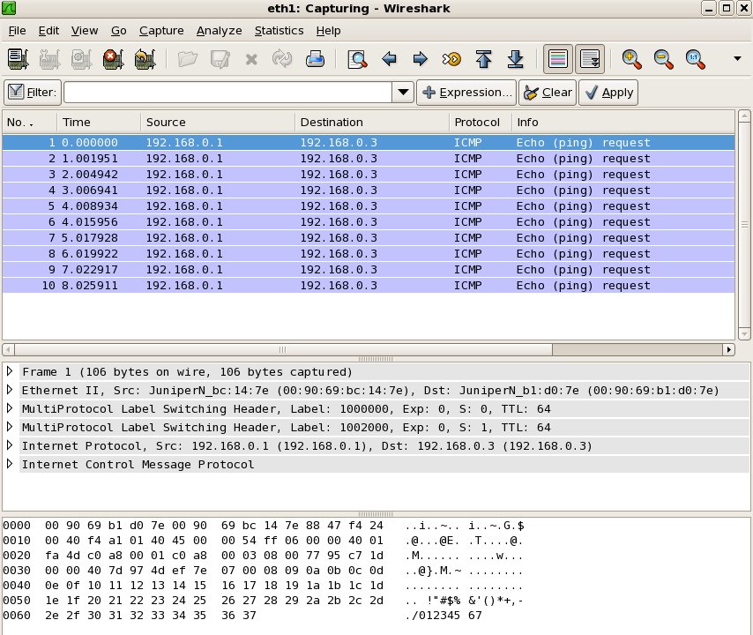
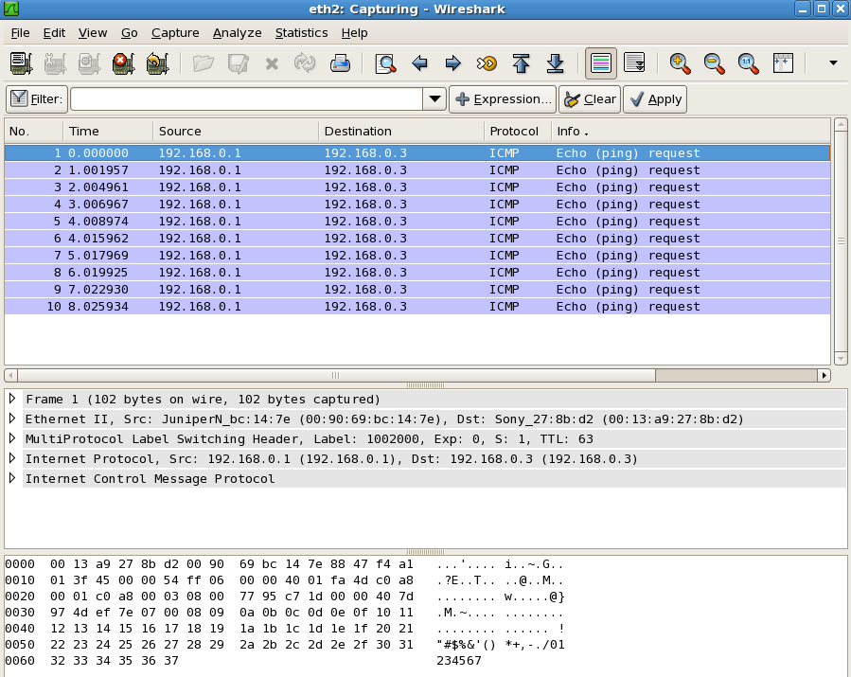

Swap+push operation
The following commands are used for setup
./lsr lsr_init
./lsr spush 2 0 3 3 786432
./lsr mac_out 13a9278bd2 3
Then using the tcpreplay utility, run the following command to transmit the captured packets:
tcpreplay intf1=eth1 preswap.cap

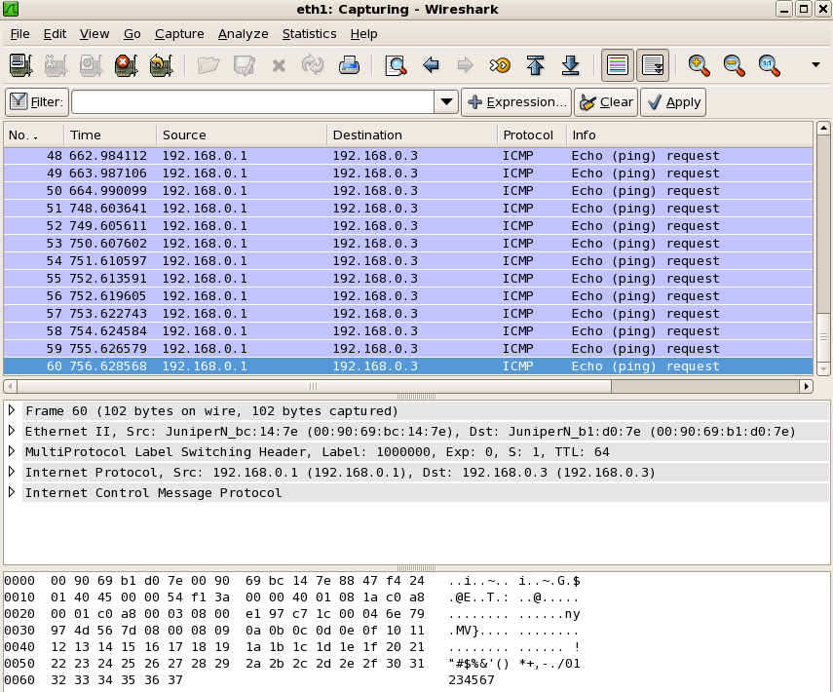

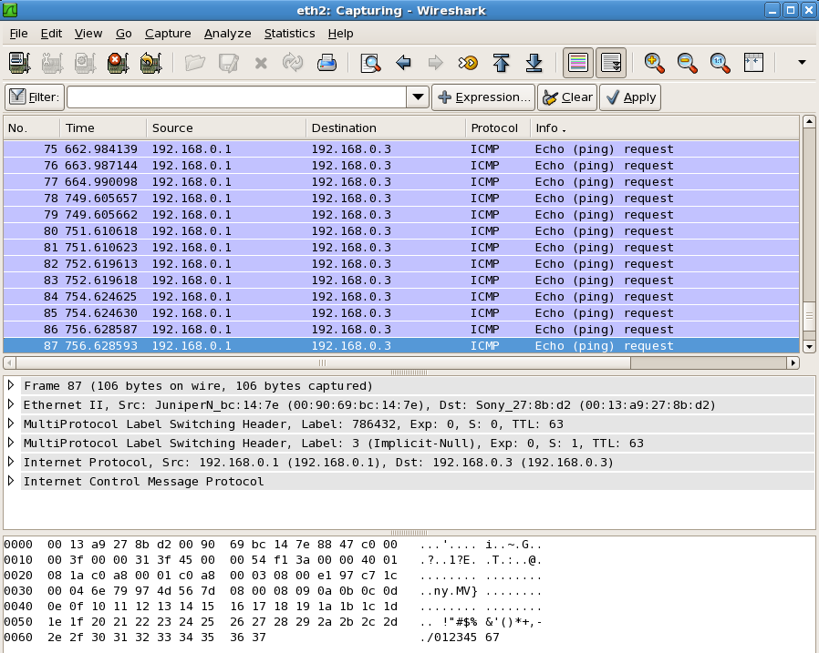
Pop+swap operation
The following commands are used for setup
./lsr lsr_init
./lsr pswap 0
./lsr swap 2 2000 3 9
./lsr mac_out 13a9278bd2 3
Then using the tcpreplay utility, run the following command to transmit the captured packets:
tcpreplay intf1=eth1 predoublepop.cap

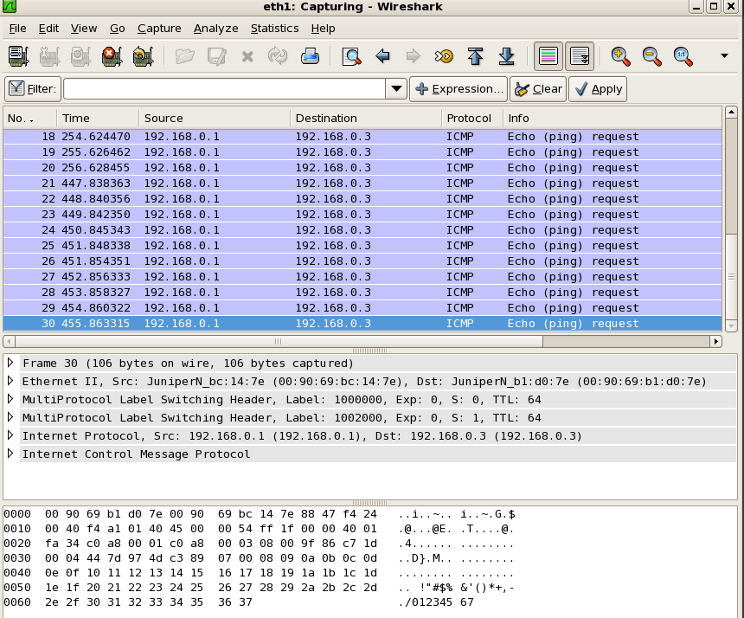
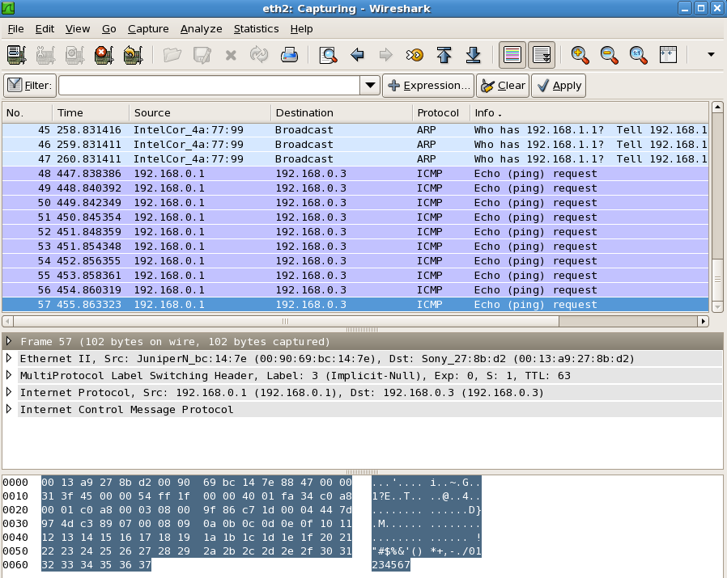

Errata
Please note the following issues have been detecting in the existing bitfile, and must be worked around in software:

- The byte count is being done on frame ingress, however the byte counter is off by 4 (too low). For example a frame of 1000 bytes will be counted at 996 bytes.

- The TTL error count is off by a factor of 8. For example a single TTL error will be counted as 8.
Additionally, the following functionality issues should be noted:
- Decrementing MPLS TTL is not supported with PHP (encapsulated IP TTL will remain unchanged after the pop). Esstentially any time PHP is performed by the NetFPGA the packet’s TTL will be restored to what it was before MPLS encapsulation took place.

- LD (Load Distribution) is not supported with the pop-swap opcode due to memory bandwidth constraints. It is supported with all other opcodes.

For Additional help and assistance:

Please contact: lsr_support@algo-logic.com

