Fabric Project
End To End

Supply chain & sales analysis
Prepared by Anas El-Alfy
Date 26/1/2026

Table of Contents
Contents
Table of Contents 2
1. Data Overview 3
2. Semantic 4
2.1 To ODS 5
2.2 To STG 6
3.SQL To DWH 7
4. Pipeline 8
5. Power BI Overview 9

Data Overview

- A DataSet of Supply Chains used by the company DataCo Global was used for the analysis. Dataset of Supply Chain , which allows the use of Machine Learning Algorithms and R Software.

- Areas of important registered activities : Provisioning , Production , Sales , Commercial Distribution.It also allows the correlation of Structured Data

- Type Data :
Structured Data : DataCoSupplyChainDataset.csv

- Types of Products : Clothing , Sports , and Electronic Supplies
Additionally it is attached in another file called DescriptionDataCoSupplyChain.csv, the description of each of the variables of the DataCoSupplyChainDatasetc.csv.

2. Semantic

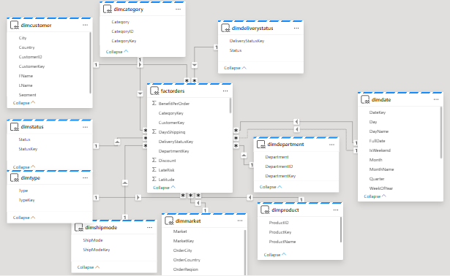

- Semantic model as showed is a star-schema shape

2.1 To ODS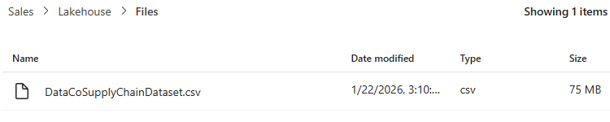

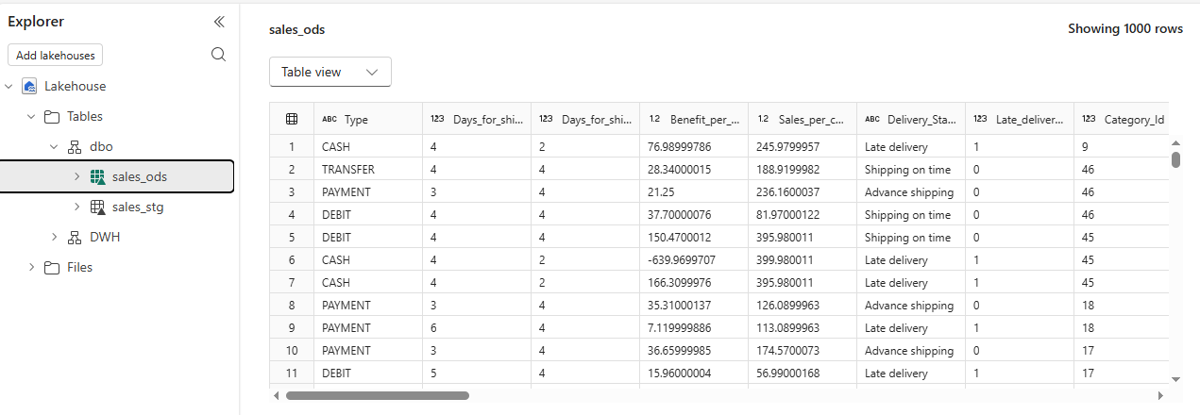

2.2 TO STG
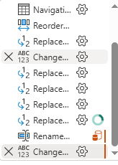

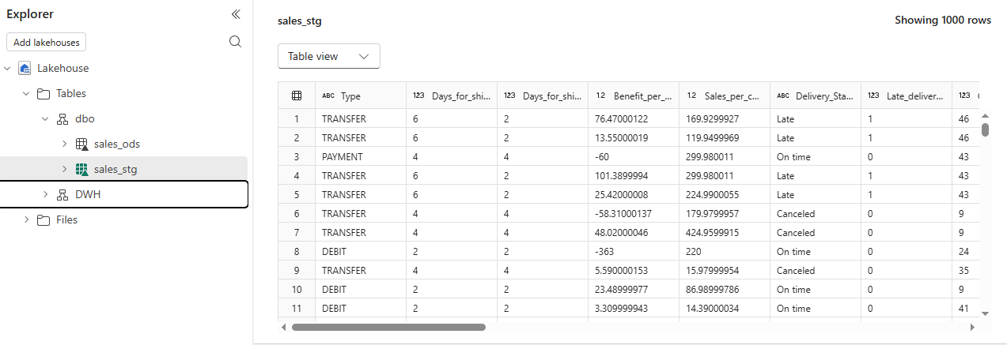

- Edit data types and Handel Nulls And Rename columns

2.3 SQL To DWH

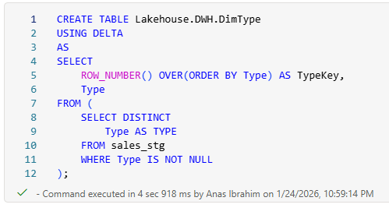

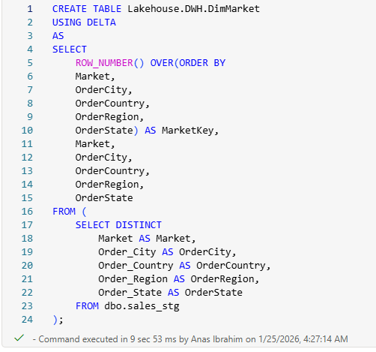

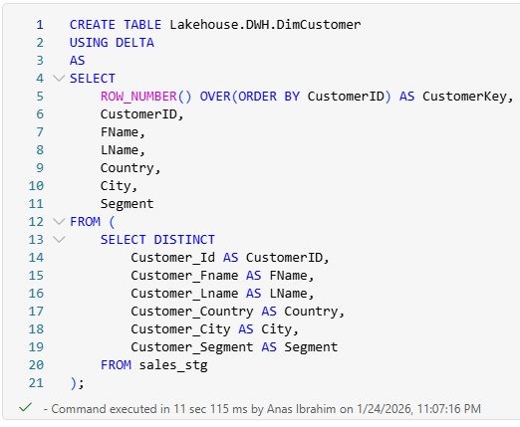

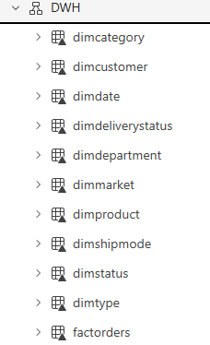

4. Pipline

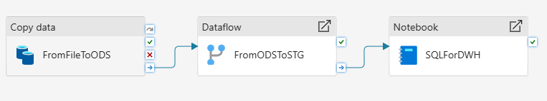

- Copy Data (Bronze Layer)
- Dataflow To create (Silver Layer)
3. DWH (Gold Layer)

5. Power BI Overview

