Software Requirements and Design Document

For

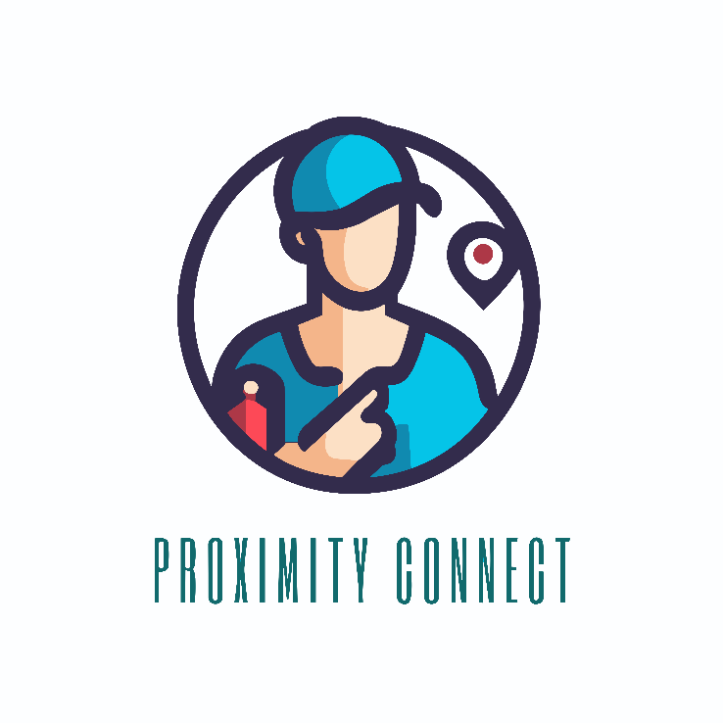Proximity Connect

**Prepared by**

**I210813 Anas Farooq**

**I210640 Muneel Haider**

**National University of Computing and**

**Emerging Sciences NUCES**

**2nd December 2023**

**Table of Contents**

1. **Introduction**
   1. **Purpose 1**
   2. **Product Scope 1**
   3. **Title 1**
   4. **Objectives 1**
   5. **Problem Statement 1**
2. **Overall Description**
   1. **Product Perspective 2**
   2. **Product Functions 2**
   3. **List of Use Cases 2**
   4. **Use Case Diagram 3**
3. **Other Nonfunctional Requirements**
   1. **Performance Requirements 4**
   2. **Safety Requirements 4**
   3. **Security Requirements 4**
   4. **Software Quality Attributes 4**
   5. **Business Rules 4**
   6. **Operating Environment 4**
   7. **User Interfaces 5 - 20**
4. **Domain Model 21**
5. **System Sequence Diagrams 22 - 31**
6. **Sequence Diagrams 32 - 43**
7. **Class Diagram 44**

# Introduction

## Purpose

## "Proximity Connect" is designed as a local service directory platform. Its primary purpose is to connect service seekers with various household service providers like carpenters, plumbers, etc. It offers an interactive platform for users to easily find and hire local service professionals.

## Product Scope

The scope of "Proximity Connect" includes providing a user-friendly interface for service seekers to register, log in, search for, and hire service providers. The platform operates as a local service directory, facilitating the interaction between customers and service providers.

## Title

"Proximity Connect: Your Local Service Directory Platform" - This title reflects the immediate solution provided by the software, which is connecting customers with local household service providers.

## Objectives

The major goals of "Proximity Connect" are:

* To simplify the process of finding and hiring local service providers.
* To provide a reliable and efficient platform for service seekers.
* To enhance local employment by connecting service providers with potential clients.
* To offer a seamless and user-friendly digital experience for household service needs.

## Problem Statement

"Proximity Connect" addresses the challenge of finding reliable and skilled local service providers for household needs. Traditionally, this process has been dependent on word-of-mouth recommendations or random local searches, often leading to inconsistent service quality and reliability. "Proximity Connect" aims to mitigate these issues by offering a centralized platform where service seekers can easily find, review, and hire trusted professionals.

# Overall Description

## Product Perspective

## "Proximity Connect" is a new, self-contained product that operates as a comprehensive solution for local service hiring. It is not a member of an existing product family nor a replacement for an existing system. As a standalone platform, it integrates user management, service provider listings, and a transactional interface. The software functions within a larger ecosystem of local services, with interfaces for user registration, service booking, and feedback mechanisms. A diagram illustrating these components and their interconnections would be beneficial.

## Product Functions

At a high level, "Proximity Connect" performs the following functions:

* User registration and account management.
* Search functionality for finding service providers.
* Booking and scheduling services.
* Payment processing and transaction management.
* Feedback and rating system for services availed.
* Administrative control for verifying and managing service providers.

## List of Use Cases

* Login to your Account.
* Register new Account.
* Search for a Service Provider.
* Hire a Service Provider.
* Pay through Card.
* Pay through Cash.
* Cancel a Hiring.
* Check Hired Service Provider.
* View Service Provider Profile.
* Manage Personal Info.
* Provide Feedback.
* Manage Service Providers.
* Filter (Search for a Service Provider).
  1. **Use Case Diagram**

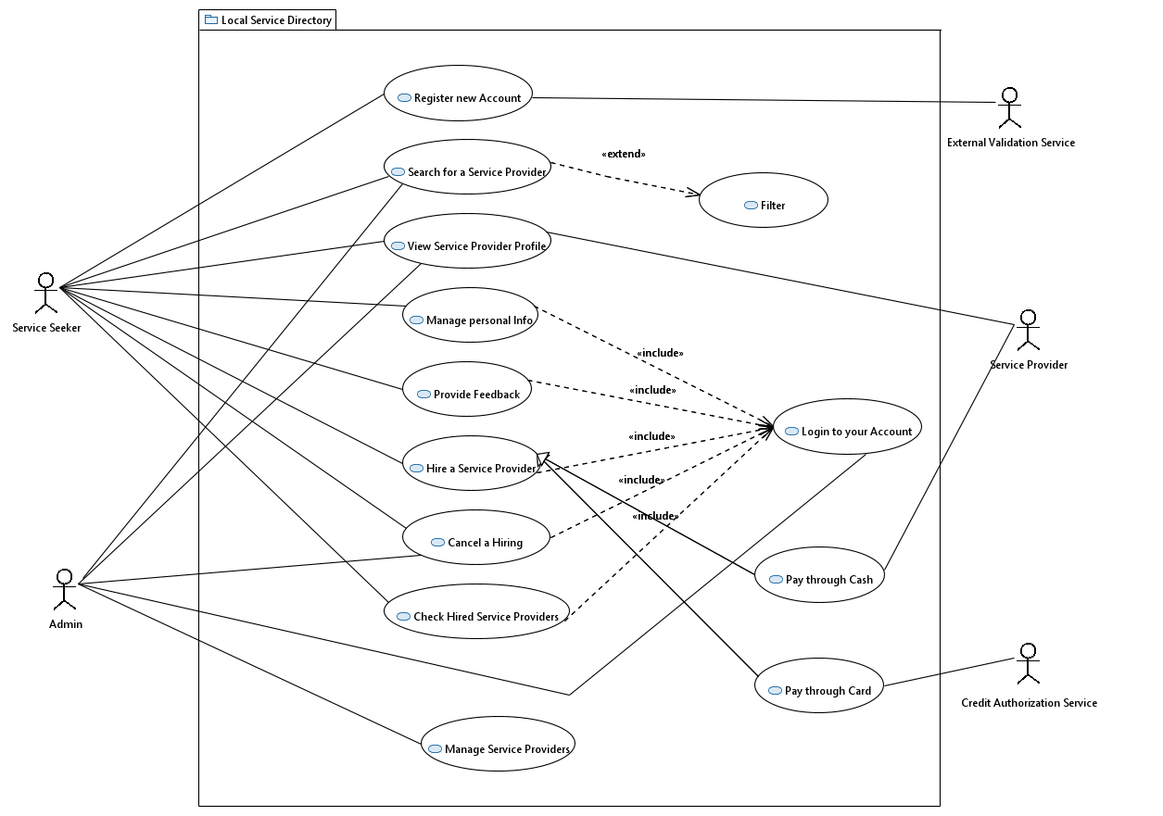

# Other Nonfunctional Requirements

## Performance Requirements

## The software performs efficiently under various user loads and network conditions. It meets specific performance criteria, including swift response times for user queries and rapid transaction processing speed. The software is scalable, effectively accommodating a growing number of users and service listings.

## Safety Requirements

"Proximity Connect" ensures the safety of its users' personal and financial information. It complies with relevant data protection regulations and standards. The software includes safeguards against data breaches and unauthorized access.

## Security Requirements

The platform has robust security measures in place to protect user data and privacy. This includes secure authentication processes, encryption of sensitive data, and adherence to relevant cyber security standards and regulations.

## Software Quality Attributes

"Proximity Connect" is characterized by key attributes such as reliability, usability, maintainability, and scalability. The platform is user-friendly, easily navigable, and adaptable for future enhancements. Its design facilitates easy maintenance and updates.

## Business Rules

The software incorporates rules like user eligibility criteria, service provider verification processes, transaction limits.

## Operating Environment

"Proximity Connect" is currently compatible exclusively with Windows computers. However, plans are in place to expand its compatibility to include a variety of other hardware and software environments, such as different operating systems, mobile devices, and web browsers, ensuring seamless coexistence with a broader range of software components and applications.

## User Interfaces

The user interface of "Proximity Connect" is intuitive and visually appealing. It adheres to standard UI/UX principles and features easy navigation, responsive design, error message display standards, and a consistent layout across different screens.

## Seeker’s Views:

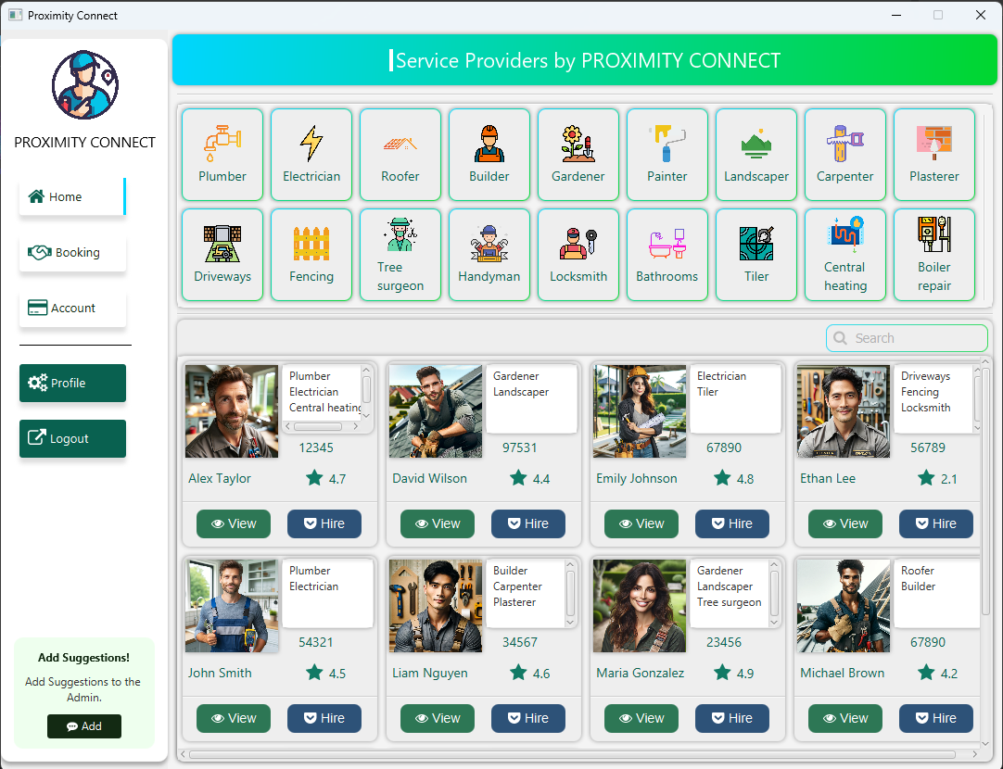

**1. Service Seeker Home View**

**Functionality**: This view enables service seekers to browse and search for service providers. It includes a dynamic **search functionality** that filters results based on category, name, gender, zip code; after that the list of service providers is again filtered based on their rating.

**Layout & Design**: The interface likely features a **grid layout** stacked on the **Scroll Pane** for displaying service provider cards, which includes essential information like name, categories, and ratings. The search field is prominently placed for easy access.

**User Interaction**: Users can interact with the provider cards to view more details or hire the provider. This interaction is intuitive, likely involving simple clicks.

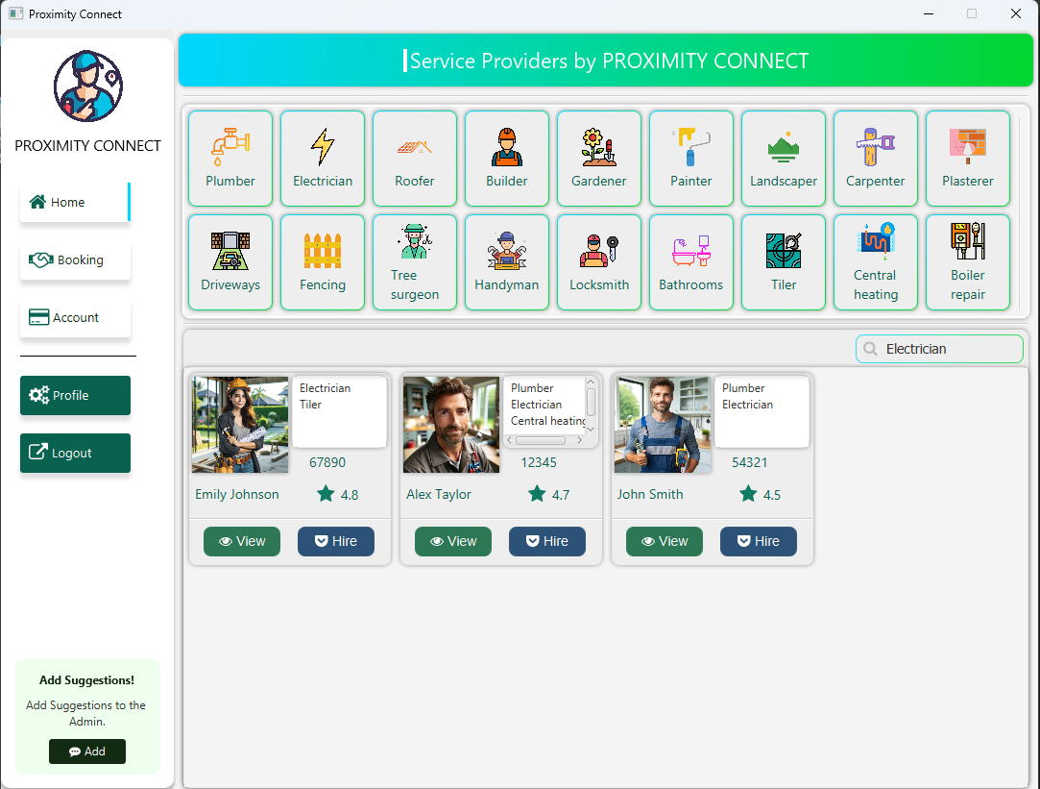

**2. Search Bar and Category Usage**

**Functionality**: The **Category View** above allows the user to select any category and then the list of service providers is filtered on the grid layout. Seemingly, the **search bar** allows the same functionality, but it also allows the user to search the service provider based on name, gender, and zip code.

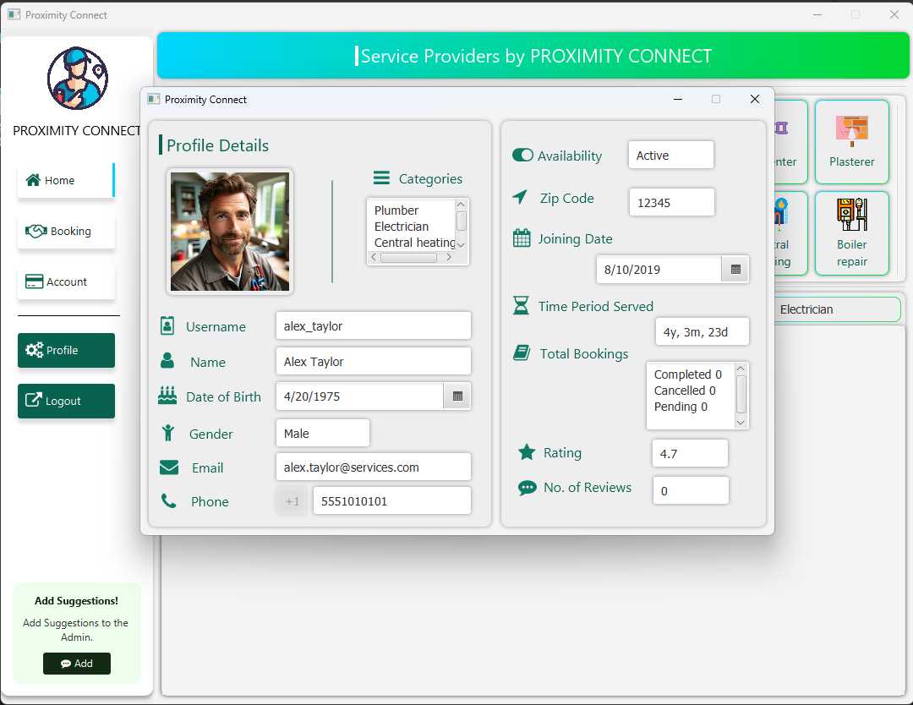

**3. Provider Profile View**

**Content Display**: Detailed information about the service provider is displayed, including personal and professional details. This encompasses a comprehensive view with sections for different types of information.

**User Engagement**: The profile view serves to provide an in-depth look at a provider, building trust and transparency between the seeker and the provider.

**Navigation**: The user can navigate back to the home view if they want to hire the provider.

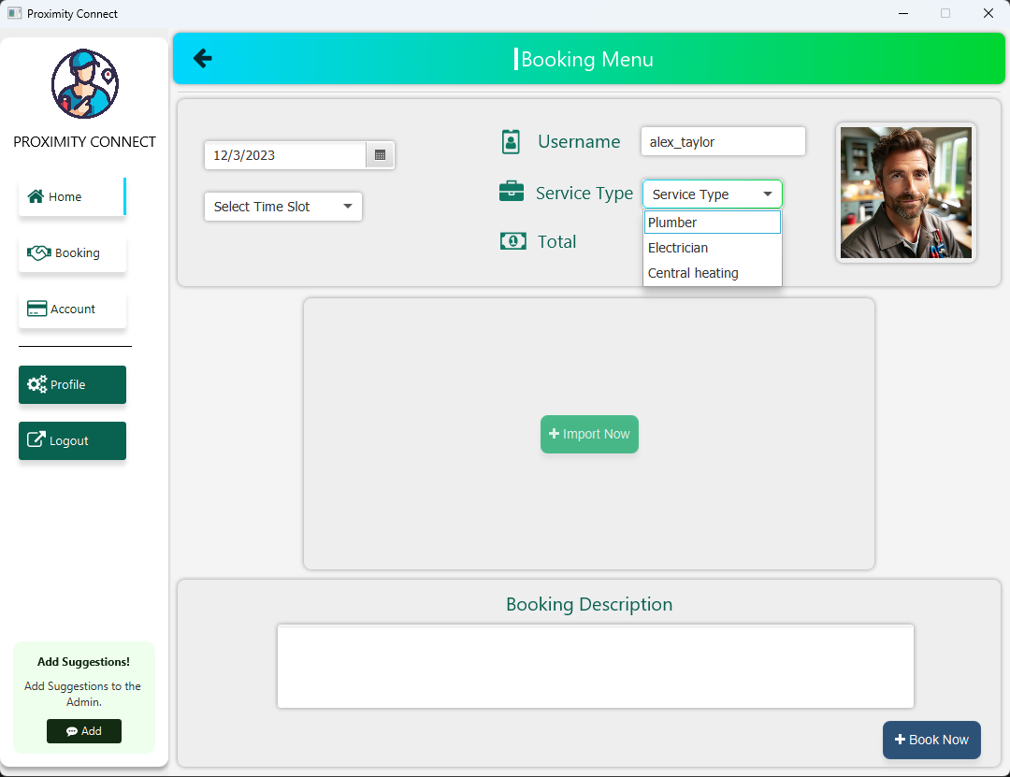

**4. Hiring Interface**

* **Functionality**: This interface pops up when the user decides to hire a provider. It requires users to choose a date, time slot, and service type.
* **Validation & Feedback**: It includes error prompts for mandatory fields, ensuring that all necessary information is provided before proceeding.

**Flexibility**: The interface allows for optional uploads and descriptions, adding flexibility and easiness to the booking process.

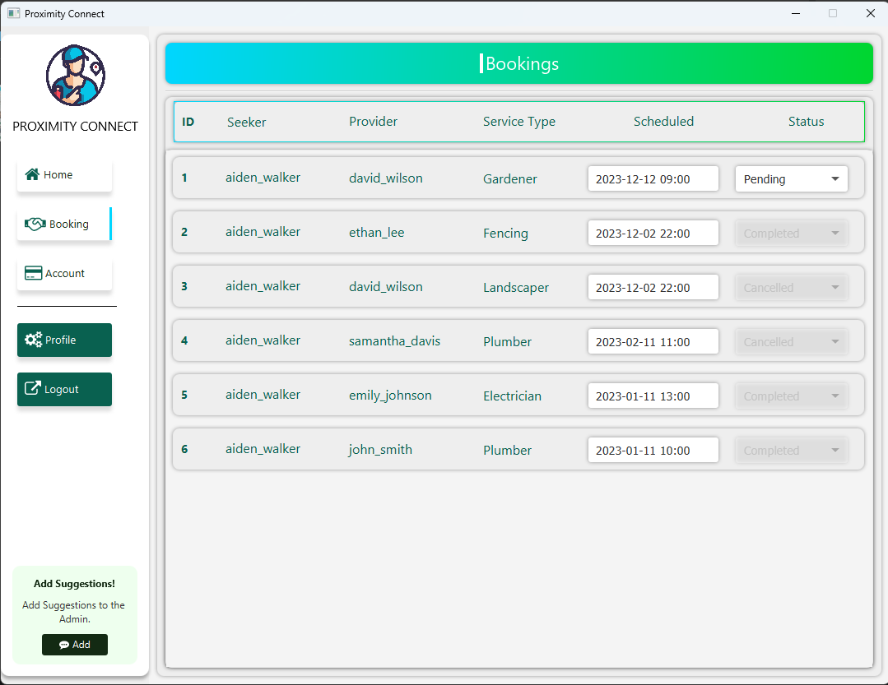

**5. Booking View**

**Booking Management**: Users can view, update, or cancel their bookings. The interface displays bookings in a list or grid format.

**Status Update**: Enables users to update the status of bookings, with restrictions on altering completed or cancelled bookings.

**Rating System**: After a booking is completed, users are prompted to rate the service, enhancing the feedback loop.

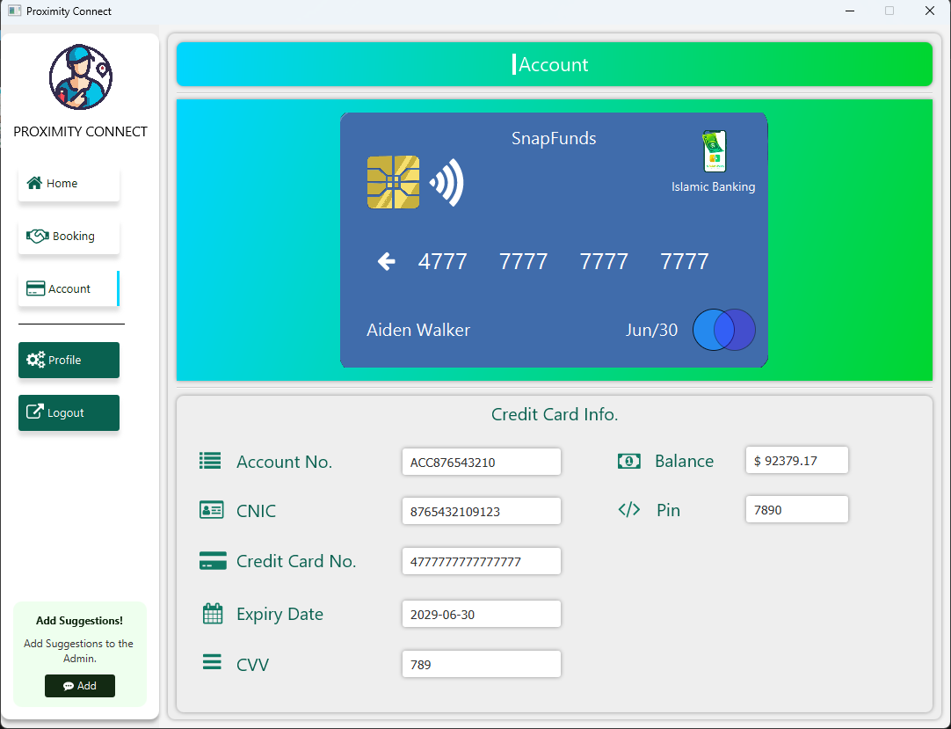

**6. Accounts View**

**Account Details**: Displays connected account and credit card information, including sensitive data like CVV and PIN.

**Security**: The display of sensitive information suggests the need for robust security measures within the application.

**User Convenience**: This view centralizes financial information, making it convenient for users to manage their finances related to the services.

**7. Profile View**

**Personalization**: Users can update contact information, change their profile picture, and modify their password.

**Security Aspects**: Includes a secure process for changing passwords, indicating a focus on user security and data protection.

**User Control**: Provides users with control over their personal information and account security.

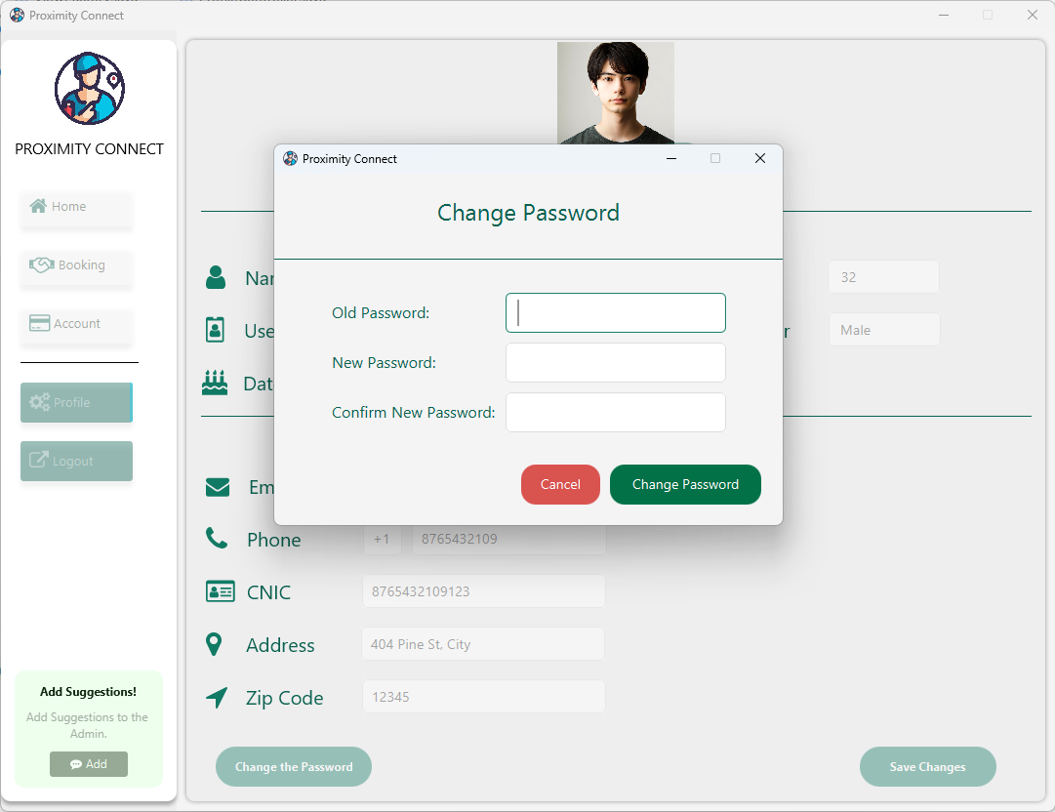

**8. Password Change View**

**Functionality**: Users must provide their old password; upon verification they can change their password that will be reflected on the database too.

**Security Aspects**: Includes a secure process for changing passwords, indicating a focus on user security and data protection.

**Easiness**: A simple procedure for changing passwords, also allows the user to navigate back if they don’t want to change their password.

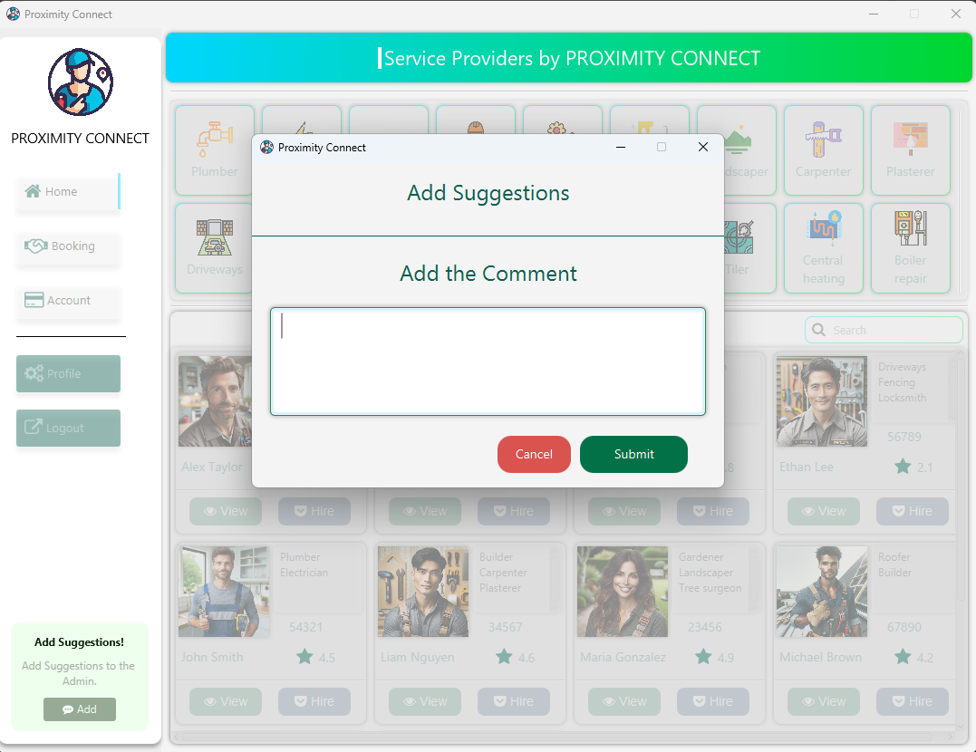

**9. Feedback and Suggestions**

**User Engagement**: Encourages users to provide feedback or suggestions, fostering a sense of community and user involvement.

**Admin Interaction**: These messages are visible to the admin, allowing for direct user-admin communication and potential improvements based on feedback.

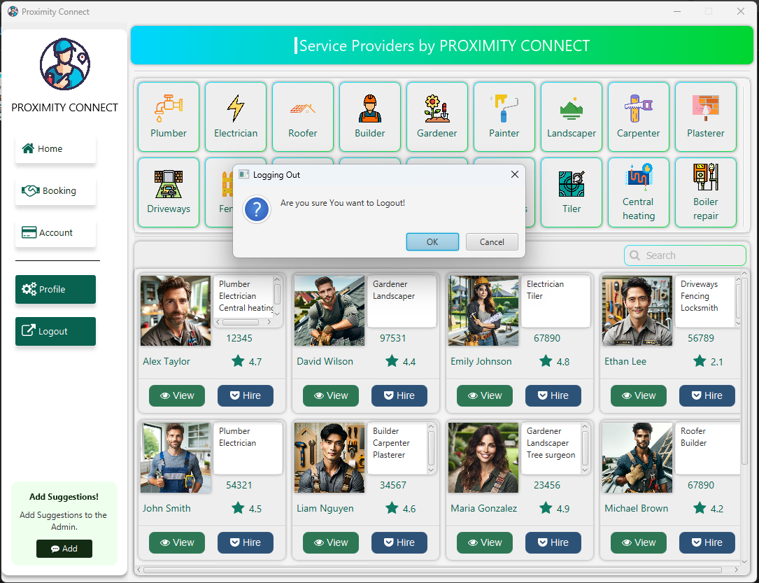

**10. Logout Functionality**

**Session Management**: The logout feature effectively manages user sessions, ensuring that users can securely exit their accounts.

**Confirmation Prompt**: The confirmation dialog prevents accidental logouts, enhancing the user experience.

## Admin Views:

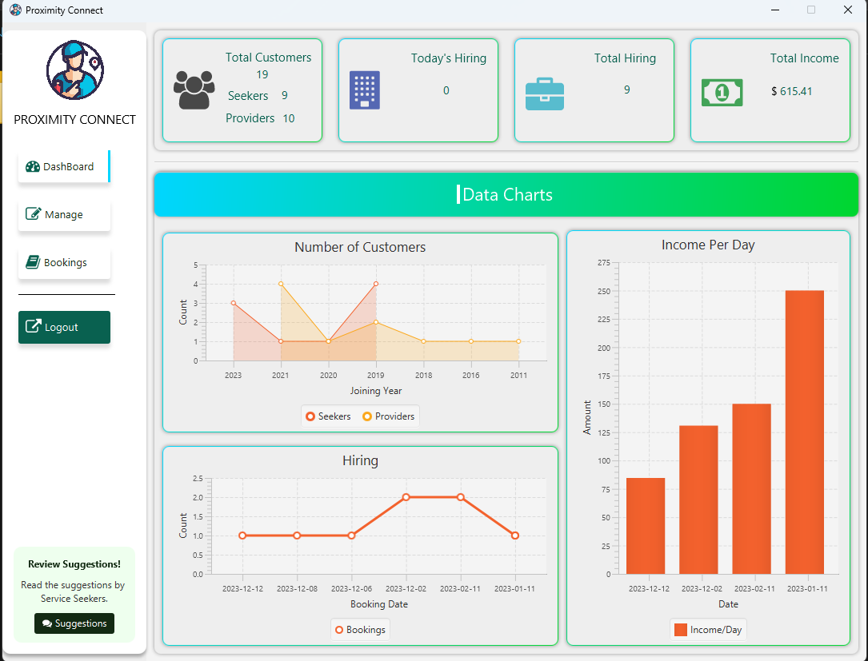

**1. Admin Home View**

**Top Display**: Features four cards showing total customers, today's hirings, total hirings, and total income. These cards dynamically fetch and display data from the database.

**Charts**:

Area Chart: Represents the count of service seekers and providers joining each year.

Line Chart: Displays the count of hirings daily.

Bar Chart: Shows daily income.

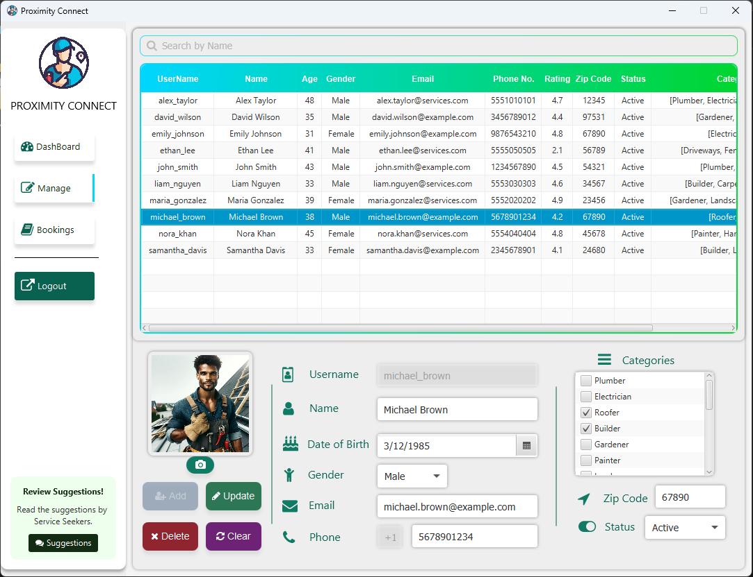

**2. Manage Service Providers View**

**CRUD Operations**: Enables admins to create, read, update, and delete service provider profiles.

**Validation Mechanism**: Ensures data integrity, such as preventing the update of a service provider's name to a null value.

**Data Presentation**: Service providers are listed in a table format. Features include searching for specific providers and sorting based on age, gender, and status (active/inactive).

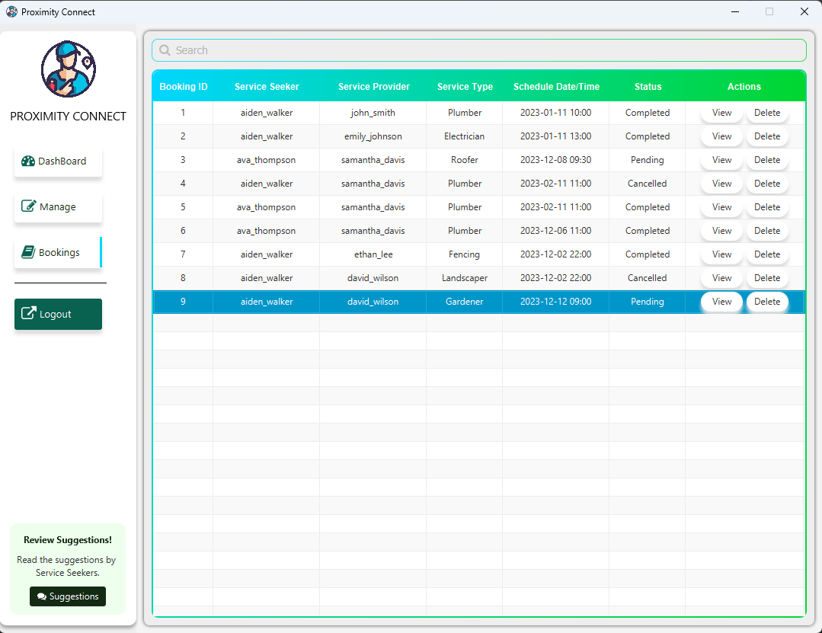

**3. Bookings View**

* **Functionality**:
* **Booking Management**: CRUD (Create, Read, Update, Delete) operations on bookings, enabling admins to maintain and manage booking records effectively.
* **Search Functionality**: Admins can search for bookings using various filters such as date, service seeker's name, service provider's name, or booking status.
* **Sorting Capabilities**: Bookings can be sorted based on date, service type, or status, helping the admin to quickly find relevant bookings.
* **User Interface Design**: The interface includes a table view for easy navigation and visualization of booking data. Action buttons for edit, delete, and view details are provided for efficient management.

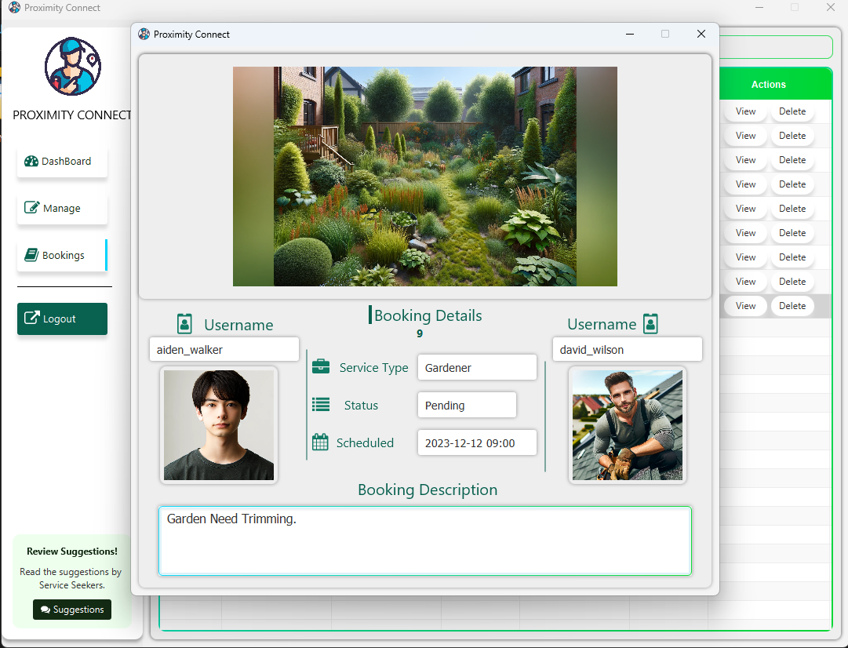

**4. Booking Details View**

* **Key Features:**
  + **Detailed Information Display**: Shows comprehensive details about a booking, including service seeker and provider information, service type, booking date and time, status, and any special requirements or notes.
  + **Interface Design**: A well-organized layout that makes it easy for the admin to read and understand booking details. The use of modal dialogs for detailed views ensures a clean and uncluttered interface.
  + **Interactivity**: Admins can interact with the booking details, such as changing the status or updating notes, directly from this view.

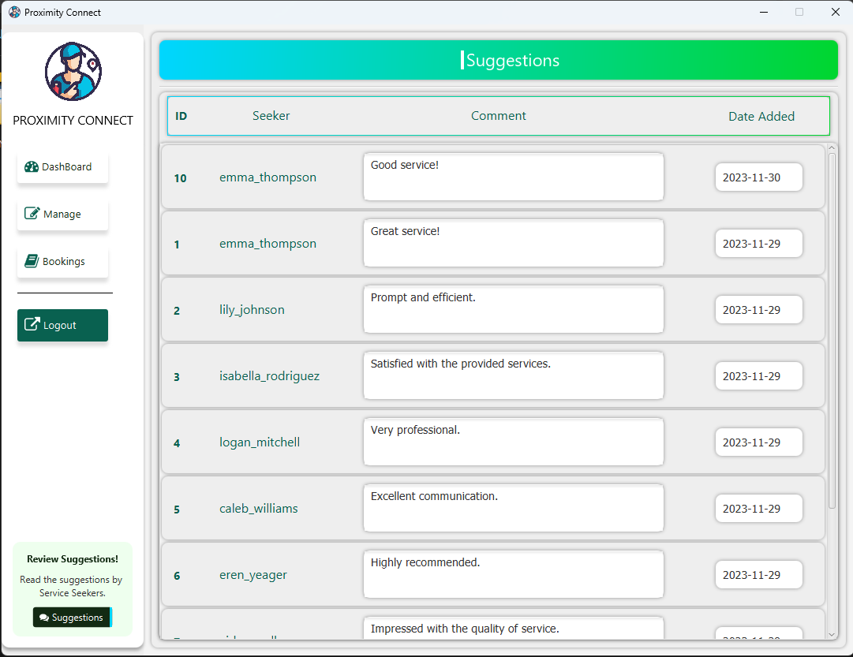

**5. Suggestions View**

* **Purpose**: This view is dedicated to reading and analyzing suggestions provided by service seekers, an essential aspect of customer feedback.
* **Functionality**:
  + **Viewing Suggestions**: Allows the admin to read through suggestions and feedback submitted by service seekers.
  + User Experience: A clean interface with a list or grid view to display suggestions, ensuring readability and ease of navigation. Each suggestion card provides a summary.
  + Analytics Integration: The view could be integrated with analytics tools to categorize and evaluate suggestions based on frequency, sentiment, and relevance. This data can inform future improvements in the LSD application.

# Domain Model

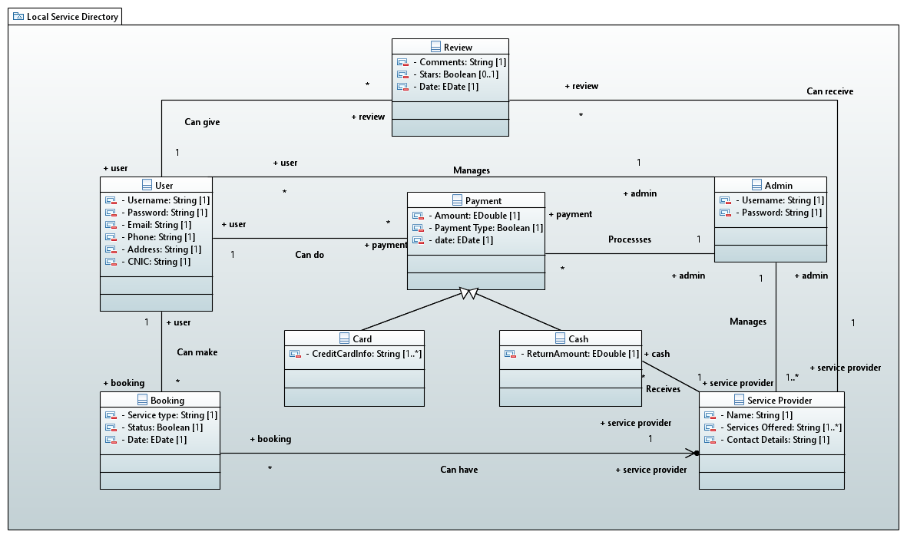

# System Sequence Diagram

1. 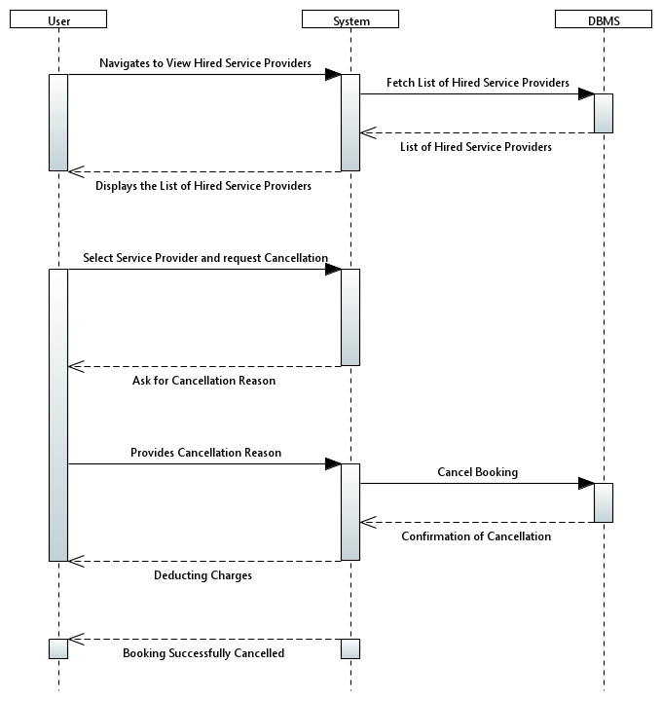**Cancel a Hiring:**
2. **Check Hired Service Providers**

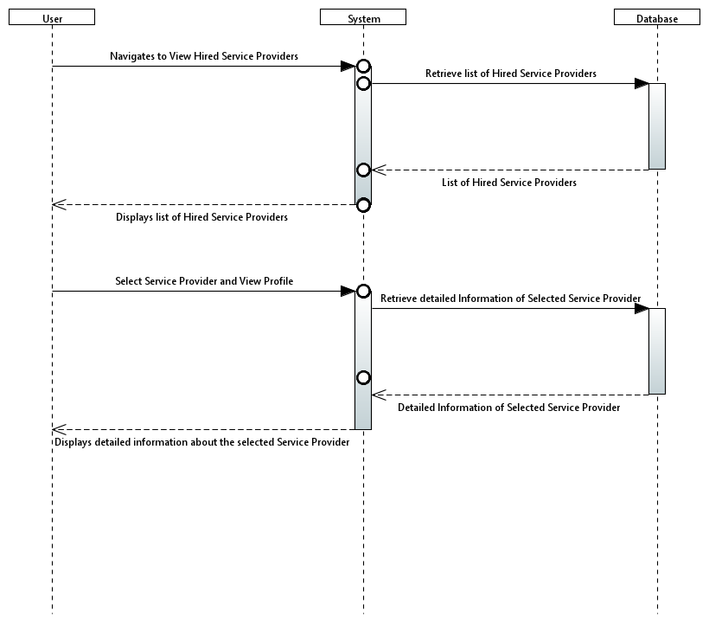

1. 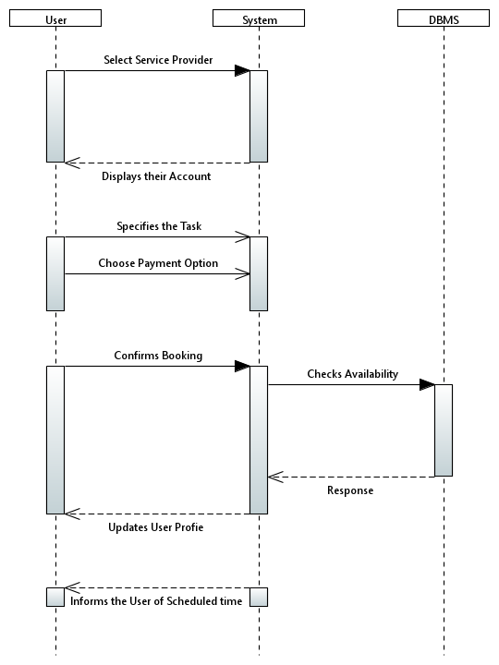**Hire a Service Provider**
2. **Login to your Account**

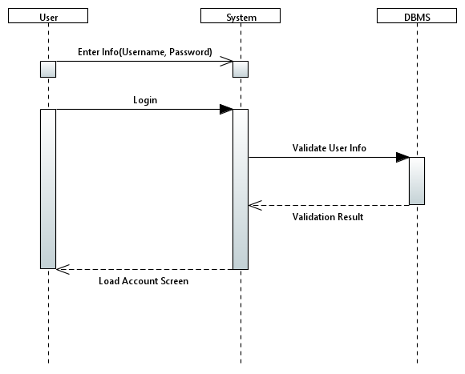‘

1. **Manage Personal Info**

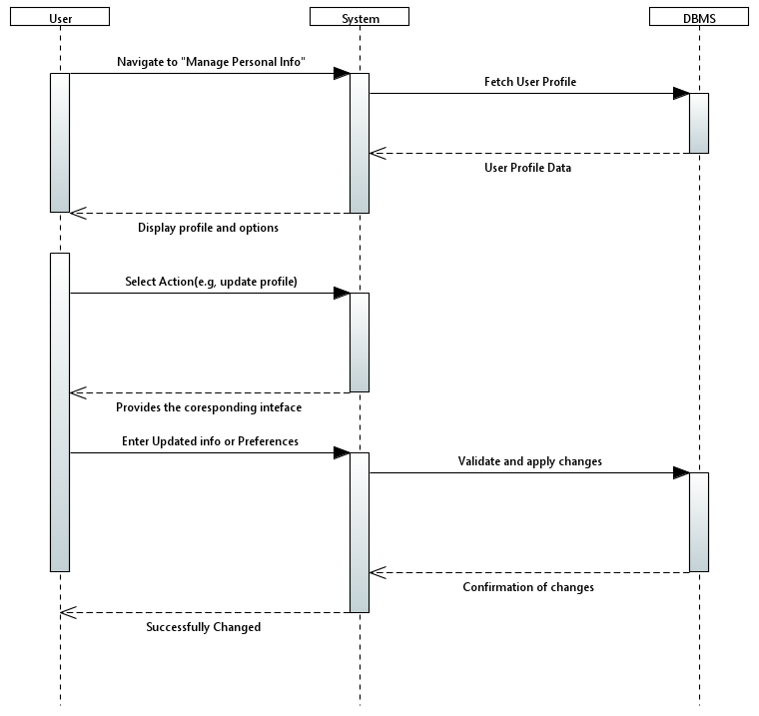

1. **Manage Service Provider**

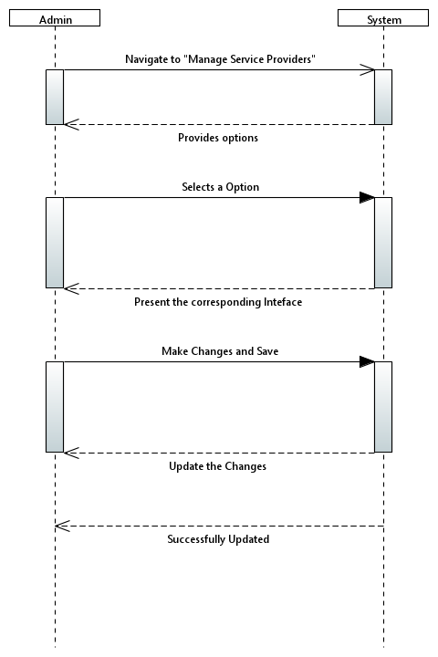

1. **Pay through Cash**

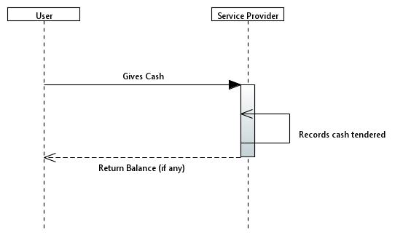

1. **Pay though Card**

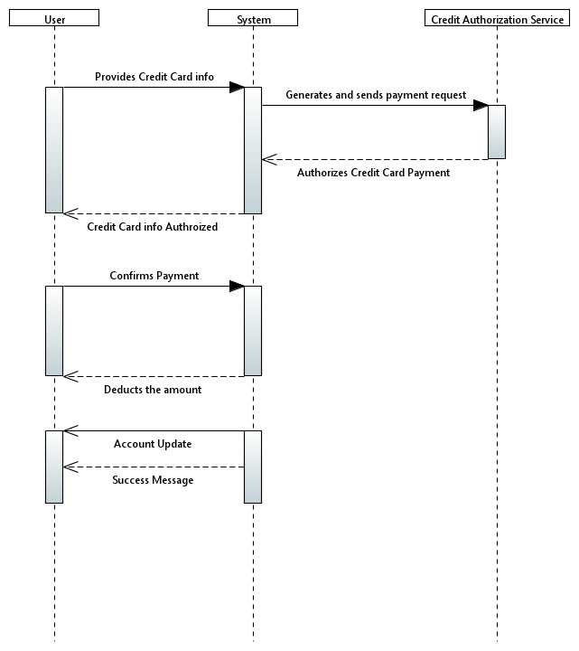

1. **Provide Feedback**

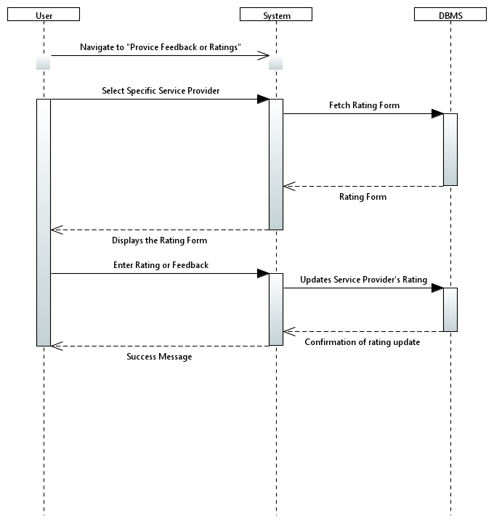

1. **Register new Account**

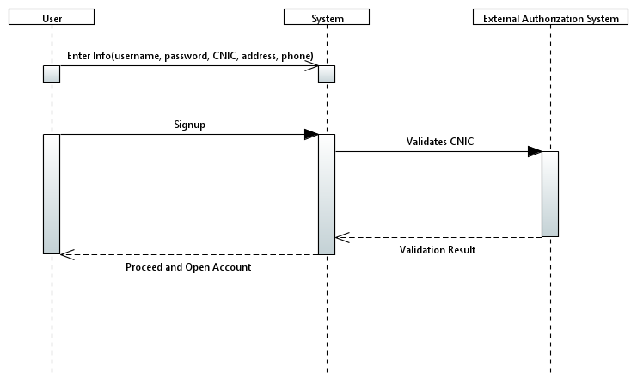

1. **Search a Service Provider**

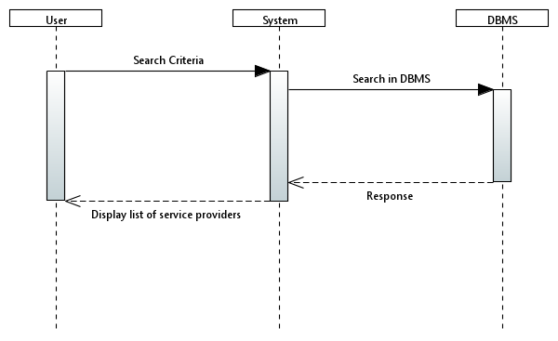

1. **View Service Provider Profile**

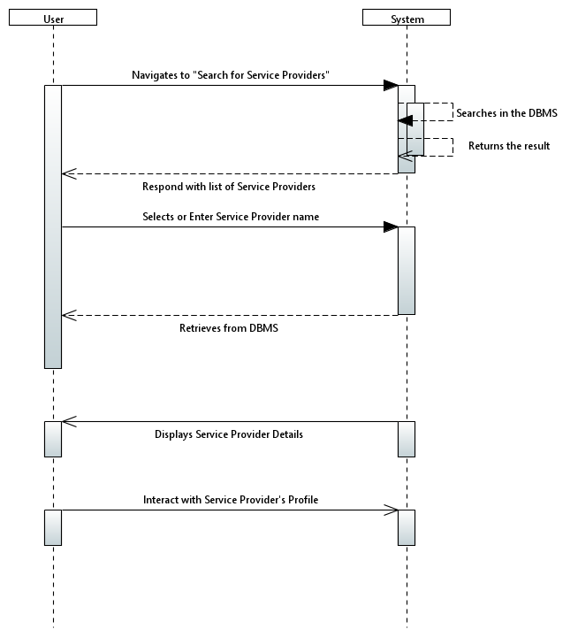

# Sequence Diagram

1. **Cancel a Hiring:**

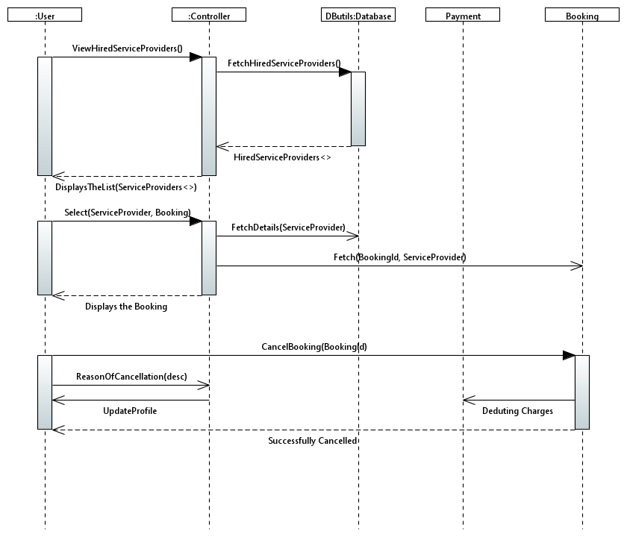

1. **Check Hired Service Providers**

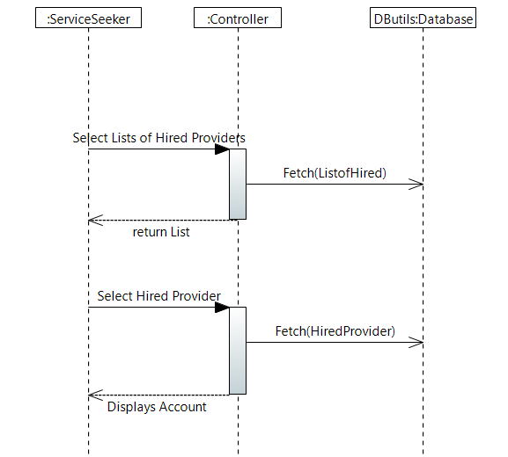

1. **Hire a Service Provider**

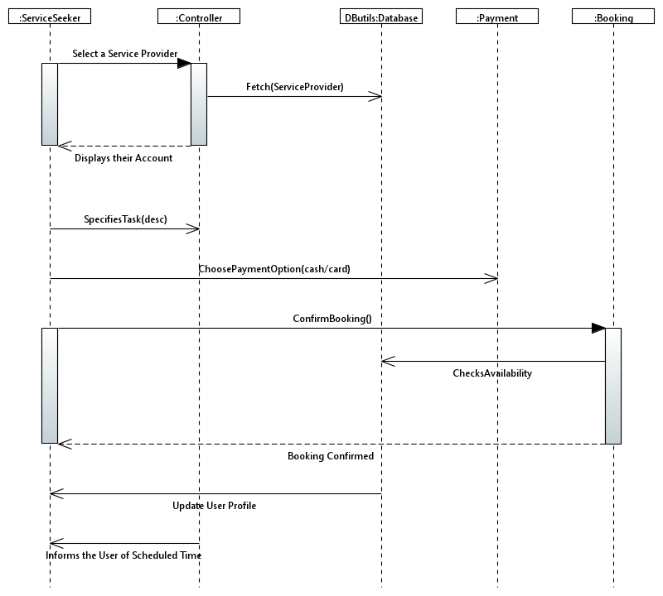

1. **Login to your Account**

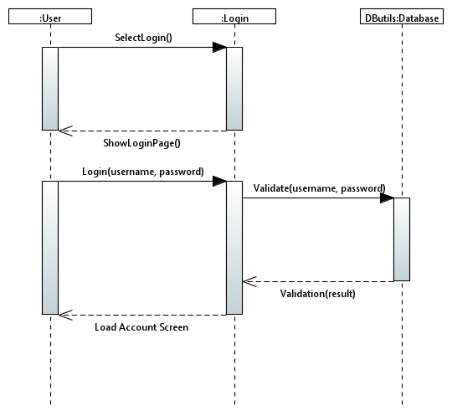

1. **Manage Personal Info**

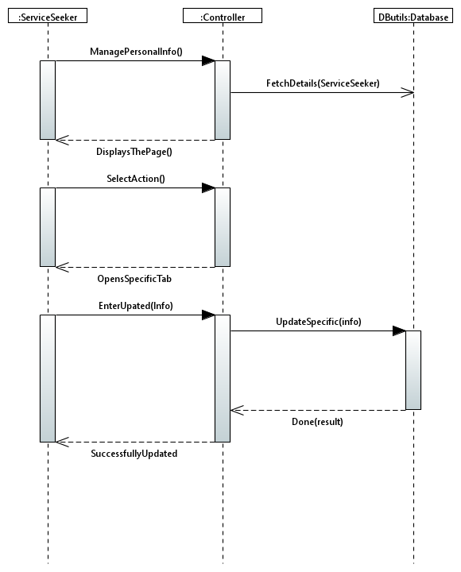

1. **Manage Service Provider**

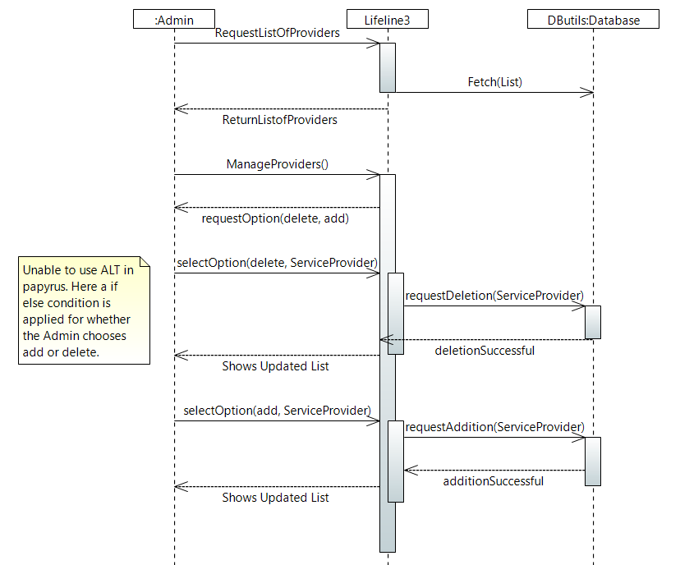

1. **Pay through Cash**

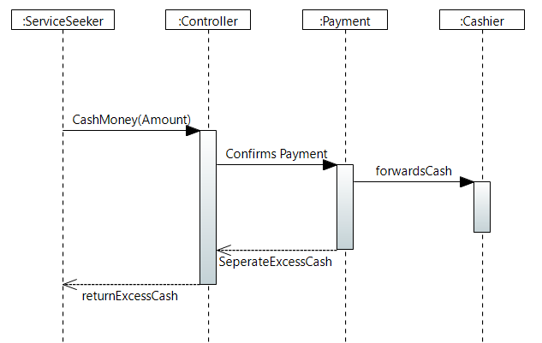

1. **Pay though Card**

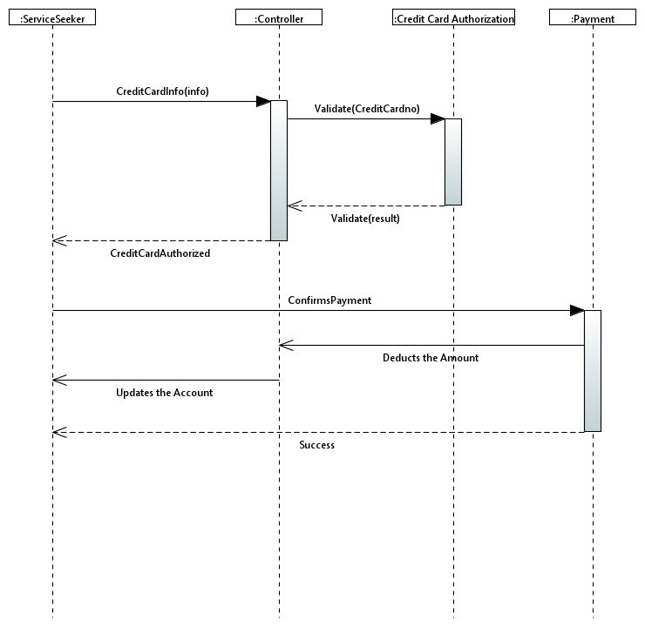

1. **Provide Feedback**

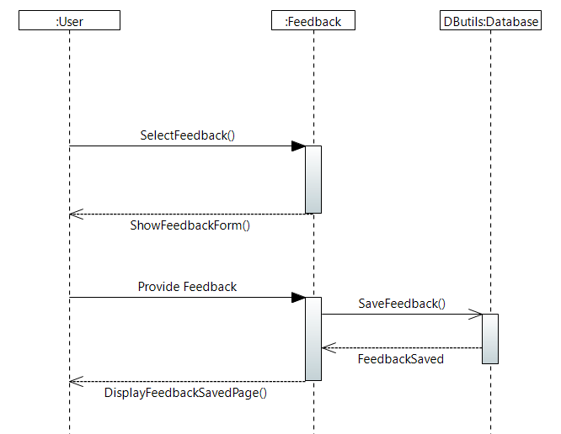

1. **Register new Account**

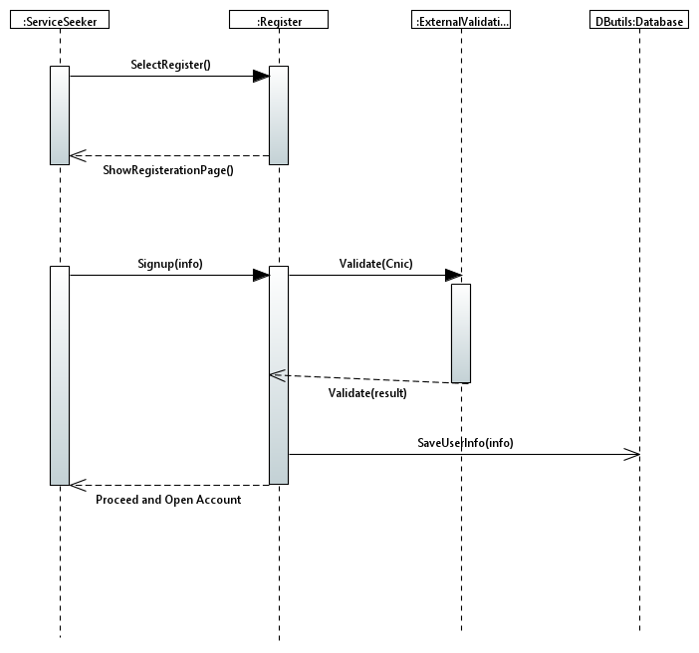

1. **Search a Service Provider**

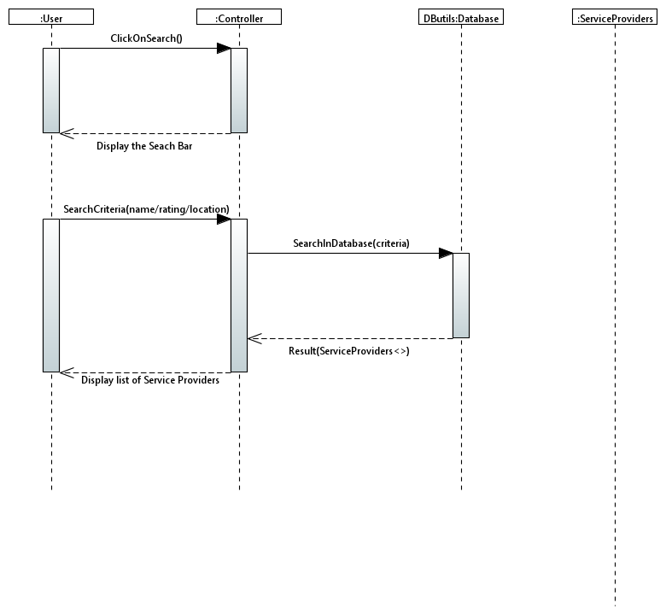

1. **View Service Provider Profile**

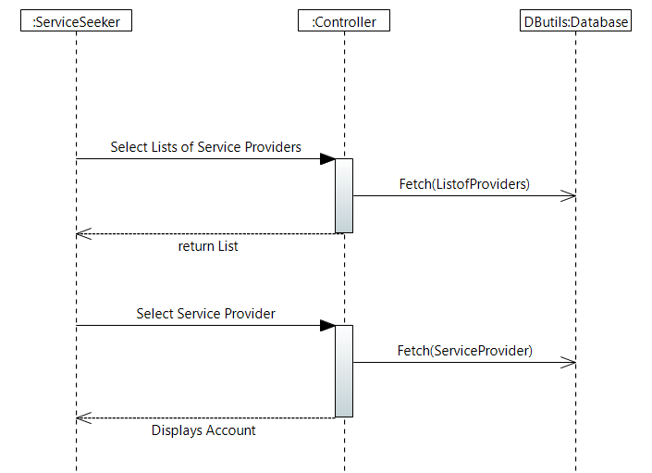

1. **Delete Service Provider**

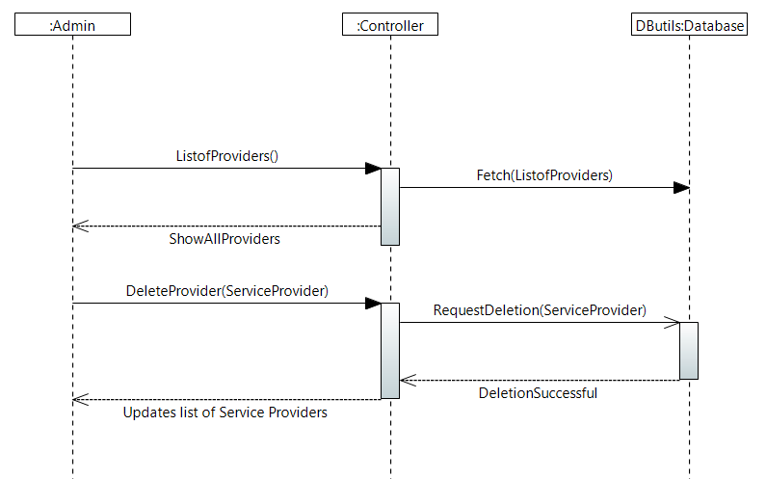

# Class Diagram

