

Compiler Construction
Project Phase-I

Name: Anas Maqsood
Reg: L1F22BSCS1078
Section: G10

Directed to: Aneela Mehmood

CC-Project — CE++

Overview
CE++ is a simplified version of C++ created to make programming more accessible and intuitive for beginners, underaged learners, and senior citizens. The language replaces traditional keywords with easy-to-understand English words so that code reads more like natural language rather than an abstract syntax. For example, instead of using cryptic terms like if, else, or void, CE++ uses descriptive words such as Suppose, Suppose_else, and empty, which clearly convey their purpose. Operators are also redesigned for clarity by replacing symbols with meaningful words like add, subtract, mult, and divide, making arithmetic and logical operations self-explanatory. Punctuations are simplified and standardized to maintain structure while reducing confusion; for instance, ;; is used as a statement terminator to distinguish it from common single semicolons, while braces {} and parentheses () are retained for familiar block and grouping syntax. This design emphasizes readability, consistency, and educational simplicity, ensuring that programming feels less intimidating and more approachable for all users.

Regex Table
Token Type | Regular Expression (Regex) | Example
Keyword | Suppose | Suppose_else | Because_of | give_out | Correct | Incorrect | take | show | Digit | Word | STOP | empty | choice | also | Point | Suppose, show, Digit
Identifier | [a-zA-Z_][a-zA-Z0-9_]* | myProg, reg_no
Integer | [0-9]+ | 5, 123
Float | [0-9]+.[0-9]+ | 15.5, 3.14
String | "([^"\] | \[\"tn])*"
Character | '[^']' | 'B'
Operator | = | > | < | equal | greater_or_equal | lesser_or_equal | not_equal | AND | OR | % | ! | ++ | -- | add | subtract | mult | divide | x < 5, A add B, %
Punctuation | ∥\|∥ | { | } | , | ;; | :: | ( ), { }, ;;

Lexical Elements

Keywords
Keyword | Meaning | Example (from your code)
Suppose | if (conditional) | Suppose(num > 3) { … }
Suppose_else | else (alternative branch) | Suppose_else { … }
Because_of | for (loop) | Because_of(Digit x = 0; x < 5; x = x + 1) { … }
give_out | return | give_out 0;;
Correct | boolean true | Correct
Incorrect | boolean false | Incorrect
take | input | take(reg_no);;
show | output/print | show("A + B = %d", A add B);;
Digit | int (data type) | Digit A = 4, B = 2;;
Word | char (data type) | Word character = 'B';;
STOP | break | STOP;;
empty | void (data type / return type) | empty myProg()
choice | logical OR (keyword form) | choice
also | logical AND (keyword form) | also
Point | float (data type) | Point float_val = 15.5;;

Operators
Symbol / Word | Operator Name | Example (from your code)
= | assignment | Digit A = 4;;
> | greater-than (relational) | num > 3
< | less-than (relational) | x < 5
add | addition | A add B
subtract | subtraction | A subtract B
mult | multiplication | A mult B
divide | division | A divide B
% | modulo | %
! | logical negation | !
equal | equality test | equal
greater_or_equal | ≥ relational | greater_or_equal
lesser_or_equal | ≤ relational | lesser_or_equal
not_equal | != relational | not_equal
AND | logical AND (operator form) | AND
OR | logical OR (operator form) | OR
++ | increment | ++
-- | decrement | --

Punctuations / Delimiters
Symbol | Role | Example (from your code)
( | left parenthesis (grouping / call) | show("…")
) | right parenthesis (grouping / call) | show("…")
{ | left brace (block start) | {
} | right brace (block end) | }
;; | statement terminator | show(x);;
, | separator in lists/arguments | Digit A = 4, B = 2;;
:: | colon token (defined, not used in sample) | ::

Finite Automata
DataTypes
Integers:
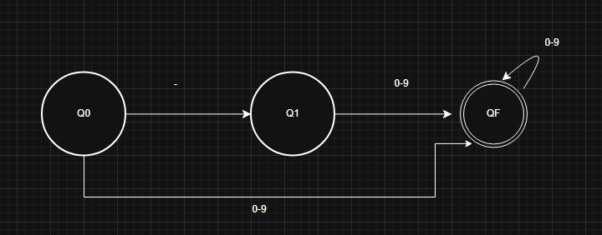
Float:
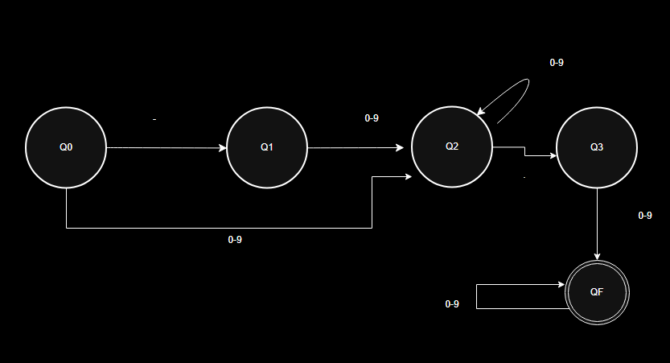

Char:
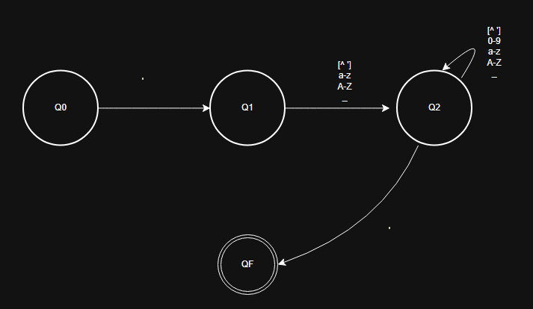
String:
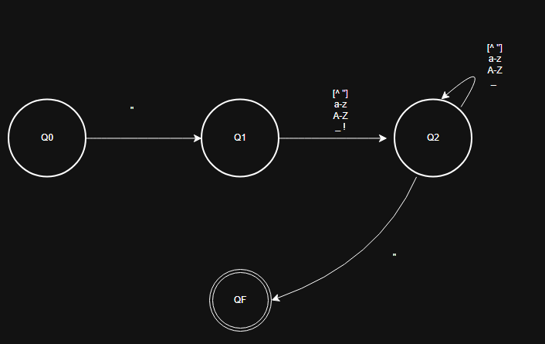

Identifier:
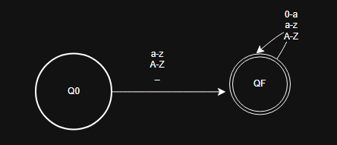

Custom Keywords
Suppose:
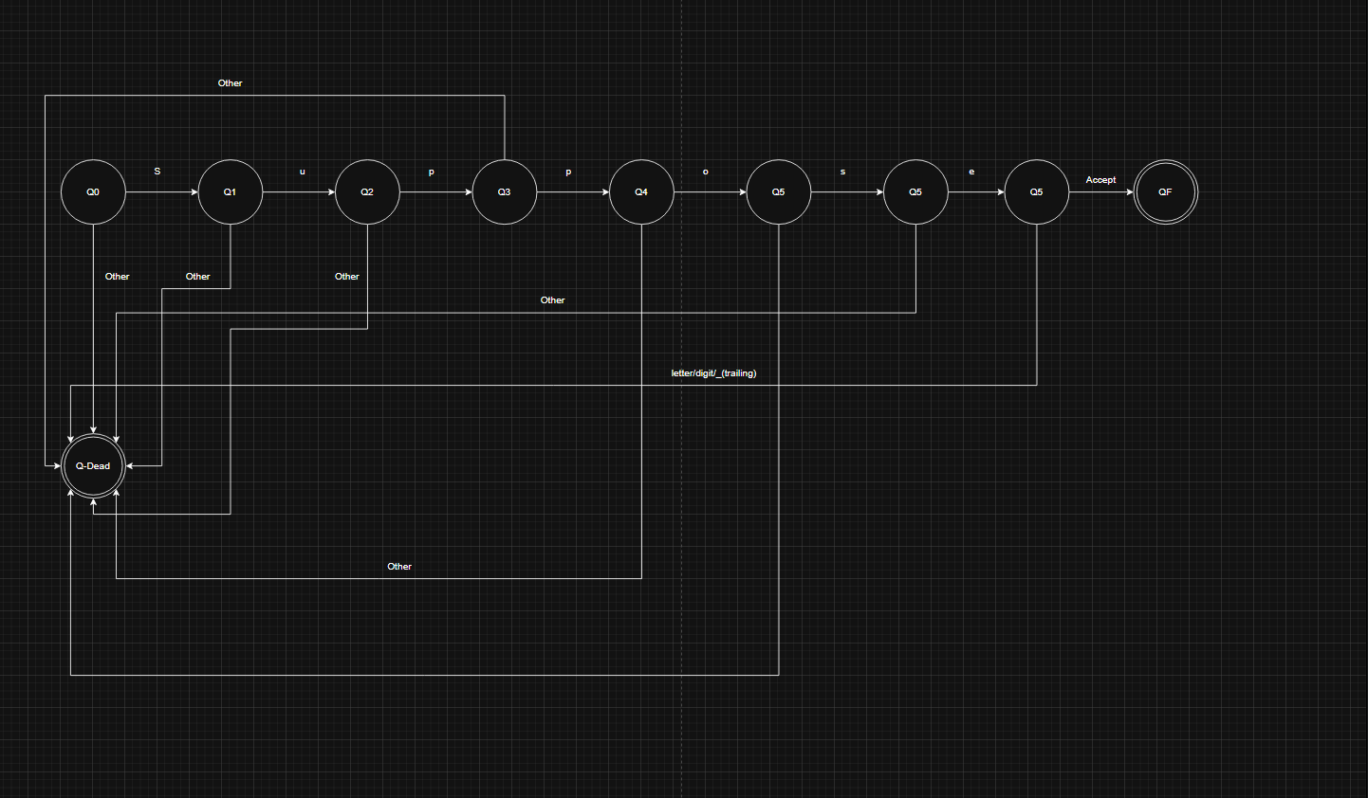
Word:
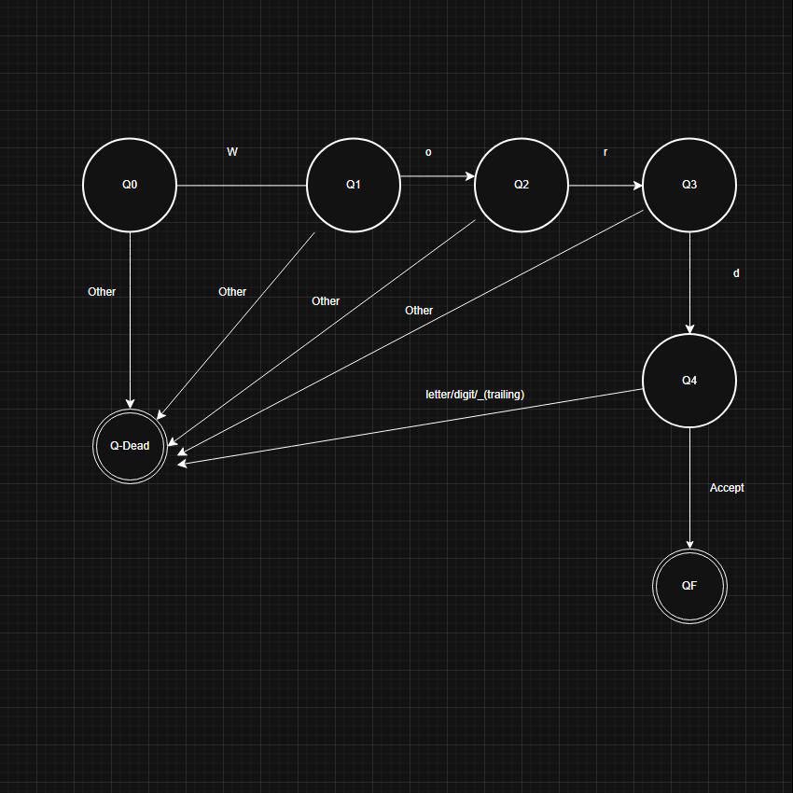

choice:
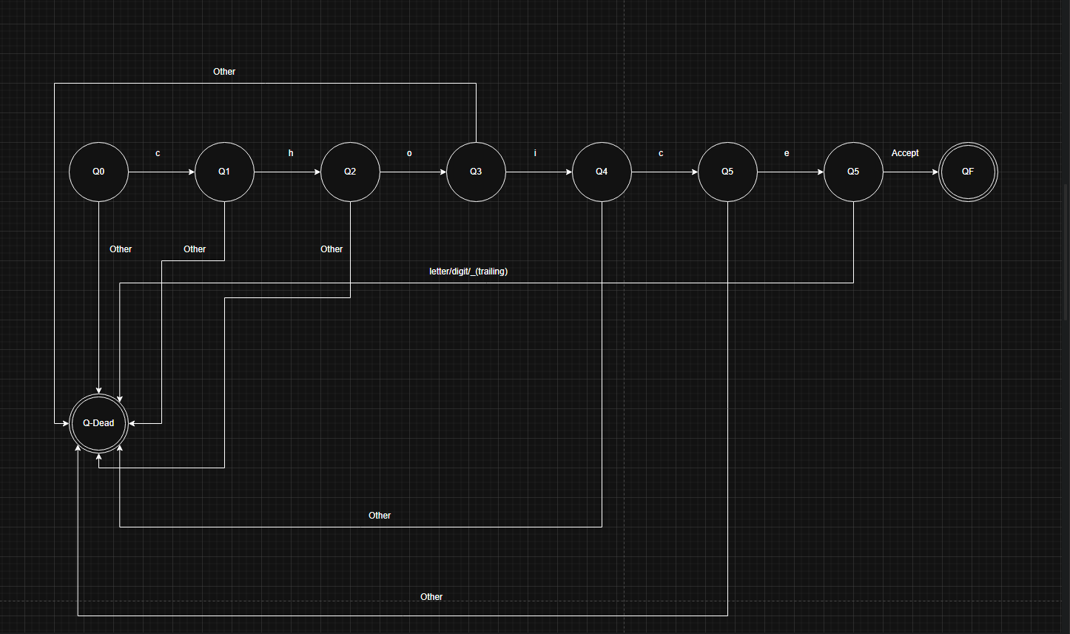
Point:
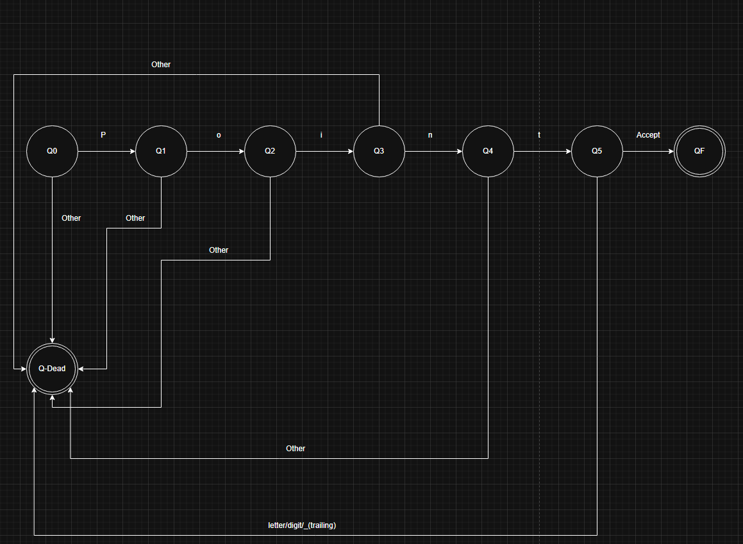
Brief Explanation
Keywords
- Suppose: Chosen as a natural-language alternative to if. Makes conditional logic more readable and intuitive for beginners.
- Suppose_else: Complements Suppose for branching. Explicit naming avoids confusion with other constructs.
- Because_of: Represents for loops. The phrase suggests “because of this condition, repeat,” making iteration logic descriptive.
- give_out: Designed to replace return. The wording clearly conveys “give out a value” at the end of a function.
- take: For input. Simple and action-oriented, easy for learners to remember.
- show: For output. Chosen for clarity,“show something on screen.”
- Digit: Represents integer type. The name directly relates to numeric digits, making its purpose obvious.
- Point: Represents floating-point type. Short and intuitive for decimals.
- Word: Represents character type. Suggests a textual element, making it beginner-friendly.
- STOP: Break statement. Strong, clear command to halt loop execution.
- empty: Represents void. Indicates “nothing returned,” aligning with its semantic meaning.
- Correct: Boolean true. Chosen for clarity and natural language feel.
- Incorrect: Boolean false. Complements Correct for logical clarity.
- choice: Logical OR keyword. Suggests “choose one option,” making OR semantics intuitive.
- also: Logical AND keyword. Suggests “include this too,” aligning with AND logic.

Operators

- = : Assignment, fundamental for variable initialization.
- add: Addition, word-based for clarity and readability.
- subtract: Subtraction, descriptive alternative to -.
- mult: Multiplication, short and clear.
- divide: Division, intuitive word form.
- > : Greater-than, standard comparison operator.
- < : Less-than, standard comparison operator.
- equal: Equality check, word-based for readability.
- not_equal: Inequality check, descriptive alternative to !=.
- ! : Logical negation, standard symbol for NOT.
- AND : Logical AND, uppercase for emphasis.
- OR – Logical OR, uppercase for emphasis.
- ++ : Increment, standard shorthand for loops.
- -- : Decrement, standard shorthand for loops.
- % : Modulo, essential for remainder operations.

Punctuations

- ( and ) : Grouping and function calls, standard in most languages.
- { and } : Block delimiters, clear structure for code blocks.
- ;; : Statement terminator, double semicolon chosen for uniqueness.
- , : Separator for multiple declarations or arguments.
- :: : Reserved for special syntax, future extensibility.

Why this design?

- Natural Language Readability: Keywords like Suppose, Because_of, give_out make code self-explanatory for beginners. They reduce the cognitive load compared to cryptic symbols.
- Consistency & Simplicity: All keywords are case-sensitive and descriptive. Operators and punctuations follow predictable patterns.
- Educational Focus: The language is designed for clarity, so learners can understand logic without memorizing abstract symbols.
- Uniqueness: Using ;; as a statement terminator and word-based operators (add, subtract) differentiates this language from C-like syntax, making it distinct yet approachable.
- Error Prevention: Clear keywords reduce ambiguity and make parsing easier. For example, STOP is unambiguous compared to break.

