**DinLMS Student Documentations**

Main Navigation bar:

1. Dashboard
2. Overview
3. Today Goal
4. Class
5. Support
6. Improve Score
7. Request Class
8. About LFWF
9. Dashboard:
   1. Profile:

* Show Profile Image
  1. Start Practice:
* Start, Resume, Stop. (Resume don’t need, when click start the button will change to Stop)
* 5 min set interval Ajax hit.
* Show todays total practice time (in main time counter)
  1. Success Progress Rate:
* Rate count from previous all activities.
  1. Widget:
* Comes from Provider
* Comes from Teacher
* Conditional widget (Can select where to show to: All Student, By Course, By Batch, By Student ID)

1. Overview:

* Overall Success rat
* Done/Not Done Assignment List with Mark.
* Done/Not Done Quiz List with Mark.
* Absent/Present Class List
* Watch Class on Daily/WeeklyMonthly
* Practice Ratio on Daily/Weekly/Monthly.
* Alert & Notification (Alert mean dynamic notification alert, Notification mean custom alert )

1. Today Goal:

* Show today practice goal, if our average practice goal is 4 hour per day, it will to to him on there. with how much she completed or how much need to complete.
* Show the Upcoming Class
* Suggest to Complete the Current Assignment
* Suggest to Complete the Current Quiz
* And suggest watching the Upcoming class videos.

1. Class:

* Class Overview
* Videos (Don’t Need)
* Assignment
* Quiz (Need to discuss about this quiz after previous requirements)
* Class Activities

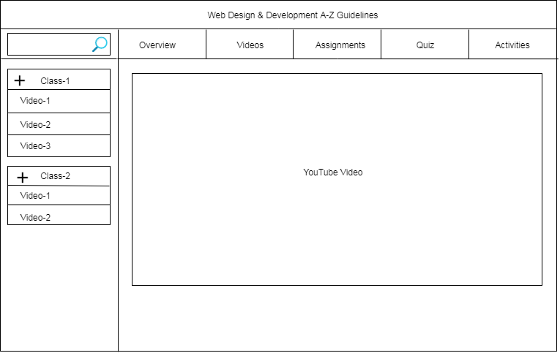

1. Support:

* Select Problem Type (HTML & CSS, WordPress, Marketplace, Development, Theme, Plugins)
* Write your problem in this text area.
* After submit a mail will be send to this batch support men – (The submit mail will send to support team or support member login panel as a notification with sound, Support member click the notification, review the full request and set a time when he can assign with the student)
* If any support member will assign with any student with support other support member can see this (he/she assign with anyone) and also see as a notification Ex: Jillur assign with this support.
* Support men reply against this request and response him/her.
* A zoom session will be created at this time.
* Student show this count down.
* Join meeting will be visible after completing the count down.

1. Improve Score:

* Need to discuss after completing the previous requirement. (Also we are thing about it, it’s maybe some extra quiz or extra assignment to improve skill)

1. Request Class:

* Select class (For which class video lecture you needed)
* Write your cause for requesting this class lecture.
* After submit Support manager will give this lecture against this request.

1. About LFWF:

* Static Page.

**DinLMS Provider Documentation**

1. Course

* Course List
* Archive Class List
* Add Archive Class
* View Class Materials/Videos

1. Batch

* Batch List
* Assigned Class List
* Add Class From Archive (For create a class--- First create Archive class and then select from archive to create a new class to this running batch)
* Create Schedule
* Assign Teacher

1. Widget

* Create for all students.

1. Assignment Archive

* Course and class list
* Create Archive assignment (against course and class) (have to discuss)

**DinLMS Teacher Documentation**

1. Student Attendance

* Batch List
* Class list
* Take Attendance
* Give Assignment from archive….(Which created by Provider)