Task_5 :Section_2

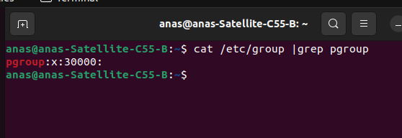
1.

2.
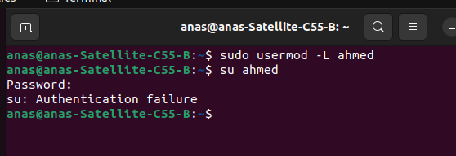

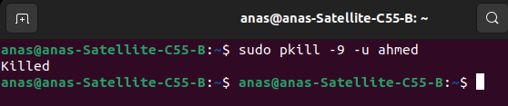
3.

but why after process killed : terminal terminated ?
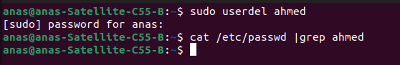

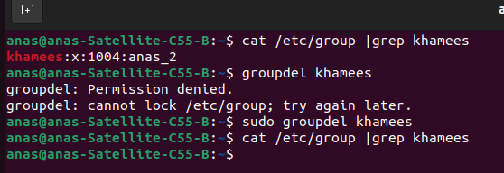
4.

5.

- adduser:
it is a script which Creat a user with its home directory and its files automatically.

But
- useradd:
it is a bin application create new user without its home directory, you should create the home directory manually.

