

BookTime

Coding Academy By Orange

Project 9 - Create Your Own Mobile Application (Hybrid)

**Supervised By**

Mohammad Al-Shwaiki

Khadeejah Hamdan

Amal Al-Dajah

**Group 5**

Dana Toughoj

Razan Zuaiter

Saja Dahamsheh

Waed Dawaghreh

Anas Al-Jawabrah

**Introduction**

BookTime is the name we chose for project 9 at coding academy by Orange. It is an application that views English books with their descriptions to guide users before they buy books, they can browse the books in the application and choose what they like and he/she will be redirected to the book at amazon page to buy it, We are trying to help people find what they love to read and spread that love by giving our users the chance to donate books for children in schools located in less fortunate districts so they might share and feel the same passion those people have for reading.

The application was built with React Native which is an open-source mobile application framework created by Facebook. It is used to develop applications for Android, Android TV, IOS, tvOS, Web, Windows and UWP. The Application we made can work on both android and IOS using expo.

**Requirements**

1. **View books**

Users can view some of our books from the home page, and they can view the rest of our books collection in a separate page called “All Books”.

1. **View best selling books**

Users can view the books categorized as best selling books in the “Best Sellers” tab on the home page.

1. **View new arriving books**

Users can view the books categorized as new arriving books in the “New Arrivals” tab on the home page.

1. **View Books that are coming soon**

Users can view the books categorized as coming soon books in the “Coming Soon” tab on the home page

1. **View Books in categories**

Users can see books categorized under the genre they belong to in the “Books Categories” page.

1. **Bookmark books**

Users can add books they like to the “Bookmarks” page to save them

1. **View bookmarked books**

Users Can view the books they bookmarked in the “Bookmarks” page.

1. **Search for books**

Users can search for books and the results will be shown immediately as you write

1. **Make Donations**

Users have the chance to donate money for us to buy books to kids going to schools in less fortunate districts.  
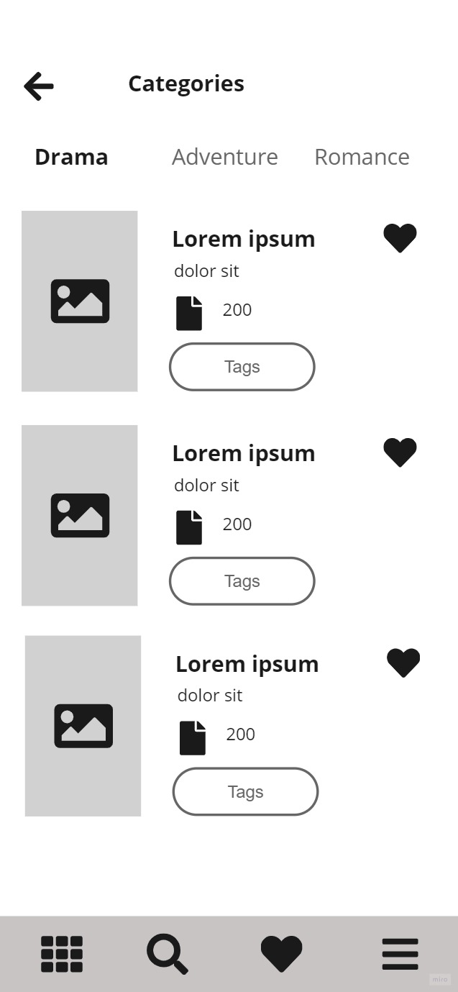

**Implementation**

1. **Wireframes**



**Figure 1 - Homepage Figure 2 - Homepage 2 Figure 3 - All Books Figure 4 - Bookmarks**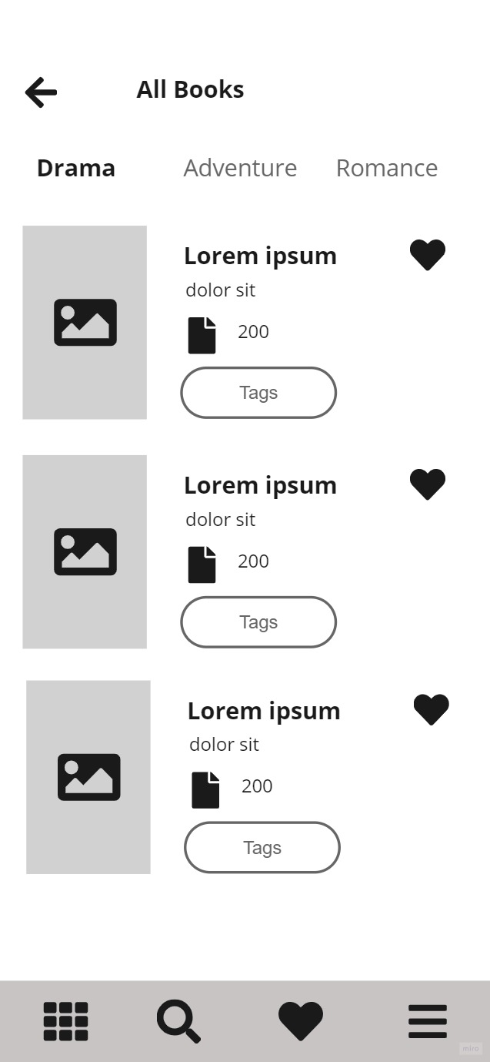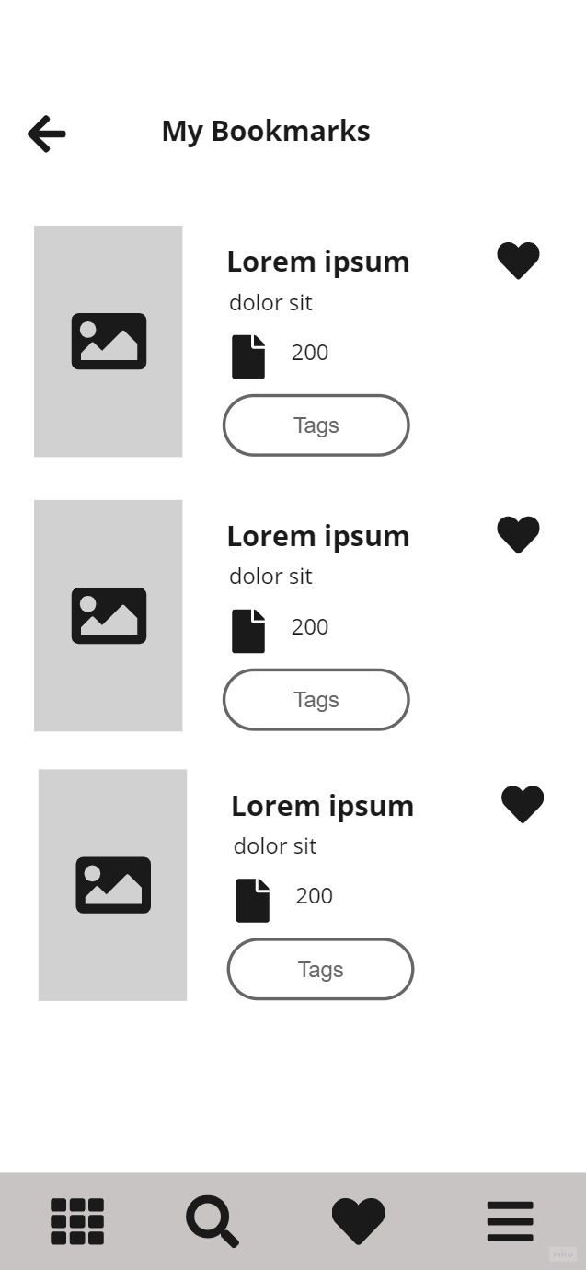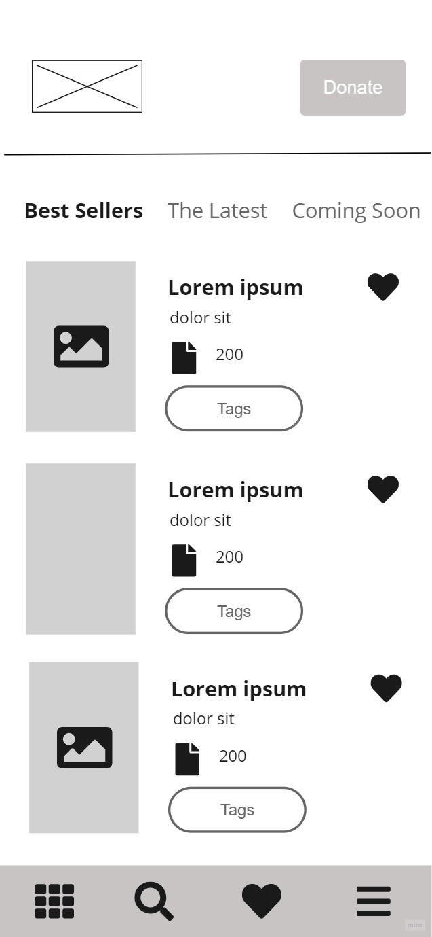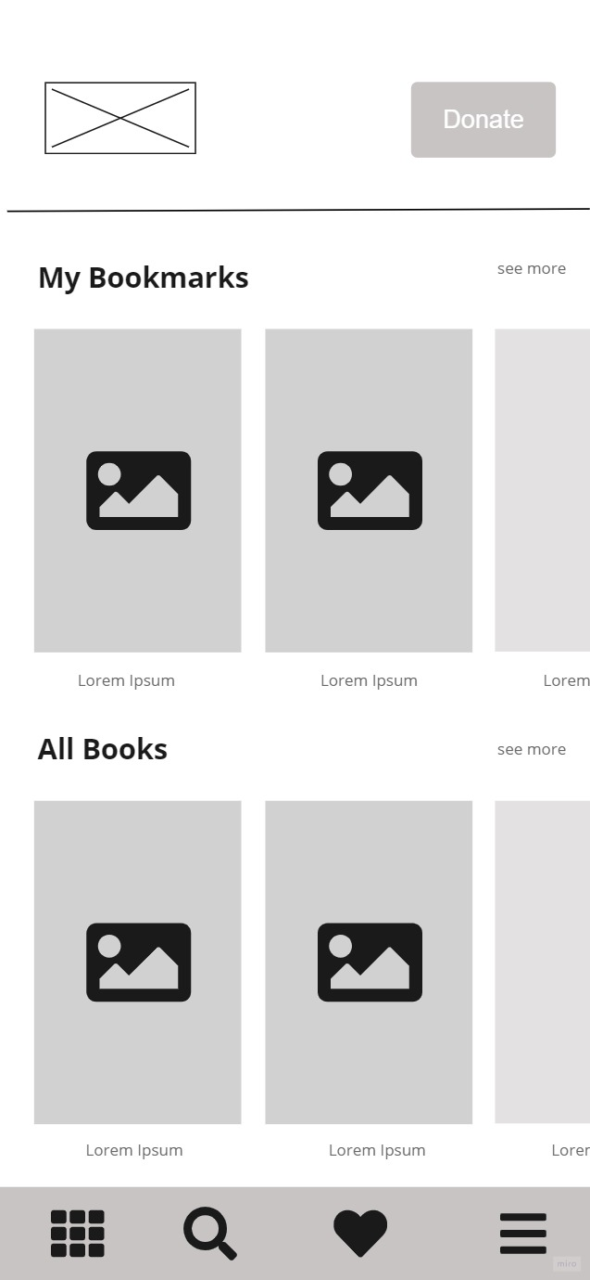



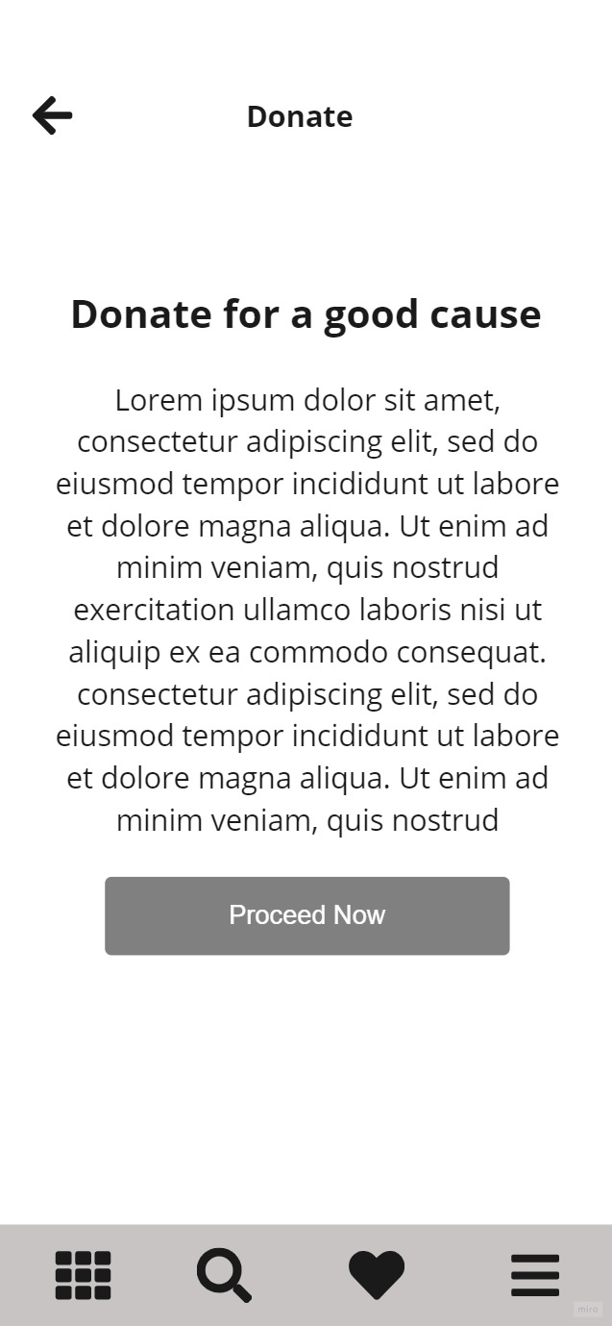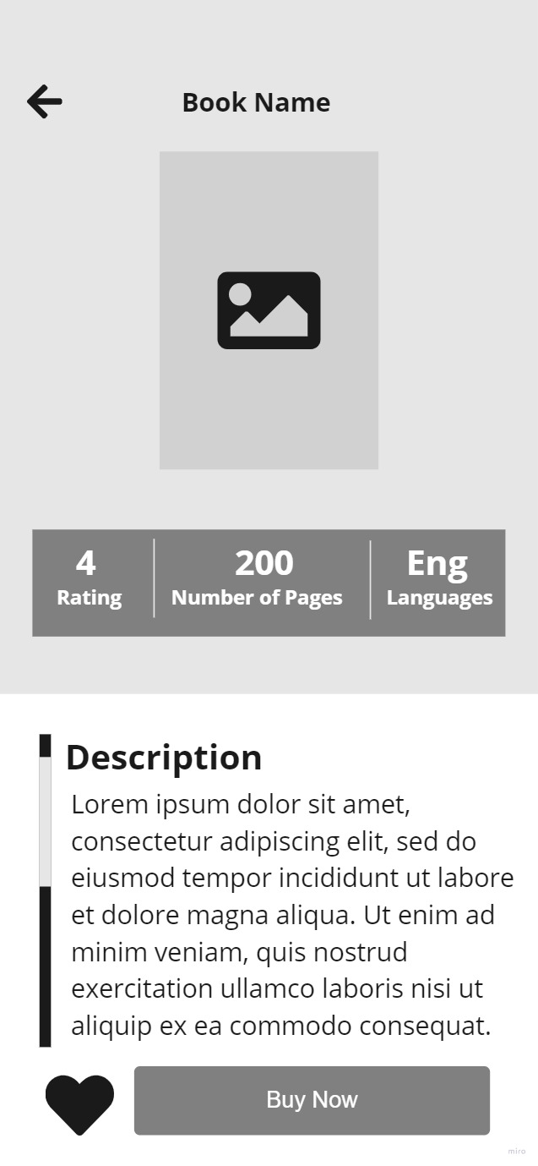

**Figure 5 - Categories Figure 6 -Book Details Figure 7 - Donate**

1. **Mockup**



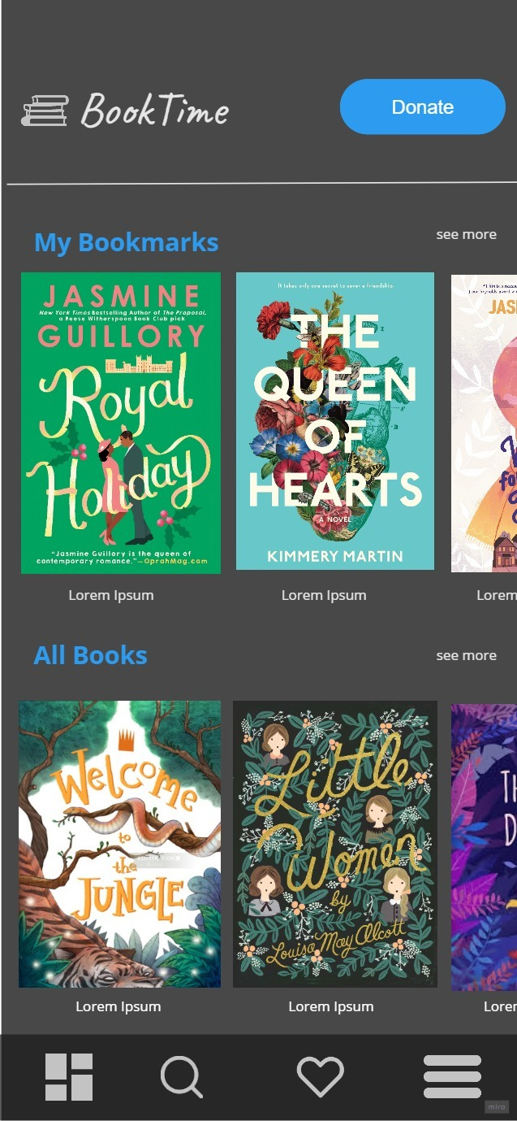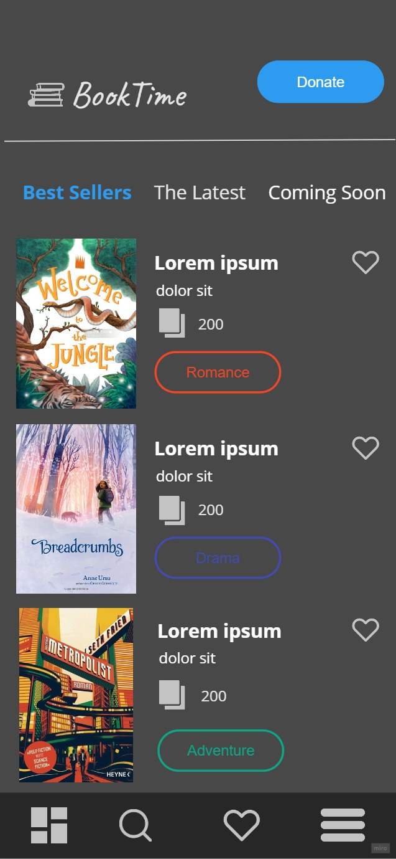

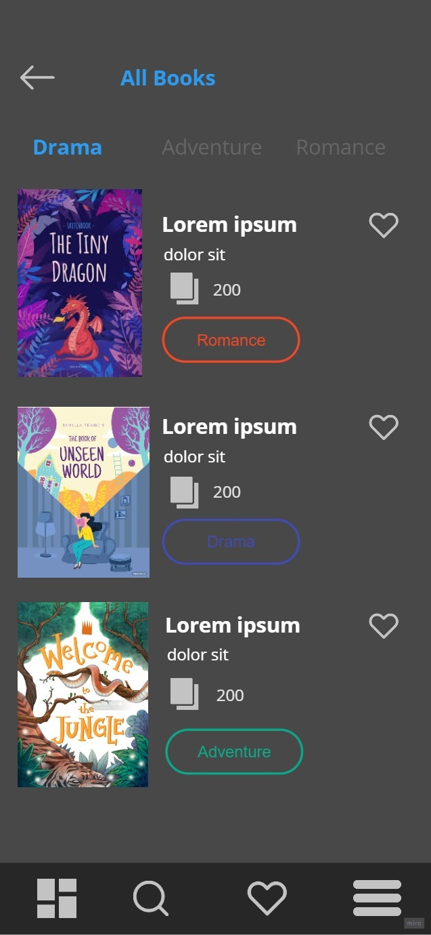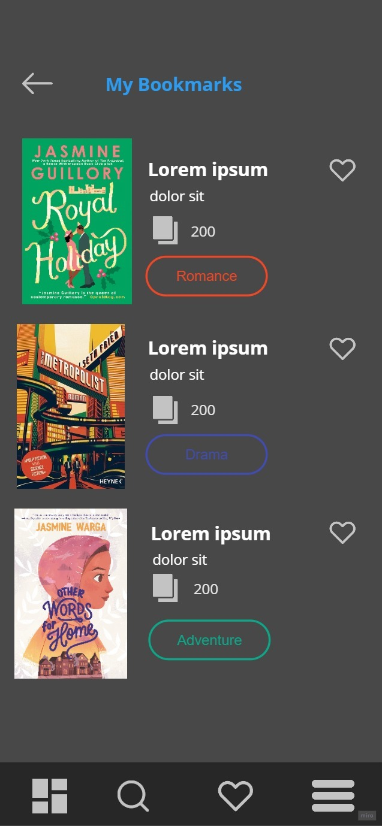

**Figure 8 - Homepage Figure 9 - Homepage 2 Figure 10 - All Books Figure 11- Bookmarks**



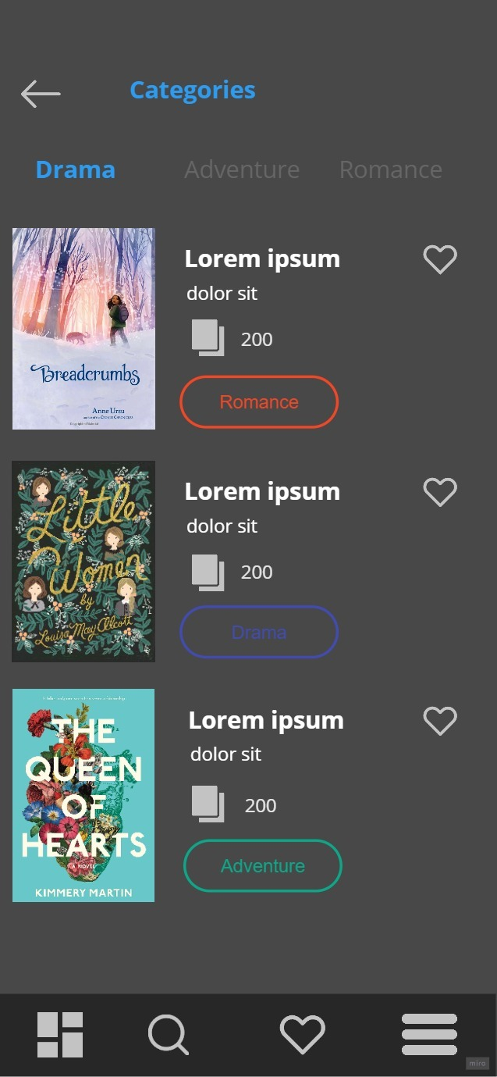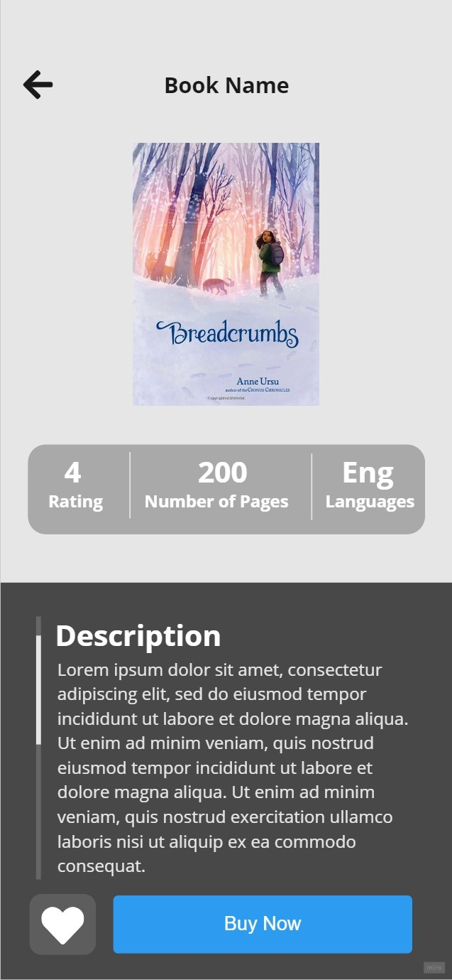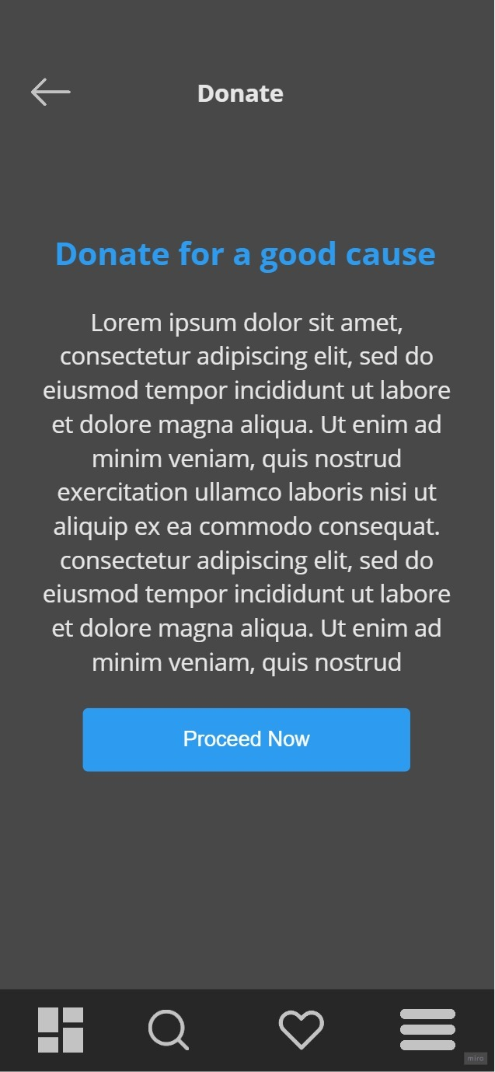

**Figure 5 - Categories Figure 6 -Book Details Figure 7 - Donate**