SIMDA — Dukumentiga Guud ee Nidaamka (Master Document)
Nov 9, 2026 · @Anas Abdiwahid

1. Hordhac
SIMDA (Somali Islamic Microfinance Development Association) waa nidaam web ah oo maamula maalgelinta yaryar ee Islaamiga ah, laga bilaabo diiwaangelinta macmiilka ilaa bixinta lacagta, lacag-celinta iyo bayaanka PDF-ka. Wuxuu beddelaa xaashiyaha Excel-ka ee kala firirsan, wuxuuna bixiyaa xisaab sax ah, xuduud laan kasta ah iyo raad-raac (audit) buuxa.
Cidda isticmaasha: shaqaalaha SIMDA (maamulka, maareeyayaasha laamaha, Header Office) iyo macaamiisha qudhooda (bogga macmiilka). Dadweynaha guud waxay arkaan bogagga dadweynaha (home, about, FAQ, contact) iyo chatbot-ka SIMDA AI.
Luqadaha: Af-Soomaali (asal), English iyo Carabi. Luqadda waxaa lagu beddelaa ?lang=so|en|ar.
Mabaadi'da shareecada ee nidaamku ku dhisan yahay:
- 0% Ribo: dulsaar ma jiro. Faa'iidada Murabaxada waa mid go'an oo bilowga lagu heshiiyo, weligeedna ma korodho.
- Murabaxo (Cost-Plus): SIMDA ayaa iibsata alaabta, kadibna macmiilka ugu iibisa qiimaha asalka + faa'iido go'an, lacagta qeyb-qeyb ayaa loo bixiyaa.
- Jimco → Sabti: qeyb kasta oo ku beegan Jimce si toos ah ayaa loogu wareejiyaa Sabti, ganaax la'aan.
- Sanduuqa Sadaqada: ganaaxa dib-u-dhaca ($15, kadib 7 maalmood) ma aha dakhli SIMDA; wuxuu galaa sanduuq sadaqo oo gooni ah.
- Keyd ma jiro: SIMDA ma qaado lacag la dhigto; maalgelin oo keliya ayay bixisaa.
Ogeysiis: nidaamku wuxuu fuliyaa xeerarka xisaabeed ee Islaamiga ah ee loo qeexay, laakiin ma laha shahaado guddi shareeco oo rasmi ah. Ka hor isticmaalka rasmiga ah, la-taliye shareeco ha eego.

2. Qaab-dhismeedka farsamada
SIMDA waa PHP 8.4 (strict types) + MySQL oo ku shaqeeya XAMPP, framework la'aan. JavaScript-ku waa vanilla, Chart.js ayaa shaxanka u sameeya. Codsi kasta wuxuu maraa hal albaab, kadib hal controller oo route-ka u gudbiya function-kiisa.
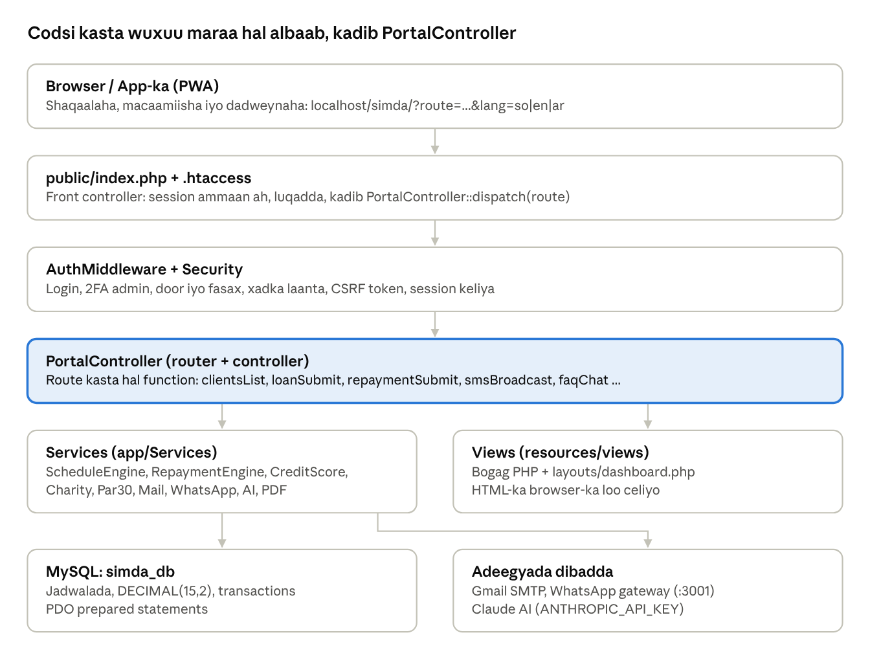
qaab-dhismeedka farsamada · 6 lakab
Controller-ku wuxuu hubiyaa xogta foomka, service-ka ayuu shaqada u dhiibaa (xisaab, transaction, email), kadib view-ga ayuu HTML-ka ka dhisaa. Fetch/JSON waxaa isticmaala chatbot-ka (faq_chat), kalkuleytarka (api_schedule_preview) iyo hubinta session-ka (auth_session_check).

3. Qaab-dhismeedka faylasha
Mashruucu wuxuu ku jiraa C:\xampp\htdocs\SIMDA. Koodka PHP waa qiyaastii 11,700 sadar (app/), bogagga (views) waa qiyaastii 18,100 sadar.
Folder / File | Waxa ku jira
index.php (root) | Albaabka koowaad: wuxuu u gudbiyaa public/index.php, si nidaamku u shaqeeyo localhost/simda/.
.htaccess (root) | Wuxuu xannibaa app, config, database, resources, .env, whatsapp-gateway; wuxuu u leexiyaa assets/, manifest.json, service-worker.js folder-ka public/.
bootstrap.php | Autoloader (App\ → app/, Database\ → database/), akhrinta .env, waqtiga Africa/Mogadishu.
public/index.php | Front controller: session ammaan ah, luqadda, kadibna PortalController::dispatch($route).
public/assets/css/simda.css | Dhammaan naqshadda (cagaar #123B32, dahab #D6B66C, light/dark, mobile).
public/assets/js/simda.js | JavaScript-ka guud: theme, sidebar, kalkuleytarka jadwalka, nav-ka dadweynaha, service worker.
public/manifest.json, public/service-worker.js, public/assets/icons/ | PWA: app-ka la rakibi karo, icons, cache-ka offline.
app/Controllers/PortalController.php | Router + controller keliya: route kasta wuxuu u leeyahay function (clientsList, loanSubmit, faqChat, ...).
app/Services/ | Caqliga ganacsiga (17 service): jadwal, lacag-celin, sadaqo, credit score, PAR30, email, WhatsApp, AI, PDF.
app/Helpers/ | Database (PDO), Env, Lang (luqadaha), Security (escape, CSRF, lacag qaab), AuditLogger, Icons (SVG), Districts.
app/Middleware/AuthMiddleware.php | Hubinta login-ka, doorarka, fasaxyada, CSRF, session-ka keliya.
config/ | app.php, database.php: dejinta guud iyo xiriirka database-ka.
resources/layouts/dashboard.php | Qolofta dashboard-ka: sidebar, header, raadinta, luqadda, theme.
resources/views/ | Bogag u kala qaybsan folder-yo: admin, applications, auth, clients, communication, dashboard, financings, groups, products, public, repayments, partials.
resources/languages/ | Turjumaadda: so.php, en.php, ar.php.
database/schema.sql | Dhammaan jadwalada (tables).
database/migrations/ | Isbeddellada database-ka ee dambe (heerarka ansixinta, alaabta Murabaxada, akoonnada macaamiisha, credit score 0–100, partners).
database/seeders/DatabaseSeeder.php, database/setup.php | Abuurista database-ka iyo xogta bilowga (doorar, fasaxyo, settings, products).
tests/run_tests.php | 22 tijaabo oo otomaatig ah oo ku shaqeeya simda_test_db.
docs/ | ARCHITECTURE.md, API.md, ERD.md.
storage/ | Cache iyo session-ka WhatsApp (whatsapp-auth).
whatsapp-gateway/ | Server Node.js yar oo WhatsApp lagu diro (QR-ka laga xiro taleefanka).
vendor/, composer.json | Maktabadaha dibadda: Anthropic SDK (Claude AI), Guzzle.

4. Doorarka iyo fasaxyada
Nidaamku wuxuu leeyahay 5 door. Qofka sameeyay codsi ma ansixin karo codsigiisa. Admin-ku wax walba wuu arkaa; fasaxyo gaar ah ayaa qof kasta loogu dari karaa bogga Permissions.
Door (slug) | Magaca | Waxa uu qaban karo | Xadka ansixinta
admin | Maamulaha Guud (System Administrator) | Wax walba: laamo, shaqaale, fasaxyo, settings, audit log, partners. Login-ka wuxuu u baahan yahay koodh 2FA oo email lagu soo diro. | Dhammaan
manager | General Manager | Kormeerka laamaha oo dhan, maamulka shaqaalaha, ansixinta lacagaha waaweyn. | Ka badan $50,000
branch_manager | Maamulaha Laanta | Kormeerka laantiisa, ansixinta kooxaha, iska-dhaafka ganaaxa sadaqada (sabab qasab ah). | $5,000 – $50,000 iyo kooxaha
loan_officer | Header Office (Shaqaale) | Diiwaangelinta macaamiisha, codsiyada maalgelinta, bixinta lacagta, qaadashada lacag-celinta. | Ilaa $5,000
client | Macmiil | Wuxuu arkaa maalgelintiisa, jadwalkiisa, lacag-bixintiisa iyo bayaankiisa PDF. | —
Xuduudda laamaha: shaqaale aan admin/manager ahayn wuxuu arkaa oo keliya xogta laantiisa (branch_id). Macmiilku wuxuu arkaa oo keliya xogtiisa (client_id). Xeerkan waxaa fuliya scopeSql() iyo clientScopeSql() ee PortalController.
Akoonka macmiilka: marka macmiil la diiwaangeliyo, si toos ah ayaa loogu sameeyaa akoon (email ama lambar taleefan) oo leh password ku-meel-gaar ah; marka ugu horreysa uu galo waxaa lagu qasbaa inuu beddelo (must_change_password).

5. Qaybaha nidaamka (modules)
Qayb kasta waxay leedahay route (?route=...), function ku jira PortalController, iyo bog ku jira resources/views/. Sidebar-ka dashboard-ka ayaa loo isticmaalaa in loo dhex maro.
Qaybta (menu) | Waxay qabato | Routes | View / Service
Dashboard | Tirooyinka guud: macaamiil, maalgelin firfircoon, lacag-celin, PAR30, shaxanka (Chart.js). | dashboard | dashboard/overview.php, DashboardAnalyticsService
Requests | Codsiyada sugaya ansixin, tirada (badge) ee sidebar-ka. | approval_queue, application_review | applications/approval_queue.php
Clients | Diiwaangelin (ID iyo taleefan keli ah, sawir, damiin qasab), eegis, raadin, u wareejin laan kale (admin). | clients, client_register, client_view, client_transfer, client_check_duplicate | clients/*.php, ClientAccountService
Guarantors | Damiinnada macaamiisha. | guarantors, guarantor_add | clients/guarantors.php
Groups | Kooxaha garab-wadaagga (3–10 qof, hoggaamiye), ansixinta Branch Manager. | groups, group_create, group_approve | groups/index.php
Products | Alaabta maalgelinta: Murabaha, Flat, Declining Balance; xadka lacagta iyo muddada, khidmadda maamulka. | products, product_save, product_toggle, product_delete | products/index.php
Applications | Codsi cusub, kaydin qabyo ah, gudbin, dib-u-gudbin hal mar kadib diidmo. | applications, application_create, application_submit_draft, application_resubmit | applications/index.php
Cash Loans | Maalgelin lacag caddaan ah oo toos ah. | loans, loan_new, loan_submit | financings/loans.php, loan_new.php
Murabaha | Heshiis Murabaxo: macmiil + alaab + faa'iido go'an; liiska alaabta (sawir, qiime, markup) iyo kuwa bogga hore ka muuqda. | murabaha, murabaha_new, murabaha_submit, murabaha_goods* | financings/murabaha*.php, MurabahaGoodsService
Disbursements | Bixinta lacagta (EVC Plus, Zaad, eDahab), net = lacagta − khidmadda; ansixin aan la bixin 30 maalmood way dhacdaa. | disbursements, disburse_submit | financings/disbursements.php, DisbursementService
Financing | Liiska maalgelinta, jadwalka, bayaannada PDF. | financings, schedules, statements, financing_view, statement_pdf | financings/index.php, view.php, StatementPdfGenerator
Payments | Qaadashada lacag-celinta, rasiidka, taariikhda. | repayments, repayment_record, repayment_submit, repayment_receipt | repayments/*.php, RepaymentEngine
Risk Management | Ganaaxa sadaqada (iyo iska-dhaafkiisa), credit score, PAR30. | charity_charges, charity_waive, credit_scores, par30 | CharityChargeService, CreditScoreEngine, Par30Service
Reports & Analytics | Bayaannada macaamiisha (PDF) iyo warbixinnada maaliyadda. | statements, reports | Par30Service, StatementPdfGenerator
Communication | SMS outbox (xasuusin 3 maalmood ka hor iyo 1 maalin kadib), iyo fariin la qoro oo loo diro macaamiisha Gmail ama WhatsApp (dooro qof qof ama dhammaan). | sms_outbox, sms_run_dispatcher, sms_broadcast | communication/sms_outbox.php, SmsReminderService, MailService, WhatsAppService
Staff | Managers, branch managers, Header Office, shaqaale: abuurid, wax-ka-beddel, xannibid, dib-u-dejin amni, dib-u-dirista aqoonsiga. | managers, branch_managers, employees, user_* | admin/manage.php
Administration | Laamaha, fasaxyada, audit log, settings, partners, tijaabada email-ka. | branches, permissions, audit_logs, settings, partners, mail_test_send | admin/*.php, AuditLogger, PartnerService
Profile | Xogta qofka, beddelka email/password oo OTP lagu xaqiijiyo. | profile, profile_*, account_password* | admin/profile.php

6. Socodka shaqada
Maalgelin kasta waxay martaa 7 tallaabo. Heerka ansixinta waxaa go'aamiya qaddarka lacagta; qofka codsiga sameeyay ma ansixin karo.
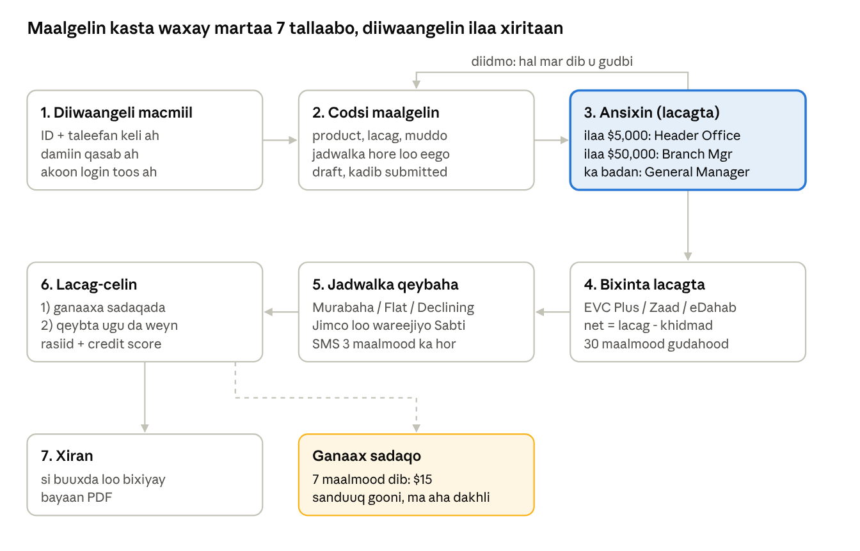
wareegga maalgelinta · 7 tallaabo
- Xannibaad: macmiil leh maalgelin >30 maalmood dib u dhacday codsi cusub ma samayn karo; kooxdu dhammaan way xannibmaan haddii xubin dib u dhacdo.
- Diidmo: codsiga la diiday wax ayaa laga beddeli karaa oo hal mar ayaa dib loo gudbin karaa.
- Ansixin aan la bixin: 30 maalmood kadib way dhacdaa (expires_at).
- Bixin hore: Murabaxada waxay helaa dhimis faa'iido (Ibra); lacag dheeraad ah waxay gashaa credit_balance macmiilka.
- Ogeysiisyo: email (iyo WhatsApp) marka codsi la gudbiyo, la ansixiyo/diido, lacag la bixiyo iyo rasiid kasta; SMS xasuusin 3 maalmood ka hor iyo 1 maalin kadib.

7. Bogagga dadweynaha, chatbot-ka iyo app-ka
Bogagga dadweynaha waxay leeyihiin menu isku mid ah: Bogga Hore · Nagu Saabsan · Adeegyada · Habka Shaqada · La-hawlgalayaasha (marka partner firfircoon jiro) · FAQ · Xiriirka. Kumbuyuutarka menu-gu hal saf ayuu ku jiraa; haddii uusan qaadin, hoos ayuu u dhaadhacaa; telefoonka wuxuu isticmaalaa batoonka ☰.
Bog | Route / File | Waxa ku jira
Bogga Hore | home → public/home.php | Carousel-ka Murabaxada (alaabta laga doortay admin), adeegyada (dialog faahfaahin), habka shaqada, kalkuleytarka jadwalka, partners, footer.
Nagu Saabsan | about → public/about.php | Taariikhda, hadafka, shareecada.
Xiriirka | contact → public/contact.php, contact_submit | Foom xiriir, lambarrada +252 616256534 / +252 613496943, KM4 Muqdisho.
FAQ | faq → public/faq.php | Su'aalaha badan iyo jawaabahooda.
Offline | offline | Bogga muuqda marka internet la'aan.
Chatbot-ka SIMDA AI (partials/ai_chat_widget.php, route faq_chat):
- Haddii ANTHROPIC_API_KEY la dejiyo, SimdaAiService ayaa Claude weydiiya jawaab ku saleysan xogta tooska ah ee database-ka (rate limit ayaa jira).
- Haddii kale, xeerar keyword ah ayaa jawaaba (codsi, Murabaxo, ribo, keyd, xafiis, damiin, ganaax, Jimco, iwm). Erayada si khaldan loo qoro waa la saxaa (x/h, q/k, xarfaha labanlaaban), su'aalaha "sideen u codsadaa" ayaa mudnaan leh.
- Luqadda waxaa la ogaadaa si toos ah (Soomaali, English, Carabi).
App-ka (PWA): manifest.json + service-worker.js ayaa nidaamka ka dhiga app la rakibi karo. Bogga hore waxaa ku yaal batoon DOWNLOAD (cagaar iyo dahab) oo ka sarreeya robot-ka chatbot-ka: 7 ilbiriqsi ayuu muuqdaa, 7 ilbiriqsi ayuu maqan yahay. Gujinta waxay furtaa daaqadda rakibaadda browser-ka; iPhone-ka wuxuu tusaa tallaabooyinka "Add to Home Screen" (partials/pwa_install_button.php). Service worker-ku ma kaydiyo bogagga lacagta ama POST-yada.

8. Database-ka
Database-ku waa MySQL/MariaDB (InnoDB) oo magaciisu yahay simda_db (tijaabooyinka: simda_test_db). Lacag kasta waa DECIMAL(15,2); xisaabta waxaa lagu sameeyaa bcmath iyo senti, si aan lacag u lumin. Xiriirka jadwalada waa foreign keys.
Jadwal | Waxa uu kaydiyo | Ku xiran
roles, permissions, role_permissions | 5-ta door iyo fasaxyada (tusaale charity.waive). | users.role_id
branches | Laamaha SIMDA. | users, clients, financings
users | Shaqaalaha iyo akoonnada macaamiisha; must_change_password, heerarka xannibaadda. | roles, branches
login_attempts, password_resets | Isku-dayada login-ka (rate limit) iyo koodhadhka OTP-ga. | users
clients | Macmiilka: client_code, ID keli ah, taleefan keli ah, email, ganacsi, dakhli, sawir, credit_balance (lacag dheeraad ah), xaalad. | branches, users
guarantors | Damiinka macmiil kasta (magac, taleefan, ID, xiriir). | clients
groups, group_members | Kooxaha garab-wadaagga iyo xubnahooda. | clients, branches
products | Noocyada maalgelinta: murabaha / flat / declining, xadka, muddada, admin_fee. | financing_applications
financing_applications | Codsiga: lacagta la codsaday, muddada, qiimaha la isku raacay, xaalad (draft → ...), required_approver_role, cidda dib u eegtay, expires_at. | clients, products, groups, users
financings | Maalgelinta la bixiyay: financing_number, lacagta, khidmadda, net-ka la bixiyay, faa'iidada, ibra_discount, wixii la bixiyay iyo haraaga, bixiye (EVC Plus/Zaad/eDahab), maturity_date, xaalad. | financing_applications (1:1), clients
installments | Qeyb kasta: original_due_date, due_date (Jimco → Sabti), was_friday_shifted, asal + faa'iido, wixii la bixiyay, xaalad. | financings
repayments | Lacag-bixin kasta: receipt_number, qaybinta (sadaqo / asal / faa'iido / credit), habka bixinta, taariikh, is_early_settlement. | financings, clients
charity_charges | Ganaaxa sadaqada ee qeyb kasta (mid keliya): qaddar, la bixiyay, haraa, xaalad, cidda iska-dhaafday iyo sababta. | installments, financings
credit_scores | Dhibcaha macmiilka (0–100), kii hore, nooca (new, excellent ... high_risk). | clients
sms_outbox | Fariimaha xasuusinta (Soomaali + English), nooca, taariikhda. | clients, financings
notifications | Ogeysiisyada nidaamka gudahiisa. | users
audit_logs | Raadka ficil kasta (cid, maxay, goorma, IP). | users
system_settings | Settings: ganaaxa ($15), maalmaha sugitaanka (7), xadka ansixinta ($5,000 / $50,000), dhicitaanka ansixinta (30 maalmood), xiriirka hay'adda. | —
murabaha_goods | Liiska alaabta Murabaxada: magac, qayb, qiimaha iibsiga, markup %, sawir, ka muuqashada bogga hore. | —
partners | La-hawlgalayaasha: logo, link, kala horreyn, firfircooni. | —
Faahfaahinta buuxda ee tiirarka: database/schema.sql iyo docs/ERD.md.

9. Services iyo mishiinnada xisaabta
Caqliga ganacsiga oo dhan wuxuu ku jiraa app/Services/. Controller-ku wuxuu soo qaataa xogta foomka, kadibna service-ka ayuu u dhiibaa; service-ku wuxuu ku shaqeeyaa transaction (ACID), si haddii wax khaldamaan aan waxba qabyo u harin.
Service | Shaqadiisa
ScheduleEngine | Wuxuu xisaabiyaa jadwalka qeybaha (Murabaha, Flat, Declining). Sentiga haray qeybta ugu dambeysa ayuu ku daraa. Jimco → Sabti.
DisbursementService | Bixinta lacagta: tixraac keli ah, net = lacagta − khidmadda, jadwalka ayuu kiciyaa; ansixinta aan la bixin 30 maalmood ayuu dhiciyaa.
RepaymentEngine | Qaybinta lacag-bixinta: marka hore ganaaxa sadaqada, kadib qeybta ugu da'da weyn. Bixin qeyb ah, bixin hore (Ibra), lacag dheeraad ah → credit_balance.
CharityChargeService | Qeyb aan la bixin 7 maalmood kadib → ganaax $15 oo sadaqo ah. Branch Manager ayaa iska dhaafi kara (sabab qasab ah, audit log).
CreditScoreEngine | Dhibcaha 0–100 (hoos eeg). Dib ayaa loo xisaabiyaa lacag-bixin kasta iyo dib-u-dhac kasta.
Par30Service | PAR30 = haraaga maalgelinta >30 maalmood dib u dhacday ÷ haraaga guud × 100, hay'adda iyo laan kasta.
SmsReminderService | Xasuusin Soomaali + English: 3 maalmood ka hor (upcoming_3_days) iyo 1 maalin kadib (overdue_1_day), mid keliya qeyb kasta.
StatementPdfGenerator | Bayaanka PDF (PHP saafi ah): jadwal, lacag-bixin, ganaax, calaamadda "FULLY REPAID / SI BUUXDA LOO BIXIYAY".
FinancingDomainService | Xeerarka maalgelinta: xadka product-ka, xannibaadda macmiil >30 maalmood dib u dhacay, heerka ansixinta.
DashboardAnalyticsService | Tirooyinka iyo shaxanka dashboard-ka.
ClientAccountService | Akoonka login-ka macmiilka: abuurid, raadin email/taleefan, beddelka password-ka.
AuthService | Login, xannibaadda isku-dayada (5 → 15 daqiiqo, 3 → 30 daqiiqo, 2 → 1 saac, 2 → 5 saac, 1 → xannibaad), rate limit.
MailService | Email Gmail SMTP: soo dhaweyn, OTP, 2FA, rasiid, go'aanka codsiga, maalgelin la bixiyay, fariinta guud. Email kasta WhatsApp ayaa sidoo kale loo diraa.
WhatsAppService | Diristta WhatsApp: gateway-ga gudaha (bilaash) ama Maytapi. Lambarka wuxuu u beddelaa +252. Wuxuu shaqeeyaa xitaa haddii curl la'aan yahay.
SimdaAiService | Chatbot-ka Claude: shakhsiyadda SIMDA AI, aqoonta tooska ah ee database-ka, rate limit.
MurabahaGoodsService | Liiska alaabta Murabaxada iyo kuwa bogga hore lagu muujiyo.
PartnerService | Maamulka la-hawlgalayaasha (logo, link, kala horreyn).
Credit score (0–100): macmiil cusub wuxuu ka bilaabaa 0 (new).
- +5 qeyb kasta oo waqtigeeda la bixiyay (ama ganaaxeeda laga dhaafay); +10 bixin buuxda oo hore.
- −3 / −8 / −15 qeyb la bixiyay 1–7 / 8–30 / >30 maalmood dib.
- −5 / −10 / −20 qeyb aan la bixin oo 1–7 / 8–30 / >30 maalmood dib u dhacday.
- Heerarka: 80+ excellent, 60+ good, 40+ fair, 20+ caution, ka hooseeya high_risk. Qof aan weligiis dib u dhicin kama hoos maro fair.
Xisaabta jadwalka:
- Murabaha: faa'iido = qiimaha × markup%; wadarta waxaa loo qaybiyaa N qeybood oo siman.
- Flat: faa'iido = asal × heerka sanadlaha × N ÷ (12 bille ama 52 todobaadle).
- Declining Balance: qaacidada PMT; faa'iidada qeyb kasta waxaa laga xisaabiyaa asalka haray.

10. Isku-xirka dibadda iyo .env
Dhammaan furayaasha iyo password-yada waxay ku jiraan .env oo keliya (lama gelin git). .env.example ayaa tusaale ah. Haddii adeeg aan la dejin, nidaamku wuu sii shaqeeyaa, adeeggaas uun baa maqan.
Adeeg | Waxa loo isticmaalo | Furayaasha .env | Haddii la dejin waayo
Gmail SMTP | Email: aqoonsiga shaqaalaha, OTP, 2FA admin, rasiidyada, go'aannada, fariimaha guud. | MAIL_HOST, MAIL_PORT, MAIL_ENCRYPTION, MAIL_USERNAME, MAIL_PASSWORD (Gmail App Password), MAIL_FROM_NAME | Email lama diro; login-ka admin-ka (2FA) ma dhammaystirmo.
WhatsApp (gateway gudaha) | Nuqul WhatsApp ah email kasta, iyo batoonka "Send by WhatsApp". | WHATSAPP_ENABLED=true, WHATSAPP_PROVIDER=local, WHATSAPP_GATEWAY_URL (http://127.0.0.1:3001), WHATSAPP_GATEWAY_KEY | Fariimaha WhatsApp way fashilmaan, sababta ayaa la tusaa.
WhatsApp (Maytapi) | Bedel lacag leh oo gateway-ga ah. | WHATSAPP_PROVIDER=maytapi, MAYTAPI_PRODUCT_ID, MAYTAPI_PHONE_ID, MAYTAPI_API_TOKEN | —
Claude AI | Chatbot-ka SIMDA AI oo fahma su'aal kasta. | ANTHROPIC_API_KEY, SIMDA_AI_MODEL | Chatbot-ku wuxuu isticmaalaa xeerarka keyword-ka.
Mobile Money | EVC Plus, Zaad, eDahab. | — | Hadda waa simulation: tixraac ayaa la sameeyaa, lacag dhab ah lama dirayo.
Gateway-ga WhatsApp (whatsapp-gateway/): server Node.js ah. Laba-guji start-whatsapp.bat, fur http://127.0.0.1:3001, kadib QR-ka ku scan-gareey taleefanka (WhatsApp → Linked devices). Session-ka waa la kaydiyaa (storage/whatsapp-auth), sidaas darteed QR-ka hal mar uun baa la scan-gareeyaa. Daaqadda waa inay furnaato inta fariimaha la dirayo.
Settings kale ee .env: APP_URL, APP_TIMEZONE, DEFAULT_LOCALE, DB_*, SESSION_LIFETIME, LOGIN_MAX_ATTEMPTS, APPROVAL_OFFICER_LIMIT, APPROVAL_BRANCH_LIMIT, LATE_CHARGE_GRACE_DAYS, DEFAULT_CHARITY_LATE_FEE, DISBURSEMENT_EXPIRY_DAYS. Qiyamka shaqada maalinlaha ah (ganaaxa, xadka) waxaa sidoo kale laga beddeli karaa Administration → Settings.

11. Amniga
Amniga wuxuu ku dhisan yahay lakabyo: qofka la xaqiijiyo, waxa uu sameyn karo la xaddido, ficil kasta la qoro.
Ilaalin | Sida ay u shaqeyso | Halka ay ku taal
Login laba tallaabo | Marka hore email/taleefan, kadib password. | login_check_email, login_submit, AuthService
2FA admin-ka | Admin-ku wuxuu helaa koodh 8 xaraf ah oo email lagu soo diro; la'aantiis ma galo. | admin2faVerify, MailService::sendAdmin2FACodeEmail
Xannibaadda isku-dayada | Password khaldan: 5 → 15 daqiiqo, kadib 3 → 30 daqiiqo, 2 → 1 saac, 2 → 5 saac, 1 → xannibaad (admin ayaa furaya). | AuthService::handleFailedPassword
Rate limit | Isku-dayo badan oo hal IP/aqoonsi ah way joogsadaan. | login_attempts
Session keliya | Akoon kasta hal meel ayuu ka furnaan karaa; login cusub kii hore ayuu saaraa. | AuthMiddleware::validateActiveSession
CSRF | Foom kasta oo POST ah wuxuu leeyahay _csrf token. | Security::csrfToken, verifyCsrfOrAbort
Doorar iyo fasaxyo | Route kasta wuxuu hubiyaa doorka; xogta waxaa lagu xaddidaa laanta ama macmiilka. | requireAuth, requireRoles, scopeSql
OTP | Beddelka password-ka, email-ka, iyo hilmaamidda password-ka waxay u baahan yihiin koodh email ah. | forgot_password_*, profile_otp_*
Audit log | Ficil kasta oo muhiim ah (login, ansixin, iska-dhaaf, fariimo, isbeddel shaqaale) waa la qoraa. | AuditLogger::log, audit_logs
Ilaalinta faylasha | .htaccess wuxuu xannibaa app, config, database, resources, .env, .git, whatsapp-gateway. | .htaccess
Escape iyo SQL | Qoraal kasta waa la escape-gareeyaa (Security::e); SQL kasta waa prepared statement (PDO). | Security, Database
Sawirrada | Sawirka macmiilka MIME-kiisa waa la hubiyaa (fileinfo). | clientRegisterSubmit
Service worker | Ma kaydiyo bogag la galo, xog lacageed, PDF ama POST. | public/service-worker.js

12. Rakibaadda iyo socodsiinta
Nidaamku wuxuu ku shaqeeyaa XAMPP (Apache + MySQL + PHP 8.4). PHP-ga waa inuu leeyahay bcmath, pdo_mysql iyo fileinfo.
- Mashruuca dhig C:\xampp\htdocs\SIMDA.
- Koobi .env.example u samee .env, kadib buuxi database-ka, Gmail-ka, WhatsApp-ka iyo (haddii la rabo) ANTHROPIC_API_KEY.
- Ka shid XAMPP Control Panel: Apache iyo MySQL.
- Samee database-ka iyo xogta bilowga:
  - C:\xampp\php\php.exe database/setup.php (xog tijaabo leh)
  - C:\xampp\php\php.exe database/setup.php --no-demo (xog nadiif ah oo rasmi ah)
- Haddii database hore jiro, orod faylasha database/migrations/ (taariikhdooda ayay ku kala horreeyaan); qaar badan app-ka ayaa si toos ah u sameeya marka ugu horreysa.
- Fur http://localhost/simda/ (bogga hore) ama http://localhost/simda/index.php?route=login.
- WhatsApp: laba-guji whatsapp-gateway\start-whatsapp.bat, QR-ka scan-gareey, daaqadda ha xirin.
- Tijaabooyinka: C:\xampp\php\php.exe tests/run_tests.php (22 tijaabo, simda_test_db).
Git: repository-ga waa main. Isbeddel kasta oo dhammaystiran waa la commit-gareeyaa oo origin main loo push-gareeyaa.
Cilad-baadhis degdeg ah:
- Bog cad ama cilad PHP → eeg C:\xampp\apache\logs\error.log.
- WhatsApp "gateway is not running" → shid start-whatsapp.bat.
- Email ma baxo → hubi MAIL_USERNAME iyo Gmail App Password-ka .env, kadib Administration → Settings → tijaabo email (mail_test_send).
- CSS/JS cusub ma muuqdaan → Ctrl+F5 (faylasha waxay leeyihiin ?v= version toos ah).

13. Tixraac degdeg ah
Si loogu daro bog ama shaqo cusub:
- Ku dar route match ka dhex jira PortalController::dispatch(): 'my_route' => self::myRoute($pdo),.
- Qor function-ka private static function myRoute(PDO $pdo): void — ku bilow AuthMiddleware::requireAuth() (iyo verifyCsrfOrAbort() haddii POST yahay).
- Caqliga ganacsiga dhig service ku jira app/Services/ (transaction haddii lacag taabto).
- Bogga dhig resources/views/<folder>/ kuna soo bandhig self::renderDashboard('<folder>/<file>.php', [...]).
- Ku dar link sidebar-ka (resources/layouts/dashboard.php) iyo turjumaadda resources/languages/so.php, en.php, ar.php.
- Jadwal cusub → database/schema.sql + fayl cusub database/migrations/YYYY_MM_DD_magac.sql.
- Ficil muhiim ah → AuditLogger::log(...).
Faylasha inta badan la beddelo:
Waxa aad rabto | Faylka
Jawaabaha chatbot-ka | PortalController::faqChat (xeerarka), SimdaAiService (Claude)
Qoraalka email-yada | app/Services/MailService.php
Naqshadda / midabada | public/assets/css/simda.css
Menu-ga bogagga dadweynaha | resources/views/public/{home,about,contact,faq}.php (dhammaan afarta)
Sidebar-ka dashboard-ka | resources/layouts/dashboard.php
Ganaaxa, xadka ansixinta | Administration → Settings (system_settings)
Batoonka Download | resources/views/partials/pwa_install_button.php
Ereybixin:
- Murabaxo / Murabaha: iib Islaami ah: qiimaha asalka + faa'iido go'an, qeyb-qeyb loo bixiyo.
- Ibra: dhimis faa'iido ah oo la siiyo macmiilka bixiya waqtiga ka hor.
- Header Office: magaca ganacsi ee doorka loan_officer.
- PAR30: boqolkiiba maalgelinta >30 maalmood dib u dhacday.
- Garab-wadaag: koox macaamiil ah oo is-dammaanad qaada.
- Disbursement: bixinta lacagta macmiilka (EVC Plus / Zaad / eDahab).
- PWA: website la rakibi karo sida app.

