DIGIX
ASSET OPS

User Manual

Version 1.0
28 September 2026
Document reference DIGIX-UM-001

Internal — DIGIX and client personnel only

Document control
Document title | DIGIX Asset Ops — User Manual
Document reference | DIGIX-UM-001
Current version | 1.0
Status | Issued for review
Issue date | 28 September 2026
Applies to build | feat/maintenance-tickets-sep21 (backend + frontend)
Owner | DIGIX implementation team
Classification | Internal — DIGIX and client personnel only

Revision history
Every issue of this manual is recorded here. The version number rises by a whole number when the structure changes or a module is added, and by a tenth when wording, screenshots or a procedure are corrected.
Version | Date | Author | Section(s) | Description of change | Approved by
1.0 | 28-Sep-2026 | DIGIX implementation team | All | First issue. Covers all 21 screens, the role and permission system, and the six end-to-end workflows. | pending

How to revise this manual
- Raise the change against the current version — quote the section number.
- Edit the source file docs/DIGIX_Asset_Ops_User_Manual.md on a branch.
- Re-take any screenshot the change affects (see §16.3) so the picture
matches the words.
- Add a row to the revision history above. Never overwrite an existing
row — a superseded instruction is part of the record.
- Raise a pull request into staging. The reviewer named in the
Approved by column signs the row off on merge.
The manual lives beside the code it describes, so the version that shipped with any build can always be recovered from the repository history.

Related documents
Reference | Document | Purpose
DIGIX-AM-002 | DIGIX_Authority_Matrix_v2_signed.xlsx | The signed organogram and role mapping this system is configured from
DIGIX-CRS-001 | Comment_Resolution_Sheet_CONSOLIDATED_28-9-26.xlsx | Client comments and their resolutions
DIGIX-RR-003 | DIGIX_Roles_and_Responsibilities_Matrix.xlsx | The authority matrix behind the default permissions
— | DIGIX_Team_Logins.xlsx | First-login credentials. Confidential — delete after handover.

Contents
Document control 2
Revision history 2
How to revise this manual 2
Related documents 2
Contents 3
Part A — Before you start 7
1. About this manual 7
1.1 Who this is for 7
1.2 What the system is for 7
1.3 Conventions used here 7
2. Signing in 8
2.1 Your first sign-in 8
2.2 If you cannot get in 8
2.3 Changing your password 8
3. Finding your way around 9
3.1 The sidebar (left) 9
3.2 The top bar 9
3.3 The page itself 9
4. What you are allowed to do 10
4.1 Two separate ideas 10
4.2 Capabilities 10
4.3 Who may change permissions 10
4.4 The default roles 11
Part B — The screens 12
5. Dashboard 12
5.1 What is on it 12
5.2 The map 12
5.3 Notes 13
6. Assets 13
6.1 The list 13
6.2 Registering an asset 13
6.3 The asset lifecycle 14
6.4 The other tabs 14
6.5 Components and serial numbers 14
7. Projects 15
7.1 The dashboard 15
7.2 Phases 15
7.3 Scope, BOQ and budget 15
8. Procurement 16
8.1 Where orders come from 16
8.2 Procurement Requests 17
8.3 Raising a purchase order 17
8.4 Approval and receiving 18
9. Inventory 19
9.1 Two kinds of component 19
9.2 Receiving 19
9.3 Issuing 19
9.4 Low stock 20
10. Installation Tracker 20
10.1 The checklist 20
10.2 Going live and handing over 20
11. Maintenance 21
11.1 Two kinds 21
11.2 Rounds 21
11.3 Parts for a visit 21
11.4 Completing a visit 22
12. Tickets 22
13. Warranties 23
14. Everything else 23
14.1 Sites, Clients, Vendors 23
14.2 Quotations, Work Orders, Finance 24
14.3 Team Management 24
14.4 Setup, Alerts, Documents, Attendance, Chat, Settings 26
Part C — Doing the work 27
15. The six workflows end to end 27
15.1 Buying something 27
15.2 Building an asset in-house 27
15.3 Installing it 27
15.4 Keeping it running — planned 27
15.5 Keeping it running — a fault 28
15.6 Running a project 28
Part D — Reference 29
16. Reference 29
16.1 Asset statuses 29
16.2 Rules the system will enforce 29
16.3 Screenshots in this manual 29
16.4 Getting help 29

Part A — Before you start

1. About this manual

1.1 Who this is for
Everyone who uses DIGIX Asset Ops: the Group Head, the Operation and CS Leads, supervisors, the store, the CS desk and the technicians in the field. It assumes no prior knowledge of the system.
You do not need to read it end to end. Part B has one chapter per screen — find the screen you are on. Part C traces the six jobs the system exists to do, from start to finish, naming the screen and the button at every step.

1.2 What the system is for
DIGIX Asset Ops follows a digital display asset through its whole life: bought or built, held in stock, assigned to a project, installed at a client's site, kept running, and eventually handed to the client or retired. Around that spine sit the things that serve it — purchasing, stock, maintenance, tickets, warranties and the money.

1.3 Conventions used here
Convention | Meaning
Bold | A button, tab or field exactly as it appears on screen
Code | A status value, a code, or something you type
→ | "then", in a sequence of clicks
⚠ | A rule the system enforces — it will stop you
💡 | Something worth knowing that is not obvious

Where a field is marked with a star on screen — Supplier \* — it is required and the form will not save without it.

2. Signing in
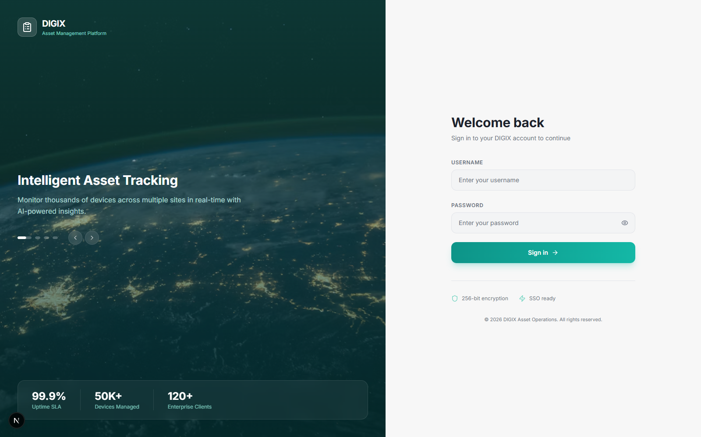
Figure 1 — The sign-in screen

2.1 Your first sign-in
- Open the address your administrator gave you.
- Enter your username and password from the credentials sheet you
were issued.
- Change your password immediately — see §2.3.
Your username is your own; it is usually your first name. Passwords on the issued sheet are first-login passwords only.
⚠ The credentials sheet is the only copy of those passwords. The system stores them scrambled and cannot show them again. If you lose yours, an administrator has to issue a new one.

2.2 If you cannot get in
What you see | What it means | What to do
"No account with that username" | The username is wrong | Check the sheet — it is case-sensitive
"Your account has been deactivated" | Somebody switched the account off | Ask your line manager
Wrong-password message | The password is wrong | Try again; after that ask for a reset

2.3 Changing your password
Settings (bottom of the sidebar) → change your password there. Do this on your first day.

3. Finding your way around
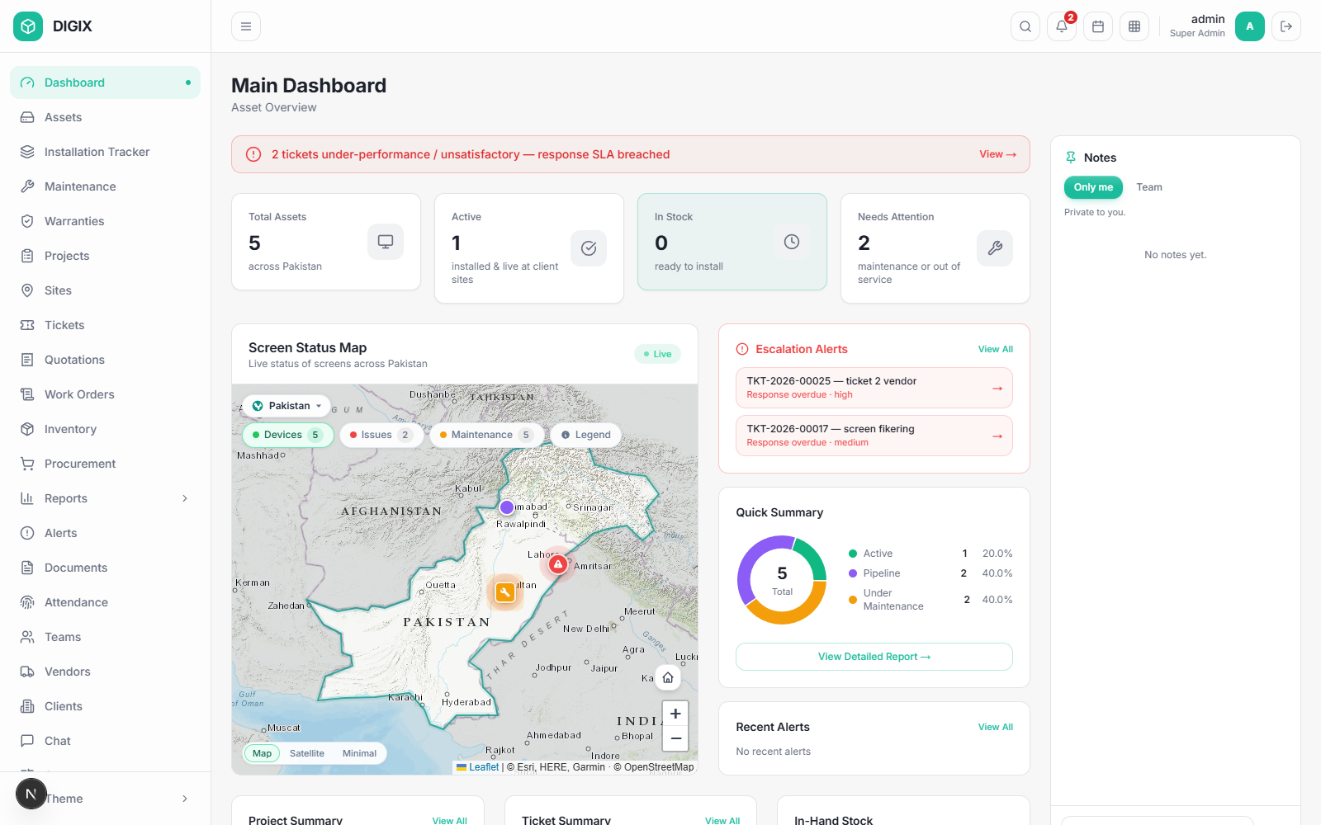
Figure 2 — The dashboard, signed in
Three parts to every screen.

3.1 The sidebar (left)
Your way into every module. You will not see all of it — the sidebar only shows what your role allows, so a technician's sidebar is much shorter than the Group Head's. That is normal and not a fault.
Clicking a section you are already inside takes you back to its list. If you are looking at one asset and click Assets, you return to the asset register.
At the bottom: Theme, which switches between light and dark.

3.2 The top bar
- Search — across the system
- Notifications (the bell, with a count) — click for the list, **Mark
all read, or View all alerts**
- Your name and role
- Logout — the right-hand icon

3.3 The page itself
Most list screens share a shape:
- A heading saying what the screen is for
- Tiles across the top — these are also filters; click one to narrow
the list to it
- A filter bar with dropdowns and a search box
- The list, ten rows to a page
- Buttons top right for the main actions
💡 The tiles are filters, not just counters. Clicking Under Maintenance on the asset screen lists exactly those assets. Clicking it again clears it.

4. What you are allowed to do
This is the part most worth understanding, because it explains why your screen differs from a colleague's.

4.1 Two separate ideas
 | What it is | Where it lives
Job title | Your place in the organisation — "Store Supervisor", "Karachi SMD Operator" | Shown on your record and in the organogram
System role | What the software lets you do | Drives every button you can see

They are deliberately separate. Two people can both be "Supervisor" in the system while holding quite different jobs.

4.2 Capabilities
Underneath the roles sit 30 capabilities — named permissions grouped into eleven areas: Money, Procurement, Inventory, Assets, Projects, Installation, Tickets, Maintenance, Commercial, People and System.
Your role grants a set of them. Any single one can then be granted or withdrawn for you personally without changing your role.
The one you will notice most is "See prices and costs". Without it, every figure in the system — unit costs, order totals, stock valuations — comes back blank. This is enforced by the server, not merely hidden on screen, so it holds however the data is reached.

4.3 Who may change permissions
You are | You may change permissions for
Super Admin | Anyone
Group Head | Anyone
A team lead (Operation Lead, CS Lead, a Supervisor) | Your own team, however far down it runs
Anyone else | Nobody

Two rules apply to everybody, including the Group Head:
⚠ Nobody edits their own permissions. Authority you can widen yourself is not authority. Ask someone above you.
⚠ Nobody grants what they do not have. A supervisor without "See prices" cannot give it to their technician.

4.4 The default roles
Role | Typically held by | Broadly
Super Admin | MIS Operator | Everything, including user administration
Group Head | Group Head | Everything
Operations Head | Operation Lead | Assets, projects, sites, procurement, maintenance; sees prices
Marketing Head | CS Lead | Client-facing work, quotations, tickets; sees prices
Supervisor | Production and Execution Supervisors | Their crew's work, inspections, maintenance; no prices
Warehouse Staff | Store Supervisor | Goods in, stock, issuing; no prices
Marketing | CS desk, Graphic Designer | Tickets and quotations; read-only elsewhere
Technician | Operators, workers, riders | Their own assigned work only
Finance | Finance | Money, reports; read-only on operations
Client Viewer | External client contact | Read-only, filtered to their own client
Vendor | Supplier portal | Their own tickets only

These are starting points. See §14.3 for changing them.

Part B — The screens

5. Dashboard
Figure 3 — Dashboard
Sidebar: Dashboard · Everyone sees this
Where you land. Read-only — nothing here changes data.

5.1 What is on it
Panel | Tells you
Four tiles | Total Assets · Active · In Stock · Needs Attention. Each is a link into a filtered asset list
Screen Status Map | Every asset with a site, pinned. Colour = status; a red pin has an open ticket, amber is in maintenance
Escalation Alerts | Tickets that have breached their response time
Quick Summary | The fleet split by status
Project / Ticket Summary | Counts by state, each a link
In-Hand Stock | Components you are watching, with quantity and value
Notes (right) | See §5.3

5.2 The map
Three grounds, chosen top-left: Map (roads and terrain), Satellite, Minimal. The chips along the top switch what is plotted — Devices, Issues, Maintenance — and Legend explains the markers. Zoom and the home button are bottom-right.
💡 If the legend covers something, close it with the × in its corner or press Escape.

5.3 Notes
A noticeboard down the right, in two parts:
- Only me — private. Nobody else ever sees these.
- Team — shared with everyone, and signed with your name.
Type @ to tag a colleague; the system offers names as you type. Tagging someone on a team note puts it in their notifications. Press Enter to post, Shift+Enter for a new line.

6. Assets
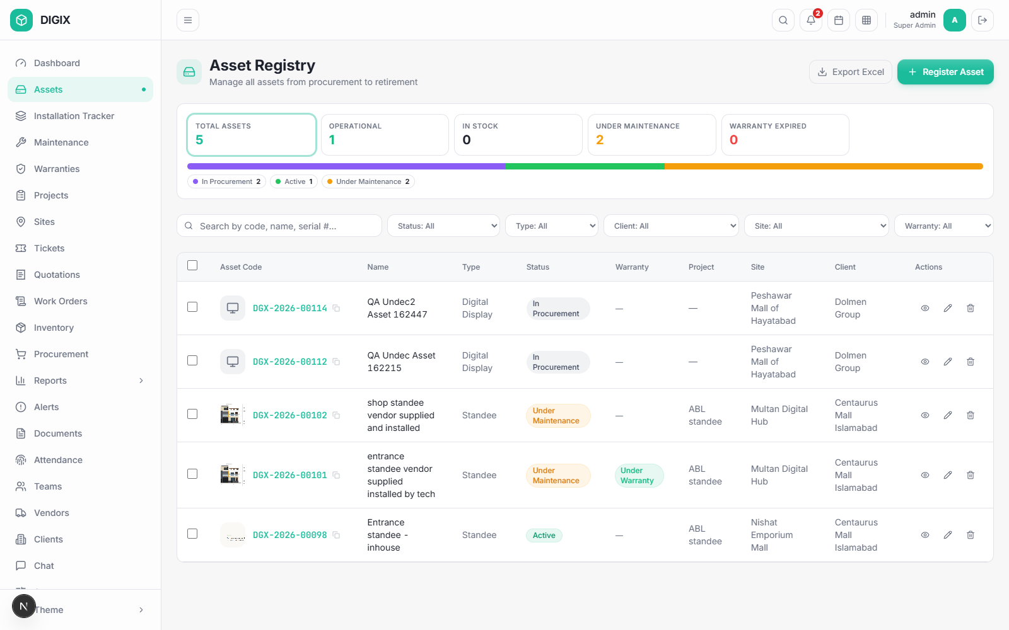
Figure 4 — Asset Registry
Sidebar: Assets · Super Admin, Group Head, Operations Head, Technician
The register of every display you own, from purchase to retirement.

6.1 The list
Tiles: Total Assets · Operational · In Stock · Under Maintenance · Warranty Expired — all clickable filters.
Filters: Status, Type, Client, Site, Warranty. Search: by code, name or serial number.
Columns: Asset Code · Name · Type · Status · Warranty · Project · Site · Client · Actions.
Buttons: Export Excel, Print labels (n) when rows are ticked (maximum 200 at a time), and Register Asset.

6.2 Registering an asset
Register Asset opens the form.
⚠ Three fields are required: Name, Asset Type and Manufacturing Route. The form will not save without them — this stops blank assets appearing in the register.
Manufacturing Route is the important choice:
Route | Meaning
In-house Production | You build it from components. It goes through production and consumes stock
Vendor / Turnkey | It arrives complete from a supplier. No production stage

6.3 The asset lifecycle
Open an asset and the Product Details tab opens on the lifecycle rail:
In Procurement → In Production → In Stock → Assigned → Installed → Active
⌐ Under maintenance
⌙ ⌙ ⌙ ⌙ ⌙ Client Property · Decommissioned
Each step shows Completed, In Progress or Not Started, with the date it was reached.
The lifecycle follows the work. You do not drive it by hand:
Stage moves to | When
In Production | Components are issued to the build
In Stock | The build is complete
Assigned | You assign it for installation
Installed | The technician completes the installation checklist
Active | The technician confirms on site with a photo
Under Maintenance | A maintenance job opens, or a ticket is raised

Only two are a human decision, under Next stage: Client Property (handing it over) and Decommissioned (retiring it).
Under maintenance hangs below Active rather than sitting on the line, because the asset comes back from it.

6.4 The other tabs
Tab | Holds
Warranties | Cover on this asset — vendor's to you, and yours to the client
Costs & Pricing | What it cost and what it is worth. Blank if you cannot see prices
Documents | Files filed against it
Maintenance History | Every visit
Lifecycle | The full audit trail — who moved it, when, and why

6.5 Components and serial numbers
The Components section lists what the asset is built from. Each row shows its Kind:
- Generic stock — interchangeable, counted (cable, brackets)
- Unique item — serialised and individually tracked
For a unique component the Serial # column shows exactly which physical unit went in, so you can trace any serial from goods-in to the asset it ended up inside.
⚠ Once a project is in execution its components and production route are fixed — the approved budget priced that parts list. The status still moves; the parts list does not.

7. Projects
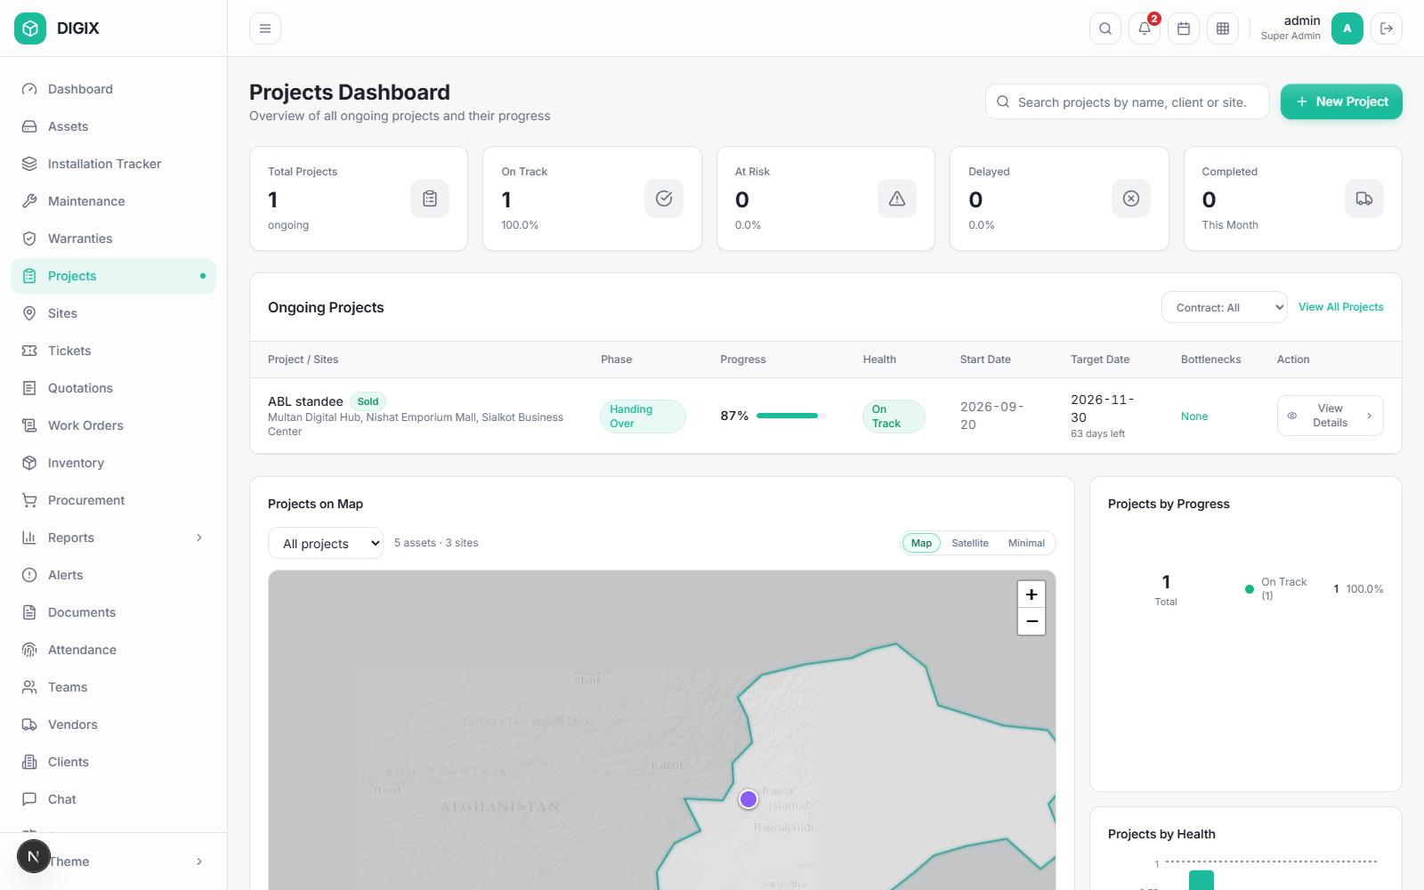
Figure 5 — Projects Dashboard
Sidebar: Projects · Super Admin, Group Head, Operations Head
A project is a client order: a number of assets, at one or more sites, to a date.

7.1 The dashboard
Tiles for Total / On Track / At Risk / Delayed / Completed, the ongoing project list, three summary cards, and Projects on Map.
On the map, pick a project from the dropdown and its assets light up while everything else greys back, so you can see where that job actually is.

7.2 Phases
A project moves through phases, and the phase follows the work — it is worked out from what is finished, not typed in.
On Hold and Order Lost are the exceptions: somebody chooses those, and they override the calculation. Clicking either again lifts it and the project returns to wherever the work actually stands.

7.3 Scope, BOQ and budget
- Scope — which assets, how many, at which site.
- Planning / BOQ — what each asset is built from, and what that costs.
- Budget — arrived at from the plan.
⚠ The budget is not typed when the project is created. It is what planning arrives at and approval freezes. Once approved, the parts list and route are locked.

8. Procurement
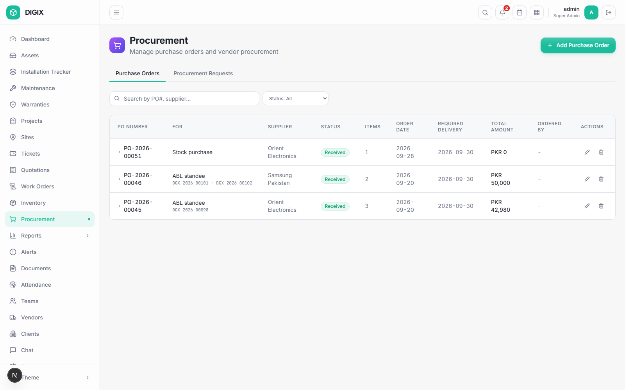
Figure 6 — Procurement
Sidebar: Procurement · Super Admin, Group Head, Operations Head, Finance, Warehouse, Supervisor
Two tabs: Purchase Orders and Procurement Requests.

8.1 Where orders come from
Source | Raised by | Appears as
A project needs a component it has not got | The project | A line under Procurement Requests
Stock fell below its minimum | Inventory | A stock replenishment request
Somebody buys something outright | You | A hand-raised order

8.2 Procurement Requests
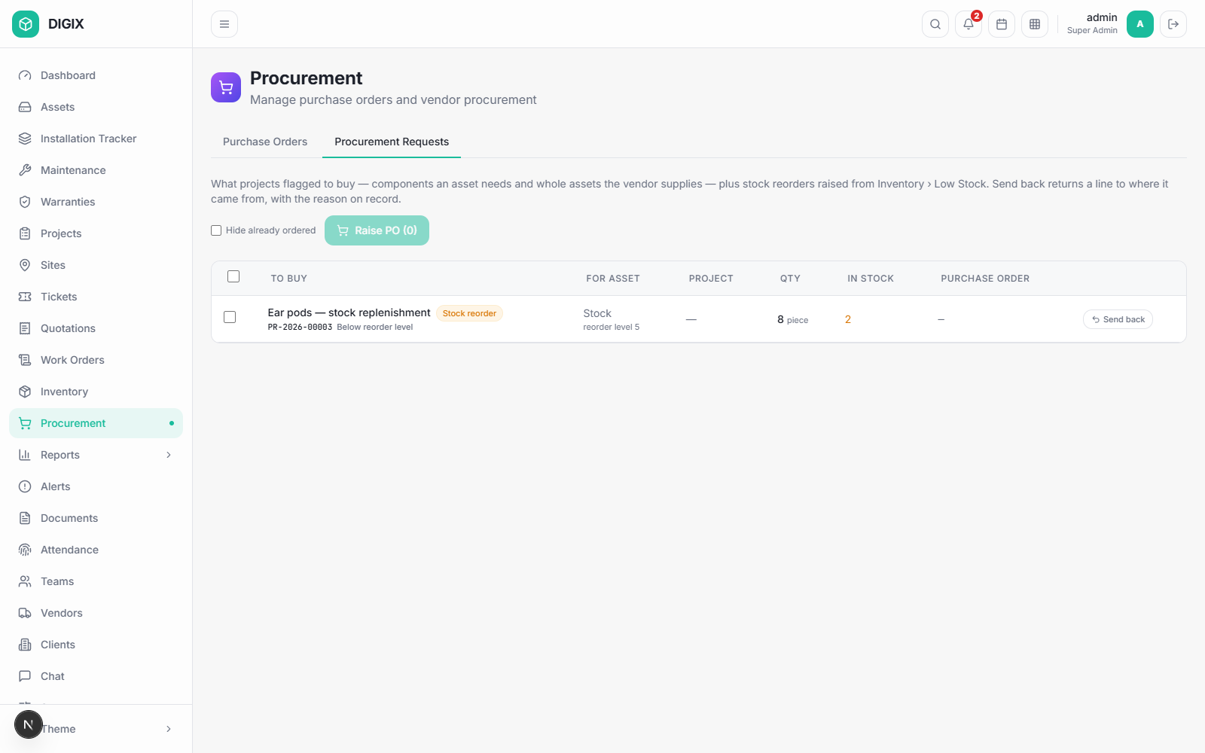
Figure 7 — Procurement Requests
Everything waiting to be bought. Tick the lines you want on one order and press Raise PO (n).
Send back returns a line to whoever raised it, with your reason — use this instead of cancelling, so the requester finds out why.

8.3 Raising a purchase order
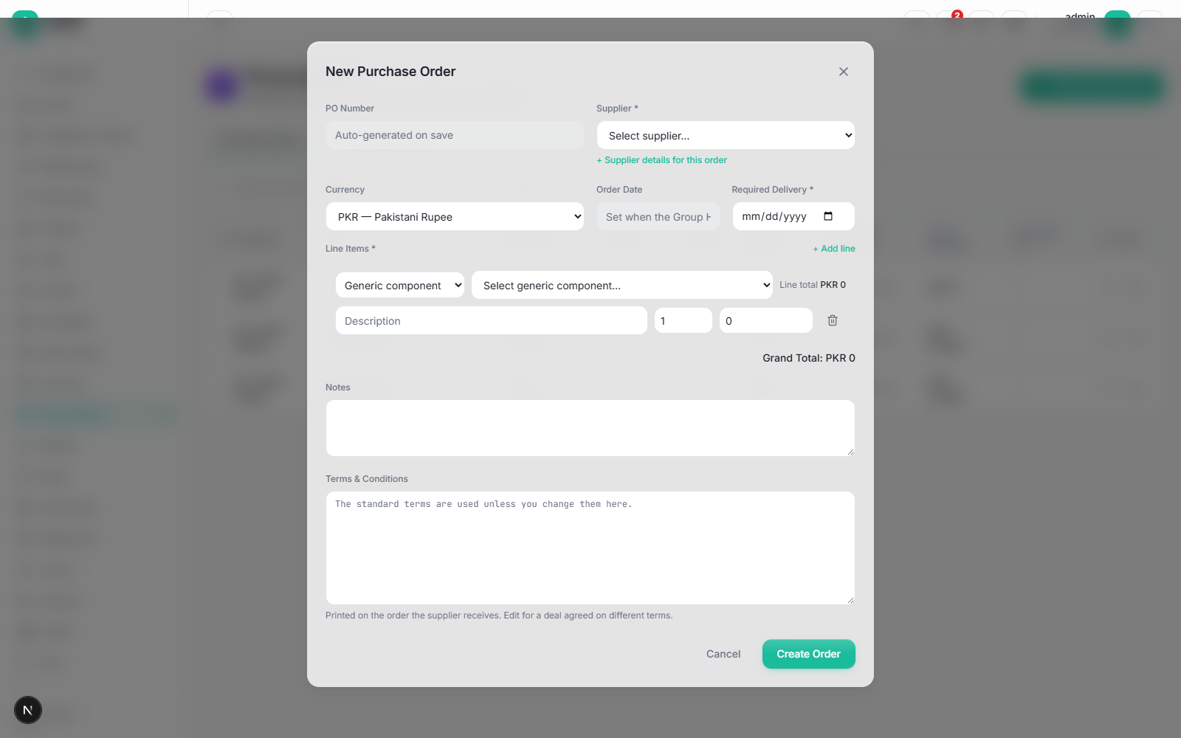
Figure 8 — Add Purchase Order
Add Purchase Order and Raise PO open the same form and collect the same things:
Field | Notes
PO Number | Generated on save
Supplier \* | Required. + Supplier details for this order adds a contact, quote reference or delivery address
Currency
Order Date | Read-only — stamped when the Group Head approves
Required Delivery \* | Required before the order leaves draft
Line Items \* | See below
Notes, Terms & Conditions | The standard terms apply unless you change them

Each line says what it buys:
- Generic component — from stock definitions
- Unique component — a serialised type
- Asset — a complete asset already registered, awaiting purchase
- Charge (free text) — freight, installation, anything not goods
+ Add line adds more. On a PO raised from requests, the requested lines are listed first with their prices editable, and anything extra goes underneath.

8.4 Approval and receiving
Draft → Pending Approval → Approved → (goods arrive) → Partially Received → Received
⚠ An order cannot leave Draft without a Required Delivery date. If you press Submit for Approval without one, the bar asks you for it there and then — fill it in and press Set date and continue.
⚠ Approval places the order. The Group Head's signature is what commits the company and stamps the order date, so there is no separate "mark as ordered" step. An approved order is received against directly.
Cancelling an order returns everything it covered to the queue, so it can be raised again.

9. Inventory
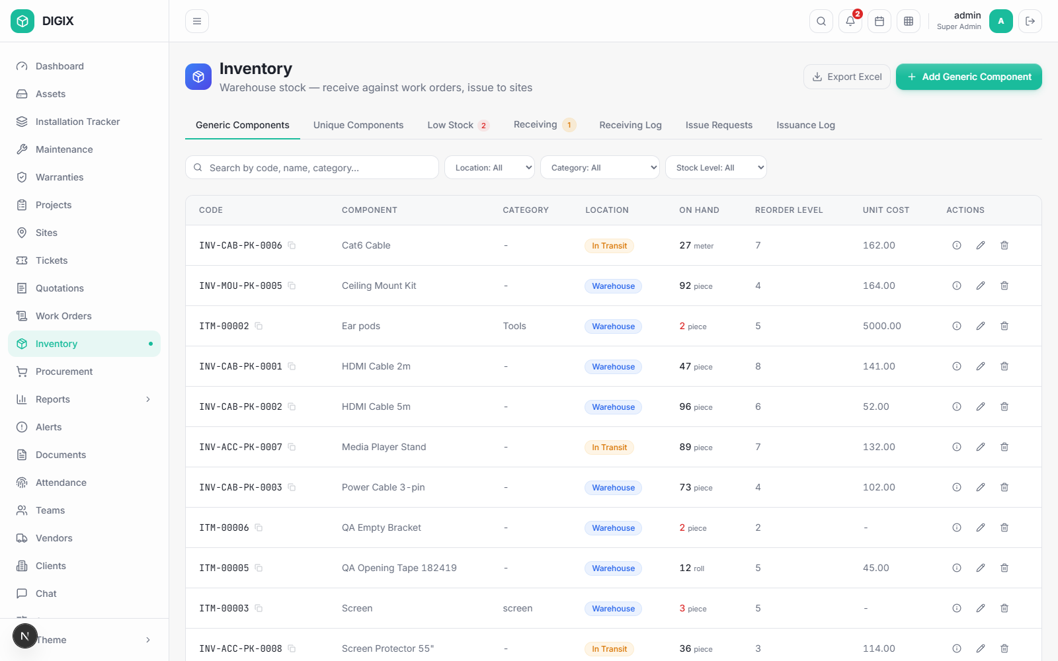
Figure 9 — Inventory
Sidebar: Inventory · Super Admin, Group Head, Operations Head, Warehouse

9.1 Two kinds of component
 | Generic | Unique
Example | Cat6 cable, brackets | A media player, an SMD module
Tracked by | Quantity | Individual serial number
On issue | A number comes off the count | A named unit leaves

Both are managed the same way, with the same vocabulary throughout.

9.2 Receiving
Goods arrive against a purchase order. Receiving records what actually turned up, which may be less than ordered. Each line is then inspected — passed into stock or rejected.
For unique components the serial numbers are captured at the door, which is what makes an individual unit traceable from then on.
⚠ Charges (freight and the like) are not goods and do not appear on the receiving form.

9.3 Issuing
⚠ Stock is issued against a request, not handed out. The technician or project asks, a supervisor approves, the store issues. This is what keeps the count honest.
The issue queue shows who asked, for which asset and project, and what it is for — a build requirement or a maintenance job.

9.4 Low stock
Components with a minimum level raise a replenishment request automatically when they fall below it. If Procurement sends one back, the reason appears here so nobody raises it again blind.

10. Installation Tracker
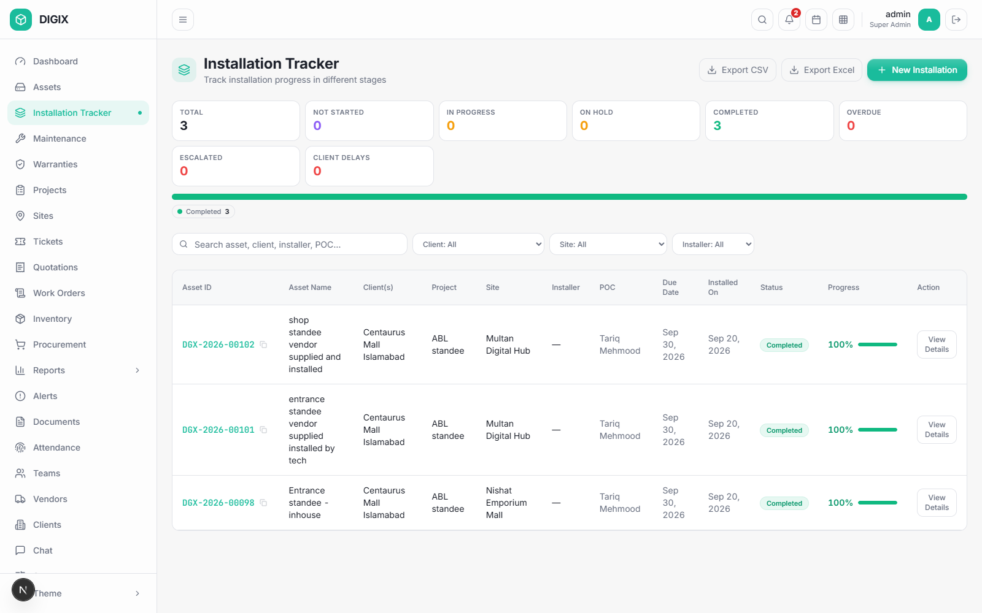
Figure 10 — Installation Tracker
Sidebar: Installation Tracker · Super Admin, Group Head, Operations Head, Technician

10.1 The checklist
Each installation has a pipeline of steps — Survey, Wiring, Metal Structure, Testing, and any you add. Pipelines can be 3 steps or 10: untick what does not apply and add your own when creating the installation.
Each step is Not Started, In Progress, On Hold, Completed or Skipped. Flag Delay records who caused it — Client, Internal, Vendor or Other.

10.2 Going live and handing over
After the checklist, two fixed steps:
- Mark Active — ⚠ requires a photo of the installed asset running.
The registry follows automatically.
- Handover — ⚠ requires the signed handover document. Download the
certificate, take it to site, upload the signed copy. A scan or a photograph both count.
Recording the handover assigns the asset to the client and completes the installation.
⚠ Once handed over or activated, the checklist is a record, not a draft. Steps cannot be added, edited, reordered or deleted afterwards.

11. Maintenance
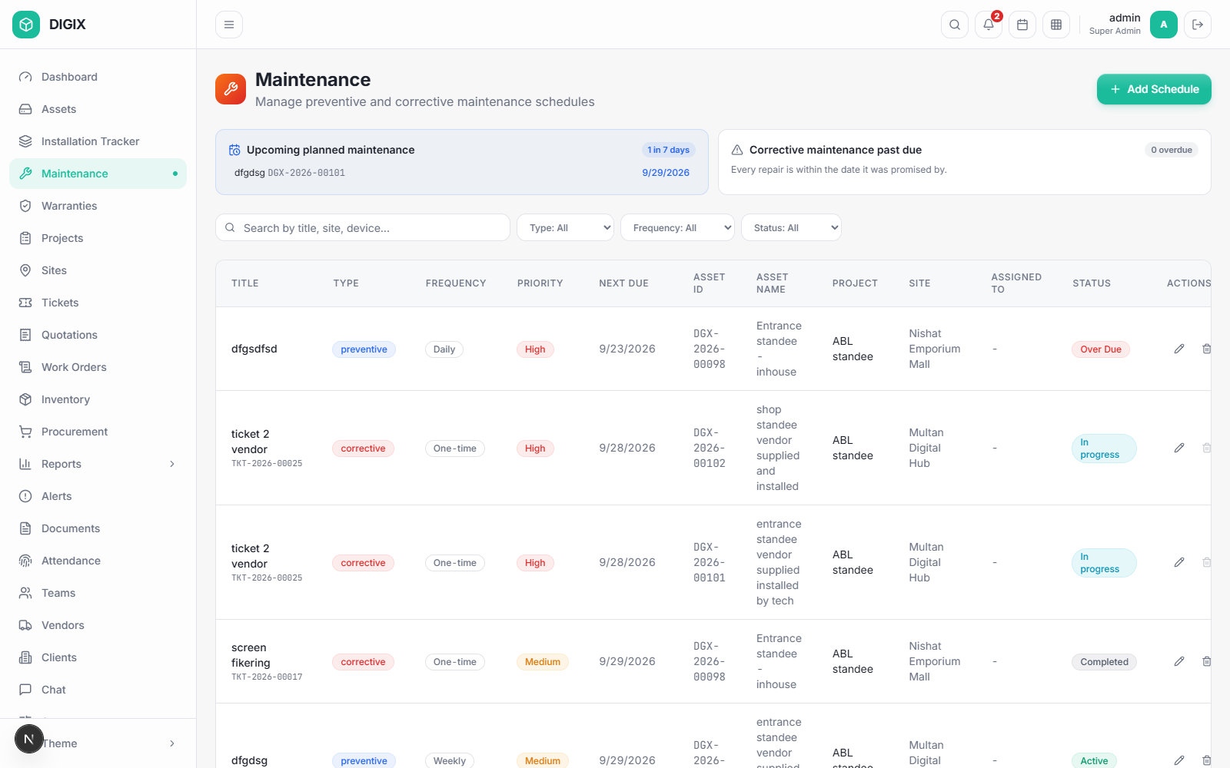
Figure 11 — Maintenance
Sidebar: Maintenance · Super Admin, Group Head, Operations Head, Technician

11.1 Two kinds
 | Preventive | Corrective
Why | Planned servicing | Something broke
Recurs | Yes — in rounds | No — one job
Starts from | A schedule you create | A ticket

11.2 Rounds
A recurring schedule is worked one round at a time. Each round has its own assigned technician, due date and actual date — because the same person will not do every visit for the next two years.
The card shows Next visit · round N with Start work and Complete visit. Below, Past visits lists every round already done.

11.3 Parts for a visit
"The technician asks, a supervisor releases, the store issues."
When you start a visit the system asks whether you need components. Raise a request per component, choosing Stock item or Unique item. A supervisor approves or rejects each line, then the store issues it.

11.4 Completing a visit
Complete visit asks for:
- Components issued — how many were used. Everything else goes back
to the store, and the return appears in receiving under its own reference. For unique items you tick the individual serials going back
- Work done, cost, photos
- Whether it is under warranty or billable
Completing the visit opens the next round. A one-time job closes out.

12. Tickets
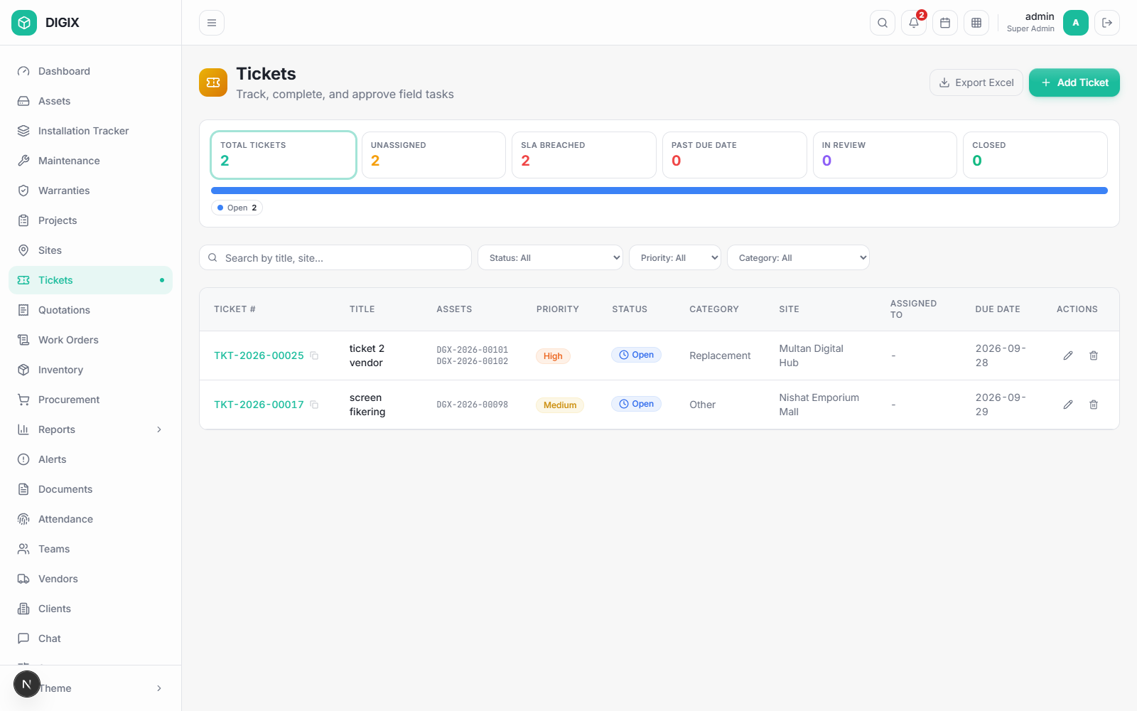
Figure 12 — Tickets
Sidebar: Tickets · most roles
A fault reported by anybody.
⚠ Raising a ticket creates maintenance work. A corrective maintenance job opens automatically, the asset goes Under Maintenance, and it returns to service when the job closes. You do not move the asset yourself.
⚠ One ticket covering several assets produces one job per asset, handled separately — two screens with the same fault are two repairs.

13. Warranties
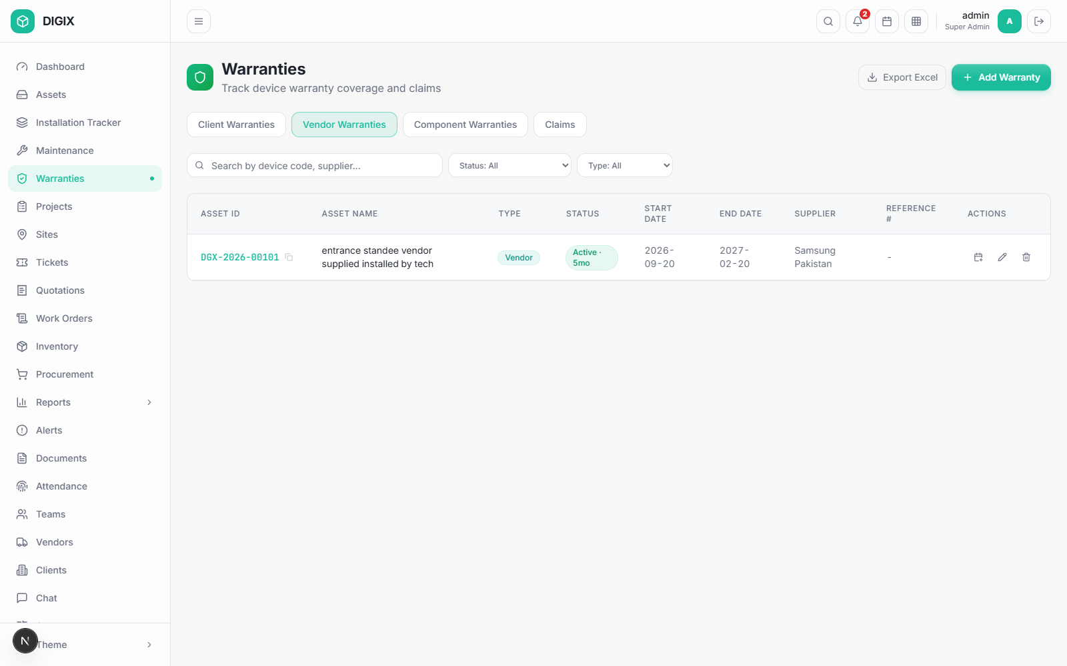
Figure 13 — Warranties
Sidebar: Warranties · Super Admin, Group Head, Operations Head
Two different things are called "warranty", and the system keeps them apart:
 | Covers | Given by
Vendor / Component | The asset or part coming in | Your supplier, to you
Client | The asset at the client's site | You, to your client

Tabs: Client Warranties · Vendor Warranties · Component Warranties · Claims. Client-facing roles see a reduced set.
💡 A client warranty with a term in months re-anchors itself to the installation date when the installation completes, so the cover starts when the asset actually went live.

14. Everything else

14.1 Sites, Clients, Vendors
Screen | Sidebar | For
Sites | Sites | Physical locations, with coordinates for the map
Clients | Clients | Who the work is for. Client IDs are generated
Vendors | Vendors | Suppliers, their terms and their warranties

14.2 Quotations, Work Orders, Finance
Screen | For
Quotations | Enquiry → quotation → negotiation → order confirmation
Work Orders | Internal jobs, approved against a value
Finance | Invoices and payments

14.3 Team Management
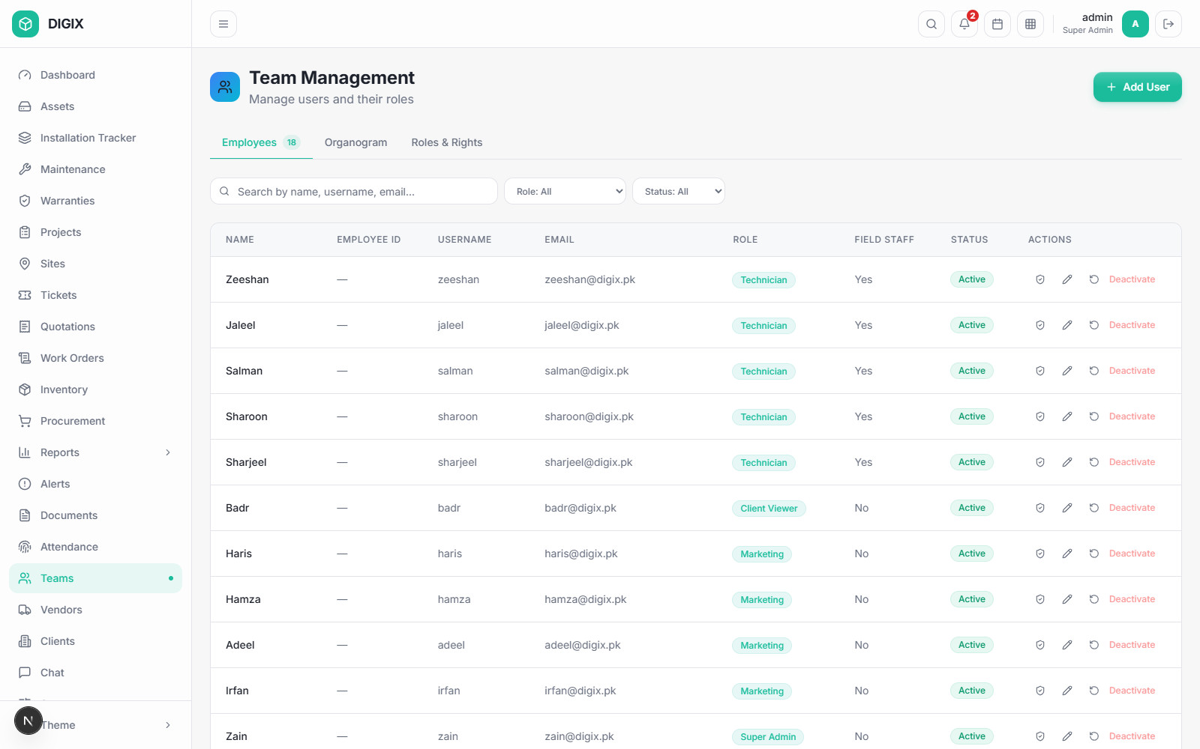
Figure 14 — Team Management
Sidebar: Teams · anyone who may see the team
Three tabs.
Employees — the roster. Each row has a shield button showing what that person may do. Anyone may look; only the people in §4.3 may change it.
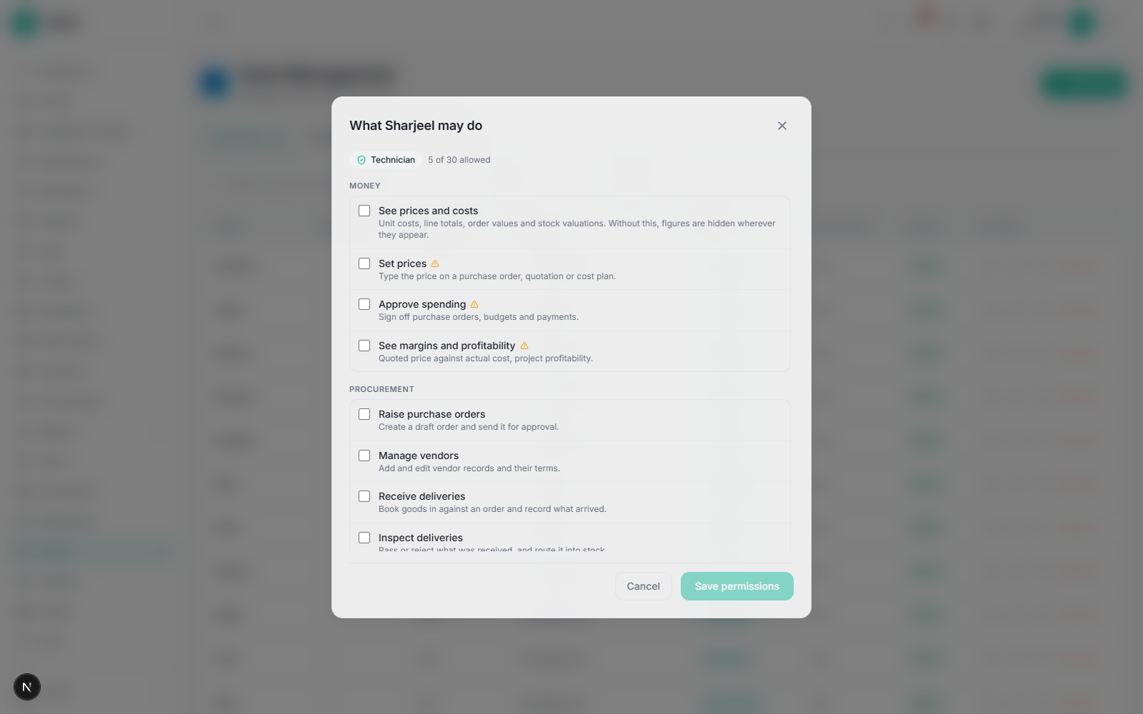
Figure 15 — Permissions for one person
A row tinted amber differs from the role — it reads granted · role says no or withdrawn, with who did it and why. Back to what {role} allows resets the person.
Organogram — who reports to whom, drawn from each person's Reports To.
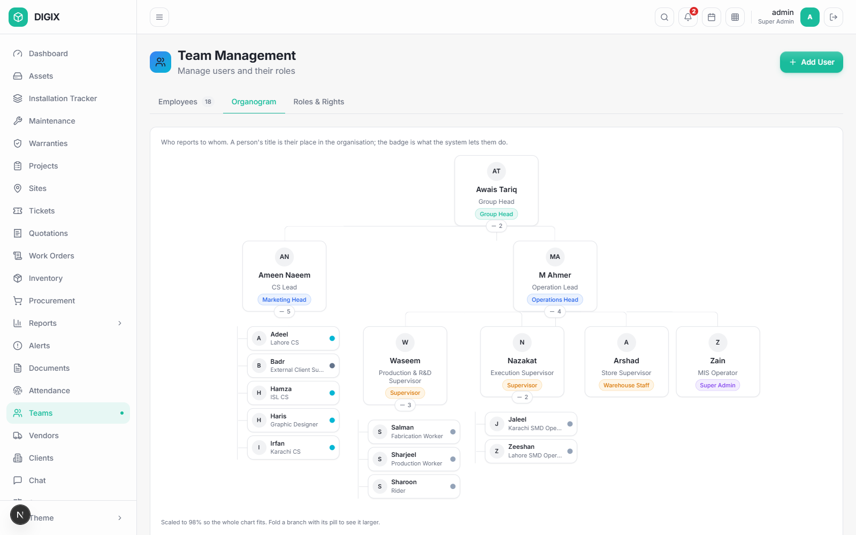
Figure 16 — Organogram
Roles & Rights — the whole grid: every role across the top, every capability down the side.
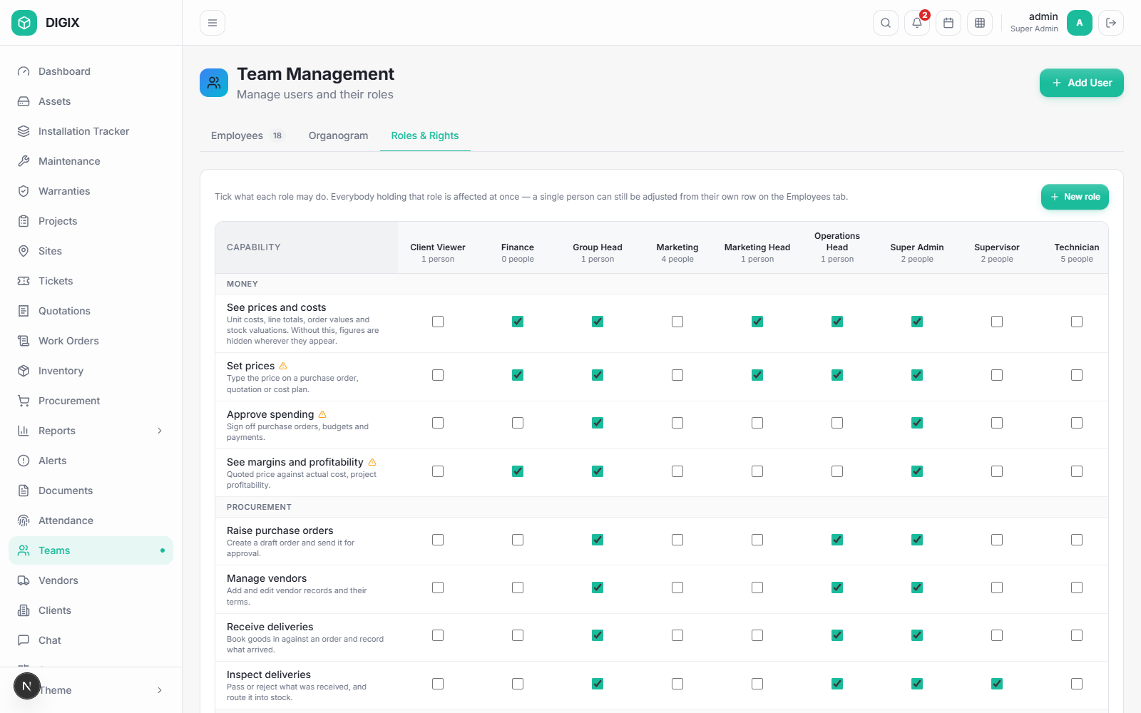
Figure 17 — Roles and Rights
Tick a box and everyone holding that role gains it — each column says how many people that is, and saves on its own. New role writes one from scratch for a job you actually have.
⚠ A built-in role cannot be deleted, because accounts are stored against it. A custom role can be, once nobody holds it.

14.4 Setup, Alerts, Documents, Attendance, Chat, Settings
Screen | For
Setup | Reference data — asset types, models, material types, routes
Alerts | System alerts needing attention
Documents | The document library
Attendance | Registers and corrections
Chat | Internal messaging; the sidebar badge counts unread
Settings | Your profile, your password, your preferences

Part C — Doing the work

15. The six workflows end to end

15.1 Buying something
# | Who | Where | Does
1 | Project / Inventory | — | A requirement appears under Procurement Requests
2 | Procurement | Procurement › Procurement Requests | Ticks the lines → Raise PO
3 | Procurement | The PO form | Supplier, Required Delivery, prices, extra lines → Raise draft PO
4 | Procurement | Purchase Orders | Submit for Approval
5 | Group Head | Purchase Orders | Approve — this places the order and stamps its date
6 | Store | Procurement | Receive items — records what arrived, with serials
7 | Store / Supervisor | Inventory › Receiving | Inspect — pass into stock or reject

15.2 Building an asset in-house
# | Who | Where | Does
1 | Operations | Assets | Register Asset — Name, Type, Route = In-house
2 | Operations | Asset › Components | Defines what it is built from
3 | Production | — | Requests components; the store issues them → In Production
4 | Production | Production steps | Works the route
5 | — | — | Build complete → In Stock

15.3 Installing it
# | Who | Where | Does
1 | Operations | Asset › Next stage | Assigns it → Assigned
2 | Operations | Installation Tracker | New Installation — site, installer, steps
3 | Technician | Installation Tracker | Works the checklist
4 | — | — | Checklist complete → Installed
5 | Technician | Installation Tracker | Mark Active (photo required) → Active
6 | Supervisor | Installation Tracker | Handover (signed document required)

15.4 Keeping it running — planned
# | Who | Where | Does
1 | Operations | Maintenance | Add Schedule — asset, frequency, start date
2 | Supervisor | The job | Assigns round N to a technician
3 | Technician | The job | Start work; asks for components if needed
4 | Supervisor | The job | Approves each part line
5 | Store | Inventory | Issues them
6 | Technician | The job | Complete visit — used vs returned, work done, cost
7 | Store | Inventory › Receiving | Checks the returned parts back in
8 | — | — | The next round opens automatically

15.5 Keeping it running — a fault
# | Who | Where | Does
1 | Anyone | Tickets | Raises a ticket against the asset
2 | System | — | Opens a corrective job per asset; asset → Under Maintenance
3 | Technician | Maintenance | Works it, as §15.4 steps 3–6
4 | — | — | Job closes; the asset returns to service

15.6 Running a project
# | Who | Where | Does
1 | Operations | Projects | Creates it — client, sites, target date
2 | Operations | Project › Scope | Which assets, how many, where
3 | Operations | Project › Planning | BOQ — what each is built from
4 | Group Head | Project › Budget | Approves. ⚠ Parts list and route lock
5 | — | — | Execution: build, install, hand over
6 | — | — | The phase follows the work throughout

Part D — Reference

16. Reference

16.1 Asset statuses
Status | Meaning
In Procurement | On order or awaiting purchase
In Production | Being built
In Stock | Built, ready to install
Assigned | Allocated to an installation
Installed | Physically up, not yet confirmed live
Active | Live at the client's site
Under Maintenance | Temporarily out of service
Client Property | Handed over to the client
Decommissioned | Retired
In Transit · RMA · Lost/Stolen | Off the normal line

16.2 Rules the system will enforce
Rule | Where
Name, Type and Manufacturing Route are required | Register Asset
An order cannot leave Draft without a Required Delivery date | Procurement
Only the Group Head or Super Admin approves an order | Procurement
Stock is issued only against a request | Inventory
A handed-over installation's steps cannot be changed | Installation
Marking active requires a photo | Installation
Recording handover requires the signed document | Installation
An approved project's parts list and route are locked | Projects
Nobody edits their own permissions | Teams
Nobody grants a capability they do not hold | Teams
A built-in role cannot be deleted | Teams
A custom role cannot be deleted while anyone holds it | Teams

16.3 Screenshots in this manual
All images live in docs/manual-images/, named for the section they illustrate. When a screen changes, re-take its screenshot at 1600 × 1000 in the light theme, signed in as an administrator so the full sidebar shows, and keep the filename. Then add a revision-history row.

16.4 Getting help
- Check the rule in §16.2 — most surprises are a deliberate rule.
- Check §4 — a missing button is usually a permission.
- Ask your line manager; the organogram (§14.3) shows who that is.
- Beyond that, raise it with the MIS Operator.
End of document — DIGIX-UM-001 v1.0, 28 September 2026.

