Learner Demographics and Course Enrollment Behavior Analysis on EduPro
Anas Ali
Data Analyst Intern | Unified Mentor Private Limited
GitHub: https://github.com/anasali0010/EduPro-Analytics-Dashboard | Streamlit: https://edupro-analytics-dashboard-i.streamlit.app/
Abstract
This paper presents a comprehensive learner demographics and course enrollment behavior analysis for the EduPro e-learning platform using interactive business intelligence and data analytics techniques. The dashboard was developed using Python, Pandas, Matplotlib, and Streamlit to examine learner composition, enrollment patterns, and course preference behavior across the platform. The dataset comprised 10,000 enrollment records from 3,000 unique learners, with an average of 3.33 courses enrolled per learner. Analysis revealed that female learners comprised 50.78% of enrollments while male learners represented 49.22%, demonstrating near-gender-parity. The largest learner cohort was aged 26–35 (4,799 enrollments), followed by 18–25 (3,255 enrollments), indicating strong adoption among young professionals and early-career learners. Data Science emerged as the most popular course category (916 enrollments), followed by Finance and Web Development. Beginner-level courses dominated with 3,573 enrollments, significantly exceeding Advanced (3,475) and Intermediate (2,952) levels. The project supports data-driven decisions in curriculum design, targeted marketing, and learner engagement strategy.
1. Introduction
Online learning platforms generate large volumes of enrollment data every day, yet raw transactional records alone provide limited insight into who the learners are and how they choose courses. Understanding learner demographics — such as age and gender composition — alongside course-selection behavior, including preferred categories and difficulty levels, is essential for platforms seeking to improve course design, targeting, and learner retention. EduPro, despite hosting thousands of enrolled learners across diverse course categories, lacked a centralized system to monitor learner demographics and enrollment behavior in a unified, interactive manner. This project was developed to transform raw enrollment data into actionable business intelligence that supports strategic decision-making in curriculum planning and learner engagement.
2. Objectives
The main objectives of this project were:
- Analyze the gender distribution of learners on the platform
- Examine age group segmentation among enrolled learners
- Identify the most and least popular course categories
- Evaluate learner preference across course difficulty levels
- Measure overall platform engagement using enrollment metrics
- Build an interactive Streamlit dashboard for ongoing monitoring
3. Dataset Description
The dataset contained learner profile and course enrollment records collected from the EduPro platform, comprising 10,000 individual enrollment transactions generated by 3,000 unique learners, corresponding to an average of 3.33 course enrollments per learner.
Table 1. Dataset Fields
Field | Description
Enrollment ID | Unique identifier for each enrollment record
Learner ID | Unique identifier for each learner
Age | Age of the learner
Gender | Gender of the learner
Country / Region | Learner's geographic location
Course Name | Title of the enrolled course
Course Category | Subject domain of the course (e.g., Data Science, Business)
Course Level | Difficulty level (Beginner, Intermediate, Advanced)
Enrollment Date | Date on which the learner enrolled
Completion Status | Whether the course was completed, in progress, or dropped
Table 2. Key Platform Metrics
Metric | Value
Total Enrollment Records | 10,000
Unique Learners | 3,000
Average Courses per Learner | 3.33
Course Categories Covered | 10+
Course Levels | 3 (Beginner, Intermediate, Advanced)

The dataset spans multiple course categories including Data Science, Finance, Web Development, Business, Project Management, Artificial Intelligence, Design, Cybersecurity, Machine Learning, and Digital Marketing, along with three course difficulty levels: Beginner, Intermediate, and Advanced.
4. Methodology
The project followed a structured analytical workflow to convert raw enrollment data into meaningful insights. Initial preprocessing involved data cleaning, handling missing demographic values, removing duplicate enrollment records, and standardizing course category and level labels to improve dataset consistency and reliability.
After preprocessing, descriptive and behavioral metrics were computed to evaluate learner demographics and enrollment patterns. Analytical techniques such as demographic segmentation, frequency distribution analysis, category popularity ranking, and cross-tabulation were applied to identify enrollment trends and behavioral patterns across learner segments.
An interactive business intelligence dashboard was then developed using Python, Pandas, Matplotlib, and Streamlit. The dashboard enabled dynamic filtering by demographic attributes and course category, real-time visualization, and comparative behavior analysis to support data-driven decisions in course design and learner engagement.
5. Exploratory Data Analysis and Insights
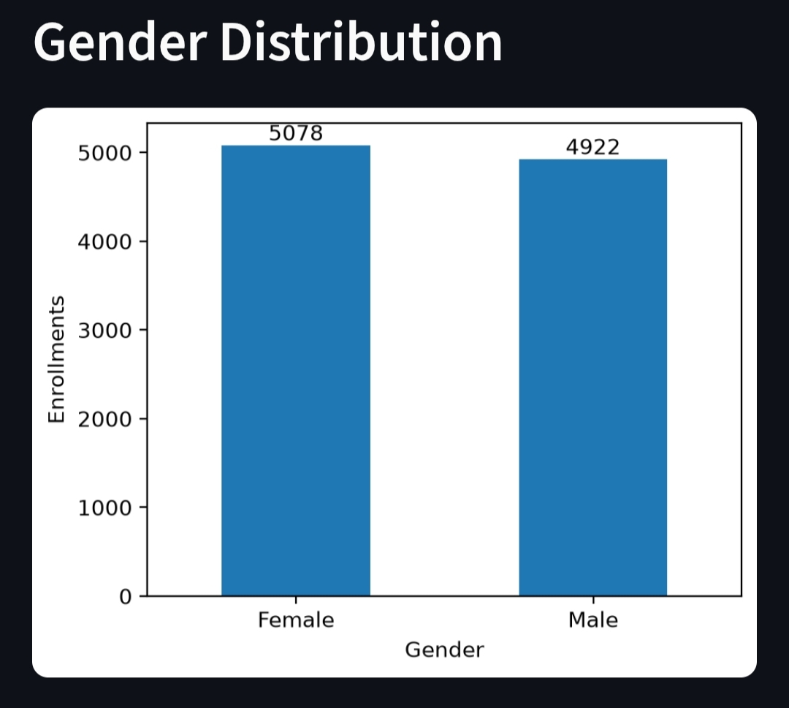
Figure 1. Gender Distribution of Learners
The gender distribution analysis revealed a near-balanced learner base, with female learners comprising 50.78% (5,078 enrollments) and male learners representing 49.22% (4,922 enrollments). This near-parity composition suggests that EduPro's course catalog appeals broadly across gender groups, representing an inclusive learning environment. However, targeted content strategies and marketing efforts could further improve engagement within specific gender-based learning preference segments.
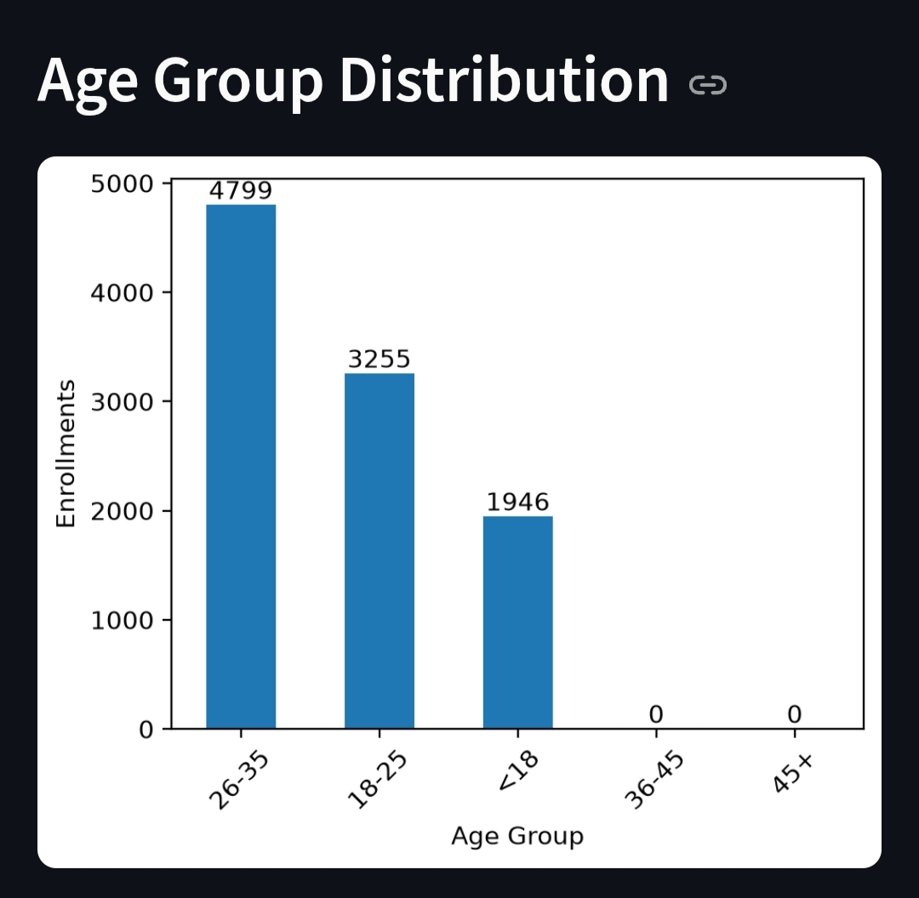
Figure 2. Age Group Distribution
The age group distribution highlighted that learners aged 26–35 represented the dominant cohort with 4,799 enrollments (47.99%), followed closely by the 18–25 age group with 3,255 enrollments (32.55%), and the <18 segment with 1,946 enrollments (19.46%). These figures indicate that the platform is predominantly used by young adults and early-career professionals, representing strong adoption among cohorts transitioning from higher education to professional careers. The concentration in these age groups points to significant growth opportunities in youth-oriented programs for learners under 18 and professional up-skilling courses for older demographics.
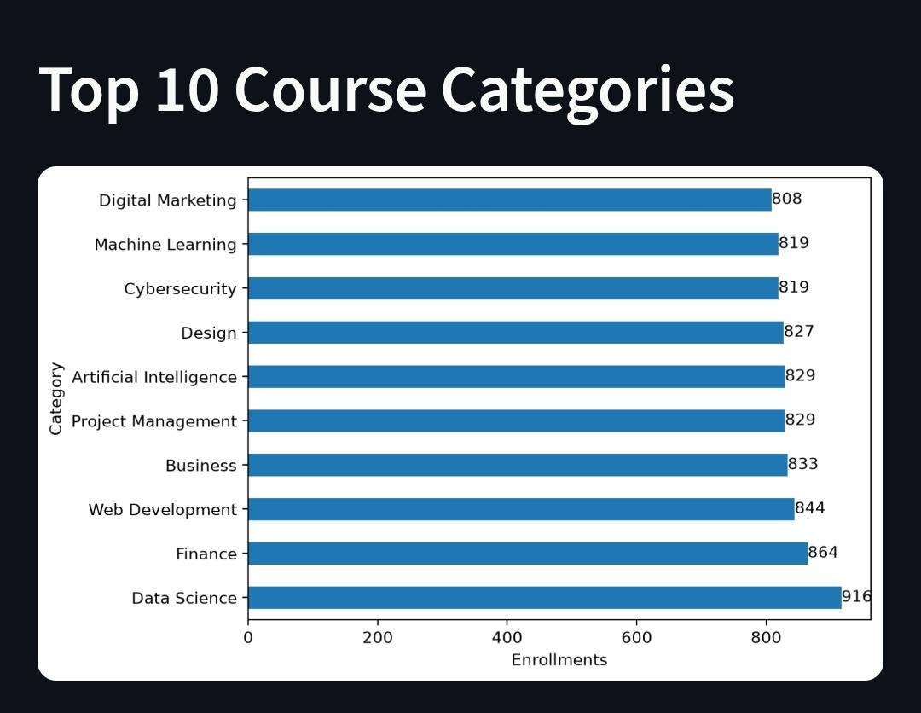
Figure 3. Top 10 Course Categories Popularity
The course category popularity analysis revealed that Data Science leads with 916 enrollments, followed by Finance (864), Web Development (844), Business (833), and Project Management (829). Artificial Intelligence and Design each captured 829 and 827 enrollments respectively, while Cybersecurity and Machine Learning tied at 819 enrollments each, with Digital Marketing closing the top 10 at 808 enrollments. This distribution indicates strong learner demand for technical and data-driven skills, with a secondary emphasis on business and creative domains. The concentration in STEM-related categories suggests an opportunity to expand and diversify offerings within high-demand technical categories while simultaneously strengthening marketing for underrepresented skill domains.
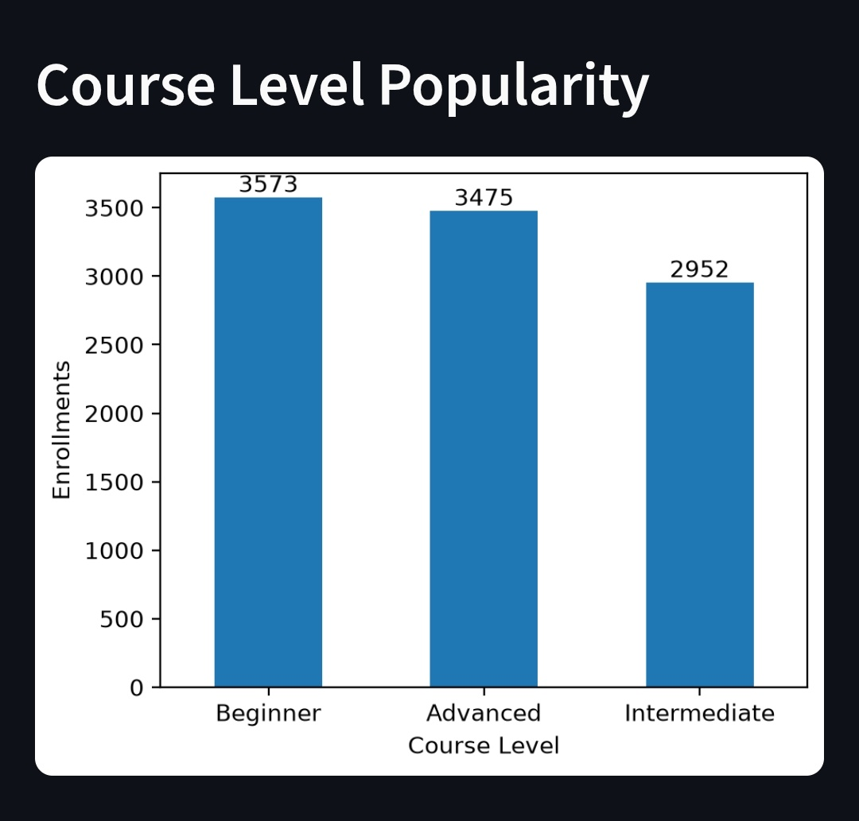
Figure 4. Course Level Popularity
The course level analysis showed that Beginner-level courses accounted for the majority of enrollments with 3,573 (35.73%), followed by Advanced-level courses with 3,475 enrollments (34.75%), while Intermediate-level courses recorded 2,952 enrollments (29.52%). This relatively balanced distribution across difficulty levels — with a slight preference for Beginner content — suggests that most learners on EduPro are entering new subject areas, reinforcing the importance of strong foundational content and well-structured learning pathways that guide learners from beginner to advanced competency levels. The substantial enrollment in Advanced courses indicates learner commitment to deep skill development.
6. Behavioral and Cross-Segment Analysis
Cross-tabulating demographic attributes with course preferences showed that enrollment behavior varies meaningfully across learner segments. The 26–35 age cohort, representing nearly half of all enrollments, demonstrated the strongest propensity toward technical categories such as Data Science, Web Development, and Machine Learning, suggesting career-advancement motivation within this group. The 18–25 cohort showed comparable technical category preferences, indicating early career preparation and skill-building orientation.
Gender-wise, category preferences were broadly similar, with female learners showing marginal variation in category distribution compared to male learners, suggesting that course content and technical relevance — rather than gender — is the primary driver of category choice. The average of 3.33 courses per learner indicates a healthy degree of repeat engagement, with most learners returning to enroll in more than one course.
7. Recommendations
Based on the analytical findings, the following recommendations were proposed:
- Strengthen intermediate-level content and pathways to bridge the gap between beginner and advanced offerings
- Develop age-specific course recommendations leveraging the strong 26–35 and 18–25 cohort preferences
- Expand finance and business course portfolios given strong enrollment performance in these categories
- Design targeted marketing campaigns emphasizing technical skill development for young professionals
- Create structured learning pathways connecting beginner to advanced courses within high-demand categories
- Continuously monitor demographic and enrollment trends through the Streamlit dashboard for real-time insights
8. Future Scope
Future enhancements may include integrating predictive analytics and machine learning models for learner churn prediction, personalized course recommendations, completion-rate forecasting, and learner outcome analysis.
Potential improvements include:
- Learner churn and drop-off prediction models
- AI-powered personalized course recommendation engine
- Enrollment demand forecasting and capacity planning
- Real-time learner engagement and progress monitoring
- Automated cohort and behavioral segment detection
- Course completion-rate analytics and learning-outcome effectiveness studies
9. Conclusion
This project successfully developed an interactive learner demographics and course enrollment behavior dashboard for the EduPro platform using modern data analytics techniques. The analysis identified key demographic patterns: gender parity at approximately 50:50, pronounced adoption among 26–35 year-olds (47.99% of enrollments), and strong concentration in technical course categories led by Data Science. The platform demonstrated relatively balanced distribution across course difficulty levels, with beginner-level courses showing a slight edge.
The dashboard transformed raw enrollment data into actionable insights, supporting improved curriculum planning, targeted learner engagement, and data-driven decision-making. The interactive Streamlit application enables real-time visualization and dynamic filtering, empowering stakeholders to monitor platform metrics and learner behavior patterns continuously. The project demonstrates the effectiveness of interactive analytics systems in improving demographic visibility and enrollment intelligence within online education platforms, providing a scalable foundation for data-driven platform optimization.

