**Naqel (Restful) API Integration Documentation**

**Last Update: 19-2-2015**

**The link for the RestFul API:**

<http://212.93.160.150/NaqelAPI/WCFShippingService.svc>

**This API contain 4 Methods:**

* TraceByWaybillNo
* TraceByRefNo
* GetShipmentDetailsByWaybillNo
* GetShipmentDetailsByRefNo

**1 – TraceByWaybillNo**

This method provide for you the tracking details for your shipment by using Naqel Waybill No and you should pass three parameters for this method.

Client ID, Password and Naqel Waybill No

And the calling for this method will be:

[http://212.93.160.150/NaqelAPI/WCFShippingService.svc/TraceByWaybillNo/{ClientID}/{Password}/{WaybillNo}](http://212.93.160.150/NaqelAPI/WCFShippingService.svc/TraceByWaybillNo/%7bClientID%7d/%7bPassword%7d/%7bWaybillNo%7d)

Example:

<http://212.93.160.150/NaqelAPI/WCFShippingService.svc/TraceByWaybillNo/1024600/123456/77878499>

The result will be a JSON format as shown in the details.

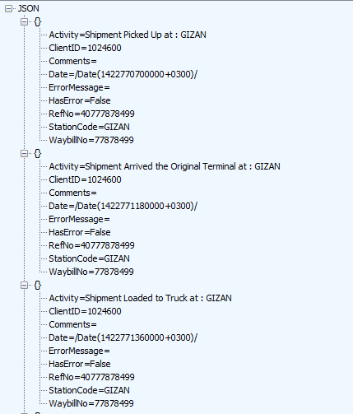

Please take a look to the **Appendix A** to get more details about Activity

**2 – TraceByRefNo**

This method provide for you the tracking details for your shipment by using your company Ref No which you provide it with the waybill and you should pass three parameters for this method.

Client ID, Password and The Ref No which you provide to us.

And the calling for this method will be:

[http://212.93.160.150/NaqelAPI/WCFShippingService.svc/TraceByRefNo/{ClientID}/{Password}/{RefNo}](http://212.93.160.150/NaqelAPI/WCFShippingService.svc/TraceByRefNo/%7bClientID%7d/%7bPassword%7d/%7bRefNo%7d)

Example:

<http://212.93.160.150/NaqelAPI/WCFShippingService.svc/TraceByRefNo/1024600/123456/40777878499>

The result will be a JSON format as shown in the details.



The result which you see it here is same as the result in previous method.

Please take a look to the **Appendix A** to get more details about Activity

**3 – GetShipmentDetailsByWaybillNo**

This method provide for you more details about your shipment and you should pass three parameters for this method.

Client ID, Password and Naqel Waybill No.

And the calling for this method will be:

[http://212.93.160.150/NaqelAPI/WCFShippingService.svc/GetShipmentDetailsByWaybillNo/{ClientID}/{Password}/{WaybillNo}](http://212.93.160.150/NaqelAPI/WCFShippingService.svc/GetShipmentDetailsByWaybillNo/%7bClientID%7d/%7bPassword%7d/%7bWaybillNo%7d)

Example:

<http://212.93.160.150/NaqelAPI/WCFShippingService.svc/GetShipmentDetailsByWaybillNo/1024600/123456/77878499>

The result will be a JSON format as shown in the details.

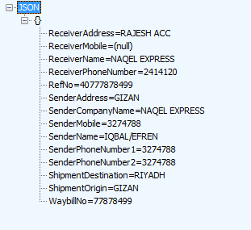

**4 – GetShipmentDetailsByRefNo**

This method provide for you more details about your shipment and you should pass three parameters for this method.

Client ID, Password and Naqel Waybill No.

And the calling for this method will be:

[http://212.93.160.150/NaqelAPI/WCFShippingService.svc/GetShipmentDetailsByRefNo/{ClientID}/{Password}/{RefNo}](http://212.93.160.150/NaqelAPI/WCFShippingService.svc/GetShipmentDetailsByRefNo/%7bClientID%7d/%7bPassword%7d/%7bRefNo%7d)

Example:

<http://212.93.160.150/NaqelAPI/WCFShippingService.svc/GetShipmentDetailsByRefNo/1024600/123456/40777878499>

The result will be a JSON format as shown in the details.



**Appendix A: List of Activities**

|  |  |
| --- | --- |
| 1 | Shipment Picked Up |
| 2 | Shipment Arrived the Original Terminal |
| 3 | Shipment Arrived the Destination Terminal |
| 4 | Shipment Loaded to Truck |
| 5 | Shipment Out For Delivery |
| 6 | Shipment Not Delivered |
| 7 | Shipment Delivered in Good Condition |
| 8 | Night Stock Scanning. |
| 9 | Return to Origin |
| 10 | Trace has been opened |