Git & GitHub Assignment Documentation
Prepared in Standard Assignment Documentation Format.

Task 1: Install Git

Outcome
Install Git completed successfully.

Objective
To learn install git.

Prerequisites
Git installed, GitHub account, Internet connection.

Step-by-Step Implementation
Step 1: Perform the task as shown in screenshots.
Screenshot Evidence:
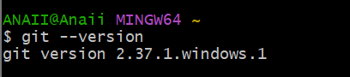

Validation Steps
Verify task completed successfully.

Explanation
Briefly explain what was done, why it is important, and its use.

Real-Time Use Case
Used in software development and DevOps workflows.

Common Errors and Troubleshooting
Permission errors, authentication issues, incorrect commands; resolve by checking configuration.

Task 2: Create GitHub Repository

Outcome
Create GitHub Repository completed successfully.

Objective
To learn create github repository.

Prerequisites
Git installed, GitHub account, Internet connection.

Step-by-Step Implementation
Step 1: Perform the task as shown in screenshots.
Screenshot Evidence:
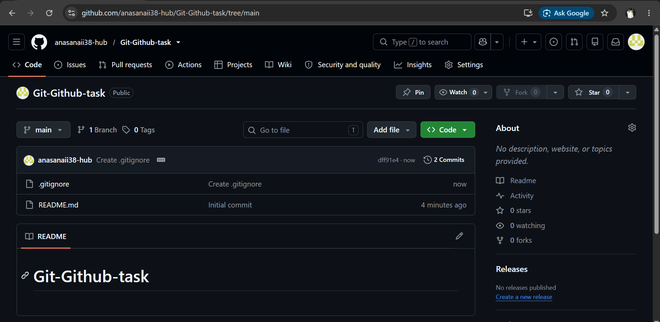

Validation Steps
Verify task completed successfully.

Explanation
Briefly explain what was done, why it is important, and its use.

Real-Time Use Case
Used in software development and DevOps workflows.

Common Errors and Troubleshooting
Permission errors, authentication issues, incorrect commands; resolve by checking configuration.

Task 3: Clone Repository

Outcome
Clone Repository completed successfully.

Objective
To learn clone repository.

Prerequisites
Git installed, GitHub account, Internet connection.

Step-by-Step Implementation
Step 1: Perform the task as shown in screenshots.
Screenshot Evidence:
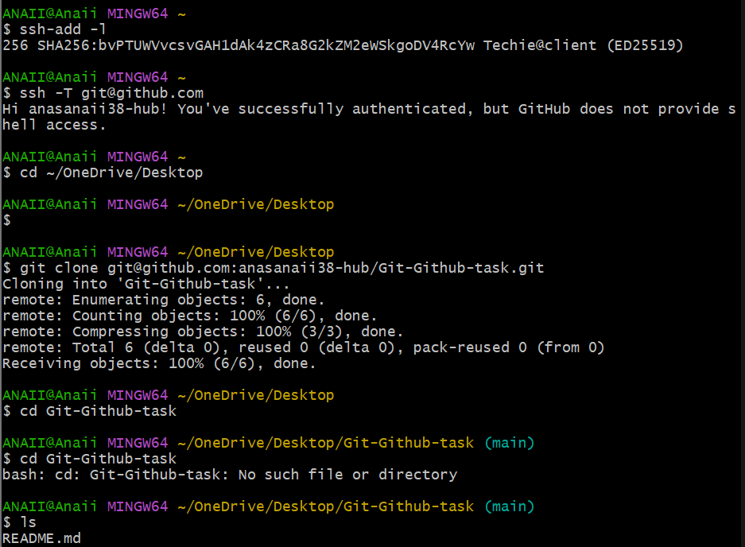

Validation Steps
Verify task completed successfully.

Explanation
Briefly explain what was done, why it is important, and its use.

Real-Time Use Case
Used in software development and DevOps workflows.

Common Errors and Troubleshooting
Permission errors, authentication issues, incorrect commands; resolve by checking configuration.

Task 4: Create Two Files

Outcome
Create Two Files completed successfully.

Objective
To learn create two files.

Prerequisites
Git installed, GitHub account, Internet connection.

Step-by-Step Implementation
Step 1: Perform the task as shown in screenshots.
Screenshot Evidence:
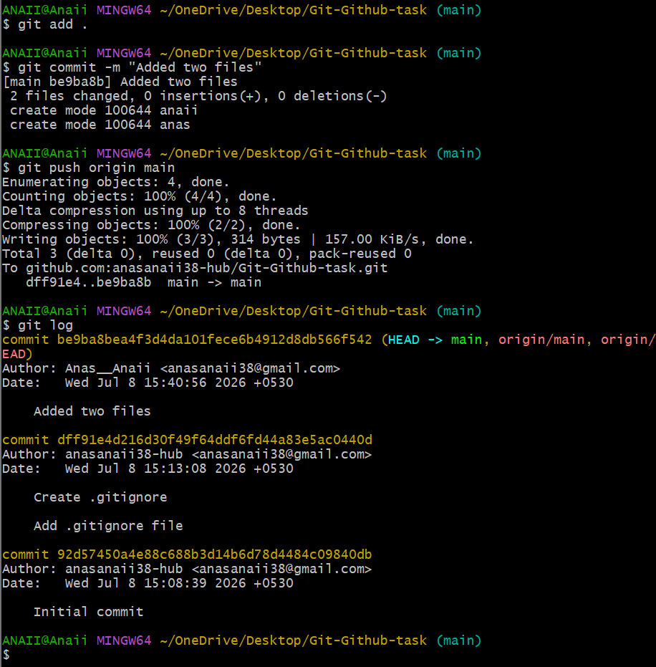

Validation Steps
Verify task completed successfully.

Explanation
Briefly explain what was done, why it is important, and its use.

Real-Time Use Case
Used in software development and DevOps workflows.

Common Errors and Troubleshooting
Permission errors, authentication issues, incorrect commands; resolve by checking configuration.

Task 5: Commit & Push Changes

Outcome
Commit & Push Changes completed successfully.

Objective
To learn commit & push changes.

Prerequisites
Git installed, GitHub account, Internet connection.

Step-by-Step Implementation
Step 1: Perform the task as shown in screenshots.
Screenshot Evidence:


Validation Steps
Verify task completed successfully.

Explanation
Briefly explain what was done, why it is important, and its use.

Real-Time Use Case
Used in software development and DevOps workflows.

Common Errors and Troubleshooting
Permission errors, authentication issues, incorrect commands; resolve by checking configuration.

Task 6: Create Local Branch

Outcome
Create Local Branch completed successfully.

Objective
To learn create local branch.

Prerequisites
Git installed, GitHub account, Internet connection.

Step-by-Step Implementation
Step 1: Perform the task as shown in screenshots.
Screenshot Evidence:
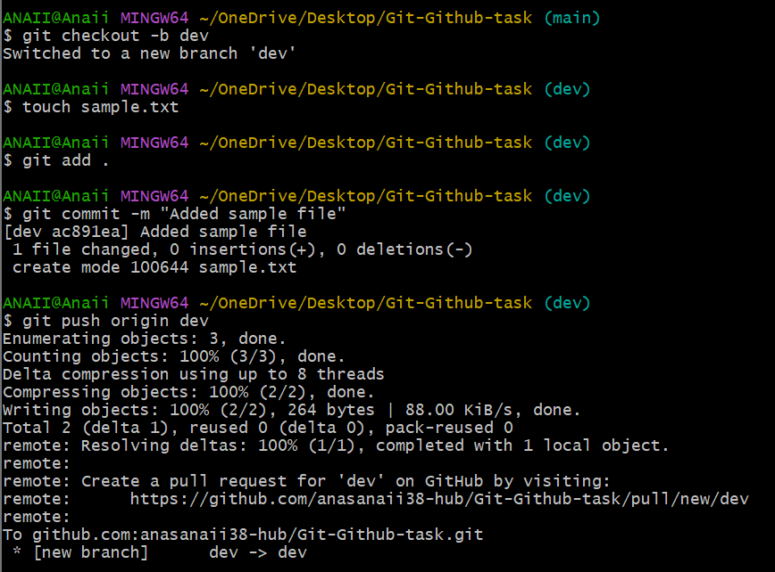

Validation Steps
Verify task completed successfully.

Explanation
Briefly explain what was done, why it is important, and its use.

Real-Time Use Case
Used in software development and DevOps workflows.

Common Errors and Troubleshooting
Permission errors, authentication issues, incorrect commands; resolve by checking configuration.

Task 7: Create Branch in GitHub

Outcome
Create Branch in GitHub completed successfully.

Objective
To learn create branch in github.

Prerequisites
Git installed, GitHub account, Internet connection.

Step-by-Step Implementation
Step 1: Perform the task as shown in screenshots.
Screenshot Evidence:
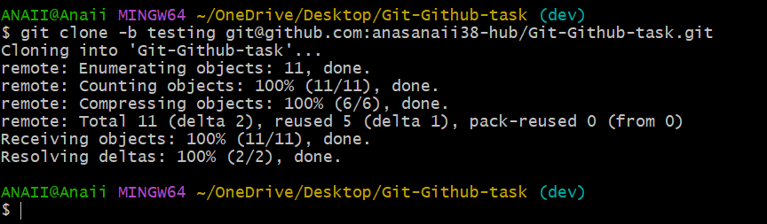

Validation Steps
Verify task completed successfully.

Explanation
Briefly explain what was done, why it is important, and its use.

Real-Time Use Case
Used in software development and DevOps workflows.

Common Errors and Troubleshooting
Permission errors, authentication issues, incorrect commands; resolve by checking configuration.

Task 8: Merge Branch with Main Locally

Outcome
Merge Branch with Main Locally completed successfully.

Objective
To learn merge branch with main locally.

Prerequisites
Git installed, GitHub account, Internet connection.

Step-by-Step Implementation
Step 1: Perform the task as shown in screenshots.
Screenshot Evidence:
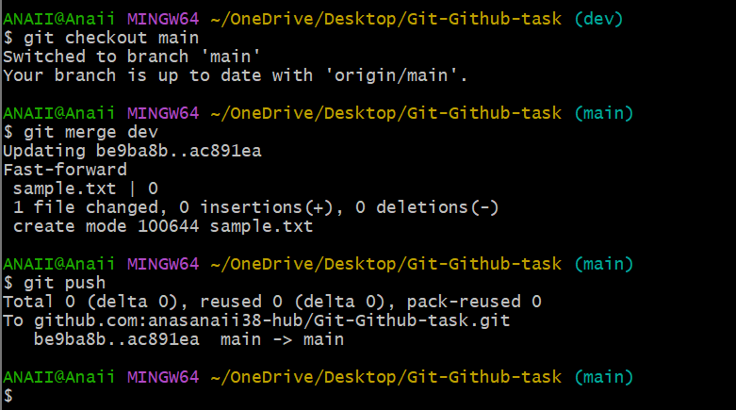

Validation Steps
Verify task completed successfully.

Explanation
Briefly explain what was done, why it is important, and its use.

Real-Time Use Case
Used in software development and DevOps workflows.

Common Errors and Troubleshooting
Permission errors, authentication issues, incorrect commands; resolve by checking configuration.

Task 9: Merge Branch via Pull Request

Outcome
Merge Branch via Pull Request completed successfully.

Objective
To learn merge branch via pull request.

Prerequisites
Git installed, GitHub account, Internet connection.

Step-by-Step Implementation
Step 1: Perform the task as shown in screenshots.
Screenshot Evidence:
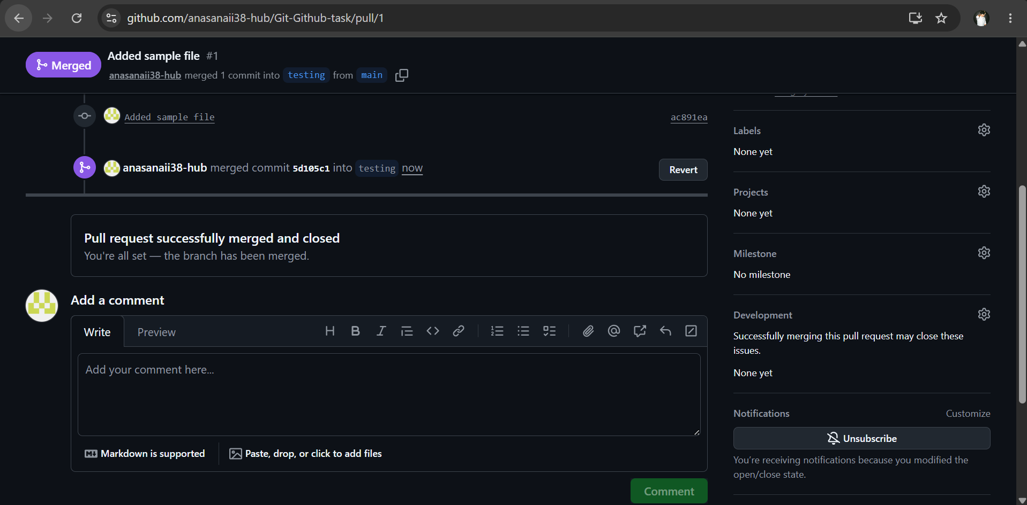

Validation Steps
Verify task completed successfully.

Explanation
Briefly explain what was done, why it is important, and its use.

Real-Time Use Case
Used in software development and DevOps workflows.

Common Errors and Troubleshooting
Permission errors, authentication issues, incorrect commands; resolve by checking configuration.

Task 10: Push File to Branch

Outcome
Push File to Branch completed successfully.

Objective
To learn push file to branch.

Prerequisites
Git installed, GitHub account, Internet connection.

Step-by-Step Implementation
Step 1: Perform the task as shown in screenshots.
Screenshot Evidence:
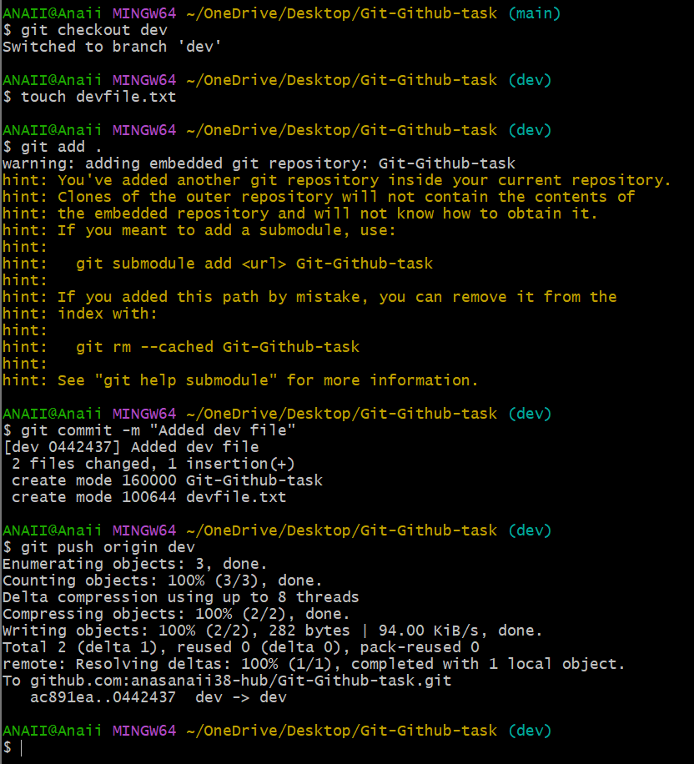

Validation Steps
Verify task completed successfully.

Explanation
Briefly explain what was done, why it is important, and its use.

Real-Time Use Case
Used in software development and DevOps workflows.

Common Errors and Troubleshooting
Permission errors, authentication issues, incorrect commands; resolve by checking configuration.

Task 11: Clone Only One Branch

Outcome
Clone Only One Branch completed successfully.

Objective
To learn clone only one branch.

Prerequisites
Git installed, GitHub account, Internet connection.

Step-by-Step Implementation
Step 1: Perform the task as shown in screenshots.
Screenshot Evidence:
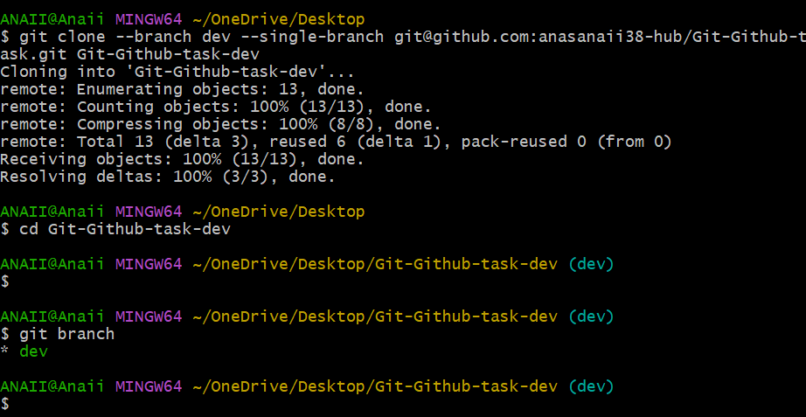

Validation Steps
Verify task completed successfully.

Explanation
Briefly explain what was done, why it is important, and its use.

Real-Time Use Case
Used in software development and DevOps workflows.

Common Errors and Troubleshooting
Permission errors, authentication issues, incorrect commands; resolve by checking configuration.

Task 12: Ignore Password File

Outcome
Ignore Password File completed successfully.

Objective
To learn ignore password file.

Prerequisites
Git installed, GitHub account, Internet connection.

Step-by-Step Implementation
Step 1: Perform the task as shown in screenshots.
Screenshot Evidence:
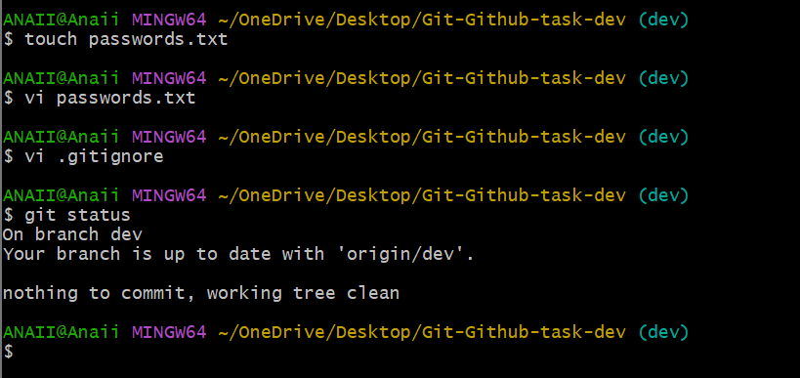

Validation Steps
Verify task completed successfully.

Explanation
Briefly explain what was done, why it is important, and its use.

Real-Time Use Case
Used in software development and DevOps workflows.

Common Errors and Troubleshooting
Permission errors, authentication issues, incorrect commands; resolve by checking configuration.

Task 13: Reset Last Commit

Outcome
Reset Last Commit completed successfully.

Objective
To learn reset last commit.

Prerequisites
Git installed, GitHub account, Internet connection.

Step-by-Step Implementation
Step 1: Perform the task as shown in screenshots.
Screenshot Evidence:
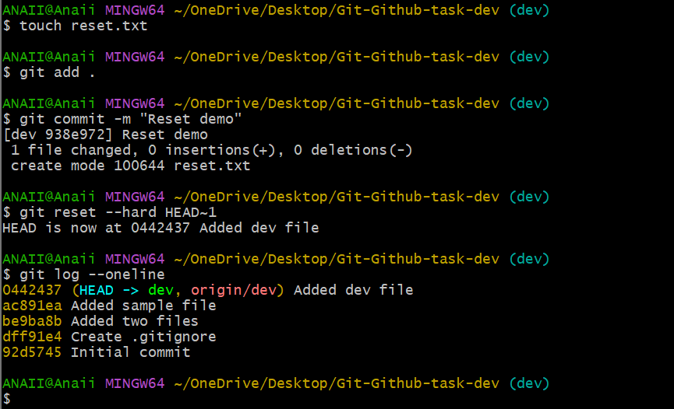

Validation Steps
Verify task completed successfully.

Explanation
Briefly explain what was done, why it is important, and its use.

Real-Time Use Case
Used in software development and DevOps workflows.

Common Errors and Troubleshooting
Permission errors, authentication issues, incorrect commands; resolve by checking configuration.

Task 14: Revert Commit

Outcome
Revert Commit completed successfully.

Objective
To learn revert commit.

Prerequisites
Git installed, GitHub account, Internet connection.

Step-by-Step Implementation
Step 1: Perform the task as shown in screenshots.
Screenshot Evidence:
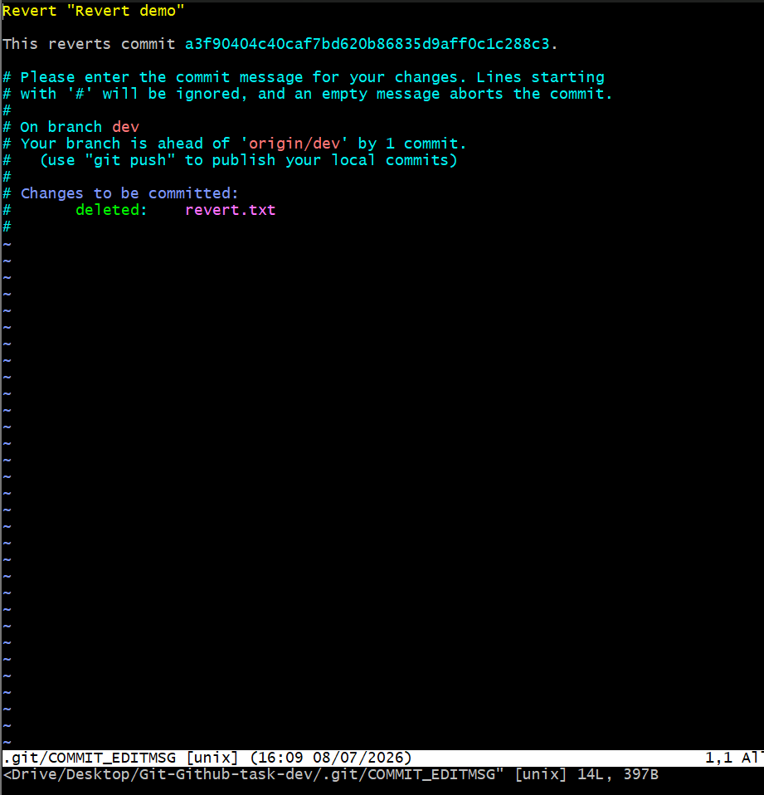

Validation Steps
Verify task completed successfully.

Explanation
Briefly explain what was done, why it is important, and its use.

Real-Time Use Case
Used in software development and DevOps workflows.

Common Errors and Troubleshooting
Permission errors, authentication issues, incorrect commands; resolve by checking configuration.

Task 15: Git Stash

Outcome
Git Stash completed successfully.

Objective
To learn git stash.

Prerequisites
Git installed, GitHub account, Internet connection.

Step-by-Step Implementation
Step 1: Perform the task as shown in screenshots.
Screenshot Evidence:
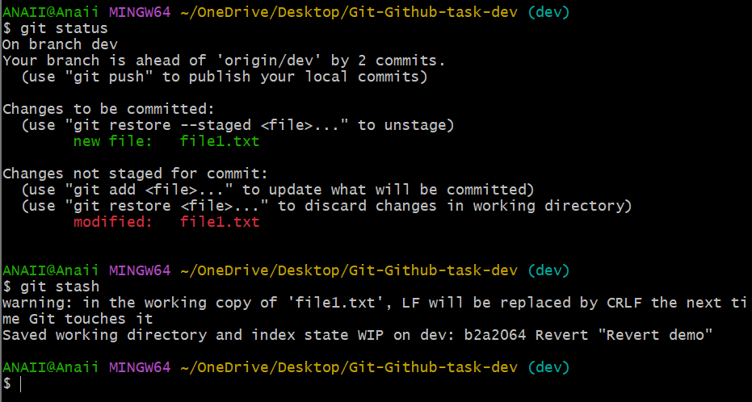

Validation Steps
Verify task completed successfully.

Explanation
Briefly explain what was done, why it is important, and its use.

Real-Time Use Case
Used in software development and DevOps workflows.

Common Errors and Troubleshooting
Permission errors, authentication issues, incorrect commands; resolve by checking configuration.

Task 16: Restore Stash

Outcome
Restore Stash completed successfully.

Objective
To learn restore stash.

Prerequisites
Git installed, GitHub account, Internet connection.

Step-by-Step Implementation
Step 1: Perform the task as shown in screenshots.
Screenshot Evidence:
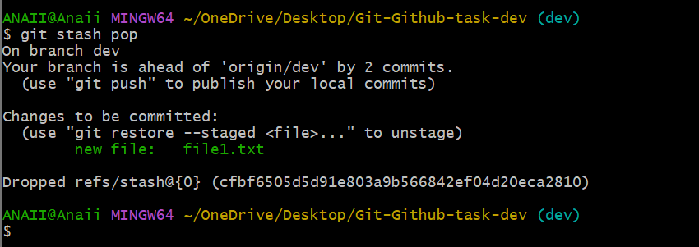

Validation Steps
Verify task completed successfully.

Explanation
Briefly explain what was done, why it is important, and its use.

Real-Time Use Case
Used in software development and DevOps workflows.

Common Errors and Troubleshooting
Permission errors, authentication issues, incorrect commands; resolve by checking configuration.

Task 17: SSH Key

Outcome
SSH Key completed successfully.

Objective
To learn ssh key.

Prerequisites
Git installed, GitHub account, Internet connection.

Step-by-Step Implementation
Step 1: Perform the task as shown in screenshots.
Screenshot Evidence:
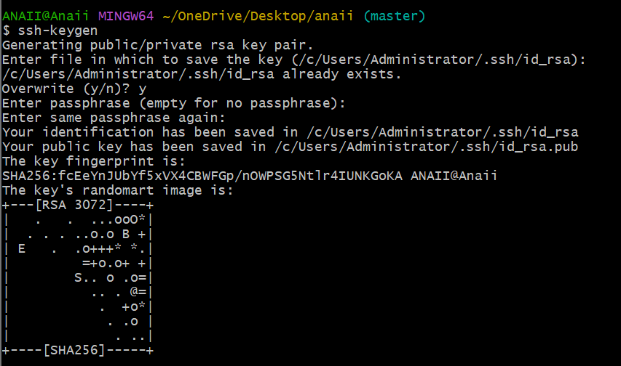

Validation Steps
Verify task completed successfully.

Explanation
Briefly explain what was done, why it is important, and its use.

Real-Time Use Case
Used in software development and DevOps workflows.

Common Errors and Troubleshooting
Permission errors, authentication issues, incorrect commands; resolve by checking configuration.

Task 18: Configure Webhook

Outcome
Configure Webhook completed successfully.

Objective
To learn configure webhook.

Prerequisites
Git installed, GitHub account, Internet connection.

Step-by-Step Implementation
Step 1: Perform the task as shown in screenshots.
Screenshot Evidence:
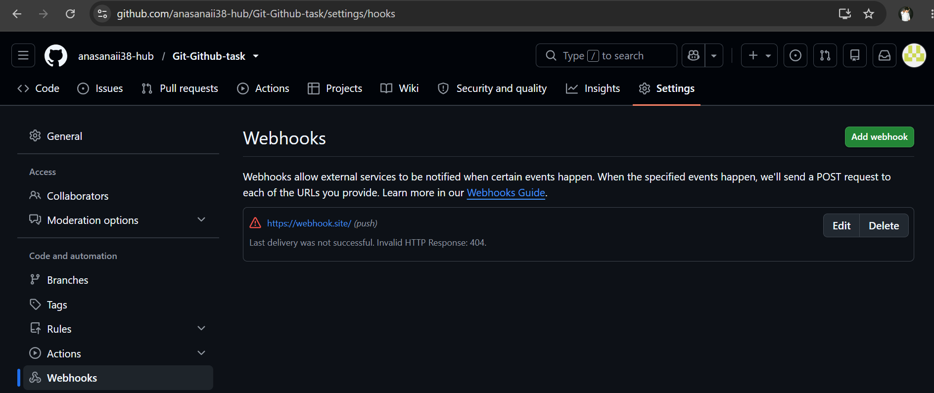

Validation Steps
Verify task completed successfully.

Explanation
Briefly explain what was done, why it is important, and its use.

Real-Time Use Case
Used in software development and DevOps workflows.

Common Errors and Troubleshooting
Permission errors, authentication issues, incorrect commands; resolve by checking configuration.

Task 19: Basic Understanding of .git

Outcome
Basic Understanding of .git completed successfully.

Objective
To learn basic understanding of .git.

Prerequisites
Git installed, GitHub account, Internet connection.

Step-by-Step Implementation
Step 1: Perform the task as shown in screenshots.
Screenshot Evidence:
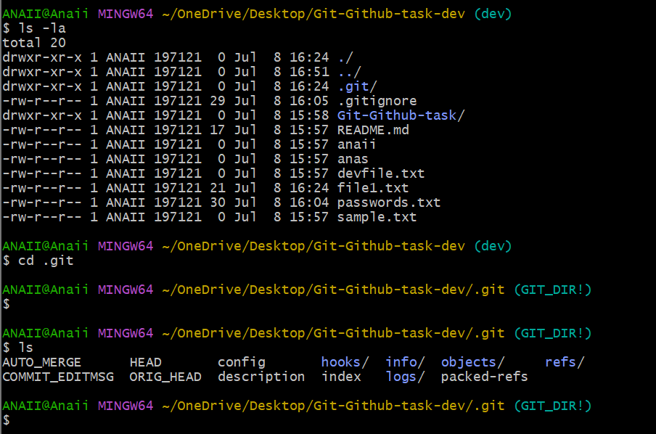

Validation Steps
Verify task completed successfully.

Explanation
Briefly explain what was done, why it is important, and its use.

Real-Time Use Case
Used in software development and DevOps workflows.

Common Errors and Troubleshooting
Permission errors, authentication issues, incorrect commands; resolve by checking configuration.

Task 20: Git Logs

Outcome
Git Logs completed successfully.

Objective
To learn git logs.

Prerequisites
Git installed, GitHub account, Internet connection.

Step-by-Step Implementation
Step 1: Perform the task as shown in screenshots.
Screenshot Evidence:
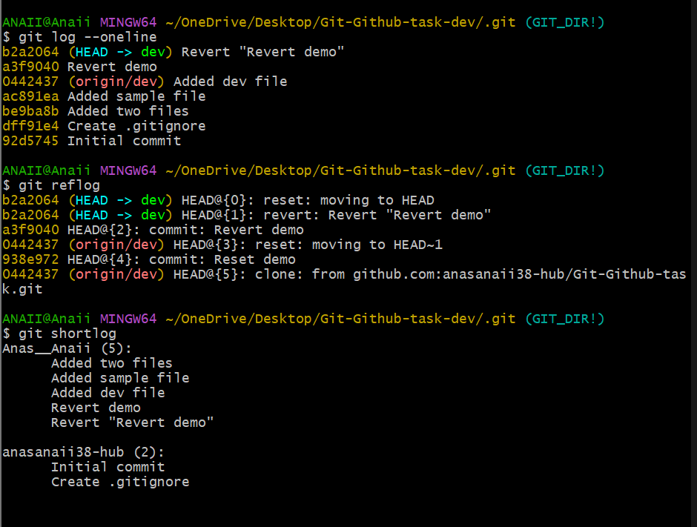

Validation Steps
Verify task completed successfully.

Explanation
Briefly explain what was done, why it is important, and its use.

Real-Time Use Case
Used in software development and DevOps workflows.

Common Errors and Troubleshooting
Permission errors, authentication issues, incorrect commands; resolve by checking configuration.

Task 21: Rename Commit Message

Outcome
Rename Commit Message completed successfully.

Objective
To learn rename commit message.

Prerequisites
Git installed, GitHub account, Internet connection.

Step-by-Step Implementation
Step 1: Perform the task as shown in screenshots.
Screenshot Evidence:
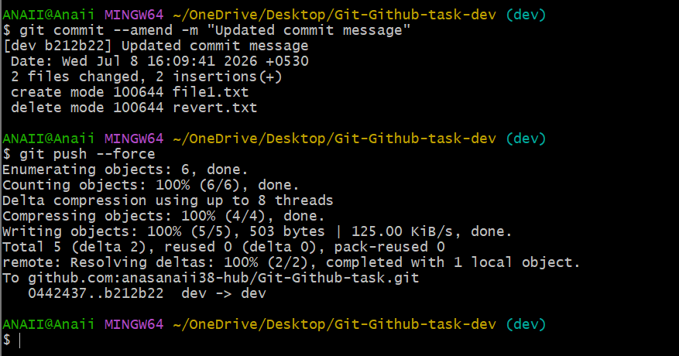

Validation Steps
Verify task completed successfully.

Explanation
Briefly explain what was done, why it is important, and its use.

Real-Time Use Case
Used in software development and DevOps workflows.

Common Errors and Troubleshooting
Permission errors, authentication issues, incorrect commands; resolve by checking configuration.

Task 22: Squash Multiple Commits

Outcome
Squash Multiple Commits completed successfully.

Objective
To learn squash multiple commits.

Prerequisites
Git installed, GitHub account, Internet connection.

Step-by-Step Implementation
Step 1: Perform the task as shown in screenshots.
Screenshot Evidence:
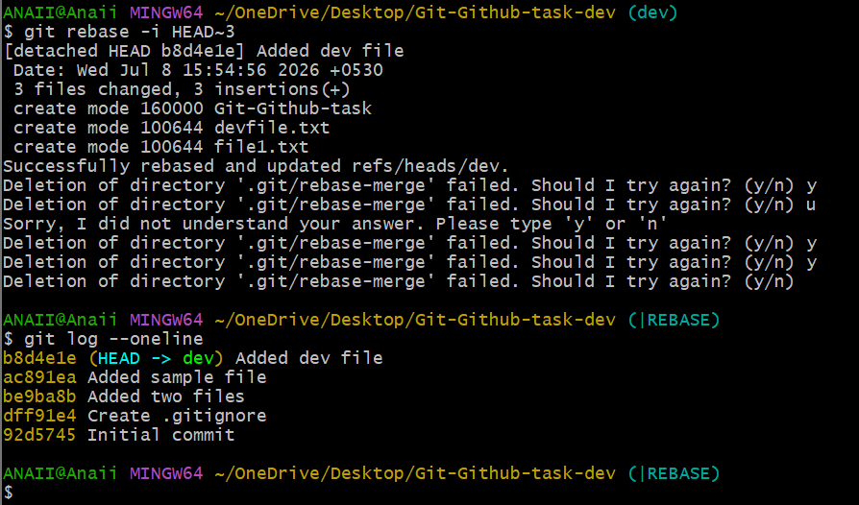

Validation Steps
Verify task completed successfully.

Explanation
Briefly explain what was done, why it is important, and its use.

Real-Time Use Case
Used in software development and DevOps workflows.

Common Errors and Troubleshooting
Permission errors, authentication issues, incorrect commands; resolve by checking configuration.

