VPC CHALLENGE
USE CASE: Setting up Transit Gateway and VPC Endpoints for a Multi-VPC
Architecture
SCENARIO:
A large organization is migrating its on-premises infrastructure to the AWS
cloud.
The organization's architecture involves multiple VPCs for different
departments and applications, each requiring secure communication with
centralized services and external resources.
The IT team needs to design and implement a scalable and efficient network
architecture to accommodate the organization's growth and ensure robust
connectivity between VPCs and external services.
- Design and deploy a scalable network architecture using AWS Transit Gateway to simplify network connectivity between multiple VPCs.
1. Understanding Requirements
Scenario:
- Multiple VPCs exist for different departments/applications.
- Each VPC needs:
  - Secure communication with other VPCs (intra-cloud traffic)
  - Access to centralized services (like Active Directory, databases)
  - Connectivity to the internet or on-premises data centers
Goal:
- Avoid complex peering between every VPC.
- Use a hub-and-spoke model with AWS Transit Gateway.
- Support scalability as the organization grows.

2. Design Considerations
a. Hub-and-Spoke Topology
- Transit Gateway acts as a central hub.
- Each VPC is a spoke connected to the TGW.
- Centralized services can reside in a dedicated “shared-services VPC.”
- On-premises connectivity is via VPN or AWS Direct Connect to TGW.
b. Security & Segmentation
- Use Route Tables in TGW to control which VPCs can communicate.
- Apply Security Groups and NACLs in VPCs.
- Optionally use VPC sharing for cross-account access.
c. Scalability & High Availability
- Transit Gateway scales horizontally, supporting thousands of VPCs.
- Multi-AZ deployment of VPCs and services ensures resilience.
- Attach Direct Connect in multiple locations for redundancy.

3. AWS Components Involved
Component | Role
AWS Transit Gateway (TGW) | Central hub for inter-VPC and on-premises routing
VPCs | Department/application networks (spokes)
Transit Gateway Attachments | Connect VPCs and VPNs/Direct Connect to TGW
Transit Gateway Route Tables | Control routing between VPCs and on-prem
VPN / Direct Connect | On-premises connectivity
Security Groups / NACLs | Traffic filtering per VPC

4. High-Level Architecture
On-Premises DC
|
[VPN / DX]
|
+----------------+
| Transit Gateway|
+----------------+
/ | \
VPC-HR VPC-Sales VPC-Finance
| | |
+--Shared Services VPC--+
(AD, DB, Logging)
Key Points:
- VPCs connect only to TGW, not directly to each other.
- Shared services VPC is accessible by all department VPCs via TGW.
- TGW manages routing dynamically, reducing peering complexity.

5. Step-by-Step Deployment Guidance
Step 1: Create Transit Gateway
- Go to VPC → Transit Gateways → Create Transit Gateway
- Configure:
  - Name: Org-TGW
  - Amazon side ASN (default is fine)
  - Enable Auto-Attach for new VPCs (optional)
  - Enable DNS support if required

- Click Create Transit Gateway

Step 2: Create VPCs (if not existing)
- Example:
  - VPC-HR: 10.0.0.0/16
  - VPC-Sales: 10.1.0.0/16
  - VPC-Finance: 10.2.0.0/16
  - Shared-Services: 10.3.0.0/16
- Create public/private subnets in each VPC.
- Deploy any required EC2 instances or services.

Step 3: Attach VPCs to Transit Gateway
- Go to Transit Gateway → Transit Gateway Attachments → Create Attachment
- Select VPC, pick the VPC and subnets to attach.
- Repeat for each VPC.

Step 4: Configure Transit Gateway Route Tables
- Go to TGW → Route Tables → Create Route Table
  - Example:
    - Default-RT for general VPC connectivity
    - Shared-Services-RT for access to central services
- Associate VPC attachments to appropriate route tables.
- Add routes:
  - For VPC-HR, route 10.1.0.0/16 → TGW attachment for Sales
  - Route 10.3.0.0/16 → TGW attachment for Shared Services
  - Similarly for other VPCs

Step 5: Configure On-Premises Connectivity (Optional)
- Create VPN connection to TGW.
- Update TGW route table with on-premises networks.
- Test connectivity from VPCs to on-prem.

Step 6: Security & Testing
- Configure Security Groups:
  - Allow traffic from TGW CIDR ranges (or specific VPCs)
- Configure NACLs if required.
- Test connectivity:
  - Ping EC2s in different VPCs
  - Access centralized services
  - Check internet routing if NAT gateway used
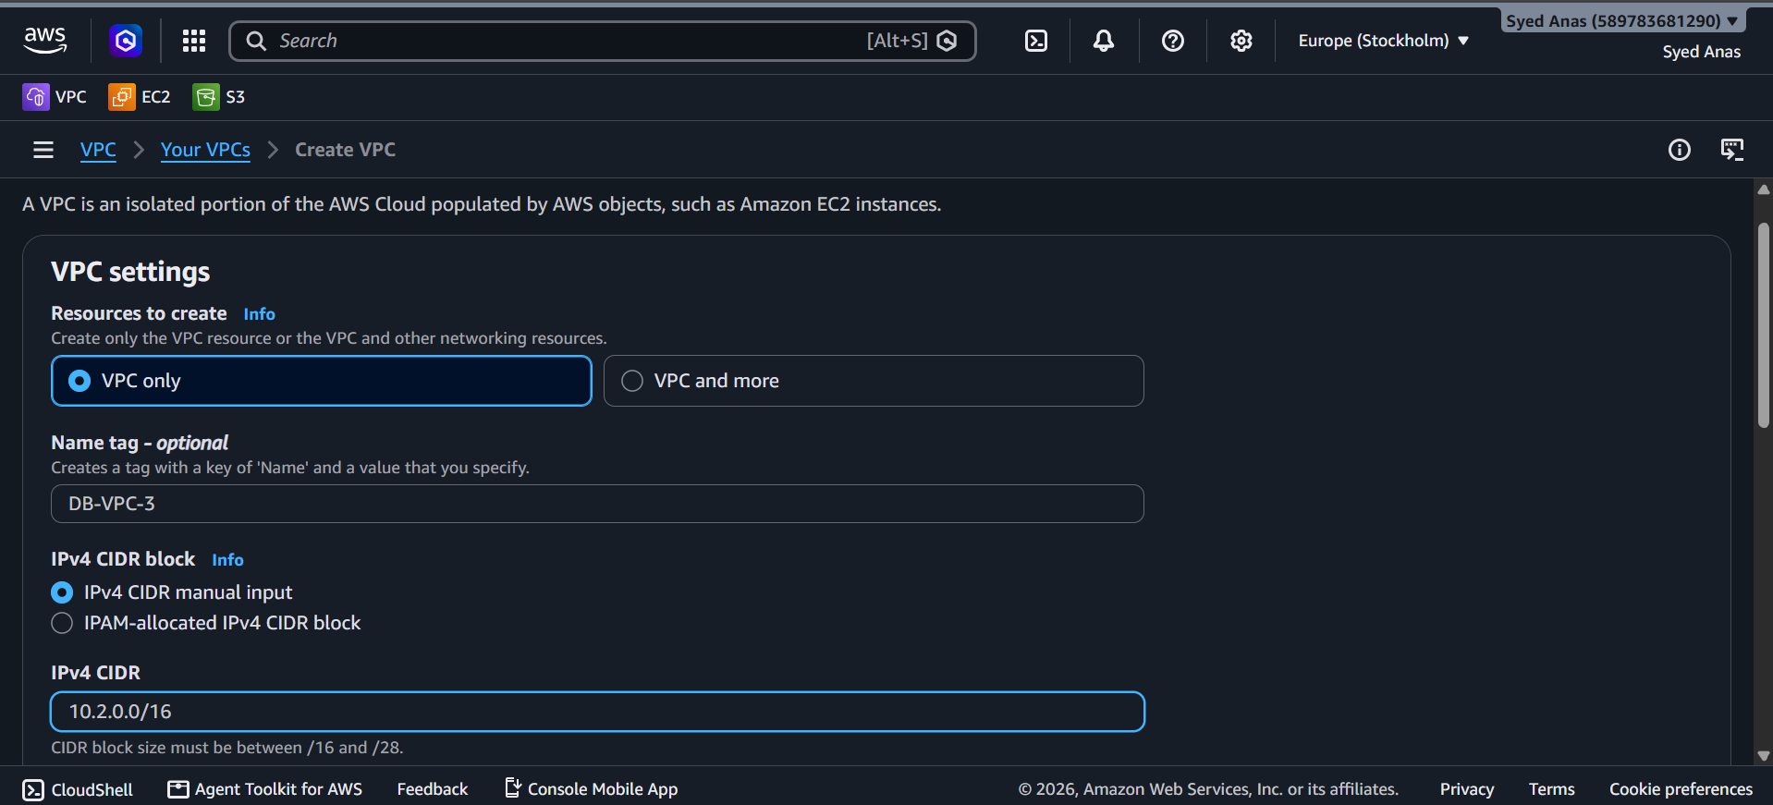
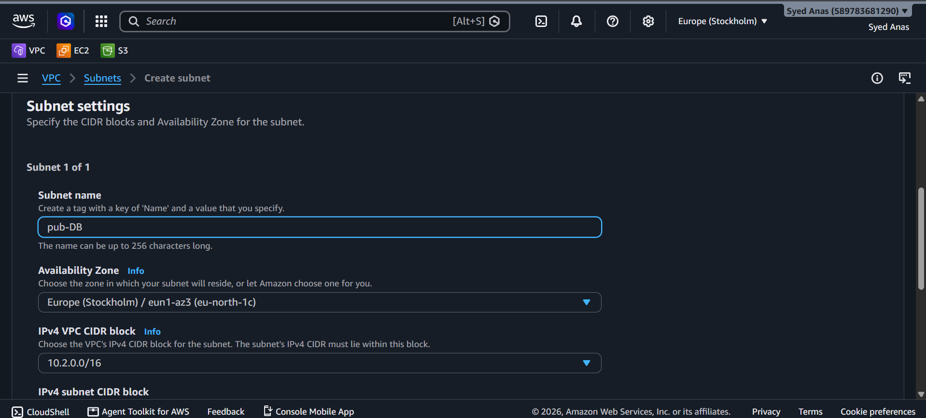
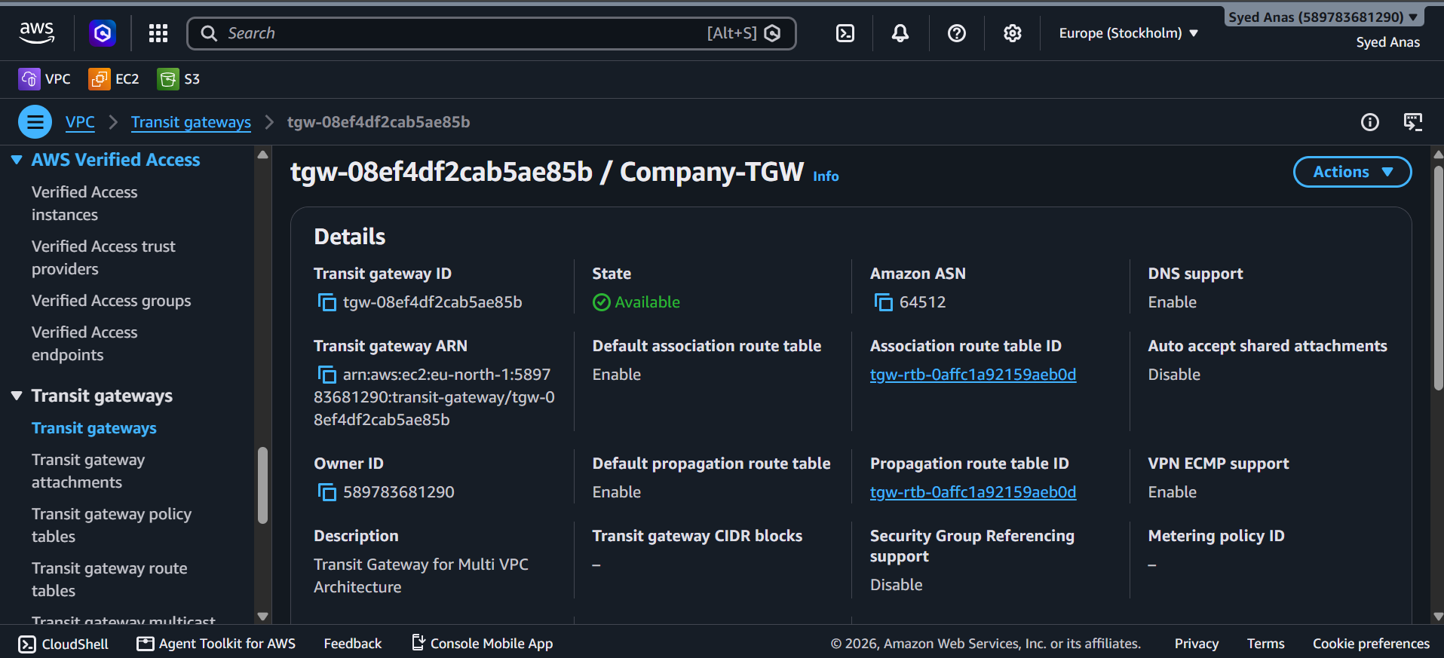
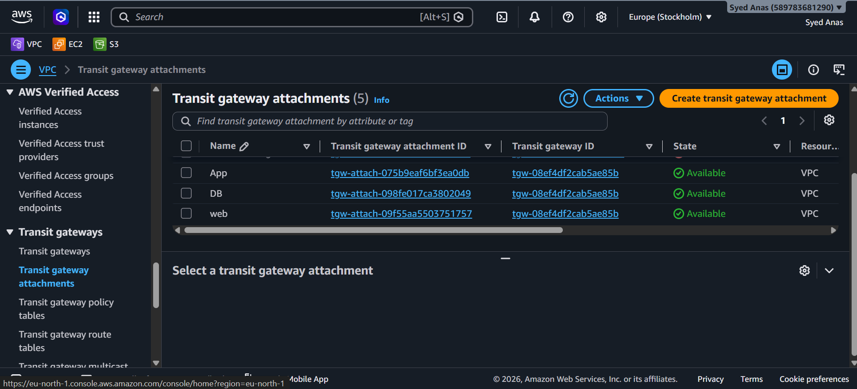
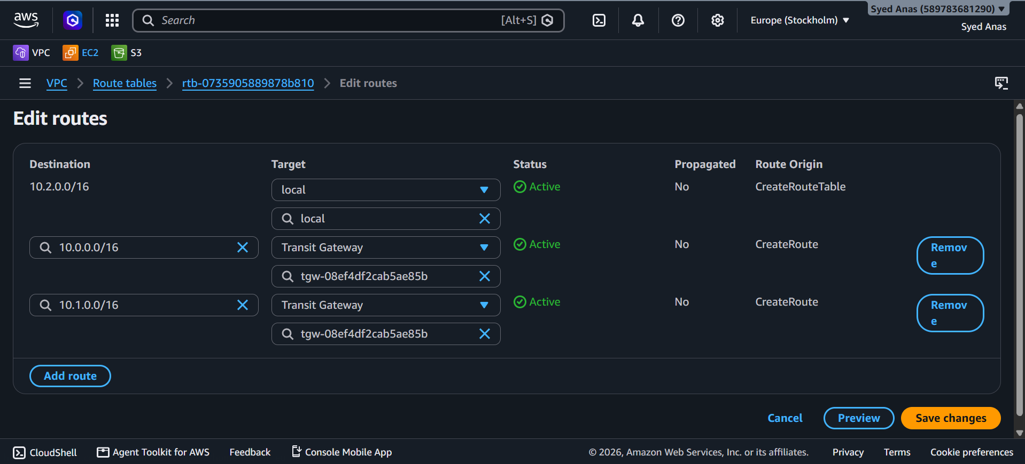

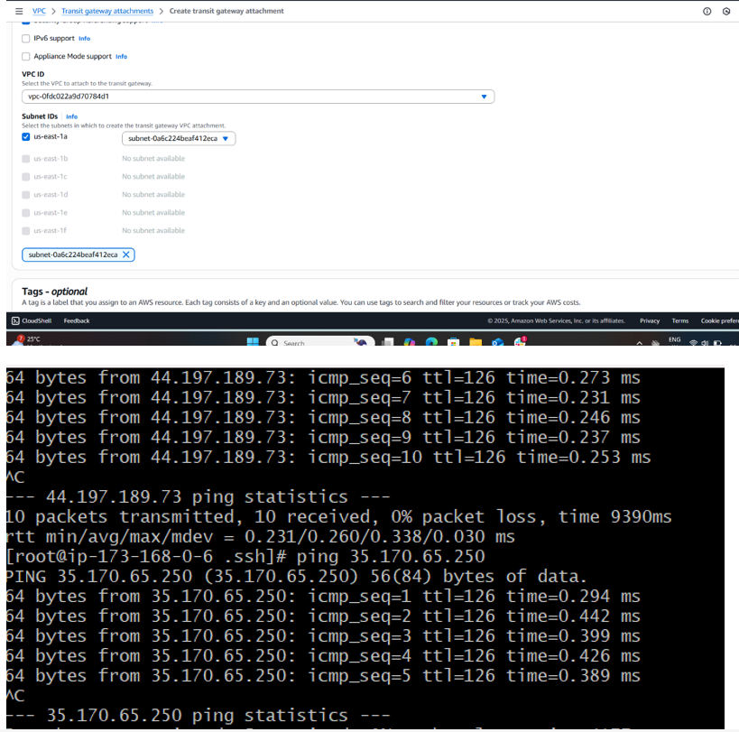

- Vpc end point is used to connect aws resources internally without internet connection.
- For that, we have created one VPC public subnet and private subnet.

6. Benefits of Using TGW
- Simplifies VPC connectivity: No need for complex peering
- Scales to thousands of VPCs
- Centralized monitoring and control
- Reduces administrative overhead

- Configure VPC endpoints to securely access AWS services without internet gateways or NAT gateways, ensuring data privacy and minimizing exposure to external threats
1. What is a VPC Endpoint?
A VPC Endpoint allows resources in your VPC (like EC2 instances) to privately connect to supported AWS services without needing:
- An Internet Gateway (IGW)
- NAT Gateway
- Public IP addresses
This ensures traffic never leaves the AWS network, enhancing security and privacy.
Types of VPC Endpoints:
Type | Use Case | Example
Interface Endpoint | Connect to AWS services via private ENIs in your VPC | S3, EC2 API, SNS, Secrets Manager
Gateway Endpoint | Connect to S3 or DynamoDB via route table entries | S3, DynamoDB

2. Benefits
- Enhanced Security: Traffic stays within AWS network.
- No Public Internet Required: Reduces attack surface.
- Cost Savings: No NAT Gateway data transfer charges.
- Simplified Routing: Direct integration with route tables.

3. Deployment Guidance
Step 1: Identify Services
Decide which AWS services your VPC resources need to access.
- S3 or DynamoDB → Gateway Endpoint
- Other services (Secrets Manager, CloudWatch, SNS, SQS, EC2 APIs, KMS, etc.) → Interface Endpoint

Step 2: Create a VPC Endpoint
A. Gateway Endpoint (S3 / DynamoDB)
- Go to VPC → Endpoints → Create Endpoint
- Select Service Name:
  - S3: com.amazonaws.<region>.s3
  - DynamoDB: com.amazonaws.<region>.dynamodb
- Select VPC where endpoint will reside.
- Select Route Tables to associate with (this will automatically add routes).
- Policy:
  - Default allows full access.
  - You can define a custom policy to restrict access to specific buckets or actions.
- Click Create Endpoint.
Routing:
- Traffic to S3 or DynamoDB automatically goes via the VPC Endpoint.
- No IGW or NAT required.

B. Interface Endpoint (Other AWS Services)
- Go to VPC → Endpoints → Create Endpoint
- Select Service Category: AWS Services
- Choose the service (e.g., Secrets Manager, CloudWatch, SNS)
- Select VPC and Subnets (private subnets recommended)
- Assign Security Groups for ENIs (allow traffic from your EC2)
- Click Create Endpoint
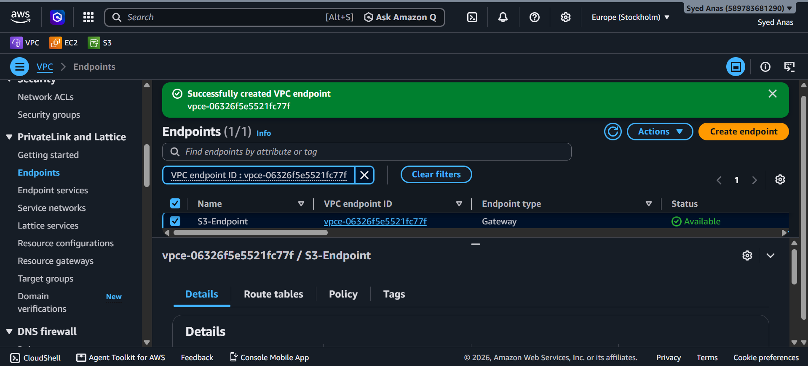
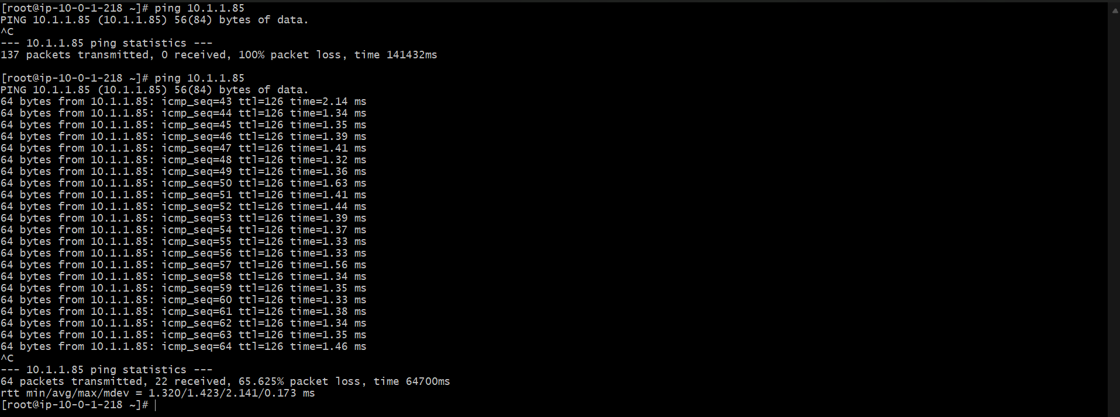
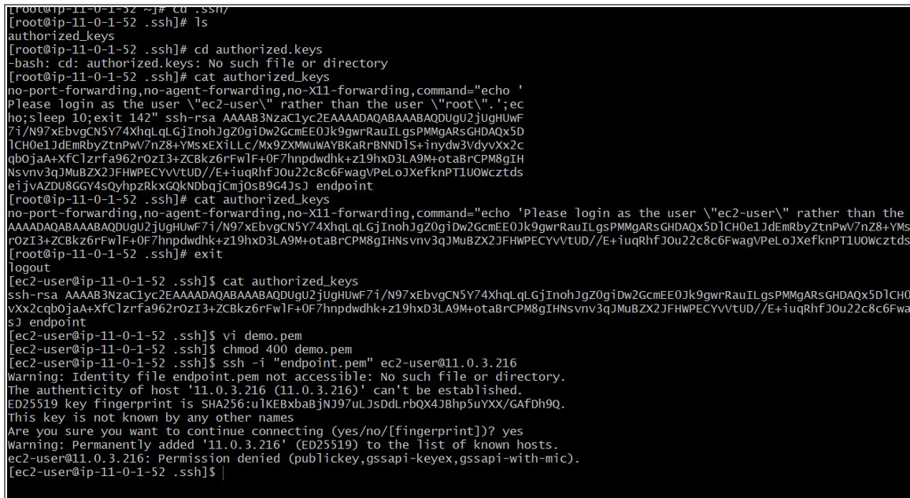
In network settings attach vpc and select private route table and click on create end point.

