Name: Anas Rasheed
Reg ID: 831075
SQL Test

Q1. List top 5 customers by total order amount.
Retrieve the top 5 customers who have spent the most across all sales orders. Show CustomerID, CustomerName, and TotalSpent.

Query:
SELECT TOP 5
c.CustomerID,
c.Name AS CustomerName,
SUM(so.TotalAmount) AS TotalSpent
FROM Customer c
INNER JOIN SalesOrder so
ON c.CustomerID = so.CustomerID
GROUP BY
c.CustomerID,
c.Name
ORDER BY
TotalSpent DESC;

Output Screenshot:
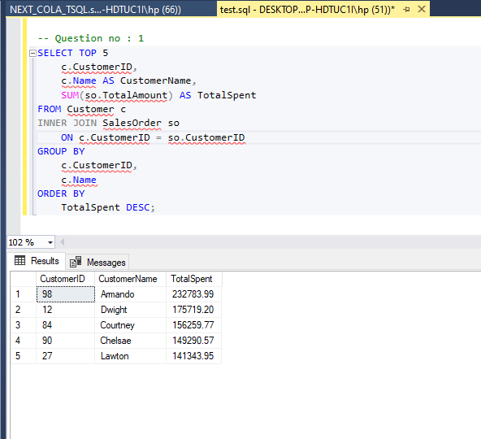

Question: 2
Find the number of products supplied by each supplier.
Display SupplierID, SupplierName, and ProductCount. Only include suppliers that have more than 10 products.

Query:
SELECT
s.SupplierID,
s.Name AS SupplierName,
COUNT(DISTINCT pod.ProductID) AS ProductCount
FROM Supplier s
INNER JOIN PurchaseOrder po
ON s.SupplierID = po.SupplierID
INNER JOIN PurchaseOrderDetail pod
ON po.OrderID = pod.OrderID
GROUP BY
s.SupplierID,
s.Name
HAVING COUNT(DISTINCT pod.ProductID) > 10
ORDER BY ProductCount DESC;

Output Screenshot:
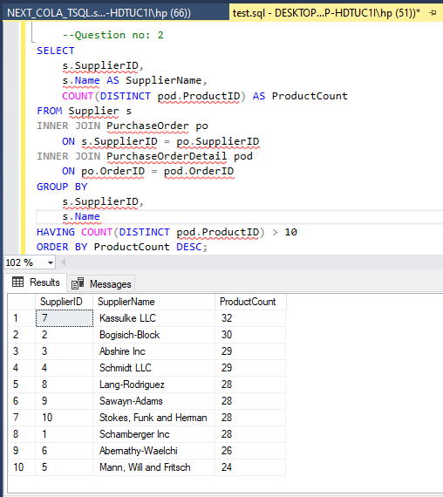

Q3. Identify products that have been ordered but never returned.
Show ProductID, ProductName, and total order quantity.
Query:
SELECT
p.ProductID,
p.Name AS ProductName,
SUM(sod.Quantity) AS TotalOrderQuantity
FROM Product p
INNER JOIN SalesOrderDetail sod
ON p.ProductID = sod.ProductID
WHERE NOT EXISTS (
SELECT 1
FROM ReturnDetail rd
WHERE rd.ProductID = p.ProductID
)
GROUP BY
p.ProductID,
p.Name
ORDER BY
TotalOrderQuantity DESC;
Output ScrenShot:
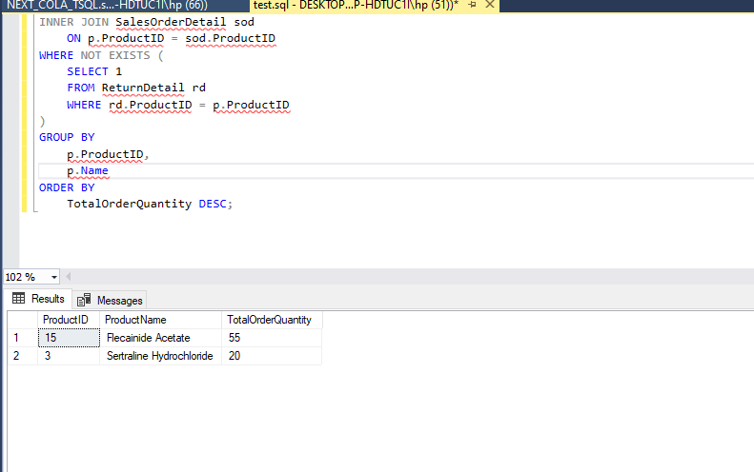

Question No : 4
For each category, find the most expensive product.
Display CategoryID, CategoryName, ProductName, and Price. Use a subquery to get the max price per category.
Query:
SELECT
c.CategoryID,
c.Name AS CategoryName,
p.Name AS ProductName,
p.Price
FROM Product p
INNER JOIN Category c
ON p.CategoryID = c.CategoryID
WHERE p.Price = (
SELECT MAX(p2.Price)
FROM Product p2
WHERE p2.CategoryID = p.CategoryID
)
ORDER BY c.CategoryID;

Output Screenshot:
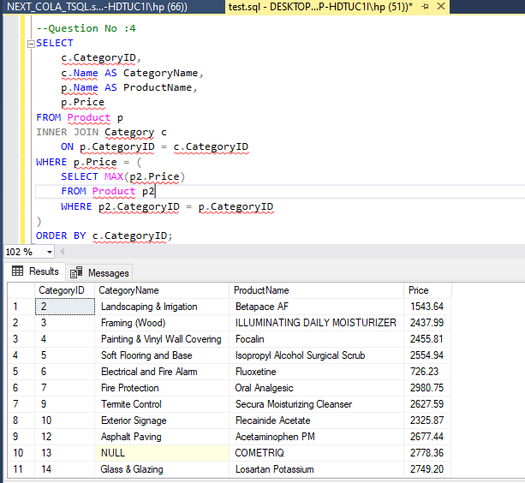

Question No : 05
List all sales orders with customer name, product name, category, and supplier.
For each sales order, display:
OrderID, CustomerName, ProductName, CategoryName, SupplierName, and Quantity.
Query:
SELECT
so.OrderID,
c.Name AS CustomerName,
p.Name AS ProductName,
cat.Name AS CategoryName,
s.Name AS SupplierName,
sod.Quantity
FROM SalesOrder so
INNER JOIN Customer c
ON so.CustomerID = c.CustomerID
INNER JOIN SalesOrderDetail sod
ON so.OrderID = sod.OrderID
INNER JOIN Product p
ON sod.ProductID = p.ProductID
INNER JOIN Category cat
ON p.CategoryID = cat.CategoryID
INNER JOIN PurchaseOrderDetail pod
ON p.ProductID = pod.ProductID
INNER JOIN PurchaseOrder po
ON pod.OrderID = po.OrderID
INNER JOIN Supplier s
ON po.SupplierID = s.SupplierID
ORDER BY so.OrderID;

Output Scrrenshot:
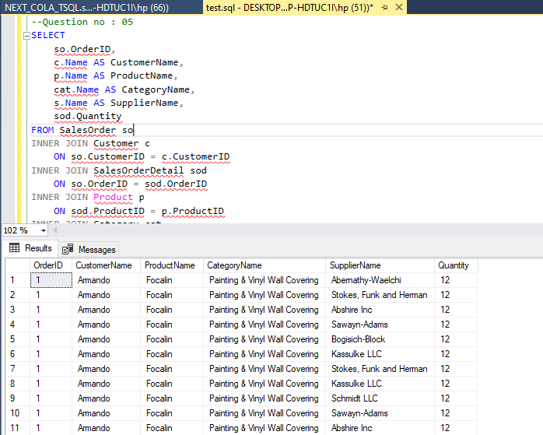

Question NO : 06
Q6. Find all shipments with details of warehouse, manager, and products shipped.
Display:
ShipmentID, WarehouseName, ManagerName, ProductName, QuantityShipped, and TrackingNumber.
Query:
SELECT
s.ShipmentID,
l.Name AS WarehouseName,
e.Name AS ManagerName,
p.Name AS ProductName,
sd.Quantity AS QuantityShipped,
s.TrackingNumber
FROM Shipment s
JOIN Warehouse w ON s.WarehouseID = w.WarehouseID
JOIN Location l ON w.LocationID = l.LocationID
JOIN Employee e ON w.ManagerID = e.EmployeeID
JOIN ShipmentDetail sd ON s.ShipmentID = sd.ShipmentID
JOIN Product p ON sd.ProductID = p.ProductID;
OutPut Screenshot:
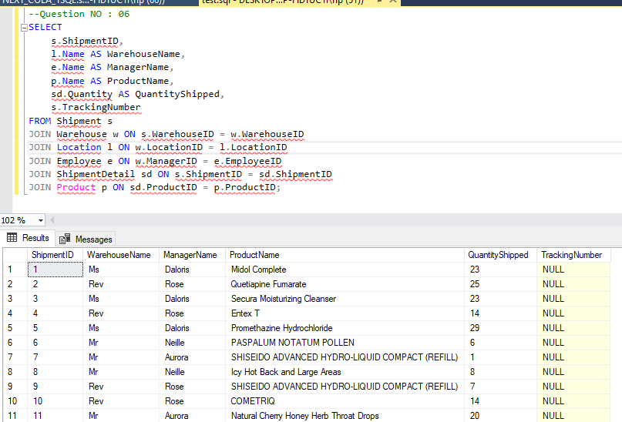

Question NO : 7
Find the top 3 highest-value orders per customer using RANK(). Display CustomerID, CustomerName, OrderID, and TotalAmount.
Query:
WITH RankedOrders AS (
SELECT
c.CustomerID,
c.Name AS CustomerName,
so.OrderID,
so.TotalAmount,
RANK() OVER (PARTITION BY c.CustomerID ORDER BY so.TotalAmount DESC) AS rnk
FROM SalesOrder so
JOIN Customer c ON so.CustomerID = c.CustomerID
)
SELECT
CustomerID,
CustomerName,
OrderID,
TotalAmount
FROM RankedOrders
WHERE rnk <= 3
ORDER BY CustomerID, rnk;
Output Screenshot:
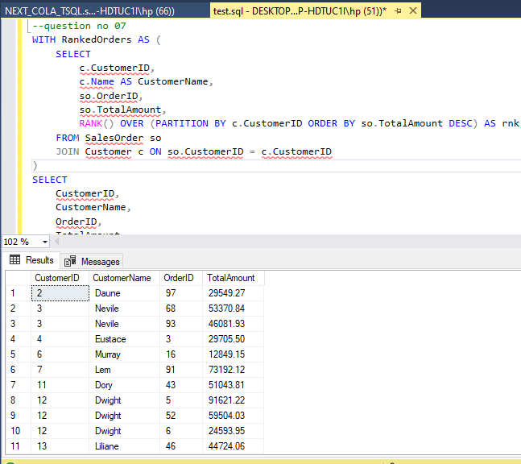

Question no : 08
For each product, show its sales history with the previous and next sales quantities (based on order date). Display ProductID, ProductName, OrderID, OrderDate, Quantity, PrevQuantity, and NextQuantity.
Query:
SELECT
p.ProductID,
p.Name AS ProductName,
so.OrderID,
so.OrderDate,
sod.Quantity,
LAG(sod.Quantity) OVER (PARTITION BY p.ProductID ORDER BY so.OrderDate) AS PrevQuantity,
LEAD(sod.Quantity) OVER (PARTITION BY p.ProductID ORDER BY so.OrderDate) AS NextQuantity
FROM SalesOrderDetail sod
JOIN SalesOrder so ON sod.OrderID = so.OrderID
JOIN Product p ON sod.ProductID = p.ProductID
ORDER BY p.ProductID, so.OrderDate;

OUTput Screenshot:

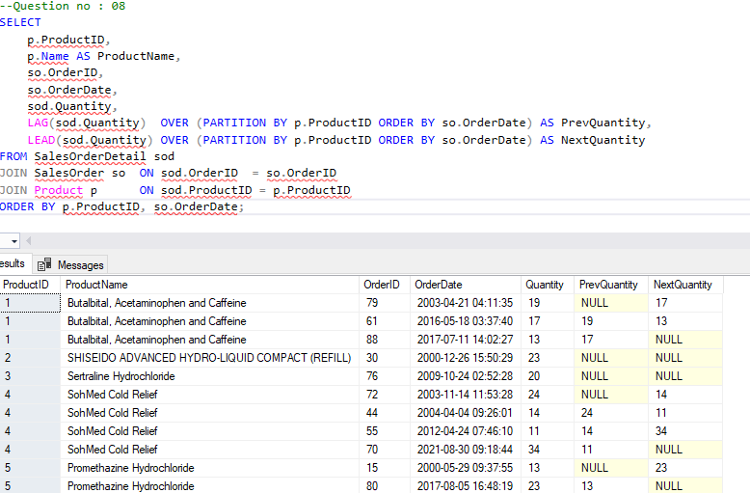

Question NO : 09
Create a view named vw_CustomerOrderSummary that shows for each customer:
CustomerID, CustomerName, TotalOrders, TotalAmountSpent, and LastOrderDate.

Query:
CREATE VIEW vw_CustomerOrderSummary AS
SELECT
c.CustomerID,
c.Name AS CustomerName,
COUNT(so.OrderID) AS TotalOrders,
SUM(so.TotalAmount) AS TotalAmountSpent,
MAX(so.OrderDate) AS LastOrderDate
FROM Customer c
LEFT JOIN SalesOrder so ON c.CustomerID = so.CustomerID
GROUP BY c.CustomerID, c.Name;

-- Saare customers dekhne ke liye
SELECT * FROM vw_CustomerOrderSummary;

-- Sirf active/high-value customers filter karna ho
SELECT *
FROM vw_CustomerOrderSummary
WHERE TotalOrders > 3
ORDER BY TotalAmountSpent DESC;

-- Specific customer dhundhna ho
SELECT *
FROM vw_CustomerOrderSummary
WHERE CustomerID = 98;

Output Screenshot:
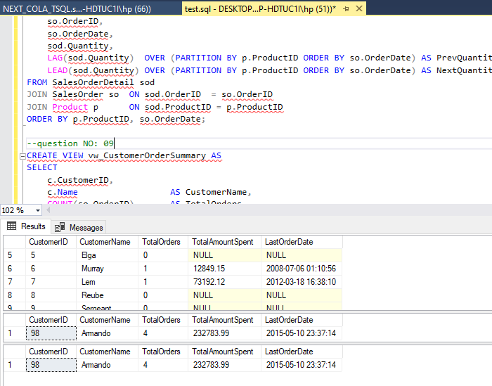

Question NO : 10
Write a stored procedure sp_GetSupplierSales that takes a SupplierID as input and returns the total sales amount for all products supplied by that supplier.

Query:
CREATE PROCEDURE sp_GetSupplierSales
@SupplierID INT
AS
BEGIN
-- Validate: Supplier exists or not
IF NOT EXISTS (SELECT 1 FROM Supplier WHERE SupplierID = @SupplierID)
BEGIN
RAISERROR('Supplier with ID %d does not exist.', 16, 1, @SupplierID);
RETURN;
END

SELECT
s.SupplierID,
s.Name AS SupplierName,
p.ProductID,
p.Name AS ProductName,
SUM(sod.TotalAmount) AS TotalSalesAmount
FROM Supplier s
JOIN PurchaseOrder po ON s.SupplierID = po.SupplierID
JOIN PurchaseOrderDetail pod ON po.OrderID = pod.OrderID
JOIN Product p ON pod.ProductID = p.ProductID
JOIN SalesOrderDetail sod ON p.ProductID = sod.ProductID
GROUP BY
s.SupplierID,
s.Name,
p.ProductID,
p.Name
ORDER BY TotalSalesAmount DESC;
END;

-- SupplierID = 4 ke liye
EXEC sp_GetSupplierSales @SupplierID = 4;

-- SupplierID = 99 ke liye (jo exist nahi karta)
EXEC sp_GetSupplierSales @SupplierID = 99;

Output Screenshot:
