Change class to className

Cart needs to be an empty array:

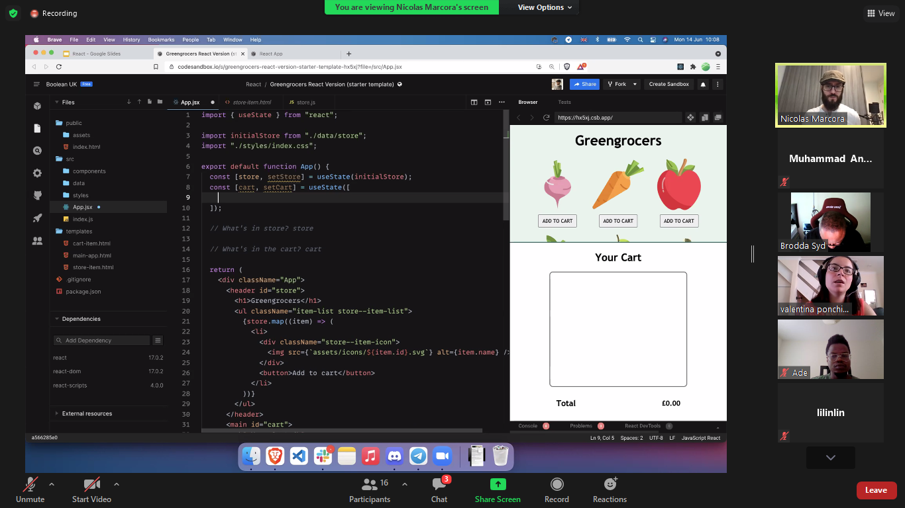

Just for testing, sir used and array with id and quantity(new) in it and used this code for cart:

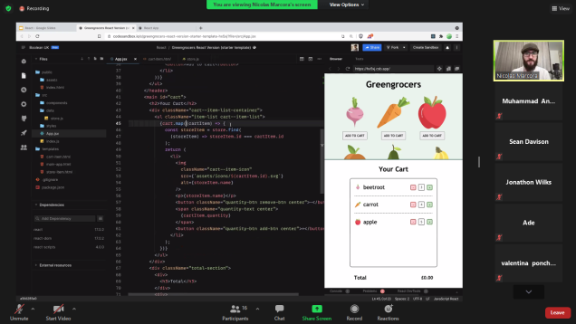

Code for total section:

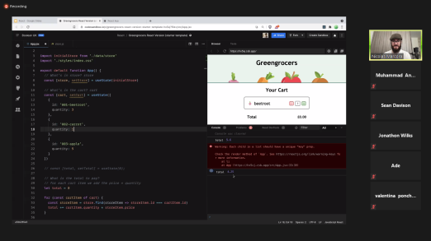

Add to cart (and) Increase quatity code:

