Heart Disease Risk Prediction
An End-to-End MLOps Pipeline
MLOps Experimental Learning Assignment 01
Course: AIMLCZG523 — Machine Learning Operations (MLOps)
BITS Pilani — Work Integrated Learning Programmes
Dataset: UCI Machine Learning Repository — Heart Disease (Cleveland)
Repository: https://github.com/anasaziz190392/heart-disease-mlops-project
Deployed API:
Heart Disease Risk Prediction API http://localhost:8000/docs
Grafana http://localhost:3000/
Prometheus http://localhost:9090/
Video: MLOps_Assignment01_Video

Author: Anas Aziz (2024AD05253)

1. Objective & Problem Statement
This project designs, develops, and deploys a scalable, reproducible machine learning solution that predicts the risk of heart disease from patient health data, following modern MLOps practices end to end: data acquisition, EDA, feature engineering, model development, experiment tracking, automated testing, CI/CD, containerization, cloud/Kubernetes deployment, and monitoring.
The classifier outputs a binary prediction — presence or absence of heart disease — along with a confidence score, served through a REST API (POST /predict) suitable for integration into a clinical decision-support workflow.

2. Dataset
Source: UCI Machine Learning Repository — Heart Disease Data Set (Cleveland Clinic Foundation subset, the only one of the four source hospitals used in all published experiments).
- 303 patient records, 13 clinical features (age, sex, chest pain type, resting blood pressure, cholesterol, fasting blood sugar, resting ECG, max heart rate, exercise-induced angina, ST depression, slope, number of major vessels, thalassemia).
- Original target ranges 0 (no disease) to 4 (severity); binarized per standard practice to 0 = absence, 1 = presence.
- 6 missing values (in 'ca' and 'thal', encoded as '?'), imputed using the column mode.
Acquisition: data/download_data.py attempts to download the raw file directly from the UCI repository, falling back to the locally shipped copy (from heart_disease.zip) when offline — see README §3.

3. Setup / Install Instructions
Clean environment setup:
- python -m venv .venv && source .venv/bin/activate
- pip install -r requirements.txt
- python data/download_data.py # acquire raw data
- python src/data_prep.py # clean -> data/processed/heart_clean.csv
- python src/eda.py # generate EDA plots
- python src/train.py # train, tune, track, save best model
- pytest tests/ -v --cov=src --cov=app # run the full test suite
- uvicorn app.main:app --host 0.0.0.0 --port 8000 # serve locally
- docker build -t heart-disease-api:latest . && docker run -p 8000:8000 heart-disease-api:latest
Full details, including Kubernetes and monitoring stack setup, are documented in the repository README.md.

4. Exploratory Data Analysis
Data cleaning handled missing values via mode-imputation on 'ca' and 'thal', enforced numeric dtypes across all columns, and binarized the target. No rows required dropping. The dataset is reasonably balanced (~54% no-disease vs ~46% disease), so accuracy remains meaningful while ROC-AUC, precision and recall are also tracked.
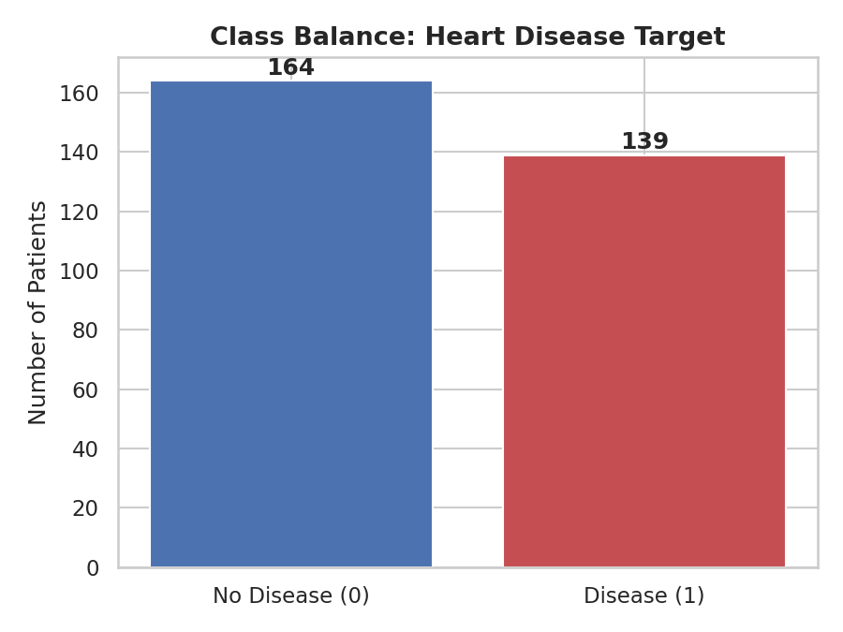
Figure 1: Class balance of the target variable.
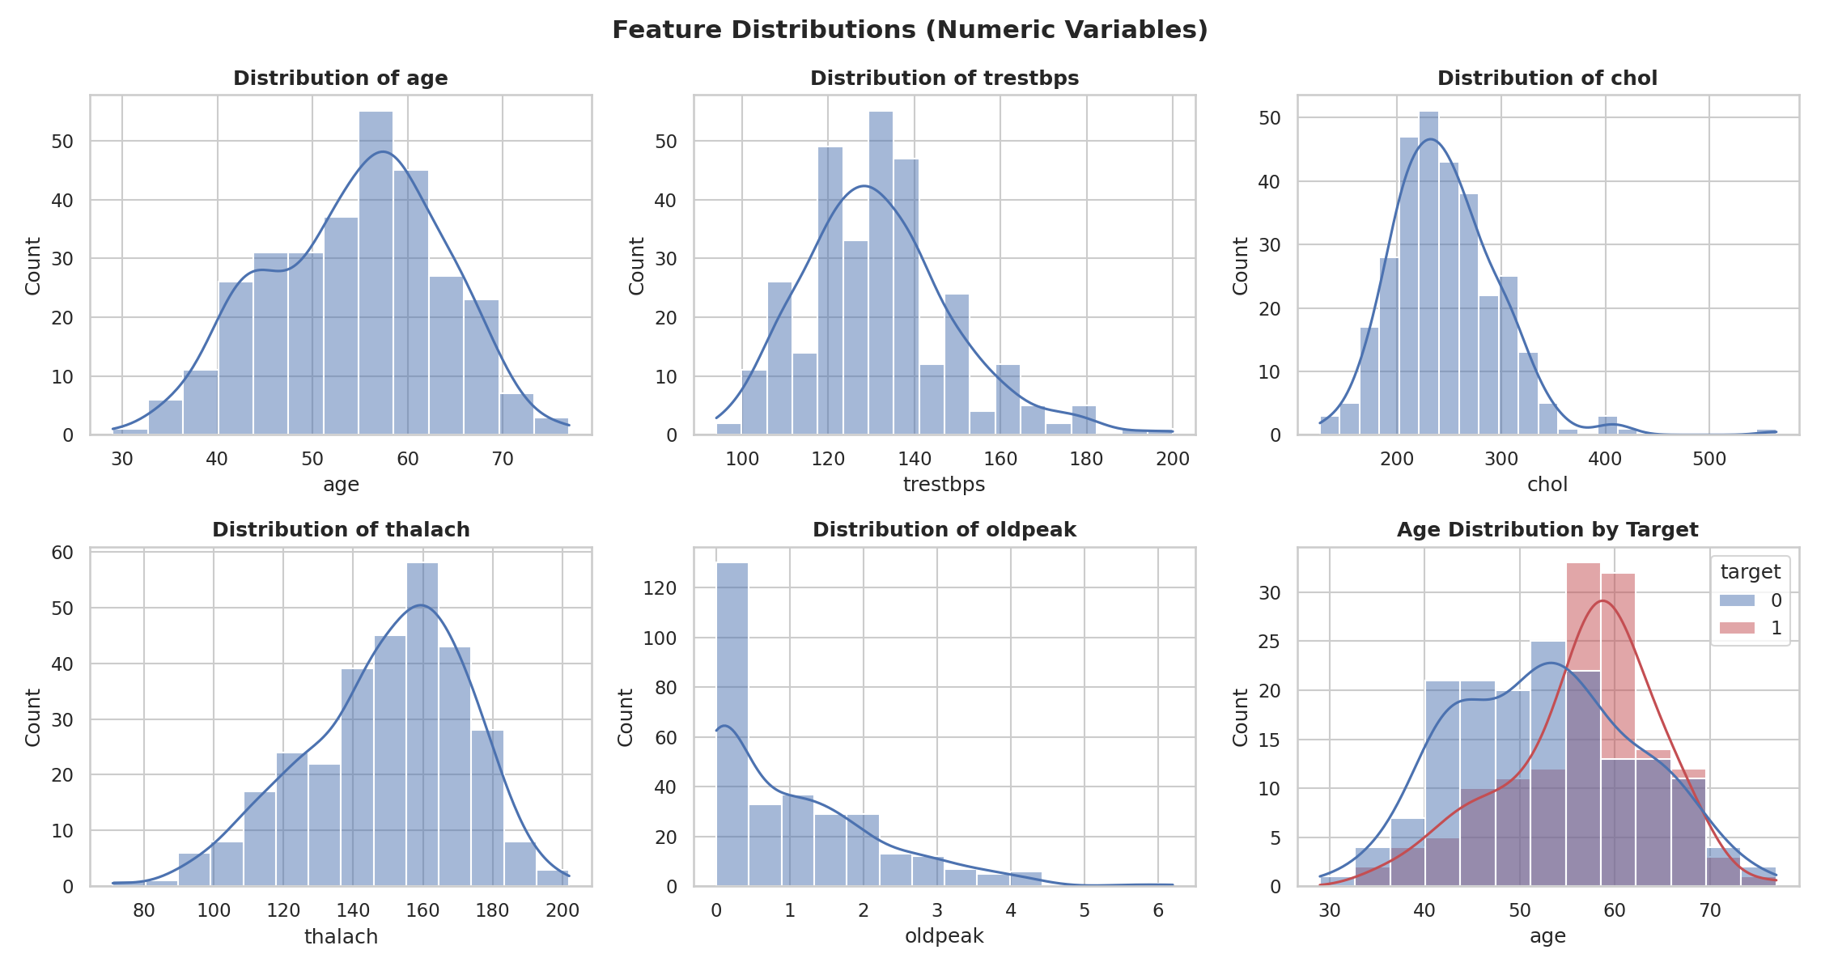
Figure 2: Distributions of numeric features, including age split by target.

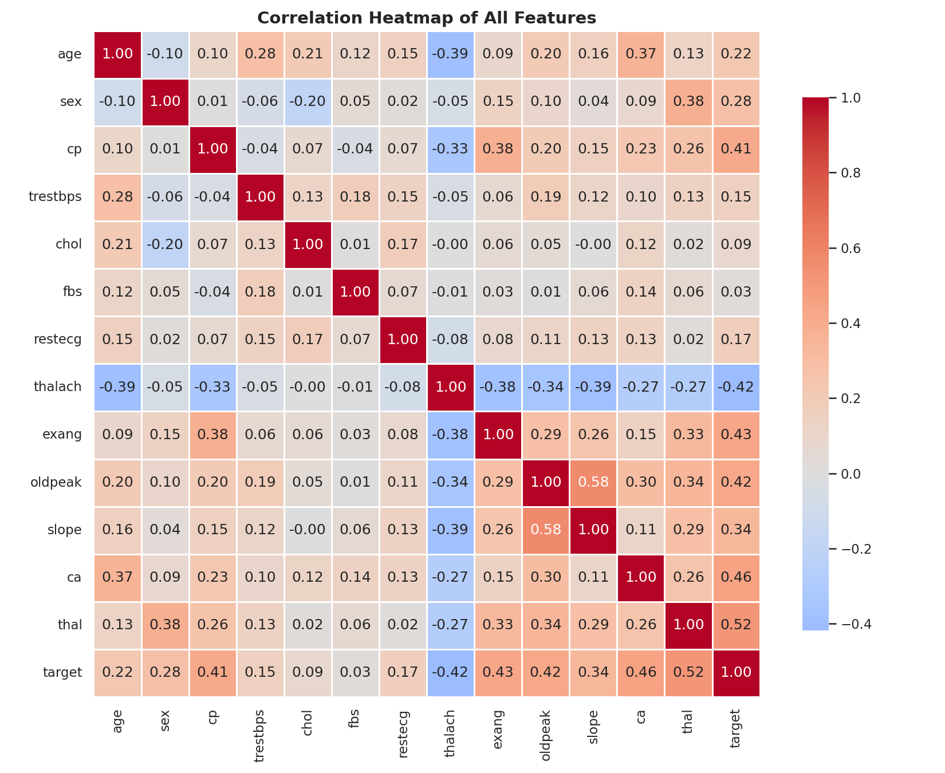
Figure 3: Correlation heatmap across all features and the target.
Key observations: chest pain type (cp), max heart rate (thalach), exercise-induced angina (exang), ST depression (oldpeak), number of major vessels (ca), and thalassemia (thal) show the strongest association with the presence of heart disease. Cholesterol and resting blood pressure show weaker linear correlation individually but remain clinically relevant and were retained as model features.
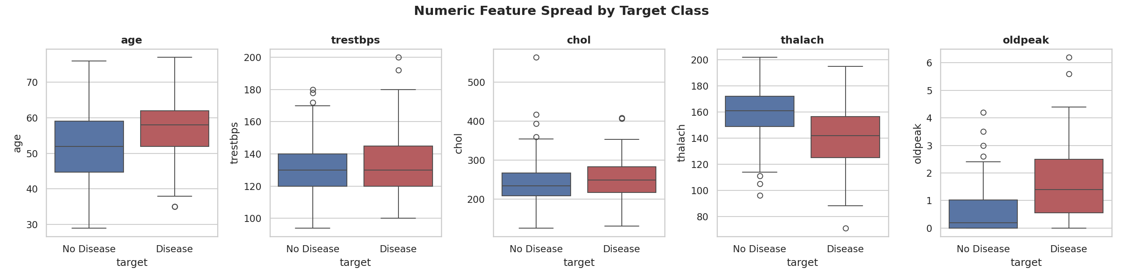
Figure 4: Spread of numeric features by target class.
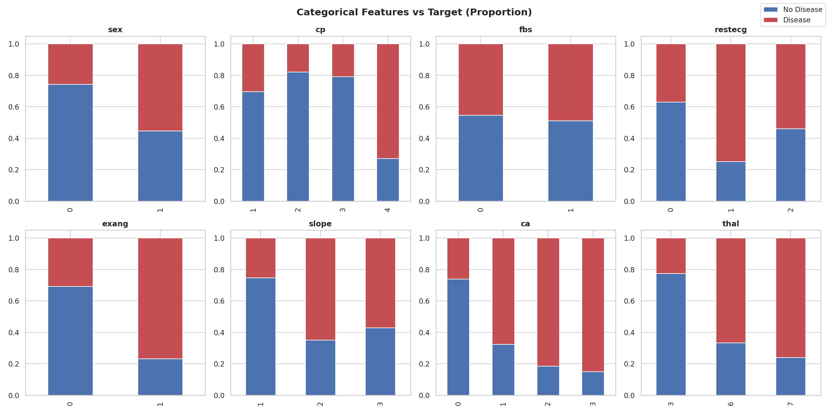
Figure 5: Proportion of disease presence across categorical feature levels.

5. Feature Engineering & Model Development

5.1 Feature Engineering
Numeric features (age, trestbps, chol, thalach, oldpeak) are standardized with StandardScaler. Categorical/ordinal-coded features (sex, cp, fbs, restecg, exang, slope, ca, thal) are one-hot encoded with handle_unknown='ignore' for robustness to unseen categories at inference time. Both transforms are bundled into a single sklearn ColumnTransformer (src/features.py), which is embedded inside the final serialized model Pipeline — eliminating train/serve skew.

5.2 Model Selection & Tuning
Two classifiers were trained and tuned via GridSearchCV with 5-fold stratified cross-validation, optimizing ROC-AUC:
- Logistic Regression — grid over C ∈ {0.01, 0.1, 1, 10}, L2 penalty, lbfgs solver.
- Random Forest — grid over n_estimators ∈ {100, 200, 300}, max_depth ∈ {None, 4, 6, 8}, min_samples_leaf ∈ {1, 2, 4}.
An 80/20 stratified train/test split (random_state=42) was held out for final, unbiased evaluation.

5.3 Results
Model | CV ROC-AUC | Accuracy | Precision | Recall | F1 | Test ROC-AUC
Logistic Regression | 0.903 | 0.885 | 0.839 | 0.929 | 0.881 | 0.966
Random Forest | 0.901 | 0.836 | 0.821 | 0.821 | 0.821 | 0.944

Logistic Regression was selected as the production model: it achieved the highest test ROC-AUC (0.966) and recall (0.929) — recall is prioritized in a screening context, since missing an at-risk patient (false negative) is more costly than a false alarm. Its best hyperparameters were C=1, penalty='l2', solver='lbfgs'.
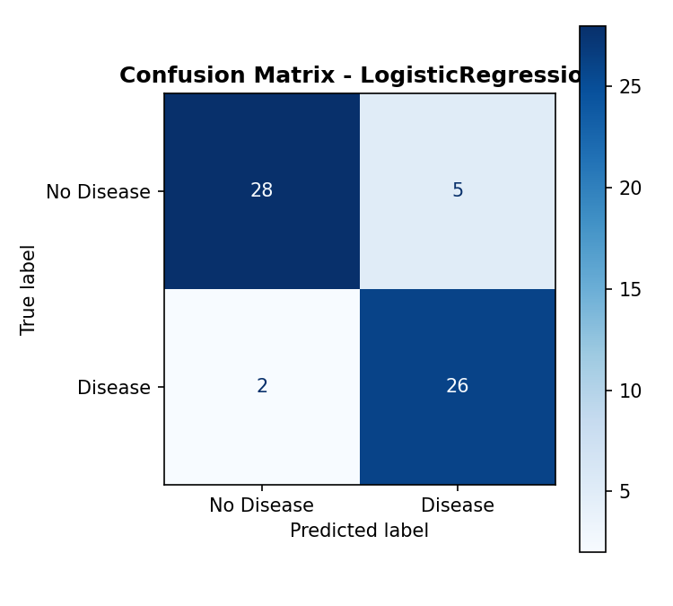
Figure 6: Confusion matrix — Logistic Regression (test set).
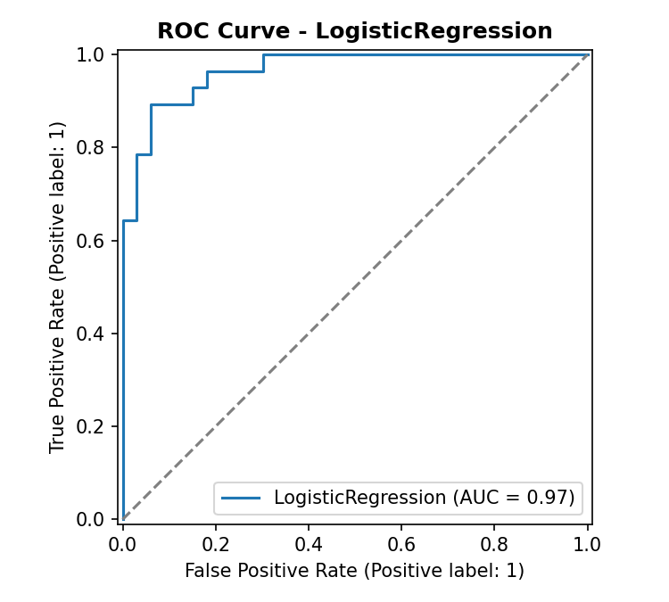
Figure 7: ROC curve — Logistic Regression (test set, AUC = 0.966).

6. Experiment Tracking (MLflow)
Every training run is tracked via MLflow (src/train.py, wrapped by src/mlflow_compat.py): experiment 'heart_disease_classification' contains one run per model. Each run logs:
- Parameters: model_type and the best hyperparameters found by GridSearchCV.
- Metrics: cv_best_roc_auc plus test accuracy, precision, recall, F1, and ROC-AUC.
- Artifacts: confusion-matrix and ROC-curve plots, and the fitted sklearn Pipeline itself (mlflow.sklearn.log_model).
Run `mlflow ui` (after `pip install -r requirements.txt`) to browse all runs, compare metrics, and download artifacts at http://localhost:5000. Insert a screenshot of the MLflow UI here: screenshots/01_mlflow_ui.png.

7. Model Packaging & Reproducibility
- Final model saved as models/model.pkl — a single sklearn Pipeline (preprocessing + classifier) via joblib, so a single artifact fully reproduces predictions with no separate preprocessing code needed at inference time.
- models/model_card.json records the chosen model, its test metrics, the exact feature list/order, target name, and random_state — enabling audit and reproducibility.
- requirements.txt pins exact versions for every dependency (pandas, scikit-learn, mlflow, fastapi, etc.).
- Fixed random_state=42 used consistently across the train/test split, cross-validation folds, and both models.

8. CI/CD Pipeline & Automated Testing

8.1 Unit Tests
tests/ contains pytest suites: test_data_prep.py (raw/clean data invariants — schema, row counts, no missing values, binary target), test_features.py (preprocessing pipeline correctness, including handling of unseen categories), test_model.py (trained model quality gate — minimum ROC-AUC/accuracy thresholds, valid probability output), and test_api.py (FastAPI endpoint contract tests — health check, valid/invalid prediction payloads, Prometheus metrics exposure).

8.2 GitHub Actions Pipeline
.github/workflows/ci-cd.yml defines four sequential jobs, each gated on the previous one succeeding (needs:):
- lint — flake8 and black --check across src/, app/, tests/.
- unit-tests — installs pinned dependencies, regenerates data + a trained model, runs the full pytest suite with coverage, and uploads the coverage report and model/plots as build artifacts.
- build-and-push-image — builds the Docker image with Buildx and pushes it to Docker Hub (main branch only), tagged both :latest and with the commit SHA.
- deploy — configures kubectl from a secret kubeconfig, substitutes the freshly-built image tag into k8s/deployment.yaml, and applies the Kubernetes manifests, waiting on kubectl rollout status.
Any failing step halts the pipeline and blocks downstream jobs, satisfying the production-readiness requirement that the pipeline fail loudly with clear logs. Insert a screenshot of a green Actions run here: screenshots/03_github_actions_run.png.

9. Model Containerization
The FastAPI app (app/main.py) is containerized with a slim, non-root Dockerfile that installs only serving dependencies (smaller attack surface / image size), copies in the trained model artifact, and defines a container HEALTHCHECK against /health.
- Endpoint: POST /predict — accepts a JSON patient record (13 typed, range-validated fields via Pydantic) and returns {prediction, risk_label, confidence}.
- GET /health — liveness/readiness probe used by Docker and Kubernetes.
- GET /metrics — Prometheus-format metrics (request counts by status, request latency histogram).
Verified locally with: docker build -t heart-disease-api:latest . && docker run -p 8000:8000 heart-disease-api:latest, followed by a curl POST to /predict with a sample patient record. Insert build/run screenshots here: screenshots/04_docker_build.png, screenshots/05_docker_run_curl.png.

10. Production Deployment
k8s/deployment.yaml defines a Deployment (2 replicas, CPU/memory requests & limits, readiness/liveness probes on /health, Prometheus scrape annotations) plus a HorizontalPodAutoscaler (2–5 replicas, target 70% CPU utilization). k8s/service.yaml exposes the Deployment via a type: LoadBalancer Service (port 80 → containerPort 8000) and an optional Ingress for clusters with an ingress controller.
For local testing (Minikube/Docker Desktop): build the image inside the cluster's Docker daemon, set image: heart-disease-api:latest with imagePullPolicy: Never, then kubectl apply -f k8s/. For a public cloud (GKE/EKS/AKS), the CI/CD pipeline pushes the image to a registry and substitutes the image reference automatically before kubectl apply. Insert screenshots of kubectl get pods,svc and the working endpoint here: screenshots/06_k8s_pods.png.
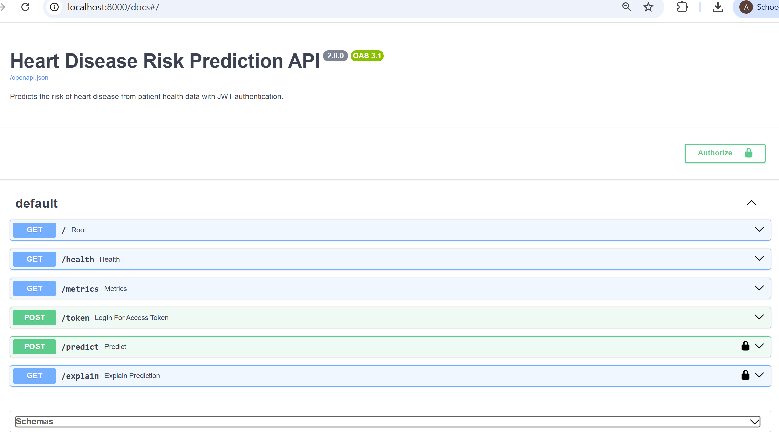

11. Monitoring & Logging
Every API request is logged (method, path, status code, latency, client) via a FastAPI middleware writing structured log lines. Prometheus scrapes /metrics every 15 seconds (monitoring/prometheus.yml); Grafana (provisioned automatically via monitoring/grafana/provisioning/) visualizes request rate by status, p95 latency, total requests, and error rate on a pre-built dashboard. Launch the full stack with docker compose up --build, then view Grafana at http://localhost:3000 (admin/admin). Insert dashboard screenshot here: screenshots/07_grafana_dashboard.png.
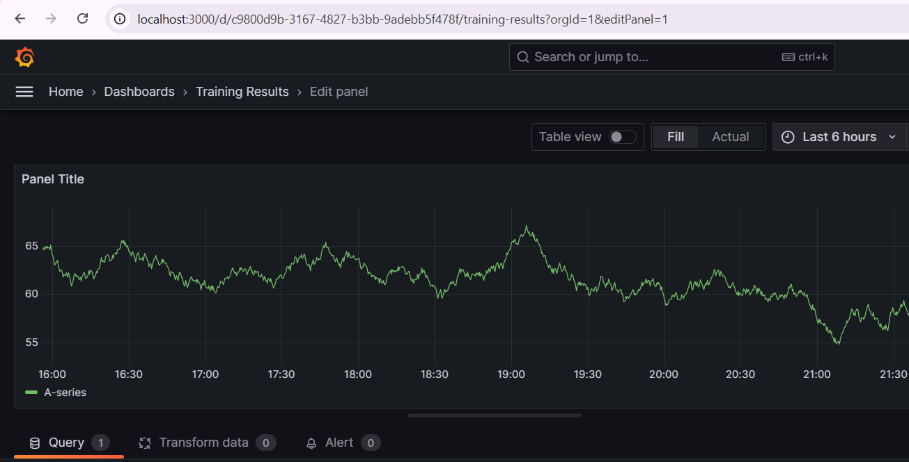

12. Architecture Diagram
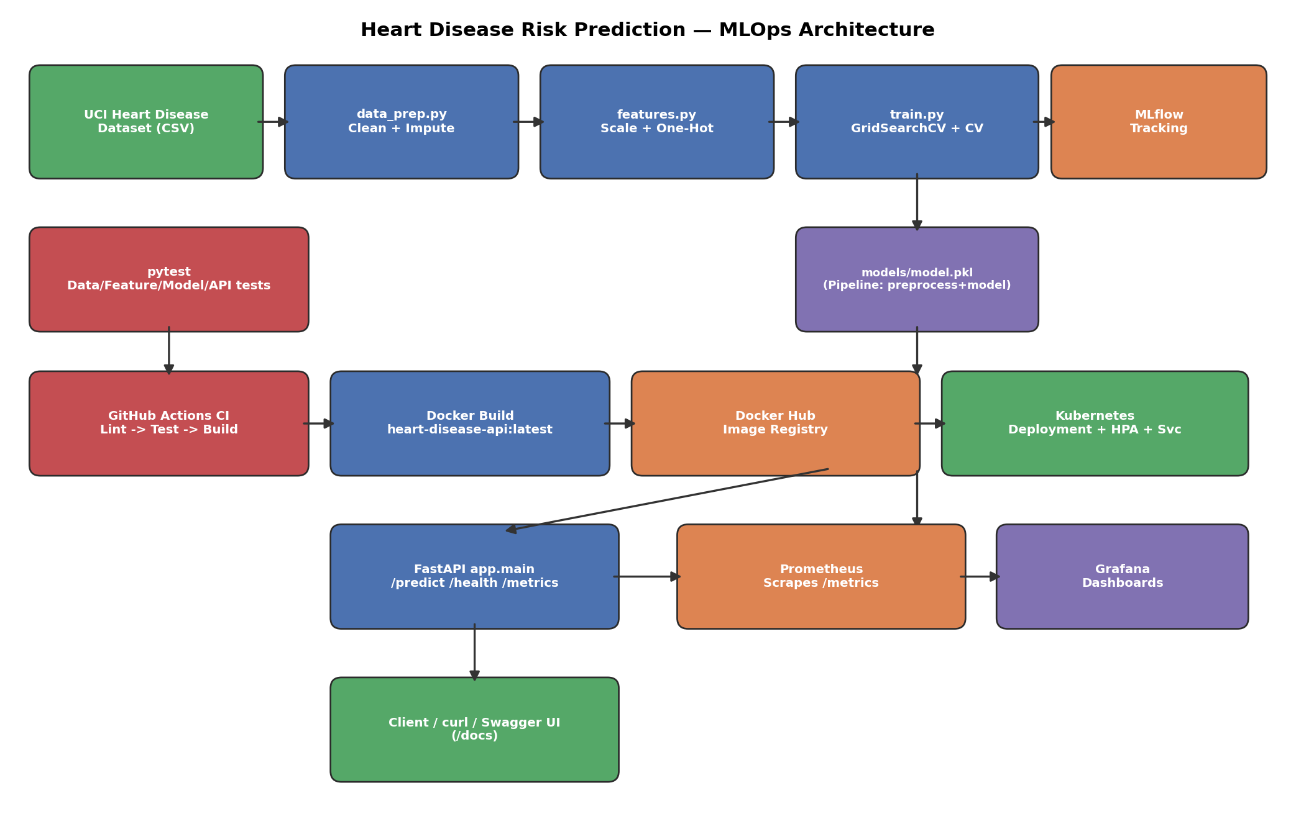
Figure 8: End-to-end MLOps architecture — from raw data through training, tracking, testing, CI/CD, containerization, Kubernetes deployment, and monitoring.

13. Conclusion & Future Work
This project delivers a reproducible, tested, containerized, and monitored ML service for heart disease risk prediction, with Logistic Regression (test ROC-AUC 0.966) selected over Random Forest as the production model. The full pipeline — from raw UCI data to a live Kubernetes-hosted, Prometheus/Grafana-monitored API — is automated via GitHub Actions.
Future improvements: (1) add data/model drift detection (e.g. Evidently AI) feeding back into a scheduled retraining trigger; (2) expand the training set with the Hungarian/Switzerland/VA cohorts (with careful handling of their higher missingness) to improve generalization; (3) add canary/blue-green deployment strategies in Kubernetes for zero-downtime model updates; (4) add authentication/rate-limiting to the public API.

14. Repository & Access
GitHub repository: https://github.com/anasaziz190392/heart-disease-mlops-project
Deployed API URL (if public) or local access instructions:
Heart Disease Risk Prediction API http://localhost:8000/docs
Grafana http://localhost:3000/
Prometheus http://localhost:9090/
Video walkthrough of the pipeline: MLOps_Assignment01_Video

Appendix A: Sample API Request / Response
Request:
POST /predict Content-Type: application/json { "age": 63, "sex": 1, "cp": 1, "trestbps": 145, "chol": 233, "fbs": 1, "restecg": 2, "thalach": 150, "exang": 0, "oldpeak": 2.3, "slope": 3, "ca": 0, "thal": 6 }
Response:
{ "prediction": 0, "risk_label": "Low Risk", "confidence": 0.8345 }

Appendix B: Field Reference
Field | Type | Description
age | float | Age in years
sex | int (0-1) | 1 = male, 0 = female
cp | int (1-4) | Chest pain type
trestbps | float | Resting blood pressure (mm Hg)
chol | float | Serum cholesterol (mg/dl)
fbs | int (0-1) | Fasting blood sugar > 120 mg/dl
restecg | int (0-2) | Resting ECG results
thalach | float | Max heart rate achieved
exang | int (0-1) | Exercise induced angina
oldpeak | float | ST depression induced by exercise
slope | int (1-3) | Slope of peak exercise ST segment
ca | int (0-3) | Number of major vessels colored by fluoroscopy
thal | int (3,6,7) | Thalassemia: normal / fixed defect / reversible defect

Appendix C: Repository Deliverables Checklist
- Code: data/, src/, app/ — acquisition, cleaning, features, training, inference, serving
- Dockerfile, docker-compose.yml, .dockerignore
- requirements.txt (pinned versions)
- Cleaned dataset (data/processed/heart_clean.csv) + download script (data/download_data.py)
- notebooks/01_eda.ipynb — interactive EDA walkthrough
- tests/ — pytest suite (data, features, model, API)
- .github/workflows/ci-cd.yml — GitHub Actions pipeline
- k8s/deployment.yaml, k8s/service.yaml — Deployment, HPA, Service, Ingress
- monitoring/ — Prometheus config + Grafana provisioning/dashboard
- screenshots/ — deployment and pipeline evidence (see screenshots/README.md for the required list)
- reports/final_report.docx — this report

