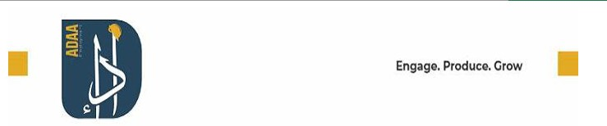

ADAA EMPLOYMENT L.L.C
Dubai
U.A.E TAX INVOICE
TRN 100476365000003
Invoice#  Invoice Date |  | : <invoice number>  : <invoice date> |  |  |  | Site: | <project name - project location>
Terms |  | : <terms>
Due Date |  | : <due date>
P.O.# |  | : <p.o (if available)>
Bill To
<Client Name>
<Client Address>
TRN <client trn>
Subject :
ADAA MANPOWER LABOR SUPPLY SERVICES FOR THE MONTH OF <Invoice Month - Year>
# | Item & Description |  | No. of Hours |  | Rate per  Hour (AED) |  | Tax % | Tax (AED) |  | Amount  (AED)
1 | <Skill>  <Rate Variant or Special Day> |  | 00.00 |  | 00.00 |  | 5.00 | 00.00 |  | 00.00
2 | BLOCK PLASTER MASON |  | 1,770.00 |  | 12.50 |  | 5.00 | 1,106.25 |  | 22,125.00
3 | SHUTTERING CARPENTER |  | 330.00 |  | 12.50 |  | 5.00 | 206.25 |  | 4,125.00
4 | HELPER |  | 8,160.00 |  | 11.00 |  | 5.00 | 4,488.00 |  | 89,760.00
Total No. of Hours <total hours> |  |  |  |  |  |  | Total Taxable Amount |  | 00.00
Total In Words  UAE <Amount in rupees (may go to next row> |  |  |  |  |  |  | Standard Rate (5%)  Total |  | 00.00  AED 00,00.00
<Amount in rupees (continuation from previous row)> |  |  |  |  |  |  | Balance Due |  | AED 00.00
Notes
<Notes>

Bank Details

A/C No.:019100470662 A/C Name :ADAA Employment LLC
IBAN No. :AE750330000019100470662 Branch Name:Sheikh Zayed Road Bank Name :MASHREQ BANK

IMPORTANT NOTE:

NOTE 1: ANY ERROR IN THE INVOICE SHOULD BE NOTIFIED WITHIN 5 WORKING DAYS-ELSE WE WILL ASSUME THAT THE INVOICE IS CORRECT.
NOTE 2: AS PER THE CONTRACT; PAYMENT SHOULD BE CALCULATED FROM THE DATE OF INVOICE.
207 Al Asmawi Building DIP 1, Dubai,UAE info@adaaemployment.com - www,employment.com
+971 4 398 1139 - P.O. Box : 393539

