***Visual Programming Lab***

***CSL-313***

***Lab Journal***



**Student Name: M. Anas Baig**

**Enrolment No.: 01-134152-037**

**Class and Section: BS(CS)-5A**

**Department of Computer Science**

**BAHRIA UNIVERSITY, ISLAMABAD**

**Task # 1.1:**

**Write a console application in C# that takes input of 2 numbers from the user and displays the entered numbers on console output.**

**Procedure/Program:**

1. **using** System;
2. **using** System.Collections.Generic;
3. **using** System.Linq;
4. **using** System.Text;
6. **namespace** ConsoleApplication1
7. {
8. **class** Program
9. {
10. **static** **void** Main(**string**[] args)
11. {
12. Console.WriteLine("Enter A:");
13. **string** a = Console.ReadLine(); //reading input from keyboard
14. Console.WriteLine("Enter B:");
15. **string** b = Console.ReadLine(); //reading input from keyboard
17. **int** A = **int**.Parse(a); //converting string to int
18. **int** B = **int**.Parse(b); //converting string to int
20. Console.WriteLine("\nValue of A:");
21. Console.WriteLine(A);
22. Console.WriteLine("Value of B:");
23. Console.WriteLine(B);
25. Console.ReadKey(); //to stop console from closing automatically
26. }
27. }
28. }

**Result/Output:**

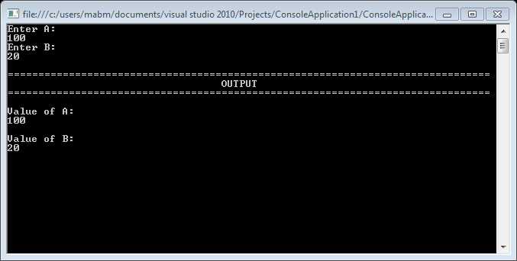

**Task # 1.2:**

**Write a console application in C# that takes input of 2 numbers from the user and displays the entered numbers and their sum on console output.**

**Procedure/Program:**

1. **using** System;
2. **using** System.Collections.Generic;
3. **using** System.Linq;
4. **using** System.Text;
6. **namespace** smjConsoleApplication1
7. {
8. **class** Program
9. {
10. **static** **int** add(**int** a, **int** b) //function to calculate sum
11. {
12. **return** (a + b);
13. }
15. **static** **void** Main(**string**[] args)
16. {
17. Console.WriteLine("Enter A:");
18. **string** a = Console.ReadLine(); //reading input from keyboard
19. Console.WriteLine("Enter B:");
20. **string** b = Console.ReadLine(); //reading input from keyboard
22. **int** A = **int**.Parse(a); //converting string to int
23. **int** B = **int**.Parse(b); //converting string to int
25. Console.WriteLine("\n===============================================================================");
26. Console.WriteLine("                                   OUTPUT                                      ");
27. Console.WriteLine("===============================================================================");
29. Console.WriteLine("\nValue of A:");
30. Console.WriteLine(A);
31. Console.WriteLine("\nValue of B:");
32. Console.WriteLine(B);
33. Console.WriteLine("\nSum:");
34. **int** sum = add(A, B); //function calling
35. Console.WriteLine(sum);
37. Console.ReadKey(); //to stop console from closing automatically
38. }
39. }
40. }

**Result/Output:**

