***Visual Programming Lab***

***CSL-313***

***Lab Journal 6***



**Student Name: M. Anas Baig**

**Enrolment No.: 01-134152-037**

**Class and Section: BS(CS)-5A**

**Department of Computer Science**

**BAHRIA UNIVERSITY, ISLAMABAD**

**Visual Programming**

**Lab Journal - Lab 06**

Name: ________M. Anas Baig______________

Enrollment #: _________0-134152-037____________

Class/Section: __________BS(CS)-5A_______________

**Objective**

The Objective of this lab are to understand the following concepts

* Menu Strip
* Main Menu
* Contextual Menu

**Task 1 :**

Implement the following exercises.

**Exercise 1**

|  |
| --- |
| Write a program that implements the examples program provided in the lab manual with the help of context menu illustration given below    If the user click on the red menu then the colour of the Label text also changed to red and so on. |

**Source Code :**

**Form1.cs File :**

1. **using** System;
2. **using** System.Collections.Generic;
3. **using** System.ComponentModel;
4. **using** System.Data;
5. **using** System.Drawing;
6. **using** System.Linq;
7. **using** System.Text;
8. **using** System.Windows.Forms;
10. **namespace** Lab6_Ex1
11. {
12. **public** partial **class** Form1 : Form
13. {
14. **public** Form1()
15. {
16. InitializeComponent();
17. }
19. **private** **void** bahriaUniversityToolStripMenuItem_Click(**object** sender, EventArgs e)
20. {
21. label1.ForeColor = Color.Blue;
22. }
24. **private** **void** label1_Click(**object** sender, EventArgs e)
25. {
27. }
29. **private** **void** blackToolStripMenuItem_Click(**object** sender, EventArgs e)
30. {
31. label1.ForeColor = Color.Black;
32. }
34. **private** **void** redToolStripMenuItem_Click(**object** sender, EventArgs e)
35. {
36. label1.ForeColor = Color.Red;
37. }
38. }
39. }

**Form Output :**

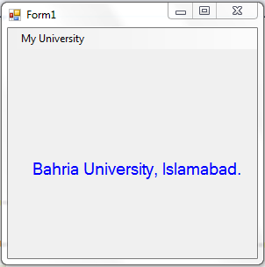

**Exercise 2**

|  |
| --- |
| Write a Program that Implements the functionality of the following design given below    **Create a menu strip which inlcudes on the car names and help menus. If the user click on any of the car name it will display the picture of that cars plus the details of the car mention at the buttom of the design picture and so on. The help menu includes overall description of the following design.** |

**Source Code :**

**Form1.cs File :**

1. **using** System;
2. **using** System.Collections.Generic;
3. **using** System.ComponentModel;
4. **using** System.Data;
5. **using** System.Drawing;
6. **using** System.Linq;
7. **using** System.Text;
8. **using** System.Windows.Forms;
10. **namespace** Lab6_Ex2
11. {
12. **public** partial **class** Form1 : Form
13. {
14. **public** Form1()
15. {
16. InitializeComponent();
17. }
19. **private** **void** audiToolStripMenuItem_Click(**object** sender, EventArgs e)
20. {
21. pictureBox1.ImageLocation = "C:/Users/MABM/Desktop/1.png";
22. label5.Text = "2016"; //model
23. label6.Text = "Audi"; //brand
24. label7.Text = "Black"; //colour
25. label8.Text = "2500cc"; //engine power
26. }
28. **private** **void** pictureBox1_Click(**object** sender, EventArgs e)
29. {
31. }
33. **private** **void** mercedesToolStripMenuItem_Click(**object** sender, EventArgs e)
34. {
35. pictureBox1.ImageLocation = "C:/Users/MABM/Desktop/2.png";
36. label5.Text = "2015"; //model
37. label6.Text = "Mercedes"; //brand
38. label7.Text = "Black"; //colour
39. label8.Text = "3000cc"; //engine power
40. }
42. **private** **void** toyotaToolStripMenuItem_Click(**object** sender, EventArgs e)
43. {
44. pictureBox1.ImageLocation = "C:/Users/MABM/Desktop/3.png";
45. label5.Text = "2017"; //model
46. label6.Text = "Toyota"; //brand
47. label7.Text = "Red"; //colour
48. label8.Text = "3000cc"; //engine power
49. }
51. **private** **void** hondaToolStripMenuItem_Click(**object** sender, EventArgs e)
52. {
53. pictureBox1.ImageLocation = "C:/Users/MABM/Desktop/4.png";
54. label5.Text = "2012"; //model
55. label6.Text = "Honda"; //brand
56. label7.Text = "Black"; //colour
57. label8.Text = "3500cc"; //engine power
58. }
59. }
60. }

**Form Output:**

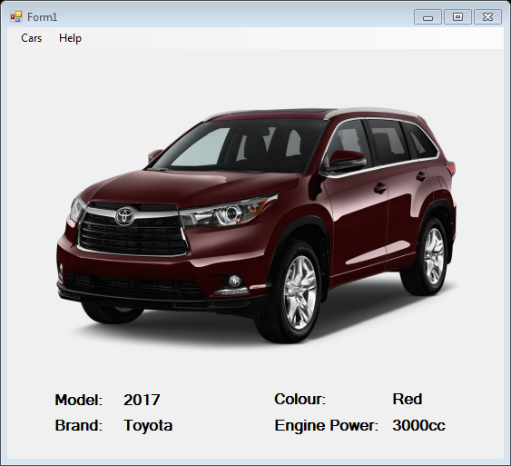

**Exercise 3**

|  |
| --- |
| Write a program that implements the functionality of the following design illusterated below    Create a menu strip which includes on different size matrices. Initially the textboxes are showing in the picture will be invisible. If the user click on any of the size matrices it will generate the matrices of that specific size i.e matrix 1 & 2. After that it asks the user to enter the values of these matrices. If the user click on the add radio button it will display the addition result of these two matrices in the ‘Answer’ Matrix and vice versa. |
|  |

**Source Code :**

**Form1.cs File :**

1. **using** System;
2. **using** System.Collections.Generic;
3. **using** System.ComponentModel;
4. **using** System.Data;
5. **using** System.Drawing;
6. **using** System.Linq;
7. **using** System.Text;
8. **using** System.Windows.Forms;
10. **namespace** Lab6_Ex3
11. {
12. **public** partial **class** Form1 : Form
13. {
14. **public** Form1()
15. {
16. InitializeComponent();
17. initialHide();
18. }
20. **private** **void** matrixToolStripMenuItem_Click(**object** sender, EventArgs e)
21. {
23. }
25. **private** **void** Form1_Load(**object** sender, EventArgs e)
26. {
28. }
30. **private** **void** radioButton1_CheckedChanged(**object** sender, EventArgs e)
31. {
32. textBox19.Text = Convert.ToString(**int**.Parse(textBox1.Text) + **int**.Parse(textBox10.Text));
33. textBox20.Text = Convert.ToString(**int**.Parse(textBox2.Text) + **int**.Parse(textBox11.Text));
34. textBox21.Text = Convert.ToString(**int**.Parse(textBox3.Text) + **int**.Parse(textBox12.Text));
35. textBox22.Text = Convert.ToString(**int**.Parse(textBox4.Text) + **int**.Parse(textBox13.Text));
36. textBox23.Text = Convert.ToString(**int**.Parse(textBox5.Text) + **int**.Parse(textBox14.Text));
37. textBox24.Text = Convert.ToString(**int**.Parse(textBox6.Text) + **int**.Parse(textBox15.Text));
38. textBox25.Text = Convert.ToString(**int**.Parse(textBox7.Text) + **int**.Parse(textBox16.Text));
39. textBox26.Text = Convert.ToString(**int**.Parse(textBox8.Text) + **int**.Parse(textBox17.Text));
40. textBox27.Text = Convert.ToString(**int**.Parse(textBox9.Text) + **int**.Parse(textBox18.Text));
41. }
43. **private** **void** x2MatrixToolStripMenuItem_Click(**object** sender, EventArgs e)
44. {
45. initialHide();
46. textBox1.Show(); textBox2.Show(); textBox4.Show(); textBox5.Show();
47. textBox10.Show(); textBox11.Show(); textBox13.Show(); textBox14.Show();
48. textBox19.Show(); textBox20.Show(); textBox22.Show(); textBox23.Show();
49. }
51. **private** **void** x3MatrixToolStripMenuItem_Click(**object** sender, EventArgs e)
52. {
53. initialHide();
54. textBox1.Show(); textBox2.Show(); textBox3.Show(); textBox4.Show(); textBox5.Show(); textBox6.Show(); textBox7.Show(); textBox8.Show(); textBox9.Show(); textBox10.Show(); textBox11.Show(); textBox12.Show(); textBox13.Show(); textBox14.Show(); textBox15.Show(); textBox16.Show(); textBox17.Show(); textBox18.Show(); textBox19.Show(); textBox20.Show(); textBox21.Show(); textBox22.Show(); textBox23.Show(); textBox24.Show(); textBox25.Show(); textBox26.Show(); textBox27.Show();
55. }
57. **public** **void** initialHide()
58. {
59. textBox1.Hide();textBox2.Hide();textBox3.Hide();textBox4.Hide();textBox5.Hide();textBox6.Hide();textBox7.Hide();textBox8.Hide();textBox9.Hide();textBox10.Hide();textBox11.Hide();textBox12.Hide();textBox13.Hide();textBox14.Hide();textBox15.Hide();textBox16.Hide();textBox17.Hide();textBox18.Hide();textBox19.Hide();textBox20.Hide();textBox21.Hide();textBox22.Hide();textBox23.Hide();textBox24.Hide();textBox25.Hide();textBox26.Hide();textBox27.Hide();
61. }
63. **private** **void** textBox10_TextChanged(**object** sender, EventArgs e)
64. {
66. }
68. **private** **void** radioButton2_CheckedChanged(**object** sender, EventArgs e)
69. {
70. textBox19.Text = Convert.ToString(**int**.Parse(textBox1.Text) - **int**.Parse(textBox10.Text));
71. textBox20.Text = Convert.ToString(**int**.Parse(textBox2.Text) - **int**.Parse(textBox11.Text));
72. textBox21.Text = Convert.ToString(**int**.Parse(textBox3.Text) - **int**.Parse(textBox12.Text));
73. textBox22.Text = Convert.ToString(**int**.Parse(textBox4.Text) - **int**.Parse(textBox13.Text));
74. textBox23.Text = Convert.ToString(**int**.Parse(textBox5.Text) - **int**.Parse(textBox14.Text));
75. textBox24.Text = Convert.ToString(**int**.Parse(textBox6.Text) - **int**.Parse(textBox15.Text));
76. textBox25.Text = Convert.ToString(**int**.Parse(textBox7.Text) - **int**.Parse(textBox16.Text));
77. textBox26.Text = Convert.ToString(**int**.Parse(textBox8.Text) - **int**.Parse(textBox17.Text));
78. textBox27.Text = Convert.ToString(**int**.Parse(textBox9.Text) - **int**.Parse(textBox18.Text));
79. }
81. **private** **void** radioButton3_CheckedChanged(**object** sender, EventArgs e)
82. {
83. textBox19.Text = Convert.ToString((**int**.Parse(textBox1.Text)\***int**.Parse(textBox10.Text))+(**int**.Parse(textBox2.Text)\***int**.Parse(textBox13.Text))+(**int**.Parse(textBox3.Text)\***int**.Parse(textBox16.Text)));
84. textBox20.Text = Convert.ToString((**int**.Parse(textBox1.Text)\***int**.Parse(textBox11.Text))+(**int**.Parse(textBox2.Text)\***int**.Parse(textBox14.Text))+(**int**.Parse(textBox3.Text)\***int**.Parse(textBox17.Text)));
85. textBox21.Text = Convert.ToString((**int**.Parse(textBox1.Text)\***int**.Parse(textBox12.Text))+(**int**.Parse(textBox2.Text)\***int**.Parse(textBox15.Text))+(**int**.Parse(textBox3.Text)\***int**.Parse(textBox18.Text)));
86. textBox22.Text = Convert.ToString((**int**.Parse(textBox4.Text)\***int**.Parse(textBox10.Text))+(**int**.Parse(textBox5.Text)\***int**.Parse(textBox13.Text))+(**int**.Parse(textBox6.Text)\***int**.Parse(textBox16.Text)));
87. textBox23.Text = Convert.ToString((**int**.Parse(textBox4.Text)\***int**.Parse(textBox11.Text))+(**int**.Parse(textBox5.Text)\***int**.Parse(textBox14.Text))+(**int**.Parse(textBox6.Text)\***int**.Parse(textBox17.Text)));
88. textBox24.Text = Convert.ToString((**int**.Parse(textBox4.Text)\***int**.Parse(textBox12.Text))+(**int**.Parse(textBox5.Text)\***int**.Parse(textBox15.Text))+(**int**.Parse(textBox6.Text)\***int**.Parse(textBox18.Text)));
89. textBox25.Text = Convert.ToString((**int**.Parse(textBox7.Text)\***int**.Parse(textBox10.Text))+(**int**.Parse(textBox8.Text)\***int**.Parse(textBox13.Text))+(**int**.Parse(textBox9.Text)\***int**.Parse(textBox16.Text)));
90. textBox26.Text = Convert.ToString((**int**.Parse(textBox7.Text)\***int**.Parse(textBox11.Text))+(**int**.Parse(textBox8.Text)\***int**.Parse(textBox14.Text))+(**int**.Parse(textBox9.Text)\***int**.Parse(textBox17.Text)));
91. textBox27.Text = Convert.ToString((**int**.Parse(textBox7.Text) * **int**.Parse(textBox11.Text)) + (**int**.Parse(textBox8.Text) * **int**.Parse(textBox15.Text)) + (**int**.Parse(textBox9.Text) * **int**.Parse(textBox18.Text)));
92. }
94. **private** **void** menuStrip1_ItemClicked(**object** sender, ToolStripItemClickedEventArgs e)
95. {
97. }
98. }
99. }

**Form Output:**

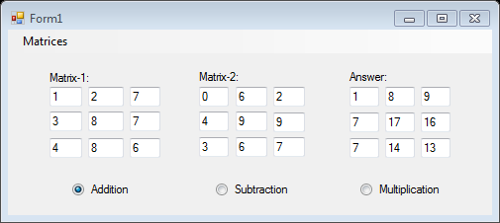

**Implement the given exercises and get them checked by your instructor. If you are unable to complete the tasks in the lab session, deposit this journal alongwith your programs (printed or handwritten) before the start of the next lab session.**

|  |  |  |
| --- | --- | --- |
| **S No.** | **Exercise** | **Checked By:** |
| 1. | Exercise 1 |  |
| 2. | Exercise 2 |  |
| 3. | Exercise 3 |  |