**DIGITAL LOGIC DESIGN (EL1005)**



**DIGITAL COUNTER**

ANAS BIN RASHID (22I-0907)

**OUTLINE**

1. PROJECT DESCRIPTION 1

2. OBJECTIVES 2

3. METHODOLOGY 2

Circuit Diagram 2

Block Diagram 3

Flow Chart 4

Proteus Diagram 5

4. HARDWARE COMPONENTS 6

5. IMPLEMENTATION PROCEDURE 7

Circuit Assembly on Proteus 7

Circuit Assembly on Breadboard 7

6. SIMULATION RESULTS 8

7. CONCLUSION 11

8. REFERENCES 11

# PROJECT DESCRIPTION

The Digital Counter project embarks on the creation of a digital counter circuit, designed to effortlessly count from 00 to 99 at the mere press of a button. This ambitious endeavor harnesses the power of key components, including the versatile 4026 ICs, the 555 Timer IC, a responsive push button, essential jumper wires, a breadboard, a 9V battery, and 7-segment displays. The circuit is meticulously realized through the integration of Proteus software for virtual simulations and a physical breadboard for real-world implementation.

At the heart of the circuit lies the ingenious implementation of the 4026 ICs, enabling flawless counting functionality. Orchestrating the timing and carry process with finesse, the revered 555 Timer IC ensures accurate synchronization throughout the counting sequence. The inclusion of a tactile push button allows users to initiate the counting process. Jumper wires, serving as the circuit's neural pathways, meticulously connect and guide the flow of signals, facilitating seamless communication between components.

The Digital Counter project serves as a testament to the team's unwavering pursuit of technological innovation and craftsmanship. By harnessing the potential of electronic components and leveraging meticulous design and implementation techniques, the project showcases a captivating fusion of intellect, creativity, and technical acumen.

# OBJECTIVES

The primary aims of this project encompass:1. Formulating and fabricating a digital counter circuit capable of incrementing from 00 to 99.2. Executing the circuit implementation utilizing 4026 ICs to facilitate counting operations and employing 7-segment displays to render visual output.3. Employing the 555 Timer IC to govern the timing and carry process, ensuring precise synchronization.4. Integrating a push button mechanism to initiate the counting process, thereby enabling user interaction.5. Scrutinizing and validating the digital counter circuit's functionality through meticulous testing procedures.

By adhering to these objectives, the project aspires to accomplish the construction of a functional and efficient digital counter circuit, showcasing intricate electronic design and assembly techniques.

# METHODOLOGY

## Circuit Diagram

The circuit diagram provides a visual representation of the digital counter circuit, showcasing the interconnections and arrangement of components. It illustrates the connections between the 4026 ICs, 555 Timer IC, push button, 7-segment displays, and other necessary components. The circuit diagram serves as a blueprint for building the circuit and understanding the flow of signals within the system.

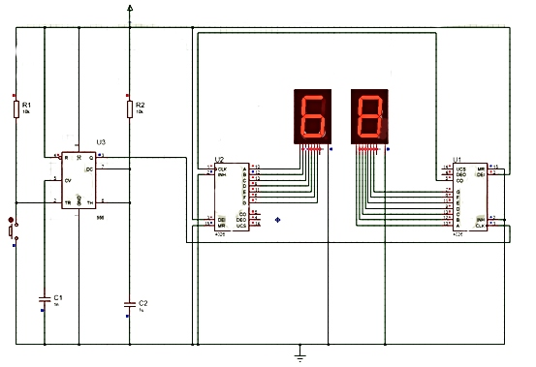

Figure *Circuit Diagram*

## Block Diagram

The block diagram presents a high-level overview of the digital counter circuit, depicting the major functional blocks and their interrelationships. It highlights the key components involved, such as the 4026 ICs, 555 Timer IC, push button, and 7-segment displays. The block diagram helps in understanding the overall architecture and organization of the circuit, facilitating a clear understanding of how different components interact.

Figure *Block Diagram*

## Flow Chart

This flowchart outlines the sequential steps involved in the creation of the project, starting from defining the project scope and gathering requirements, to designing the circuit diagram, selecting components, assembling the circuit on Proteus for simulation and testing, refining the design, setting up the breadboard, testing the circuit's functionality,

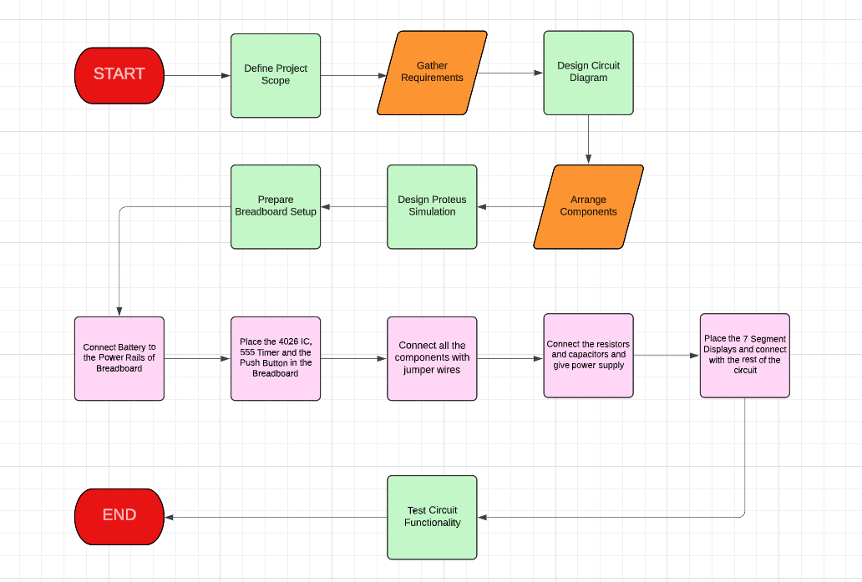

Figure *Flowchart*

## Proteus Diagram

The Proteus diagram showcases the virtual implementation of the digital counter circuit using Proteus software. It includes the placement of components on the virtual breadboard, their connections, and any additional simulation settings. The Proteus diagram demonstrates the practical realization of the circuit design in a virtual environment, enabling testing and verification of functionality before physical implementation.

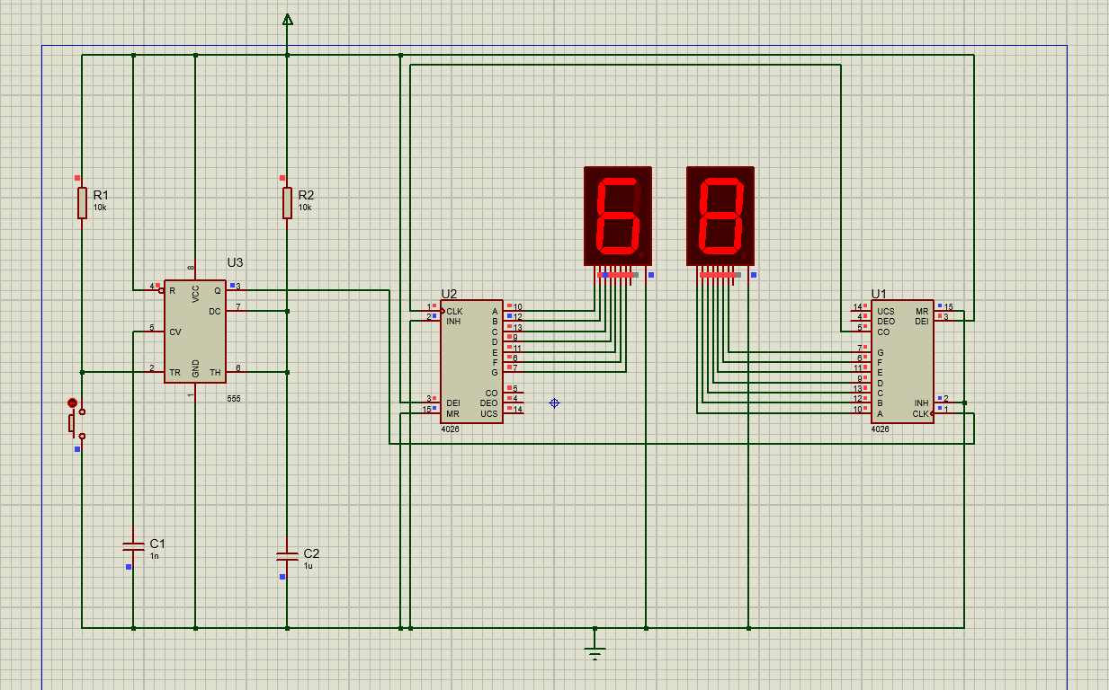

Figure *Proteus Implementation*

# HARDWARE COMPONENTS

The list of hardware components used in the project includes:1. 2x 4026 ICs2. 555 Timer IC3. Push Button4. Jumper Wires5. Breadboard6. 9V Battery7. 2x 7-Segment Display8. Resistors (10k & 22k)9. Capacitors (22uF & 1uF)

# IMPLEMENTATION PROCEDURE

The implementation was done in two parts which have been explained as follows:

## Circuit Assembly on Proteus

1. Launch Proteus software and create a new project.
2. Arrange the required components on the workspace, including two 4026 ICs, a 555 Timer IC, a push button, two 7-segment displays, resistors (10k and 20k), and capacitors (22uF and 1uF).
3. Connect the VCC and GND pins of the components based on the circuit diagram, ensuring proper power distribution and grounding.
4. Connect the CLK (clock) input of the first 4026 IC to the output of the 555 Timer IC, which will regulate the counting timing.
5. Connect the Q0 to Q9 outputs of the first 4026 IC to the A to G inputs of the first 7-segment display.
6. Establish the carry connection by connecting the carry output (CO) of the first 4026 IC to the CLK input of the second 4026 IC.
7. Connect the Q0 to Q9 outputs of the second 4026 IC to the A to G inputs of the second 7-segment display.
8. Connect the push button to the reset (MR) pin of both 4026 ICs, enabling the reset functionality when pressed.
9. Verify and double-check all the connections to ensure accuracy and proper signal flow.
10. Save the project and simulate the circuit in Proteus to validate its functionality and performance.

## Circuit Assembly on Breadboard

1. Gather all the necessary components, including two 4026 ICs, a 555 Timer IC, a push button, jumper wires, a breadboard, a 9V battery, two 7-segment displays, resistors (10k and 20k), and capacitors (22uF and 1uF).
2. Begin by placing the components on the breadboard, following the layout depicted in the circuit diagram.
3. Connect the VCC and GND pins of the components to the respective power and ground rails on the breadboard, ensuring proper power distribution.
4. Connect the CLK (clock) input of the first 4026 IC to a suitable point on the breadboard to receive the clock signal from the 555 Timer IC.
5. Connect the Q0 to Q9 outputs of the first 4026 IC to the corresponding inputs of the first 7-segment display, adhering to the pin connections specified in the circuit diagram.
6. Establish the carry connection by linking the carry output (CO) of the first 4026 IC to the CLK input of the second 4026 IC.
7. Connect the Q0 to Q9 outputs of the second 4026 IC to the A to G of the second 7-segment display.
8. Connect the push button to the reset (MR) pin of both 4026 ICs, allowing for resetting the counter when the button is pressed.
9. Thoroughly inspect and review all the connections to ensure their accuracy and stability on the breadboard.
10. Insert the 9V battery into the appropriate slot on the breadboard to power the circuit.
11. Verify the connections once again, checking for any potential short circuits or loose connections.
12. With all the components securely connected, the digital counter circuit is now ready for testing.

By meticulously following these implementation procedures on both Proteus software and a physical breadboard, the digital counter circuit can be successfully assembled, paving the way for accurate counting from 00 to 99 with the push of a button.

# SIMULATION RESULTS

The simulation results of the Proteus Implementation are shown below as they count from 00 to 99:

Figure *Simulation Results*

# CONCLUSION

In the realm of circuitry, the Digital Counter project stands as an exemplar of ingenuity and precision, having successfully realized the design and implementation of a remarkable digital counter circuit. With the astute integration of revered components such as the 4026 ICs, 555 Timer IC, push button, and captivating 7-segment displays, this endeavor showcases a seamless symphony of electronic prowess and visual enchantment. The meticulous craftsmanship displayed in both the Proteus software simulation and the physical breadboard assembly attest to the unwavering commitment to excellence. By achieving flawlessly accurate counting from 00 to 99 and ensuring reliable resetting, this project leaves an indelible mark, inviting admirers to marvel at the intricate dance of electrons and stoking an insatiable passion for the captivating world of digital circuits.

# REFERENCES

1. INNOSPIRE. (2019, January 28). *7 Segment Digital Counter Circuit using 4026 and 555 IC | Proteus Simulation* [Video]. YouTube. <https://www.youtube.com/watch?v=1i9yW5s503o>
2. Donald, F. (2015). Two Digit Counter Circuit using 7 Segment and IC 4026. *Gadgetronicx*. <https://www.gadgetronicx.com/two-digit-counter-circuit-7-segment/>
3. Melly Calms. (2017, March 23). *Shot Clock (2-digit 7 Segment Cathode Display) TUTORIAL* [Video]. YouTube. <https://www.youtube.com/watch?v=MOV-3OVqCSI>