EXHEART — BRFSS 2015 Results Report

Notebook 01 Complete Results | Md Anas Biswas | University of Portsmouth | June 2026

github.com/anasbiswas1/exheart-research

1. Model Performance Metrics
Full stacked ensemble (XGBoost + LightGBM + Random Forest + MLP) with Platt scaling calibration on BRFSS 2015 (n=253,680, 9.4% positive class). Test set n=50,736. Operational threshold pt=0.12.

Metric | Value | Interpretation
AUC-ROC | 0.85 | Discriminative performance
AUPRC | 0.371 | 4x above random baseline (0.094)
Brier Score | 0.071 | Calibrated probability quality
ECE pre-calibration | 0.252 | 25% average miscalibration
ECE post-calibration | 0.012 | 95% ECE reduction after Platt
Sensitivity @ pt=0.12 | 0.77 | True positive rate at threshold
Specificity @ pt=0.12 | 0.772 | True negative rate at threshold
AUC weighted (survey) | 0.8599 | Population-representative estimate
AUC unweighted | 0.8505 | Raw test set estimate
Brier weighted (survey) | 0.063 | Population-weighted calibration
MLP standalone AUC | 0.8500 | Strongest individual base learner
Meta-learner MLP coef | 2.998 | MLP dominates stack (XGB=0.092)

1.1 ROC & Precision-Recall Curves
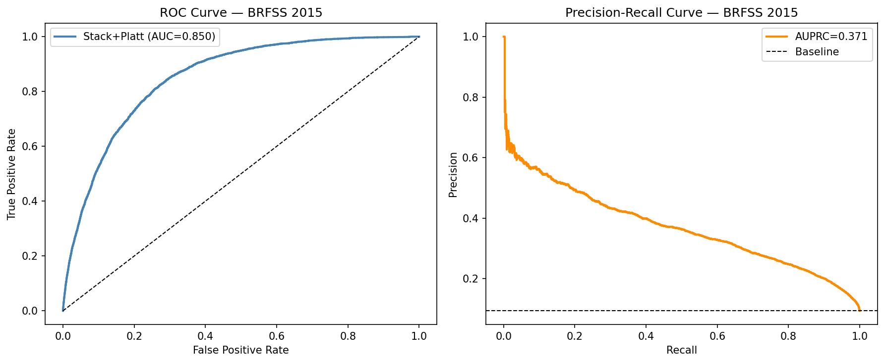
Figure 1. ROC curve (AUC=0.850) and Precision-Recall curve (AUPRC=0.371). Both curves show strong discriminative performance despite 9.6:1 class imbalance.

1.2 MLP Training Curves
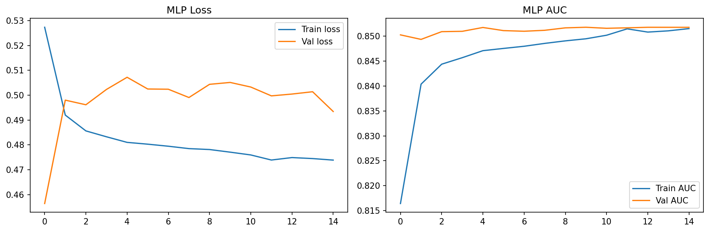
Figure 2. MLP training history. Early stopping triggered at epoch 15. Val AUC=0.8517 with healthy convergence — no overfitting.

1.3 Calibration Curve
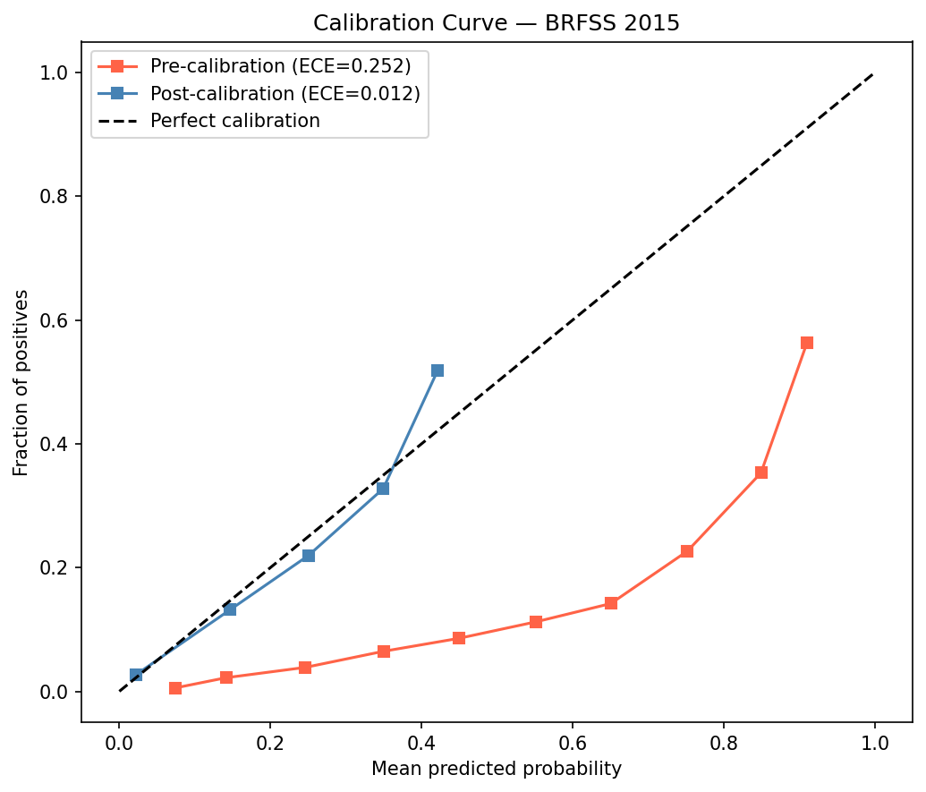
Figure 3. Calibration curves before (ECE=0.252) and after (ECE=0.012) Platt scaling. 95% ECE reduction demonstrates the clinical reliability of output probabilities.

1.4 Decision Curve Analysis
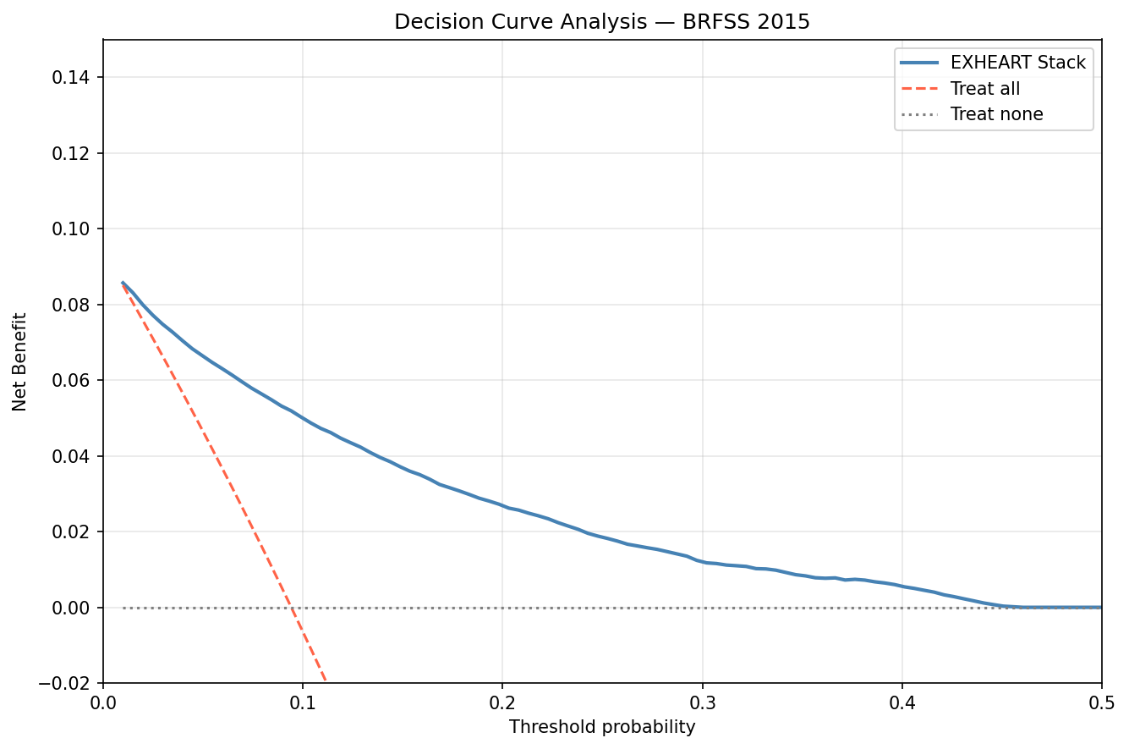
Figure 4. Decision Curve Analysis. EXHEART stack provides positive net benefit over treat-all and treat-none baselines across a wide threshold range (0.05-0.40).

2. Explainability Analysis

2.1 SHAP Global Feature Importance
Global SHAP importance computed via TreeSHAP on XGBoost. Age dominates with nearly 2x the importance of the next feature (GenHlth). The top-5 features align with established CVD risk factors.

Feature | SHAP Rank | Mean |SHAP| | LIME Rank | Mean |LIME|
Age | 1 | 0.7645 | 2 | 0.0525
GenHlth | 2 | 0.4968 | 3 | 0.048
HighBP | 3 | 0.4739 | 6 | 0.0326
Sex | 4 | 0.3548 | 4 | 0.0453
HighChol | 5 | 0.3224 | 5 | 0.0398
Smoker | 6 | 0.1844 | 7 | 0.0213
DiffWalk | 7 | 0.1335 | 8 | 0.0205
Stroke | 8 | 0.1284 | 1 | 0.1077
Income | 9 | 0.1082 | 12 | 0.0084
Diabetes | 10 | 0.1058 | 9 | 0.0188
PhysHlth | 11 | 0.0719 | 13 | 0.0061
BMI | 12 | 0.064 | 15 | 0.0052
Education | 13 | 0.0467 | 16 | 0.0048
NoDocbcCost | 14 | 0.0355 | 11 | 0.0093
HvyAlcoholConsump | 15 | 0.034 | 10 | 0.0158
CholCheck | 16 | 0.0321 | 18 | 0.0
MentHlth | 17 | 0.0294 | 14 | 0.0055
PhysActivity | 18 | 0.0202 | 20 | 0.0
Veggies | 19 | 0.0149 | 21 | 0.0
Fruits | 20 | 0.0125 | 17 | 0.0046
AnyHealthcare | 21 | 0.0076 | 19 | 0.0

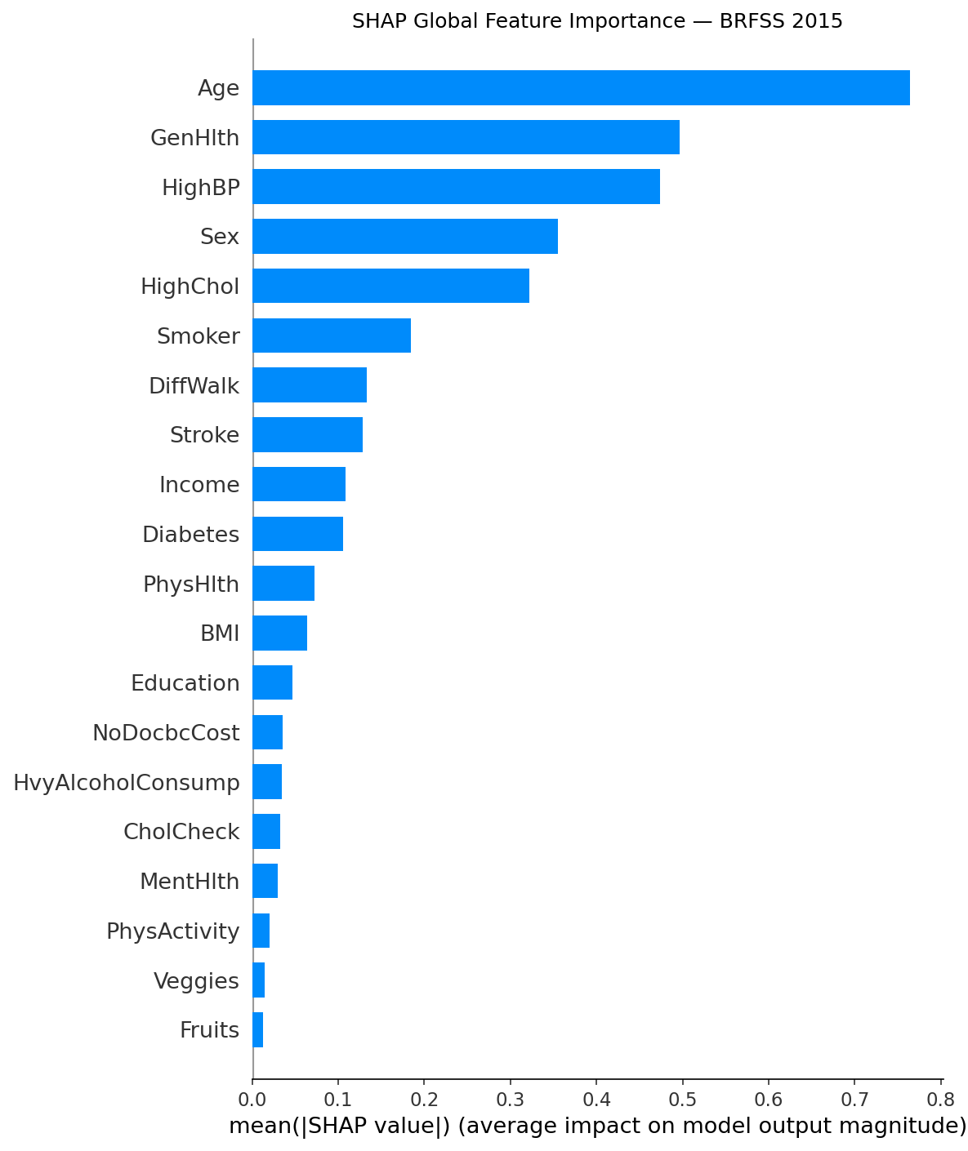
Figure 5. SHAP global feature importance (mean |SHAP value|). Age is the dominant predictor, followed by GenHlth, HighBP, Sex, and HighChol.

2.2 SHAP Interaction Heatmap
Pairwise SHAP interaction values reveal which feature pairs amplify each other. Key interactions include Age x GenHlth, Age x HighBP, and Sex x Age — directly motivating the subgroup-stratified fairness audit.
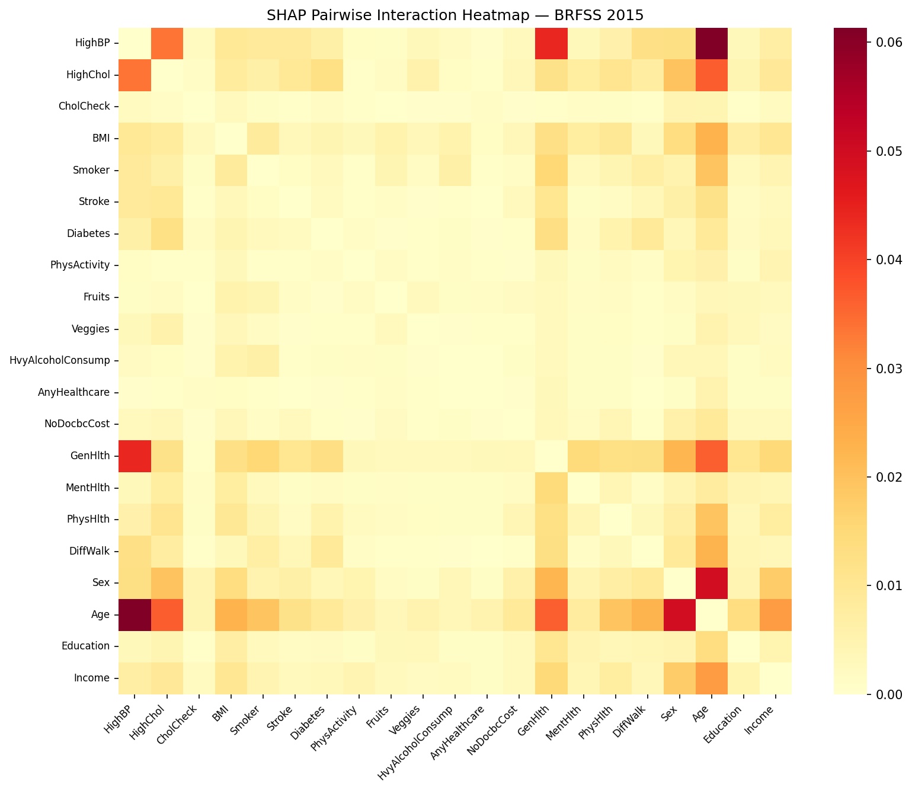
Figure 6. Pairwise SHAP interaction heatmap. Warmer colours indicate stronger interaction effects. Age-related interactions dominate.

2.3 SHAP-LIME Consistency Analysis
Kendall-τ=0.743, Spearman-ρ=0.895, Jaccard@3=0.5, Jaccard@5=0.667. Both p-values=0.000.

Metric | Value | Interpretation
Kendall-τ | 0.743 | Strong global rank agreement
Spearman-ρ | 0.895 | Very high overall rank correlation
p-value (both) | < 0.0001 | Highly significant
Jaccard@3 | 0.5 | Age & GenHlth agree; Stroke vs HighBP disagree
Jaccard@5 | 0.667 | 4 of 6 top features shared
SHAP top-3 | Age, GenHlth, HighBP | Global SHAP leaders
LIME top-3 | Age, GenHlth, Stroke | LIME elevates Stroke to rank 1
Stroke SHAP rank | 8 | Moderate global importance
Stroke LIME rank | 1 | Dominant local importance — context-dependent effect

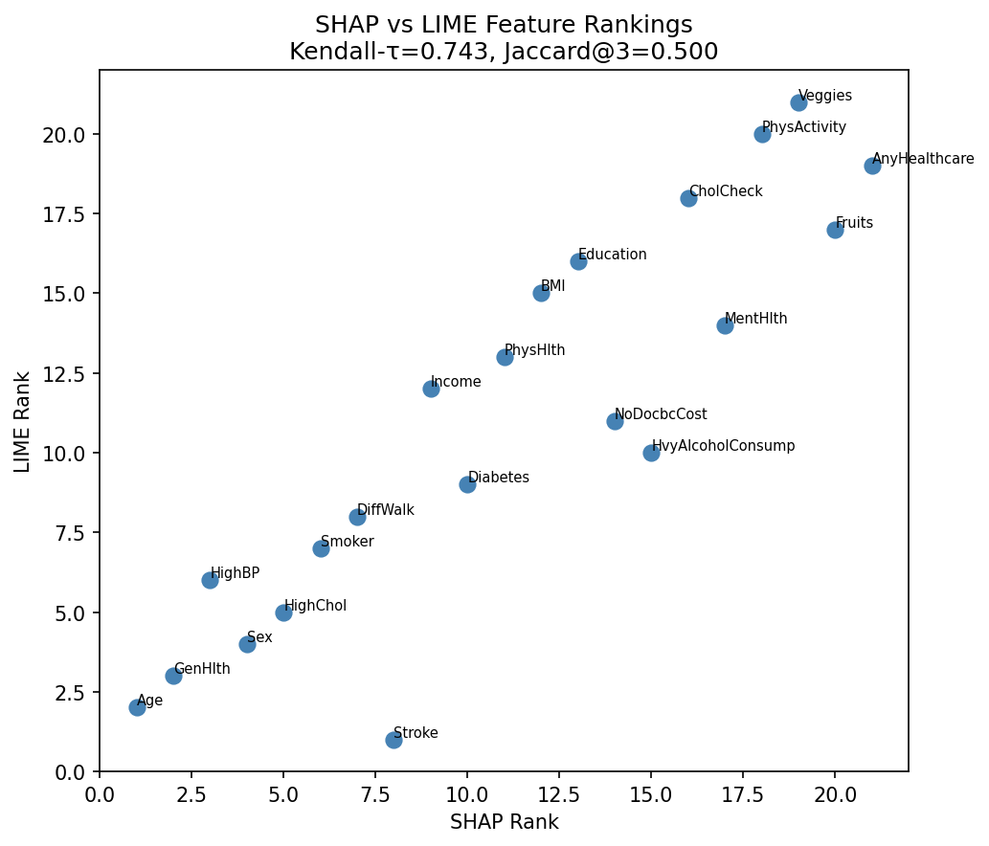
Figure 7. SHAP vs LIME feature rank scatter. Points on the diagonal indicate agreement. Stroke (rank 8 SHAP vs rank 1 LIME) is the key outlier — its effect is highly localised.

3. Fairness Audit
All fairness metrics computed at operational threshold pt=0.12. TPR = True Positive Rate (sensitivity per group). Selection rate = proportion of group predicted positive.

3.1 Sex Fairness
Sex TPR gap: 0.135. Female patients (group 0) are systematically under-detected despite lower baseline prevalence.
group | n | prevalence | TPR | selection_rate
0.0 | 28300.0 | 0.072 | 0.693 | 0.211
1.0 | 22436.0 | 0.122 | 0.828 | 0.365

3.2 Age Fairness
Age TPR range: 0.000 - 0.890. Young adults (groups 1-2) are near-completely missed. Direct consequence of Age being SHAP rank 1.
group | n | prevalence | TPR | selection_rate
1.0 | 1123.0 | 0.006 | 0.143 | 0.002
2.0 | 1567.0 | 0.008 | 0.0 | 0.001
3.0 | 2228.0 | 0.01 | 0.261 | 0.009
4.0 | 2811.0 | 0.014 | 0.128 | 0.021
5.0 | 3214.0 | 0.02 | 0.317 | 0.042
6.0 | 4024.0 | 0.039 | 0.458 | 0.079
7.0 | 5238.0 | 0.058 | 0.559 | 0.138
8.0 | 6262.0 | 0.072 | 0.687 | 0.205
9.0 | 6606.0 | 0.1 | 0.744 | 0.298
10.0 | 6399.0 | 0.133 | 0.791 | 0.412
11.0 | 4650.0 | 0.163 | 0.854 | 0.537
12.0 | 3156.0 | 0.193 | 0.875 | 0.625
13.0 | 3458.0 | 0.243 | 0.89 | 0.734

3.3 Income Fairness
Income TPR gap: 0.238. High-income patients under-detected due to lower prevalence pushing them below threshold.
group | n | prevalence | TPR | selection_rate
1.0 | 1984.0 | 0.157 | 0.872 | 0.508
2.0 | 2295.0 | 0.186 | 0.876 | 0.568
3.0 | 3239.0 | 0.152 | 0.842 | 0.484
4.0 | 4094.0 | 0.141 | 0.813 | 0.431
5.0 | 5096.0 | 0.124 | 0.8 | 0.362
6.0 | 7294.0 | 0.102 | 0.782 | 0.313
7.0 | 8648.0 | 0.081 | 0.703 | 0.225
8.0 | 18086.0 | 0.05 | 0.638 | 0.135

3.4 Intersectional Fairness
Single-attribute audits mask severe intersectional disparities. Sex x Age shows a TPR gap of 0.972 — nearly 7x the Sex-only gap of 0.135.

Sex x Age Summary:
Metric | Value | Interpretation
Cells with n>=30 | 26 | Statistically reliable intersections
TPR range | 0.000 - 0.972 | Near-complete failure to near-perfect
Max TPR gap | 0.972 | 6.8x larger than Sex-only gap

Sex x Income Summary:
Metric | Value | Interpretation
Cells with n>=30 | 16
TPR range | 0.447 - 0.918
Max TPR gap | 0.471

Age x Income Summary:
Metric | Value | Interpretation
Cells with n>=30 | 104
TPR range | 0.000 - 0.962
Max TPR gap | 0.962

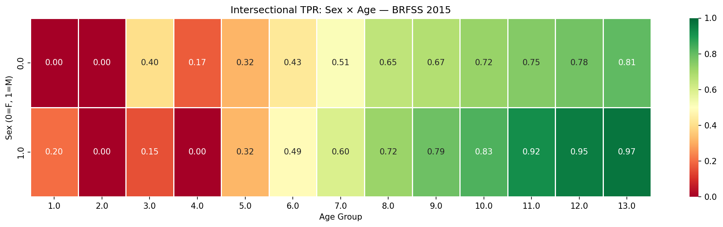
Figure 8. Intersectional TPR heatmap: Sex x Age. Cells show TPR per group combination. Young females (top-left) are the hardest-to-detect group. Empty cells indicate n<30.

4. Fairness Mitigation — Pareto Frontier
Threshold shifting mitigation applied with strength swept from 0 (no mitigation) to 1 (full equalisation). Pareto frontier shows the fairness-utility trade-off for Sex TPR gap vs AUC.

Setting | AUC | Sex TPR Gap
No mitigation (s=0.00) | AUC=0.8505 | Sex TPR gap=0.1349
Moderate (s=0.50) | AUC=0.8464 | Sex TPR gap=0.1237
Full (s=1.00) | AUC=0.8440 | Sex TPR gap=0.1121
Max fairness gain | 16.9% TPR gap reduction | From 0.1349 to 0.1121
AUC cost (full mitigation) | 0.0065 | Less than 1% absolute loss

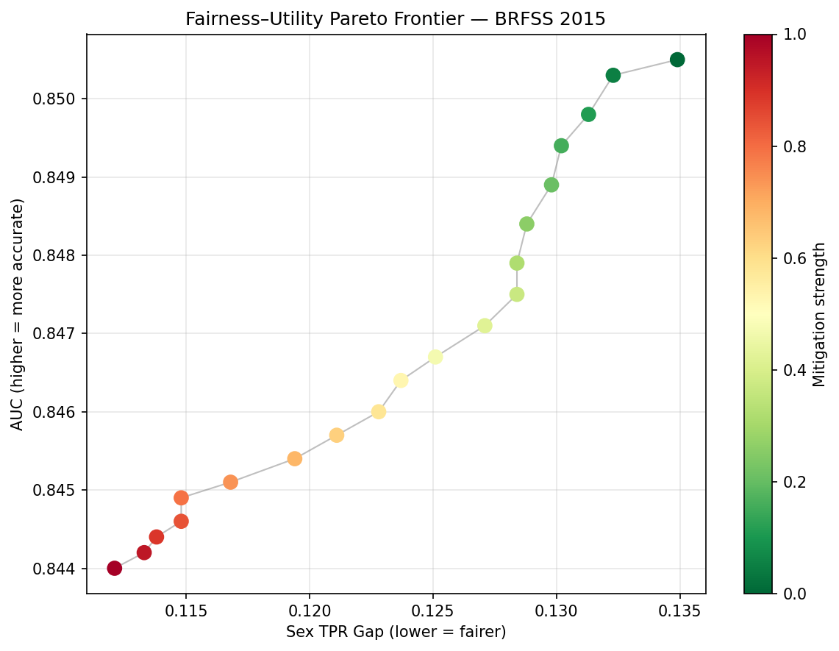
Figure 9. Fairness-Utility Pareto Frontier. Each point is a mitigation strength setting. Colour indicates strength (green=low, red=high). The curve is smooth with no cliff edges — clinicians can choose any operating point.

5. Key Findings Summary
All findings from BRFSS 2015 Notebook 01, ready for paper writing:

Finding | Result
F1 — Performance | AUC=0.850, AUPRC=0.371, Brier=0.071. Survey-weighted AUC=0.860 (BRFSS oversamples older adults).
F2 — Calibration | Platt scaling reduces ECE from 0.252 to 0.012 (95% reduction). Model probabilities are clinically reliable post-calibration.
F3 — MLP contribution | MLP is the strongest base learner (AUC=0.850) and receives the highest meta-learner weight (2.998 vs XGB 0.092). Neural network adds unique signal over tree ensemble.
F4 — DCA | EXHEART provides positive net benefit over treat-all and treat-none across threshold range 0.05-0.40, validating clinical utility.
F5 — SHAP ranking | Age (0.764) >> GenHlth (0.497) > HighBP (0.474) > Sex (0.355) > HighChol (0.322). GenHlth (subjective self-rating) outranks clinical measurements — noteworthy for discussion.
F6 — SHAP-LIME | Global agreement is strong (τ=0.743, ρ=0.895) but top-3 diverges (Jaccard=0.500). Stroke flips from SHAP rank 8 to LIME rank 1 — context-dependent local effect.
F7 — Sex fairness | Female TPR=0.693 vs Male TPR=0.828. Gap=0.135. Female heart disease systematically under-detected.
F8 — Age fairness | Age group 2 (25-30): TPR=0.000. Age group 13 (80+): TPR=0.890. Range=0.890. Young adults completely missed — direct consequence of Age as dominant SHAP feature.
F9 — Income fairness | Inverted gradient: low-income TPR=0.872, high-income TPR=0.638. High-income under-detection due to low prevalence at threshold pt=0.12.
F10 — Intersectional | Sex x Age TPR gap=0.972 (6.8x larger than Sex-only). Age x Income gap=0.962. Single-attribute audits severely understate true disparities.
F11 — Mitigation | 16.9% Sex TPR gap reduction at only 0.0065 AUC cost. Smooth Pareto frontier — favourable fairness-utility trade-off.
F12 — Survey weights | Weighted AUC=0.860 vs unweighted=0.851. BRFSS oversampling of older adults slightly deflates apparent performance.

6. Next Steps
- NB02 — BRFSS 2020: Temporal transport: apply frozen 2015 model to 2020. Measure AUC/ECE/fairness drift. Also run independent 2020 pipeline. Race/ethnicity fairness audit (6 groups).
- NB03 — Cardio: Cross-domain validation on clinical exam dataset (70,000 records). SHAP-LIME consistency comparison across instruments.
- NB04 — Cross-Dataset: Aggregate all results. Temporal drift analysis. Cross-dataset Pareto comparison. Survey-weighted summary table.
- Paper §I-IV: Introduction, related work, datasets, methodology. Use F1-F12 findings to populate results sections.

Generated June 2026 • github.com/anasbiswas1/exheart-research • NB01 Complete

