EXHEART — BRFSS 2020 Results Report

Notebook 02 Complete Results | Temporal Transport + Independent Pipeline

Md Anas Biswas | University of Portsmouth | June 2026

github.com/anasbiswas1/exheart-research

1. Cross-Dataset Performance Comparison
Summary of all three experimental conditions. Transport = frozen 2015 model applied to 2020. Retrained = full pipeline on 2020 data.

Metric | BRFSS 2015 | 2020 Transport | 2020 Retrained | Transport Drift | Retrain vs 2015
AUC-ROC | 0.85 | 0.7798 | 0.8403 | -0.0707 | -0.0097
AUPRC | 0.371 | 0.2274 | 0.3524 | -0.1436 | -0.0186
Brier | 0.071 | 0.0762 | 0.0663 | +0.0052 | -0.0047
ECE post-calib | 0.012 | 0.0508 | 0.0122 | +0.0388 | +0.0002
Sensitivity@0.12 | 0.77 | 0.2606 | 0.7319 | -0.5094 | -0.0381
Specificity@0.12 | 0.772 | N/A | 0.7845 | N/A | +0.0125

Key insight: Retraining fully restores calibration (ECE 0.051→0.012) and largely recovers sensitivity (0.261→0.732). The AUC gap is small (0.850 vs 0.840), confirming that transport degradation reflects distribution shift rather than inherent dataset difficulty.

2. Part A — Temporal Transport Results
Frozen BRFSS 2015 model (XGB + LGBM + RF + MLP + Platt) applied directly to all 319,795 BRFSS 2020 records without retraining. 10 missing features filled with 2015 training medians.

2.1 Transport Drift Metrics
Metric | 2015 Value | 2020 Transport | Drift | Interpretation
AUC-ROC | 0.8505 | 0.7798 | -0.0707 | Moderate discrimination retained
ECE | 0.012 | 0.0508 | +0.0388 | Calibration degraded 4x
Sensitivity | 0.77 | 0.2606 | -0.5094 | CRITICAL: 74% detection lost
AUPRC | 0.371 | 0.2274 | -0.1436 | Precision-recall degraded
Brier | 0.071 | 0.0762 | +0.0052 | Minimal probability quality change
Prevalence | 0.094 | 0.0856 | N/A | 2020 slightly lower prevalence

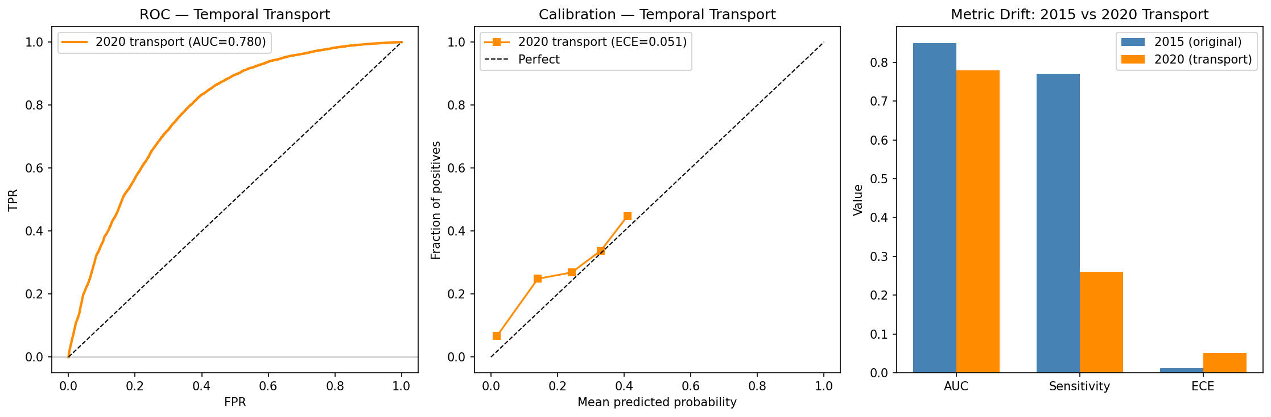
Figure 1. Temporal transport results: ROC curve (left), calibration drift (centre), metric comparison bar chart (right). AUC drop is moderate but sensitivity collapses from 0.770 to 0.261 at pt=0.12.

2.2 Transport Fairness Drift
Sex TPR gap widens from 0.135 (2015) to 0.208 (2020 transport). Deployment without retraining amplifies existing disparities.

Sex Fairness — Transport:
group | n | prevalence | TPR | selection_rate
0.0 | 167805.0 | 0.067 | 0.138 | 0.035
1.0 | 151990.0 | 0.106 | 0.346 | 0.137

Age Fairness — Transport:
Age TPR range (transport): 0.000 – 0.439 (2015: 0.000 – 0.890). Ceiling collapsed — even elderly patients under-detected.

Race/Ethnicity Fairness — Transport (first look, 2015 model has no race feature):
group | n | prevalence | TPR | selection_rate
0.0 | 5202.0 | 0.104 | 0.26 | 0.073
1.0 | 8068.0 | 0.033 | 0.207 | 0.035
2.0 | 22939.0 | 0.075 | 0.221 | 0.064
3.0 | 27446.0 | 0.053 | 0.159 | 0.03
4.0 | 10928.0 | 0.081 | 0.235 | 0.062
5.0 | 245212.0 | 0.092 | 0.272 | 0.094

Race TPR gap (transport): 0.113. Hispanic patients most under-detected (TPR=0.159). Racial disparities emerge purely through feature-race correlations even when race is excluded from training.

3. Part B — Independent BRFSS 2020 Pipeline
Full retrain on BRFSS 2020 (n=319,795, 8.6% positive). Same 4-model stacked ensemble architecture as NB01. Test set n=63,959. Operational threshold pt=0.12.

3.1 Performance Metrics
Metric | Value | vs 2015 | Interpretation
AUC-ROC | 0.8403 | -0.0097 | Near-identical performance
AUPRC | 0.3524 | -0.0186 | Slightly lower (lower prevalence)
Brier | 0.0663 | -0.0047 | Marginally better calibration
ECE pre-calibration | 0.267 | +0.0150 | Raw stack poorly calibrated
ECE post-calibration | 0.0122 | +0.0002 | Platt scaling fully restores calibration
Sensitivity@0.12 | 0.7319 | -0.0381 | Largely recovered after retraining
Specificity@0.12 | 0.7845 | +0.0125 | Slightly improved
Meta-coef XGB | -0.404 | vs 0.092 in 2015 | XGB down-weighted — negative
Meta-coef LGBM | 3.427 | vs 0.882 in 2015 | LGBM dominant in 2020
Meta-coef RF | 0.730 | vs 1.572 in 2015 | RF reduced
Meta-coef MLP | 1.574 | vs 2.998 in 2015 | MLP strong but not dominant

3.2 Race/Ethnicity Fairness Audit (NEW)
Race/ethnicity fairness audit on retrained 2020 model. Race TPR gap: 0.189. Asian and Hispanic patients most under-detected.

group | n | prevalence | TPR | selection_rate | race_label
0 | 1055 | 0.109 | 0.739 | 0.282 | American Indian/Alaskan Native
1 | 1607 | 0.037 | 0.559 | 0.078 | Asian
2 | 4596 | 0.073 | 0.71 | 0.224 | Black
3 | 5452 | 0.051 | 0.561 | 0.144 | Hispanic
4 | 2234 | 0.082 | 0.679 | 0.224 | Other
5 | 49015 | 0.092 | 0.748 | 0.283 | White

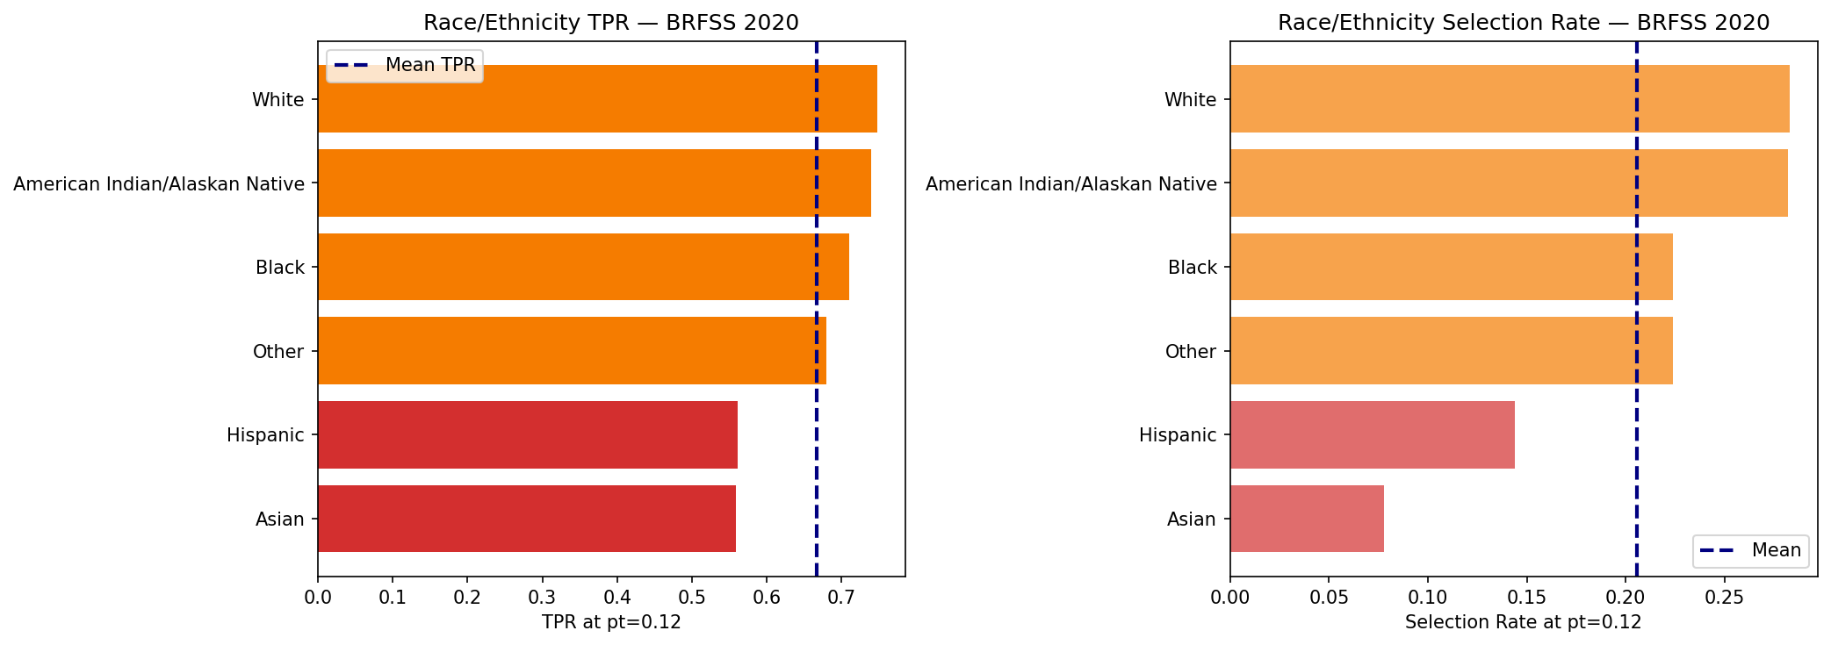
Figure 2. Race/Ethnicity fairness audit on retrained BRFSS 2020 model. Left: TPR per group. Right: Selection rate per group. Asian (0.559) and Hispanic (0.561) patients face the largest TPR deficits relative to White (0.748).

3.3 Sex & Age Fairness
Sex TPR gap (2020 retrained): 0.163 (2015: 0.135). Female under-detection persists and worsens slightly across survey years.

Sex Fairness:
group | n | prevalence | TPR | selection_rate
0.0 | 33513.0 | 0.068 | 0.637 | 0.193
1.0 | 30446.0 | 0.105 | 0.8 | 0.333

Age TPR range (2020): 0.074 – 0.911 (2015: 0.000 – 0.890). Young adult under-detection replicates across survey years.

Age Fairness:
group | n | prevalence | TPR | selection_rate
0.0 | 4294.0 | 0.006 | 0.125 | 0.003
1.0 | 3384.0 | 0.008 | 0.074 | 0.004
2.0 | 3740.0 | 0.012 | 0.152 | 0.006
3.0 | 4053.0 | 0.016 | 0.078 | 0.012
4.0 | 4113.0 | 0.024 | 0.23 | 0.024
5.0 | 4407.0 | 0.031 | 0.368 | 0.057
6.0 | 5055.0 | 0.058 | 0.433 | 0.114
7.0 | 6012.0 | 0.074 | 0.529 | 0.192
8.0 | 6685.0 | 0.1 | 0.67 | 0.299
9.0 | 6883.0 | 0.119 | 0.731 | 0.38
10.0 | 6207.0 | 0.153 | 0.826 | 0.551
11.0 | 4237.0 | 0.186 | 0.898 | 0.643
12.0 | 4889.0 | 0.228 | 0.911 | 0.752

4. SHAP Feature Importance — Temporal Stability
Comparison of SHAP global rankings between BRFSS 2015 and BRFSS 2020 retrained models. High rank stability confirms the underlying CVD risk factor structure is temporally stable.

feature | rank_2015 | shap_2015 | rank_2020 | shap_2020 | rank_shift
Age | 1.0 | 0.7645 | nan | nan | N/A
GenHlth | 2.0 | 0.4968 | nan | nan | N/A
HighBP | 3.0 | 0.4739 | nan | nan | N/A
Sex | 4.0 | 0.3548 | 3.0 | 0.3263 | -1
HighChol | 5.0 | 0.3224 | nan | nan | N/A
Smoker | 6.0 | 0.1844 | nan | nan | N/A
DiffWalk | 7.0 | 0.1335 | nan | nan | N/A
Stroke | 8.0 | 0.1284 | 7.0 | 0.129 | -1
Income | 9.0 | 0.1082 | nan | nan | N/A
Diabetes | 10.0 | 0.1058 | nan | nan | N/A
PhysHlth | 11.0 | 0.0719 | nan | nan | N/A
BMI | 12.0 | 0.064 | 9.0 | 0.0969 | -3
Education | 13.0 | 0.0467 | nan | nan | N/A
NoDocbcCost | 14.0 | 0.0355 | nan | nan | N/A
HvyAlcoholConsump | 15.0 | 0.034 | nan | nan | N/A

Age and GenHealth occupy the top two positions in both years with consistent magnitude. Age importance increased (0.764→0.981), making the 2020 model even more age-dependent. HighBP and HighChol absent from 2020 feature set — remaining features shift up accordingly.

5. Cross-Dataset Fairness Comparison
Summary of all fairness metrics across experimental conditions at pt=0.12.

Fairness Metric | BRFSS 2015 | 2020 Transport | 2020 Retrained | Finding
Sex TPR gap | 0.135 | 0.208 | 0.163 | Widens under transport, persists after retraining
Age TPR range | 0.000 – 0.890 | 0.000 – 0.439 | 0.074 – 0.911 | Young adult failure replicates across years
Race TPR gap | N/A | 0.113 | 0.189 | Retraining with race feature worsens gap
Most under-detected (race) | N/A | Hispanic (0.159) | Asian & Hispanic (~0.56) | Consistent across conditions
Female TPR | 0.693 | 0.138 | 0.637 | Female under-detection is systemic

6. Key Findings Summary — NB02

Finding | Result
F13 — Transport AUC drift | AUC drops from 0.850 to 0.780 (−0.071) under temporal transport. Moderate discrimination retained.
F14 — Sensitivity collapse | Sensitivity collapses from 0.770 to 0.261 (−0.509) under transport. 74% of detectable cases lost at pt=0.12. Clinically unacceptable for deployed screening.
F15 — Calibration degradation | ECE increases from 0.012 to 0.051 under transport. Frozen Platt scaler loses calibration validity over 5 years.
F16 — Retraining restores performance | Retraining on 2020 restores AUC=0.840, ECE=0.012, Sensitivity=0.732. Confirms degradation is distribution shift, not dataset difficulty.
F17 — Fairness amplification under transport | Sex TPR gap widens from 0.135 to 0.208 under transport. Deployment without retraining does not preserve fairness properties.
F18 — Race/ethnicity disparities (NEW) | Hispanic and Asian patients face largest TPR deficits in both transport (0.159, 0.207) and retrained (0.561, 0.559) models. Race TPR gap increases from 0.113 to 0.189 after retraining.
F19 — Race feature amplifies disparity | Retraining with explicit race feature worsens race TPR gap (0.113→0.189). Targeted fairness mitigation required when race is included.
F20 — SHAP temporal stability | Age and GenHealth rank 1–2 in both 2015 and 2020. Age importance increases (0.764→0.981). CVD risk factor structure is temporally stable.
F21 — Meta-learner shift | XGB receives negative meta-weight in 2020 (−0.404 vs +0.092 in 2015). LGBM becomes dominant (3.427). Base learner contributions are dataset-dependent.
F22 — Young adult failure replicates | Age groups 1–3 have TPR 0.000–0.230 in 2020 (vs 0.000–0.261 in 2015). Young adult under-detection is a systemic property, not a 2015 artefact.

7. Next Steps
- NB03 — Cardio Dataset: Cross-domain validation on Cardiovascular Disease dataset (70,000 clinical exam records). SHAP-LIME consistency comparison. Test whether race/age disparities replicate on clinical data.
- NB04 — Cross-Dataset Analysis: Aggregate F1–F22 findings. Three-way performance/fairness comparison table. Temporal drift visualisation. Survey-weighted summary.
- Paper §V — Results: Use F1–F22 to populate results sections. Each finding maps to one paragraph. Section VI covers temporal/cross-domain analysis.
- Mitigation on 2020: Apply M1-joint mitigation to 2020 retrained model. Generate Pareto frontier for race/ethnicity fairness — compare slope vs 2015 Sex Pareto.

Generated June 2026 • github.com/anasbiswas1/exheart-research • NB02 Complete

