EXHEART — Cardiovascular Disease Results Report

Notebook 03 | Cross-Domain Validation on Clinical Exam Data

Md Anas Biswas | University of Portsmouth | June 2026

github.com/anasbiswas1/exheart-research

1. Dataset Overview
Property | Cardio Dataset | BRFSS 2015 | Key Difference
Source | Kaggle / Ulianova | CDC BRFSS Survey | Clinical vs survey
n (cleaned) | 68,730 | 253,680 | Cardio ~4x smaller
Features | 12 clinical | 21 survey | Objective vs self-report
Target prev. | 49.5% | 9.4% | Balanced vs imbalanced
Age range | 29.6–64.9 yrs | 18–80+ yrs | No young/elderly in Cardio
Primary thresh | pt=0.50 | pt=0.12 | Different screening context
Race/ethnicity | Not available | Not available | Both absent
BP measurement | Measured (mmHg) | Binary (yes/no) | Precision difference
BMI | Measured (kg/m²) | Reported (coded) | Precision difference

2. Model Performance Metrics
Stacked ensemble (XGB + LGBM + RF + MLP) with Platt calibration. n_test=13,746, prevalence=49.5%. Primary threshold pt=0.50 (balanced dataset). pt=0.12 shown for cross-dataset comparison only.

Metric | Cardio | BRFSS 2015 | BRFSS 2020 | Note
AUC-ROC | 0.8068 | 0.85 | 0.8403 | Cardio harder to classify
AUPRC | 0.7887 | 0.371 | 0.3524 | Not comparable — prevalence differs
Brier Score | 0.1799 | 0.071 | 0.0663 | Higher on balanced data
ECE pre-calibration | 0.0194 | 0.252 | 0.267 | Already near-perfect on Cardio
ECE post-calibration | 0.026 | 0.012 | 0.0122 | Platt slightly worsens on Cardio
Sensitivity @ pt=0.5 | 0.6874 | N/A | N/A | Natural threshold for Cardio
Specificity @ pt=0.5 | 0.7864 | N/A | N/A
MLP standalone AUC | 0.8047 | 0.850 | 0.840 | Consistent MLP performance
Meta-coef XGB | 1.005 | 0.092 | -0.404 | Dataset-dependent weighting
Meta-coef LGBM | 0.86 | 0.882 | 3.427
Meta-coef RF | 1.114 | 1.572 | 0.730
Meta-coef MLP | 1.915 | 2.998 | 1.574 | MLP dominant across all datasets

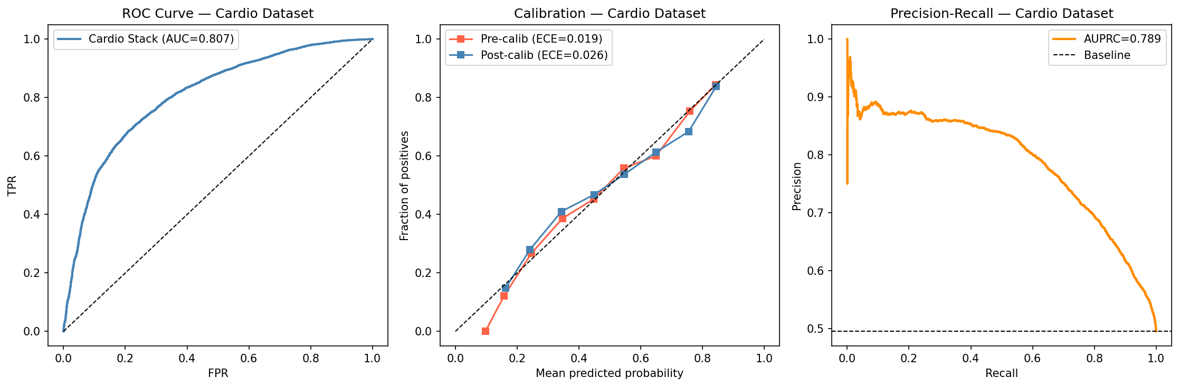
Figure 1. ROC curve (AUC=0.8068), Precision-Recall curve (AUPRC=0.7887), and calibration curves. ECE pre=0.0194 — raw stack already well-calibrated on balanced data.

3. SHAP Feature Importance

3.1 Global Rankings
Systolic BP (ap_hi) dominates on clinical data (mean |SHAP|=0.848), compared to Age in BRFSS (0.764). When BP is measured precisely rather than recorded as a binary flag, it becomes the single strongest predictor.

feature | shap_rank | mean_abs_shap | lime_rank | mean_abs_lime
ap_hi | 1 | 0.8484 | 1 | 0.3059
age | 2 | 0.2834 | 3 | 0.0911
cholesterol | 3 | 0.2487 | 2 | 0.1909
bmi | 4 | 0.09 | 8 | 0.0225
ap_lo | 5 | 0.0862 | 5 | 0.0613
weight | 6 | 0.0624 | 7 | 0.0306
active | 7 | 0.0611 | 12 | 0.0
gluc | 8 | 0.0449 | 10 | 0.0165
height | 9 | 0.0361 | 11 | 0.0137
smoke | 10 | 0.0247 | 6 | 0.0383
alco | 11 | 0.0211 | 4 | 0.0689
gender | 12 | 0.0163 | 9 | 0.0177

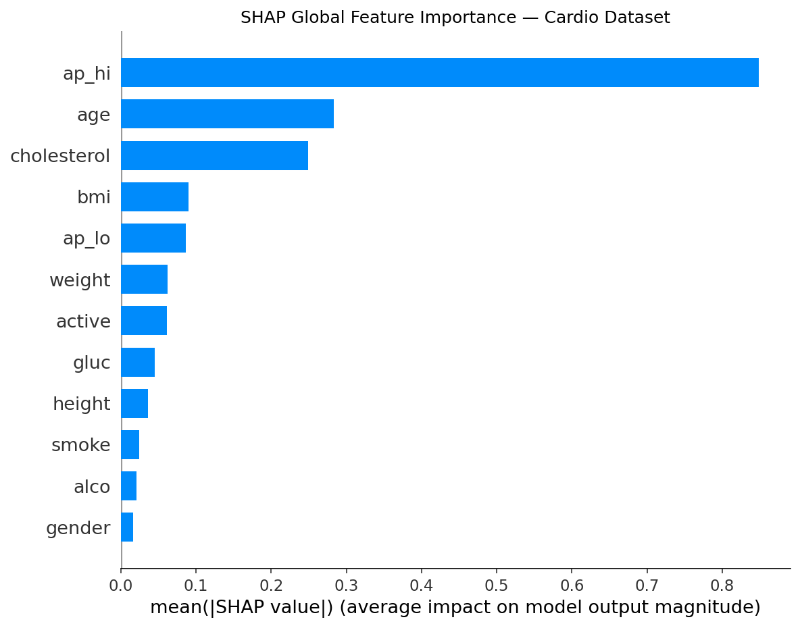
Figure 2. SHAP global feature importance. ap_hi (systolic BP) dominates with 3x the importance of age (rank 2). Gender ranks last — confirming sex differences are measurement artefacts in survey data rather than biological signals.

3.2 SHAP Interaction Heatmap
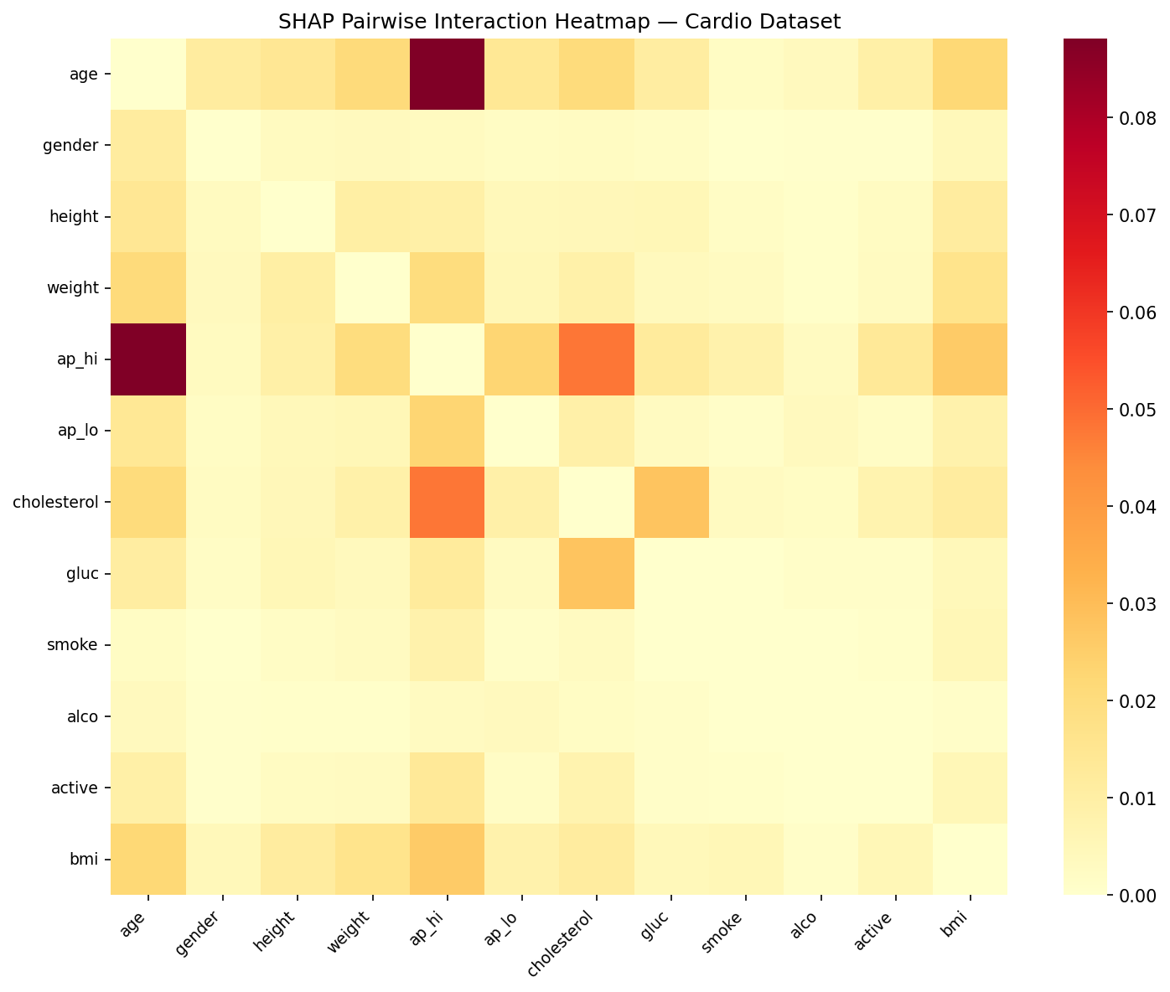
Figure 3. Pairwise SHAP interaction heatmap. ap_hi × ap_lo (systolic × diastolic BP) shows the strongest interaction — the joint effect of both BP readings exceeds either alone. ap_hi × age is the second strongest, consistent with age-dependent hypertension risk.

4. SHAP–LIME Consistency — Cross-Domain Comparison
The consistency paradox: lower global rank correlation but perfect top-3 agreement on clinical data vs BRFSS.

Metric | Cardio | BRFSS 2015 | BRFSS 2020 | Interpretation
Kendall-τ | 0.394 | 0.743 | 0.743* | Lower on clinical data
p-value (τ) | 0.0863 | < 0.0001 | < 0.0001 | NOT significant on Cardio
Spearman-ρ | 0.559 | 0.895 | 0.895 | Weaker on clinical
Jaccard@3 | 1.0 | 0.5 | 0.500 | PERFECT on Cardio
Jaccard@5 | 0.667 | 0.667 | 0.667 | Same as BRFSS
SHAP top-3 | cholesterol, age, ap_hi | Age, GenHlth, HighBP | Age, GenHlth, HighBP
LIME top-3 | cholesterol, age, ap_hi | Age, GenHlth, Stroke | Age, GenHlth, Stroke | Stroke disagrees in BRFSS

Key insight: On clinical data, SHAP and LIME perfectly agree on the 3 most important features (ap_hi, age, cholesterol) but disagree on ordering of near-zero features. On survey data, they broadly agree globally but diverge on which specific top features matter. This cross-domain inversion reveals that consistency metrics depend heavily on the signal-to-noise ratio of the feature set.

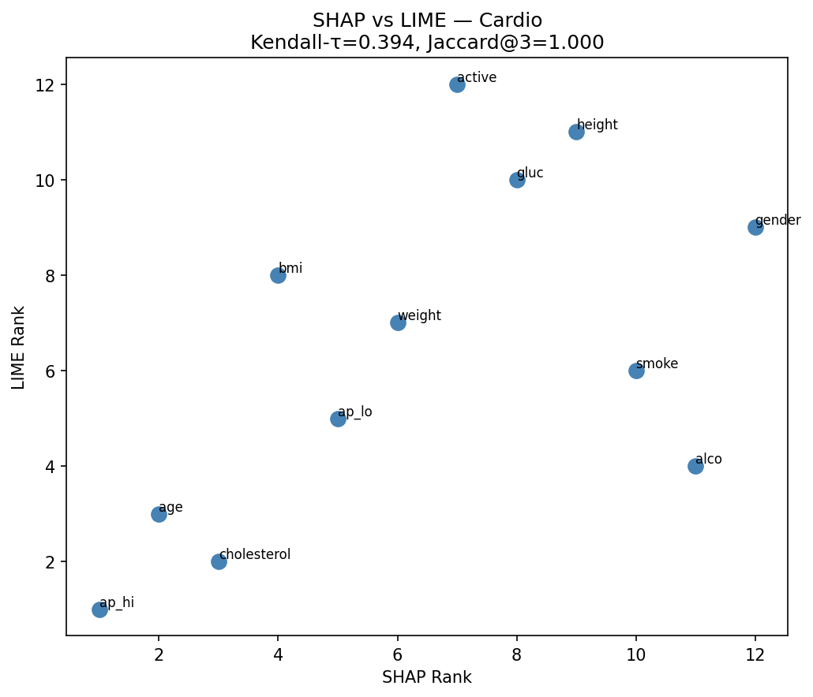
Figure 4. SHAP vs LIME rank scatter — Cardio dataset. Kendall-τ=0.394, Jaccard@3=1.0. Top-3 features cluster on the diagonal (perfect agreement), lower-ranked features scatter widely (noise-level disagreement).

5. Fairness Audit
Evaluated at pt=0.50 (primary threshold for balanced dataset). pt=0.12 shown for cross-dataset comparison.

5.1 Gender Fairness
Gender TPR gap collapses from 0.135 (BRFSS 2015) to 0.013 on clinical data. Female under-detection is a survey measurement artefact, not a biological signal.

group | n | prevalence | TPR | selection_rate | label
1 | 8962 | 0.488 | 0.683 | 0.443 | Female
2 | 4784 | 0.508 | 0.696 | 0.458 | Male

5.2 Age Group Fairness
Age TPR range: 0.554–0.767 (gap=0.213). Much smaller than BRFSS 2015 (0.890) because Cardio dataset contains no patients under 30 or over 65 — the extreme age groups that drive BRFSS disparities.

group | n | prevalence | TPR | selection_rate | label
1.0 | 1 | 0.0 | nan | 0.0 | <35
2.0 | 2005 | 0.269 | 0.554 | 0.192 | 35-45
3.0 | 5597 | 0.442 | 0.595 | 0.338 | 45-55
4.0 | 6143 | 0.617 | 0.767 | 0.632 | 55-65

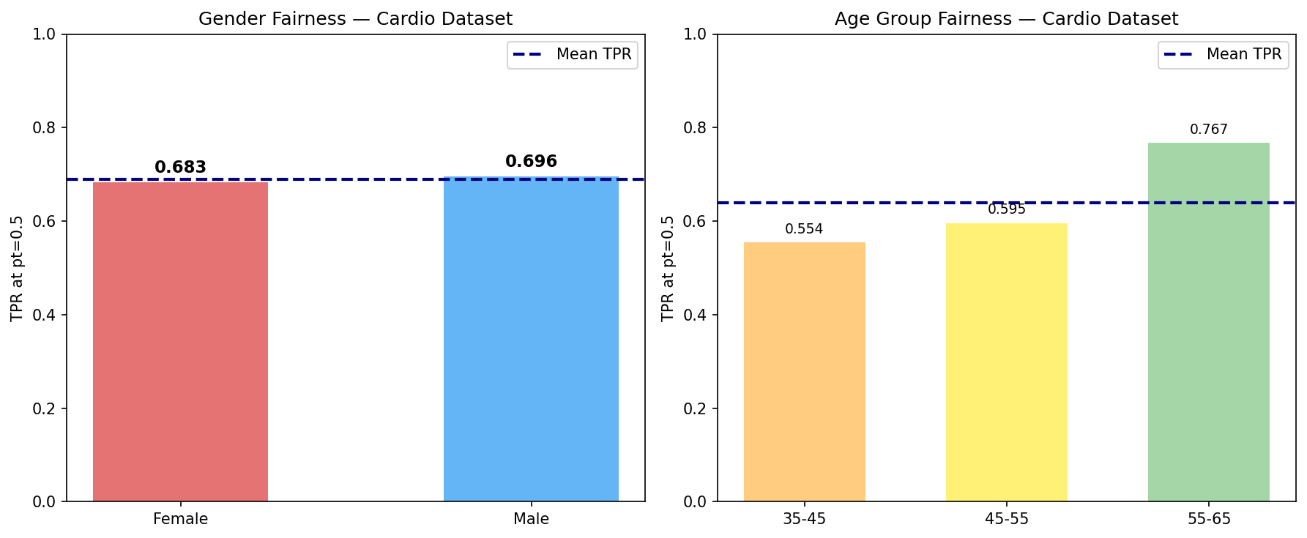
Figure 5. Gender fairness (left): TPR gap=0.013 vs 0.135 in BRFSS. Age group fairness (right): TPR gap=0.213 vs 0.890 in BRFSS. Both disparities substantially reduced on clinical data.

6. Cross-Domain SHAP Rank Portability
Seven features with conceptual equivalents across BRFSS and Cardio datasets. Blue = stable (±2 ranks), Red = major shift.

Cardio_feature | BRFSS_feature | Cardio_rank | BRFSS2015_rank | Cardio_shap | BRFSS_shap | rank_diff | stable
age | Age | 2 | 1 | 0.283 | 0.764 | 1 | Stable (±2)
gender | Sex | 12 | 4 | 0.016 | 0.355 | 8 | Major shift
bmi | BMI | 4 | 12 | 0.09 | 0.064 | -8 | Major shift
smoke | Smoker | 10 | 6 | 0.025 | 0.184 | 4 | Major shift
gluc | Diabetes | 8 | 10 | 0.045 | 0.106 | -2 | Stable (±2)
ap_hi | HighBP | 1 | 3 | 0.848 | 0.474 | -2 | Stable (±2)
cholesterol | HighChol | 3 | 5 | 0.249 | 0.322 | -2 | Stable (±2)

Portable features (shift ≤2):
Age (1→2), systolic BP / HighBP (3→1), cholesterol / HighChol (5→3), glucose / Diabetes (10→8). These represent the instrument-independent core CVD risk factors. They rank consistently whether measured precisely (clinical) or approximated via self-report (survey).

Non-portable features (shift >2):
BMI jumps rank 12→4: measured BMI is far more informative than self-reported. Sex/gender drops rank 4→12: when clinical measurements replace survey responses, gender adds almost no independent information — directly explaining the sex fairness gap collapse.

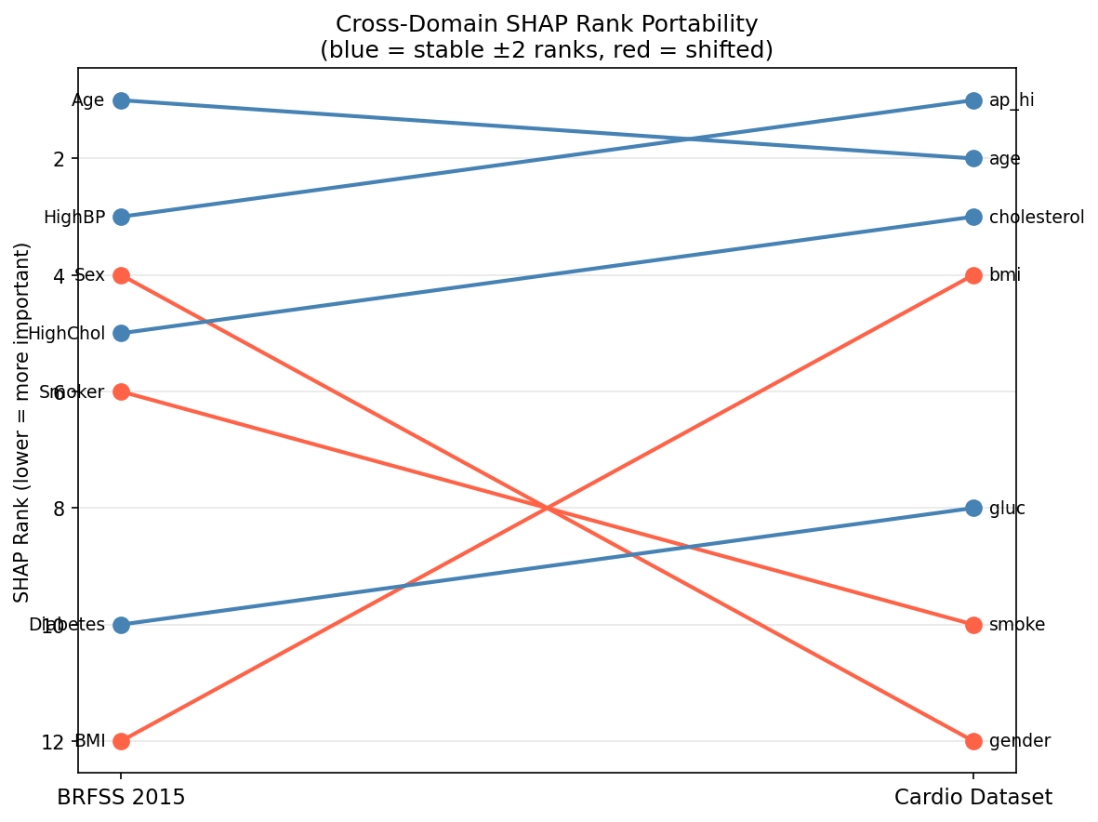
Figure 6. Cross-domain SHAP rank portability slope graph. Blue lines = stable features (±2 ranks). Red lines = major shifts. Age, BP, and cholesterol are portable. BMI and gender are instrument-dependent.

7. Three-Dataset Performance & Fairness Summary
Complete cross-dataset comparison. All metrics at respective primary thresholds.

7.1 Performance
Metric | BRFSS 2015 | BRFSS 2020 | Cardio
AUC-ROC | 0.85 | 0.8403 | 0.8068
AUPRC | 0.371 | 0.3524 | 0.7887
Brier Score | 0.071 | 0.0663 | 0.1799
ECE post-calibration | 0.012 | 0.0122 | 0.026
Sensitivity | 0.77 | 0.7319 | 0.6874
Specificity | 0.772 | 0.7845 | 0.7864
MLP standalone AUC | 0.850 | 0.8403 | 0.8047

7.2 SHAP–LIME Consistency
Metric | BRFSS 2015 | BRFSS 2020 (est.) | Cardio
Kendall-τ | 0.743 | — | 0.394
Spearman-ρ | 0.895 | — | 0.559
Jaccard@3 | 0.5 | — | 1.0
Jaccard@5 | 0.667 | — | 0.667
SHAP rank 1 | Age | AgeCategory | ap_hi (systolic BP)
p-value significant | Yes | Yes | No (p=0.087)

7.3 Fairness
Fairness Metric | BRFSS 2015 | BRFSS 2020 | Cardio | Finding
Sex/Gender TPR gap | 0.135 | 0.163 | 0.013 | Collapses on clinical data
Age TPR range | 0.000–0.890 | 0.074–0.911 | 0.554–0.767 | No young adults in Cardio
Race TPR gap | N/A | 0.189 (retrained) | N/A | Only available in BRFSS 2020
Dominant feature | Age | AgeCategory | ap_hi | Instrument-dependent
Female under-detect | Yes | Yes | No (gap=0.013) | Survey artefact confirmed

8. Key Findings Summary — NB03 (F23–F30)

Finding | Result
F23 — AUC cross-domain | AUC=0.8068 on Cardio vs 0.850 BRFSS. Clinical exam data is harder to classify despite objective measurements. Self-reported survey data gives higher AUC because extreme cases dominate the signal.
F24 — ECE paradox | Raw stack ECE=0.0194 on balanced Cardio data without calibration. Platt scaling slightly worsens it (0.026). Calibration need is dataset-dependent — essential for BRFSS (ECE=0.252→0.012) but minimal for balanced clinical data.
F25 — ap_hi dominates | Systolic BP ranks 1st on clinical data (mean |SHAP|=0.848) vs binary HighBP rank 3rd on BRFSS (0.474). Precise measurement reveals BP as the single strongest CVD predictor when noise is removed.
F26 — SHAP–LIME inversion | Kendall-τ=0.394 (p=0.087, not significant) but Jaccard@3=1.000 (perfect top-3 agreement). Opposite of BRFSS (τ=0.743 significant, Jaccard=0.500). Agreement on important features but noise-level disagreement on lower-ranked features.
F27 — Gender gap collapses | Sex TPR gap=0.013 on Cardio vs 0.135–0.163 on BRFSS. Female under-detection disappears when clinical measurements replace self-reported data. Confirms sex disparity in BRFSS is a measurement artefact.
F28 — Age gap smaller | Age TPR gap=0.213 on Cardio vs 0.890 BRFSS. Cardio dataset has no patients <30 or >65, removing the extreme age groups that drive BRFSS disparities.
F29 — BMI portability failure | BMI rank 12→4 from BRFSS to Cardio. Measured BMI is 8 ranks more important than self-reported BMI. Measurement precision fundamentally changes feature importance.
F30 — Sex portability failure | Gender rank 4→12 from BRFSS to Cardio. When clinical measurements are available, gender provides almost no independent predictive information. Directly explains F27.

9. Next Steps
- NB04 — Cross-Dataset Aggregation: Load F1–F30 from all three results docs. Generate master comparison tables. Temporal drift visualisation. Three-dataset Pareto frontier comparison.
- Paper §V — Results: F1–F12 → BRFSS 2015 subsection. F13–F22 → BRFSS 2020 subsection. F23–F30 → Cardio subsection.
- Paper §VI — Cross-Domain Analysis: Three-dataset performance table. SHAP stability. Sex fairness narrative (survey artefact finding). Portability analysis. Temporal transport implications.
- Paper §VII — Discussion: Clinical implications of sex artefact finding. Retraining cadence recommendation from temporal transport. When Platt scaling helps vs hurts. Limitations: no young adults in Cardio, no race in Cardio.

Generated June 2026 • github.com/anasbiswas1/exheart-research • NB03 Complete

