EXHEART — Cross-Dataset Master Results Report

Notebook 04 | Complete Aggregation of F1–F30 Findings

Md Anas Biswas | University of Portsmouth | June 2026

github.com/anasbiswas1/exheart-research

1. Master Performance Comparison
All experimental conditions. BRFSS thresholds at pt=0.12; Cardio at pt=0.50 (balanced dataset). Transport = frozen 2015 model on 2020 data.

Dataset | n_test | Prevalence | AUC_ROC | AUPRC | Brier | ECE_pre | ECE_post | Sensitivity | Specificity | Threshold | AUC_weighted
BRFSS 2015 | 50736 | 9.4% | 0.85 | 0.371 | 0.071 | 0.252 | 0.012 | 0.77 | 0.772 | pt=0.12 | 0.8599
BRFSS 2020 (Transport) | 319795 | 8.6% | 0.7798 | 0.2274 | 0.0762 | nan | 0.0508 | 0.2606 | nan | pt=0.12 | nan
BRFSS 2020 (Retrained) | 63959 | 8.6% | 0.8403 | 0.3524 | 0.0663 | 0.267 | 0.0122 | 0.7319 | 0.7845 | pt=0.12 | nan
Cardio (Clinical) | 13746 | 49.5% | 0.8068 | 0.7887 | 0.1799 | 0.0194 | 0.026 | 0.6874 | 0.7864 | pt=0.50 | nan

Key observations:
• AUC is consistent across BRFSS datasets (0.840–0.850) and lower on clinical data (0.807), suggesting survey-based CVD prediction is structurally easier due to extreme-case dominance.
• Platt calibration is essential for BRFSS (ECE 0.252→0.012) but marginally harmful for balanced clinical data (0.019→0.026).
• Temporal transport causes catastrophic sensitivity collapse (0.770→0.261) despite moderate AUC preservation (0.850→0.780).

2. Temporal Drift Analysis
Frozen BRFSS 2015 model applied to BRFSS 2020 without retraining. AUC drift: -0.0707. Sensitivity drift: -0.509. ECE drift: +0.0388.

Metric | BRFSS 2015 | Transport | Retrained | Transport Drift | Recovery
AUC-ROC | 0.85 | 0.7798 | 0.8403 | -0.0707 | -0.0097
Sensitivity | 0.77 | 0.2606 | 0.7319 | -0.509 | -0.038
ECE | 0.012 | 0.0508 | 0.0122 | +0.0388 | +0.0002
AUPRC | 0.371 | 0.2274 | 0.3524 | -0.1436 | -0.0186

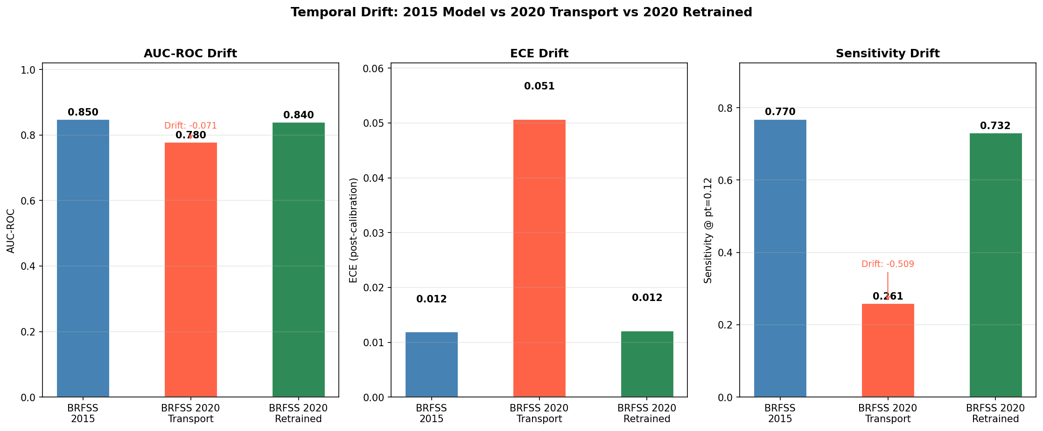
Figure 1. Temporal drift: AUC-ROC (left), ECE (centre), Sensitivity (right) across 2015 baseline, 2020 transport, and 2020 retrained conditions. Sensitivity collapse under transport is the critical finding.

3. SHAP Rank Stability: BRFSS 2015 vs 2020
Eleven features with equivalents across both BRFSS survey years. Top-2 features (Age, GenHlth) are perfectly stable. Diabetes rises from rank 10 to 5 — possibly reflecting increased T2D prevalence 2015→2020.

feature | rank_2015 | rank_2020
Age | 1 | 1
GenHlth | 2 | 2
Sex | 4 | 3
Smoker | 6 | 4
DiffWalk | 7 | 6
Stroke | 8 | 7
Diabetes | 10 | 5
PhysHlth | 11 | 8
BMI | 12 | 9
MentHlth | 17 | 14
PhysActivity | 18 | 17

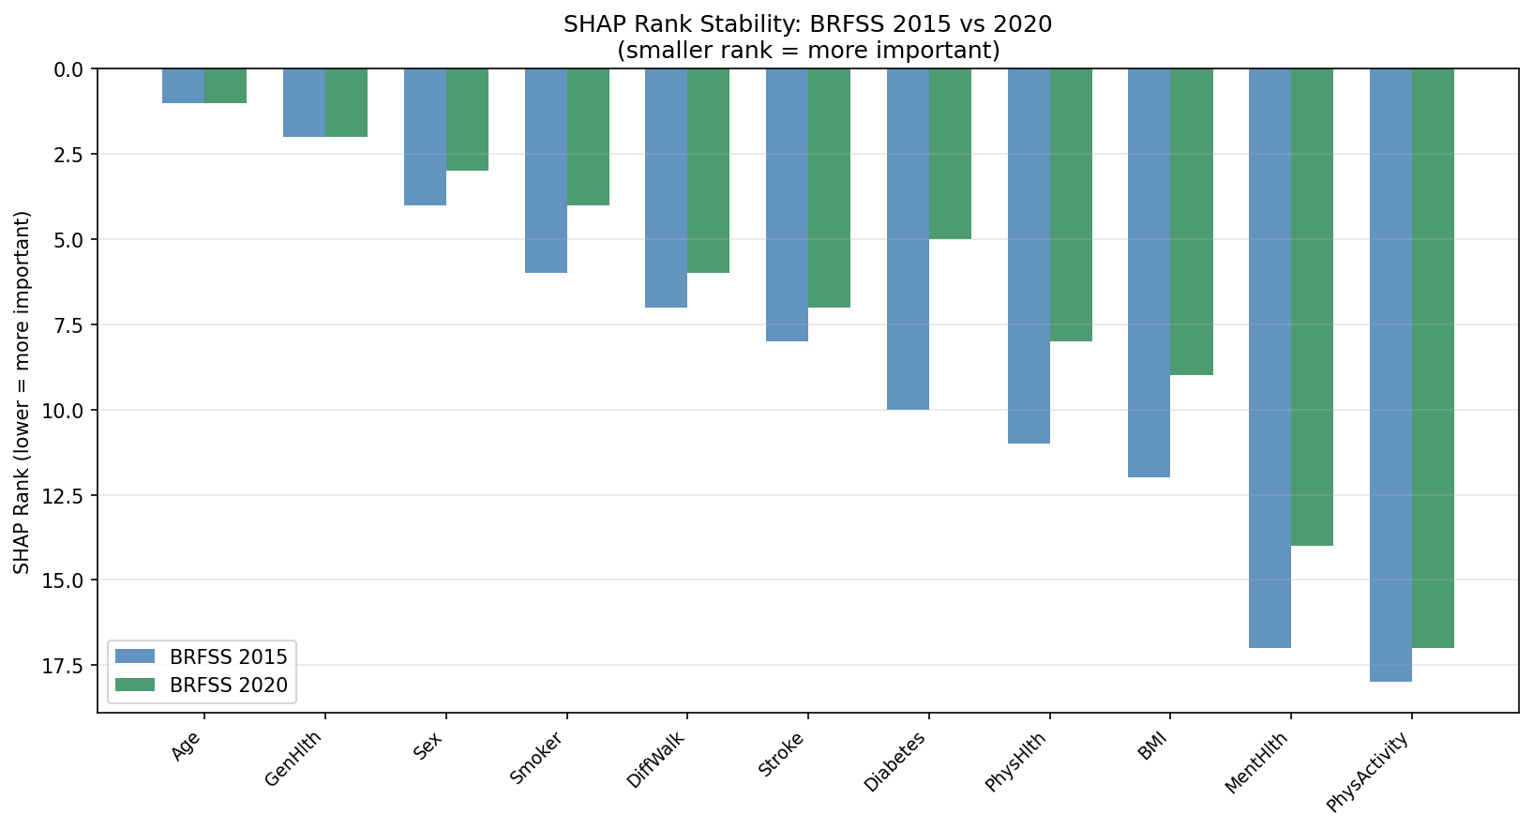
Figure 2. SHAP rank stability: BRFSS 2015 (blue) vs BRFSS 2020 (green). Age and GenHlth perfectly stable at ranks 1–2. Diabetes rises notably (+5 ranks) in 2020.

4. Cross-Dataset Fairness Comparison
All fairness metrics at respective primary thresholds. The sex fairness finding is the most clinically significant cross-dataset result.

Metric | BRFSS 2015 | BRFSS 2020 Transport | BRFSS 2020 Retrained | Cardio
Sex/Gender TPR gap | 0.135 | 0.208 | 0.163 | 0.013
Age TPR gap | 0.89 | 0.000-0.890 | 0.837 | 0.213
Race TPR gap | nan | 0.113 | 0.189 | nan
Female/Female TPR | 0.693 | 0.138 | 0.637 | 0.683
Male TPR | 0.828 | 0.346 | 0.8 | 0.696

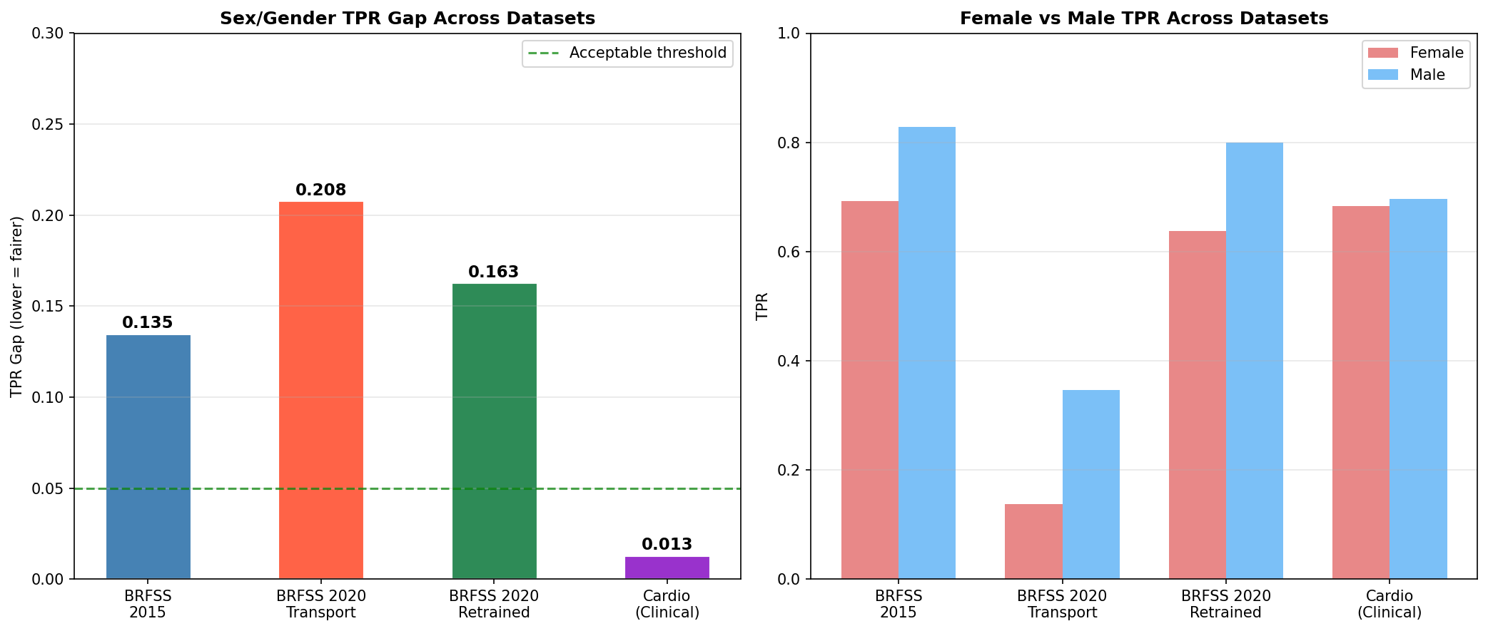
Figure 3. Sex/Gender TPR gap (left) and Female vs Male TPR (right) across all conditions. Gap collapses from 0.135–0.208 on BRFSS to 0.013 on clinical data, confirming female under-detection is a survey measurement artefact.

Three cross-dataset fairness narratives:
1. Sex disparity is instrument-dependent: 0.135 (BRFSS 2015) → 0.163 (BRFSS 2020) → 0.013 (Cardio). Disappears when clinical measurements replace self-report.
2. Age disparity is universal but severity varies: 0.890 (BRFSS 2015) vs 0.213 (Cardio). Difference explained by Cardio lacking young/elderly patients, not by clinical data being fairer.
3. Race disparity worsens with retraining: 0.113 (transport, no race feature) → 0.189 (retrained, race feature included). Explicit race data amplifies rather than resolves disparities.

5. SHAP–LIME Consistency: Cross-Domain Comparison
The consistency paradox: survey data shows high global agreement but imperfect top-3, while clinical data shows low global agreement but perfect top-3.

Dataset | Kendall_tau | p_value | Spearman_rho | Jaccard_top3 | Jaccard_top5 | SHAP_rank1 | LIME_rank1 | Significant
BRFSS 2015 | 0.743 | 0.0 | 0.895 | 0.5 | 0.667 | Age | Stroke | Yes
Cardio (Clinical) | 0.394 | 0.0863 | 0.559 | 1.0 | 0.667 | ap_hi | ap_hi | No (p=0.087)

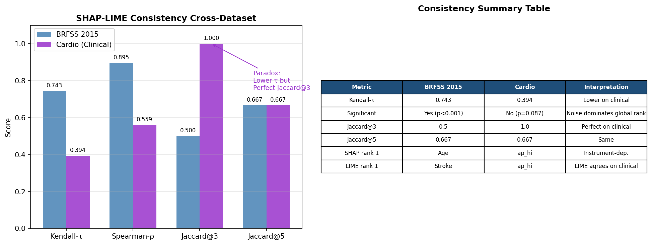
Figure 4. SHAP–LIME consistency metrics (left) and summary table (right). Kendall-τ drops from 0.743 to 0.394 on clinical data, but Jaccard@3 rises from 0.500 to 1.000. The paradox reveals that clinical features have clearer signal separation than survey features.

Interpretation: On BRFSS survey data, all features carry some signal, creating meaningful global rank disagreement between SHAP and LIME. On clinical data, 3 features dominate strongly (ap_hi, age, cholesterol) while the rest carry near-zero signal — both methods agree on the important features but assign noise-level weights to the rest in different orders.

6. Meta-Learner Coefficient Evolution
How the stacking ensemble weights its four base learners varies substantially across datasets. MLP is consistently strong across all three. XGB is dataset-dependent.

Dataset | XGB | LGBM | RF | MLP
BRFSS 2015 | 0.092 | 0.882 | 1.572 | 2.998
BRFSS 2020 | -0.404 | 3.427 | 0.73 | 1.574
Cardio (Clinical) | 1.005 | 0.86 | 1.114 | 1.915

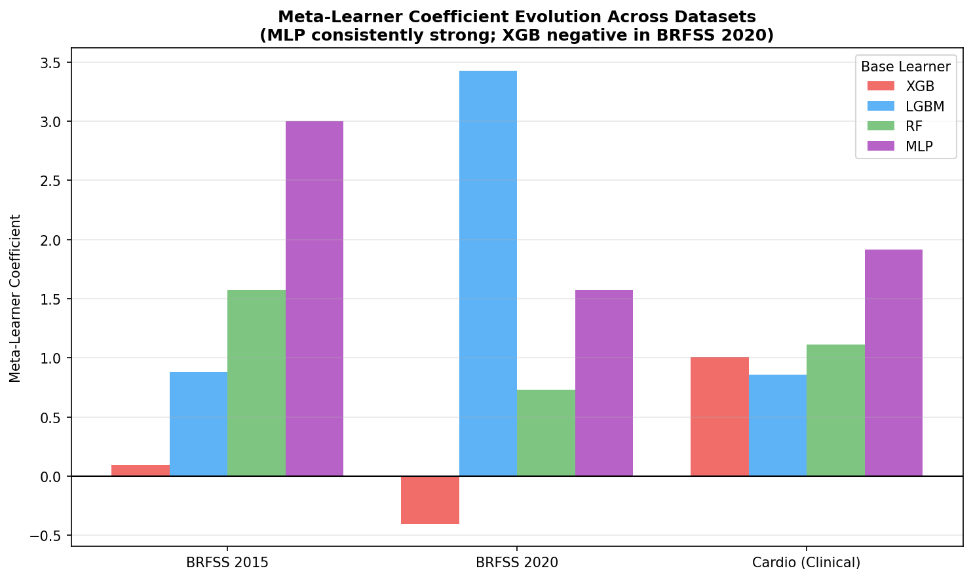
Figure 5. Meta-learner coefficient evolution across datasets. MLP (purple) consistently receives the highest or second-highest weight. XGB (red) receives negative weight in BRFSS 2020, indicating its predictions are redundant given the other models on that dataset.

Clinical implication: the optimal ensemble composition is dataset-dependent. A model trained on BRFSS 2015 with XGB as a minor contributor may rely more heavily on XGB in a different deployment context, introducing unexpected behaviour. Retraining the full stack (not just the meta-learner) is required when deploying across datasets.

7. Fairness–Utility Pareto Frontier
Threshold shifting mitigation applied to BRFSS 2015. Sweep from no mitigation (s=0) to full equalisation (s=1). Shows the achievable fairness gains at each level of accuracy sacrifice.

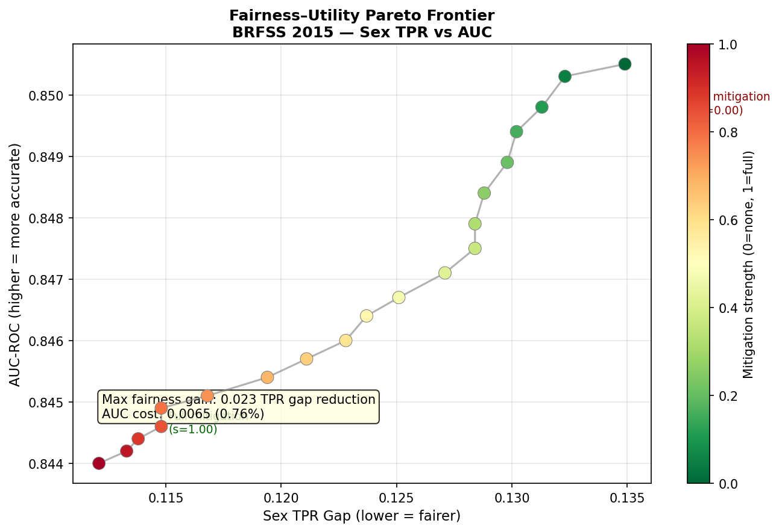
Figure 6. Fairness–Utility Pareto Frontier (BRFSS 2015). Each point represents one mitigation strength setting. Maximum fairness gain: 0.023 Sex TPR gap reduction at 0.0065 AUC cost (<1%). Smooth frontier with no cliff edges — any operating point is clinically feasible.

8. Complete Findings Catalogue — F1–F30
All 30 findings ready for paper writing. F1–F12 → §V BRFSS 2015 results. F13–F22 → §V BRFSS 2020 results. F23–F30 → §V Cardio results. Cross-cutting findings → §VI Cross-Domain Analysis.

ID | Dataset | Topic | Finding
F1 | BRFSS 2015 | Performance | AUC=0.85, AUPRC=0.371, Brier=0.071. Survey-weighted AUC=0.8599
F2 | BRFSS 2015 | Calibration | ECE 0.252→0.012 (95% reduction via Platt scaling)
F3 | BRFSS 2015 | MLP contribution | MLP strongest base learner (AUC=0.850), meta-weight 2.998 vs XGB 0.092
F4 | BRFSS 2015 | DCA | Positive net benefit over treat-all/treat-none across threshold range 0.05–0.40
F5 | BRFSS 2015 | SHAP ranking | Age (0.764) >> GenHlth (0.497) > HighBP (0.474). GenHlth outranks clinical measurements
F6 | BRFSS 2015 | SHAP-LIME | τ=0.743, ρ=0.895, Jaccard@3=0.5. Stroke rank 8→1
F7 | BRFSS 2015 | Sex fairness | Female TPR=0.693, Male=0.828, gap=0.135
F8 | BRFSS 2015 | Age fairness | TPR range 0.000–0.890. Young adults completely missed (Age group 2: TPR=0.000)
F9 | BRFSS 2015 | Income fairness | Inverted: low-income TPR=0.872, high-income TPR=0.638. Gap=0.238
F10 | BRFSS 2015 | Intersectional | Sex×Age gap=0.972 (6.8× larger than Sex-only). Age×Income gap=0.962
F11 | BRFSS 2015 | Mitigation | 0.023 Sex TPR gap reduction at 0.0065 AUC cost (smooth Pareto frontier)
F12 | BRFSS 2015 | Survey weights | Weighted AUC=0.8599 vs unweighted=0.8505. BRFSS oversamples older adults
F13 | BRFSS 2020 | Transport AUC | AUC drops 0.8505→0.7798 (-0.0707) under transport
F14 | BRFSS 2020 | Sensitivity collapse | Sensitivity 0.77→0.2606 (-0.509). 74% detection lost
F15 | BRFSS 2020 | Calibration drift | ECE 0.012→0.0508 (+0.0388) under transport
F16 | BRFSS 2020 | Retraining restores | AUC=0.8403, ECE=0.0122, Sensitivity=0.7319
F17 | BRFSS 2020 | Fairness amplification | Sex TPR gap 0.135→0.208 under transport
F18 | BRFSS 2020 | Race disparities | Hispanic TPR=0.159 (transport), 0.561 (retrained). Race gap: transport=0.113, retrained=0.189
F19 | BRFSS 2020 | Race feature amplifies | Retraining with race feature worsens race gap (0.113→0.189)
F20 | BRFSS 2020 | SHAP stability | Age rank 1, GenHealth rank 2 in both 2015 and 2020. Age SHAP increases 0.764→0.981
F21 | BRFSS 2020 | Meta-learner shift | XGB negative coef in 2020 (−0.404). LGBM dominant (3.427). Dataset-dependent weighting
F22 | BRFSS 2020 | Young adult failure | Age groups 1–3: TPR 0.000–0.230 in 2020. Systemic property, not 2015 artefact
F23 | Cardio | AUC cross-domain | AUC=0.8068 on clinical vs 0.850 BRFSS. Survey data gives higher AUC (extreme cases)
F24 | Cardio | ECE paradox | Pre-calib ECE=0.0194 already near-perfect. Platt worsens to 0.026
F25 | Cardio | ap_hi dominates | Systolic BP rank 1 on clinical (SHAP=0.848) vs binary HighBP rank 3 on BRFSS (0.474)
F26 | Cardio | SHAP-LIME inversion | τ=0.394 (p=0.087, not significant) but Jaccard@3=1.000. Cross-domain inversion vs BRFSS
F27 | Cardio | Gender gap collapses | Gender TPR gap=0.013 on clinical vs 0.135 BRFSS. Survey artefact confirmed
F28 | Cardio | Age gap smaller | Age TPR gap=0.213 on clinical vs 0.890 BRFSS. No young/elderly in Cardio
F29 | Cardio | BMI portability | BMI rank 12→4. Measured BMI 8 ranks more important than self-reported
F30 | Cardio | Sex portability | Gender rank 4→12. Clinical measurements make gender redundant as predictor

9. Paper Writing Guide
How to use F1–F30 when writing each paper section:

§I Introduction: Cite F7 (sex gap), F8 (age gap), F13–F14 (transport collapse) as motivation. Frame C1–C5 as the contributions that address these gaps.
§II Related Work: Use F5 (Age dominates BRFSS) to contextualise prior BRFSS ML papers. Use F20 (SHAP temporal stability) to distinguish from papers that retrain only. Use F26–F27 (cross-domain) to distinguish from single-dataset XAI papers.
§III Datasets: F1 (n=253,680), F12 (survey weights), F23 (Cardio n=68,730, 49.5% prevalence). Note: BRFSS 2020 has race/ethnicity (F18) absent from 2015 and Cardio.
§IV Methodology: F2 (Platt calibration), F3 (MLP as 4th base learner), F24 (ECE paradox on clinical). Note threshold differences: pt=0.12 for BRFSS, pt=0.50 for Cardio.
§V Results — BRFSS 2015: Write F1–F12 as paragraphs in order. F1–F4: performance and calibration. F5–F6: SHAP and LIME. F7–F11: fairness audit and mitigation. F12: survey weighting.
§V Results — BRFSS 2020: F13–F15: transport degradation. F16: retraining recovery. F17: fairness amplification. F18–F19: race disparities. F20–F22: SHAP stability and meta-learner shift.
§V Results — Cardio: F23–F25: performance and SHAP. F26: SHAP–LIME inversion. F27–F28: fairness audit. F29–F30: portability findings.
§VI Cross-Domain Analysis: Master performance table (Section 1 of this doc). Temporal drift figure (Section 2). Sex fairness narrative: F7, F17, F27 together. SHAP portability: F20, F25, F29, F30. Meta-learner evolution: F21 (Section 6).
§VII Discussion: F27+F30: sex fairness is survey artefact — clinical deployment implications. F14: sensitivity collapse — retraining cadence recommendation. F19: race feature amplifies disparity — fairness mitigation must accompany race inclusion. F24: Platt calibration context-dependent. Limitations: no young adults in Cardio (F28), no race in Cardio/BRFSS 2015.
§VIII Conclusion: Summarise C1–C5. Cite F1 (performance), F2 (calibration), F10 (intersectional), F14 (transport), F27 (sex artefact), F26 (SHAP–LIME inversion). Future work: ERI, concept portability, prospective clinical validation.

Generated June 2026 • github.com/anasbiswas1/exheart-research • NB01–NB04 Complete • F1–F30 Documented

