Trustworthy Explainable Early-Warning for Student Outcomes
Progress report built from saved results. Md Anas Biswas, University of Portsmouth. 2026-06-05.

1. Dataset and feature engineering (NB01)
OULAD: 32,593 student-module enrolments. Overall at-risk rate 0.528. The at-risk rate rises with deprivation, from 0.425 in the least deprived band (90-100%) to 0.648 in the most deprived (0-10%); disabled students are flagged at 0.619 against 0.518 for their peers.
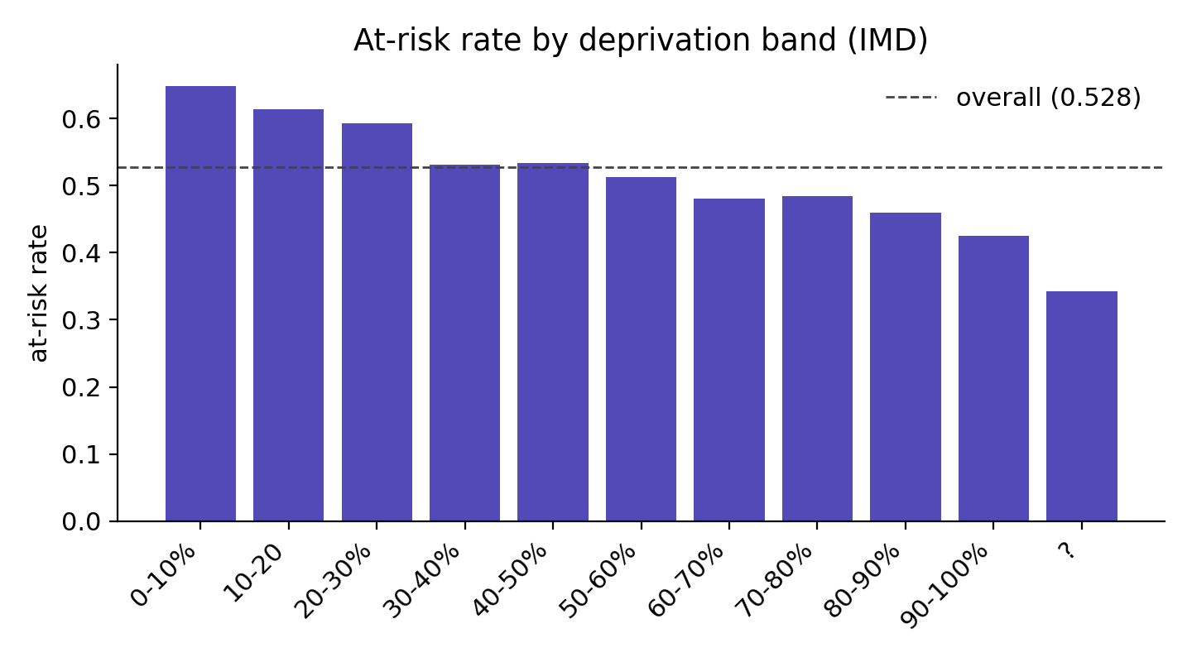
At-risk rate by deprivation band (IMD).
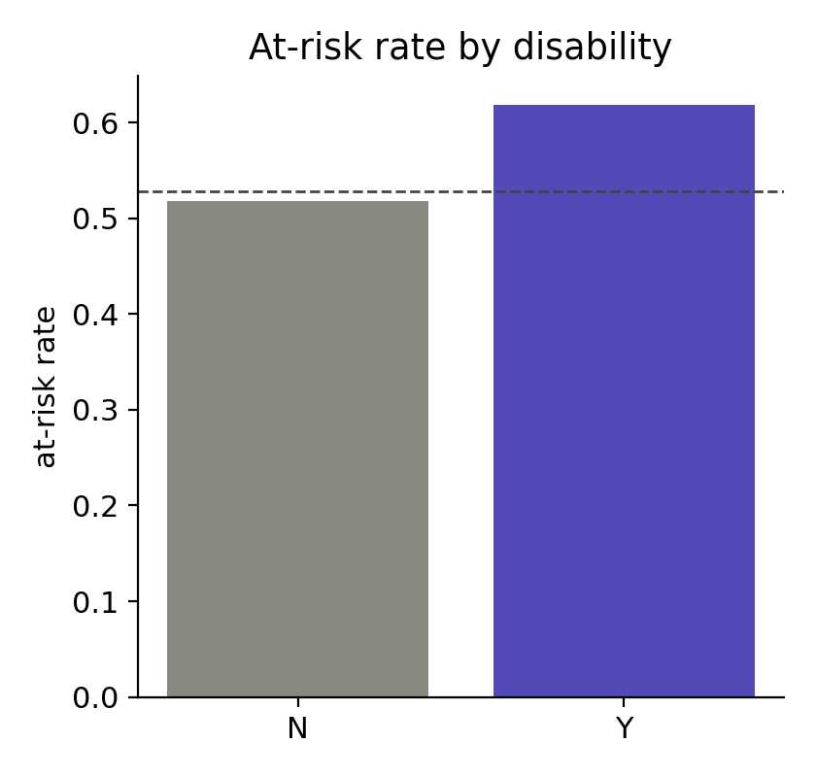
At-risk rate by declared disability.

2. Models and calibration (NB02)
cutoff_week | model | auroc | recall | f1 | brier_cal | ece_uncal | ece_cal
5 | hgb | 0.8527 | 0.7220 | 0.7699 | 0.1549 | 0.0146 | 0.0187
5 | logreg | 0.8297 | 0.7199 | 0.7495 | 0.1674 | 0.0327 | 0.0220
5 | rf | 0.8463 | 0.7074 | 0.7630 | 0.1588 | 0.0213 | 0.0253
10 | hgb | 0.9050 | 0.7789 | 0.8254 | 0.1217 | 0.0128 | 0.0191
10 | logreg | 0.8937 | 0.7815 | 0.8201 | 0.1278 | 0.0147 | 0.0142
10 | rf | 0.9020 | 0.7911 | 0.8283 | 0.1230 | 0.0238 | 0.0165
15 | hgb | 0.9318 | 0.7894 | 0.8513 | 0.1014 | 0.0128 | 0.0103
15 | logreg | 0.9182 | 0.7902 | 0.8395 | 0.1121 | 0.0164 | 0.0096
15 | rf | 0.9297 | 0.8239 | 0.8560 | 0.1030 | 0.0168 | 0.0080
25 | hgb | 0.9689 | 0.8774 | 0.9118 | 0.0652 | 0.0136 | 0.0095
25 | logreg | 0.9600 | 0.8533 | 0.8960 | 0.0746 | 0.0146 | 0.0099
25 | rf | 0.9685 | 0.8739 | 0.9133 | 0.0649 | 0.0172 | 0.0056
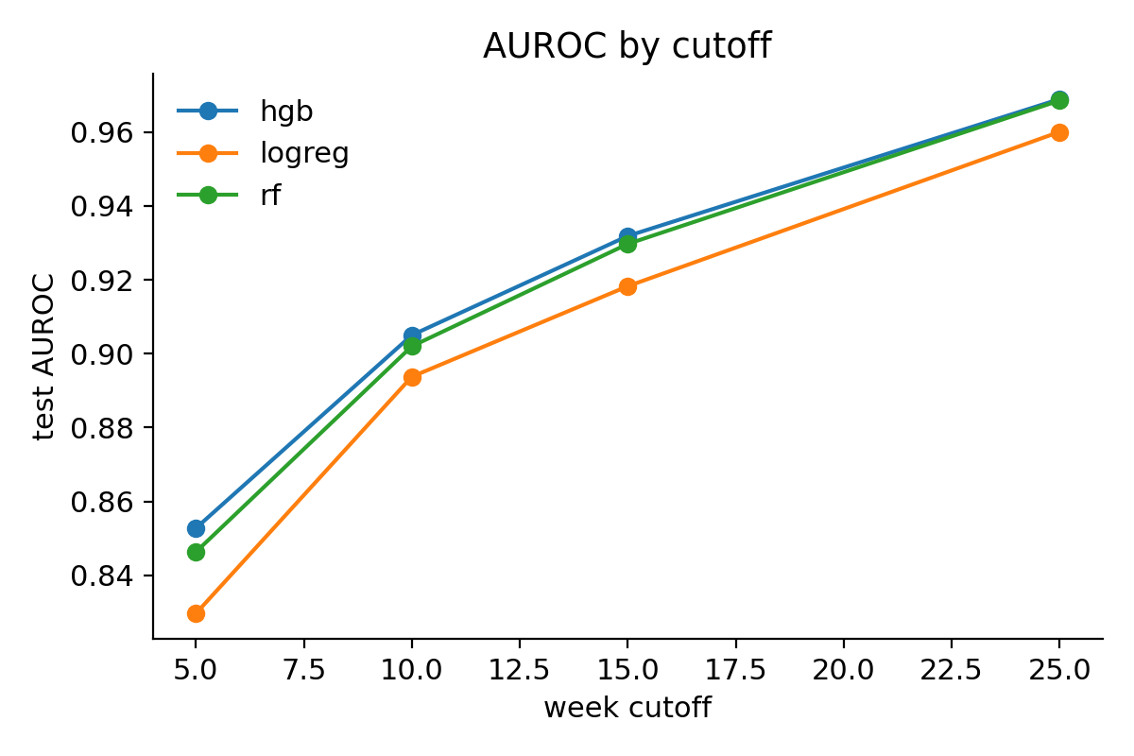
Test AUROC by week cutoff, three model families.
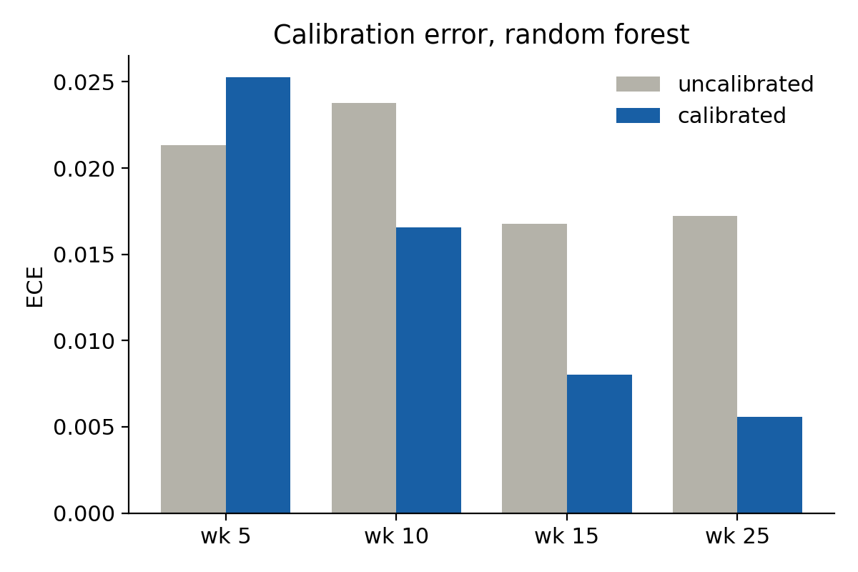
Calibration error before and after isotonic, random forest.
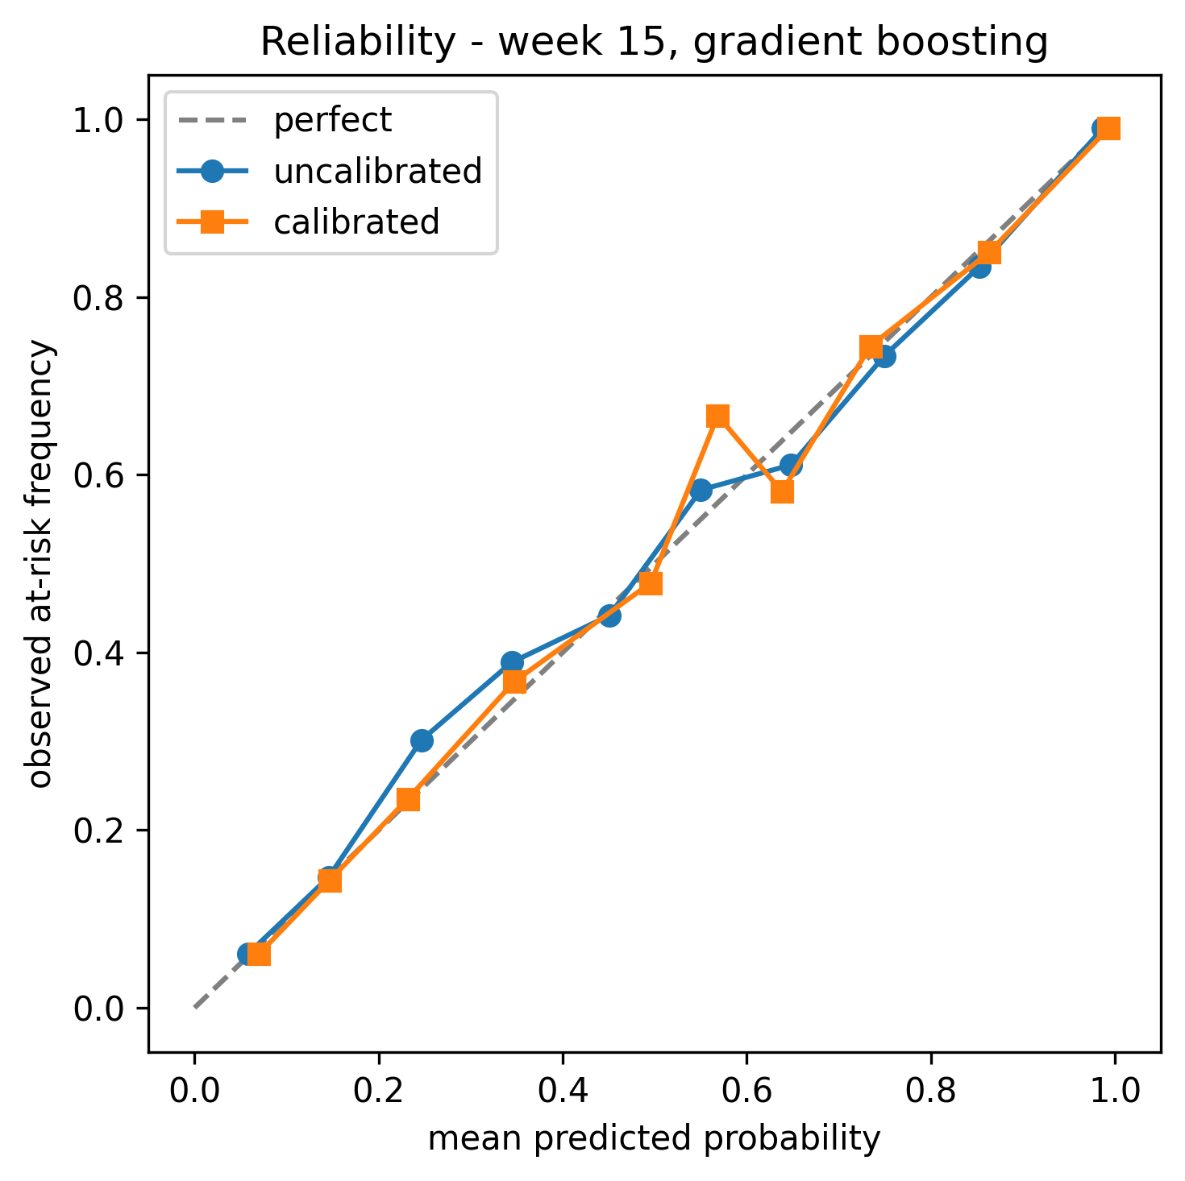
Reliability curve, week 15 gradient boosting.

3. Explanation agreement and faithfulness (NB03, NB04)
Cross-model SHAP agreement (Spearman rank correlation, 95% CI). The two tree models agree strongly and logistic regression converges toward them as the cutoff grows; all intervals exclude zero.
cutoff_week | pair | spearman | spearman_lo | spearman_hi
5 | logreg-rf | 0.4737 | 0.4579 | 0.4927
5 | logreg-hgb | 0.3639 | 0.3523 | 0.3901
5 | rf-hgb | 0.9127 | 0.9048 | 0.9237
10 | logreg-rf | 0.5598 | 0.5415 | 0.5782
10 | logreg-hgb | 0.5305 | 0.5128 | 0.5592
10 | rf-hgb | 0.7418 | 0.7192 | 0.7668
15 | logreg-rf | 0.6960 | 0.6667 | 0.7039
15 | logreg-hgb | 0.5696 | 0.5531 | 0.6013
15 | rf-hgb | 0.6697 | 0.6587 | 0.7076
25 | logreg-rf | 0.7350 | 0.7216 | 0.7527
25 | logreg-hgb | 0.6532 | 0.6386 | 0.6654
25 | rf-hgb | 0.7888 | 0.7705 | 0.7991
Faithfulness used predicted-class deletion AOPC (positive for every model after the fix). The deprived-minus-affluent gap was recomputed within predicted-risk bands to control for the higher base risk of deprived students. After adjustment the gap for gradient boosting is consistent with zero at every cutoff (adjusted gaps -0.0108, -0.0108, -0.0121, 0.0001, all intervals spanning zero). I therefore report no reliable subgroup difference in explanation faithfulness: the apparent disparity was a base-rate artifact. This stands as a methodological caution, since subgroup faithfulness is often reported without controlling for base rate.
cutoff_week | model | del_aopc_predclass | raw_gap_imd | adj_gap_imd | adj_lo | adj_hi
5 | logreg | 0.2166 | 0.0079 | 0.0033 | -0.0059 | 0.0162
5 | rf | 0.1808 | 0.0027 | -0.0061 | -0.0194 | 0.0086
5 | hgb | 0.1824 | 0.0041 | -0.0108 | -0.0220 | 0.0077
10 | logreg | 0.2767 | 0.0034 | 0.0043 | -0.0084 | 0.0221
10 | rf | 0.2198 | 0.0050 | -0.0046 | -0.0186 | 0.0116
10 | hgb | 0.2527 | 0.0203 | -0.0108 | -0.0291 | 0.0059
15 | logreg | 0.3013 | -0.0144 | 0.0101 | -0.0086 | 0.0241
15 | rf | 0.2536 | 0.0285 | -0.0106 | -0.0231 | 0.0077
15 | hgb | 0.2867 | 0.0496 | -0.0121 | -0.0290 | 0.0122
25 | logreg | 0.2973 | -0.0292 | -0.0038 | -0.0249 | 0.0154
25 | rf | 0.2748 | 0.0184 | -0.0074 | -0.0197 | 0.0129
25 | hgb | 0.3324 | 0.0595 | 0.0001 | -0.0198 | 0.0181
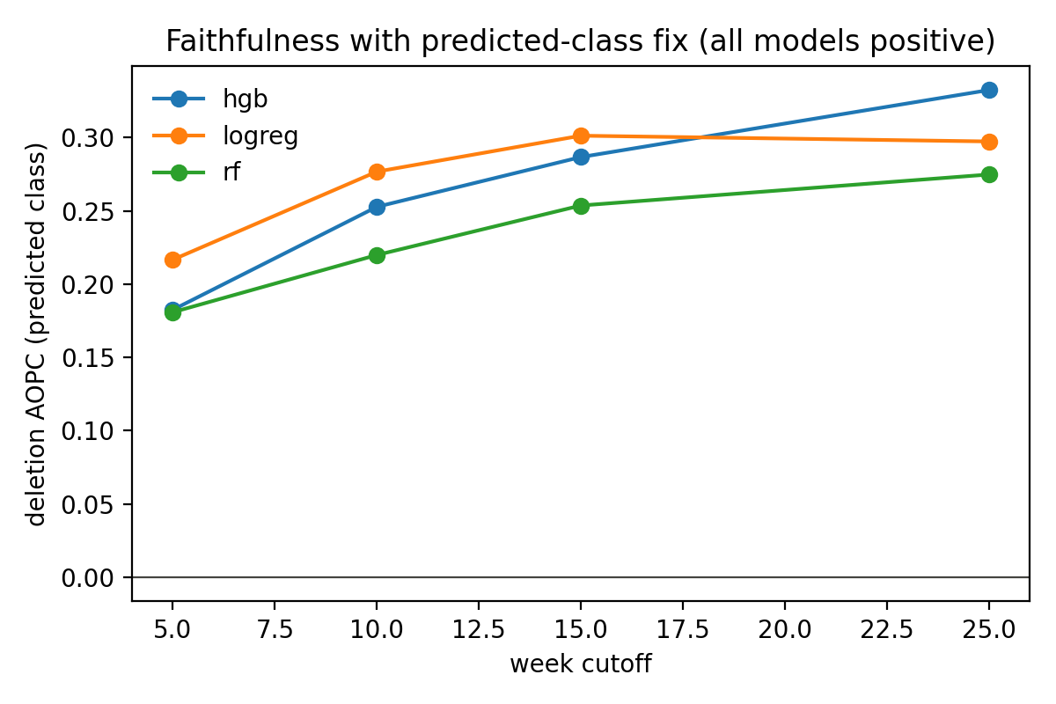
Predicted-class deletion AOPC by model (sign-corrected).
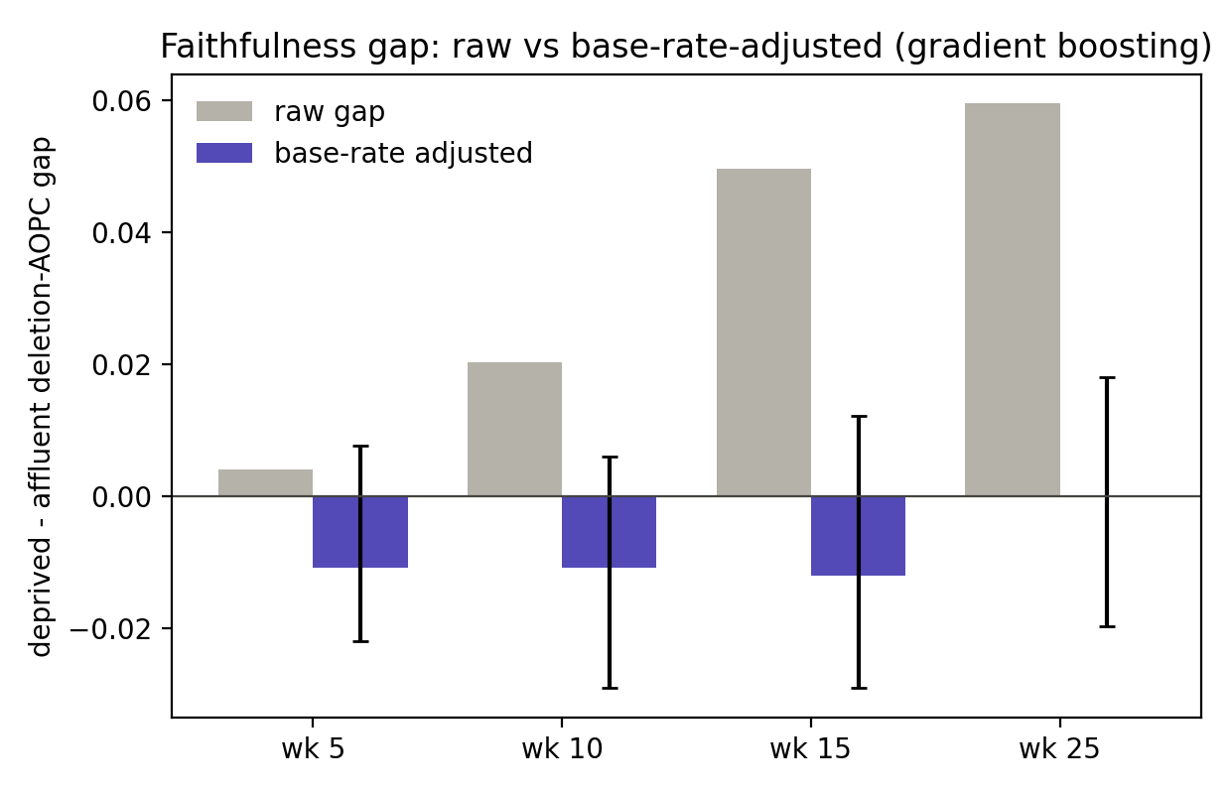
Faithfulness gap: raw vs base-rate-adjusted.

4. Fairness audit (NB04)
The flag fires substantially more often for deprived and disabled students (demographic-parity gaps of roughly 0.12 to 0.16 on deprivation, reliable at every cutoff). On its own this is not a harm, because these groups carry genuinely higher risk. The equity concern is the false-positive side: not-at-risk students in these groups are over-flagged, with the FPR gap excluding zero at weeks 5, 10, 15 and 25 on deprivation and weeks 10 and 15 on disability for gradient boosting. The over-flagging is widest at the early cutoffs and narrows by week 25, so the burden is heaviest where the system acts soonest. Age shows no reliable disparity.
False-positive-rate gaps (group A minus group B, 95% CI):
cutoff_week | model | attribute | fpr_gap | fpr_lo | fpr_hi
5 | logreg | imd | 0.0912 | 0.0526 | 0.1345
5 | logreg | disability | 0.0446 | -0.0107 | 0.1011
5 | logreg | age | 0.0758 | -0.0603 | 0.1839
5 | rf | imd | 0.0477 | 0.0123 | 0.0837
5 | rf | disability | 0.0673 | 0.0140 | 0.1222
5 | rf | age | 0.1159 | 0.0251 | 0.1817
5 | hgb | imd | 0.0462 | 0.0115 | 0.0820
5 | hgb | disability | 0.0508 | -0.0019 | 0.1029
5 | hgb | age | 0.0602 | -0.0561 | 0.1564
10 | logreg | imd | 0.0713 | 0.0406 | 0.1072
10 | logreg | disability | 0.0473 | -0.0016 | 0.0987
10 | logreg | age | -0.0745 | -0.2213 | 0.0508
10 | rf | imd | 0.0375 | 0.0028 | 0.0731
10 | rf | disability | 0.0537 | 0.0028 | 0.1034
10 | rf | age | -0.0051 | -0.1347 | 0.1058
10 | hgb | imd | 0.0621 | 0.0304 | 0.0947
10 | hgb | disability | 0.0538 | 0.0031 | 0.1037
10 | hgb | age | -0.0223 | -0.1571 | 0.0877
15 | logreg | imd | 0.0537 | 0.0250 | 0.0844
15 | logreg | disability | 0.0560 | 0.0109 | 0.1087
15 | logreg | age | -0.0201 | -0.1489 | 0.0732
15 | rf | imd | 0.0479 | 0.0162 | 0.0810
15 | rf | disability | 0.0843 | 0.0344 | 0.1369
15 | rf | age | 0.0358 | -0.0726 | 0.1256
15 | hgb | imd | 0.0319 | 0.0068 | 0.0579
15 | hgb | disability | 0.0590 | 0.0183 | 0.1044
15 | hgb | age | -0.0095 | -0.1187 | 0.0799
25 | logreg | imd | 0.0211 | -0.0012 | 0.0428
25 | logreg | disability | 0.0324 | -0.0031 | 0.0696
25 | logreg | age | -0.0009 | -0.1023 | 0.0637
25 | rf | imd | 0.0272 | 0.0084 | 0.0462
25 | rf | disability | -0.0010 | -0.0260 | 0.0254
25 | rf | age | -0.0103 | -0.1071 | 0.0538
25 | hgb | imd | 0.0278 | 0.0083 | 0.0493
25 | hgb | disability | 0.0205 | -0.0108 | 0.0538
25 | hgb | age | -0.0049 | -0.1013 | 0.0592
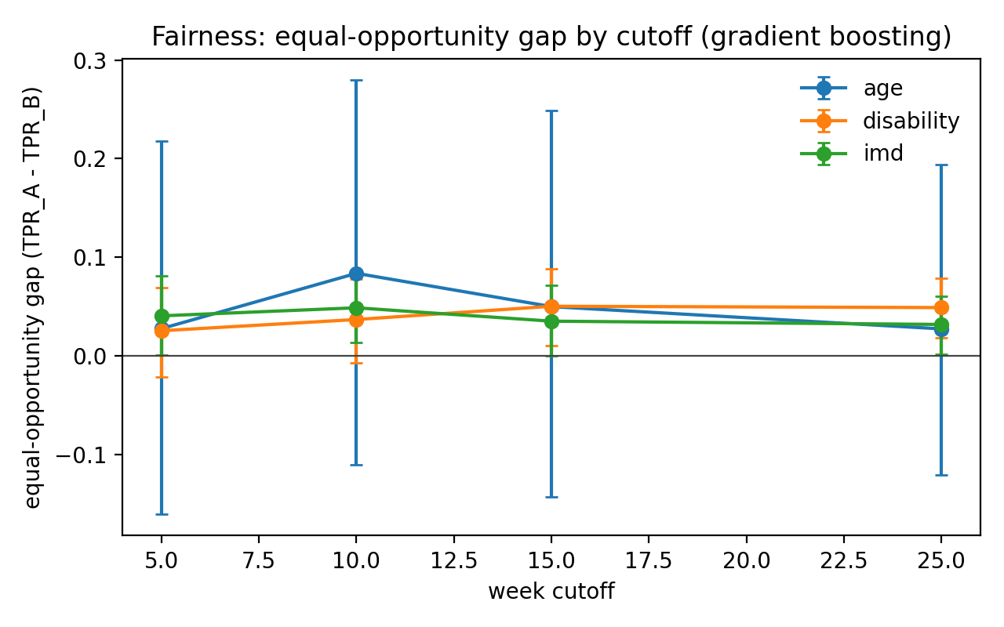
Equal-opportunity gap by cutoff and attribute.

5. Counterfactual recourse (NB05)
Recourse was measured with mutability-constrained counterfactuals (DiCE random search; only behavioural features may change), reporting the standardised distance to flip the flag and whether a counterfactual was found. The deprived-minus-affluent distance gap is reported raw and base-rate-adjusted within predicted-risk bands.
After adjustment the distance gap is consistent with zero at both cutoffs (adjusted gaps -1.79, -5.64, intervals spanning zero), and the raw gap even changes sign across cutoffs. Counterfactual availability is equal across groups (success rates near 0.90 for both deprived and affluent students). I therefore report no reliable recourse-burden disparity by deprivation: deprived students need no more behavioural change to clear the flag, and recourse is found about as often, as for affluent students.
cutoff_week | dist_deprived | dist_affluent | dist_gap_raw | dist_gap_adj | dist_gap_adj_lo | dist_gap_adj_hi
5.0000 | 23.7057 | 21.1480 | 2.5577 | -1.7899 | -7.4116 | 3.2814
15.0000 | 11.6941 | 16.1860 | -4.4919 | -5.6445 | -14.5475 | 1.3298
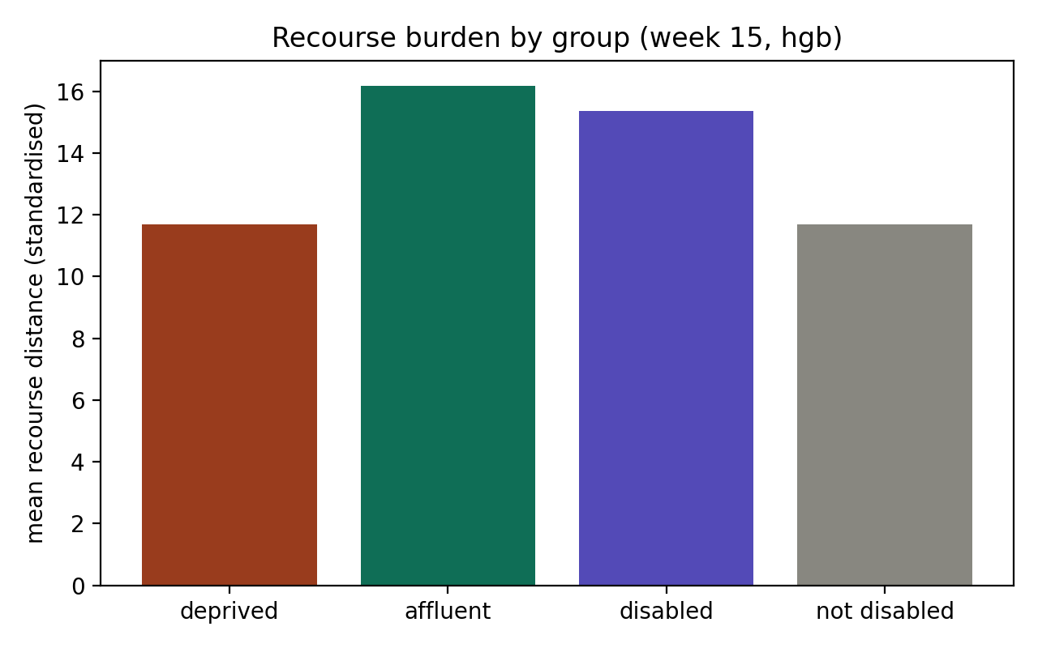
Mean recourse distance by group (week 15).
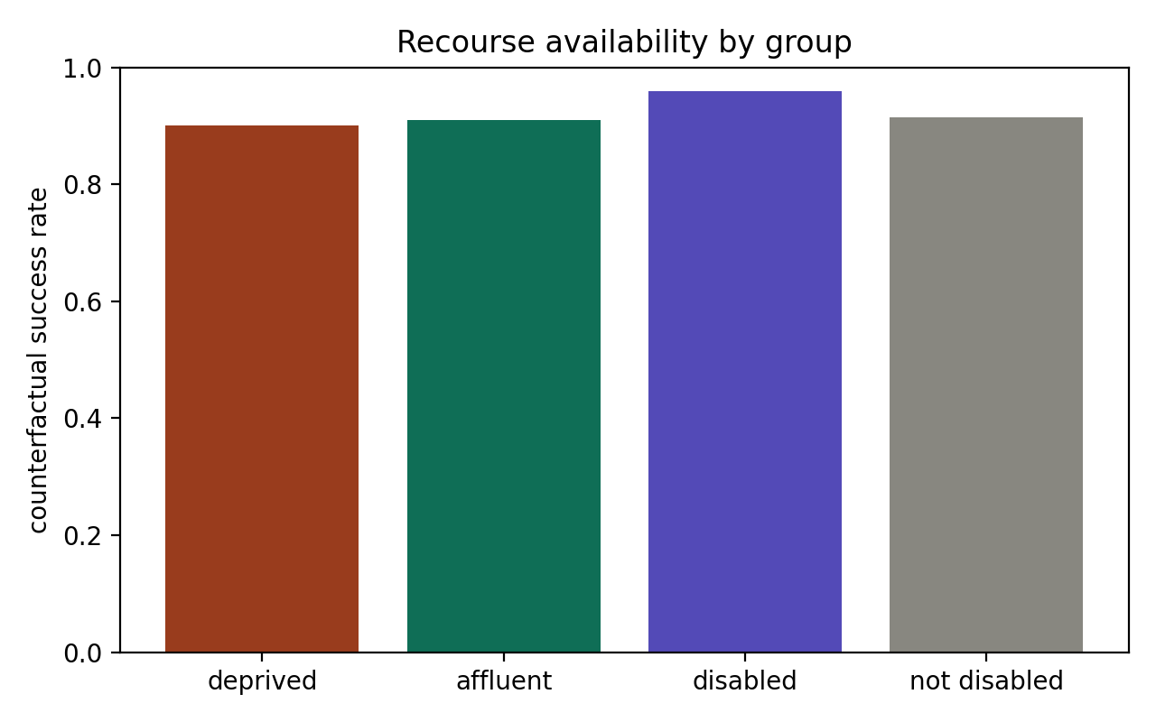
Counterfactual availability by group.
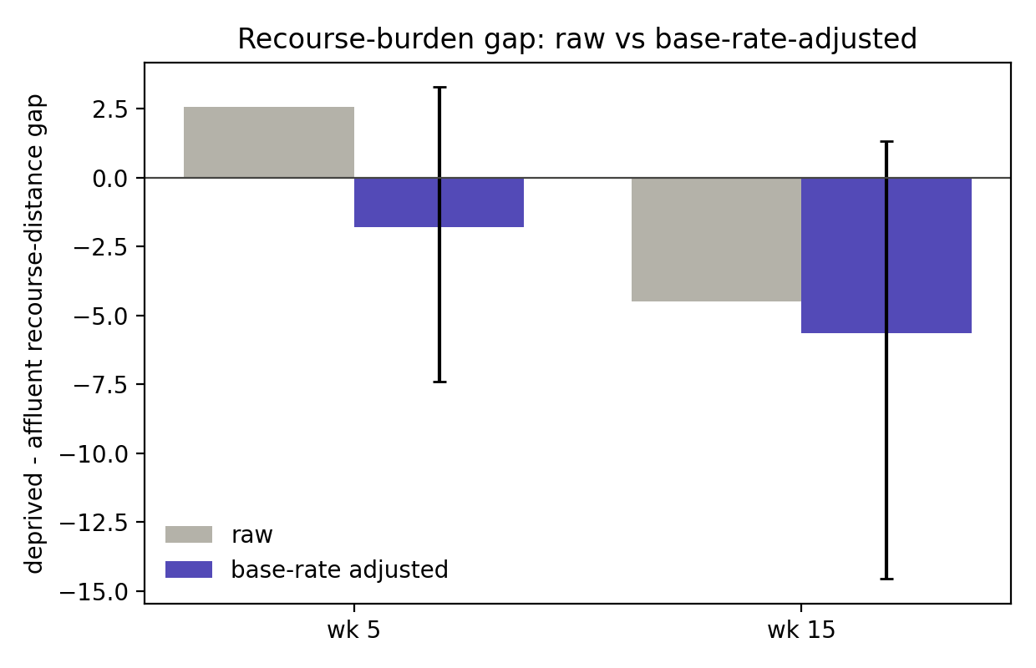
Recourse-burden gap: raw vs base-rate-adjusted.

6. Trust-equity summary (C6)
Consolidated trust-equity view by protected group (week 15, gradient boosting): subgroup calibration error, true- and false-positive rates, recourse distance, and counterfactual availability.
group | ECE | TPR | FPR | recourse_distance | cf_success_rate
deprived | 0.0178 | 0.8159 | 0.0912 | 11.6941 | 0.9018
affluent | 0.0198 | 0.7808 | 0.0594 | 16.1860 | 0.9091
disabled | 0.0395 | 0.8337 | 0.1270 | 15.3607 | 0.9273
not_disabled | 0.0088 | 0.7835 | 0.0680 | 11.6926 | 0.9139
Across four trust dimensions the layer is equitable on three and shows one localised harm. Calibration holds within groups (subgroup ECE 0.0178 deprived versus 0.0198 affluent, and 0.0395 disabled versus 0.0088 non-disabled). Explanation faithfulness shows no reliable subgroup difference after base-rate adjustment, and recourse burden likewise shows no reliable difference, with counterfactuals found about equally often for every group. The single exception is false-positive burden: not-at-risk deprived students are flagged at 0.0912 against 0.0594 for affluent, and not-at-risk disabled students at 0.1270 against 0.0680 for non-disabled. The inequity in this system is concentrated at the decision threshold, not in explanation quality, calibration, or the recourse pathway. The base-rate adjustment is what allows the three nulls to be asserted rather than mistaking base-rate artifacts for harms.
Remaining work: the Withdrawn-excluded robustness variant, and threshold or post-processing mitigation targeted at the false-positive burden, which is the one dimension where the trust layer is not equitable.

