Auditing the Trust Layer: Calibration, Explanation Faithfulness, Fairness, and Recourse in an Explainable Early-Warning System for Student Outcomes
Md Anas Biswas, University of Portsmouth. Draft, 2026-06-05.

Abstract
Early-warning systems that flag students at risk of failing are increasingly built on machine learning, yet a flag is only trustworthy if its probability is well calibrated, its explanation is faithful, its errors are distributed fairly, and the student is offered a feasible path to change the outcome. I study these properties together on the Open University Learning Analytics Dataset, treating them as one trust layer over a temporal early-warning model rather than as isolated metrics. Three model families are trained at four within-course cutoffs, calibrated, and audited for cross-model explanation agreement, explanation faithfulness, fairness, and counterfactual recourse, each with bootstrap confidence intervals. Two methodological points emerge. First, a naive subgroup comparison of explanation faithfulness reports a sizeable disparity that disappears entirely once predicted base rate is controlled, so subgroup faithfulness gaps can be base-rate artifacts. The same control removes an apparent recourse disparity. Second, the one inequity that is real and survives both base-rate adjustment and a change of label definition is a false-positive burden: students who are deprived or disabled, and who are not at risk, are over-flagged, and the burden is heaviest at the earliest cutoffs where the system acts soonest. Calibration, explanation faithfulness, and recourse are equitable across deprivation and disability; the inequity is concentrated at the decision threshold. I argue that trust audits should be conducted jointly and with base-rate controls, and that mitigation in this setting belongs at the operating threshold rather than in the explanation or recourse machinery.

1. Introduction
Predictive early-warning systems are now common in higher education, where models trained on virtual learning environment activity and assessment records flag students likely to fail so that support can be directed early. The predictive task is well studied. What is less settled is whether the surrounding apparatus that makes such a system usable and accountable, the calibrated probability, the feature explanation, the fairness of the decision, and the recourse offered to a flagged student, behaves equitably for the students who most depend on it.
These properties are usually examined one at a time and in aggregate. A model is reported as calibrated, or its explanations as faithful, or its decisions as fair, but rarely all of these together and rarely within protected groups. That gap matters, because a system can be well calibrated and accurate overall while its explanations are less faithful, or its recourse more costly, for a disadvantaged subgroup. I refer to the combination of calibration, explanation, fairness, and recourse as the trust layer, and I audit it as a whole.
I make three contributions. First, I assemble a single trust-layer audit over a temporal early-warning model and report every component by protected group with bootstrap confidence intervals. Second, I show that a subgroup faithfulness comparison, and a subgroup recourse comparison, each produce an apparent disparity that vanishes once predicted base rate is controlled, which is a cautionary methodological result for subgroup explanation audits. Third, I identify the one inequity that is robust: a false-positive over-flagging of deprived and disabled students that survives both base-rate adjustment and a change in how at-risk is defined, and that is concentrated at the earliest cutoffs.

2. Related work
Early-warning prediction on log and assessment data is established, and the Open University Learning Analytics Dataset has become a common benchmark for it. Work on explainability in this setting typically applies feature-attribution methods such as SHAP to interpret a single model, and work on fairness typically reports group error-rate differences for a single decision threshold. Calibration of risk scores and actionable recourse through counterfactual explanations are each active areas in their own right. The contribution here is not a new attribution or recourse method but the joint, subgroup-resolved, base-rate-controlled audit of these properties on one system, and the empirical finding about where inequity does and does not arise.

3. Data and problem setup
The Open University Learning Analytics Dataset comprises 32,593 student-module enrolments across seven linked tables, including 10,655,280 daily virtual learning environment click records, 173,912 assessment submissions, and student demographics. The primary target labels a student at-risk if the final result is Fail or Withdrawn, against Pass or Distinction, which yields a positive rate of 0.528. Withdrawal is kept in the positive class because a student who leaves is precisely whom an early-warning system should catch; a Fail-only variant is examined in the robustness analysis.
Prediction is made at four within-course cutoffs, weeks 5, 10, 15, and 25, and every feature summarises only activity observed up to its cutoff, so an early prediction cannot see late outcomes. A monotonicity check, that accumulated clicks at a later cutoff never fall below those at an earlier one, returned zero violations, evidencing the absence of post-cutoff leakage. Each enrolment is described by 27 features spanning engagement, assessment behaviour, and registration. Protected attributes are excluded from the model inputs and retained only for the audit. The data is split, stratified by outcome, into 19,555 training, 6,519 calibration, and 6,519 test enrolments.
The motivation for a trust-equity audit is visible in the raw labels. The at-risk rate rises almost monotonically with deprivation, from 0.425 in the least deprived band to 0.648 in the most deprived, and disabled students are at-risk at 0.619 against 0.518 for their peers. The outcome the model learns is therefore already strongly associated with protected status, so the equity questions are substantive.
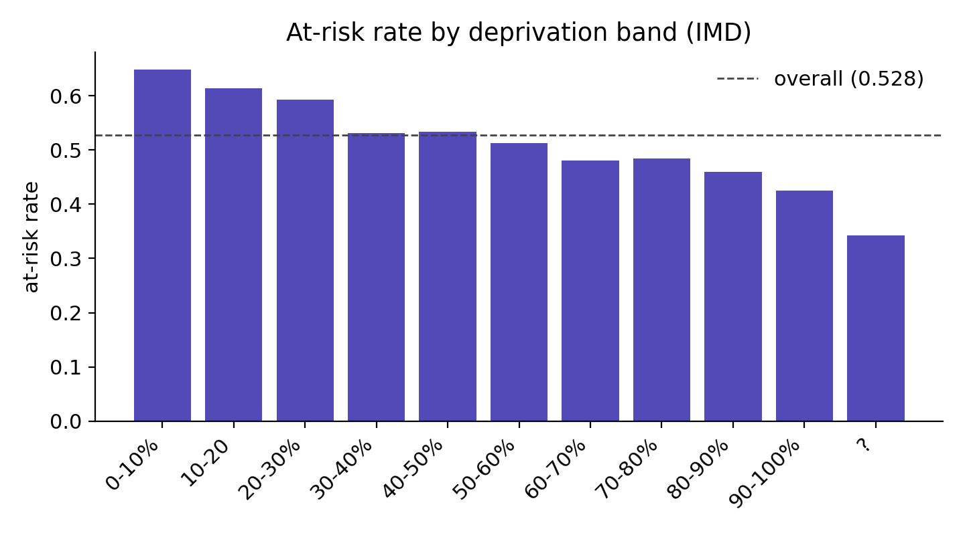
Figure 1. At-risk rate by deprivation band (IMD).
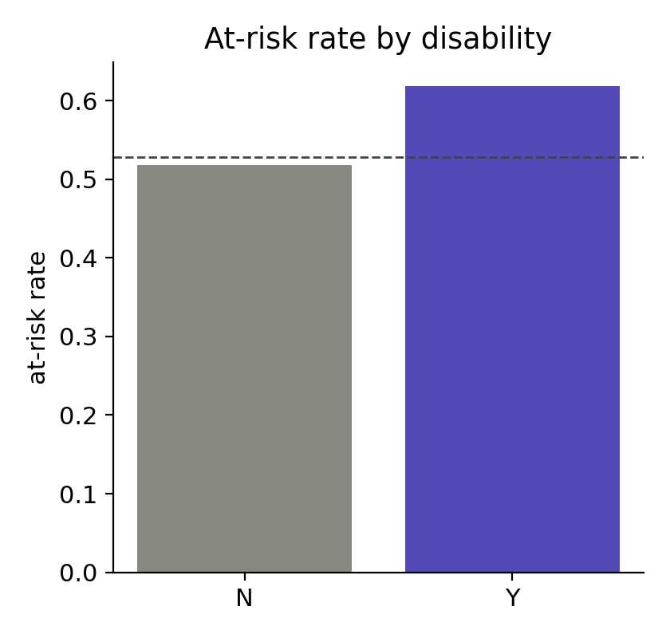
Figure 2. At-risk rate by declared disability.

4. Methods

4.1 Models and calibration
Three deliberately different model families are trained at each cutoff: logistic regression, random forest, and gradient boosting. The diversity is intentional, because the cross-model agreement analysis is only meaningful if the models have different inductive biases. Each model is fit on the training split with balanced class weighting; a calibrator is fit on the held-out calibration split; and all metrics are reported on the untouched test split. Imputation medians and the logistic-regression scaler are fit on the training split only. Calibration follows a hybrid rule, isotonic regression when the calibration set exceeds thirty examples and Platt scaling otherwise; isotonic was selected throughout. Calibration quality is reported as Brier score and expected calibration error (ECE).

4.2 Explanation agreement and faithfulness
SHAP values are computed per model on a stratified sample of each test split, using tree explainers for the ensemble models and the closed-form linear explainer for logistic regression. Cross-model agreement is the Spearman and Kendall rank correlation of mean absolute SHAP feature importances between model pairs. Faithfulness is measured by deletion: features are removed in order of importance and the decline in the model confidence is integrated into an area-over-the-perturbation-curve (AOPC). I measure confidence in the predicted class, which keeps the metric well signed for every model. To test subgroup faithfulness I compute the deprived-minus-affluent AOPC gap, and because deprived students carry higher base risk and therefore predictions further from the decision boundary, I recompute that gap within predicted-risk bands to separate a genuine difference from a base-rate effect.

4.3 Fairness and recourse
The fairness audit reports flag rate, true-positive rate, and false-positive rate per protected group, and the demographic-parity, equal-opportunity, and false-positive-rate gaps, across deprivation, disability, and age band. Recourse is measured with mutability-constrained counterfactuals generated by DiCE, in which only behavioural features may change while protected attributes and fixed history are held; for each flagged student I record whether a counterfactual was found, its standardised distance, and its sparsity. The deprived-minus-affluent recourse-distance gap is reported raw and base-rate adjusted, mirroring the faithfulness analysis. All gaps carry 1,000-resample bootstrap confidence intervals. A counterfactual found by DiCE random search is a valid but not necessarily minimal recourse, so the distance is interpreted as a recourse cost and the group comparison as the robust quantity.

5. Results

5.1 Predictive performance and calibration
Discrimination improves monotonically with the cutoff, from an AUROC of about 0.83 to 0.85 at week 5 to 0.96 to 0.97 at week 25, which quantifies the early-warning trade-off: useful prediction is possible from the first five weeks and sharpens as behaviour accumulates. Gradient boosting and random forest lead, with logistic regression close behind. Calibration error is low before any post-hoc step, between 0.013 and 0.033, so isotonic calibration maintains and modestly improves the probabilities rather than rescuing them, with the clearest gains at the later cutoffs.
cutoff_week | model | auroc | recall | f1 | brier_cal | ece_uncal | ece_cal
5 | hgb | 0.8527 | 0.7220 | 0.7699 | 0.1549 | 0.0146 | 0.0187
5 | logreg | 0.8297 | 0.7199 | 0.7495 | 0.1674 | 0.0327 | 0.0220
5 | rf | 0.8463 | 0.7074 | 0.7630 | 0.1588 | 0.0213 | 0.0253
10 | hgb | 0.9050 | 0.7789 | 0.8254 | 0.1217 | 0.0128 | 0.0191
10 | logreg | 0.8937 | 0.7815 | 0.8201 | 0.1278 | 0.0147 | 0.0142
10 | rf | 0.9020 | 0.7911 | 0.8283 | 0.1230 | 0.0238 | 0.0165
15 | hgb | 0.9318 | 0.7894 | 0.8513 | 0.1014 | 0.0128 | 0.0103
15 | logreg | 0.9182 | 0.7902 | 0.8395 | 0.1121 | 0.0164 | 0.0096
15 | rf | 0.9297 | 0.8239 | 0.8560 | 0.1030 | 0.0168 | 0.0080
25 | hgb | 0.9689 | 0.8774 | 0.9118 | 0.0652 | 0.0136 | 0.0095
25 | logreg | 0.9600 | 0.8533 | 0.8960 | 0.0746 | 0.0146 | 0.0099
25 | rf | 0.9685 | 0.8739 | 0.9133 | 0.0649 | 0.0172 | 0.0056
Table 1. Test performance and calibration error by cutoff and model.
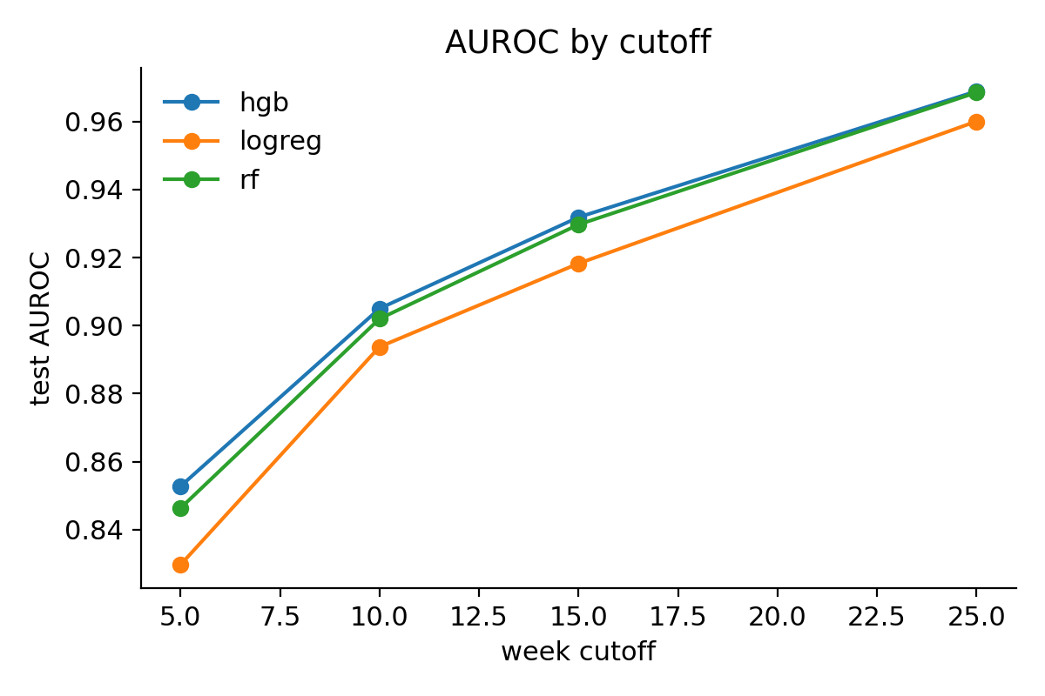
Figure 3. Test AUROC by week cutoff.
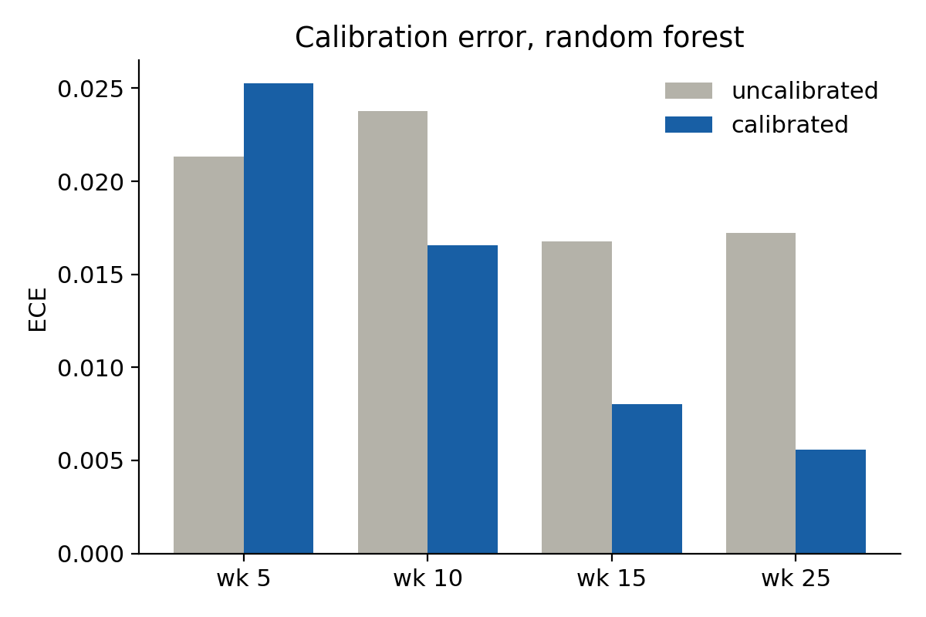
Figure 4. Calibration error before and after isotonic calibration, random forest.

5.2 Cross-model explanation agreement
The two tree models agree strongly on which features drive a flag, with a Spearman rank correlation of 0.91 at week 5 settling around 0.67 to 0.79 at later cutoffs, while logistic regression begins more divergent and converges toward them as the cutoff grows. Every interval excludes zero. Comparable predictive accuracy combined with substantial, growing agreement on the explanation supports treating the attributions as a stable account of the model rather than an artifact of one architecture.
cutoff_week | pair | spearman | spearman_lo | spearman_hi
5 | logreg-rf | 0.4737 | 0.4579 | 0.4927
5 | logreg-hgb | 0.3639 | 0.3523 | 0.3901
5 | rf-hgb | 0.9127 | 0.9048 | 0.9237
10 | logreg-rf | 0.5598 | 0.5415 | 0.5782
10 | logreg-hgb | 0.5305 | 0.5128 | 0.5592
10 | rf-hgb | 0.7418 | 0.7192 | 0.7668
15 | logreg-rf | 0.6960 | 0.6667 | 0.7039
15 | logreg-hgb | 0.5696 | 0.5531 | 0.6013
15 | rf-hgb | 0.6697 | 0.6587 | 0.7076
25 | logreg-rf | 0.7350 | 0.7216 | 0.7527
25 | logreg-hgb | 0.6532 | 0.6386 | 0.6654
25 | rf-hgb | 0.7888 | 0.7705 | 0.7991
Table 2. Cross-model SHAP agreement (Spearman, 95% CI).

5.3 Faithfulness and a base-rate artifact
Deletion AOPC is positive for every model once measured on the predicted class. A naive deprived-minus-affluent comparison reports a positive faithfulness gap, suggesting explanations are more faithful for deprived students. That gap does not survive control for base rate. Recomputed within predicted-risk bands, the gradient-boosting gap is consistent with zero at every cutoff, with all intervals spanning zero. I therefore report no reliable subgroup difference in explanation faithfulness, and I draw the methodological conclusion that subgroup faithfulness gaps reported without base-rate control can be artifacts of differing distance from the decision boundary.
cutoff_week | model | del_aopc_predclass | raw_gap_imd | adj_gap_imd | adj_lo | adj_hi
5 | logreg | 0.2166 | 0.0079 | 0.0033 | -0.0059 | 0.0162
5 | rf | 0.1808 | 0.0027 | -0.0061 | -0.0194 | 0.0086
5 | hgb | 0.1824 | 0.0041 | -0.0108 | -0.0220 | 0.0077
10 | logreg | 0.2767 | 0.0034 | 0.0043 | -0.0084 | 0.0221
10 | rf | 0.2198 | 0.0050 | -0.0046 | -0.0186 | 0.0116
10 | hgb | 0.2527 | 0.0203 | -0.0108 | -0.0291 | 0.0059
15 | logreg | 0.3013 | -0.0144 | 0.0101 | -0.0086 | 0.0241
15 | rf | 0.2536 | 0.0285 | -0.0106 | -0.0231 | 0.0077
15 | hgb | 0.2867 | 0.0496 | -0.0121 | -0.0290 | 0.0122
25 | logreg | 0.2973 | -0.0292 | -0.0038 | -0.0249 | 0.0154
25 | rf | 0.2748 | 0.0184 | -0.0074 | -0.0197 | 0.0129
25 | hgb | 0.3324 | 0.0595 | 0.0001 | -0.0198 | 0.0181
Table 3. Deletion AOPC and the raw versus base-rate-adjusted deprivation faithfulness gap.
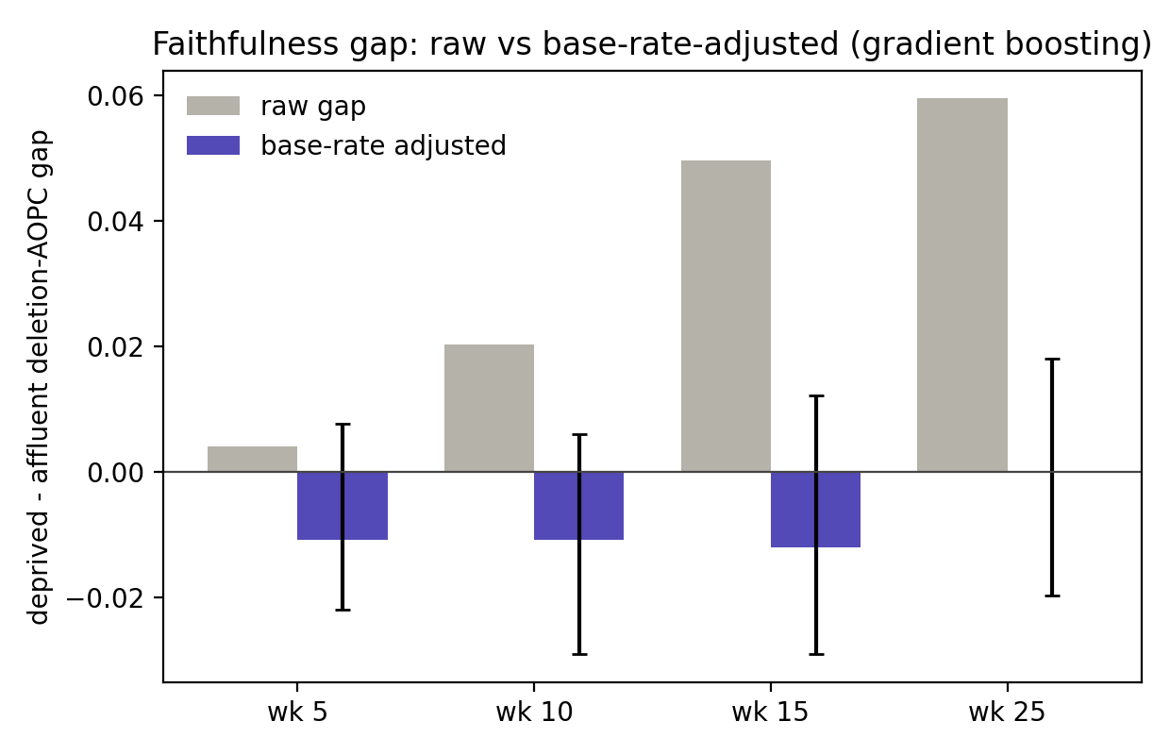
Figure 5. Faithfulness gap: raw versus base-rate-adjusted.

5.4 Fairness audit
The flag fires substantially more often for deprived and disabled students, with demographic-parity gaps on deprivation of roughly 0.12 to 0.16 that are reliable at every cutoff. On its own this is not a harm, because these groups carry genuinely higher risk. The equity concern is the false-positive side: students who are not at risk are over-flagged if they are deprived or disabled. The false-positive-rate gap excludes zero across the early cutoffs for deprivation and the middle cutoffs for disability, and it is widest at the early cutoffs and narrows by week 25, so the burden is heaviest exactly where the system acts soonest. Age shows no reliable disparity on any measure.
cutoff_week | model | attribute | fpr_gap | fpr_lo | fpr_hi
5 | logreg | imd | 0.0912 | 0.0526 | 0.1345
5 | logreg | disability | 0.0446 | -0.0107 | 0.1011
5 | rf | imd | 0.0477 | 0.0123 | 0.0837
5 | rf | disability | 0.0673 | 0.0140 | 0.1222
5 | hgb | imd | 0.0462 | 0.0115 | 0.0820
5 | hgb | disability | 0.0508 | -0.0019 | 0.1029
10 | logreg | imd | 0.0713 | 0.0406 | 0.1072
10 | logreg | disability | 0.0473 | -0.0016 | 0.0987
10 | rf | imd | 0.0375 | 0.0028 | 0.0731
10 | rf | disability | 0.0537 | 0.0028 | 0.1034
10 | hgb | imd | 0.0621 | 0.0304 | 0.0947
10 | hgb | disability | 0.0538 | 0.0031 | 0.1037
15 | logreg | imd | 0.0537 | 0.0250 | 0.0844
15 | logreg | disability | 0.0560 | 0.0109 | 0.1087
15 | rf | imd | 0.0479 | 0.0162 | 0.0810
15 | rf | disability | 0.0843 | 0.0344 | 0.1369
15 | hgb | imd | 0.0319 | 0.0068 | 0.0579
15 | hgb | disability | 0.0590 | 0.0183 | 0.1044
25 | logreg | imd | 0.0211 | -0.0012 | 0.0428
25 | logreg | disability | 0.0324 | -0.0031 | 0.0696
25 | rf | imd | 0.0272 | 0.0084 | 0.0462
25 | rf | disability | -0.0010 | -0.0260 | 0.0254
25 | hgb | imd | 0.0278 | 0.0083 | 0.0493
25 | hgb | disability | 0.0205 | -0.0108 | 0.0538
Table 4. False-positive-rate gaps for deprivation and disability (group A minus B, 95% CI).
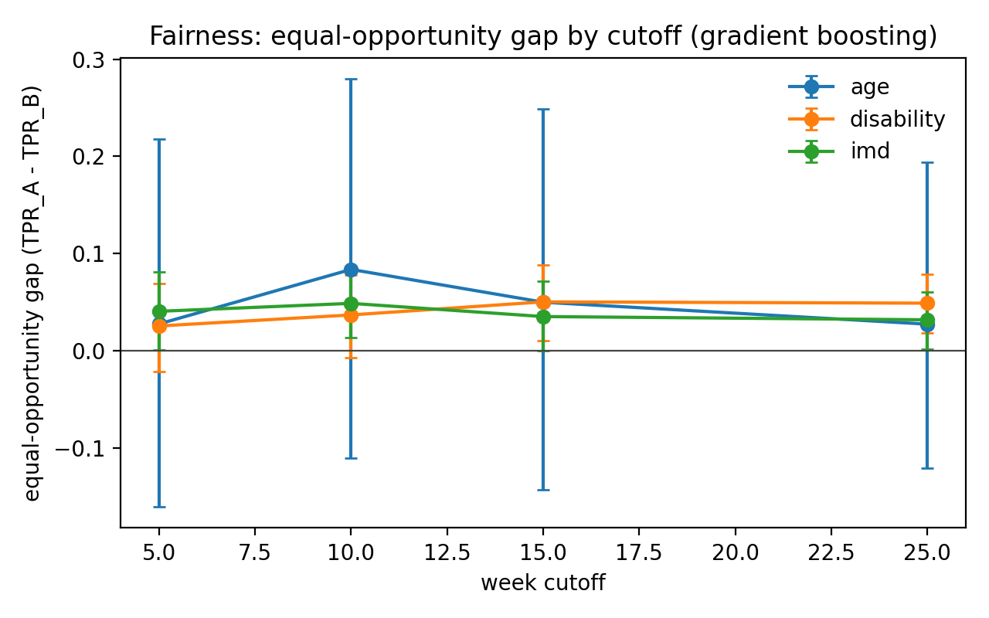
Figure 6. Equal-opportunity gap by cutoff and attribute.

5.5 Counterfactual recourse
Recourse shows the same pattern as faithfulness. The raw deprived-minus-affluent recourse-distance gap is small and changes sign across cutoffs, and after base-rate adjustment it is consistent with zero at both cutoffs examined, with intervals spanning zero. Counterfactual availability is equal across groups, with success rates near 0.90 for both deprived and affluent students. I therefore report no reliable recourse-burden disparity by deprivation: deprived students need no more behavioural change to clear the flag, and recourse is found about as often, as for affluent students.
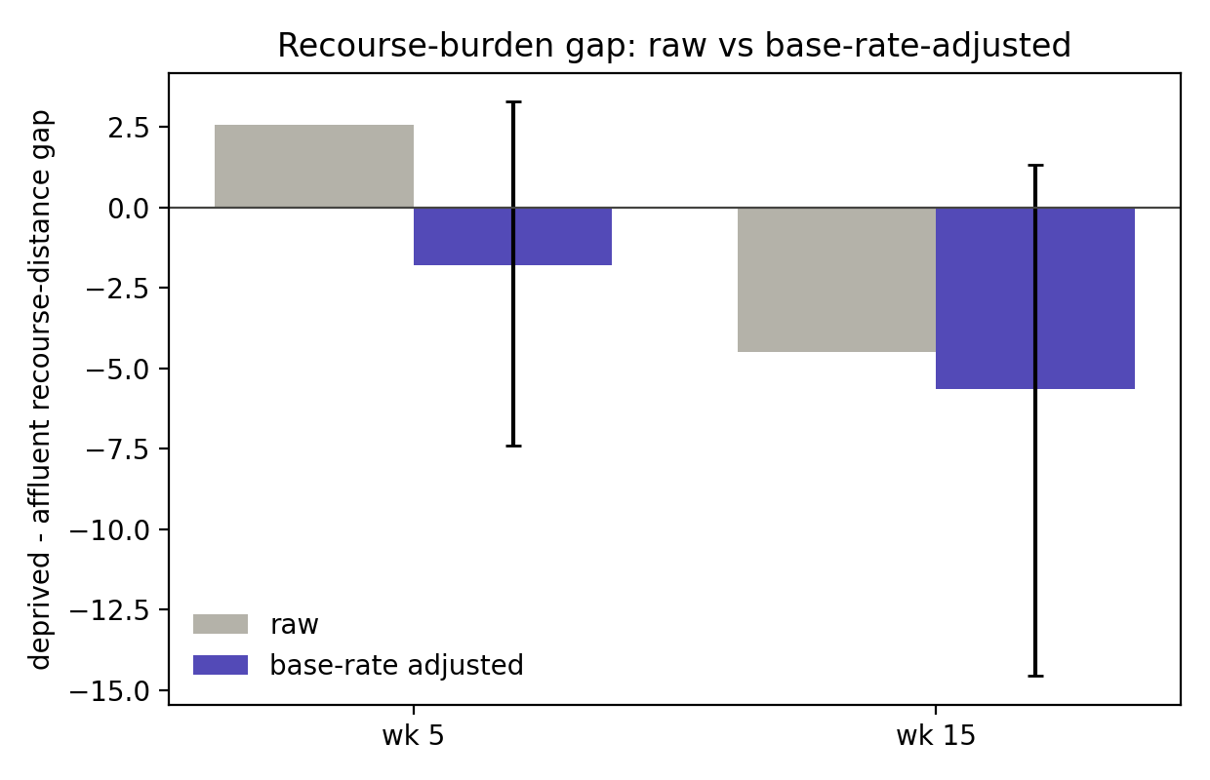
Figure 7. Recourse-burden gap: raw versus base-rate-adjusted.
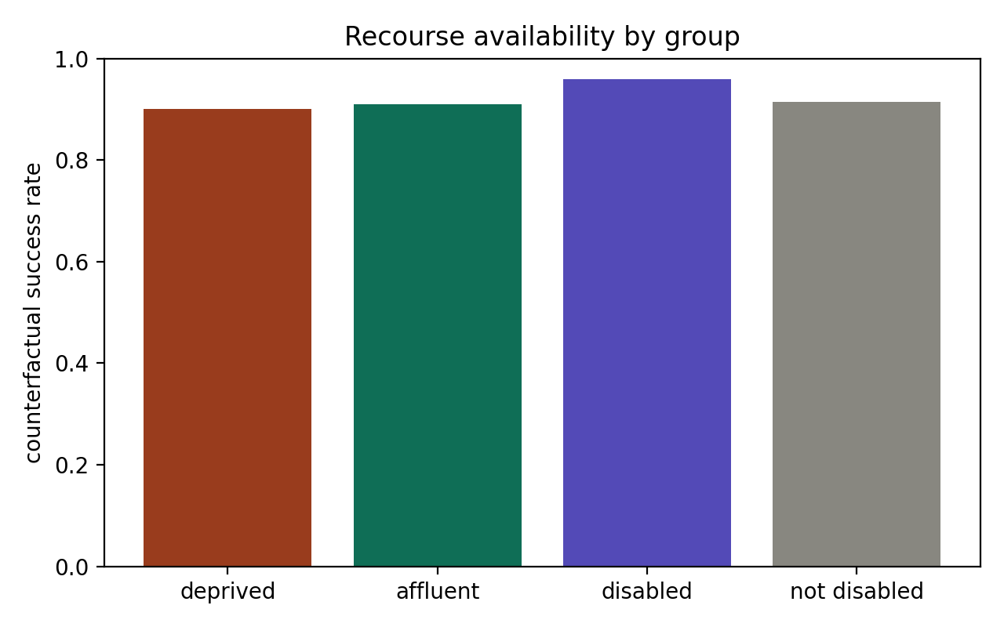
Figure 8. Counterfactual availability by group.

5.6 Trust-equity synthesis
Bringing the components together by protected group at week 15 shows the consolidated picture. Subgroup calibration is low and similar across deprivation and acceptable across disability. True-positive and false-positive rates, recourse distance, and counterfactual availability complete the view. Across four trust dimensions the layer is equitable on three, calibration, faithfulness, and recourse, and shows one localised harm, the false-positive burden. The inequity is concentrated at the decision threshold, not in explanation quality, calibration, or the recourse pathway.
group | ECE | TPR | FPR | recourse_distance | cf_success_rate
deprived | 0.0178 | 0.8159 | 0.0912 | 11.6941 | 0.9018
affluent | 0.0198 | 0.7808 | 0.0594 | 16.1860 | 0.9091
disabled | 0.0395 | 0.8337 | 0.1270 | 15.3607 | 0.9273
not_disabled | 0.0088 | 0.7835 | 0.0680 | 11.6926 | 0.9139
Table 5. Trust-equity summary by protected group (week 15, gradient boosting).

5.7 Robustness to the label definition
To test whether the findings depend on how at-risk is defined, I redefine the target as Fail only, moving Withdrawn into the negative class, which lowers the positive rate to 0.215 and makes the problem imbalanced. Discrimination drops modestly but holds, with AUROC between 0.68 and 0.81. Calibration remains strong, with ECE between 0.006 and 0.016, so the calibration claim is robust to the harder label. At a fixed 0.5 threshold the imbalanced model flags very few students, so a deployment on this target would require a prevalence-based operating threshold; this is a deployment note rather than a defect. Crucially, the deprivation false-positive gap for gradient boosting remains positive and excludes zero at every cutoff under the new label. The one real equity finding survives the change of definition, which strengthens it.
cutoff_week | auroc_main | auroc_failonly | ece_failonly | fpr_gap_imd_failonly | fpr_failonly_lo | fpr_failonly_hi
5 | 0.8527 | 0.7065 | 0.0081 | 0.0074 | 0.0001 | 0.0146
10 | 0.9050 | 0.7442 | 0.0079 | 0.0112 | 0.0019 | 0.0206
15 | 0.9318 | 0.7694 | 0.0065 | 0.0131 | 0.0002 | 0.0245
25 | 0.9689 | 0.8126 | 0.0128 | 0.0234 | 0.0056 | 0.0398
Table 6. Main versus Fail-only comparison (gradient boosting).
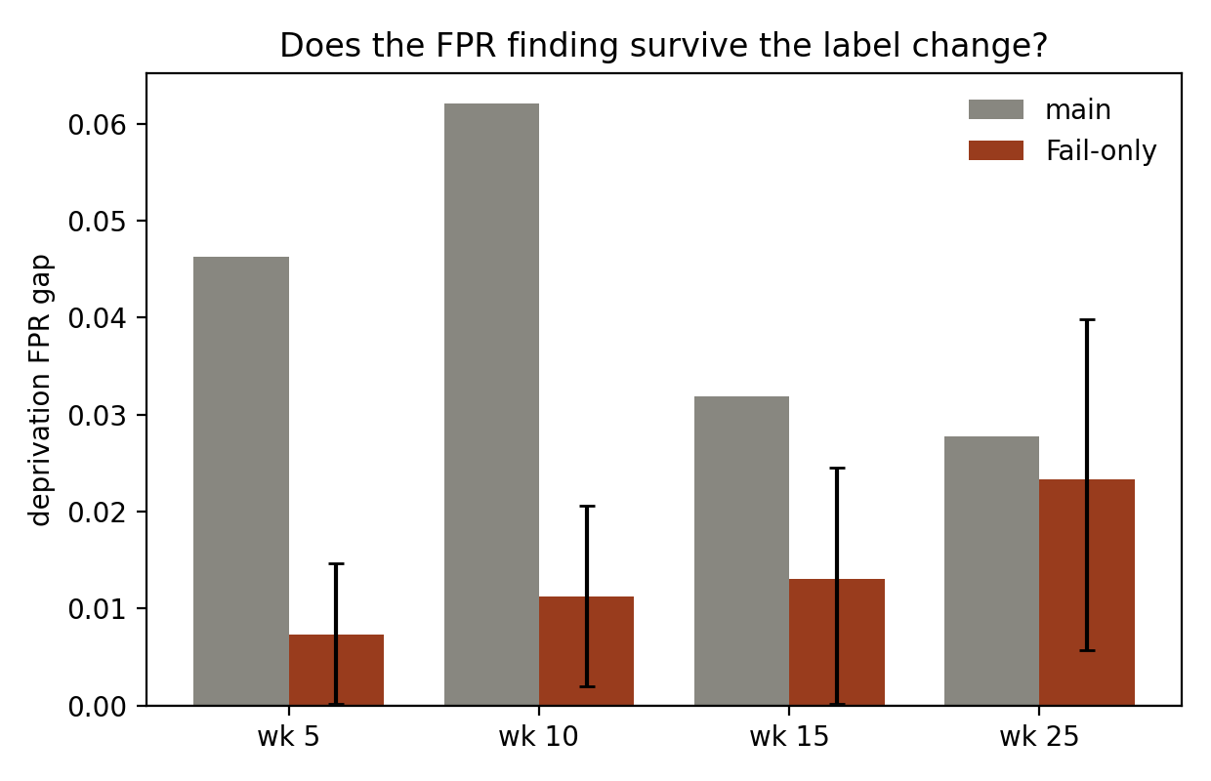
Figure 9. Deprivation FPR gap, main versus Fail-only.

6. Discussion
Two lessons follow. The first is methodological: auditing explanation faithfulness or recourse by subgroup without controlling for base rate can manufacture a disparity that is an artifact of differing distance from the decision boundary. In this data, a naive analysis would have reported that explanations are more faithful for deprived students and that recourse differs by group, and both claims dissolve under a within-risk-band comparison. Subgroup trust audits should adjust for base rate.
The second is substantive: the inequity in this system is not in the explanation, the calibration, or the recourse, but in the rate at which not-at-risk disadvantaged students are flagged. This is informative for mitigation. Because the model explains and offers recourse equitably and is well calibrated within groups, intervention should target the operating threshold, for example group-aware or cost-sensitive thresholds that equalise false-positive rates, rather than the explanation or recourse machinery. The concentration of the burden at the earliest cutoffs is a practical caution, since these are the points at which intervention is most valuable and over-flagging most consequential.

7. Limitations
The study is on a single institution dataset, so the magnitudes may not transfer. The recourse counterfactuals use DiCE random search and report a valid rather than guaranteed-minimal recourse, so the distance is a cost estimate and the group comparison is the robust quantity; a minimal-distance method would tighten this. Counterfactual actionability assumes the behavioural features are genuinely under student control, which is an approximation. The fairness audit uses a fixed 0.5 threshold for comparability, and the Fail-only analysis shows this is not an appropriate operating point for an imbalanced label. Temporal transfer across course presentations is not examined here and is left for future work.

8. Conclusion
I audited the trust layer of an explainable early-warning system as a whole, by protected group, with base-rate controls and bootstrap confidence intervals. The model predicts early and is well calibrated, its explanations agree across architectures, and its faithfulness and recourse are equitable once base rate is controlled. The one robust inequity is a false-positive over-flagging of deprived and disabled students, concentrated early and stable to the label definition. The practical implication is that mitigation belongs at the decision threshold, and the methodological implication is that subgroup trust audits must control for base rate or risk reporting artifacts as findings.

