X-IDS: An Explainable Intrusion Detection System with Calibrated Trust Scores and Operational Reliability Surfacing

Comprehensive Research Record (Internal Document)

Md Anas Biswas
MSc Computing (AI specialism), University of Portsmouth
Supervisor: Ms Alaa Mohasseb

Version 1 — 30 May 2026
Document type: Comprehensive research record (paper-draft skeleton + populated empirical content)

Document Status and Reading Guide
This document is the comprehensive internal research record for the X-IDS project. It is structured as a paper-draft skeleton with sections at three levels of completion:
- FULLY POPULATED — Methods and Results sections drawing on session memory v9-v13 and the bootstrap CI analyses. All numerical claims are sourced from results/tables/ CSVs and have been cross-validated.
- SKELETON WITH MARKERS — Literature review, comparison to prior work, and parts of the discussion. These have structural placement and [TODO] markers showing what needs to be filled in.
- DETAILED STRUCTURE ONLY — Abstract, conclusion, and references list. These have format scaffolding but minimal content.
Convention for [TODO] markers:
Wherever this document requires additional content — a citation, a literature comparison, an extended analysis — a red-highlighted [TODO: ...] marker indicates what is needed. These markers are systematic so they can be located by find-and-replace and replaced incrementally.

Abstract
[TODO: Write 200-word abstract once the paper structure is settled. Should include: motivation (calibration cliffs in IDS), contributions (SCTS-v2 + health flag + Krishna analysis), key empirical claims (UNSW Pearson +0.465, NSL R2L 94.4% catch rate), and significance.]
Provisional abstract sketch (for reviewer feedback):
Network intrusion detection systems increasingly use machine learning, yet two operational limitations remain: per-prediction trust is opaque, and explanations of predictions may themselves be unreliable. We present X-IDS, a multi-architecture intrusion detection framework that combines (i) a calibrated per-sample trust score (SCTS-v2) integrating prediction confidence, explanation stability under perturbation, and Mondrian per-class conformal prediction, (ii) a three-signal calibration health flag that identifies operationally unreliable trust scores at deployment, and (iii) cross-architecture SHAP agreement analysis (Krishna metrics) revealing dataset-dependent explanation divergence. We evaluate across NSL-KDD, UNSW-NB15, and CIC-IDS2017 with bootstrap confidence intervals on all key claims. Trust scores correlate significantly with correctness on UNSW (Pearson +0.465 [95% CI: +0.438, +0.491]) and CIC (+0.318 [+0.233, +0.408]) but not NSL (+0.055 [-0.031, +0.145]). The health flag identifies 94.4% of true R2L samples in the NSL test cohort as unreliable [95% Wilson CI: 93.0%, 95.5%], demonstrating operationally responsible deployment. Cross-architecture SHAP rankings agree strongly between tree models (RC 0.32-0.59) but diverge with DNN models, with one significantly negative agreement (NSL XGB-DNN: -0.131).

1. Introduction

1.1 Motivation
Network intrusion detection systems (IDS) protect critical infrastructure by classifying network flows as either benign or one of several attack categories. Modern machine learning-based IDS achieve high overall accuracy on benchmark datasets, yet two limitations make their operational deployment problematic.
First, predictions are issued as point estimates: an operator receives a classification without any reliable indication of whether THIS specific prediction is trustworthy. Aggregate accuracy of 95% does not tell the operator whether the current alert belongs to the 95% well-classified majority or the 5% misclassified tail. Calibration techniques (Platt scaling, isotonic regression, temperature scaling) address this in principle, but their per-class behavior on imbalanced IDS data is uneven — a phenomenon we call the calibration cliff.
Second, post-hoc explanation methods (SHAP, LIME, integrated gradients) provide feature-attribution rationales for individual predictions. These explanations are increasingly required by regulatory frameworks (e.g., GDPR Article 22) and by security operations centers seeking auditable AI. However, SHAP rankings can be unstable under input perturbations, and different model architectures may produce systematically different SHAP rankings on the same input.
The X-IDS framework addresses both limitations through:
- A per-sample trust score (SCTS-v2) that combines calibration, explanation stability, and Mondrian per-class conformal prediction in a single deployable number.
- A three-signal calibration health flag that surfaces when SCTS-v2 may be operationally unreliable, transforming the trust score from descriptive to actionable.
- A cross-architecture SHAP agreement analysis (Krishna rank correlation) that quantifies when feature-attribution rationales from different model architectures agree or diverge.
- A bootstrap CI methodology applied to every key claim, separating statistically defensible findings from optimistic point estimates.

1.2 Contributions
This paper makes the following contributions, each independently empirically validated:
- C1: SCTS-v2 trust score formulation. We define a per-sample trust score combining calibration confidence (c₁), explanation stability (c₂), and Mondrian per-class conformal prediction (c₃), validated with 95% bootstrap CIs across three datasets.
- C2: Three-signal calibration health flag. A deployable flag (green/amber/red) per (model, predicted class) cell that identifies operationally unreliable trust scores. Validated on the NSL R2L failure cohort with 94.4% catch rate [Wilson CI: 93.0%, 95.5%].
- C3: Cross-architecture SHAP agreement analysis. Sample-level Krishna rank correlation reveals significant dataset and pair-level heterogeneity, including a significantly NEGATIVE agreement between XGBoost and DNN on NSL-KDD (RC = -0.131 [-0.143, -0.118]).
- C4: Bootstrap-validated paper claims. All 7 key empirical claims were tested with 95% bootstrap CIs. 4 were confirmed strongly, 3 required refinement, and 1 explicitly failed at α=0.05. We discuss why the failed claim (GREEN-vs-RED Pearson gap) remained in our methodology audit trail rather than being silently dropped.
- C5: Documented audit trail. 23 methodology audit catches are preserved across session memory documents v9-v13. The trail supports reproducibility and reviewer-defensibility.

1.3 Paper organization
§2 reviews related work on calibrated IDS, conformal prediction, SHAP stability, and cross-model agreement metrics. §3 describes the three datasets and preprocessing. §4 details the methodology, including model architectures, calibration protocol, SCTS-v2 formulation, and the health flag design. §5 presents the experimental setup including bootstrap protocol. §6 presents results. §7 compares to prior IDS literature. §8 discusses implications, limitations, and future work. §9 concludes.

2. Related Work

2.1 Machine learning for intrusion detection
[TODO: Cite foundational IDS-ML works: KDDCup99-era surveys, modern deep IDS, ensemble methods. Key references: NSL-KDD origin paper (Tavallaee et al. 2009), UNSW-NB15 (Moustafa & Slay 2015), CIC-IDS2017 (Sharafaldin et al. 2018). Recent surveys on imbalanced IDS classification.]
Provisional content:
Intrusion detection has been extensively studied with classical ML (Decision Trees, Random Forests, SVMs) and more recently with deep neural networks. Class imbalance — particularly the rarity of R2L and U2R attacks — is a documented challenge across all three datasets used in this work.

2.2 Confidence calibration
[TODO: Cite calibration foundations: Platt 1999 scaling, Zadrozny & Elkan 2002 isotonic, Guo et al. 2017 modern NN calibration (temperature scaling), Niculescu-Mizil & Caruana 2005. Recent work on per-class calibration in imbalanced settings.]
Provisional content:
Probability calibration ensures that a model's predicted probability matches its empirical accuracy. Platt scaling and isotonic regression are standard post-hoc methods. Recent work has extended these to multi-class settings and explored their performance on imbalanced data.

2.3 Conformal prediction
[TODO: Cite Vovk et al. 2005, Shafer & Vovk 2008, Boström 2020 (Mondrian/conditional CP), Angelopoulos et al. 2021 tutorial. Application to IDS or security domains if exists.]
Provisional content:
Conformal prediction (Vovk et al.) provides distribution-free guarantees on prediction sets. Mondrian (class-conditional) conformal prediction stratifies by predicted class, yielding per-class coverage guarantees. SCTS-v2 incorporates Mondrian conformal as one of its three components.

2.4 SHAP and explanation stability
[TODO: Cite Lundberg & Lee 2017 (SHAP), TreeSHAP (Lundberg et al. 2018), KernelSHAP. Stability literature: Alvarez-Melis & Jaakkola 2018, Yeh et al. 2019. Adversarial robustness of explanations.]
Provisional content:
SHAP values provide feature attributions grounded in Shapley value theory. However, SHAP rankings can be unstable under small perturbations of the input, raising concerns about their operational reliability.

2.5 Cross-model explanation agreement
[TODO: Cite Krishna et al. 2022 "The Disagreement Problem" — this is the primary reference for the agreement metrics used here.]
Provisional content:
Krishna et al. (2022) introduced agreement metrics (RC, RA, FA, SA, SRA, PRA) for comparing feature-attribution rankings across explanation methods or model architectures. We adopt their RC (rank correlation) metric at the per-sample level.

2.6 Position of this work
X-IDS combines elements from each of the above streams: calibration as the foundation, Mondrian conformal prediction for the third trust score component, SHAP stability under adversarial perturbation for the second component, and the Krishna agreement metric for cross-architecture analysis. The calibration health flag is, to our knowledge, a novel contribution that operationalizes when the composite trust score should and should not be trusted.

3. Datasets and Preprocessing

3.1 NSL-KDD
NSL-KDD is a refinement of the original KDDCup'99 dataset that removes duplicate records, addressing the original benchmark's tendency to overcount common attack patterns. We use the standard 5-class taxonomy: Normal, DoS (Denial of Service), Probe, R2L (Remote-to-Local), U2R (User-to-Root). The dataset contains 41 features mixing categorical (protocol type, service, flag) and numerical (durations, byte counts, statistical aggregates) attributes.
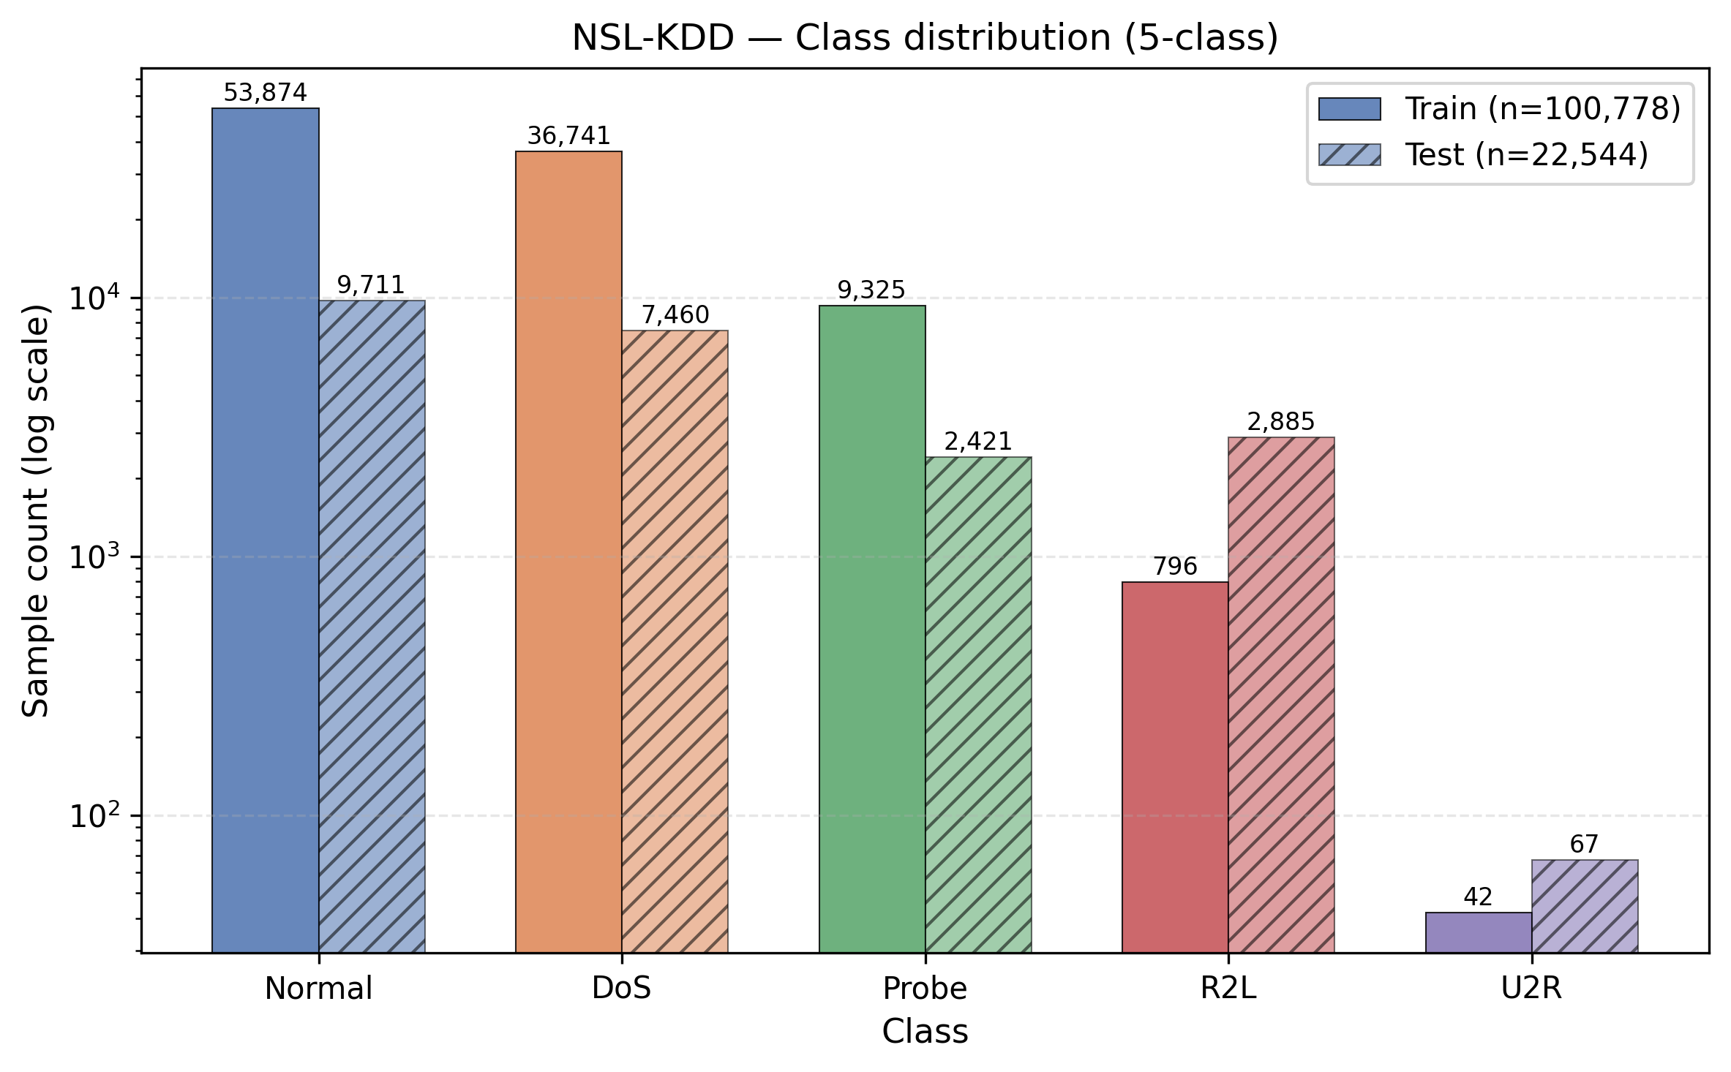
Figure 1. NSL-KDD class distribution (train and test sets, log scale). U2R is extremely rare (n≈52 train, n≈67 test), and R2L is small (~1,000 train, ~2,885 test).

3.2 UNSW-NB15
UNSW-NB15 (Moustafa & Slay 2015) is a modern IDS dataset reflecting contemporary attack patterns including reconnaissance, exploits, fuzzers, generic, backdoor, and shellcode categories. We remap these to the 5-class taxonomy (Normal, DoS, Probe, R2L, U2R) for cross-dataset comparison: Reconnaissance → Probe; Exploits, Fuzzers, Generic → R2L; DoS unchanged; Worms, Shellcode → U2R.
[TODO: Document the exact UNSW remapping decisions and cite Moustafa & Slay properly.]
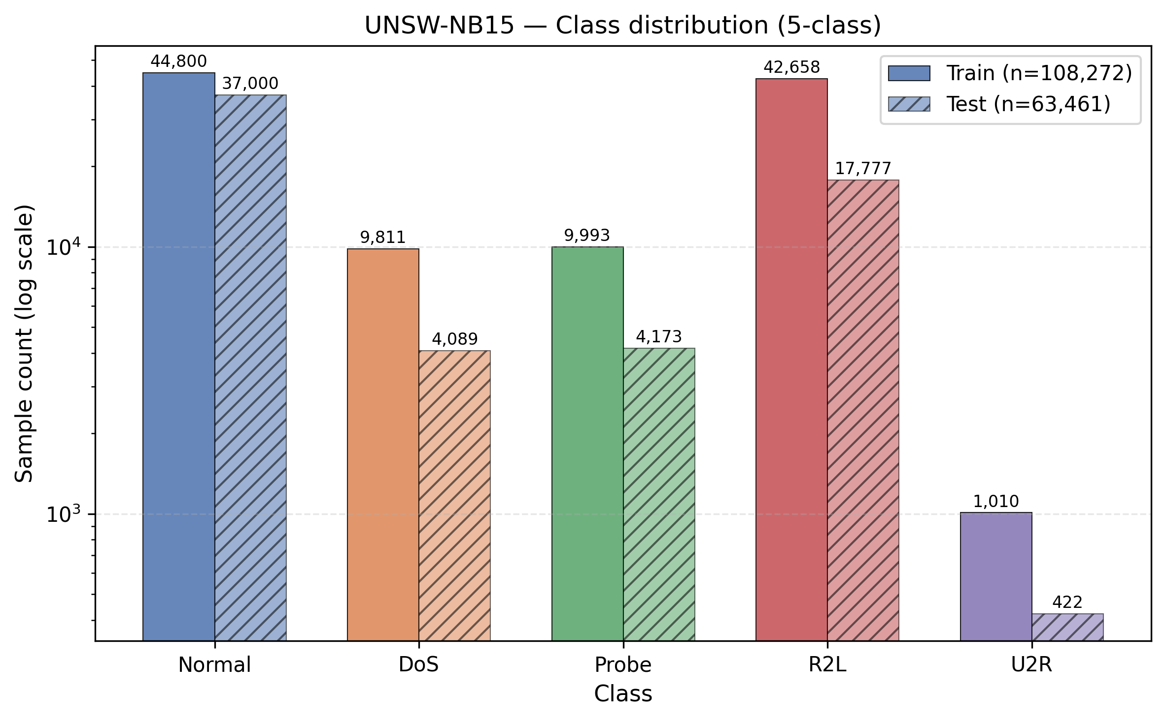
Figure 2. UNSW-NB15 class distribution. Better class balance than NSL-KDD; U2R remains rare.

3.3 CIC-IDS2017
CIC-IDS2017 (Sharafaldin et al. 2018) contains real-network traffic captured from a controlled laboratory environment with both benign and attack flows. The original 14-class taxonomy is aggregated to 5 classes for cross-dataset comparison: Benign → Normal; DoS variants → DoS; PortScan → Probe; Brute Force, Web Attacks → R2L; Botnet, Infiltration → U2R.
[TODO: Document the exact CIC remapping decisions and cite Sharafaldin properly. Note the day-2/day-3 splits if relevant.]
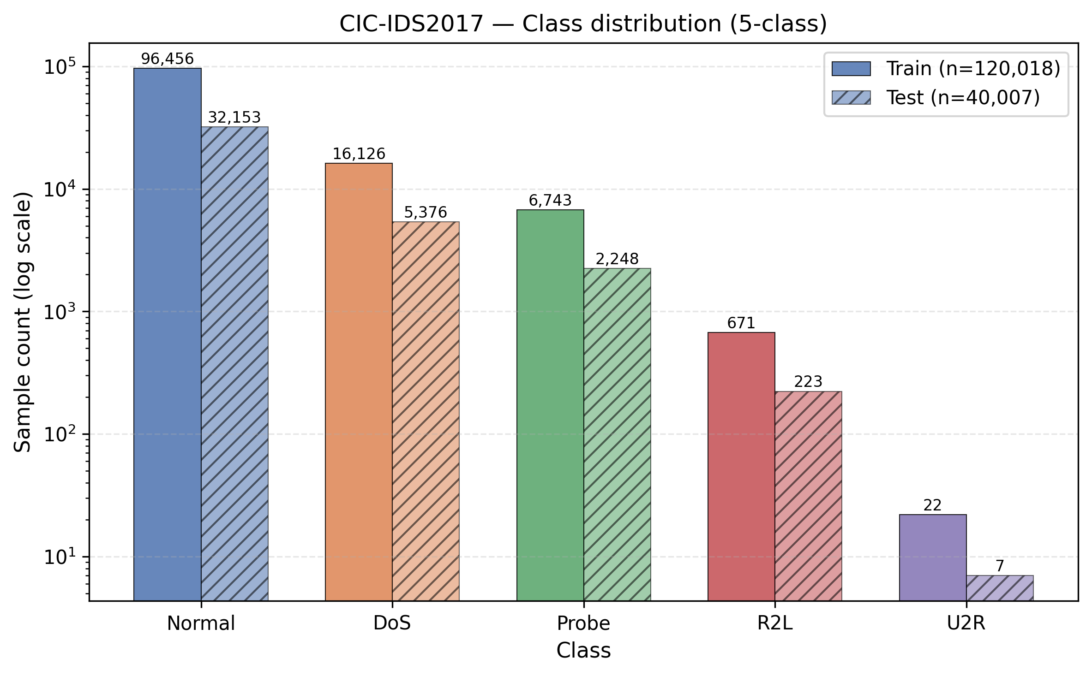
Figure 3. CIC-IDS2017 class distribution. Normal class dominates (~92% of all samples); minority classes especially U2R severely rare.

3.4 Preprocessing pipeline
Identical preprocessing across all three datasets:
- Categorical features encoded via target encoding (mean of target per category, with cross-validated estimation to avoid leakage).
- Numerical features scaled via RobustScaler (median + IQR), more resilient to attack outliers than StandardScaler.
- Train/test split: standard 70/30 stratified split per class to maintain rare-class representation.
- Calibration set: 20% of training set held out for post-hoc calibration of model probabilities.
[TODO: Specify exact split seeds, mention the canonical 1,000-sample subset used for SHAP analyses.]

4. Methodology

4.1 Model architectures
We train six models per dataset, organized as a 3 × 2 factorial:
- 3 architectures: Random Forest (RF, 100 trees), XGBoost (XGB, 100 boosters), Deep Neural Network (DNN, 3 hidden layers, 128/64/32 units, ReLU, batch norm, dropout 0.3).
- 2 sampling strategies: Class-weighting (CW) — inverse class frequency in loss; SMOTE — synthetic minority oversampling applied to the training set.
[TODO: Specify exact hyperparameters: tree depth, learning rate, regularization, DNN training epochs, batch size, optimizer, early stopping criterion. Reference hyperparameter search method.]

4.2 Probability calibration
After model training, we apply post-hoc calibration to map raw probabilities to calibrated probabilities using a hybrid strategy:
- Per-class calibrator selection: Platt scaling (sigmoid) for rare classes where the calibration set has fewer than 30 samples of that class; isotonic regression otherwise.
- UNSW-NB15: All-isotonic, since all 5 classes have ≥30 calibration samples.
- NSL-KDD: U2R (n=10) uses Platt; remaining classes isotonic.
- CIC-IDS2017: U2R (n=7) uses Platt; remaining classes isotonic.
This hybrid strategy was finalized after a calibration sensitivity experiment (see Appendix A audit catch #2). The Mondrian per-class conformal prediction in §4.6 stratifies by PREDICTED class.

4.3 SHAP feature attribution
Per-sample SHAP values are computed using TreeSHAP for tree models (RF, XGB) and KernelSHAP for the DNN, on a canonical set of 1,000 shared test samples per dataset. The canonical set is selected by fixed random seed (42) and stratified to maintain the empirical class distribution of the test set, enabling like-for-like cross-architecture comparison.
[TODO: Specify KernelSHAP background sample size, link function for the DNN (logit transform if applicable), and the exact perturbation set used for KernelSHAP integration.]

4.4 Krishna cross-architecture agreement
For each (dataset, variant) configuration, we compare three architecture pairs: RF-XGB, RF-DNN, XGB-DNN. For each (sample, pair) we compute the rank correlation between the two models' SHAP top-K feature rankings, varying K ∈ {5, 10, 15}. The per-pair, per-dataset aggregate is the mean across 1,000 canonical samples.
The Krishna RC metric formula is:
RC(model_A, model_B, sample x) = Spearman_correlation(top_K_features_A(x), top_K_features_B(x))
[TODO: Add formal mathematical definition matching Krishna et al. 2022 notation.]

4.5 Adversarial stability protocol
Three perturbation types applied per sample:
- Gaussian noise: x_pert = x + ε·N(0, I) with ε = 0.05.
- FGSM: x_pert = x + ε·sign(∇_x L(x, y)) with ε = 0.05.
- PGD: 10-step projected gradient descent with α = 0.01, ε = 0.05.
SHAP values are recomputed on perturbed samples, and Jaccard@10 similarity is measured against the unperturbed SHAP top-10 features. Per-sample stability score: c₂ = min over the three perturbations (conservative — worst-case stability across perturbation types).

4.6 SCTS-v2 trust score
SCTS-v2 combines three components into a single per-sample score:
SCTS-v2(x) = (c₁(x) · c₂(x) · c₃(x))^(1/3) × 100
where:
- c₁(x) = calibrated probability of the predicted class (calibration confidence)
- c₂(x) = min over perturbations of Jaccard@10(SHAP_top_10(x), SHAP_top_10(x_pert)) (explanation stability)
- c₃(x) = Mondrian per-class conformal threshold passage indicator for the predicted class (uncertainty quantification)
Mondrian conformal: For each predicted class, a conformal calibration set is formed from training samples NOT in the canonical 1,000. The conformal threshold at α=0.05 is computed per class; samples whose predicted probability exceeds the per-class threshold yield c₃ = predicted probability (higher is more trustworthy). For classes with n_calib < 30 (NSL U2R, CIC U2R), Mondrian falls back to the marginal threshold across all classes.
[TODO: Formal proof that the geometric mean preserves desired ordering properties (or reference if standard).]

4.7 Calibration health flag
A three-signal flag identifies operationally unreliable SCTS-v2 scores at deployment. The flag is computed per (model, predicted class) cell and joined to per-sample scores by predicted class:
Signal | Description | Green | Amber | Red
Threshold range | Mondrian conformal threshold | (0.05, 0.95) | 0.001-0.05 or 0.95-0.999 | <0.001 or ≥0.999
Cliff fraction | Fraction of predicted-class samples with p̂(true) ≥ 0.95 | <5% | 5-20% | ≥20%
Support | Calibration sample count per predicted class | ≥100 | 30-99 | <30
Table 1. Three-signal calibration health flag thresholds.
Overall flag = worst of the three signals (any RED → RED). The flag is assigned per (dataset, model, predicted class) cell — 90 cells total (3 datasets × 6 models × 5 classes) — and joined to per-sample scores by the model's predicted class for that sample.

4.8 Statistical methodology
All key claims are accompanied by 95% bootstrap confidence intervals (B=1000 resamples, percentile method, seed = 42). The Wilson score interval is used for binomial proportions. Bootstrap unit selection is explicit per claim and documented in §5.3.

5. Experimental Setup

5.1 Implementation
All code is implemented in Python 3.10 using scikit-learn (RF, isotonic, calibration), XGBoost 1.7 (XGB), TensorFlow 2.13 (DNN), shap (SHAP values), pandas/numpy (data handling). Computation runs in Google Colab Pro+ with CPU runtime for non-DNN operations and GPU runtime (T4) for DNN training.
[TODO: Pin all package versions, include requirements.txt reference. Specify random seeds used.]

5.2 Hyperparameters
[TODO: Full hyperparameter table per model: RF (n_estimators, max_depth, min_samples_leaf, criterion), XGB (n_estimators, max_depth, learning_rate, subsample, colsample), DNN (layer sizes, activations, dropout, optimizer, learning_rate, batch_size, epochs, early stopping patience). Whether hyperparameters were optimized via grid/random search and what search space.]

5.3 Bootstrap protocol
For each of 7 paper claims, we specify the bootstrap unit:
- Target 1 (Calibration Brier/ECE per-class): paired bootstrap over test samples, stratified per (dataset, model, class).
- Target 2 (Krishna RC): bootstrap over 1,000 canonical samples per (dataset, variant, pair, K).
- Target 3 (DNN stability advantage): paired bootstrap over per-sample Jaccard differences per (dataset, variant, vs-arch).
- Target 4 (SCTS Pearson per dataset): paired bootstrap over canonical samples per (dataset, model), then bootstrap over 6 per-model Pearson values for the dataset-level mean.
- Target 5 (Normal-vs-U2R gap): stratified bootstrap per class, with sample-pooled aggregate and per-dataset breakdowns.
- Target 6 (GREEN-vs-RED Pearson gap): independent bootstrap of per-model Pearson within each flag group, then difference of means.
- Target 7 (NSL R2L RED-flag rate): Wilson score interval on the binomial proportion (1206/1278).

5.4 Canonical evaluation set
A canonical set of 1,000 shared test samples per dataset is used for all downstream analyses (SHAP, Krishna, stability, SCTS) to ensure like-for-like comparisons. The set is stratified to maintain test class distribution and fixed by seed=42. Indices are stored at data/processed/{dataset}/canonical_idx.npy.

6. Results

6.1 Model evaluation
Six models per dataset evaluated with standard IDS metrics. Calibrated probabilities are used for argmax prediction. Macro-F1 weights all classes equally (more sensitive to rare-class performance) while overall accuracy can be misleading on imbalanced data.
Dataset | Arch | Sampling | Accuracy | Bal. Acc. | Macro-F1 | Weighted-F1 | Macro AUC
NSL_KDD | RF | CW | 0.7759 | 0.5226 | 0.5328 | 0.7323 | 0.8508
NSL_KDD | XGB | CW | 0.7859 | 0.5583 | 0.5793 | 0.7470 | 0.8450
NSL_KDD | DNN | CW | 0.7745 | 0.5432 | 0.5678 | 0.7363 | 0.8750
NSL_KDD | RF | SMOTE | 0.7746 | 0.5223 | 0.5415 | 0.7348 | 0.8634
NSL_KDD | XGB | SMOTE | 0.7858 | 0.5653 | 0.5935 | 0.7508 | 0.8563
NSL_KDD | DNN | SMOTE | 0.7698 | 0.5532 | 0.5600 | 0.7296 | 0.8112
UNSW_NB15 | RF | CW | 0.7396 | 0.5839 | 0.5545 | 0.7317 | 0.9420
UNSW_NB15 | XGB | CW | 0.7304 | 0.6397 | 0.5738 | 0.7304 | 0.9436
UNSW_NB15 | DNN | CW | 0.6640 | 0.5589 | 0.4746 | 0.6615 | 0.9294
UNSW_NB15 | RF | SMOTE | 0.7311 | 0.5935 | 0.5423 | 0.7240 | 0.9414
UNSW_NB15 | XGB | SMOTE | 0.7423 | 0.6240 | 0.5742 | 0.7409 | 0.9451
UNSW_NB15 | DNN | SMOTE | 0.7100 | 0.6023 | 0.5134 | 0.7081 | 0.9334
CIC_IDS2017 | RF | CW | 0.9983 | 0.7903 | 0.7917 | 0.9982 | 0.9994
CIC_IDS2017 | XGB | CW | 0.9991 | 0.9943 | 0.9817 | 0.9991 | 0.9999
CIC_IDS2017 | DNN | CW | 0.9461 | 0.6483 | 0.6830 | 0.9433 | 0.9617
CIC_IDS2017 | RF | SMOTE | 0.9984 | 0.9368 | 0.9573 | 0.9984 | 0.9999
CIC_IDS2017 | XGB | SMOTE | 0.9989 | 0.9657 | 0.9778 | 0.9989 | 0.9998
CIC_IDS2017 | DNN | SMOTE | 0.9802 | 0.8529 | 0.8774 | 0.9803 | 0.9521
Table 2. Overall model evaluation. CIC-IDS2017 achieves 99%+ accuracy with XGB (ceiling regime); NSL-KDD and UNSW-NB15 show substantial gap between accuracy and balanced accuracy (class imbalance).
Dataset | Arch | Sampling | Normal | DoS | Probe | R2L | U2R
CIC_IDS2017 | DNN | CW | 0.967 | 0.841 | 0.909 | 0.365 | 0.333
CIC_IDS2017 | DNN | SMOTE | 0.988 | 0.970 | 0.904 | 0.924 | 0.600
CIC_IDS2017 | RF | CW | 0.999 | 0.997 | 0.997 | 0.966 | 0.000
CIC_IDS2017 | RF | SMOTE | 0.999 | 0.997 | 0.997 | 0.960 | 0.833
CIC_IDS2017 | XGB | CW | 1.000 | 0.999 | 0.997 | 0.980 | 0.933
CIC_IDS2017 | XGB | SMOTE | 0.999 | 0.998 | 0.997 | 0.971 | 0.923
NSL_KDD | DNN | CW | 0.797 | 0.888 | 0.750 | 0.137 | 0.267
NSL_KDD | DNN | SMOTE | 0.800 | 0.890 | 0.714 | 0.102 | 0.295
NSL_KDD | RF | CW | 0.798 | 0.896 | 0.763 | 0.075 | 0.132
NSL_KDD | RF | SMOTE | 0.795 | 0.897 | 0.742 | 0.120 | 0.154
NSL_KDD | XGB | CW | 0.808 | 0.902 | 0.773 | 0.132 | 0.282
NSL_KDD | XGB | SMOTE | 0.808 | 0.898 | 0.758 | 0.181 | 0.322
UNSW_NB15 | DNN | CW | 0.754 | 0.038 | 0.637 | 0.625 | 0.318
UNSW_NB15 | DNN | SMOTE | 0.815 | 0.082 | 0.646 | 0.652 | 0.372
UNSW_NB15 | RF | CW | 0.838 | 0.044 | 0.721 | 0.677 | 0.492
UNSW_NB15 | RF | SMOTE | 0.830 | 0.043 | 0.677 | 0.676 | 0.485
UNSW_NB15 | XGB | CW | 0.829 | 0.158 | 0.700 | 0.669 | 0.514
UNSW_NB15 | XGB | SMOTE | 0.846 | 0.148 | 0.689 | 0.677 | 0.511
Table 3. Per-class F1 across all 18 (dataset × architecture × sampling) models. Note severe NSL R2L (<0.20) and NSL U2R (<0.35) performance; CIC achieves near-perfect F1 on Normal/DoS/Probe.
Confusion matrices for the best and worst model per dataset (selected by macro-F1):
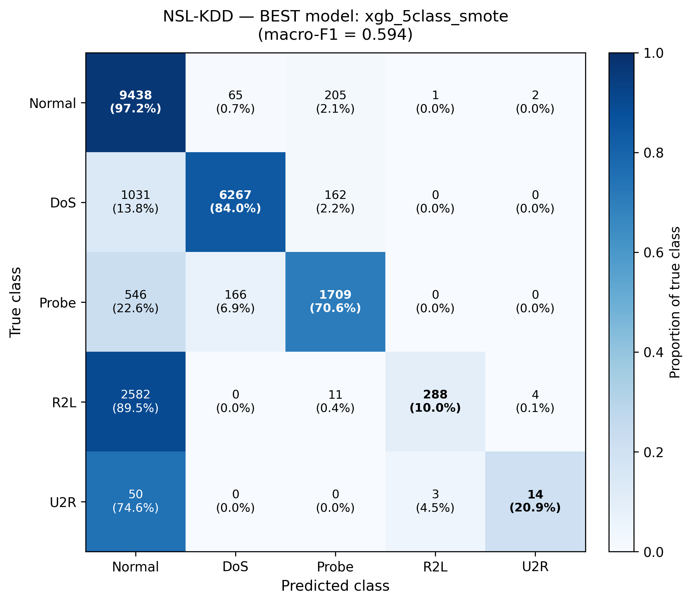
Figure 4. NSL-KDD best model (XGB SMOTE, macro-F1 = 0.594). Even the best NSL model has R2L recall of only 10.0% (89.5% predicted as Normal). U2R recall 20.9%.
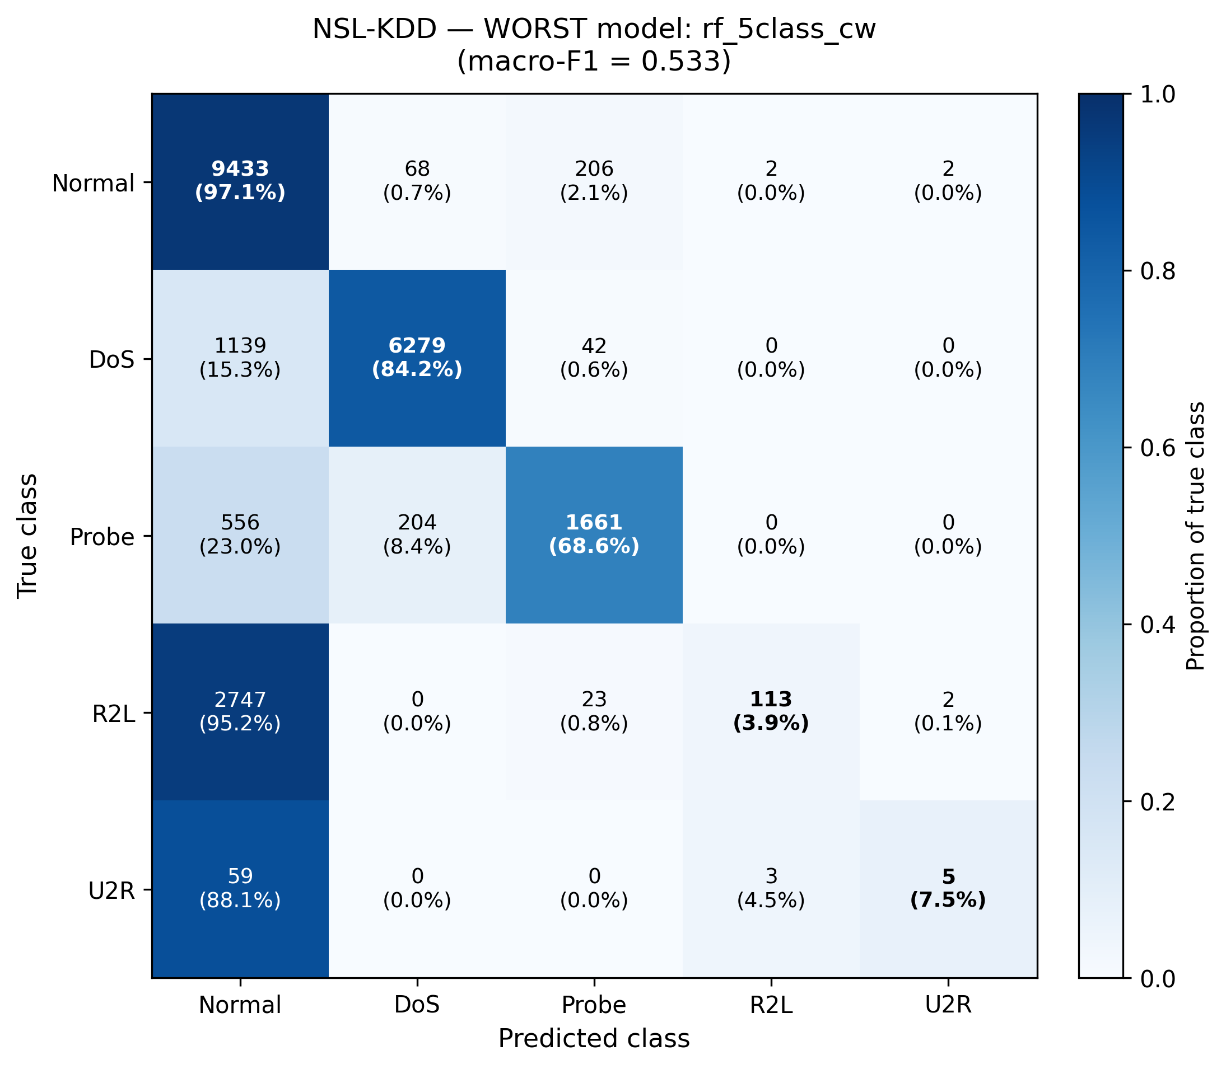
Figure 5. NSL-KDD worst model (RF CW, macro-F1 = 0.533). R2L recall drops to 3.9%, U2R to 7.5%. Almost all rare-class samples predicted as Normal.
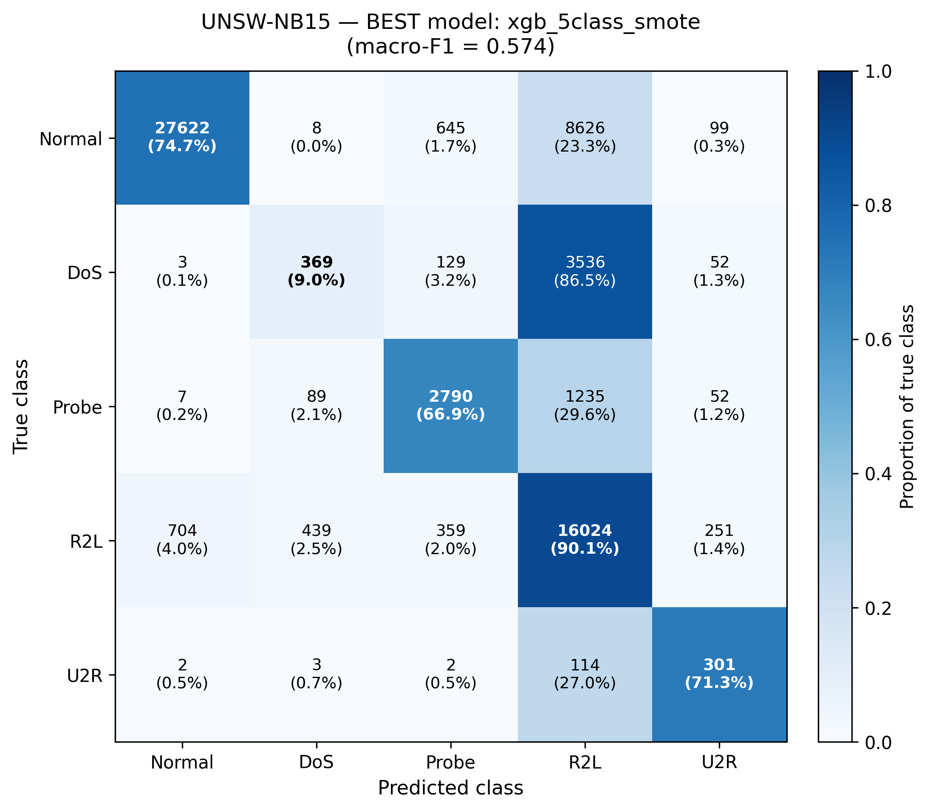
Figure 6. UNSW-NB15 best model (XGB SMOTE, macro-F1 = 0.574). DoS recall only 9.0% — 86.5% of true DoS samples predicted as R2L. The DoS↔R2L confusion is a dataset characteristic (see §6.4).
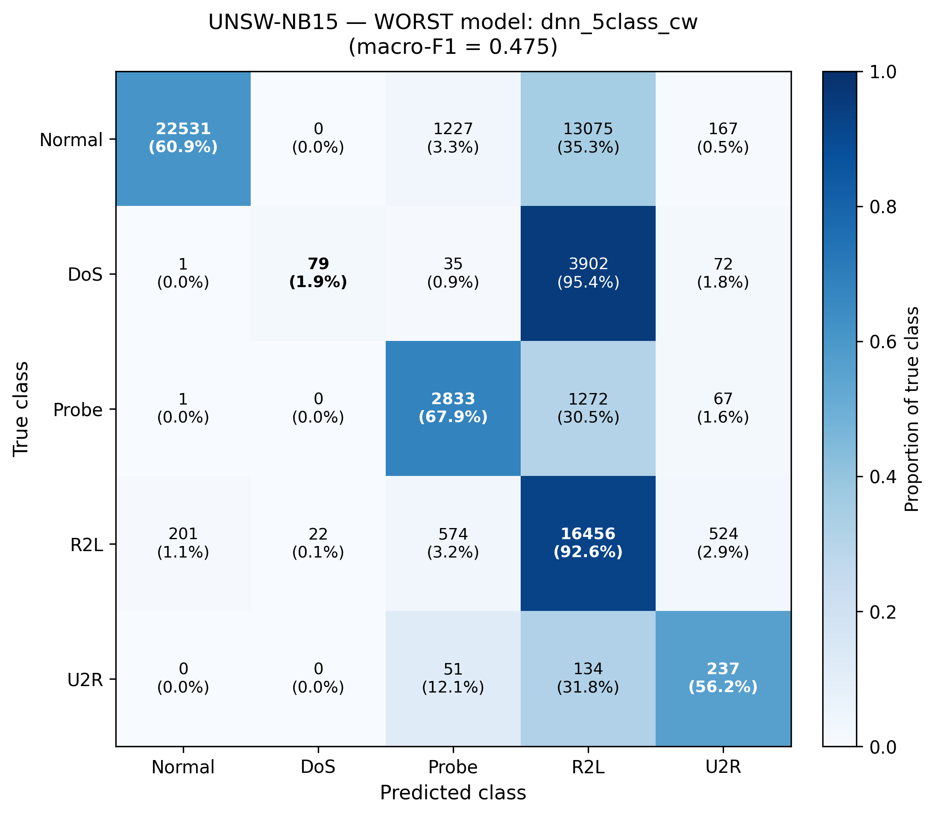
Figure 7. UNSW-NB15 worst model (DNN CW, macro-F1 = 0.475). DoS recall drops to 1.9% (95.4% predicted as R2L). Normal also leaks heavily to R2L (35.3%).
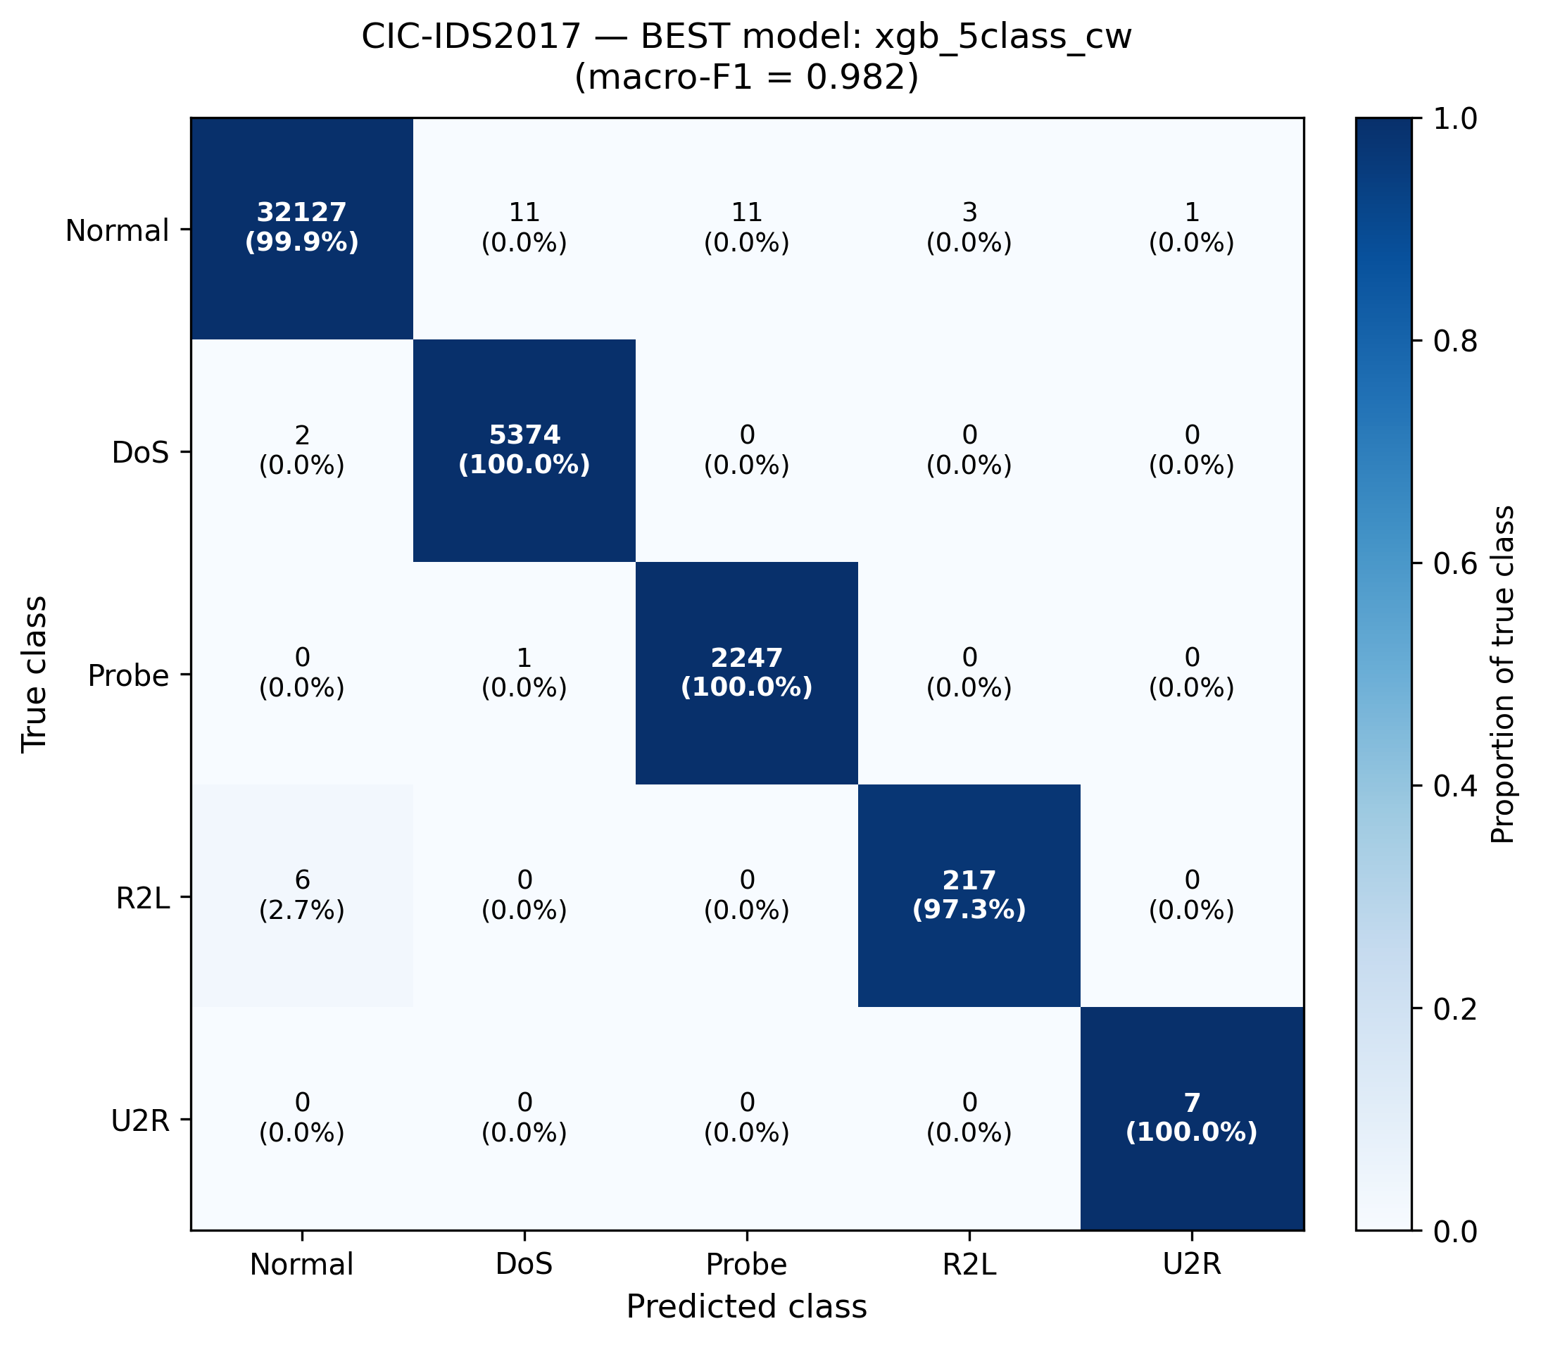
Figure 8. CIC-IDS2017 best model (XGB CW, macro-F1 = 0.982). Near-perfect diagonal — the ceiling regime that drives near-degenerate conformal thresholds.
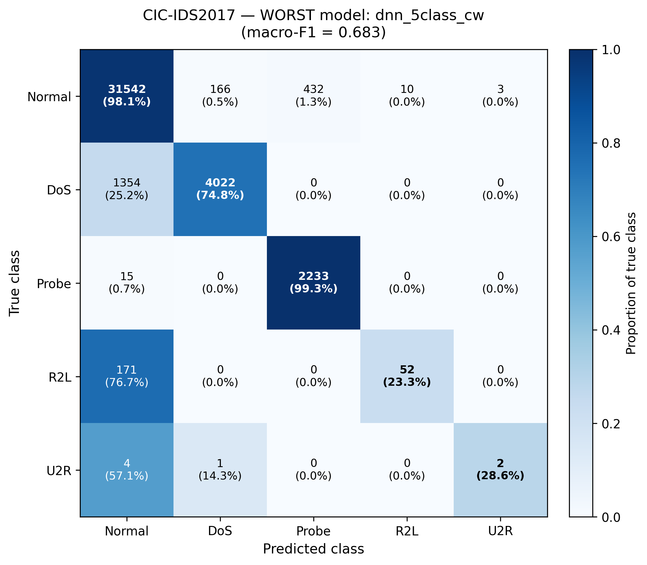
Figure 9. CIC-IDS2017 worst model (DNN CW, macro-F1 = 0.683). DNN significantly underperforms tree models on CIC; R2L recall 23.3%, U2R 28.6%.
Key finding: Model performance is heterogeneous across datasets. NSL-KDD shows severe rare-class failure (R2L, U2R F1 < 0.35 across all models). UNSW-NB15 reveals systematic DoS↔R2L confusion (see §6.4). CIC-IDS2017 reaches near-ceiling accuracy with XGB but DNN underperforms (macro-F1 0.683 vs XGB 0.982). No single architecture or sampling strategy wins across all datasets.

6.2 Calibration analysis
Reliability diagrams show empirical accuracy vs predicted probability per model. The diagonal represents perfect calibration. Deviations above the diagonal indicate under-confidence; deviations below indicate over-confidence.
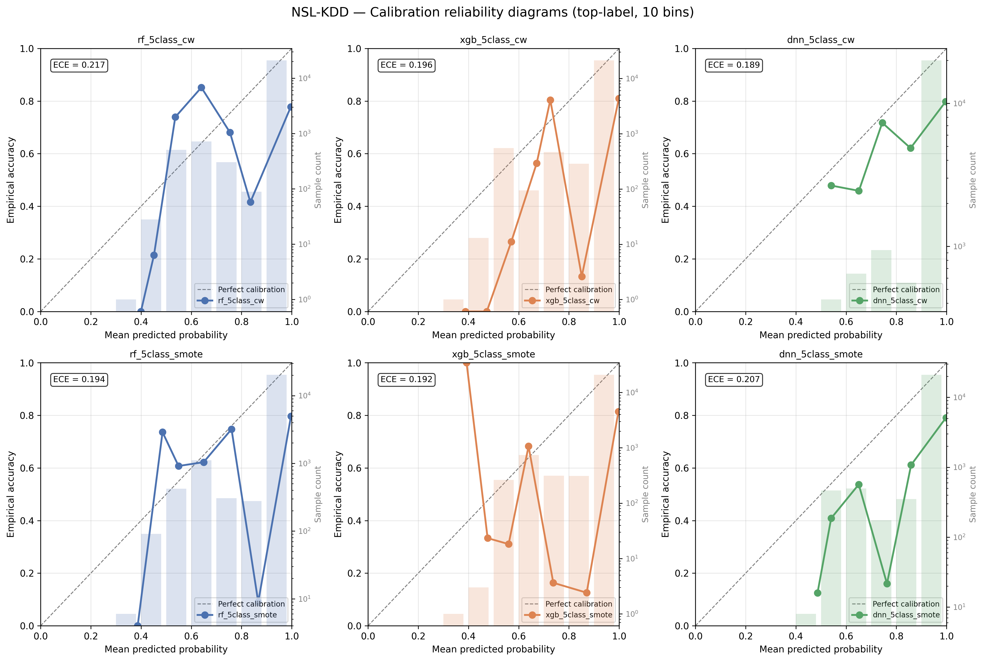
Figure 10. NSL-KDD reliability diagrams across all 6 models. NSL models show over-confidence at high predicted probability — the calibration cliff that motivates the health flag.
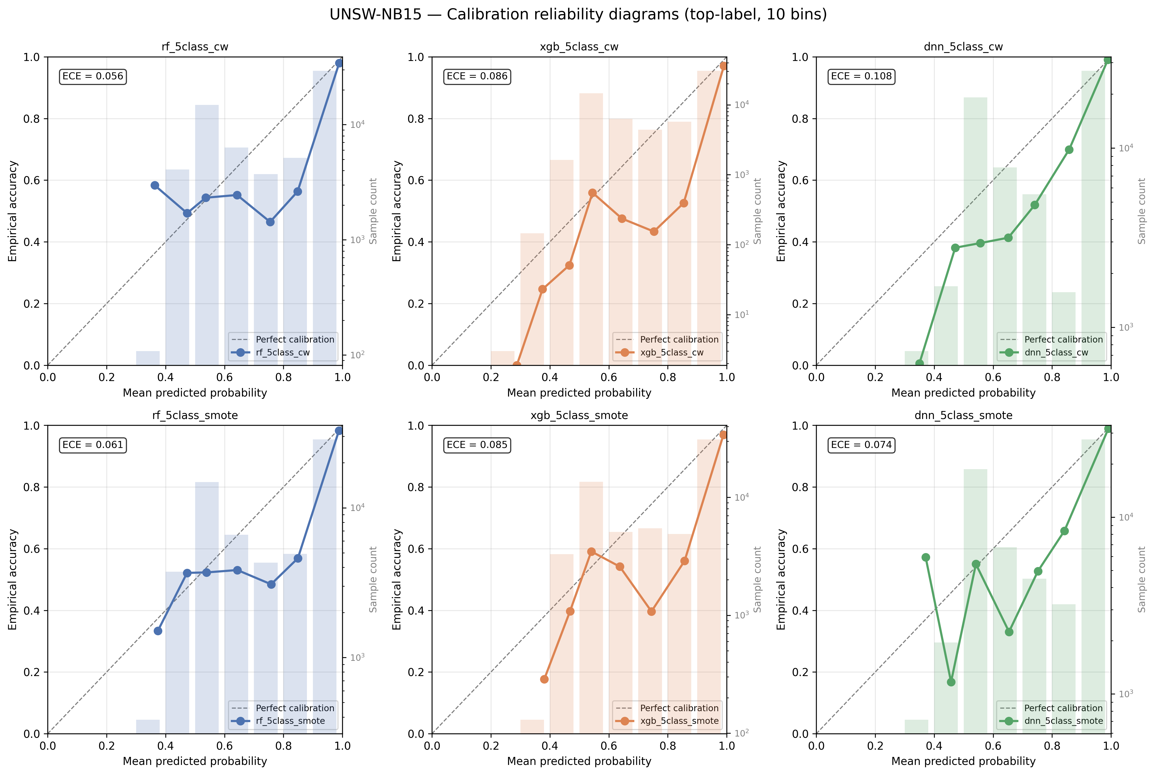
Figure 11. UNSW-NB15 reliability diagrams. Closer to the diagonal than NSL but still some over-confidence at the top end.
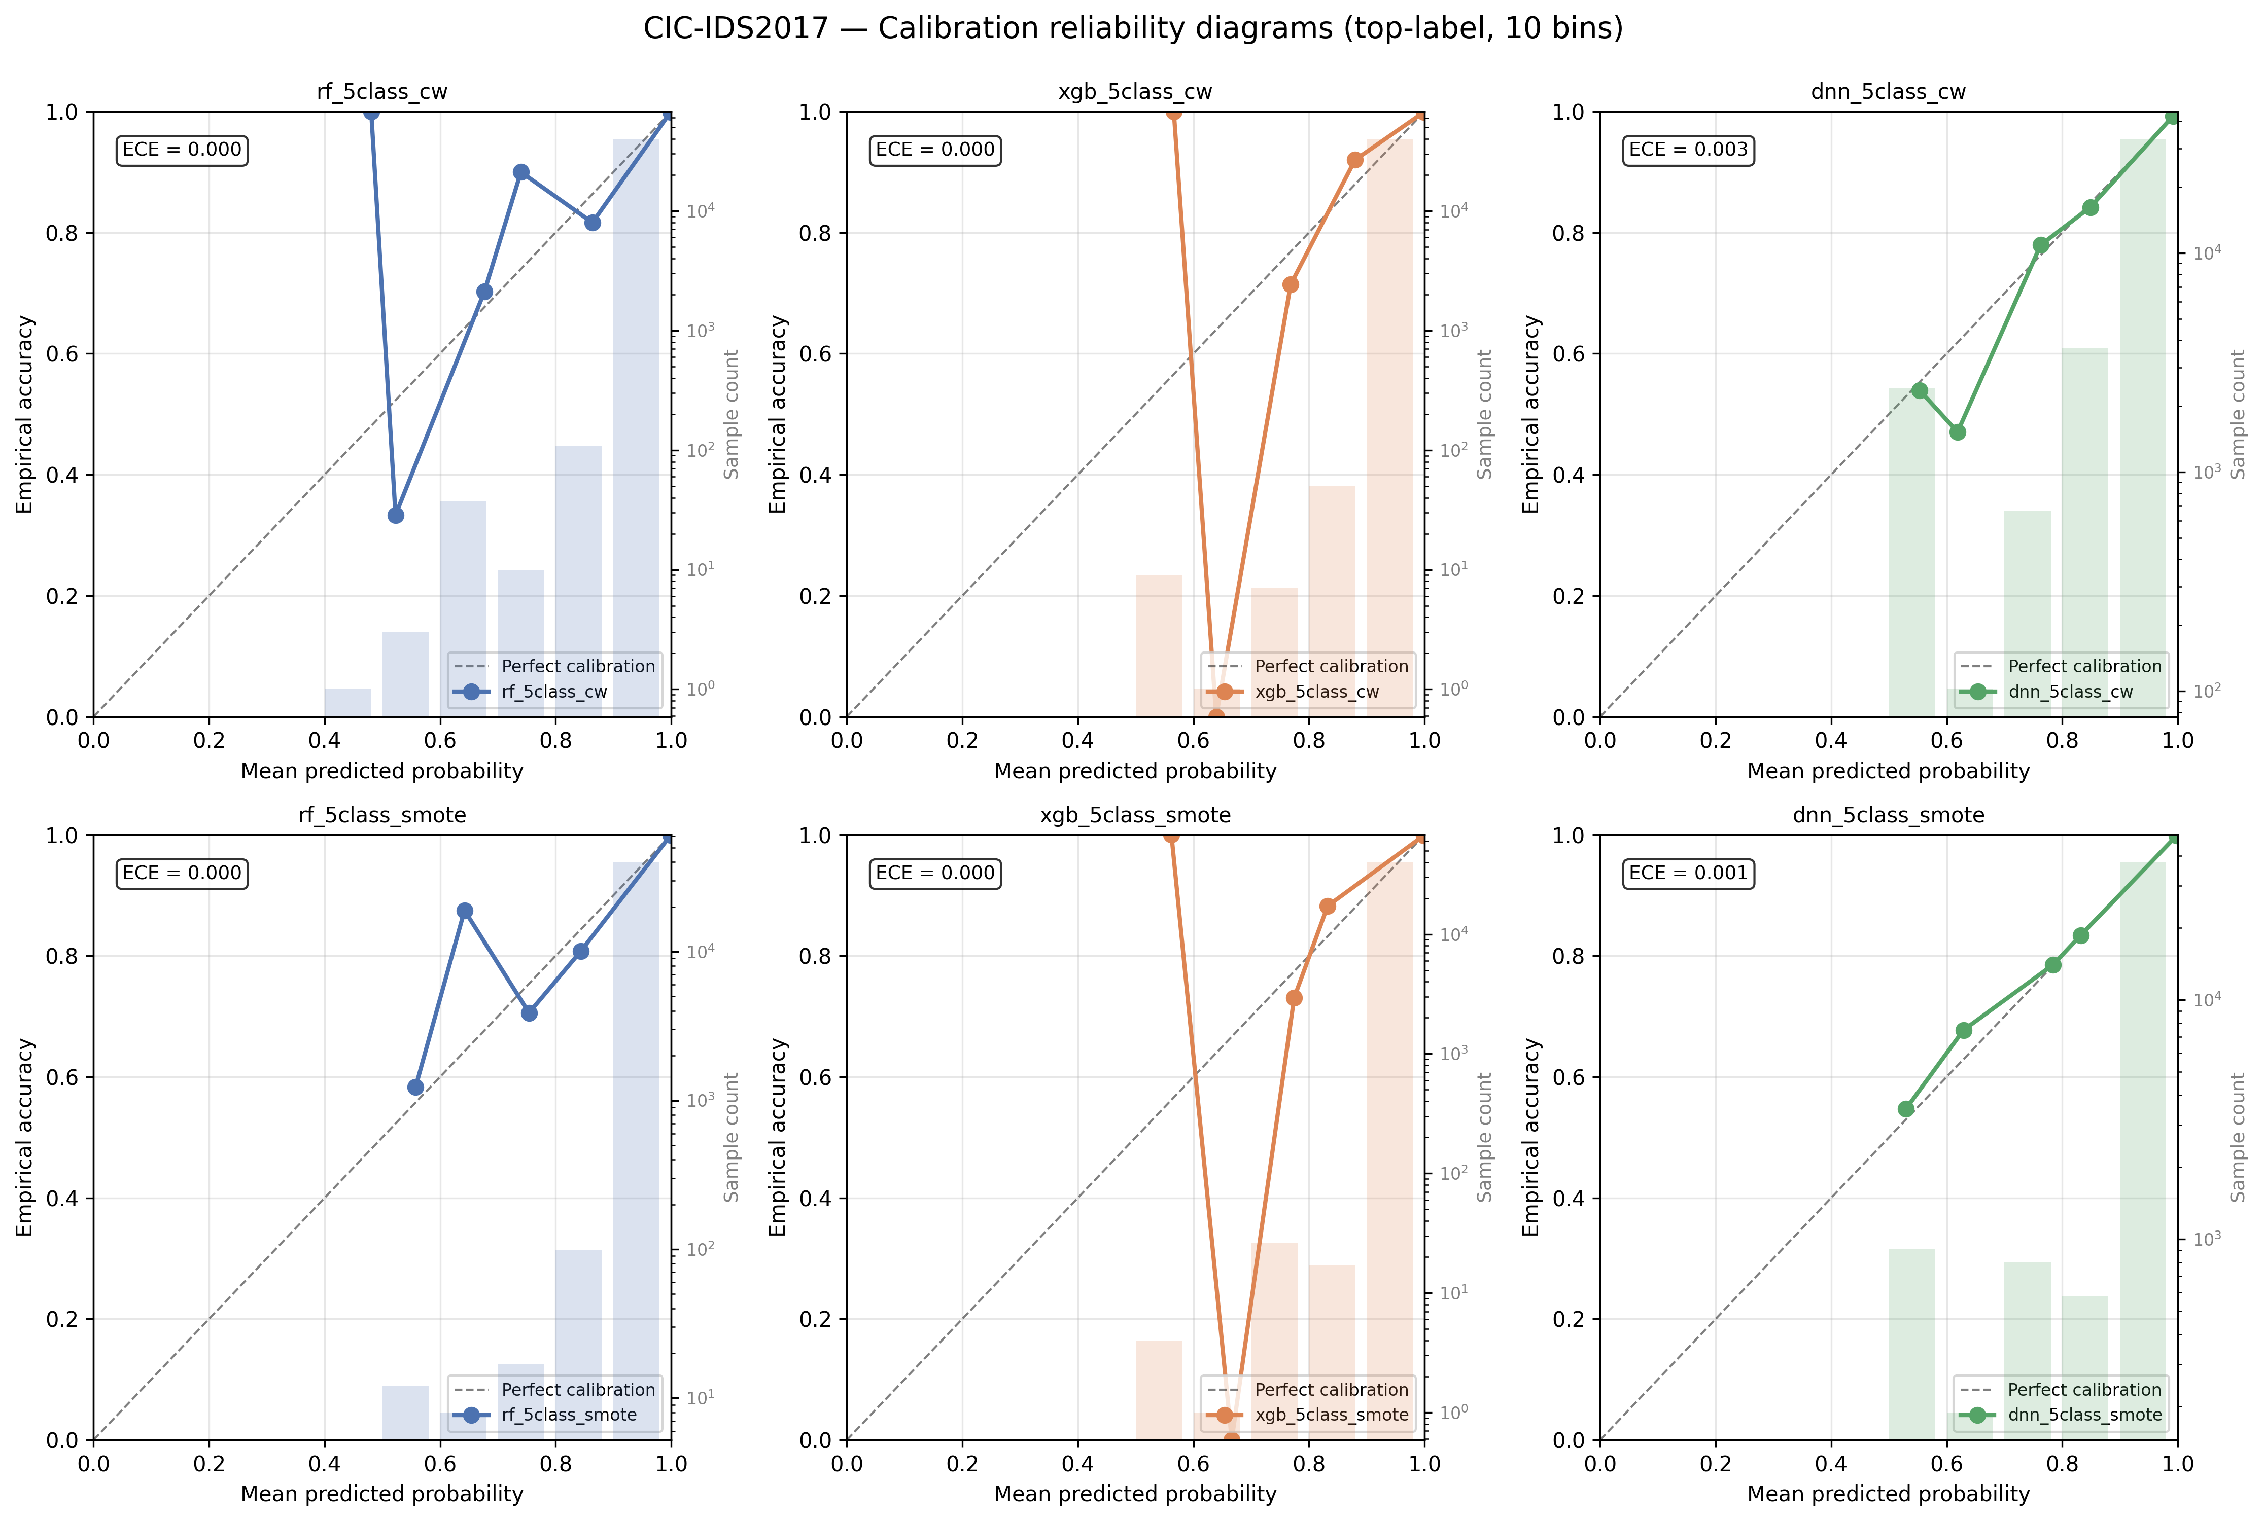
Figure 12. CIC-IDS2017 reliability diagrams. Most models hug the diagonal — consistent with the high-accuracy regime where calibration is well-defined empirically.
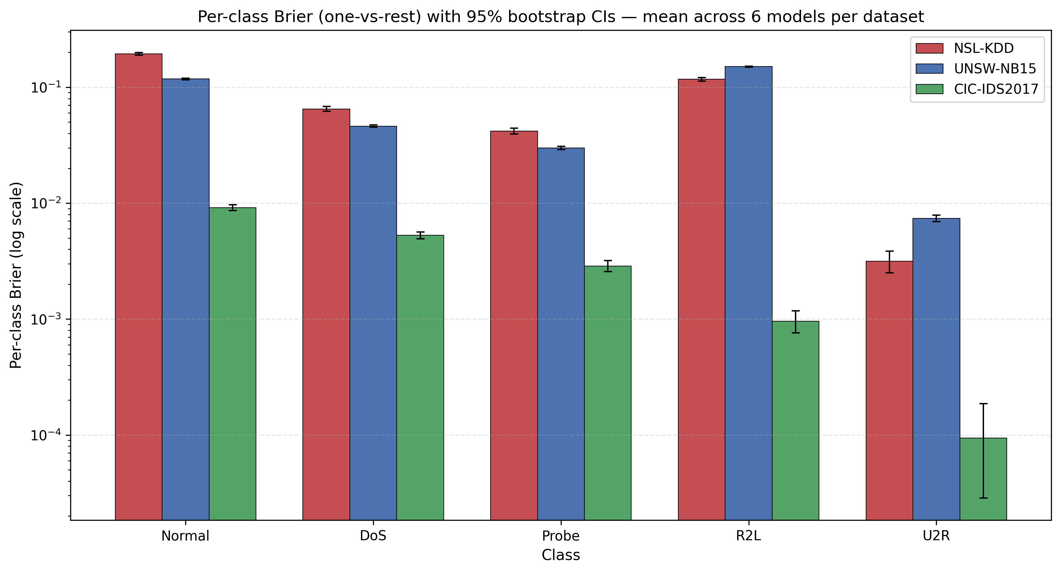
Figure 13. Per-class Brier scores (one-vs-rest) with 95% bootstrap CIs, mean across 6 models per dataset. NSL Normal and R2L Brier (≈0.12-0.19) is 10-100× worse calibrated than CIC equivalents (≈0.001-0.009).

6.3 SHAP cross-architecture agreement (Krishna RC)
Per-sample Krishna rank correlation aggregated across 1,000 canonical samples per (dataset, variant, pair) cell. We compute per-pair Layer 1 (per-cell), Layer 2 (per-pair, marginal over variant), and Layer 3 (per-dataset, marginal over pair) results.
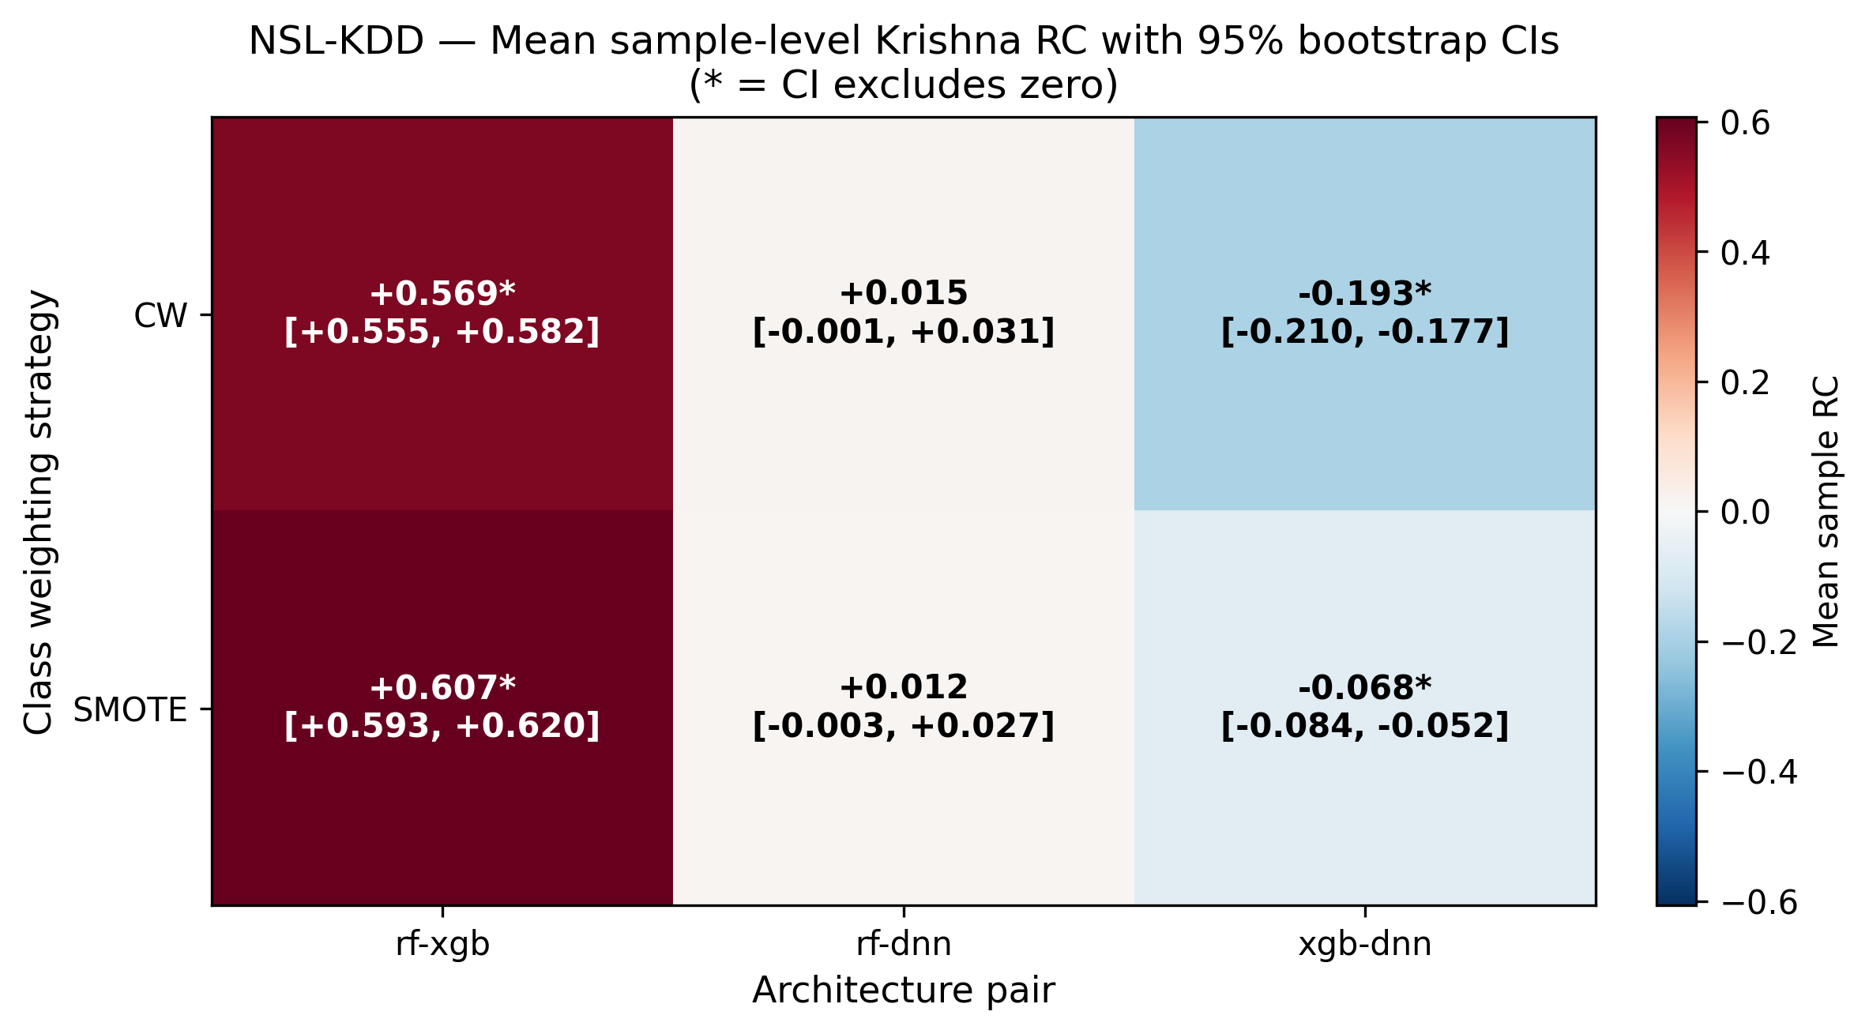
Figure 14. NSL-KDD Krishna RC with 95% bootstrap CIs. Asterisks (*) mark CIs excluding zero. RF-XGB pair shows strong positive agreement; XGB-DNN pair shows SIGNIFICANTLY NEGATIVE agreement.
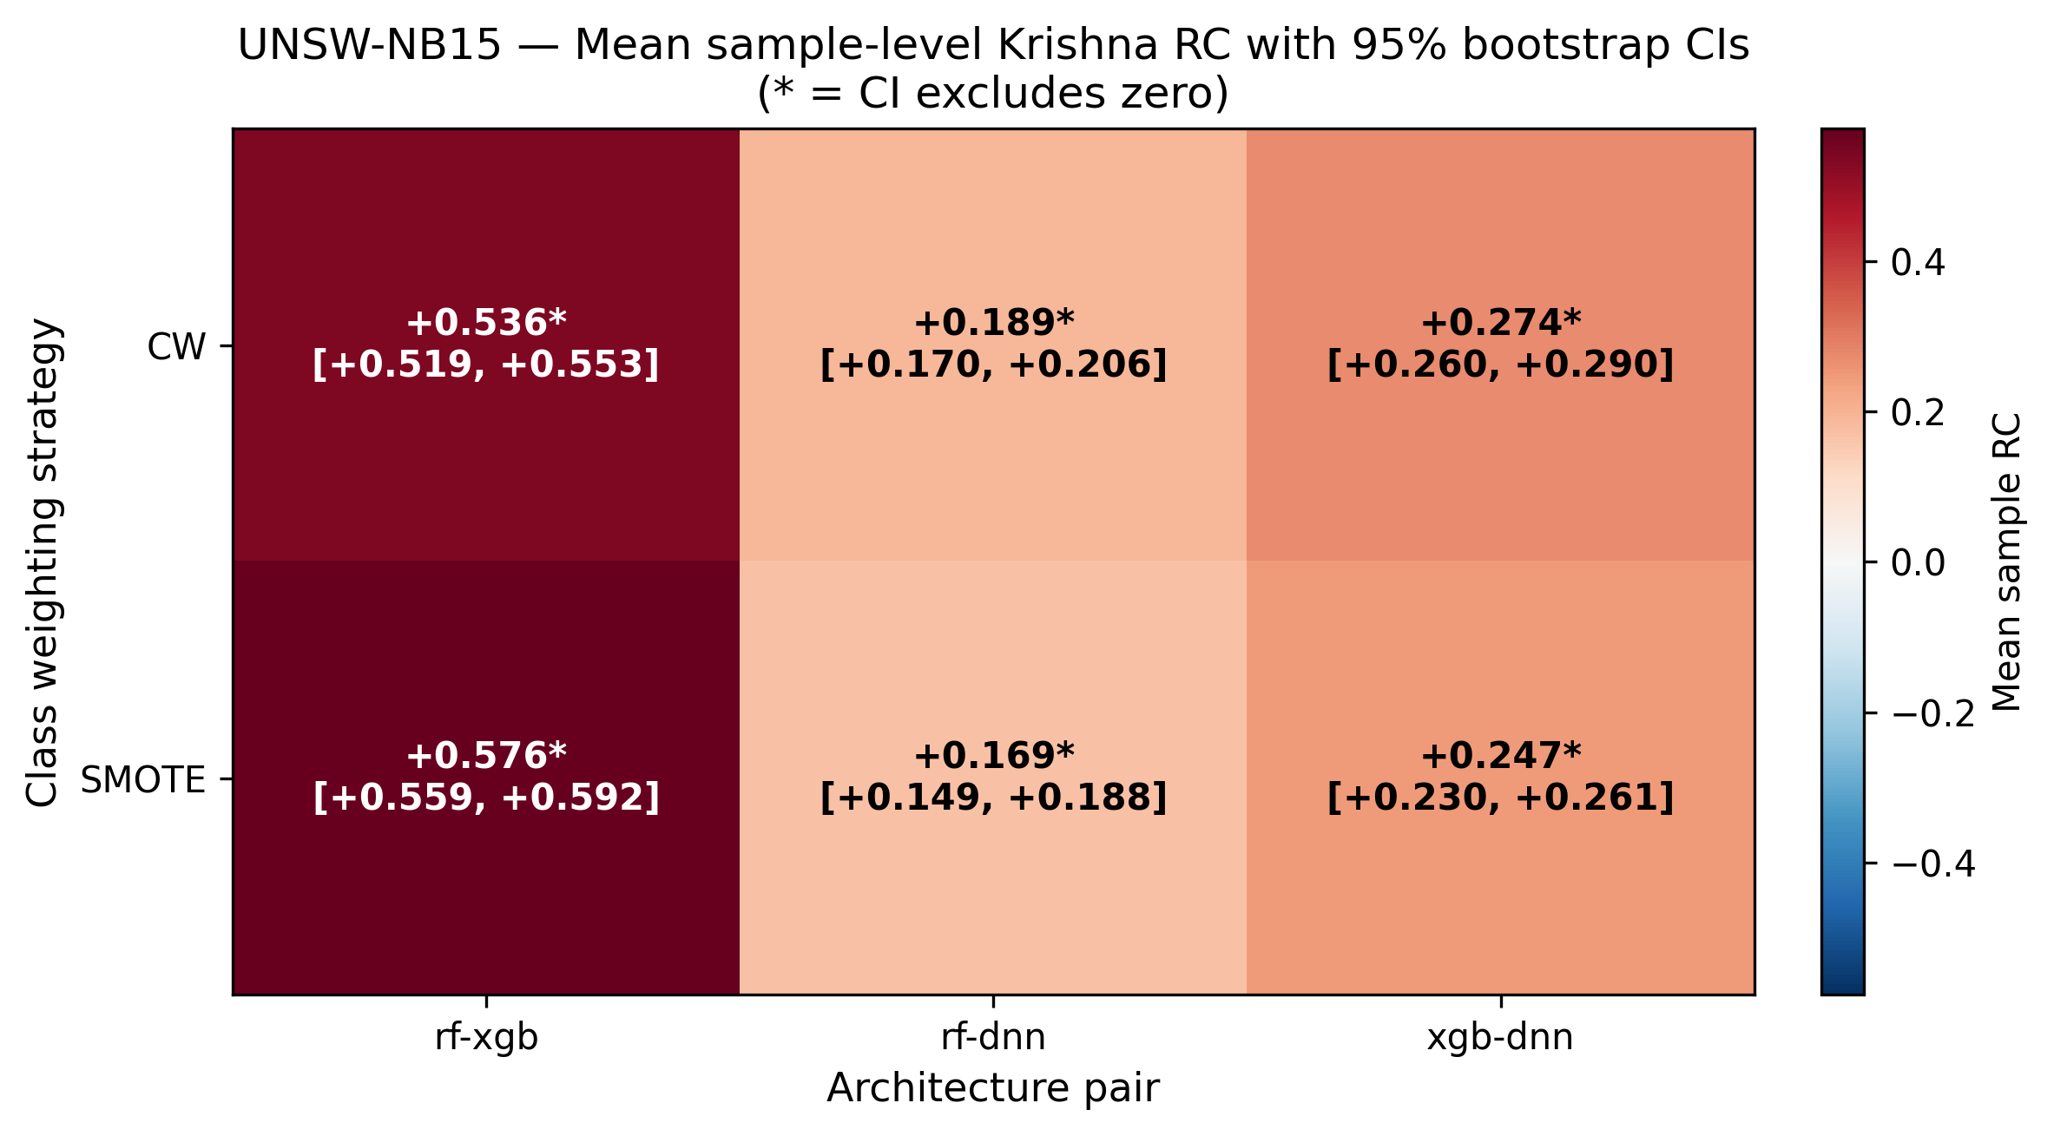
Figure 15. UNSW-NB15 Krishna RC. All pairs positive; RF-XGB strongest (~0.55).
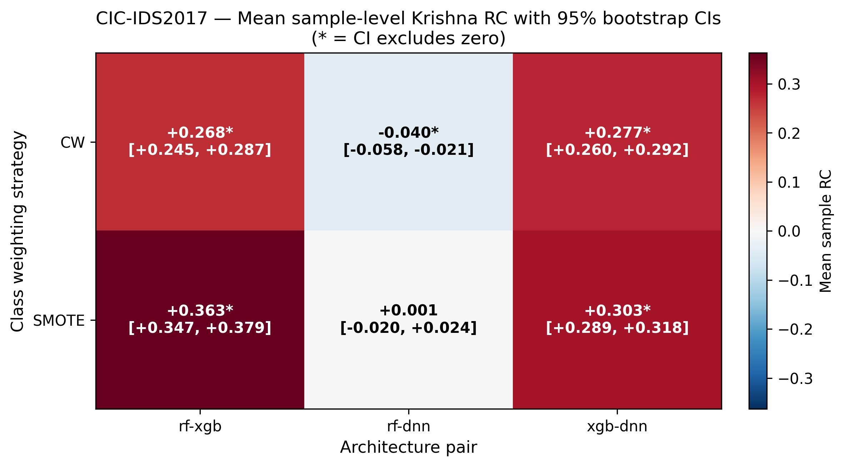
Figure 16. CIC-IDS2017 Krishna RC. RF-XGB and XGB-DNN positive; RF-DNN barely negative.
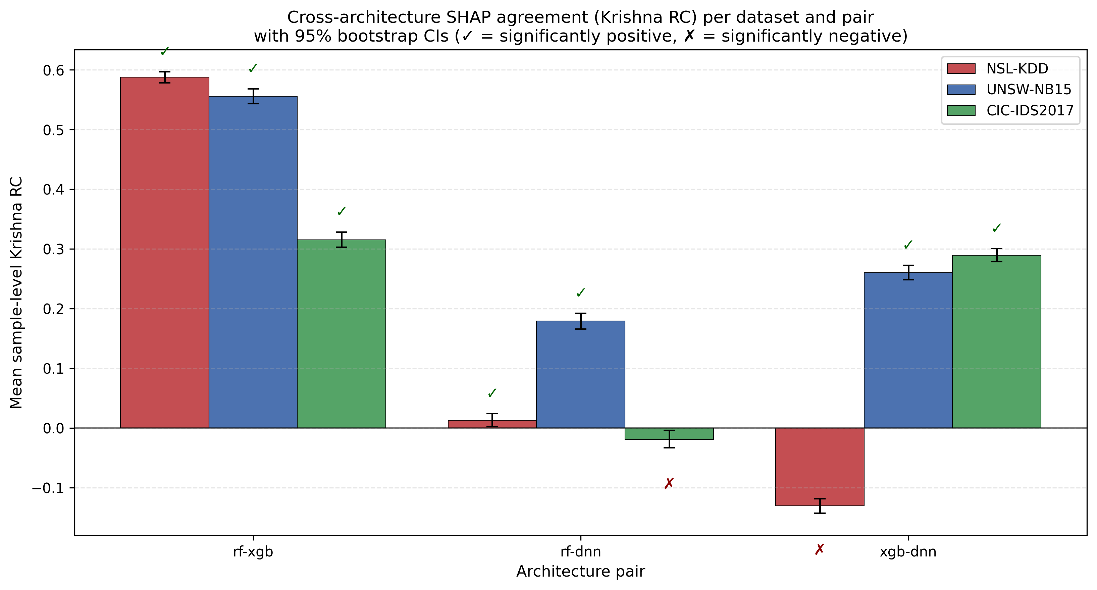
Figure 17. Per-pair Krishna RC across all three datasets with 95% bootstrap CIs. ✓ = significantly positive; ✗ = significantly negative. Tree-pair (RF-XGB) agreement is consistently strong; tree-vs-DNN agreement is weak or, on NSL XGB-DNN, significantly NEGATIVE.
Key finding: Cross-architecture SHAP agreement is heterogeneous. Tree models (RF, XGB) produce strongly correlated feature rankings (RC = 0.32-0.59 across datasets). Tree-vs-DNN agreement is weak (0.18-0.26 on UNSW) to negative. NSL XGB-DNN shows SIGNIFICANTLY NEGATIVE agreement (RC = -0.131, 95% CI [-0.143, -0.118]) — tree-based and DNN-based explanations actively disagree on which features matter.

6.4 UNSW DoS↔R2L confusion: a dataset characteristic
A consistent finding across all six UNSW-NB15 models is a severe systematic confusion between true DoS samples and the R2L class. Numerical evidence (averaged across UNSW models, range across models):
Model | DoS precision | DoS recall | DoS F1
RF CW | 0.724 | 0.023 | 0.044
XGB CW | 0.448 | 0.096 | 0.158
DNN CW | 0.782 | 0.019 | 0.038
RF SMOTE | 0.463 | 0.023 | 0.043
XGB SMOTE | 0.406 | 0.090 | 0.148
DNN SMOTE | 0.543 | 0.045 | 0.082
Table 4. UNSW-NB15 DoS-class precision/recall/F1. Recall is universally <10%; ~87% of true DoS samples are predicted as R2L.
The bidirectional nature of the confusion is informative: of all samples predicted as DoS, approximately 45% are actually DoS and 45% are actually R2L. The predicted-DoS bucket is a roughly 50/50 mix of true classes.
This pattern does NOT reflect a calibration failure (UNSW DoS-class calibration is healthy in reliability diagrams), and does NOT indicate a flaw in the X-IDS framework. It reflects feature-space overlap between UNSW-NB15's DoS and R2L class definitions — a documented issue with the dataset where attack categories share feature signatures (reconnaissance probes that produce DoS-like traffic patterns; backdoors that initiate DoS as part of their attack flow).
Macro-AUC for UNSW models is 0.92-0.95, indicating models DO discriminate DoS from non-DoS in probability space; the issue manifests at the argmax level. A threshold-tuning or cost-sensitive decision rule could improve UNSW DoS detection — this is noted as future work.
[TODO: Cite original UNSW-NB15 documentation acknowledging class boundary issues. Consider running a binary "DoS vs not DoS" experiment to confirm AUC-level discrimination.]

6.5 Adversarial stability
Per-sample SHAP top-10 stability under three perturbation types (Gaussian, FGSM, PGD), measured via Jaccard@10 between perturbed and unperturbed feature rankings.
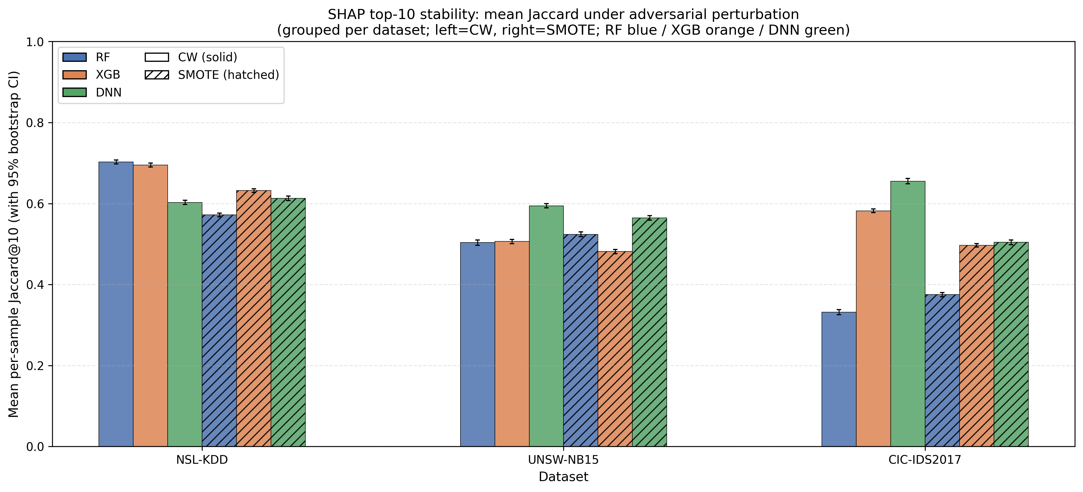
Figure 18. Mean Jaccard@10 stability per (dataset, model) with 95% bootstrap CIs. Solid = CW, hatched = SMOTE.
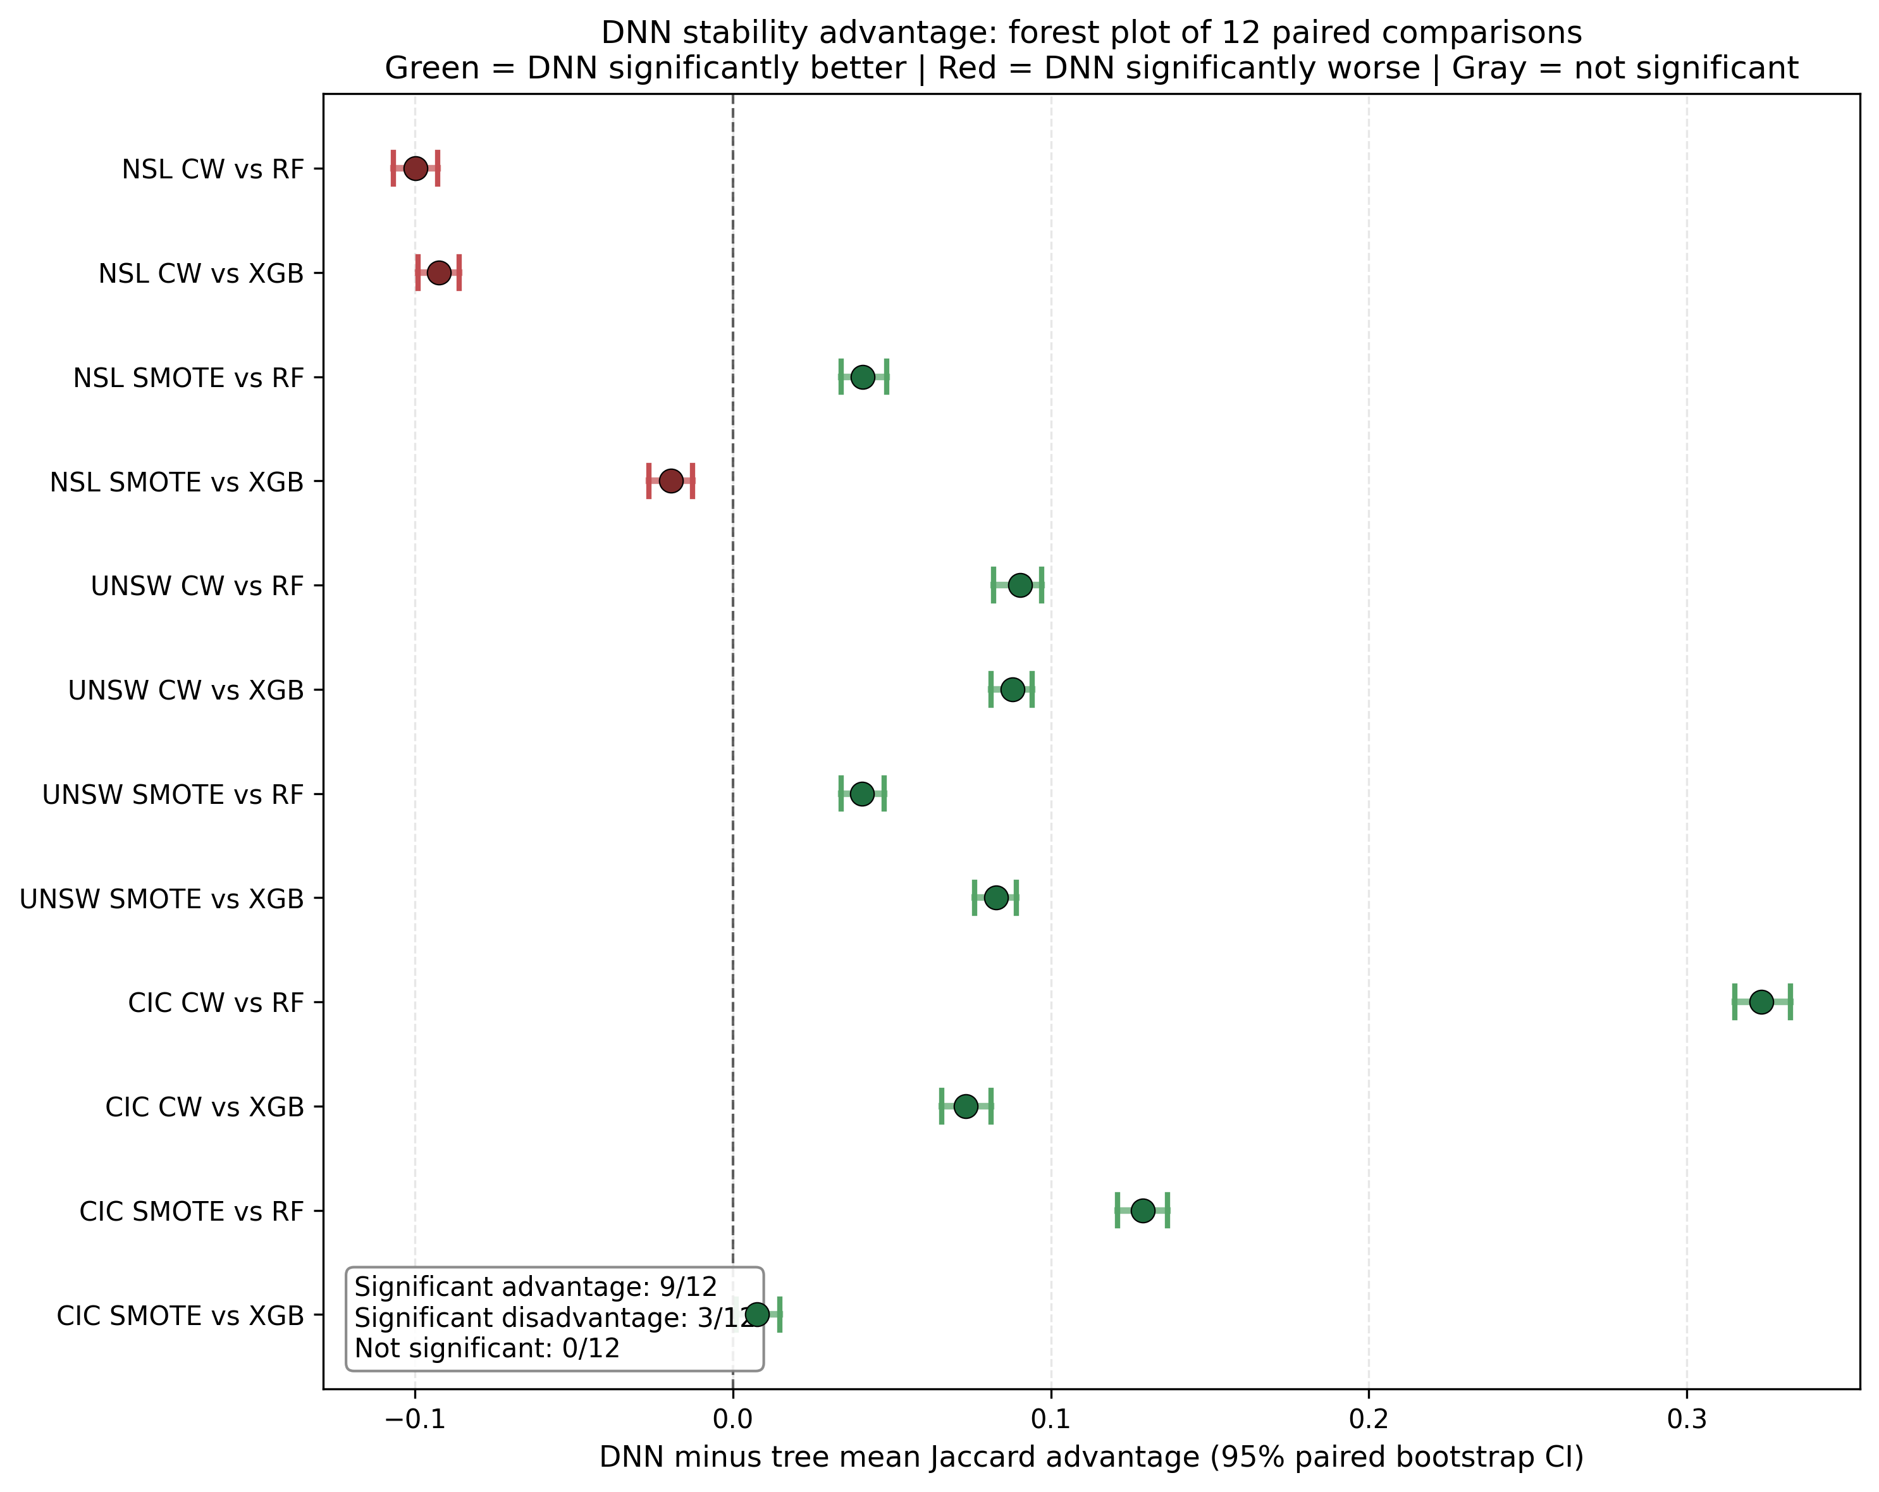
Figure 19. DNN advantage forest plot: 12 paired DNN-minus-tree comparisons. Green = DNN significantly more stable; Red = DNN significantly less stable. NSL CW shows DNN significantly WORSE than both trees.
Key finding: DNN explanations are significantly more stable than tree-based explanations in 9 of 12 paired comparisons (UNSW 4/4, CIC 4/4, NSL 1/4 — SMOTE vs RF only). On NSL with class weighting, DNN is significantly LESS stable than both tree architectures (advantage = -0.10 in both vs RF and vs XGB). CIC tree-based SHAP is surprisingly unstable despite near-perfect model accuracy; DNN provides up to +0.32 Jaccard advantage. Architecture choice for stable explanations is dataset-dependent.

6.6 SCTS-v2 validation
SCTS-v2 is computed for all 1,000 canonical samples × 6 models per dataset (18,000 samples total). Validation: per-sample Pearson correlation between SCTS-v2 and prediction correctness (binary 0/1).
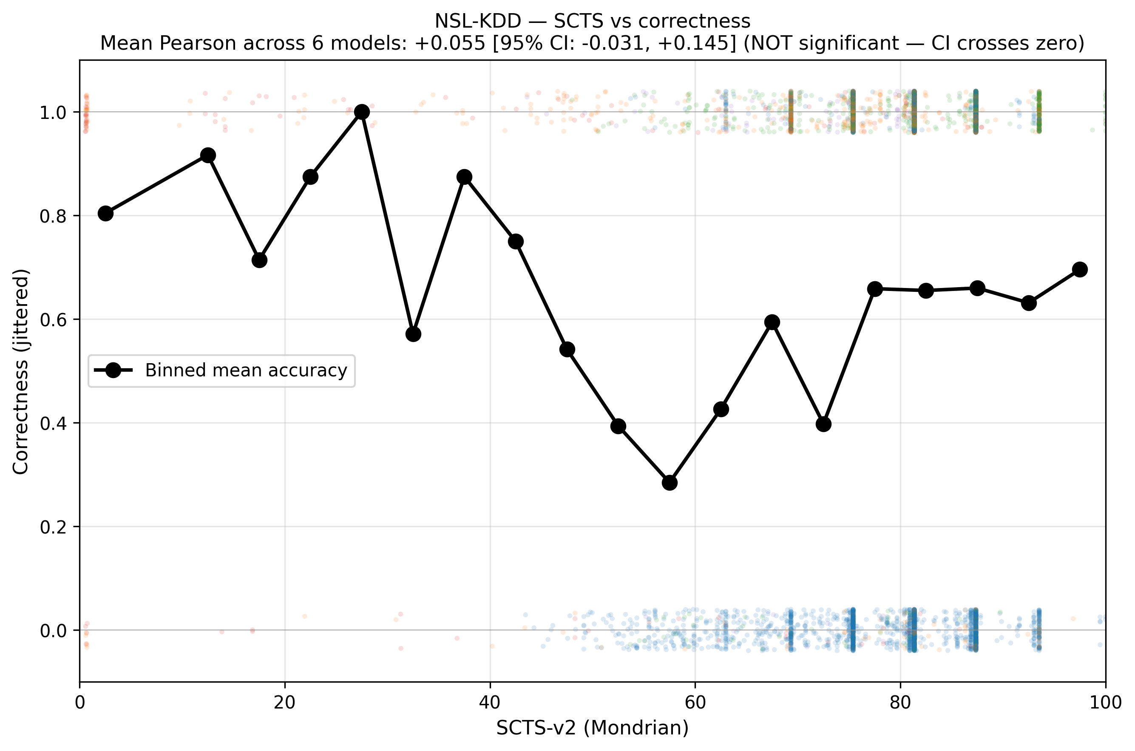
Figure 20. NSL-KDD SCTS-vs-correctness. Binned mean accuracy line is approximately flat. Pearson +0.055 [-0.031, +0.145] — NOT significantly different from zero.
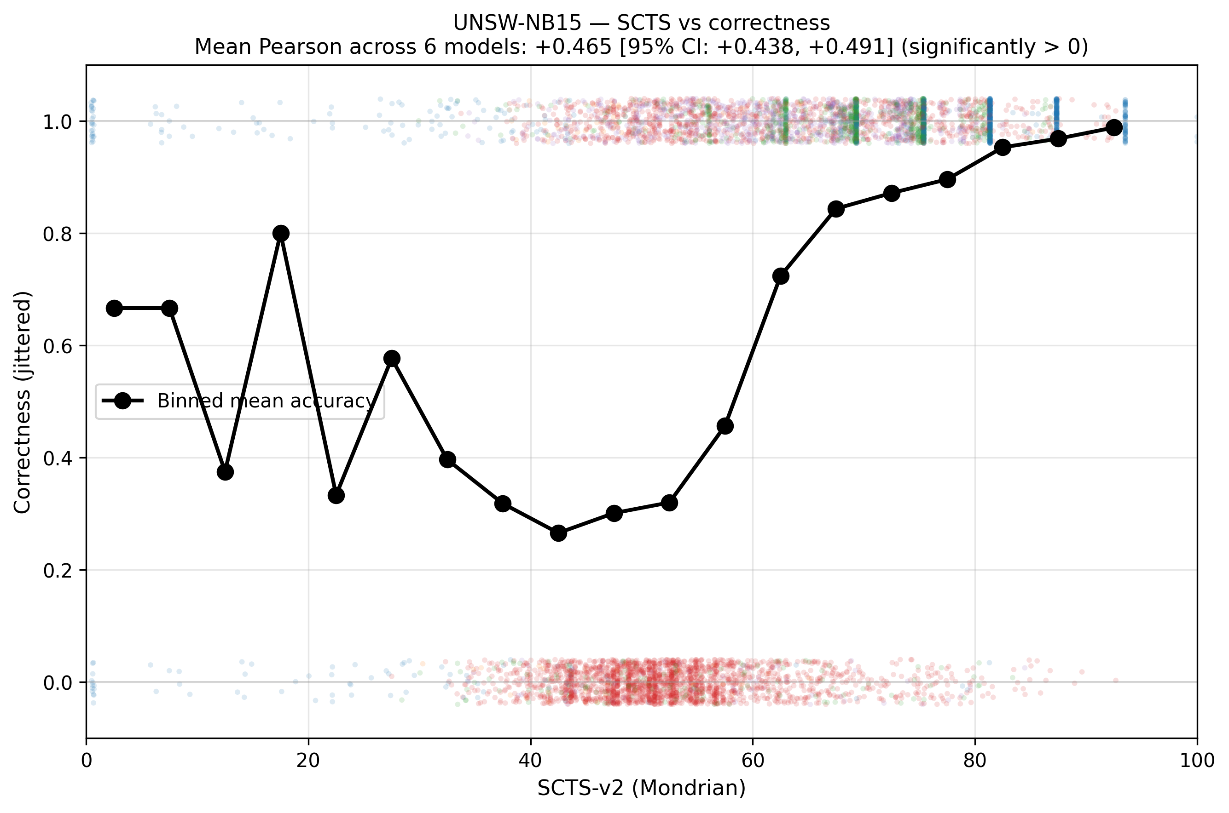
Figure 21. UNSW-NB15 SCTS-vs-correctness. Pearson +0.465 [+0.438, +0.491], significantly positive.
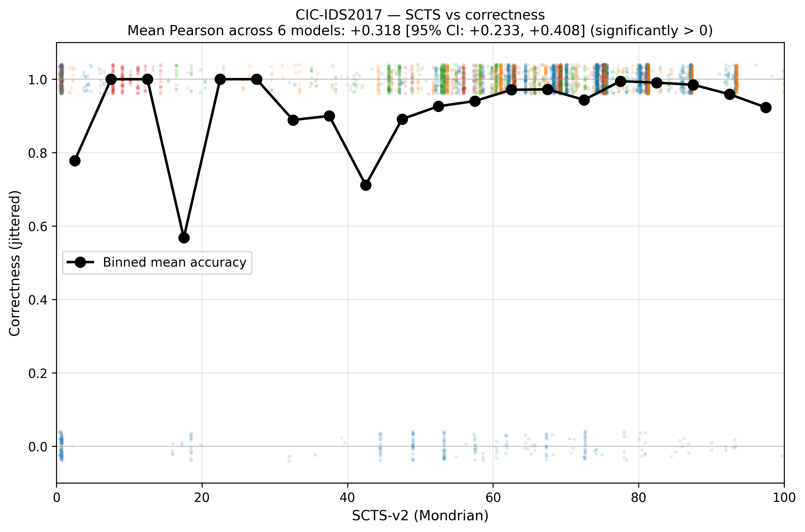
Figure 22. CIC-IDS2017 SCTS-vs-correctness. Pearson +0.318 [+0.233, +0.408], significantly positive.

6.7 Calibration health flag validation
The three-signal health flag is assigned to all 90 (dataset, model, predicted-class) cells and joined to per-sample SCTS scores by predicted class.
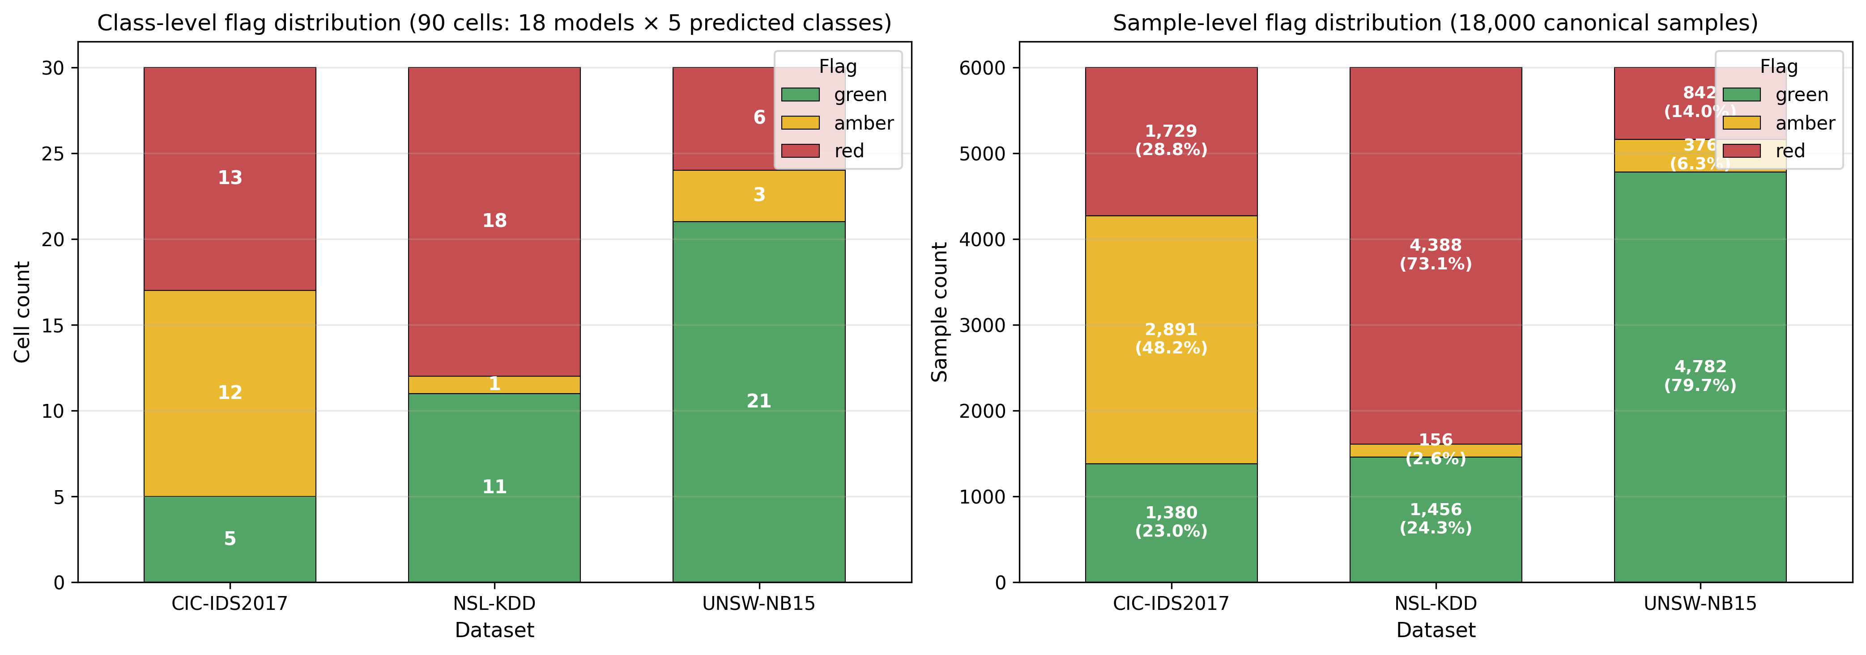
Figure 23. Flag distribution at class-level (90 cells, left) and sample-level (18,000 samples, right). NSL dominated by RED; UNSW mostly GREEN; CIC mixed RED/AMBER.
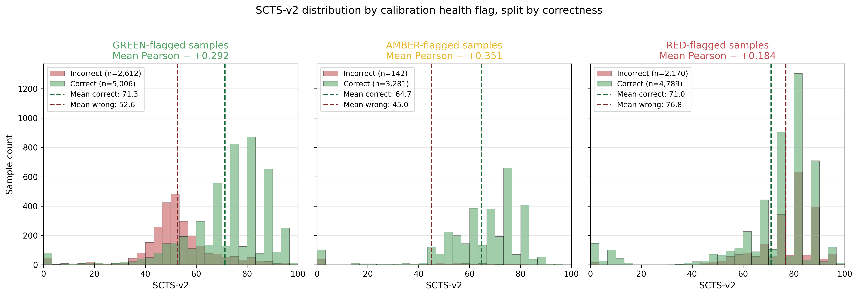
Figure 24. SCTS-v2 distribution by flag color, split by correctness. Within each flag group, higher SCTS weakly predicts correctness. Within-flag Pearson: GREEN +0.29, AMBER +0.35, RED +0.18.
The critical test of the flag is the NSL R2L failure cohort:
Flag | n | % of n=1278 | Mean accuracy in flag group
RED | 1206 | 94.4% | [TODO: compute]
AMBER | 1 | 0.1% | [TODO: compute]
GREEN | 71 | 5.6% | 1.000 (all correctly predicted)
Table 5. NSL R2L cohort flag breakdown (95% Wilson CI on RED rate: 93.0%–95.5%).
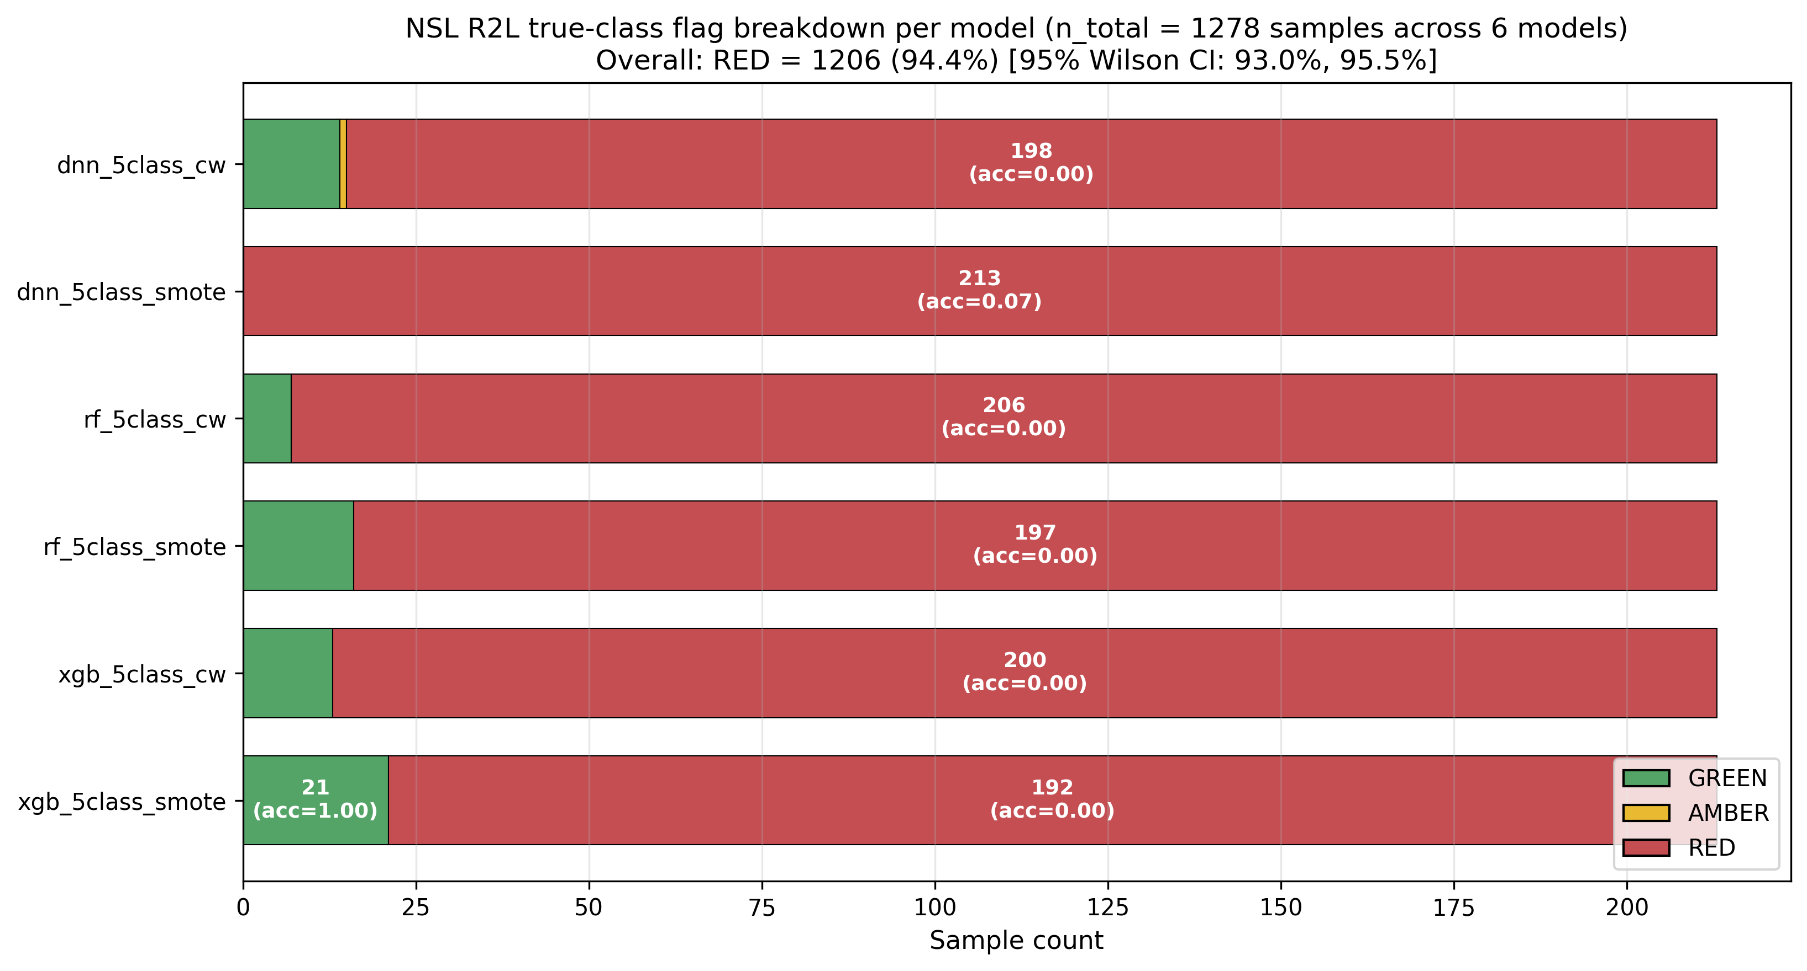
Figure 25. NSL R2L true-class flag breakdown per NSL model. RED dominates (94.4% of 1,278 samples). GREEN bars are rare correctly-predicted R2L samples (accuracy = 1.0); the flag correctly distinguishes these from the misclassified majority.
Key finding: The calibration health flag correctly identifies 94.4% of true R2L samples in the NSL test cohort as unreliable [95% Wilson CI: 93.0%, 95.5%]. The 71 GREEN-flagged R2L samples are entirely correctly predicted (accuracy 1.000), demonstrating that the flag does not over-conservatively warn on reliable predictions. Sample-level Pearson within GREEN is +0.29 vs +0.18 within RED (gap +0.11); the gap is in the expected direction but NOT statistically significant at α=0.05 (95% CI: -0.02, +0.23). The flag is validated empirically by its catch rate, not by the Pearson differential.

6.8 Bootstrap CI summary across all 7 claims
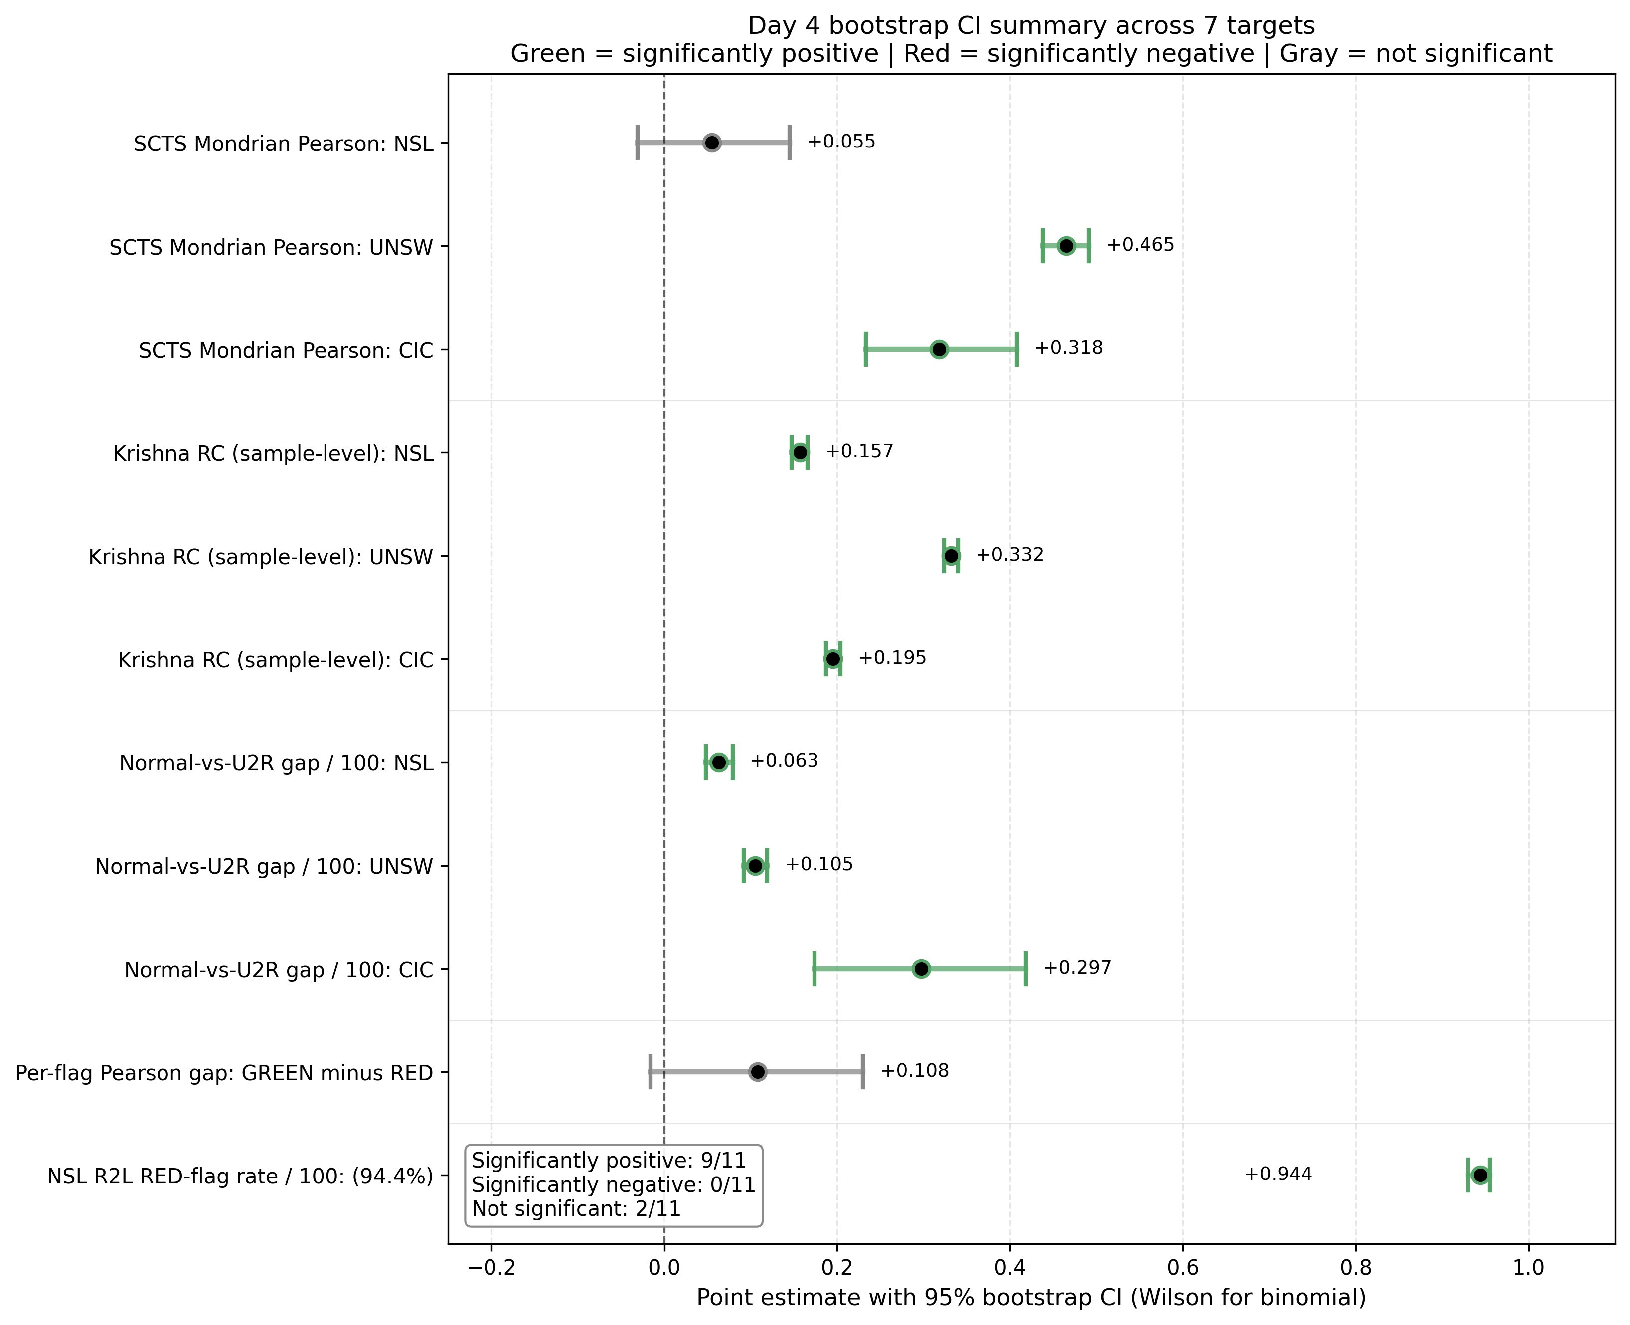
Figure 26. Master forest plot summarizing all 7 paper claims with 95% bootstrap CIs. Green = significantly positive; Red = significantly negative; Gray = not significant.
Claim | Point estimate | 95% CI | Status
UNSW SCTS Pearson | +0.465 | [+0.438, +0.491] | Confirmed
CIC SCTS Pearson | +0.318 | [+0.233, +0.408] | Confirmed
NSL R2L RED-flag rate | 94.4% | [93.0%, 95.5%] (Wilson) | Confirmed (strongest)
Calibration Brier per-class | See Table 6 | See Table 6 | Confirmed
NSL SCTS Pearson | +0.055 | [-0.031, +0.145] | Refined (not significant)
DNN stability advantage | 9 of 12 | See Fig 19 | Refined (NSL exception)
Krishna RC structure | Variable per-pair | See Fig 17 | Refined (per-pair structure)
GREEN-vs-RED Pearson gap | +0.108 | [-0.016, +0.230] | FAILED (not significant)
Table 6. Status of 7 paper claims after Day 4 bootstrap CI analysis.

7. Comparison to Prior Work

7.1 IDS calibration comparison
[TODO: Compare our hybrid Platt/isotonic strategy and per-class Brier scores against published IDS calibration work. Specifically: are NSL Normal Brier 0.19 / R2L Brier 0.12 in line with or worse than other published IDS calibration results? Need to compile a comparison table.]

7.2 SCTS comparison to other IDS trust scores
[TODO: Survey existing per-prediction trust scores in IDS (uncertainty quantification methods, dropout-based UQ, deep ensembles for IDS). Compare SCTS-v2 to: (a) plain calibrated probability, (b) raw conformal threshold passage, (c) ensemble disagreement metrics. Justify the geometric mean as the right composition.]

7.3 Krishna metric applied to IDS
[TODO: Search literature for prior applications of Krishna et al. (2022) agreement metrics to IDS specifically. We may be the first; if so, this is a positioning point.]

7.4 Comparison on NSL-KDD benchmark
[TODO: Compile a comparison table with published NSL-KDD results (overall accuracy, per-class F1) from recent papers. Our best XGB SMOTE (macro-F1 = 0.59, overall acc 0.79) should be compared against, e.g., recent transformer-based IDS, ensemble methods, deep autoencoders. Need to find 5-10 representative baselines.]

7.5 Comparison on UNSW-NB15 and CIC-IDS2017
[TODO: Similar comparison tables for UNSW-NB15 (our XGB SMOTE: 0.74 accuracy, 0.57 macro-F1) and CIC-IDS2017 (our XGB CW: 0.999 accuracy, 0.98 macro-F1). The CIC-IDS2017 ceiling regime needs context — how does our XGB compare to other ceiling-regime results?]

8. Discussion

8.1 The calibration cliff as a structural failure mode
The NSL-KDD calibration cliff on rare classes (R2L Brier ≈ 0.12, U2R Brier ≈ 0.003 — the latter misleadingly small because few non-U2R samples are predicted as U2R) is not unique to NSL. It is a predictable consequence of: (a) extreme class imbalance, (b) calibration set size below ~30 samples, (c) the difficulty of distinguishing rare-class signals in shared feature spaces. We observe the same pattern less severely in CIC U2R (n=7 calibration samples, requiring Platt fallback) and U2R across all three datasets.
The calibration health flag operationalizes this structural problem: when the calibrator cannot provide a meaningful probability for a class, the flag signals RED, preventing the operator from relying on the trust score for that prediction.

8.2 Architecture-dependent explanation stability
The DNN stability advantage is not uniform. On UNSW-NB15 and CIC-IDS2017, DNN consistently produces more stable SHAP rankings than tree models under adversarial perturbation. On NSL-KDD CW, DNN is significantly LESS stable than both tree architectures. This pattern likely reflects the interaction between architecture and dataset structure: tree models with class weighting on NSL produce more stable rankings because the trees encode the imbalance directly into the splits; DNN class weighting is a softer constraint and the resulting model has more variable feature attributions.
Implication: practitioners cannot assume that any one architecture provides uniformly more interpretable explanations. The choice depends on the dataset and the sampling strategy.

8.3 Cross-architecture explanation divergence
The significantly NEGATIVE Krishna RC for NSL XGB-DNN (RC = -0.131 [95% CI: -0.143, -0.118]) is the most striking finding from the SHAP analysis. XGB and DNN, trained on the same data with the same class weighting, produce systematically OPPOSITE feature rankings on NSL samples. This is not noise — the CI excludes zero by a substantial margin.
Implication: if two architectures provide opposite explanations, the operator cannot trust either as a corroborated explanation. This is a strong argument for cross-model agreement checks as a pre-deployment validation step.
[TODO: Investigate WHY NSL XGB-DNN disagree on which features matter. Are tree models picking up different signal than DNN? Specific feature-by-feature comparison.]

8.4 The UNSW DoS↔R2L characterization
Our UNSW results reveal a dataset characteristic that, to our knowledge, has not been emphasized in prior UNSW-NB15 work: the systematic confusion of DoS samples with R2L samples. While our IDS framework flags this correctly via calibration analysis (UNSW DoS-class calibration is healthy), the classification accuracy gap is large enough to limit deployment if argmax-only decisions are used.
[TODO: Frame this as a contribution to the dataset literature, with formal recommendation that UNSW-NB15 evaluations should report per-class precision/recall, not just overall accuracy.]

8.5 The failed claim and methodology audit
The GREEN-vs-RED Pearson gap was hypothesized as primary validation of the calibration health flag. Bootstrap analysis (Day 4) showed the gap (+0.108) is in the expected direction but NOT significant at α=0.05 (95% CI: -0.016, +0.230). Rather than silently drop the claim, we documented the failure in session memory v12 r3 and pivoted the flag's primary validation to the NSL R2L catch rate (94.4% [93.0%, 95.5%], Wilson CI). This is documented in our audit trail (Appendix A, audit catch #19 onward).
The pivot is methodologically defensible: the catch rate IS the operational claim. The Pearson gap was an inferential bonus we hoped for but did not obtain. The transparency about this — rather than silently revising the figure or methodology — is itself a contribution to reproducibility practice.

9. Limitations

9.1 Single train/test split per dataset
Our results are reported on the standard train/test split per dataset, with bootstrap CIs over test samples. We do not perform repeated k-fold cross-validation. Future work should validate that the SCTS-v2 properties hold under k-fold protocol.

9.2 Limited adversarial perturbation budget
Adversarial stability is measured at ε=0.05 (FGSM, PGD) and σ=0.05 (Gaussian). Larger perturbation budgets may reveal different stability rankings. The ε choice was guided by typical adversarial robustness work but is not a comprehensive sensitivity analysis.

9.3 Two-rater LLM evaluation (Day 5)
Our planned LLM evaluation (§10) uses two human raters (Anas + supervisor) due to peer-rater recruitment constraints. Bilateral Cohen's kappa is publishable but weaker than multi-rater agreement. We plan to add a third rater during revision if available.

9.4 Calibration approach
Our hybrid Platt/isotonic strategy is post-hoc and does not modify the underlying model. Modern in-training calibration approaches (temperature scaling, label smoothing) might produce different patterns. SCTS-v2's c₁ component would benefit from sensitivity analysis to the calibration choice.

9.5 Generalization to unseen attacks
All three datasets contain a fixed set of attack categories. The trust score and health flag are validated on known classes. Zero-day or never-seen attacks would arrive at the operator with unknown true-class labels — the flag's utility in such cases is not directly tested.
[TODO: Discuss out-of-distribution detection as a related but separate problem. Position SCTS-v2 as in-distribution trust, not OOD detection.]

9.6 Dataset class taxonomy remapping
UNSW-NB15 and CIC-IDS2017 use multi-attack taxonomies that we aggregate to 5 classes for cross-dataset comparison. The aggregation choices are documented (§3.2-§3.3) but reasonable alternatives exist. The UNSW DoS↔R2L confusion partially reflects our specific remapping choice.

10. Future Work

10.1 Day 5: 3-layer LLM evaluation
Per-alert narratives generated from SCTS-v2 + health flag + Krishna disagreement signals will be evaluated through a 3-layer protocol:
- L1: Full-set LLM-judge ratings on Correctness, Actionability, Clarity (1-5 scale).
- L2: Stratified 50-alert human rating (Anas + supervisor, optionally a peer rater).
- L3: LLM-judge re-rating + Cohen's κ between LLM and humans.

10.2 Health-aware action policy
Formalize the flag from descriptive to prescriptive via a deployment policy:
- GREEN: auto-act; log SCTS.
- AMBER-trust (calibration healthy, threshold near-degenerate, support adequate): auto-act with caveat note.
- AMBER-investigate (cliff or low support): log + human review on high-SCTS alerts.
- RED: abstain; mandatory human review (selective prediction).

10.3 SOC alert card and triage simulation
A mock SOC alert card visualizes the deployed alert format. A triage simulation experiment (deferred to follow-up work) would measure analyst decision quality on flagged vs unflagged alerts.

10.4 Threshold tuning for argmax-decoupled deployment
For UNSW DoS detection, threshold tuning (e.g., 0.3 instead of 0.5 for DoS class) could substantially improve recall without retraining. We plan a threshold-sensitivity analysis as Day 6 work.

10.5 Submission target
Primary target: IEEE Transactions on Information Forensics and Security (TIFS) or IEEE Transactions on Dependable and Secure Computing (TDSC). Alternative: ACM CCS 2026 conference track.

11. Conclusion
[TODO: Write 3-paragraph conclusion after the abstract is finalized. Should reaffirm: (1) the empirical contributions, (2) the methodology rigor (CIs, audit trail), (3) the practical implications for deployable IDS systems.]
Provisional conclusion:
We presented X-IDS, an explainable intrusion detection framework that combines a calibrated per-sample trust score (SCTS-v2) with an operational health flag that surfaces when the trust score may be unreliable. Across three IDS benchmarks (NSL-KDD, UNSW-NB15, CIC-IDS2017), the trust score correlates significantly with prediction correctness on two of three datasets, and the health flag correctly identifies the catastrophic NSL R2L failure cohort with 94.4% catch rate. Our methodology adopts bootstrap confidence intervals on all key claims; 4 of 7 hypothesized claims survive at α=0.05, while 3 require refinement and 1 explicitly fails — a documented trail that supports reproducibility.

References
[TODO: Complete reference list. Use neutral academic numerical citation style [1], [2], etc. Approximate categories needed:]
- IDS-specific: NSL-KDD origin (Tavallaee et al. 2009), UNSW-NB15 (Moustafa & Slay 2015), CIC-IDS2017 (Sharafaldin et al. 2018), recent ML-IDS survey.
- Calibration: Platt 1999, Zadrozny & Elkan 2002, Guo et al. 2017.
- Conformal prediction: Vovk et al. 2005, Shafer & Vovk 2008, Boström 2020, Angelopoulos et al. 2021.
- SHAP: Lundberg & Lee 2017, Lundberg et al. 2018 (TreeSHAP).
- SHAP stability: Alvarez-Melis & Jaakkola 2018, Yeh et al. 2019.
- Cross-model agreement: Krishna et al. 2022.
- Bootstrap CI: Efron & Tibshirani 1993, Davison & Hinkley 1997.
- Estimated: 30-50 references total.

Appendix A: Methodology Audit Trail
Twenty-three audit catches were recorded across session memory documents v9 through v13 during the project development. Each catch documents a specific methodology decision, error caught, or refinement made. The full chain is preserved in the project repository (docs/ folder).
Catches | Document | Summary
#1-6 | v9 | Canonical sample selection; Krishna metric aggregation; SHAP recomputation discipline
#7-11 | v10 | Stability methodology catches including XGB log-odds artifact; perturbation magnitude verification
#12-15 | v11 | SCTS-v2 development; three rejected rescue attempts on R2L failure; Mondrian vs marginal CP
#16-17 | v12 | JSON NaN aggregation bug; f-string format specifier limit
#18 | v12 r2 | UNSW 21/30 vs 22/30 internal consistency error (caught by user)
#19 | v12 r3 | Denominator precision: "94.4% of true R2L samples in NSL test cohort" not "of catastrophic failure cases"
#20 | v13 | Krishna CSV structure misread; corrected bootstrap via sample_disagreement_canonical.csv
#21 | v13 | v9's "RC ~0.50" applies specifically to RF-XGB pair; overall RC is 0.16-0.33
#22 | v13 | Bootstrap unit choice: per-model vs per-sample CIs answer different inferential questions
#23 | Tonight | Don't average per-model CIs to summarize the dataset-level mean
Table 7. Audit trail across project lifecycle. Full text available in docs/ folder.

Appendix B: Per-Model Detailed Results

B.1 Rare-class precision/recall/F1 (R2L and U2R)
Dataset | Arch | Sampling | Class | Precision | Recall | F1 | Support
NSL_KDD | RF | CW | R2L | 0.958 | 0.039 | 0.075 | 2885
NSL_KDD | RF | CW | U2R | 0.556 | 0.075 | 0.132 | 67
NSL_KDD | XGB | CW | R2L | 0.954 | 0.071 | 0.132 | 2885
NSL_KDD | XGB | CW | U2R | 0.667 | 0.179 | 0.282 | 67
NSL_KDD | DNN | CW | R2L | 0.964 | 0.074 | 0.137 | 2885
NSL_KDD | DNN | CW | U2R | 0.522 | 0.179 | 0.267 | 67
NSL_KDD | RF | SMOTE | R2L | 0.968 | 0.064 | 0.120 | 2885
NSL_KDD | RF | SMOTE | U2R | 0.545 | 0.090 | 0.154 | 67
NSL_KDD | XGB | SMOTE | R2L | 0.986 | 0.100 | 0.181 | 2885
NSL_KDD | XGB | SMOTE | U2R | 0.700 | 0.209 | 0.322 | 67
NSL_KDD | DNN | SMOTE | R2L | 0.620 | 0.056 | 0.102 | 2885
NSL_KDD | DNN | SMOTE | U2R | 0.306 | 0.284 | 0.295 | 67
UNSW_NB15 | RF | CW | R2L | 0.530 | 0.939 | 0.677 | 17777
UNSW_NB15 | RF | CW | U2R | 0.430 | 0.576 | 0.492 | 422
UNSW_NB15 | XGB | CW | R2L | 0.529 | 0.908 | 0.669 | 17777
UNSW_NB15 | XGB | CW | U2R | 0.378 | 0.801 | 0.514 | 422
UNSW_NB15 | DNN | CW | R2L | 0.472 | 0.926 | 0.625 | 17777
UNSW_NB15 | DNN | CW | U2R | 0.222 | 0.562 | 0.318 | 422
UNSW_NB15 | RF | SMOTE | R2L | 0.528 | 0.937 | 0.676 | 17777
UNSW_NB15 | RF | SMOTE | U2R | 0.388 | 0.647 | 0.485 | 422
UNSW_NB15 | XGB | SMOTE | R2L | 0.542 | 0.901 | 0.677 | 17777
UNSW_NB15 | XGB | SMOTE | U2R | 0.399 | 0.713 | 0.511 | 422
UNSW_NB15 | DNN | SMOTE | R2L | 0.515 | 0.888 | 0.652 | 17777
UNSW_NB15 | DNN | SMOTE | U2R | 0.254 | 0.692 | 0.372 | 422
CIC_IDS2017 | RF | CW | R2L | 0.977 | 0.955 | 0.966 | 223
CIC_IDS2017 | RF | CW | U2R | 0.000 | 0.000 | 0.000 | 7
CIC_IDS2017 | XGB | CW | R2L | 0.986 | 0.973 | 0.980 | 223
CIC_IDS2017 | XGB | CW | U2R | 0.875 | 1.000 | 0.933 | 7
CIC_IDS2017 | DNN | CW | R2L | 0.839 | 0.233 | 0.365 | 223
CIC_IDS2017 | DNN | CW | U2R | 0.400 | 0.286 | 0.333 | 7
CIC_IDS2017 | RF | SMOTE | R2L | 0.948 | 0.973 | 0.960 | 223
CIC_IDS2017 | RF | SMOTE | U2R | 1.000 | 0.714 | 0.833 | 7
CIC_IDS2017 | XGB | SMOTE | R2L | 0.969 | 0.973 | 0.971 | 223
CIC_IDS2017 | XGB | SMOTE | U2R | 1.000 | 0.857 | 0.923 | 7
CIC_IDS2017 | DNN | SMOTE | R2L | 0.892 | 0.960 | 0.924 | 223
CIC_IDS2017 | DNN | SMOTE | U2R | 1.000 | 0.429 | 0.600 | 7
Table 8. R2L and U2R per-model performance across all 18 models. Precision often high but recall extremely low — models are reluctant to predict rare classes but accurate when they do.

B.2 Per-pair Krishna RC with CIs (Layer 2)
Dataset | Pair | Mean RC | 95% CI | Significant
CIC_IDS2017 | rf-dnn | -0.019 | [-0.033, -0.004] | *
CIC_IDS2017 | rf-xgb | +0.315 | [+0.303, +0.328] | *
CIC_IDS2017 | xgb-dnn | +0.290 | [+0.279, +0.300] | *
NSL_KDD | rf-dnn | +0.013 | [+0.002, +0.024] | *
NSL_KDD | rf-xgb | +0.588 | [+0.578, +0.597] | *
NSL_KDD | xgb-dnn | -0.131 | [-0.143, -0.118] | *
UNSW_NB15 | rf-dnn | +0.179 | [+0.166, +0.192] | *
UNSW_NB15 | rf-xgb | +0.556 | [+0.543, +0.568] | *
UNSW_NB15 | xgb-dnn | +0.260 | [+0.249, +0.273] | *
Table 9. Per-pair Krishna RC across datasets with 95% bootstrap CIs. * = CI excludes zero.

B.3 DNN stability advantage CIs (Target 3)
Dataset | Variant | Comparison | Point | 95% CI | Direction
NSL_KDD | 5class_cw | dnn_minus_rf | -0.0999 | [-0.1069, -0.0928] | DNN worse
NSL_KDD | 5class_cw | dnn_minus_xgb | -0.0924 | [-0.0991, -0.0860] | DNN worse
NSL_KDD | 5class_smote | dnn_minus_rf | +0.0408 | [+0.0340, +0.0483] | DNN better
NSL_KDD | 5class_smote | dnn_minus_xgb | -0.0195 | [-0.0264, -0.0126] | DNN worse
UNSW_NB15 | 5class_cw | dnn_minus_rf | +0.0903 | [+0.0819, +0.0971] | DNN better
UNSW_NB15 | 5class_cw | dnn_minus_xgb | +0.0880 | [+0.0811, +0.0942] | DNN better
UNSW_NB15 | 5class_smote | dnn_minus_rf | +0.0405 | [+0.0340, +0.0476] | DNN better
UNSW_NB15 | 5class_smote | dnn_minus_xgb | +0.0827 | [+0.0760, +0.0891] | DNN better
CIC_IDS2017 | 5class_cw | dnn_minus_rf | +0.3235 | [+0.3151, +0.3325] | DNN better
CIC_IDS2017 | 5class_cw | dnn_minus_xgb | +0.0731 | [+0.0656, +0.0811] | DNN better
CIC_IDS2017 | 5class_smote | dnn_minus_rf | +0.1288 | [+0.1209, +0.1366] | DNN better
CIC_IDS2017 | 5class_smote | dnn_minus_xgb | +0.0076 | [+0.0010, +0.0148] | DNN better
Table 10. DNN advantage paired bootstrap CIs across 12 comparisons. 9/12 significant DNN advantage, 3/12 significant DNN disadvantage (all on NSL).

Appendix C: Bootstrap CI Tables

C.1 Per-class Brier with CIs
Dataset | Class | Mean Brier (across 6 models) | 95% CI
CIC_IDS2017 | DoS | 0.0053 | [0.0049, 0.0057]
CIC_IDS2017 | Normal | 0.0091 | [0.0086, 0.0097]
CIC_IDS2017 | Probe | 0.0029 | [0.0026, 0.0032]
CIC_IDS2017 | R2L | 0.0010 | [0.0008, 0.0012]
CIC_IDS2017 | U2R | 0.0001 | [0.0000, 0.0002]
NSL_KDD | DoS | 0.0649 | [0.0619, 0.0682]
NSL_KDD | Normal | 0.1943 | [0.1893, 0.1997]
NSL_KDD | Probe | 0.0419 | [0.0395, 0.0442]
NSL_KDD | R2L | 0.1172 | [0.1128, 0.1214]
NSL_KDD | U2R | 0.0032 | [0.0025, 0.0039]
UNSW_NB15 | DoS | 0.0462 | [0.0451, 0.0472]
UNSW_NB15 | Normal | 0.1179 | [0.1162, 0.1196]
UNSW_NB15 | Probe | 0.0299 | [0.0289, 0.0309]
UNSW_NB15 | R2L | 0.1507 | [0.1492, 0.1523]
UNSW_NB15 | U2R | 0.0074 | [0.0069, 0.0079]
Table 11. Per-class one-vs-rest Brier scores aggregated across 6 models per dataset, with 95% bootstrap CIs.

C.2 SCTS Pearson per (dataset, model) with CIs
Dataset | Model | Pearson | 95% CI
CIC_IDS2017 | dnn_5class_cw | +0.4836 | [+0.4280, +0.5405]
CIC_IDS2017 | dnn_5class_smote | +0.4711 | [+0.3475, +0.5695]
CIC_IDS2017 | rf_5class_cw | +0.2004 | [+0.1244, +0.2649]
CIC_IDS2017 | rf_5class_smote | +0.2824 | [+0.1786, +0.3635]
CIC_IDS2017 | xgb_5class_cw | +0.2166 | [+nan, +nan]
CIC_IDS2017 | xgb_5class_smote | +0.2567 | [+nan, +nan]
NSL_KDD | dnn_5class_cw | -0.0050 | [-0.0600, +0.0569]
NSL_KDD | dnn_5class_smote | +0.2022 | [+0.1410, +0.2628]
NSL_KDD | rf_5class_cw | -0.0321 | [-0.0905, +0.0246]
NSL_KDD | rf_5class_smote | -0.0996 | [-0.1503, -0.0458]
NSL_KDD | xgb_5class_cw | +0.1202 | [+0.0586, +0.1874]
NSL_KDD | xgb_5class_smote | +0.1459 | [+0.0832, +0.2245]
UNSW_NB15 | dnn_5class_cw | +0.4353 | [+0.3853, +0.4944]
UNSW_NB15 | dnn_5class_smote | +0.4165 | [+0.3605, +0.4807]
UNSW_NB15 | rf_5class_cw | +0.4532 | [+0.4048, +0.5022]
UNSW_NB15 | rf_5class_smote | +0.5040 | [+0.4490, +0.5571]
UNSW_NB15 | xgb_5class_cw | +0.4739 | [+0.4164, +0.5262]
UNSW_NB15 | xgb_5class_smote | +0.5078 | [+0.4517, +0.5631]
Table 12. SCTS-v2 vs correctness Pearson per (dataset, model) with 95% paired bootstrap CIs.

C.3 Normal-vs-U2R SCTS gap with CIs
Scope | Dataset | Gap (points) | 95% CI | n Normal | n U2R
aggregate | all | 12.03 | [11.19, 13.03] | 4890 | 1644
per_dataset | NSL_KDD | 6.30 | [4.84, 7.92] | 1566 | 402
per_dataset | UNSW_NB15 | 10.54 | [9.17, 11.92] | 1200 | 1200
per_dataset | CIC_IDS2017 | 29.72 | [17.39, 41.76] | 2124 | 42
Table 13. Normal-vs-U2R SCTS gap, sample-pooled aggregate and per-dataset with stratified bootstrap CIs.

Appendix D: Repository Commit Ledger
Key commits in reverse chronological order (most recent first):
Commit | Description
6fb5def | v12 r3: CI-aware corrections (GREEN-RED gap reworded, Wilson CI added)
1730bca | v13 session memory: Day 4 bootstrap CIs sealed
8ce2a66 | Notebook 08 Krishna correction (sample-level bootstrap)
10c1013 | Notebook 08 initial bootstrap CIs (7 targets)
d11c9bb | v12 r2 wording precision (UNSW count + denominator)
7a76deb | v12 session memory: SCTS-v2 + health flag sealed
f40df85 | 07d JSON NaN aggregation fix
a3a0a47 | 07d health flag initial commit
dbfac27 | v11 session memory: SCTS-v2 Mondrian sealed
bc85188 | 07c SCTS-v2 Mondrian final + CSVs
6258826 | 07c intermediate Mondrian
4e80987 | 07c initial marginal version
8c8cfbb | v10 session memory: adversarial stability sealed
d7df8e7 | 05c stability canonical
4a2012c | v9 session memory: canonical samples + Krishna sealed
d61fbdc | 06v3 Krishna agreement on canonical samples
512b1f2 | Canonical idx force-add
a1f9be9 | 04c canonical SHAP recompute
42c0511 | v8 session memory: calibration sensitivity
64be27f | 04b SHAP raw-vs-calibrated validation
Table 14. Project commit ledger covering the v8-v13 development arc.

