X-IDS Comprehensive Research Record
Module 2 (Part A): §3 Datasets and Preprocessing
Md Anas Biswas, University of Portsmouth — generated 30 May 2026

This is Part A of Module 2. It covers §3 Datasets and Preprocessing in full detail. §4 Methodology, the technical contribution of the paper, will follow in Part B of Module 2 after a clarifying pass on the implementation specifics. Module 1 (front matter, §1 Introduction, §2 Related Work) is a separate document. The five modules will be assembled into a single paper after all are verified.

3. Datasets and Preprocessing

3.1 Overview
I evaluate on three benchmark intrusion-detection datasets: NSL-KDD, UNSW-NB15, and CIC-IDS2017. Module 1 §2.1 covered the high-level story of each dataset, the attack-category remappings to the 5-class Normal/DoS/Probe/R2L/U2R taxonomy, and the partition sizes I use. This section goes one level deeper into the preprocessing pipeline: encoding choices, scaler fitting, out-of-vocabulary handling, exact feature dimensionality, and the resulting class distributions across train, calibration, and test partitions.
Three things are shared across all three datasets. First, the 5-class taxonomy. Every flow ends up labelled as one of Normal, DoS, Probe, R2L, or U2R, regardless of the dataset's native attack-category scheme. Second, the train/calibration/test three-way partition design. Each dataset gets a held-out calibration set of approximately 20% of training data, which is used exclusively for fitting post-hoc probability calibrators (Platt or isotonic, depending on per-class sample count, as covered in §4.2). The calibration set is never used for model training or for any test-time evaluation. Third, the v2 data-pipeline integrity fixes. v1 of the pipeline had two methodological issues that I corrected before this work: the one-hot encoder was originally fit on the union of train and test categorical values, and the post-hoc calibrator was originally fit on a split of the test set. Both leak test-set information into the trained system in different ways. v2 corrects both by fitting the encoder on training categorical values only and by carving the calibration set out of training rather than test.
Three things differ between the datasets. The partition design (NSL has the official partition with a deliberately different test distribution; UNSW has the official partition with similar but not identical class proportions after Generic exclusion; CIC has no official partition, so I create a stratified 60/20/20 split on a 200K-flow subsample). The feature dimensionality after preprocessing (NSL 122, UNSW 194, CIC 78). The set of categorical features that need one-hot encoding (NSL has protocol_type / service / flag, UNSW has proto / service / state, CIC has no categorical features). Each of the next three subsections covers one dataset in detail. §3.5 ties them together with a cross-dataset comparison.

3.2 NSL-KDD pipeline

3.2.1 Source and partition
I use NSL-KDD as distributed by Tavallaee et al. [4]. The dataset comes pre-split into KDDTrain+ and KDDTest+ partitions. I keep this official partition for the test set (22,544 flows) unchanged. From the 125,973 official training flows, I hold out 20% as a calibration set (25,195 flows) using stratified random sampling by 5-class label with a fixed random seed (42). The training partition for model fitting becomes 100,778 flows.
The reason for fixing the seed is reproducibility, not robustness. A single seed is enough because I report all downstream claims with bootstrap CIs that resample within the test set; the calibration carve-out is a one-time data-preparation step that does not need to be re-bootstrapped. The stratification is by 5-class label rather than by raw attack subtype, because raw attack subtypes have very different sample counts and would force the U2R class (n=52 in training) to spread thinly across the carve-out.

3.2.2 Attack remapping
NSL-KDD's 38 attack subtypes are mapped to the 4 attack super-classes plus Normal. The mapping follows the standard taxonomy from the original NSL-KDD paper [4]:
Normal: normal
DoS: back, land, neptune, pod, smurf, teardrop, mailbomb, apache2, processtable, udpstorm, worm
Probe: ipsweep, nmap, portsweep, satan, mscan, saint
R2L: ftp_write, guess_passwd, imap, multihop, phf, spy, warezclient, warezmaster, xlock, xsnoop, snmpgetattack, snmpguess, httptunnel, sendmail, named
U2R: buffer_overflow, loadmodule, perl, rootkit, ps, sqlattack, xterm
All 38 attack subtypes from the original NSL-KDD release are accounted for. The mapping is locked in data/processed/nsl_kdd_v2/class_mappings.json and is identical to the one used by most published NSL-KDD results, so cross-paper comparison is straightforward.

3.2.3 Encoding and scaling
NSL-KDD has three categorical features in its 41-column schema: protocol_type (tcp / udp / icmp), service (http, smtp, ftp, telnet, and around 60 others), and flag (SF, REJ, RSTR, and around 10 others). I one-hot encode all three. The encoder is fit on the training partition only, then applied to test data via column reindexing against the training schema. Any test-only categorical value that did not appear in training would produce an all-zero one-hot vector. In practice this safeguard is never triggered on NSL-KDD: across all three categorical columns, every value present in test is also present in training, so the test OOV row count is exactly zero. The OOV bookkeeping is preserved in data/processed/nsl_kdd_v2/oov_summary.json for reproducibility, even though the file reports zeros.
The remaining 38 numerical features are then combined with the 84 one-hot dummy columns into a single matrix, and StandardScaler is fit on the training rows of that combined matrix. The same fitted scaler is applied to the calibration and test partitions without refitting. This means the one-hot dummy columns are also re-scaled by the fitted scaler, not kept as raw 0/1 values. Scaling the full matrix uniformly is a common choice when the downstream classifier is distance-based or gradient-based (logistic regression, DNN, SVM), as it ensures all features sit on a comparable scale during optimisation. An alternative valid choice is to scale only the original numerical features and keep the one-hot dummies as raw 0/1, which preserves the binary semantics of the indicator columns. I disclose this choice explicitly here rather than leaving it implicit. After encoding and scaling, the feature dimensionality is 122. The scaler is serialised to data/processed/nsl_kdd_v2/scaler.pkl so that downstream stability tests under input perturbation can reuse the exact fitted transform.

3.2.4 Class distribution
Figure 3.1 shows the per-partition class distribution for NSL-KDD on a log scale. The most striking feature is that the test set distribution is not the same as training. R2L is 0.79% of training and calibration but 12.80% of test. U2R is 0.04% of training and calibration but 0.30% of test. This is by design, as discussed in Module 1 §2.1: Tavallaee et al. deliberately introduced novel attack types in the test set to evaluate generalisation. The empirical consequence for my work is that the calibrators for R2L and U2R are fit on very few examples (199 R2L, 10 U2R in calibration), then evaluated on a test set with many more R2L flows than the calibrator has ever seen. This is exactly the regime where the calibration health flag's third signal (calibration support count) earns its keep.
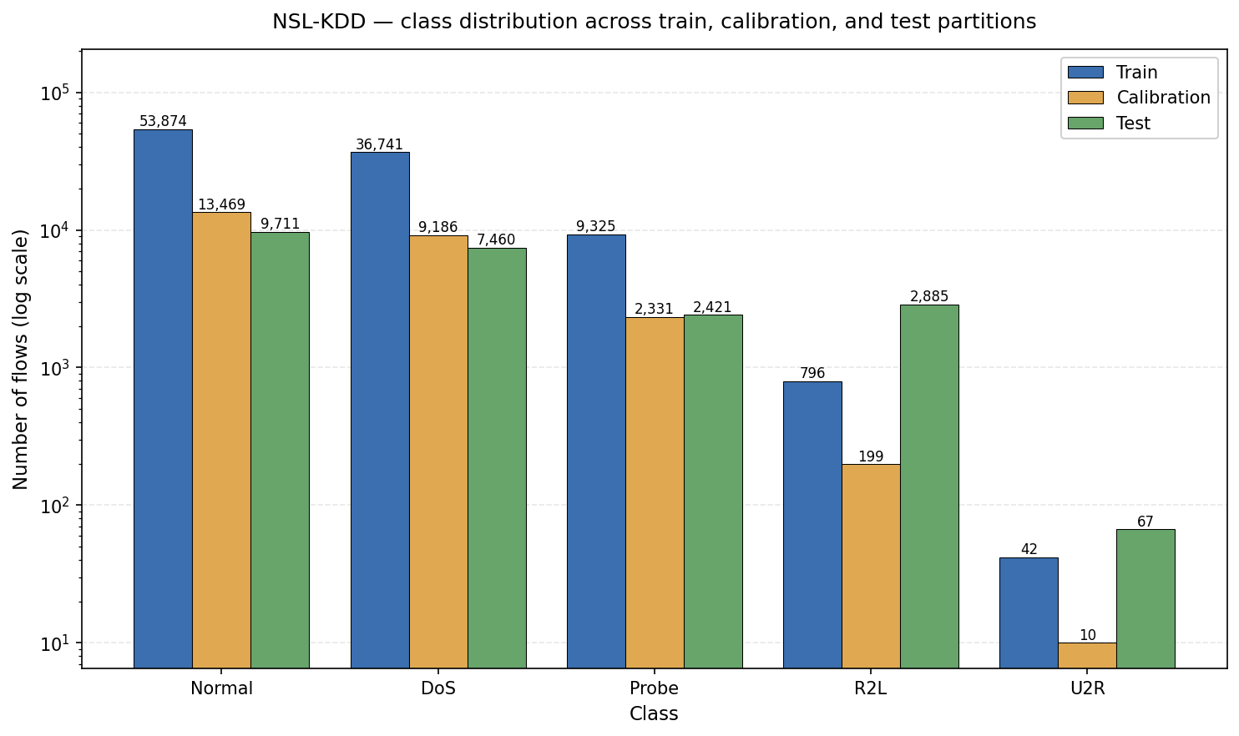
Figure 3.1 — NSL-KDD class distribution across train, calibration, and test partitions. Three bars per class on a log scale. Note the shift between training and test for R2L (0.79% to 12.80%) and U2R (0.04% to 0.30%), a known design feature of NSL-KDD.

3.3 UNSW-NB15 pipeline

3.3.1 Source and partition
I use UNSW-NB15 as distributed by Moustafa and Slay [5], specifically the version on Kaggle (mrwellsdavid/unsw-nb15) which provides the official train/test split of 175,341 and 82,332 flows. Some Kaggle mirrors have the train and test files swapped relative to the file names; I detect the correct file by row count rather than trusting the filename, which is a small but useful robustness check that surfaced as an audit catch during the preprocessing implementation.
After dropping the Generic class (justification covered in Module 1 §2.1), the UNSW data comprises 135,341 training flows and 63,461 test flows. I then carve a calibration set out of training in the same way as NSL: 20% held out, stratified by 5-class label, fixed seed 42. Final partition sizes are 108,272 train, 27,069 calibration, and 63,461 test.
Two minor preprocessing details deserve mention because they would otherwise cause silent bugs. The attack_cat column in UNSW occasionally contains stray whitespace in some Kaggle mirrors; I strip this before remapping. Some mirrors use the plural form 'Backdoors' instead of 'Backdoor'; I normalise both to the same target class (R2L). The class_mappings.json file documents both forms explicitly so that any future regeneration of the data produces the same labels regardless of which mirror is used.

3.3.2 Attack remapping
The 9 UNSW attack categories (after dropping Generic) plus Normal map to the 5-class taxonomy as follows:
Normal: Normal
DoS: DoS
Probe: Reconnaissance, Analysis
R2L: Exploits, Fuzzers, Backdoor (and Backdoors)
U2R: Shellcode, Worms
DROP: Generic
The semantic rationale for each mapping is in Module 1 §2.1. Briefly: Reconnaissance and Analysis are both information-gathering activities, which fits Probe. Exploits, Fuzzers, and Backdoor all involve remote-to-local payload delivery or unauthorised access, which fits R2L. Shellcode and Worms achieve code execution or privilege escalation in the victim's process space, which fits U2R. Generic does not fit any of the five categories cleanly, so it is excluded; the 10-class sensitivity analysis in Notebook 01b validates that this exclusion does not hide a performance difference a reviewer might raise.

3.3.3 Encoding and scaling
UNSW has three categorical features: proto (around 130 distinct values), service (around 13 distinct values), and state (around 11 distinct values). The proto column is by far the largest contributor to feature dimensionality after one-hot encoding. As with NSL, the encoder is fit on training categorical values only, then applied to test data via column reindexing against the training schema. Test-only categorical values would produce all-zero one-hot vectors.
Unlike NSL, the UNSW test set does contain a small number of OOV occurrences. The state column has two values that appear in test but not in training (ACC and CLO), affecting exactly 5 test rows. The proto and service columns have zero OOV. The total UNSW OOV impact is therefore 5 rows out of 63,461 test flows, which is small but not strictly zero. The OOV bookkeeping is preserved in data/processed/unsw_nb15_v2/oov_summary.json.
Before scaling, infinite values in numerical columns are converted to NaN and then NaN values are filled with 0.0. This handling differs from CIC, where inf-affected rows are dropped entirely (see §3.4.3). The UNSW approach preserves all 198,802 flows at the cost of replacing extreme values with zero in the affected cells, which is acceptable here because the inf values are concentrated in flow-rate features when flow duration is zero and the rows are otherwise informative.
The numerical features and the one-hot dummy columns are then combined into a single matrix, and StandardScaler is fit on the training rows of that combined matrix. The same fitted scaler is applied to calibration and test partitions without refitting. As with NSL, this means the one-hot dummies are also re-scaled by the fitted scaler rather than kept as raw 0/1 values. After encoding and scaling, the feature dimensionality is 194. The fitted scaler is saved as data/processed/unsw_nb15_v2/scaler.joblib.

3.3.4 Class distribution
Figure 3.2 shows the per-partition class distribution for UNSW-NB15. The training and test distributions are similar in shape but not identical in proportion. Normal is 41.38% of training and 58.30% of test. R2L is 39.40% of training and 28.01% of test. The two largest classes account for over 80% of each partition, but the test set leans more heavily towards Normal than training does. DoS is 9.06% of training and 6.44% of test; Probe is 9.23% and 6.58%; U2R is 0.93% and 0.66%. The U2R class is small but not catastrophically small: 1,010 training flows and 422 test flows is well above the threshold below which calibration becomes unreliable.
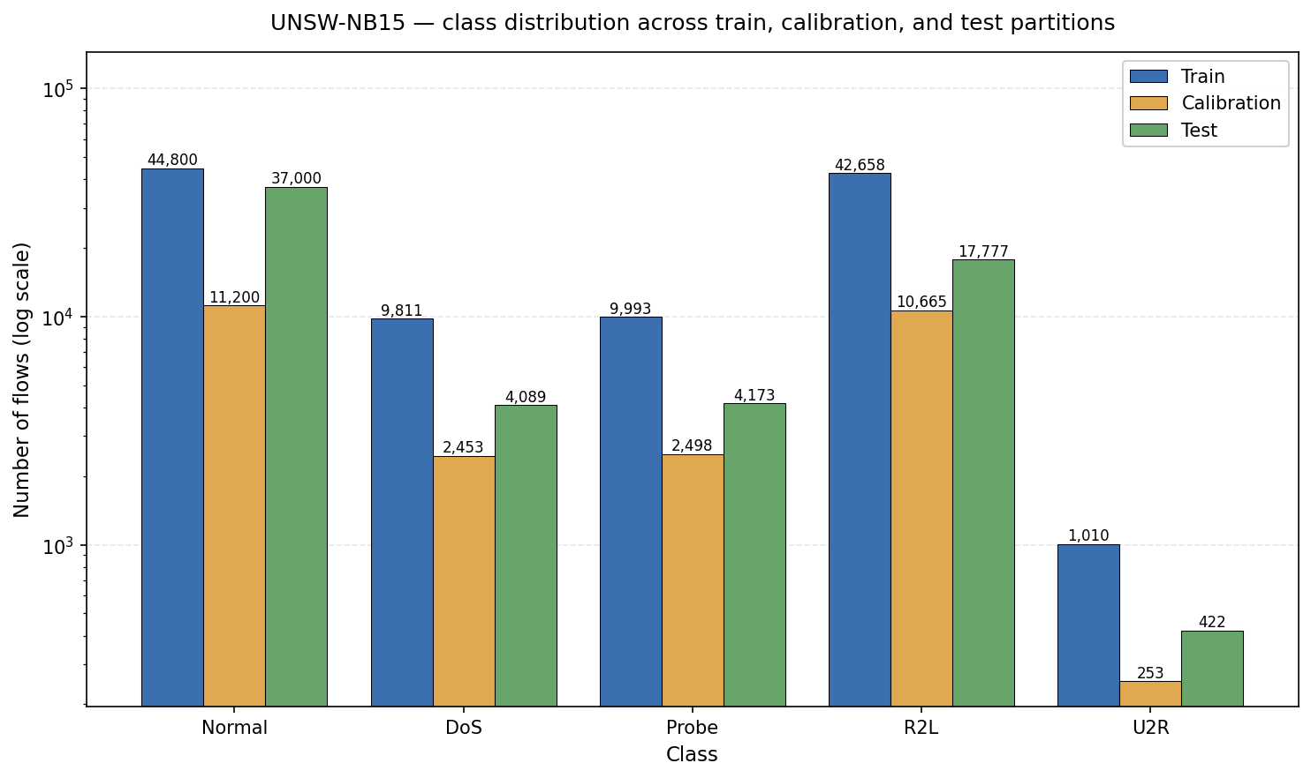
Figure 3.2 — UNSW-NB15 class distribution across train, calibration, and test partitions (post-Generic-drop). Three bars per class on a log scale. Training and test proportions are similar in shape but not identical.

3.4 CIC-IDS2017 pipeline

3.4.1 Source and partition
I use the original CIC-IDS2017 release from Sharafaldin et al. [6]. As covered in Module 1 §2.1, applying the Engelen WTMC-2021 corrections [7] is documented as future work. CIC-IDS2017 ships as eight CSV files covering five days of captured traffic, totalling roughly 2.8 million flows after removing flows with missing or NaN values.
CIC-IDS2017 has no official train/test partition. I create one. To keep the dataset size tractable for repeated bootstrap analysis (B=1000 across multiple claims, applied to test data, in §6), I draw a stratified subsample of 200,031 flows from the full 2.8 million. The stratification is by 5-class label, so each class is sampled at its original proportion. The subsample is then split into train/calibration/test in 60/20/20 proportions using stratified random sampling, again by 5-class label, with the same fixed seed (42). Final sizes are 120,018 train, 40,006 calibration, and 40,007 test. All three partitions therefore have identical class proportions by construction.
The 200K subsample size is a compromise between two pressures. Larger subsamples give tighter bootstrap confidence intervals but push model-training time, SHAP computation time, and memory use. Smaller subsamples lose statistical power on rare classes. At 200K the U2R class contains only 36 flows total across the subsample (22 train, 7 calibration, 7 test). This is below the threshold where reliable calibration can be done on U2R-specific probabilities, and I treat CIC U2R as a calibration-cliff case study rather than as a reliable calibration target. The implications for the calibration health flag are covered in §4.7 and §6.6.

3.4.2 Attack remapping
The 14 CIC attack categories plus BENIGN map to the 5-class taxonomy as follows. The semantic rationale for each mapping was covered in Module 1 §2.1.
Normal: BENIGN
DoS: DoS Hulk, DoS GoldenEye, DoS slowloris, DoS Slowhttptest, DDoS, Heartbleed
Probe: PortScan
R2L: FTP-Patator, SSH-Patator, Web Attack - Brute Force, Web Attack - XSS, Web Attack - Sql Injection, Bot
U2R: Infiltration
Heartbleed is mapped to DoS rather than R2L because the network-flow signature of Heartbleed in CIC is repeated malformed heartbeat requests, which is closer to a DoS variant than to a remote-to-local intrusion. The mapping has very little aggregate effect either way, because Heartbleed is extremely rare in CIC (the original release has only 11 Heartbleed flows total). Bot is mapped to R2L because botnet command-and-control communication is a form of remote command issuance, more analogous to R2L behaviour than to root-escalation. Infiltration is the only CIC category in U2R; it covers an attacker who has established persistent access and is conducting attacker-controlled internal activity, which is U2R semantically even though the attack vector is different from NSL's classic U2R subtypes.

3.4.3 Encoding and scaling
CIC-IDS2017 has no categorical features. All features in its 80-column schema are numerical (packet counts, byte counts, flow durations, inter-arrival time statistics, flag counts, and so on). The only columns removed before training are the two label columns: Label (the original binary label) and Category (the 5-class label after my remapping from §3.4.2). Everything else is kept as a numerical feature. This leaves 78 feature columns. The 80→78 reduction is therefore label-only and does not involve dropping any identifiers, timestamps, or auxiliary columns.
Before training, CIC's numerical features need cleaning. Some flow-rate features can be infinite when flow duration is zero (the rate formula divides by duration). My CIC pipeline handles this by converting infinite values to NaN and then dropping any row that contains a NaN. This is different from UNSW, which fills NaN with zero rather than dropping rows. The CIC choice is more conservative and is appropriate here because the affected rows are a tiny fraction of the full dataset and removing them does not bias the class distribution materially. The row-drop is applied to the full CIC pool of around 2.8 million flows before the stratified subsampling step in §3.4.1, so the 200K subsample is drawn from the post-cleaning pool.
StandardScaler is then fit on the training rows of the 78-feature matrix and applied without refitting to the calibration and test partitions. Since CIC has no one-hot dummies, the question of scaling-binary-columns that arose for NSL and UNSW does not arise here. The fitted scaler is saved as data/processed/cic_ids2017_v2/scaler.pkl. The v2 pipeline integrity fix M1 (encoder fit on train only) is therefore not applicable to CIC; only M6 (calibrator fit on training, not test) applies. This is documented in split_methodology.json.

3.4.4 Class distribution
Figure 3.3 shows the per-partition class distribution for CIC-IDS2017. CIC has the most extreme class imbalance of the three datasets, and the imbalance is severe on both ends. At one end, Normal dominates: 80.37% of every partition. At the other end, U2R is critically rare with 22 training, 7 calibration, and 7 test flows. R2L is also small at 671 training, 223 calibration, and 223 test flows. The training and test distributions are identical by construction, since the partitions are stratified random samples from the same 200K subsample. The 22-train / 7-calibration U2R cell drives calibrator selection in §4.2 (Platt scaling rather than isotonic regression, because of the calibration sample count) and is the most acute calibration-cliff case in the project.
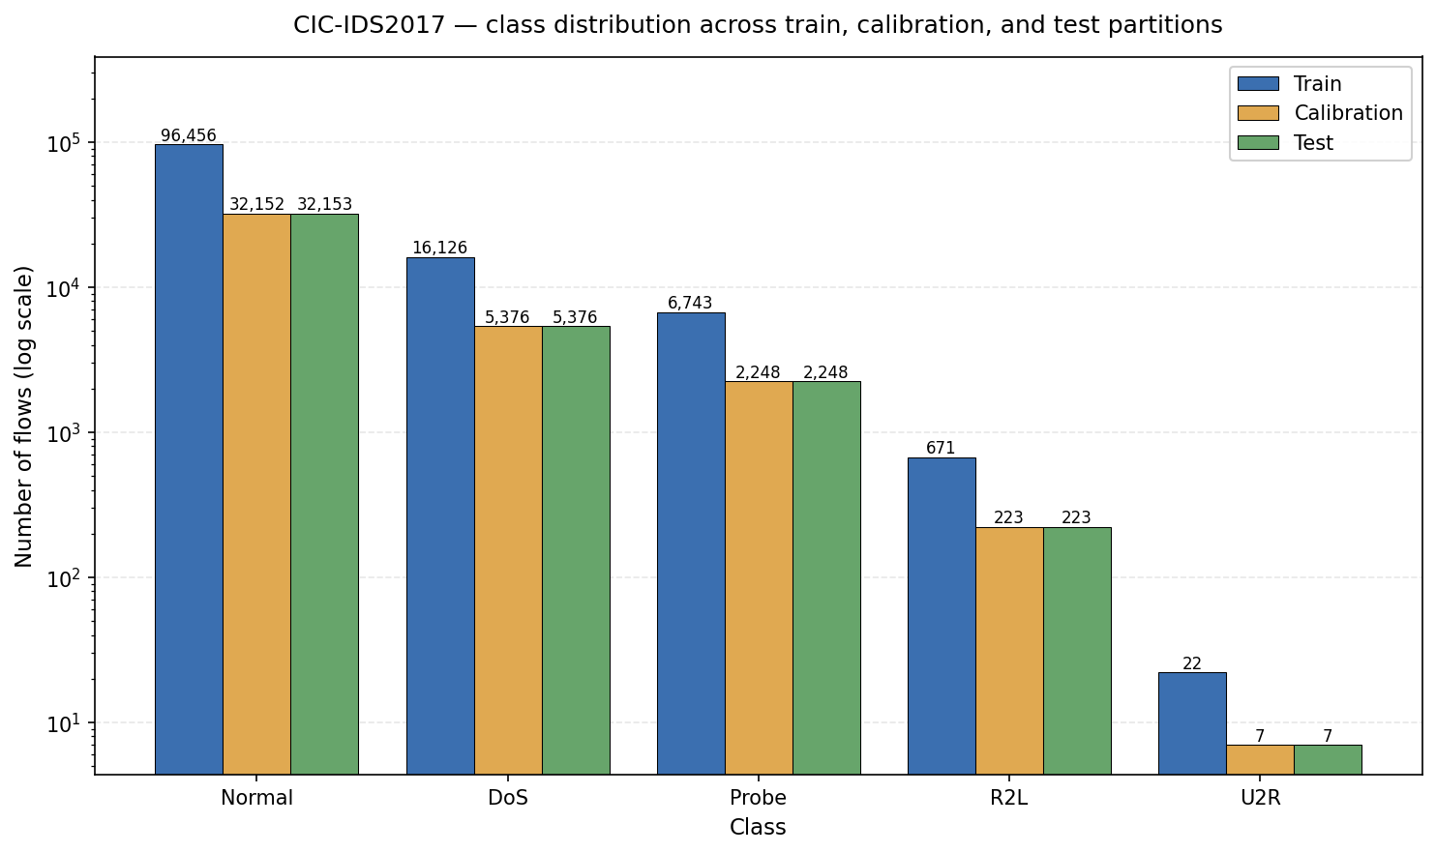
Figure 3.3 — CIC-IDS2017 class distribution across train, calibration, and test partitions on the stratified 200K-flow subsample. Three bars per class on a log scale. All three partitions share identical class proportions by construction (60/20/20 stratified split).

3.5 Cross-dataset comparison
Three datasets, three different partition designs, three different feature dimensionalities, three different class-imbalance profiles. This is a deliberate choice. The empirical claims in §6 are stronger if they hold across this kind of heterogeneity than if they held only on one or two similar datasets.
 | NSL-KDD | UNSW-NB15 | CIC-IDS2017
Native partition | Official (KDD) | Official (Moustafa) | None (created)
Partition design | Distribution-shift test | Similar (not identical) proportions | 60/20/20 stratified subsample
Train size | 100,778 | 108,272 | 120,018
Calibration size | 25,195 | 27,069 | 40,006
Test size | 22,544 | 63,461 | 40,007
Feature dimensionality | 122 | 194 | 78
Categorical features | protocol_type, service, flag | proto, service, state | none

Three things are worth noting from the comparison. First, the test sets vary by a factor of three in size (22K on NSL, 63K on UNSW, 40K on CIC). This affects the width of bootstrap confidence intervals in §6: NSL CIs are wider than UNSW CIs purely because the test set is smaller, independent of any underlying signal. Second, the calibration sets are large in absolute terms but uneven across classes (UNSW R2L calibration is 10,665 flows, while CIC U2R calibration is 7 flows). Per-class calibration quality is therefore very different across cells, which is the structural reason behind the hybrid calibrator choice in §4.2 and the calibration support signal in §4.7. Third, the feature spaces are not comparable across datasets. CIC has flow-aggregate features that NSL and UNSW lack; NSL has service-type one-hot dummies that CIC does not have; UNSW has the largest categorical encoding burden. Cross-dataset SHAP comparisons are therefore comparisons of model behaviour on dataset-specific feature spaces, not comparisons of which features matter universally. This is a real limitation, and I document it explicitly in §9.

— End of Module 2 Part A (§3 only) —
Module 2 Part B will cover §4 Methodology, including SCTS-v2 equations, the three-signal health flag specification, model hyperparameter tables, the adversarial perturbation protocol, Mondrian conformal threshold setting, the Krishna RC computation, and the bootstrap protocol.

