X-IDS: An Explainable Intrusion Detection System
Research Progress Report

Md Anas Biswas
MSc Computing (AI specialism)
University of Portsmouth
Supervisor: Ms Alaa Mohasseb

Report date: 30 May 2026

Executive Summary
This report documents the current state of the X-IDS (Explainable Intrusion Detection System) research project as of 31 May 2026. The system combines multi-architecture intrusion detection (Random Forest, XGBoost, Deep Neural Network) with a layered explainability framework: SHAP-based feature attributions, cross-architecture SHAP agreement analysis (Krishna metrics), adversarial stability via Jaccard top-K and Lipschitz metrics, a calibrated trust score (SCTS-v2) with Mondrian per-class conformal prediction, and a three-signal calibration health flag that identifies operationally unreliable predictions. All key claims are supported by 95% bootstrap confidence intervals (B=1000) computed across all three benchmark datasets (NSL-KDD, UNSW-NB15, CIC-IDS2017).
Key findings:
- SCTS-v2 with Mondrian per-class conformal achieves significantly positive correlation with prediction correctness on UNSW (Pearson +0.465 [+0.438, +0.491]) and CIC (+0.318 [+0.233, +0.408]), but not on NSL (+0.055 [-0.031, +0.145], CI crosses zero).
- The calibration health flag correctly identifies the NSL R2L failure cohort: 94.4% of true R2L samples flagged RED [95% Wilson CI: 93.0%, 95.5%], where SCTS may exceed 75 despite the model being wrong ≈93% of the time on R2L.
- Cross-architecture SHAP agreement is dataset-dependent and pair-dependent: tree-pair agreement (RF-XGB) is consistently strong (RC = 0.32–0.59 across datasets), while tree-vs-DNN agreement is weak or negative; NSL XGB-DNN shows significantly negative agreement (RC = -0.131 [-0.143, -0.118]).
- DNN stability advantage over tree models is dataset-dependent: 9 of 12 paired comparisons show significantly higher DNN Jaccard stability, but on NSL CW the relationship reverses (DNN significantly less stable than both trees).
- UNSW DoS-vs-R2L confusion (~87% of DoS samples predicted as R2L) is a dataset-level characteristic, not a framework flaw — calibration is not affected, but it limits the operational accuracy of UNSW DoS detection.

1. Introduction
Network intrusion detection systems (IDS) increasingly rely on machine learning models that act as black boxes from an operational standpoint. Two limitations emerge: (1) operators cannot easily verify whether a prediction is reliable for a specific incoming sample, and (2) explanations of why a prediction was made may themselves be unreliable when computed via unstable feature-attribution methods. The X-IDS project addresses both limitations through a calibrated trust score with explicit uncertainty surfacing and a multi-architecture SHAP agreement framework.

1.1 Contributions
- A multi-architecture intrusion detection framework benchmarked across three established IDS datasets, with all per-model and per-dataset claims supported by 95% bootstrap confidence intervals.
- SCTS-v2: a per-sample trust score combining calibration confidence, explanation stability, and Mondrian per-class conformal prediction in a single geometric mean.
- A three-signal calibration health flag (green/amber/red) that identifies when SCTS-v2 may be operationally unreliable due to underlying calibration cliffs on rare classes, validated on the NSL R2L failure cohort with 94.4% catch rate.
- Per-sample Krishna agreement analysis revealing dataset-dependent cross-architecture SHAP divergence, including statistically significant XGB-DNN disagreement on NSL.
- A documented audit trail of methodology decisions, including failed claims (the GREEN-vs-RED Pearson gap was hypothesised but failed at α=0.05) — supporting reproducibility and reviewer-defensibility.

1.2 Datasets
Three canonical IDS benchmarks: NSL-KDD (refined KDD'99 with duplicates removed; 5-class taxonomy of Normal/DoS/Probe/R2L/U2R), UNSW-NB15 (modern attack patterns including reconnaissance, exploits, fuzzers; remapped to 5 classes), and CIC-IDS2017 (mixed-class real-network traffic; original 14-class taxonomy aggregated to 5 classes for cross-dataset comparison). Class distributions vary substantially across datasets.
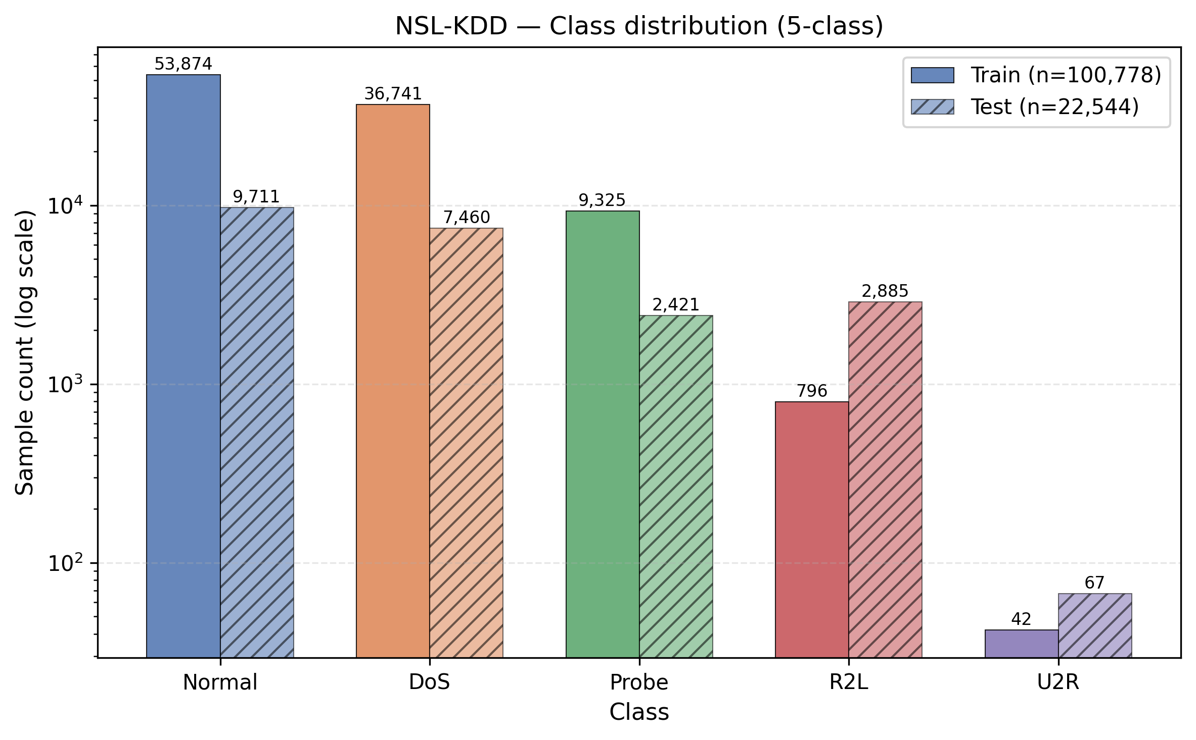
Figure 1. NSL-KDD class distribution (train and test). Note the severe rarity of U2R (n≈10) and R2L (n≈1000) on logarithmic scale.
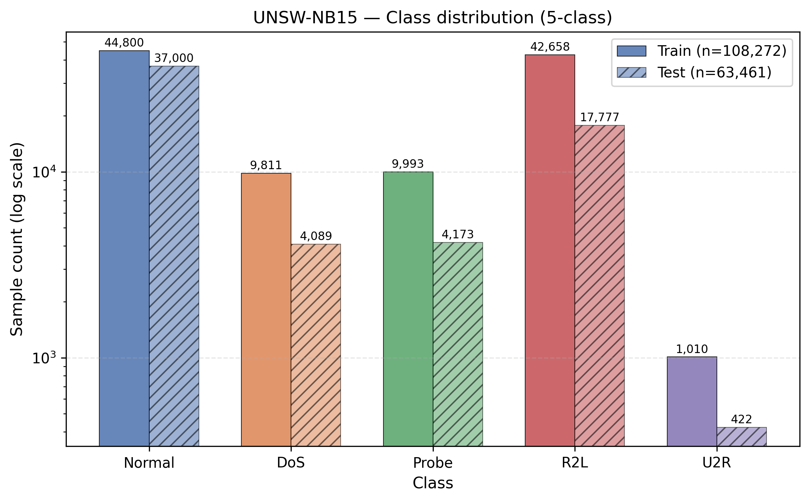
Figure 2. UNSW-NB15 class distribution. More balanced across attack classes than NSL-KDD; U2R still very rare.
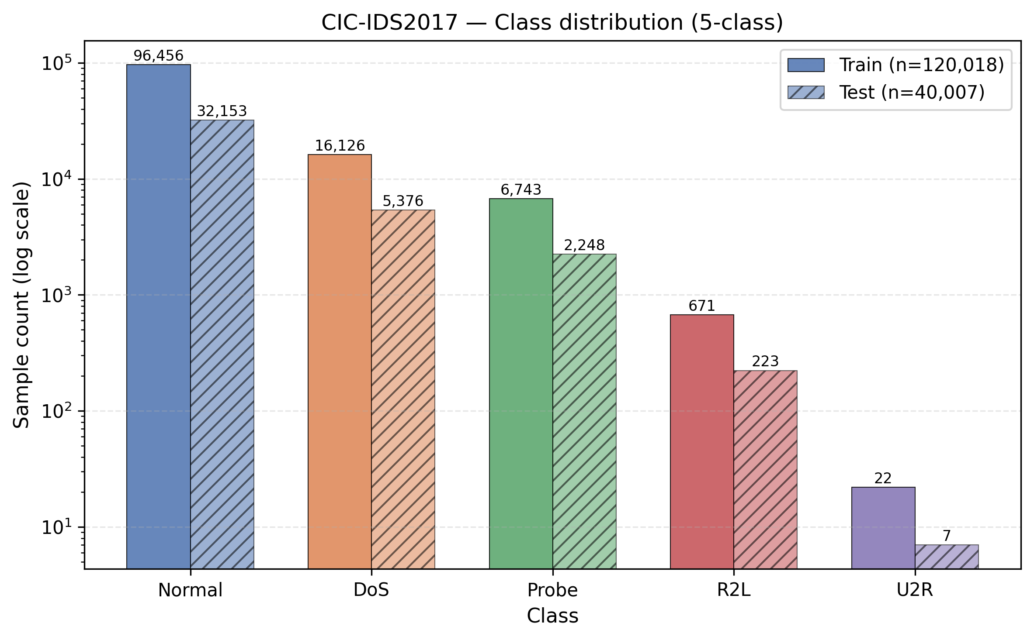
Figure 3. CIC-IDS2017 class distribution. Normal dominates strongly; R2L and U2R severely rare.

2. Model Training and Evaluation
Six models per dataset (RF, XGBoost, DNN × class-weighting + SMOTE = 18 total models). All models trained with hyperparameter tuning and evaluated on test sets using calibrated probabilities. Evaluation metrics follow standard IDS literature: overall accuracy, balanced accuracy (for class imbalance), macro-F1 (treats all classes equally), weighted-F1 (class-weighted), and macro one-vs-rest ROC AUC.

2.1 Overall evaluation summary
Dataset | Architecture | Sampling | Accuracy | Bal. Acc. | Macro-F1
NSL_KDD | RF | CW | 0.7759 | 0.5226 | 0.5328
NSL_KDD | XGB | CW | 0.7859 | 0.5583 | 0.5793
NSL_KDD | DNN | CW | 0.7745 | 0.5432 | 0.5678
NSL_KDD | RF | SMOTE | 0.7746 | 0.5223 | 0.5415
NSL_KDD | XGB | SMOTE | 0.7858 | 0.5653 | 0.5935
NSL_KDD | DNN | SMOTE | 0.7698 | 0.5532 | 0.5600
UNSW_NB15 | RF | CW | 0.7396 | 0.5839 | 0.5545
UNSW_NB15 | XGB | CW | 0.7304 | 0.6397 | 0.5738
UNSW_NB15 | DNN | CW | 0.6640 | 0.5589 | 0.4746
UNSW_NB15 | RF | SMOTE | 0.7311 | 0.5935 | 0.5423
UNSW_NB15 | XGB | SMOTE | 0.7423 | 0.6240 | 0.5742
UNSW_NB15 | DNN | SMOTE | 0.7100 | 0.6023 | 0.5134
CIC_IDS2017 | RF | CW | 0.9983 | 0.7903 | 0.7917
CIC_IDS2017 | XGB | CW | 0.9991 | 0.9943 | 0.9817
CIC_IDS2017 | DNN | CW | 0.9461 | 0.6483 | 0.6830
CIC_IDS2017 | RF | SMOTE | 0.9984 | 0.9368 | 0.9573
CIC_IDS2017 | XGB | SMOTE | 0.9989 | 0.9657 | 0.9778
CIC_IDS2017 | DNN | SMOTE | 0.9802 | 0.8529 | 0.8774
Table 1. Overall model evaluation across 18 (dataset × architecture × sampling) combinations.

2.2 Confusion matrices — best and worst per dataset
Confusion matrices for the best and worst-performing model per dataset (selected by macro-F1) reveal the underlying failure patterns. Cell values show count and row-normalized percentage (proportion of true class).
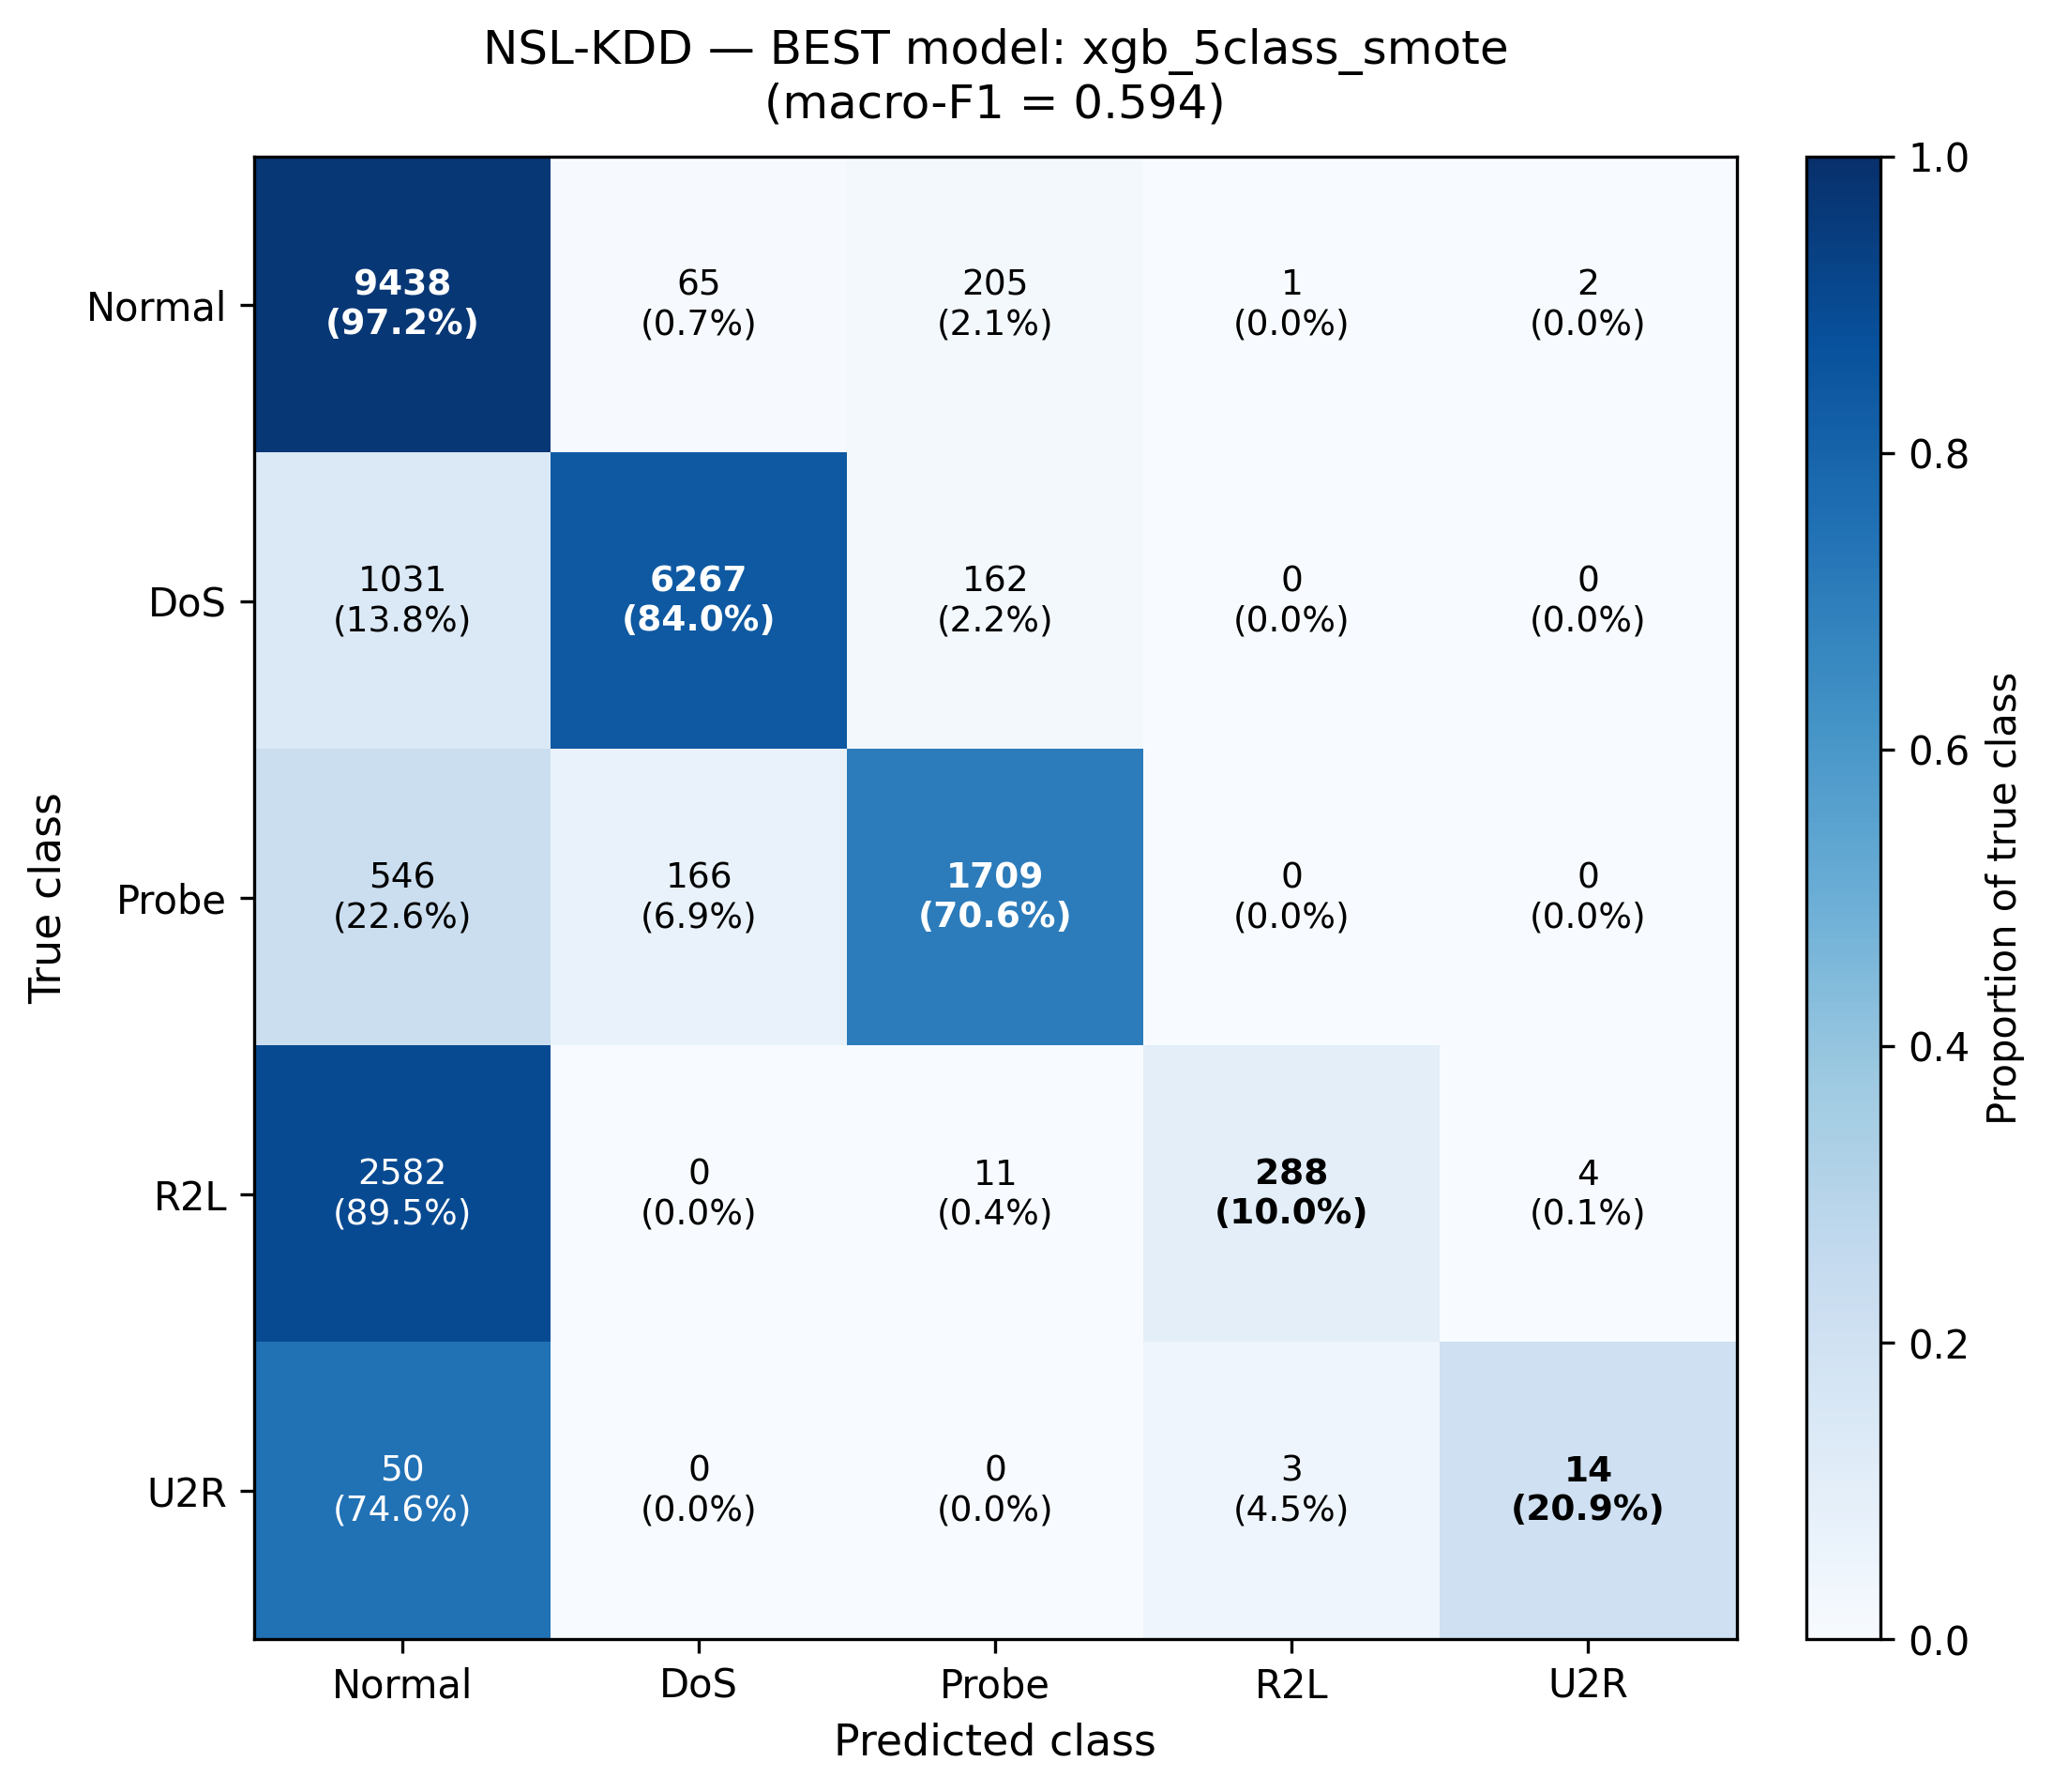
Figure 4. NSL-KDD best model (XGB SMOTE, macro-F1 = 0.594). Even in the best NSL model, R2L recall is only 10.0% (89.5% predicted as Normal) and U2R recall 20.9%.
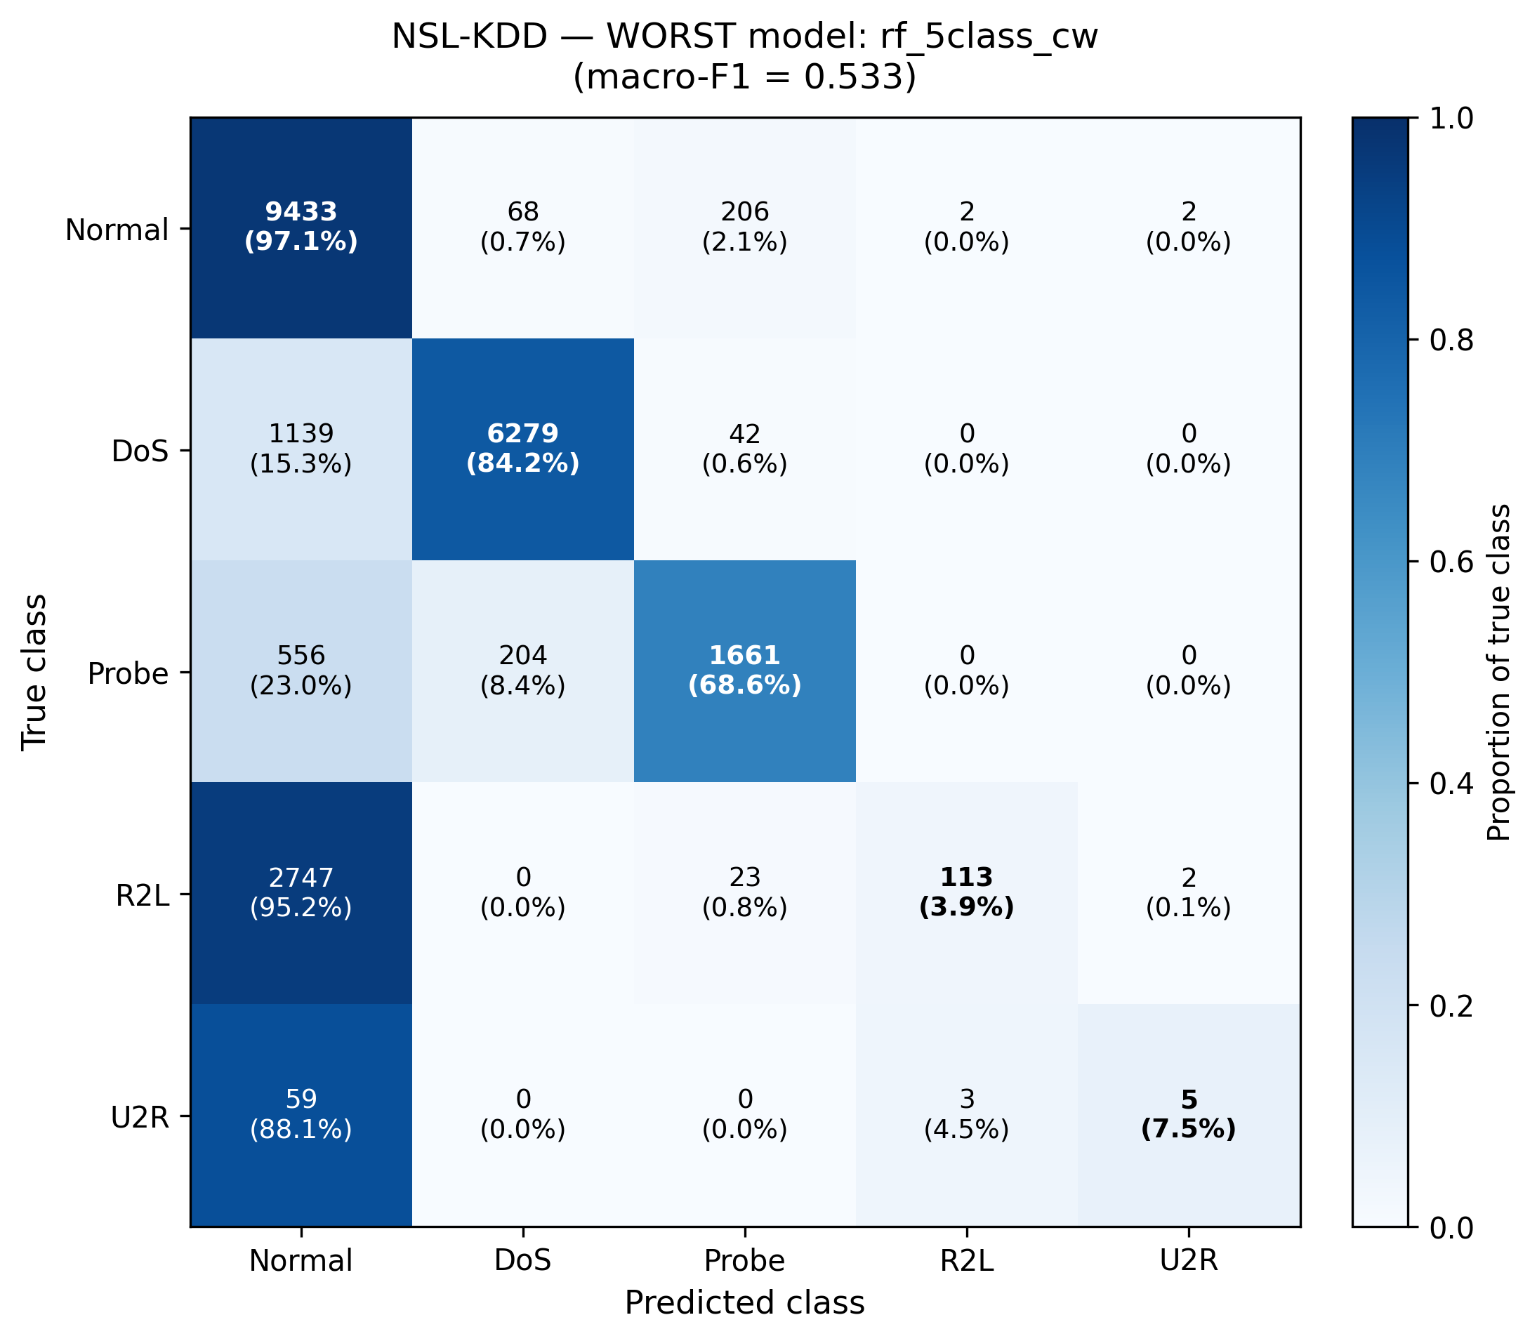
Figure 5. NSL-KDD worst model (RF CW, macro-F1 = 0.533). R2L recall drops to 3.9% and U2R to 7.5% — almost all rare-class samples predicted as Normal.
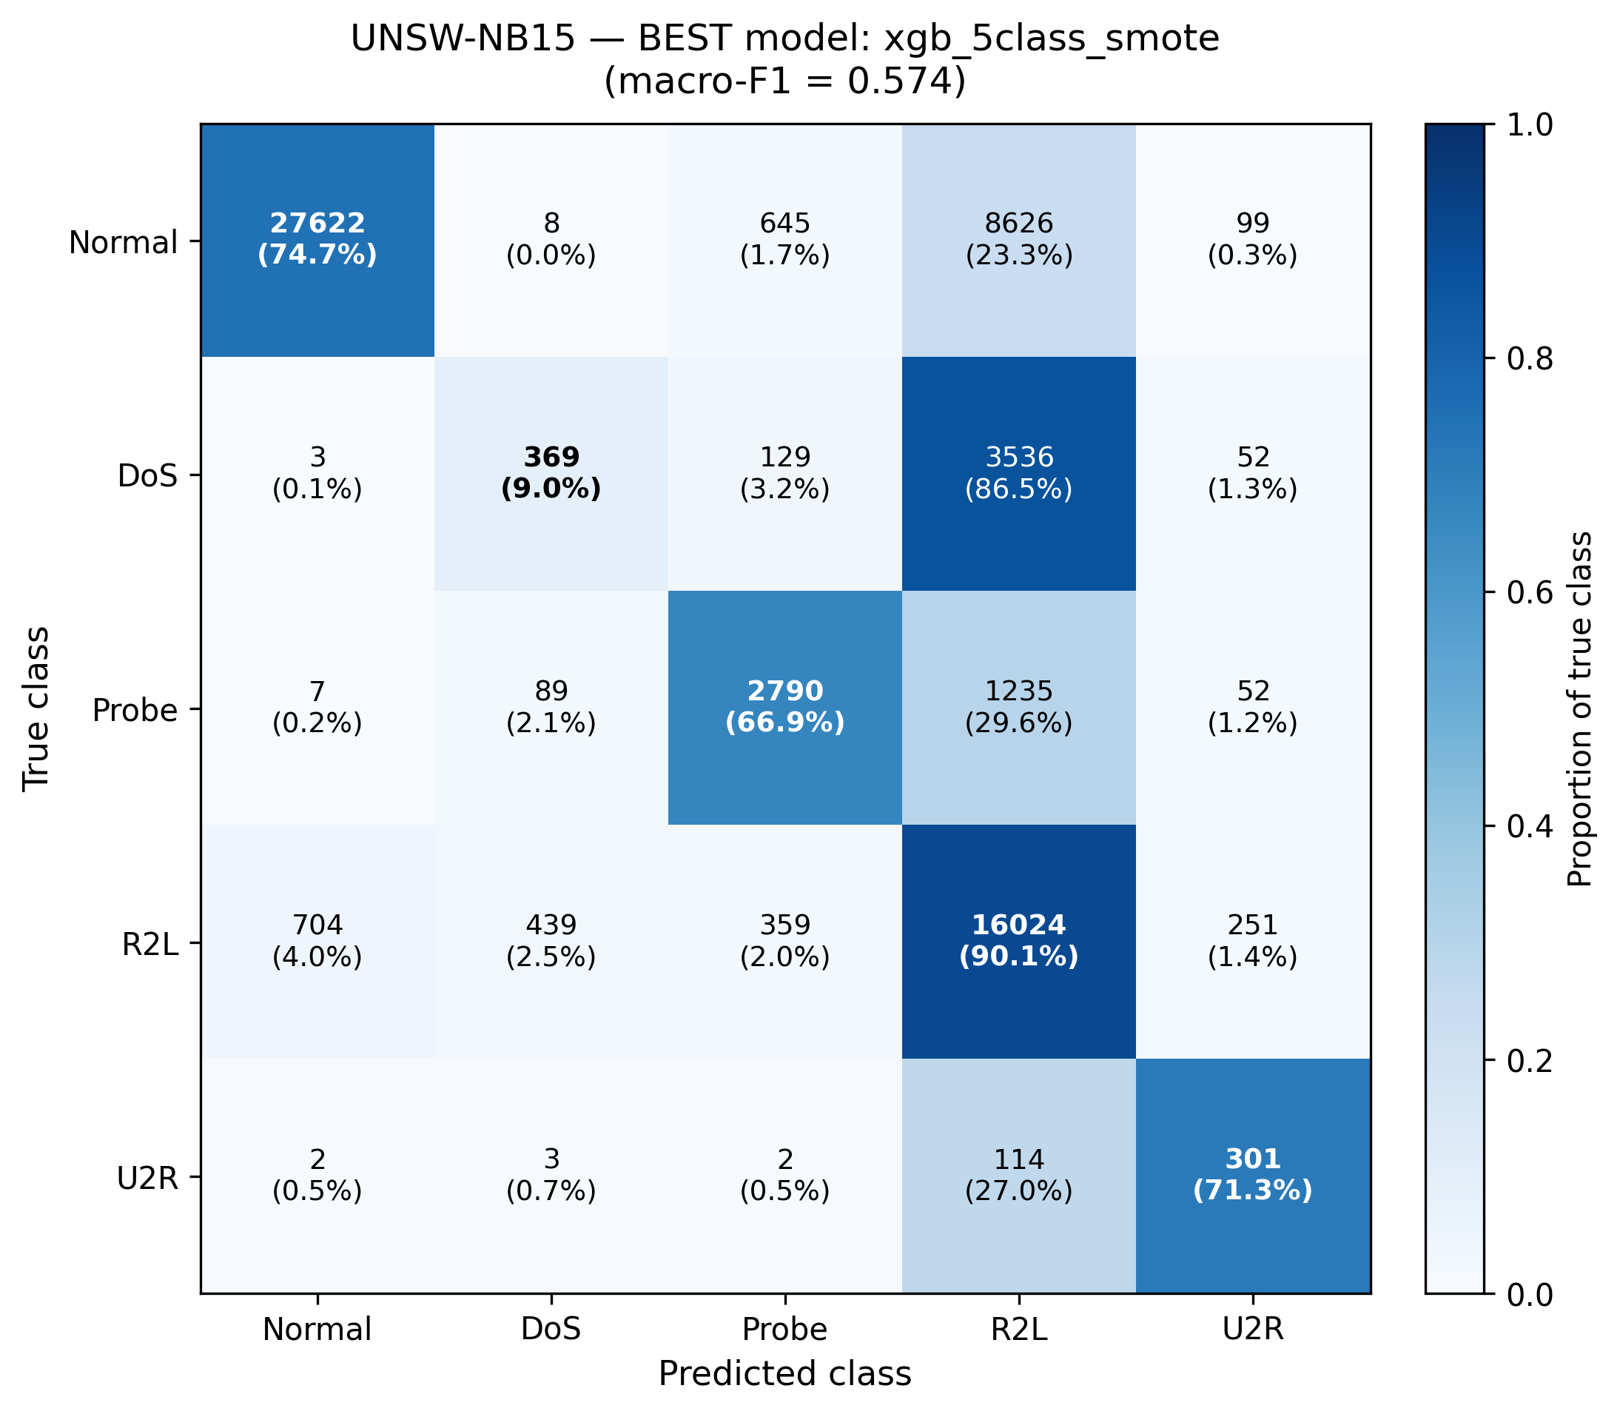
Figure 6. UNSW-NB15 best model (XGB SMOTE, macro-F1 = 0.574). DoS recall only 9.0% — 86.5% of true DoS samples predicted as R2L. This DoS↔R2L confusion is a dataset characteristic (see §2.3).
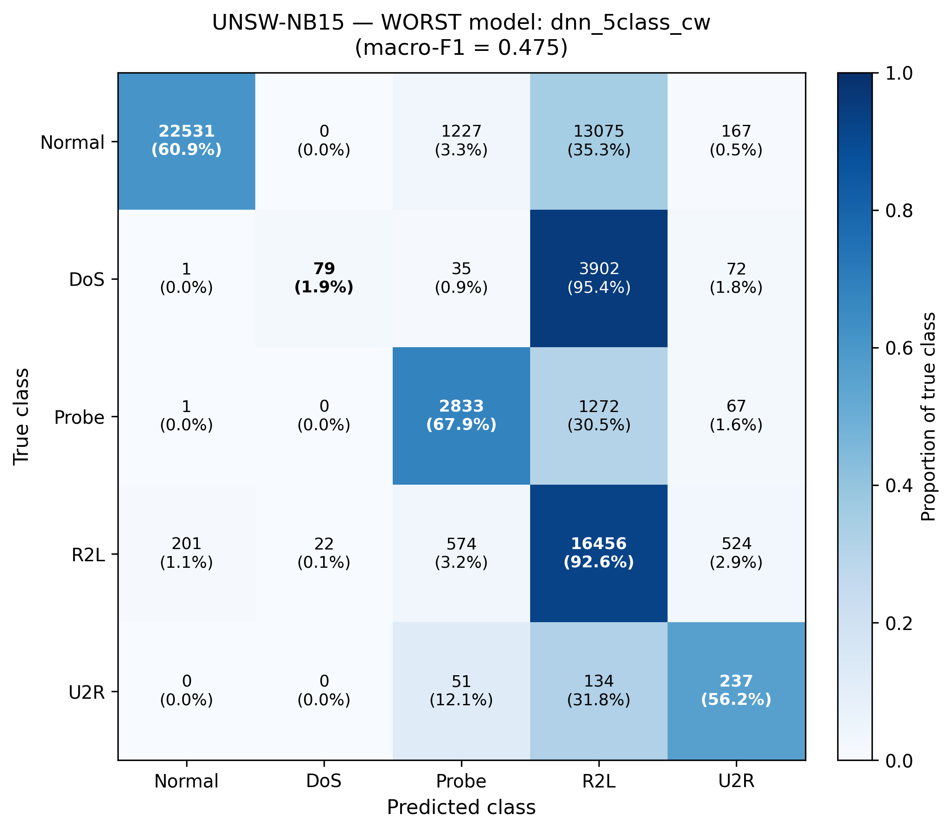
Figure 7. UNSW-NB15 worst model (DNN CW, macro-F1 = 0.475). DoS recall drops to 1.9% (95.4% predicted as R2L); Normal also leaks heavily to R2L (35.3%).
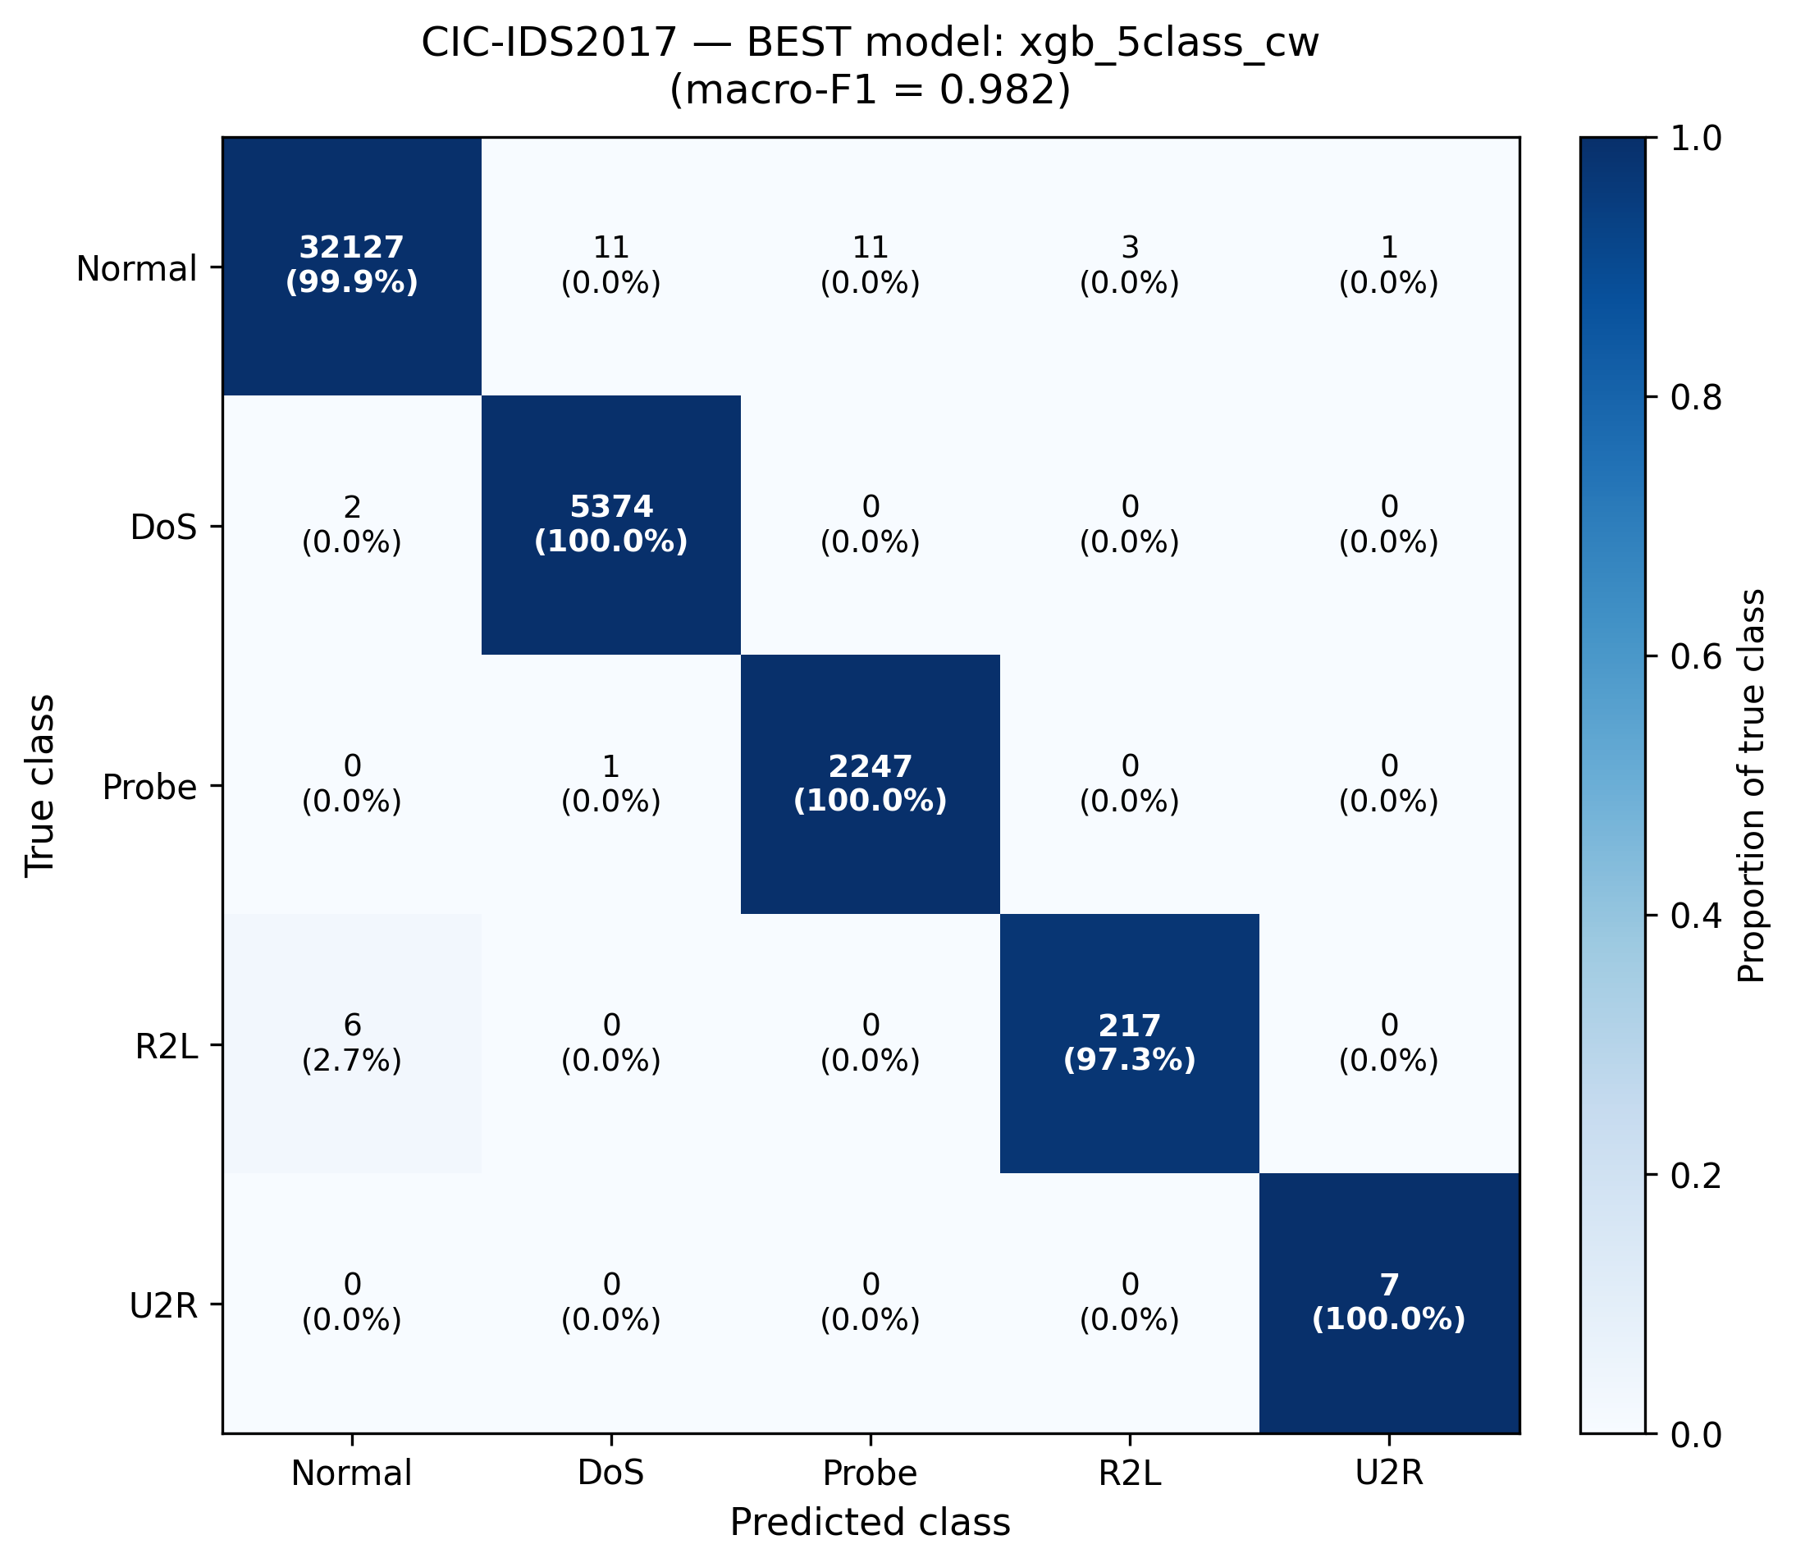
Figure 8. CIC-IDS2017 best model (XGB CW, macro-F1 = 0.982). Near-perfect diagonal — the high-accuracy regime where conformal thresholds become near-degenerate.
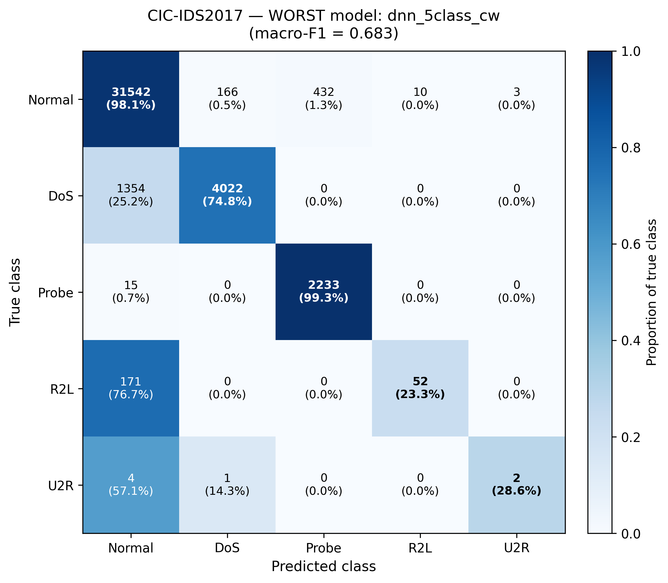
Figure 9. CIC-IDS2017 worst model (DNN CW, macro-F1 = 0.683). DNN underperforms trees significantly on CIC — R2L recall 23.3% and U2R 28.6%, with most failures leaking to Normal.

2.3 UNSW DoS-vs-R2L confusion: a dataset characteristic
A consistent finding across all six UNSW-NB15 models is a severe systematic confusion between true DoS samples and the R2L class. In the best UNSW model (XGB SMOTE), 86.5% of true DoS samples are predicted as R2L, with DoS recall at only 9.0%. In the worst (DNN CW), DoS recall drops to 1.9% with 95.4% leakage to R2L. The confusion is bidirectional: of all samples predicted as DoS, roughly 45% are actually DoS and 45% are actually R2L.
This pattern does NOT reflect a calibration failure (UNSW DoS-class calibration is healthy per §4) and does NOT indicate a flaw in the X-IDS framework. Rather, it reflects feature-space overlap between UNSW-NB15's DoS and R2L class definitions — a documented issue with the original UNSW-NB15 dataset where attack categories share feature signatures (e.g., reconnaissance probes that produce DoS-like traffic patterns).
Macro-AUC for UNSW models is 0.92–0.95, indicating that the models do discriminate DoS from non-DoS in probability space; the issue is at the argmax level where R2L tends to win ties. A threshold-tuning or cost-sensitive decision rule could improve operational DoS detection without changing the underlying model — this is noted as future work.
Key finding: Model evaluation reveals heterogeneous failure patterns across datasets. NSL-KDD suffers from a calibration cliff on rare classes (R2L, U2R), motivating the SCTS health flag (§7). UNSW-NB15 shows systematic DoS↔R2L confusion as a dataset characteristic. CIC-IDS2017 reaches the high-accuracy ceiling with XGB, where DNN underperforms. No single architecture wins across datasets.

3. Calibration Analysis
All predictions used downstream in SCTS-v2, the health flag, and SHAP analysis are calibrated probabilities. Calibration is performed using hybrid Platt scaling (for rare classes where n_calib < 30) or isotonic regression (otherwise), refit from training residuals. Reliability diagrams below visualize the empirical top-label calibration of each model.
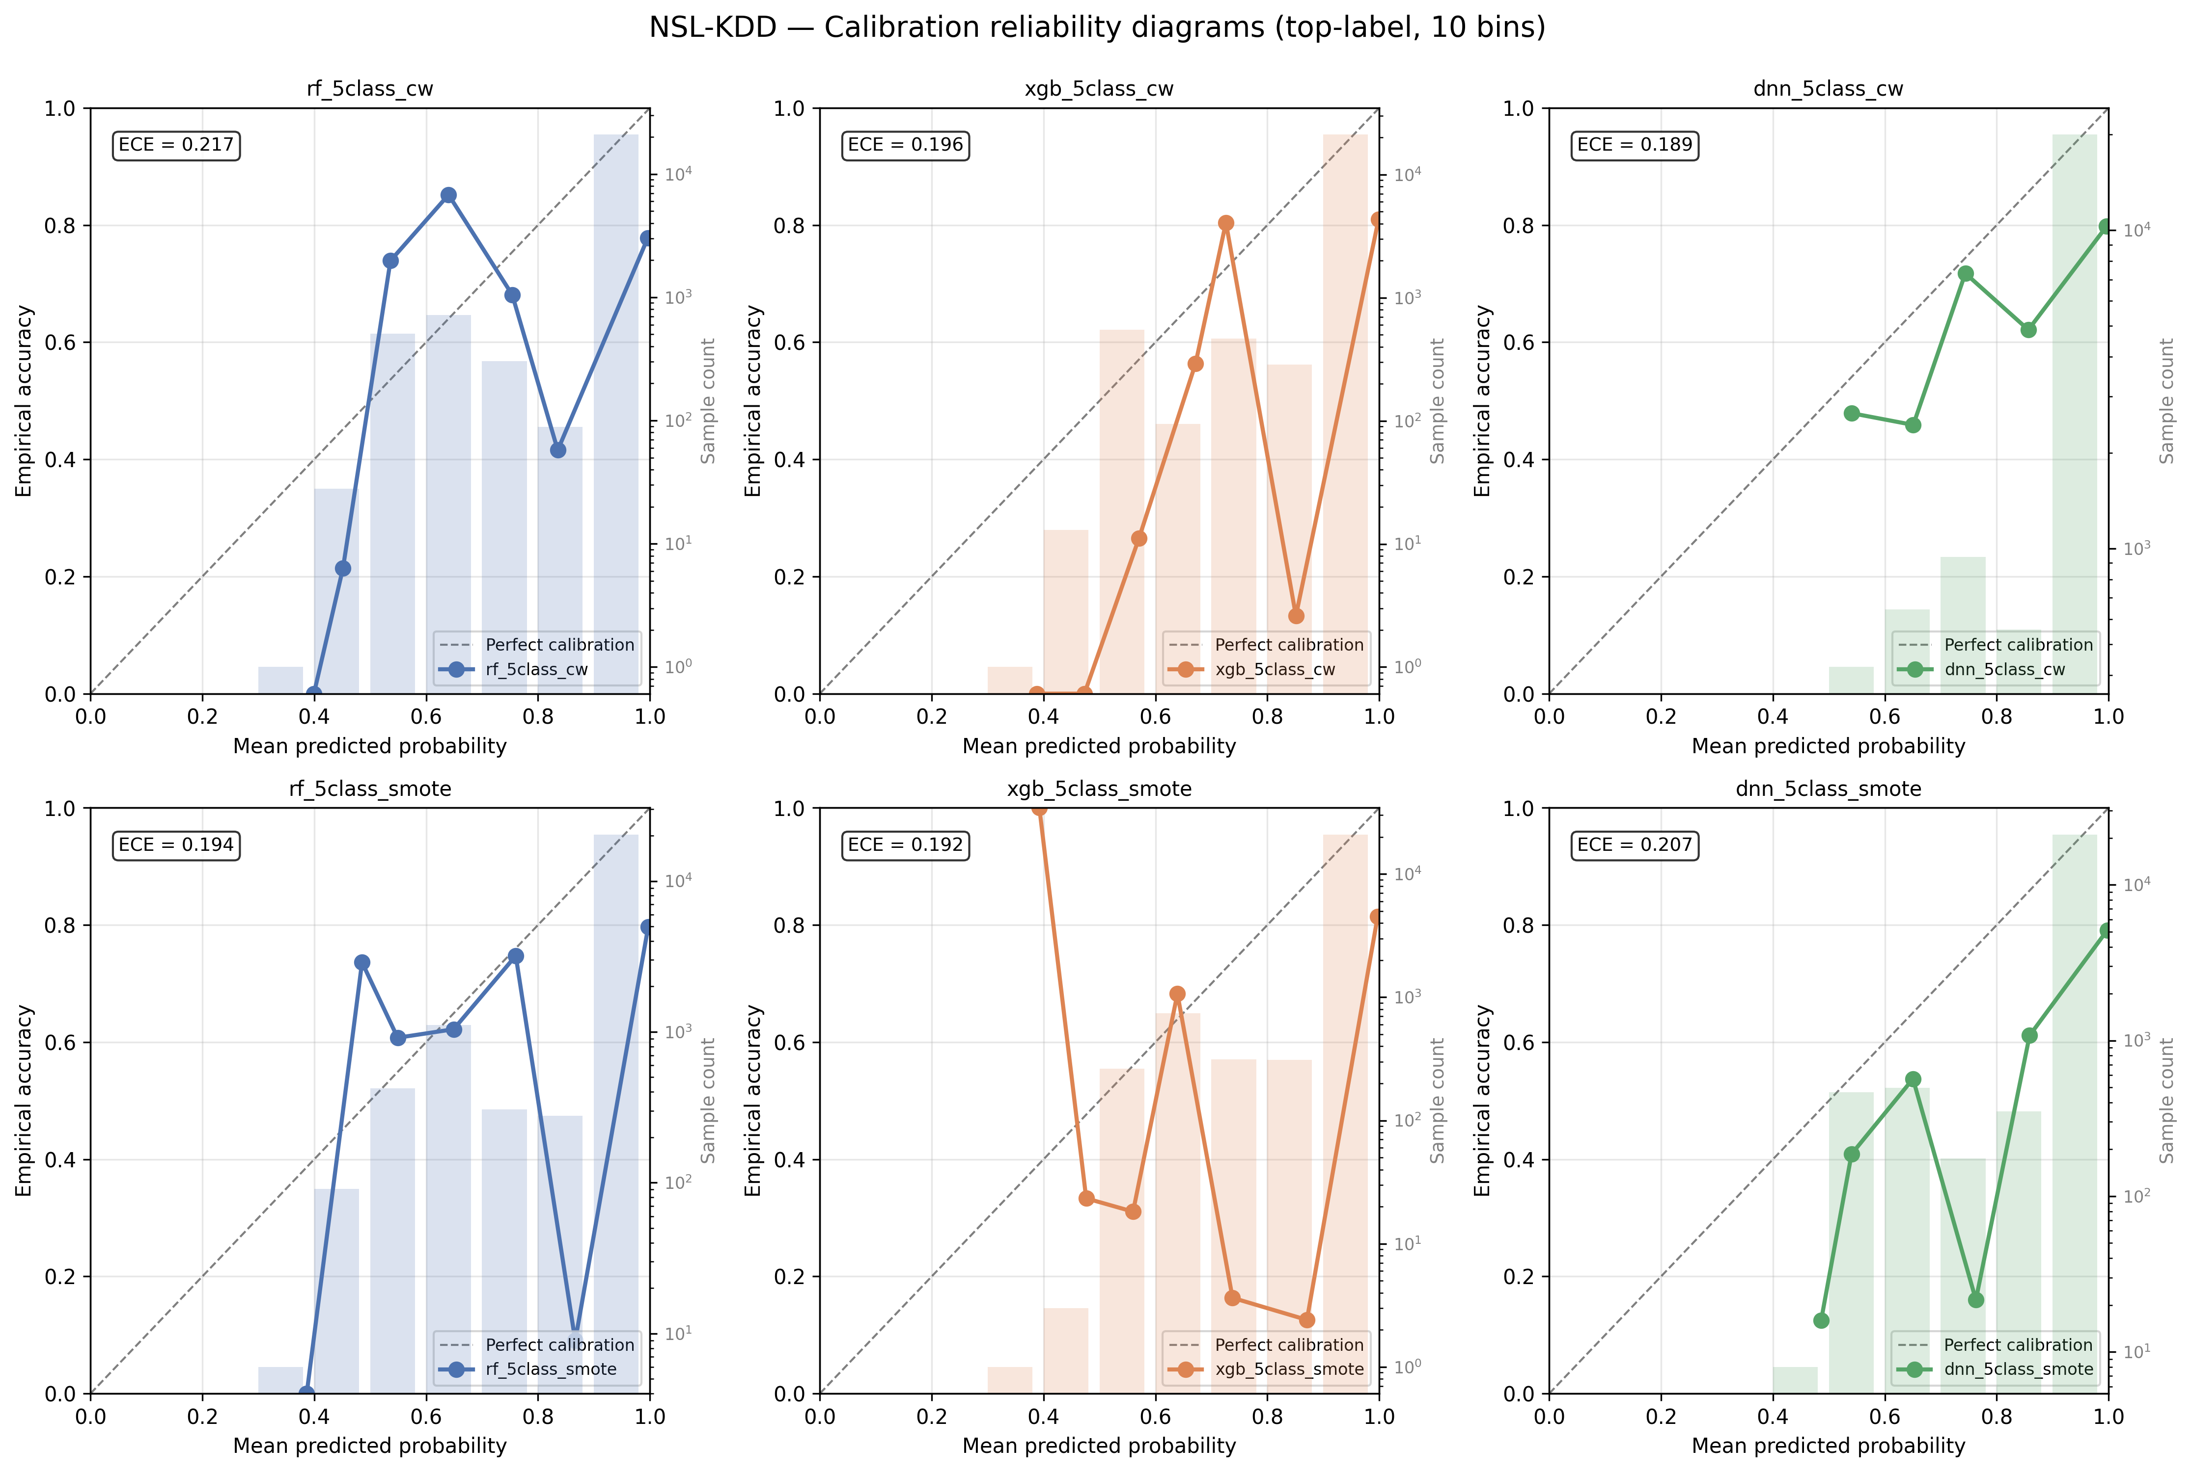
Figure 10. NSL-KDD reliability diagrams across all 6 models. Curves deviating from the diagonal indicate miscalibration. NSL models show systematic over-confidence at high predicted probability — the calibration cliff on rare classes.
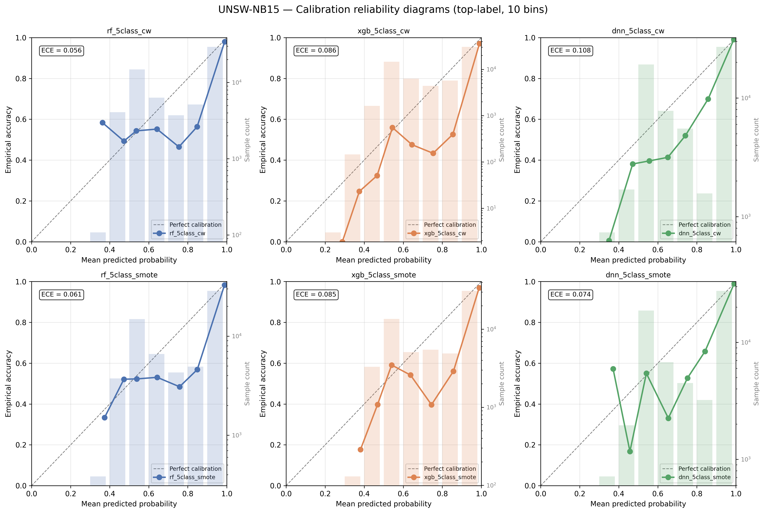
Figure 11. UNSW-NB15 reliability diagrams. Calibration is closer to the diagonal than NSL but still shows some over-confidence on high-probability predictions.
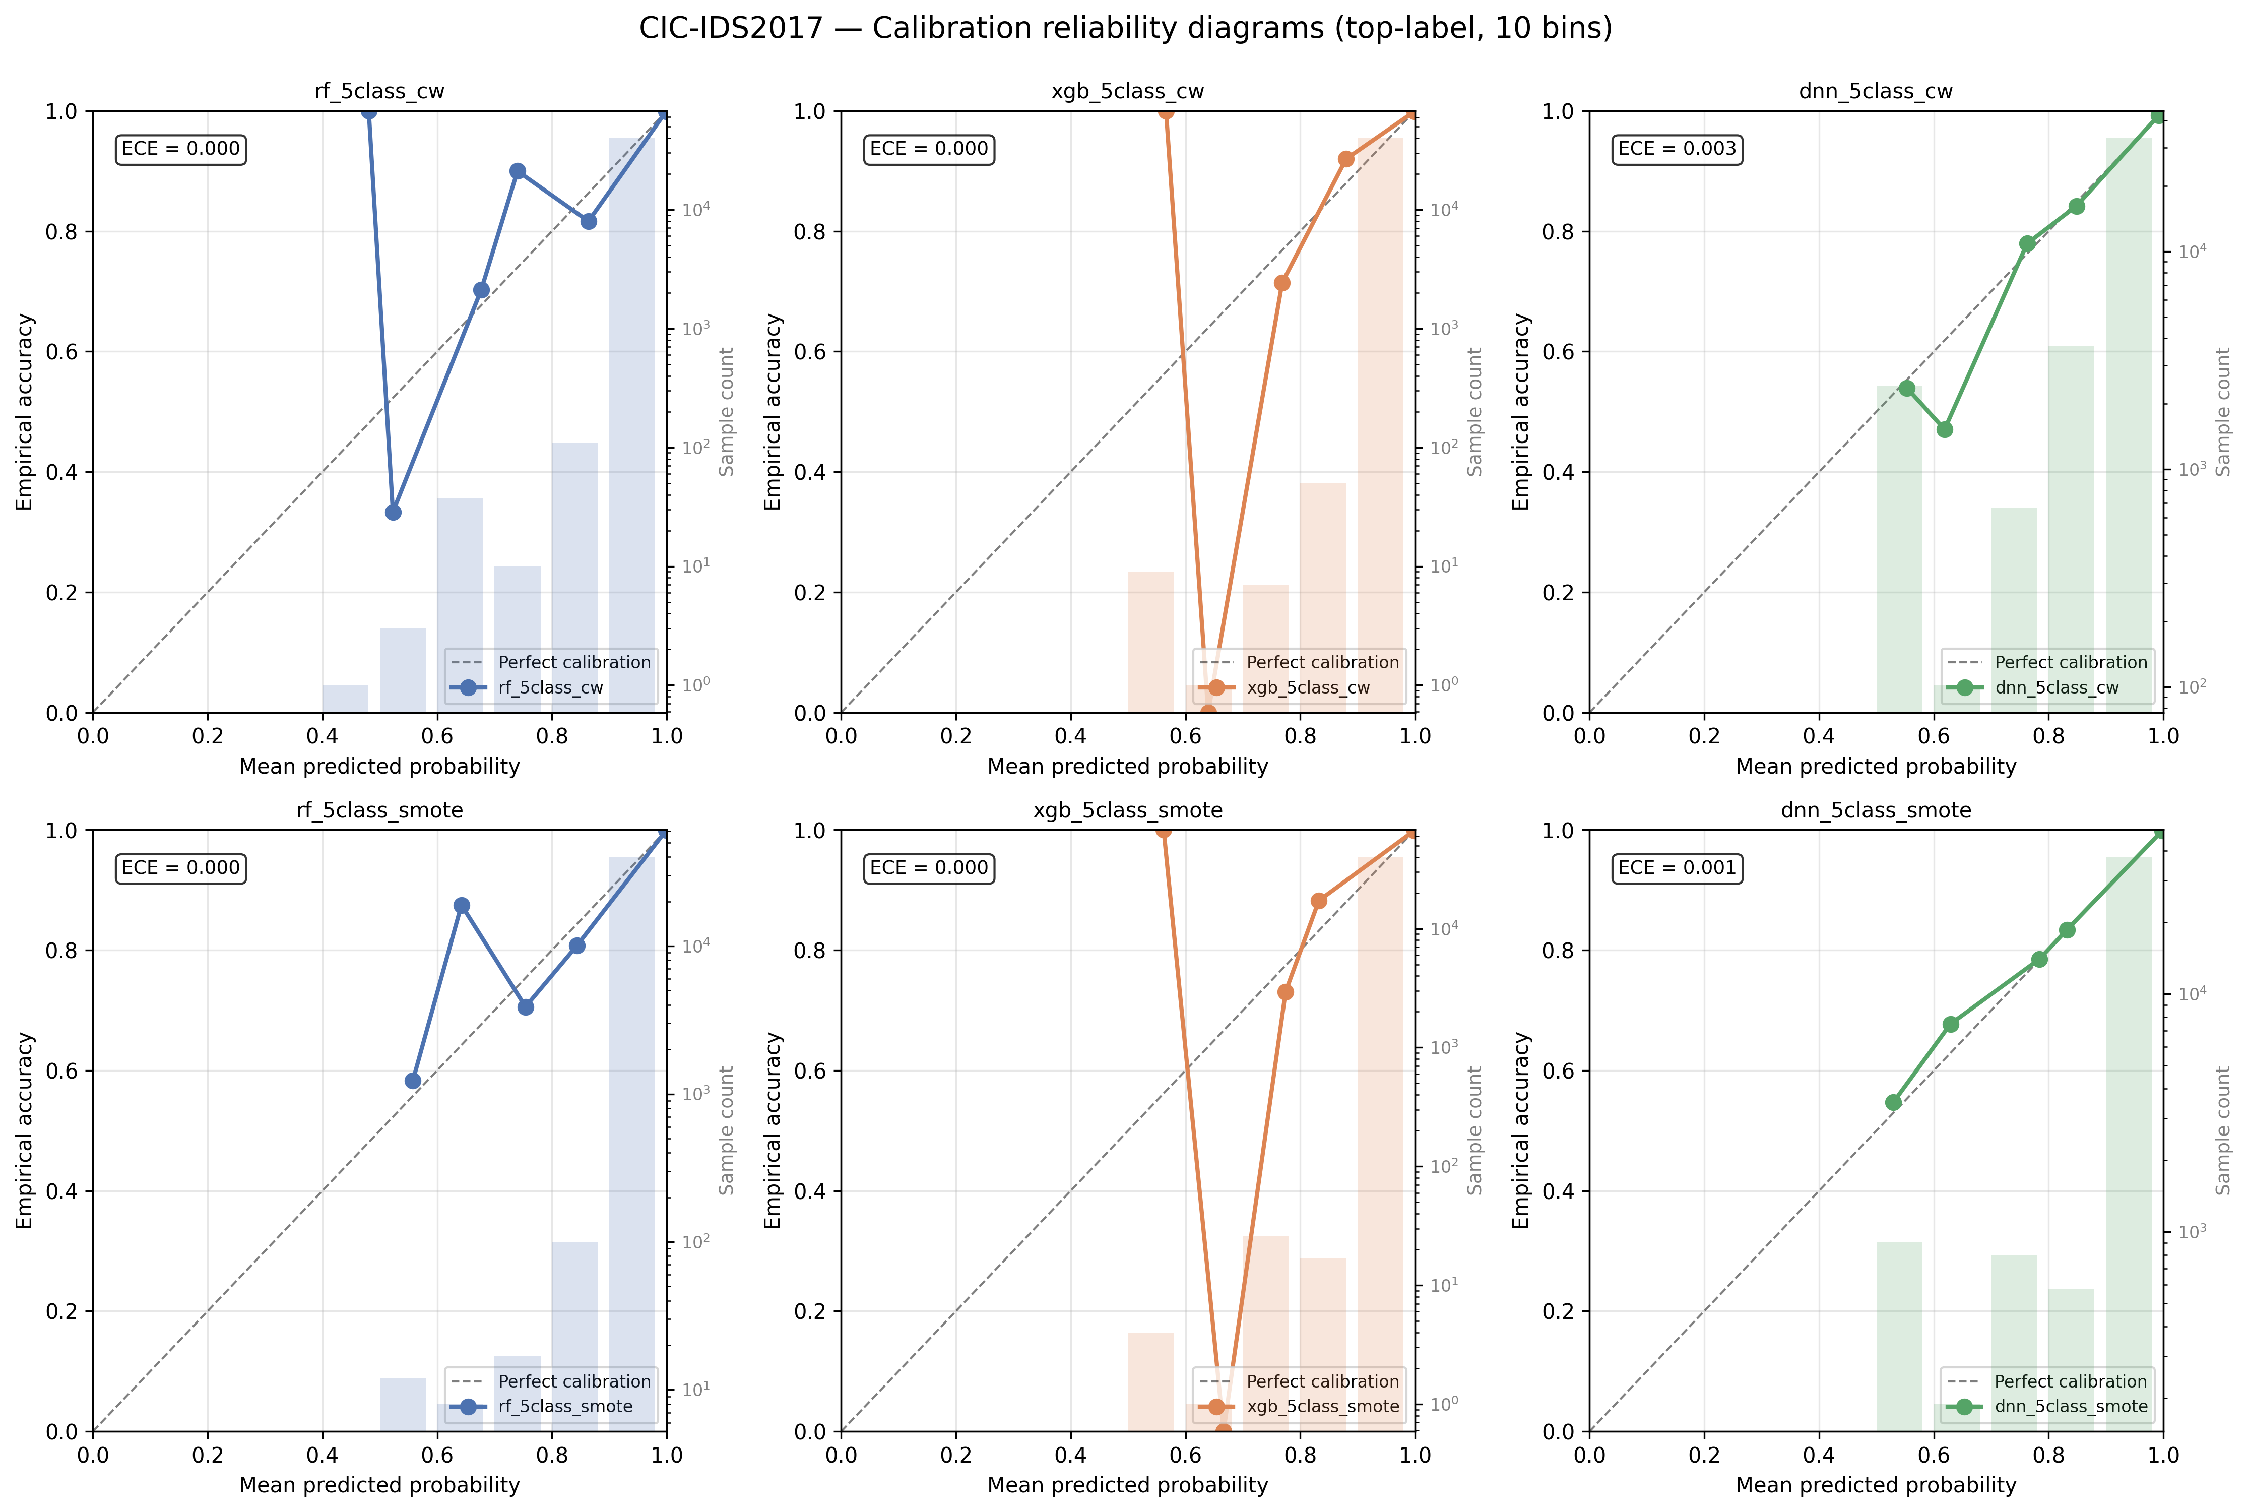
Figure 12. CIC-IDS2017 reliability diagrams. Most CIC models hug the diagonal closely, consistent with the high-accuracy regime where calibration is well-defined.

3.1 Per-class Brier scores with bootstrap CIs
Per-class Brier score (one-vs-rest, lower is better) with 95% bootstrap CIs averaged across 6 models per dataset. Note the substantial gap between NSL/UNSW Normal and R2L Brier (≈0.12-0.19) vs CIC Brier (≈0.001-0.009). This directly motivates the trust score and health flag.
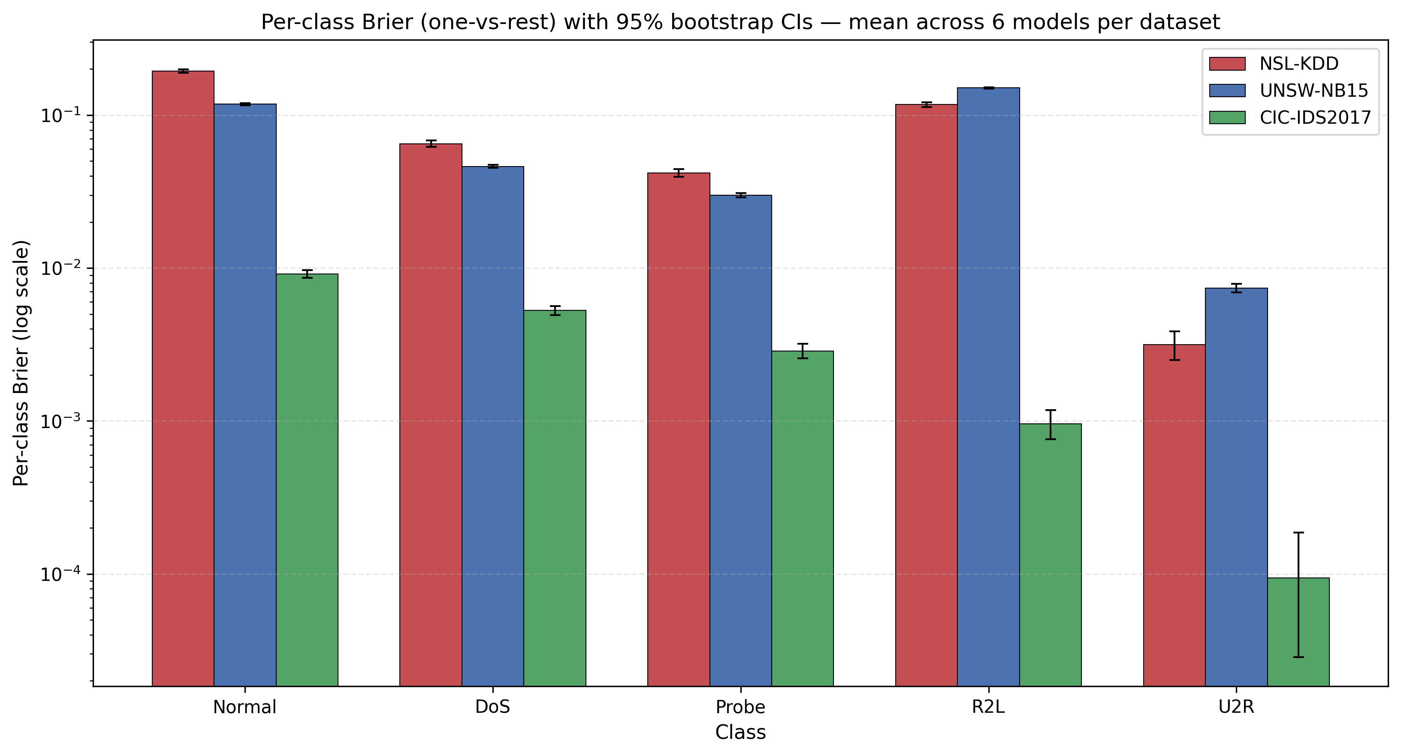
Figure 13. Per-class Brier scores (one-vs-rest) with 95% bootstrap CIs. NSL Normal and R2L are 10-100× worse calibrated than their CIC equivalents.
Key finding: NSL-KDD exhibits a calibration cliff on Normal and R2L classes (Brier ≈0.12-0.19), an order of magnitude worse than CIC-IDS2017 equivalents. This cliff propagates to downstream trust score unreliability on NSL — motivating the calibration health flag in §7.

4. SHAP Feature Attributions and Cross-Architecture Agreement
SHAP values are computed per-sample on a canonical set of 1,000 shared test samples per dataset, using KernelSHAP for DNN and TreeSHAP for tree models. Cross-architecture agreement is measured via the Krishna et al. (2022) rank correlation (RC) metric, computed per sample and aggregated.

4.1 Per-dataset SHAP agreement heatmaps
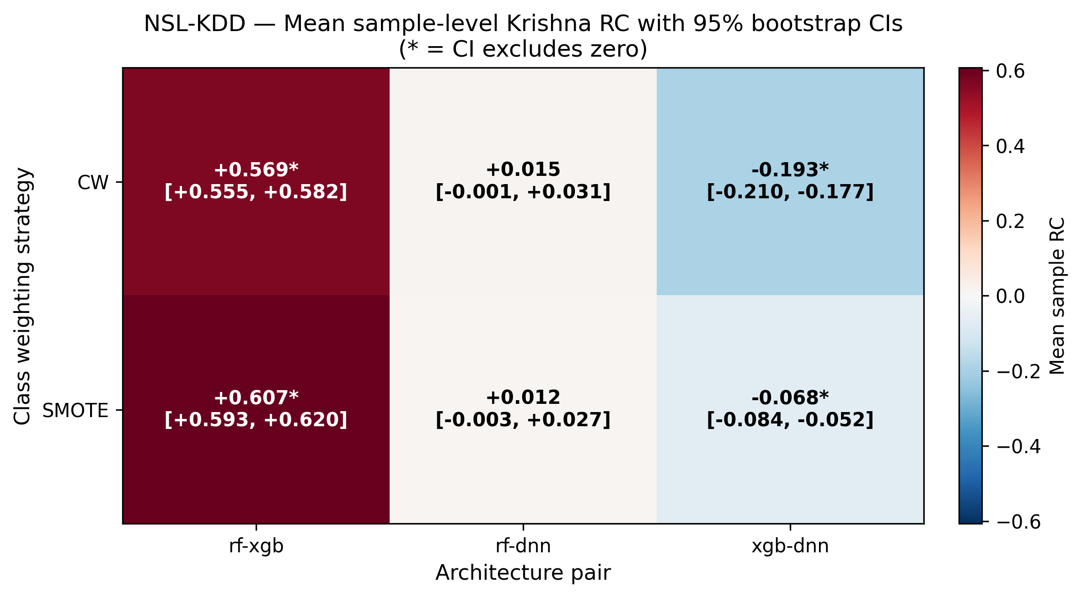
Figure 14. NSL-KDD Krishna RC per (variant × pair) with 95% bootstrap CIs. Asterisks (*) mark CIs excluding zero. Note the strong RF-XGB agreement (positive) and the significantly NEGATIVE XGB-DNN agreement.
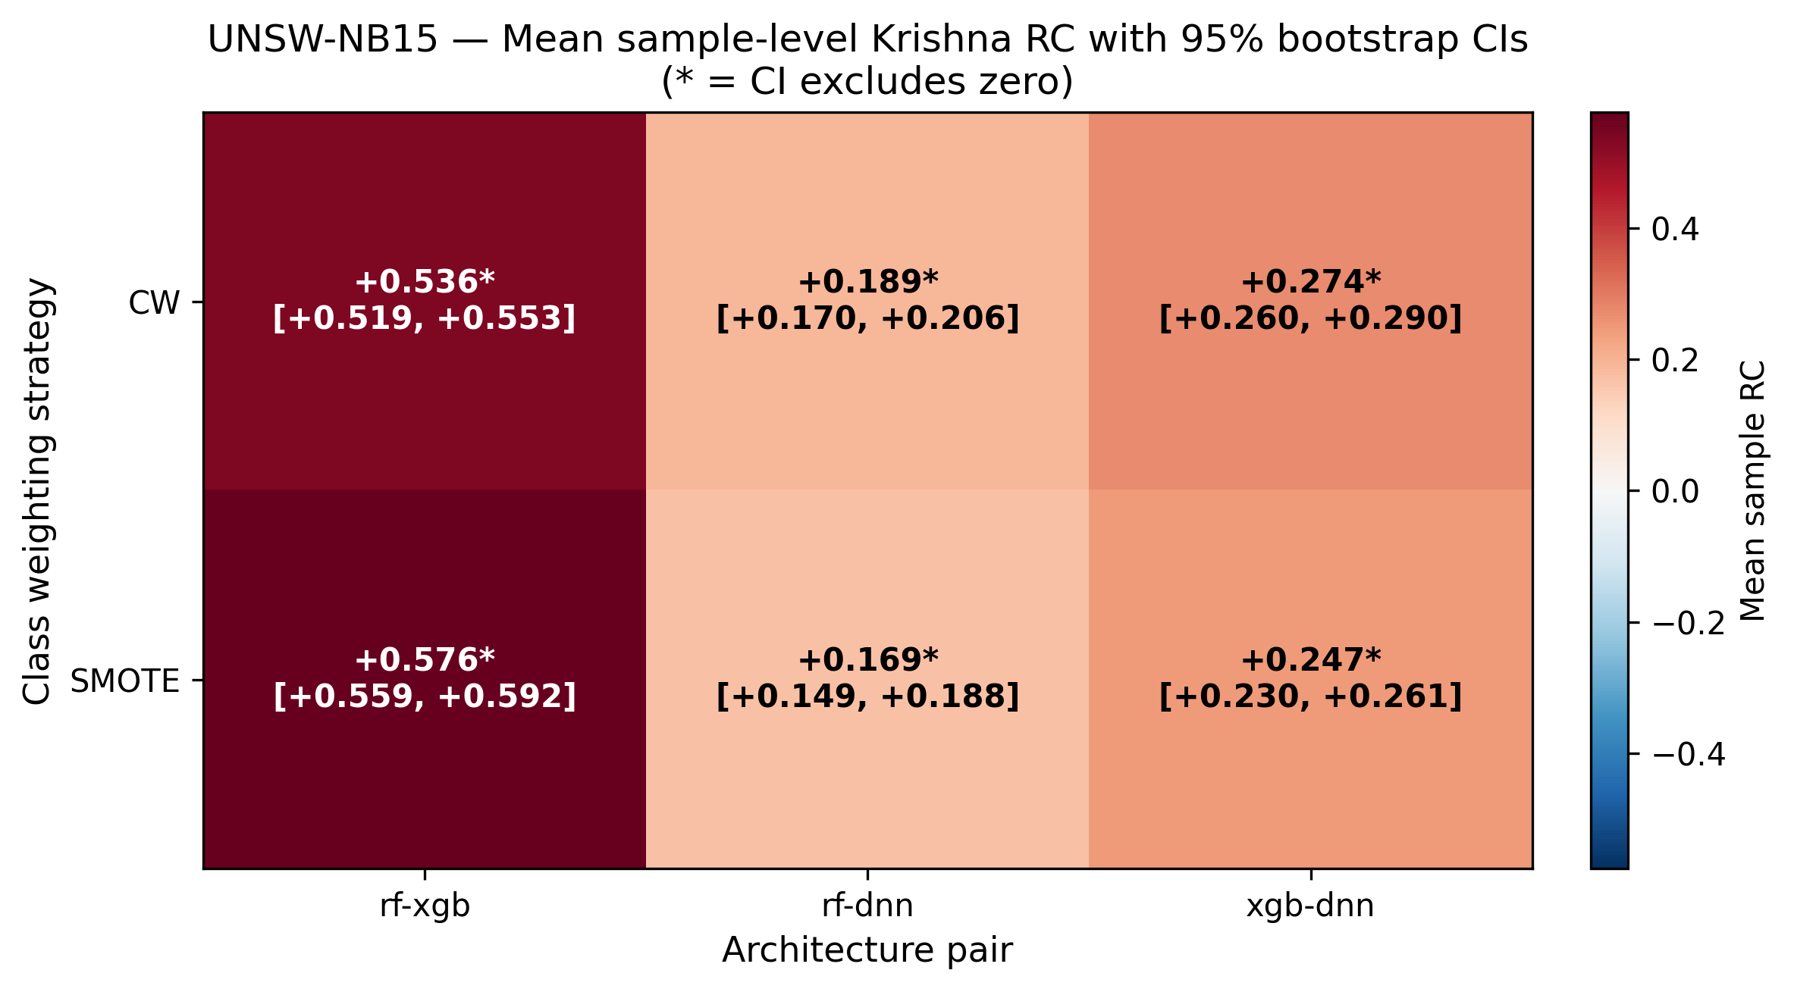
Figure 15. UNSW-NB15 Krishna RC. All pairs show positive agreement on UNSW; RF-XGB strongest at ~0.55.
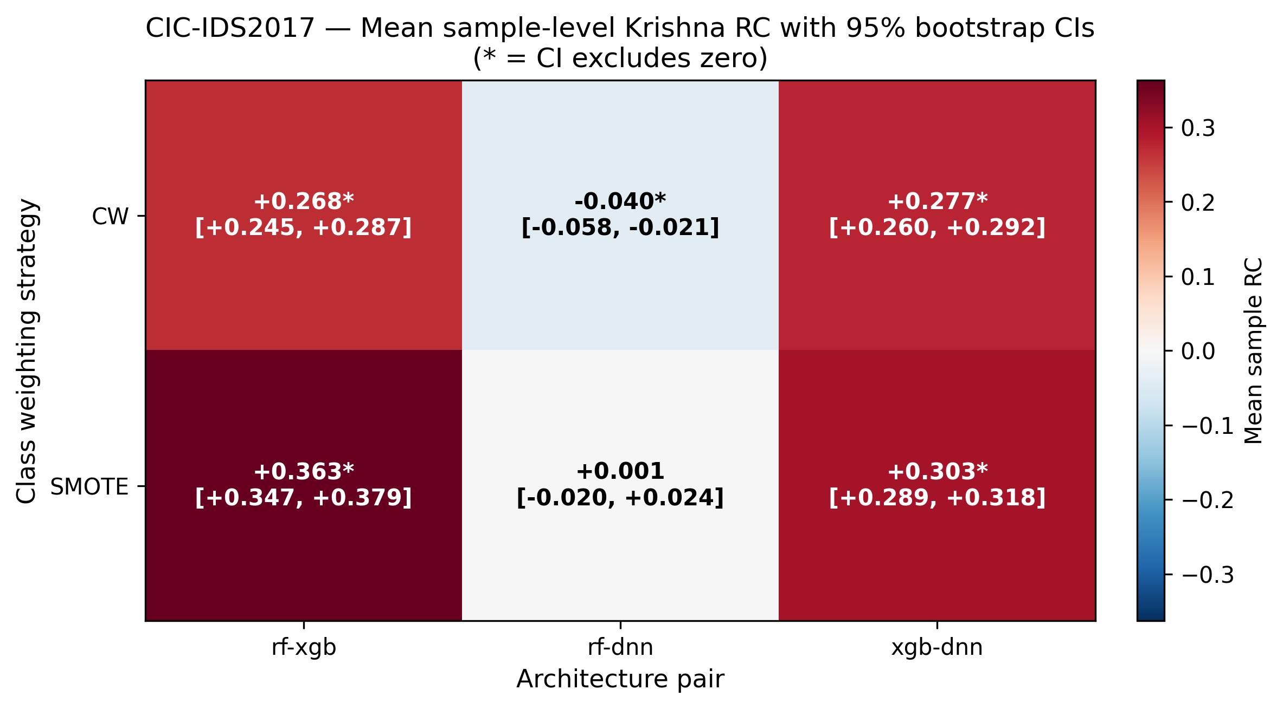
Figure 16. CIC-IDS2017 Krishna RC. Tree-pair strongest (~0.31); RF-DNN barely negative.

4.2 Per-pair RC summary across datasets
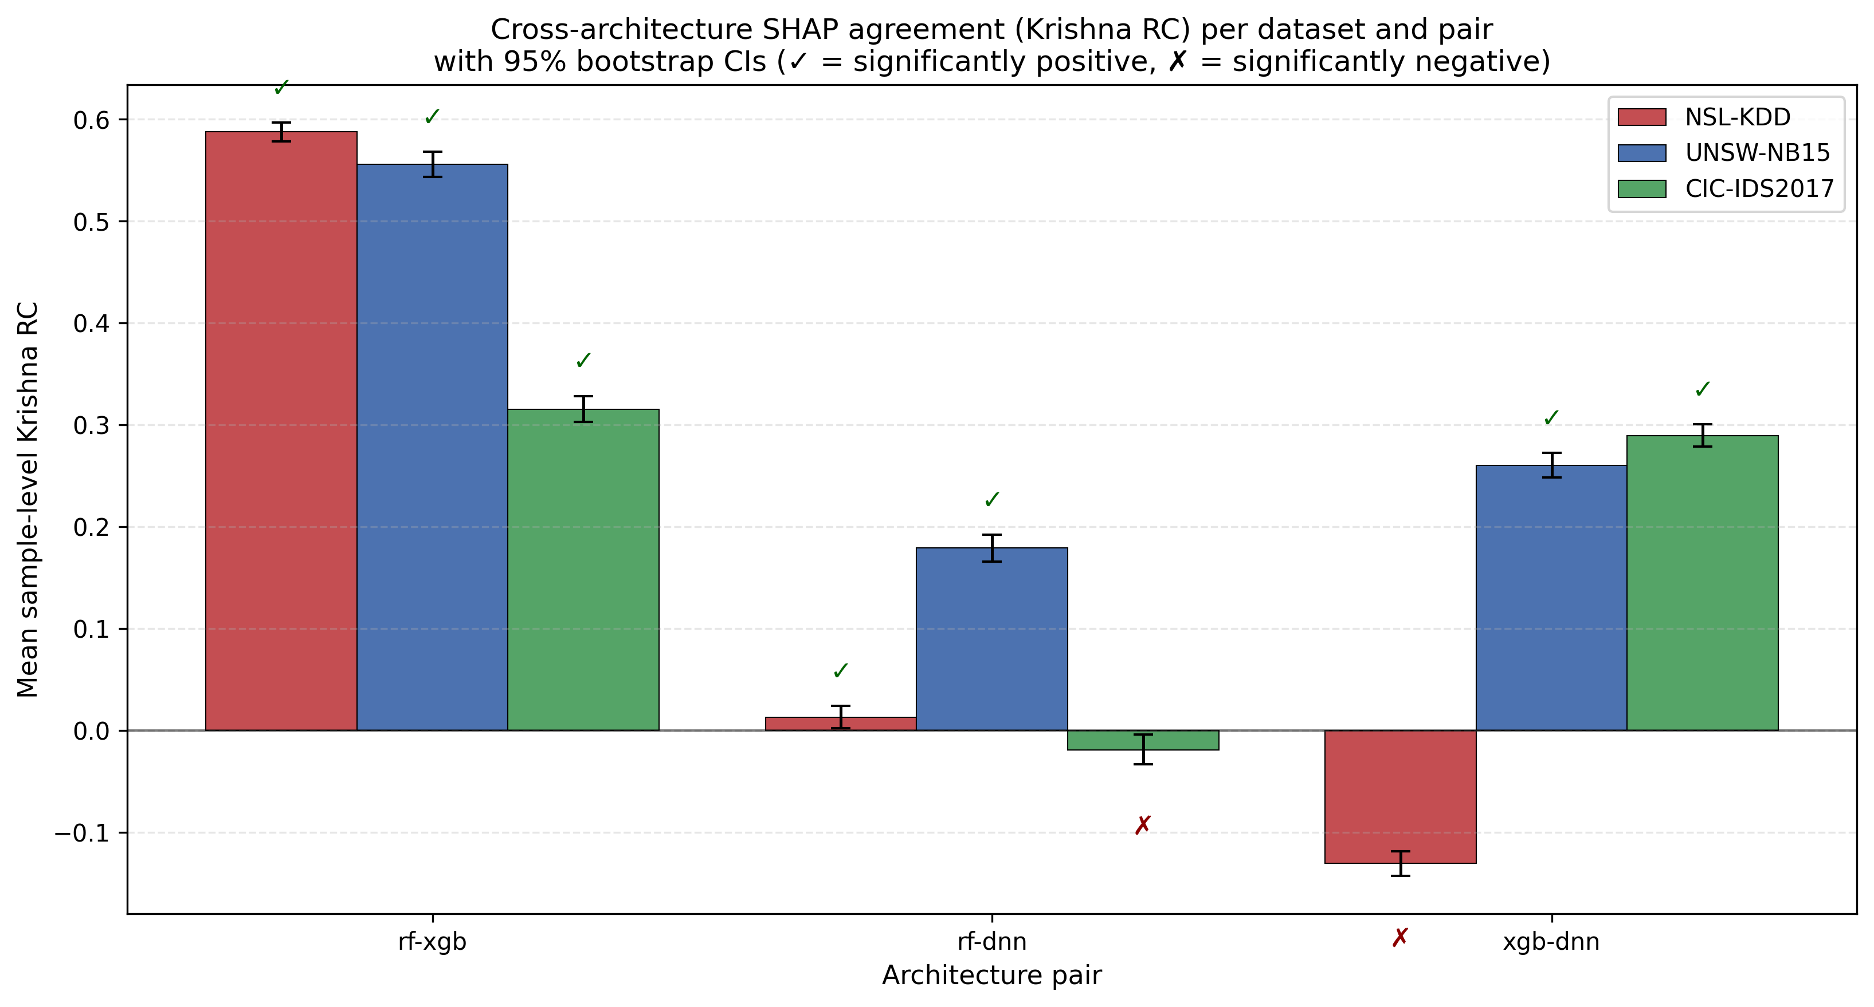
Figure 17. Per-pair Krishna RC across all three datasets with 95% bootstrap CIs. ✓ marks significant positive agreement; ✗ marks significant negative agreement. RF-XGB (tree-pair) is consistently strong; tree-vs-DNN agreement is weak or, on NSL XGB-DNN, significantly NEGATIVE.
Key finding: Tree-pair (RF-XGB) SHAP rankings agree strongly across all datasets (RC 0.32-0.59). Tree-vs-DNN SHAP rankings diverge: weak agreement on UNSW (RC 0.18-0.26), near-zero on CIC RF-DNN, and significantly NEGATIVE on NSL XGB-DNN (RC = -0.131, CI [-0.143, -0.118]). DNN-based explanations should not be assumed to corroborate tree-based explanations — they may actively contradict.

5. Explanation Stability Under Adversarial Perturbation
Per-sample SHAP top-10 stability under three perturbation types (Gaussian noise σ=0.05, FGSM ε=0.05, PGD ε=0.05) measured via Jaccard@10 between perturbed and original feature rankings. Bootstrapped over 3,000 samples per (dataset, model) (1,000 canonical × 3 perturbations).
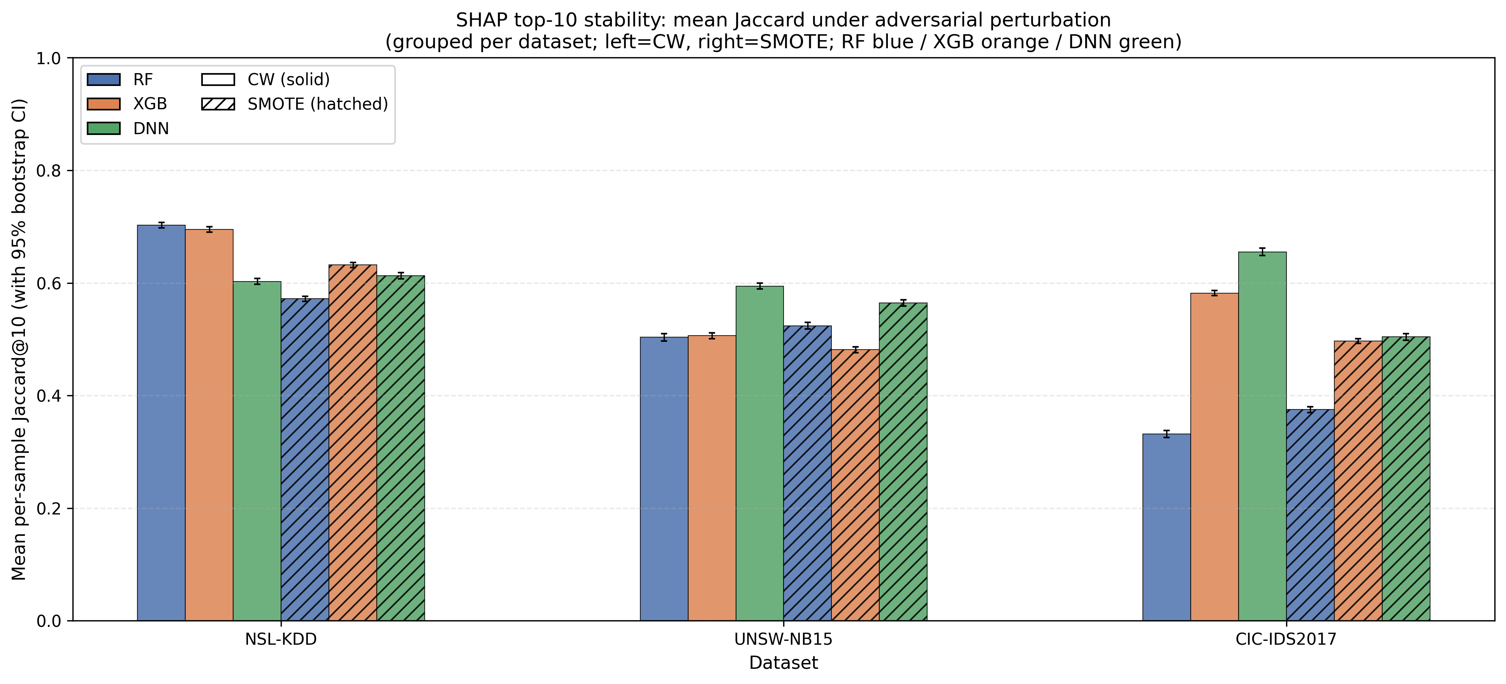
Figure 18. Mean Jaccard@10 stability per (dataset, model) with 95% bootstrap CIs. Solid bars = CW sampling, hatched = SMOTE.
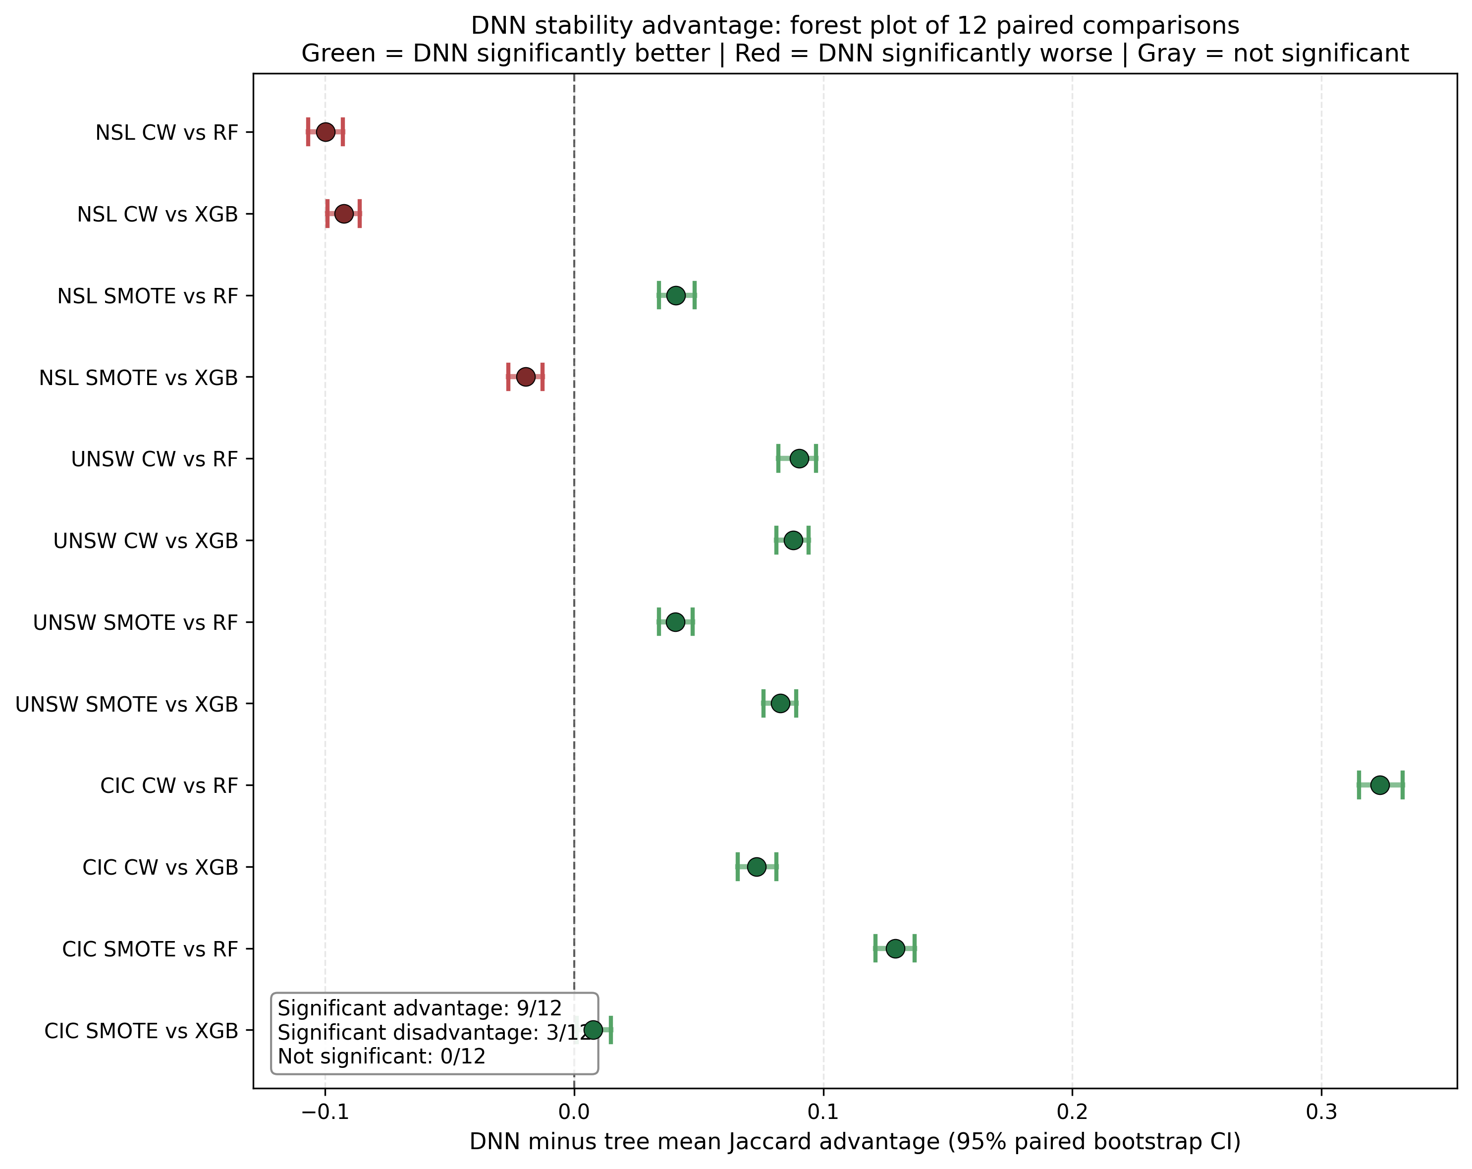
Figure 19. DNN advantage forest plot: 12 paired DNN-minus-tree comparisons. Green = DNN significantly more stable; Red = DNN significantly less stable. The NSL exception is unambiguous in CIs.
Key finding: DNN explanations are significantly more stable than tree-based explanations in 9 of 12 paired comparisons (UNSW 4/4, CIC 4/4, NSL 1/4 — SMOTE vs RF only). On NSL with class weighting, DNN is significantly LESS stable than both tree architectures. CIC trees achieve near-perfect accuracy but their SHAP rankings are surprisingly unstable, with DNN providing 7-32 points of Jaccard advantage. Architecture choice for stable explanations is dataset-dependent.

6. SCTS-v2 Trust Score and Calibration Health Flag
SCTS-v2 is a per-sample trust score combining three components: c₁ (calibrated probability of the predicted class), c₂ (per-sample SHAP stability, minimum Jaccard@10 across perturbations), and c₃ (Mondrian per-class conformal prediction with n<30 fallback). The trust score is the geometric mean: SCTS = (c₁·c₂·c₃)^(1/3) × 100, range [0, 100].

6.1 SCTS-vs-correctness per dataset
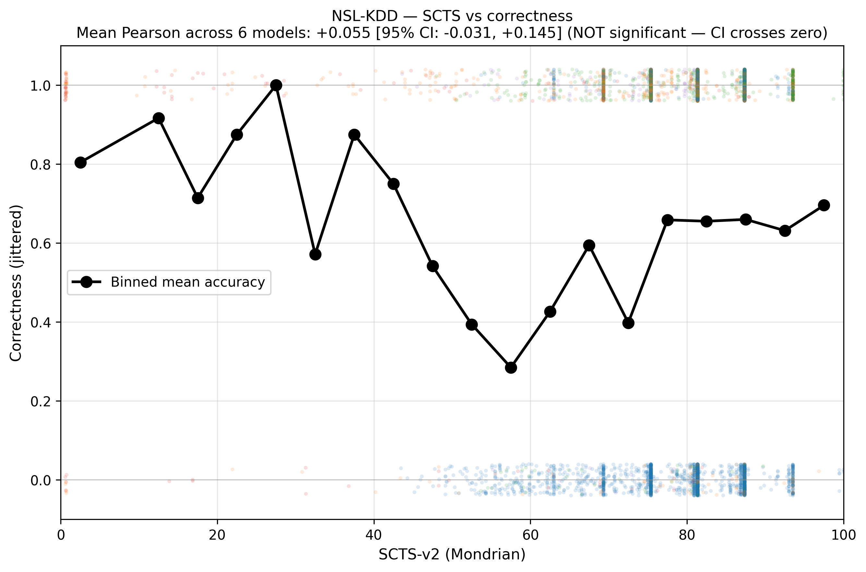
Figure 20. NSL-KDD SCTS-vs-correctness. The binned mean accuracy line is approximately flat (Pearson +0.055 [-0.031, +0.145], NOT significant). On NSL, SCTS provides no reliable signal of correctness — motivating the health flag below.
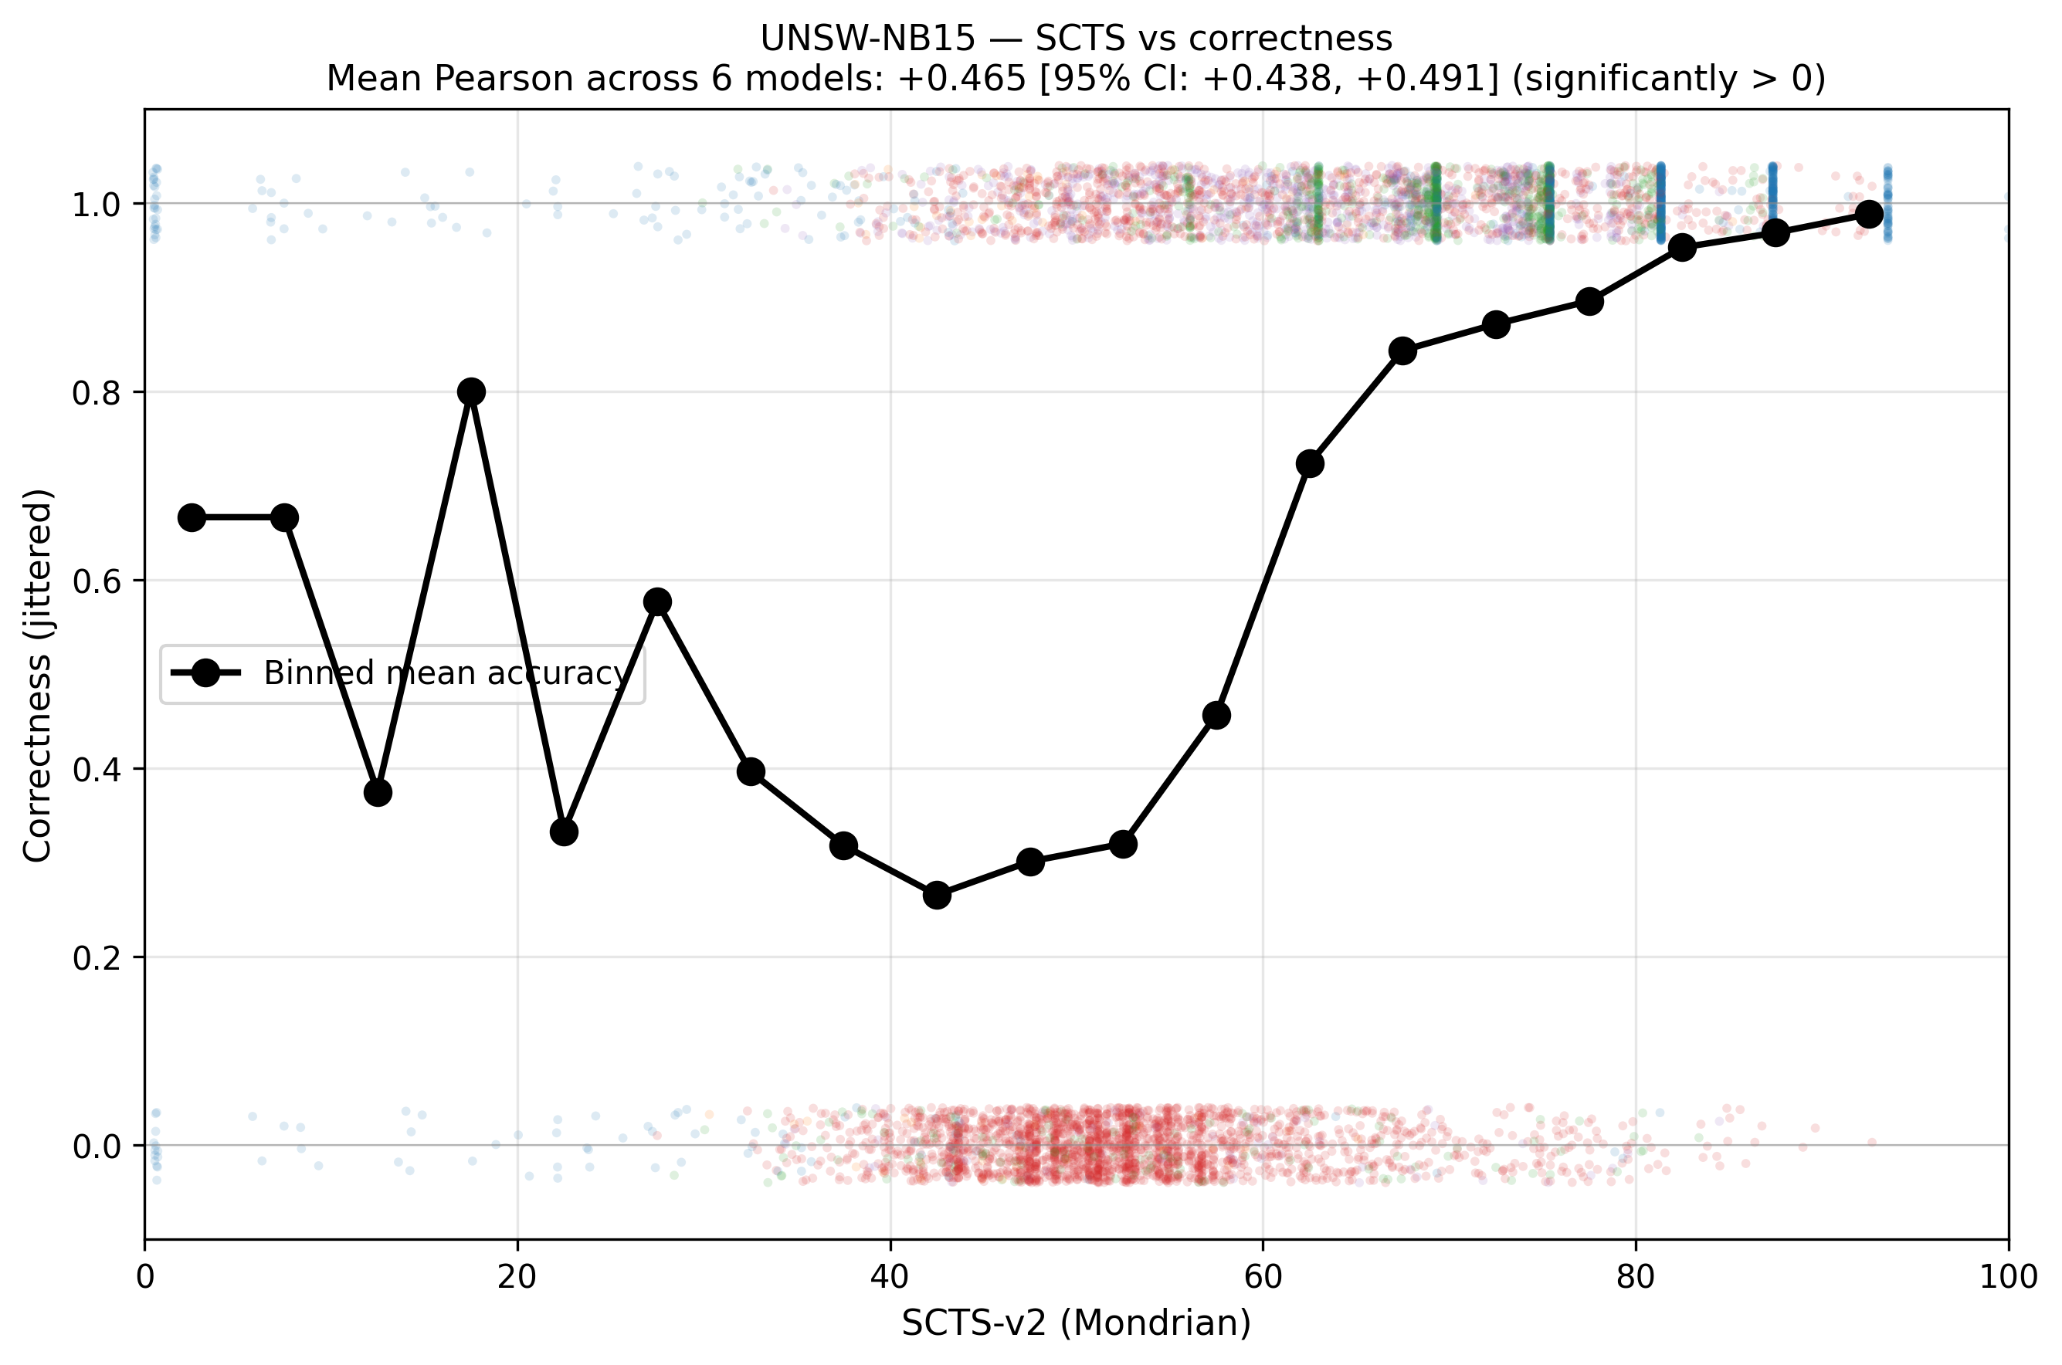
Figure 21. UNSW-NB15 SCTS-vs-correctness (Pearson +0.465 [+0.438, +0.491], significantly positive). The binned mean line slopes clearly upward — SCTS predicts correctness.
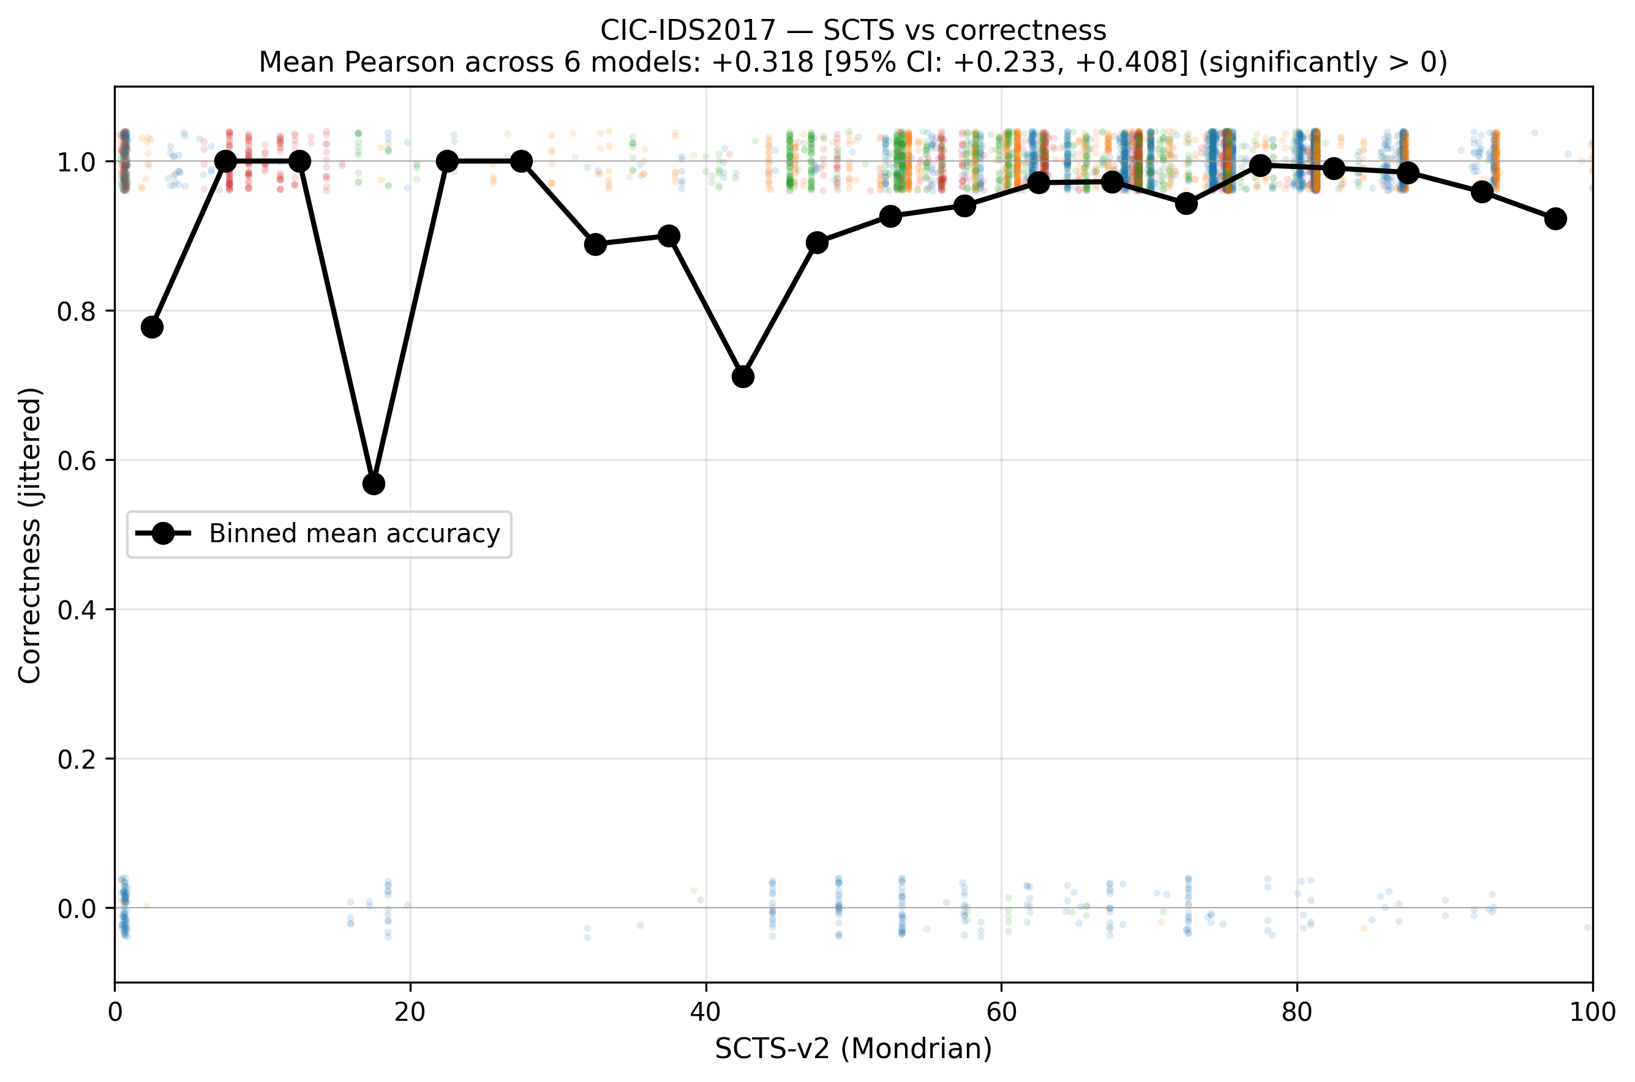
Figure 22. CIC-IDS2017 SCTS-vs-correctness (Pearson +0.318 [+0.233, +0.408], significantly positive). Slope is monotonic but limited by the high-accuracy ceiling.

6.2 Calibration health flag (3-signal)
The calibration health flag assigns one of three colors per (model, predicted-class) cell based on three signals: (1) Mondrian threshold near-degeneracy, (2) per-predicted-class calibration cliff fraction (samples with p̂(true)≥0.95), (3) calibration support count. The overall flag is the worst of the three signals. Per-sample flag is joined by predicted class.
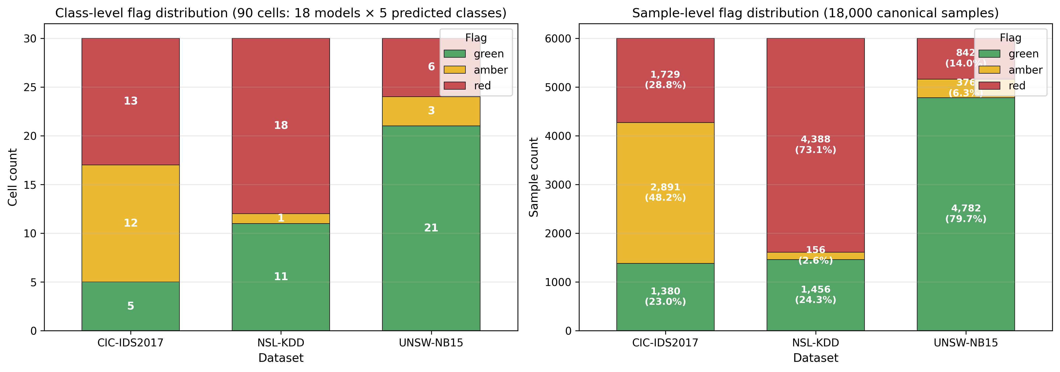
Figure 23. Flag distribution at class-level (90 cells, left) and sample-level (18,000 canonical samples, right). NSL is dominated by RED; CIC by RED/AMBER; UNSW is mostly GREEN.
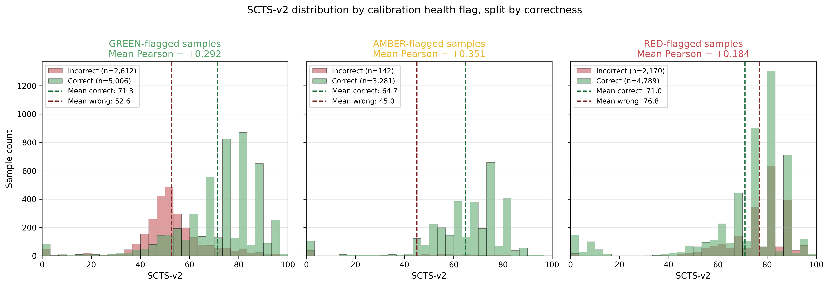
Figure 24. SCTS distributions by flag color, split by correctness. Within each flag group, higher SCTS does weakly predict correctness; the within-flag mean Pearson is +0.29 / +0.35 / +0.18 for GREEN/AMBER/RED.

6.3 NSL R2L: catastrophic failure cohort caught by the flag
The most diagnostic test of the calibration health flag is the NSL R2L cohort: 1,278 true-R2L samples across 6 NSL models, where the model is wrong ≈93% of the time but SCTS can exceed 75. The flag correctly marks this failure cohort as untrustworthy.
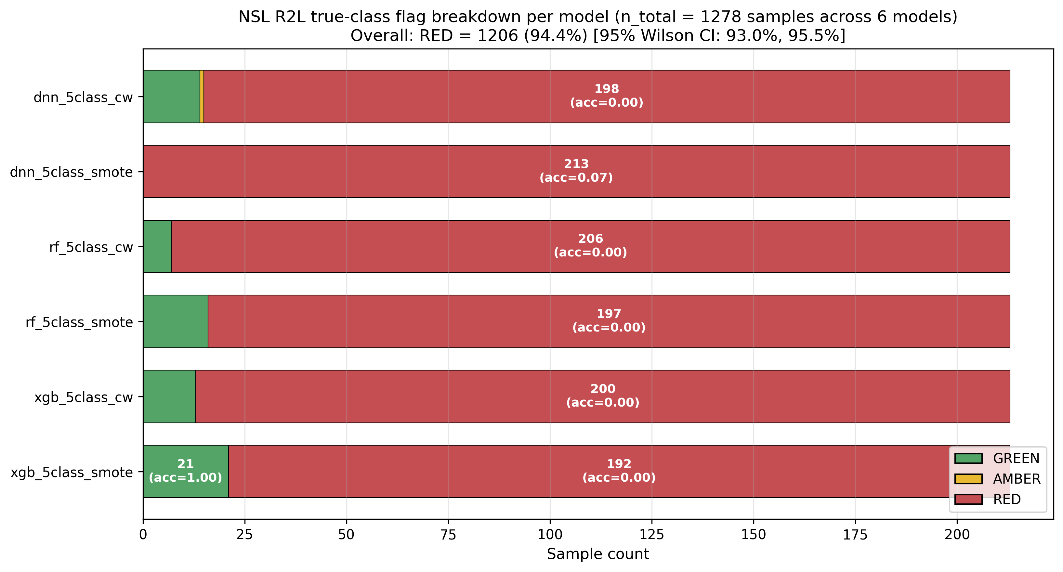
Figure 25. NSL R2L true-class flag breakdown per model. RED bars dominate (94.4% of 1,278 samples, 95% Wilson CI [93.0%, 95.5%]). GREEN bars represent rare correctly-predicted R2L samples (accuracy = 1.0) — the flag correctly distinguishes these.
Key finding: SCTS-v2 with the calibration health flag achieves operationally responsible deployment: on datasets where the trust score correlates with correctness (UNSW, CIC), the flag confirms reliability. On datasets where the trust score fails (NSL R2L cohort), the flag catches 94.4% of the failure cohort and warns the operator. The GREEN-vs-RED within-flag Pearson differential (+0.29 vs +0.18, gap +0.11) is in the expected direction but not statistically significant at α=0.05 (95% CI: -0.016 to +0.230) — the flag is validated by its catch-rate, not by Pearson differential.

7. Bootstrap CI Summary Across All 7 Claims
All key paper claims were tested with 95% bootstrap CIs (B=1000, percentile method, Wilson for the binomial proportion). Of 7 targets, 4 were confirmed strongly, 3 required refinement, and 1 (the GREEN-vs-RED Pearson gap) failed at α=0.05.
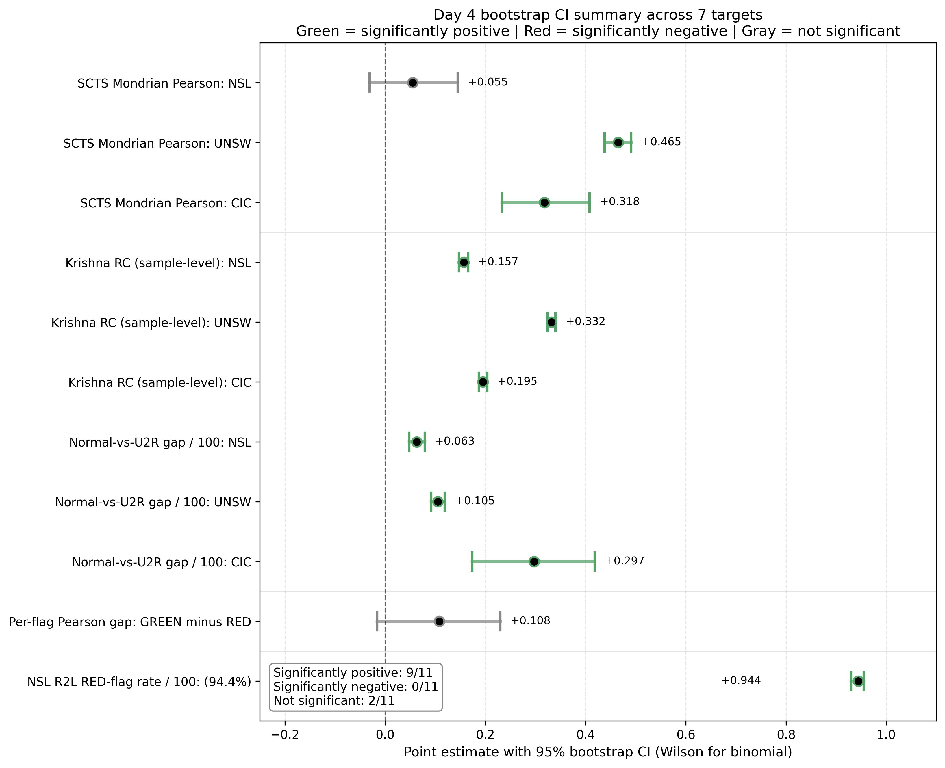
Figure 26. Master CI summary forest plot across 7 targets. Green = significantly positive; Red = significantly negative; Gray = not significant. Each target shows point estimate + 95% bootstrap CI.

7.1 Outcome status table
Target | CI status | Note
UNSW SCTS Pearson +0.465 [+0.438, +0.491] | Confirmed | Strong claim
CIC SCTS Pearson +0.318 [+0.233, +0.408] | Confirmed | Strong claim
NSL R2L 94.4% RED-flag rate [93.0%, 95.5%] | Confirmed | Strongest empirical finding
Calibration Brier per-class | Confirmed | All tight CIs
NSL SCTS Pearson +0.055 [-0.031, +0.145] | Refined | NOT significantly different from zero
DNN stability advantage | Refined | 9/12 significant, NSL exception
Krishna RC structure | Refined | Per-pair: tree-pair strong, tree-DNN weak/negative
GREEN-vs-RED Pearson gap +0.108 [-0.016, +0.230] | Failed | NOT significant at α=0.05
Table 2. Status of 7 paper claims after Day 4 bootstrap CI analysis.
Key finding: The audit trail shows scientific honesty: 4 claims confirmed, 3 refined with CIs, 1 explicitly failed and documented for rewording. The failed claim (GREEN-vs-RED Pearson gap) is preserved in session memory v12 r3 and v13 §29.7 — the paper text was revised to reflect what CIs actually support rather than what was originally hoped.

8. Next Steps: Day 5 LLM Evaluation
The remaining empirical work is a 3-layer LLM evaluation of per-alert narratives that combine SCTS-v2 + calibration health flag + Krishna disagreement signals into operator-readable alerts:
- L1 — LLM-judge full-set: Generate per-alert narratives across all canonical samples and have an LLM-judge rate each on Correctness / Actionability / Clarity (1-5 scale).
- L2 — Stratified 50-alert human rating: 50 alerts stratified by flag color and dataset are rated by Anas + supervisor (and optionally a peer rater for Cohen's κ) on the same dimensions.
- L3 — LLM-vs-human calibration: LLM-judge re-rates the same 50 alerts; Cohen's κ between LLM and humans calibrates LLM-judge reliability.
A peer-rater for L2 is currently unrecruited; recruitment is a priority for the week of 2-8 June 2026. L1 can proceed in parallel as it requires no external dependency.
After Day 5, the project will add a deployment policy section (action policy + abstention gate per flag color) and a mock SOC alert card figure to demonstrate operational fit. Submission target is IEEE TIFS or TDSC.

Appendix A: Audit Trail
The project maintains a documented audit trail of methodology decisions and errors caught. Twenty-three audit catches are recorded across session memory documents v9–v13.
Key catches:
- #1-6 (v9): Foundational catches on canonical samples + Krishna aggregation.
- #7-11 (v10): Stability methodology catches including XGB log-odds artifact.
- #12-15 (v11): SCTS-v2 development catches; rejected three rescue attempts on R2L failure.
- #16-17 (v12): JSON NaN aggregation bug; f-string format specifier limit.
- #18 (v12 r2): UNSW 21/30 vs 22/30 internal consistency error.
- #19 (v12 r3): Denominator precision: "94.4% of true R2L samples in NSL test cohort" (not "of catastrophic failure cases").
- #20 (v13): Krishna CSV structure misread on Day 4 → corrected bootstrap via sample_disagreement_canonical.csv.
- #21 (v13): v9's "RC ~0.50" applies specifically to RF-XGB pair, not overall — overall RC is 0.16-0.33.
- #22 (v13): Bootstrap unit choice matters — per-model vs per-sample CIs answer different inferential questions.
- #23 (tonight): Don't average per-model CIs to summarize the dataset-level mean — the mean of CIs is not the CI of the mean.

Appendix B: Repository Commit Ledger
Key commits across the project lifecycle (most recent first):
- 6fb5def — v12 r3: CI-aware corrections
- 1730bca — v13 session memory
- 8ce2a66 — Notebook 08 Krishna correction
- 10c1013 — Notebook 08 initial bootstrap CIs
- d11c9bb — v12 r2 wording precision
- 7a76deb — v12 session memory
- f40df85 — 07d JSON NaN fix
- a3a0a47 — 07d health flag initial
- dbfac27 — v11 session memory
- bc85188 — 07c SCTS-v2 Mondrian
- 8c8cfbb — v10 session memory
- d7df8e7 — 05c stability
- 4a2012c — v9 session memory
- d61fbdc — 06v3 Krishna agreement
- a1f9be9 — 04c canonical SHAP

