 

Imam Mohammad Bin Saud Islamic University

College of Computer and Information Sciences

**StoresHub**

**By:**

Hashem Bajabaa 437015783

Anas Alzhrani 438010515

Rayan Alshanabah 439027005

**Supervised by:**

Dr. Qaisar Abbas

Final report | first version

March 11, 2021 |29th Shaban, 1442



Imam Mohammad Bin Saud Islamic University

College of Computer and Information Sciences

**StoresHub**

**By:**

Students Name(s), ID(s) and Department(s)

We hereby certify that this project satisfies the project requirements:

|  |  |
| --- | --- |
| **Approved by** | **[Supervisor Name]** |
| **Date of Approval** |  |
| **Signature** |  |

|  |  |
| --- | --- |
| **Approved by** | **[Vice Dean of Educational Affairs Name]** |
| **Date of Approval** |  |
| **Signature** |  |

##### Declaration

We , , and being members of final year project group number

, declare that this report contains only work completed by members of our group except for information obtained in a legitimate way from literature, company or university sources. All information from these other sources has been duly referenced and acknowledged in accordance with the University Policy on Plagiarism.

Furthermore, we declare that in completing the project, the individual group members had the following responsibilities and contributed in the following proportions

to the final outcomes of the project:

|  |  |  |  |
| --- | --- | --- | --- |
| **Student ID** | **Responsibility1** | **% Contributed2** | **Signature** |
|  |  |  |  |
|  |  |  |  |
|  |  |  |  |

##### Acknowledgment

First and foremost, we would like to present our deepest gratitude to Almighty

ALLAH for his bounties and blessings and for giving us the ability to finish this project

We would like to express our deep appreciation and our sincere gratitude to our supervisor Dr. Qaisar Abbas for his valuable advice guidance throughout this project.

Finally, we would like to thank our families and friends for continued encouragements and support during this project and along the years of study.

**Table of Contents**

**Chapter 1**

1.1 Introduction: 7

1.2 Aims and Objectives: 8

1.2.1 Aim: 8

1.2.2 The objectives: 8

1.3 Methodology: 9

1.4 Project Timeline 10

1.5 Team Qualifications 10

1.6 Conclusion: 11

**Chapter 2**

2.1 Introduction 13

2.2 Background 13

2.2.1 Web application overview 14

2.2.2 Web application 15

2.2.3 websites 15

2.2.4 E-commerce 17

2.3 Related Work 18

2.3.1 E-commerce 18

2.3.2 Web Application 19

2.4 Conclusion 21

**Chapter 3**

3.1 Introduction 23

3.2 Purpose 23

3.3 Definitions, Acronyms, and Abbreviations 24

3.4 User Characteristics 24

3.5 Product Perspective 25

3.6 Product Functions 25

3.7 General Constraints 26

3.7.1 Interface Constraints: 26

3.7.2 Technology Constraints: 26

3.7.3 Privacy and Security Constraint 26

3.8 Assumptions and Dependencies 26

3.9 Interfaces 27

3.9.1 User interface: 27

3.9.2 Software interface: 27

3.9.3 Hardware interface: 27

3.10 User Requirements 28

3.10.1 Functional Requirements 28

3.10.2 Non-Functional Requirements 32

3.11 System architecture 34

3.12 UML Diagrams: 34

3.12.1 Use-case Diagram 35

3.12.2 Activity Diagram 43

3.12.3 Sequence diagram 45

3.12.4 Class Diagram 46

3.13 Conclusion 54

**Abstract**

The e-commerce industry is developing rapidly around the world year after year [1]. Now days, it’s impossible to imagine the world without e-commerce, where consumers could buy whatever they need anytime, anywhere conveniently. With large quantity of EC web apps appearance for each store, consumers have been distracted. Although to provide the stores owners the ability to host their products, people who would like to start a business and can’t afford the cost. Our platform will solve it all where, diverse products from various shops and dealers will be available. In order, to implement it, coding will take the largest effort for frontend and backend. Frontend require JavaScript, html, CSS, and react.js and python language for server side as backend. This document consists of three chapters, each chapter deals with part of the project and discuss it in detail. For the first chapter we will give an introduction of the project and proposal. Second chapter going to provide us with background knowledge to understand the topics problem, then an important insight from the related work will be covered. Lastly, we will extend the system and user characteristics and constrains, although a web application functional and non-functional requirements, followed by high and low level diagrams all in third chapter.

**Keywords**

Web Application, E-Commerce, Front-End, Back-End, shopping Cart, Shipping, Website, Web server, JavaScript, HTML, CSS, React, Python, Django, Database, SEO, Customer.

**List of abbreviation**

**List of Figures**

**Fig. ‎1‑1. shares of E-Commerce sales** 7

**Fig. ‎1‑1. Project Management Plan** 10

**Fig. ‎3‑1. SPA** 29

**Fig. ‎3‑1. 3.12.1 Use-case Diagram** 30

**Fig. ‎3‑1. 3.12.2 Activity Diagram of Order** 37

**Fig. ‎3‑2. 3.12.2 Activity Diagram of Customer Activities** 38

**Fig. ‎3‑1. 3.12.3 Sequence diagram** 39

**Fig. ‎3‑1. Class Diagram** 40

**List of Tables**

**Table. ‎1.5.1 Team Qualification** 10

**Table. ‎2.2.1 Web Application Terms** 14

**Table. ‎2.2.2 Web Application vs Website** 14

**Table. ‎2.2.3 E-commerce Terms** 16

**Table. ‎3.3.1 3.3 Definitions, Acronyms, and Abbreviations** 21

#### Introduction

# Introduction:

Trading process from long time ago until now days based on the idea of a place where merchants and consumers gather in one place to trade. People used to go out to the market to buy what they need and merchants could sell their products. Sometimes customers need to visit more than one place to buy his needs. Usually as many countries have independent market to sell a specific product for instance, gold market, Perfume market, clothing mall and tech store. Our platform will gather all those stores under one umbrella. Although we will be creating a fertile environment that will empower beginner Entrepreneurs to reach their customers easily in one place without needing to rent a store or build their own E-commerce website/app. The platform will save cost for marketing, store, development and difficulty to manage operations, inventory, payments, shipping privacy and security. “In 2020, E-Commerce sales are expected to account for 15.5 percent of retail sales worldwide.” [2]. To reach our project we will build a web application as our platform. In order, we need to learn HTML, CSS, bootstrap, JavaScript, react.js for Frontend and python, django.py and SQL for Backend. However, we will be using more technologies undecided yet to build the web application such as, AWS for hosting.

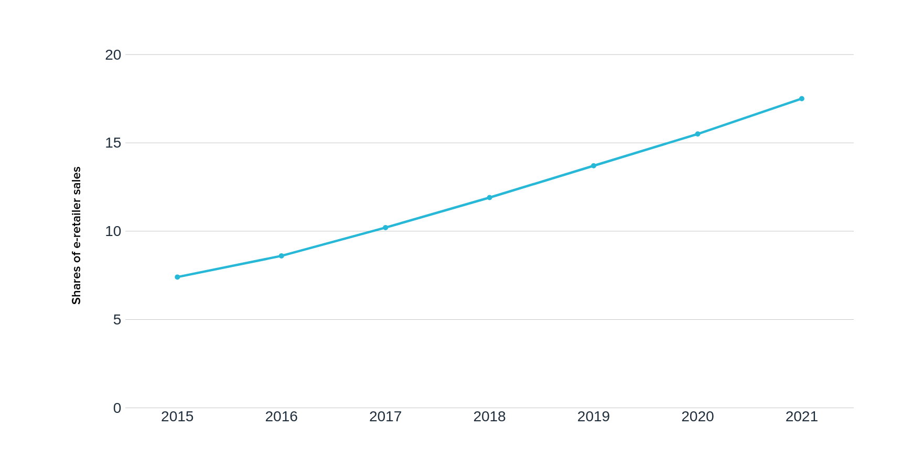

**Fig. ‎1‑1. shares of E-Commerce sales**

In this proposal we will provide our goals of the project through aims and objectives that are going to be achieved. Then, we will describe how our project will be implemented in methodology. After that, a project Gantt chart timeline discussed in details followed by team qualifications. Finally, a brief conclusion about the project and proposal in general.

# Aims and Objectives:

## Aim:

Our platform aims to create opportunities to new and small merchants to become entrepreneurs by digitalize their business and providing their needs. Although keeping entrepreneurs focused in business, increase profit, expansion, growth and developing products. In order to do that we need to reducing cost and distractions such as, marketing, rent a store, development, operations, inventory, payments and shipping.

## The objectives:

* Learn frontend html, CSS, JavaScript, react.js
* Learn backend python, Django, SQL, NoSQL, AWS
* Get familiar with APIs and server
* Design usable and user-friendly interface
* Developing and testing a web application
* Build up our technical writing skills and improve communication skills

# Methodology:

We will be developing a platform in web application technology to serve multiple traders and buyers. Our E-commerce project will be divided into two main sides; the first side will be the merchant’s side where they could manage their products, add, delete and edit. Second side is for customers where they could buy, review and evaluate. The most work will be in frontend and backend of the web application. Developing the project interface and features will be the frontend job. Although we need to deal with the server side, data workflow, database and APIs through the backend side. For the frontend we will be using html, CSS, bootstrap, JavaScript and react.js which is JavaScript library. As a backend python will be the backbone represented with django.py and MySQL which is python library. In order, to accomplish the project we will need to do more than coding such as, design, mange, documentation, testing, hosing and buying a domain for hosting.

# Project Timeline

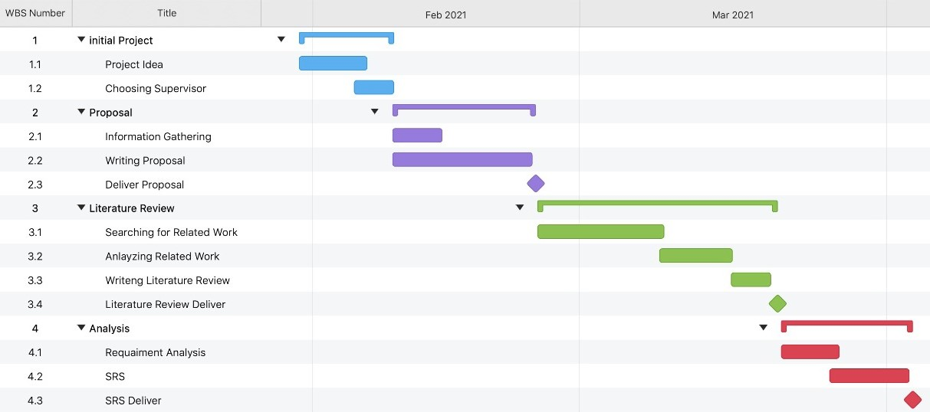

**Fig. ‎1‑1. Project Management Plan**

**Note:** more tasks will be added through GP2

# Team Qualifications

**Table. ‎1.5.1 Team Qualification**

|  |  |
| --- | --- |
| Name | Skills |
| Hashem Bajabaa | * Team Management * Basics in web development |
| Anas Alzhrani | * Java development * Basics SQL Database |
| Rayan Alshanabah | * Java development * Basics in web development |

# Conclusion:

In conclusion, the platform used web application model to facilitate traders selling products and customers buying from multiple traders in one place. We belief our platform could add a value in the marketplace and introduce new people to the business world by making selling, buying and managing products easer. Although we picked the latest and best technologies for us to implement our project.

#### Background

# Introduction

In this chapter we will give a brief explanation about E-commerce and web application background in scientific way. Certainly, studying our topics background will make us capability to understand, improve and optimize the topics. Although reading, compare and summarize the related works is very important, helpful and will protect us from reinventing the wheel which will save valuable time. As it will give us various advantages such as, the ability to get the knowledge of where people in the same filed did achieve, reach and if they solve problems that act on our side or get an idea about what the upcoming problems they facing it. In the following sections we will discuss in detailed the background of e-commerce and web application. Followed by related work as we will examine the similar project.

# **Background**

At the first, we provide a brief description about web terminologies to clarify any dust. As going through, an overview section is important to understand the concept behind web application and e-commerce. Following, we indicate the trends-off web application and e-commerce comparing with their primitive abstractions.

## Web application overview

As the rapid development of the internet, the world wide web becomes the richest source for information. the Web has been evolved from being a huge repository of pages used primarily for accessing static information like websites. In the 1999, were an important era where the concept of web application appeared in Java language as no need to download the whole page from server. Now days, web applications have become a powerful platform and deployment a new web technologies languages and methods to create a dynamic page in addition, desktop apps are converted to web apps. Web application could provide collaboration and cooperation among large numbers of users. A Web application is a client-software application run by the client in a browser. The main function of a browser is to provide an information received from a server side and send back the data to user's. web applications is a cross-platform services due to, the approach that client do not depend on the user operating system. Web application show up after plenty of problems such as, a onvenient way to make web apps work on different operating systems smoothly, reducing cost and time consuming.

**Table. ‎2.2.1 Web Application Terms**

|  |  |
| --- | --- |
| Terminology | Description |
| HTML | Is a language that structure the web page |
| Cascading Style Sheets (CSS) | CSS is a style sheet language used to give web pages a better design look |
| JavaScript | Is a scripting language that let web pages interactive |
| Web Server | A computer that run web application for end- users |
| Web application | is simply an application that is dealing with a Web browser over the Internet |

Web application vs websites

They both have an advantage and disadvantage, but what serve our project and will be added value for us is web application.

## Web application

Developers do not need to prepare different versions of the same app for Microsoft Window, Mac OS, Linux, etc. An app is created only once for any platform and it can work on any operating system. Although, content is dynamically changing. More covered on table

## websites

Website is a list of pages that are designed to show up in your browser and retrieve information to the users. Websites are static content means content does not update dynamically. It cannot be adjustable for different devices screen. Users cannot act interactive or even communicate back to the site.

**Table. ‎2.2.2 Web Application vs Website**

|  |  |  |
| --- | --- | --- |
| Parameter | Web application | Website |
| Content | dynamic | static |
| OS platform | Cross-platform | None |
| Screen adjustable | Yes | None |
| Deployment | All changes require the entire project to be re-compiled | Small changes never require a full re-compilation |
| Compilation | must be precompiled | None |
| Task and Complexity | Complex | None |
| Authentication | Must | Unnecessary |
| User interaction | View, read and manipulate | Only view and read |

## E-commerce

e-commerce means electronic commerce that deals with goods and services throughout the internet. Since the internet has developed rapidly and information technologies have become powerful, secure and public which helped to create a good environment for enterprise sector here e-commerce phonomime appear by 2000. Companies in united states and western Europe start to present their services and goods over the internet using secure connections and electronic payment services. Now, e-commerce is rapidly growing affecting all industries which makes businesses changing their model. Studies shows that e-commerce create a positive impact on enterprise level which helped to increase performance and reduce cost with less effort. Although it provides huge features for companies to increase their revenue, build solid customers database. Even though, it could predict customers’ needs and answer important quotations such as, what they like and they don’t like, time they spend on shopping, when they are coming again throughout complex algorithms. E-commerce assists to make user shopping easy, usable and useful by adding a lot of functionality e.g., shopping cart, payment method, delivery and search engine optimization (SEO), related products and customer reviews.

**Table. ‎2.2.3 E-commerce Terms**

|  |  |
| --- | --- |
| Terms | Description |
| Gateway | Is a platform for processes payments on online purchase |
| SEO | Marketing technique for increasing quantity and quality of traffic |
| B2B | selling services or goods to another business |
| B2C | selling services or goods to customer directly |
| E-commerce | Paying or selling through the internet |
| Brick and Mortar | face-to-face selling or buying |
| trends | Is a measurement method for traffic |

# Related Work

This section will summarize papers into two subsections E-commerce and web application

## E-commerce

As this study says from the twenty-first century there has been a leap in electronic commerce and this leap throughout the global economy, especially in the improvement and development electronic commerce offers many benefits to companies in terms of geographical expansion and increased profits while reducing operational costs.

**VALUE OF LOCAL SHOWROOMS TO ONLINE COMPETITORS.**

This study talks about the traditional trade in galleries and e-commerce via the Internet. Where this study indicates that the traditional trade in the local showrooms has a specific time for sale compared to electronic commerce that is 24 hours a day, which increases the percentage of sales of the e-commerce. As this study found that there is a small percentage in the competition of traditional commerce with electronic commerce.

**Eliciting Customer Wishes Using Example-Based Heuristics in E-Commerce Applications**

In this study, it says that electronic commerce allows sellers to display their products, and with more sellers, competition increases in the global market. When the volume of sellers increases, the increase in the volume of offers available for products also increases. This study found that when the volume of sellers increases in a commodity, it becomes difficult for the customer to compare in terms of prices, but in electronic commerce, it is possible to compare in terms of prices for the required commodity.

## Web Application

**User Experience Design in Web Applications**

Web site different from and web applications in user interaction and design. Web sites deliver static content and by using content management system their content is regularly, web application have wide range of interactive features/functionalities and dynamic content. And there are different methodologies and methods for presenting the content in a more efficient and effective way to the users. This is due to the diversity of information received from web applications.

And Converting desktop applications or converting them into web applications and their main feature in displaying them via the browser can make them an effective option to simplify and facilitate the functions on different devices and also for ease of use. Companies and businesses also focus on user experience (UX) so that machine learning is embedded in applications and more and more products are automated. To ensure that a minimum of resources is spent on support, companies and organizations spend researching a user's experience before branding their product. User experience is used as a strategy for customer experience, marketing, product development, and digital product influencing. As the number of minutes of phone use has increased over the years. Web applications use analytics algorithms and relevancy metrics to measure page views, user visits, often searched items, etc. There are techniques involved in driving user behavior.

**Vulnerabilities and Security of Web Applications**

As a result of the massive use of data via the Internet, many vulnerabilities have emerged such as attacks, fraud, and the use of illegal means to harm a business on the Internet. Hackers also target web applications, by controlling networks through intrusion detection. Therefore, the security of the (web application) layer is extremely important for unauthorized users. The development of the web application depends on the communication process between the client and the server, and there are some points in avoiding penetration:

. The parameters inputted have to be checked for their validity based on their data types, length of fields.

. The legality of the parameters is checked by patterns and values for presence of null values, duplicate values etc.

. The application should have the capability to display proper error message for informing the user.

. The error message should be restricted to sensitive user credentials (i.e. userid, password), Card Details etc.  
  
**Visual methods for Web application design**

In recent years, a number of techniques have been developed for usability assessment. These depend mainly on user interactions with the systems and as such, they require a practical implementation of the system, meaning that a usable assessment can only be made late in the development process. At this stage, going back and making architectural changes to the design is extremely costly.

# Conclusion

E-commerce has been a wide topic to cover and to write about it. We tried to provide a useful and valuable information to conduct our project. We narrowed the circle of searching on gathering data from the Saudi database library (SDL) and we have been able to get interesting papers. However, in the next chapter, we will be working on analyzing the system and determines requirements for both user and system.

#### Analysis

# Introduction

This section gives a scope description and overview of everything included in this document. although, the purpose for this document is described and a list of abbreviations and definitions is provided. Followed by UML diagrams that describe the software functionality and how stakeholders could interact with the system. This chapter is very important because it will describe in details the features, functionality, of the system and how users will interact with it. At the end, a prototype shows the web application design and features as a demo.

# Purpose

The purpose of this section is to give a detailed description of the requirements for the “StoresHub” web application. It will illustrate the purpose and complete declaration for the development of system. Also, it will explain what the system should do and how it will do it. This meant is meant to be proposed to a customer for its approval and a reference for the developing team to build the system

# Definitions, Acronyms, and Abbreviations

**Table. ‎3.3.1 3.3 Definitions, Acronyms, and Abbreviations**

|  |  |
| --- | --- |
| *Term* | *Definition* |
| *User* | *Someone who interacts with the web application* |
| *Stakeholder* | *Any person who has interaction with the system who is not a developer* |
| UML | S |
| Customer | A person who is using the system but created account |
| Admin | A person who has the ability to manage the system, accounts and modify products |
| SRS | Software Requirements Specification |
| Stock | The amount of any products int the inventory |
| Promotion | A price discount with a specific percentage applied by admin and merchant to customers |
| Merchant | A person who can create a store page and add/delete products |

# User Characteristics

The StoresHub users are simply anyone could access the Internet and web browser. We assumed that users familiars with the concept of using online store and we trying to make it simple as we can. Although, People who would like to have their e-commerce store online and customers who likes to shop online as it convenient.

# Product Perspective

StoresHub software is a web application that enable people to have their own store as a page on the web to presenting their products in one place along with many other stores. Although, customers have the ability to browse the system and buy what the like easily. StoresHub will support multiple devices such as, phones, tablets and computers and multiple operating system for instance, android, IOS, and windows. However, it is going to be supported on most popular browser like Internet Explorer, Mozilla Firefox and Google Chrome.

# Product Functions

StoresHub web application users divided into three possible users Customers, Merchants and Admins. Customers and merchant, they will initiate the system where merchant will create their own stores and adding the products then, customers could browse those products and added to their cart and complete the purchase process. Admin is the one who will manage the merchants and customers processes.

# General Constraints

Thy system provides access of browsing the StoresHub for all potential users, but in order to use the functionality of the system you need to log in. you could log in as a customer who would like to bought products or as a merchant to sell your products. As a privacy and security perspective we will be using encryptions protocols in order to secure our users and database would be separated on external server. Although, the database will store the username and passwords for users on encrypted way. However, users will be forced to use strong passwords as they sign up so we could prevent hackers from trying to suggest passwords.

## Interface Constraints:

Because this is a Web based application that’s why it should work on major browsers such as Google Chrome, Internet explorer, Mozilla Firefox, Opera etc.

## Technology Constraints:

The web application will be implemented in HTML, CSS, JavaScript and React for front-end and python Django and MongoDB for the back-end as a server side.

## Privacy and Security Constraint

Privacy and security will be taking seriously to protect our users and provide a trustable environment. We will be using a multi-factor authentication to login, encryption connection, encrypted database by using web cryptography APIs and the system will force the users for a strong password.

# Assumptions and Dependencies

In StoresHub we Assumed that it will be uploaded on a web server and it will be on running mode all the time which makes users capable of interacting with the system. Although we suppose customers have been dealing with other online stores and having the initial knowledge about how to use it. Each user will be separated from the other and have deferent features and functionality.

# Interfaces

## User interface:

Since, StoresHub is a web application we will implemented as a one page so, we expected to have a user-friendly interface. However, we will make sure to make the system easy to use as we can and make it useful, usable, and used. In order to reach that we will take a lot of perspectives in consideration such as choose a descriptive and meaningful icons to reflect the icon functionality, easy navigation and more.

## Software interface:

Our StoresHub web application aimed to support most of the web browsers in order to achieve convenient accessibility to the end-users. Although our web application has the advantage to run on many different operating systems and doesn’t require a specific one.

## Hardware interface:

The end-user hardware requirements are easily and simple since they only need to use any device that has the ability to browse the internet websites and could run a browser application

# User Requirements

## Functional Requirements

|  |  |
| --- | --- |
| **Functional requirement FR-1:** | Sign up |
| **Related Requirements:** | Internet connection and web browser |
| **Initiating Actor:** | Customer, Admin, Merchant |
| **Actor Goal:** | Register in the system |
| **Pre-conditions:** | The user must have name, phone number, email address  And determine user type |
| **Post-conditions:** | The user will have access to some service |
| ***Side effects:*** | None |

|  |  |
| --- | --- |
| **Functional requirement FR-2:** | Login |
| **Related Requirements:** | Internet connection and web browser |
| **Initiating Actor:** | Customer, Admin, Merchant |
| **Actor Goal:** | To log in the web application |
| **Pre-conditions:** | Must to sign up first, Correct username/email and password |
| **Post-conditions:** | The user will have access to some service |
| ***Side effects:*** | None |

|  |  |
| --- | --- |
| **Functional requirement FR-3:** | **Logout** |
| **Related Requirements:** | Internet connection and web browser |
| **Initiating Actor:** | Customer, Admin, Merchant |
| **Actor Goal:** | To logged out of system |
| **Pre-conditions:** | Must login |
| **Post-conditions:** | User will leave the system |
| ***Side effects:*** | None |

|  |  |
| --- | --- |
| **Functional requirement FR-4:** | Add Items to cart |
| **Related Requirements:** | Internet connection and web browser |
| **Initiating Actor:** | Customer |
| **Actor Goal:** | To add product to cart for purchase later |
| **Pre-conditions:** | Must login |
| **Post-conditions:** | Product will be added |
| ***Side effects:*** | None |

|  |  |
| --- | --- |
| **Functional requirement FR-5:** | Delete Items to cart |
| **Related Requirements:** | Internet connection and web browser |
| **Initiating Actor:** | Customer |
| **Actor Goal:** | To delete product from cart |
| **Pre-conditions:** | Must login |
| **Post-conditions:** | Product will be deleted |
| ***Side effects:*** | None |

|  |  |
| --- | --- |
| **Functional requirement FR-6:** | Add Promotion |
| **Related Requirements:** | Internet connection and web browser |
| **Initiating Actor:** | Admin, Merchant |
| **Actor Goal:** | To add a promotion code for customer use |
| **Pre-conditions:** | For merchant must to have products first |
| **Post-conditions:** | Promotion will be added and mail will be sent to customer |
| ***Side effects:*** | None |

|  |  |
| --- | --- |
| **Functional requirement FR-7:** | Use Promotion |
| **Related Requirements:** | Internet connection and web browser |
| **Initiating Actor:** | Customer |
| **Actor Goal:** | To use a promotion code on his purchase |
| **Pre-conditions:** | Must to complete checkout |
| **Post-conditions:** | Price discount |
| ***Side effects:*** | None |

|  |  |
| --- | --- |
| **Functional requirement FR-8:** | Checkout |
| **Related Requirements:** | Internet connection and web browser |
| **Initiating Actor:** | Customer |
| **Actor Goal:** | To process purchase |
| **Pre-conditions:** | Product on shopping cart |
| **Post-conditions:** | Complete purchase |
| ***Side effects:*** | None |

|  |  |
| --- | --- |
| **Functional requirement FR-9:** | Purchase Product |
| **Related Requirements:** | Internet connection and web browser |
| **Initiating Actor:** | Customer |
| **Actor Goal:** | To bought what on shopping cart |
| **Pre-conditions:** | Must checkout |
| **Post-conditions:** | go to paying page |
| ***Side effects:*** | None |

|  |  |
| --- | --- |
| **Functional requirement FR-10:** | Add product to store |
| **Related Requirements:** | Internet connection and web browser |
| **Initiating Actor:** | Merchant |
| **Actor Goal:** | To add product to store |
| **Pre-conditions:** | Must have store before |
| **Post-conditions:** | Product added |
| ***Side effects:*** | None |

|  |  |
| --- | --- |
| **Functional requirement FR-11:** | Delete product from store |
| **Related Requirements:** | Internet connection and web browser |
| **Initiating Actor:** | Merchant |
| **Actor Goal:** | To delete product from store |
| **Pre-conditions:** | Must have store before |
| **Post-conditions:** | Product deleted |
| ***Side effects:*** | None |

## Non-Functional Requirements

* **Privacy for user’s data**

The web application will keep user’s data without sharing and dedicated data such as emails, passwords will be encrypted stored on database.

* **Usability**

We will make sure to provide a usable interface to our users and evaluate our system with Nielsen’s 10 heuristics methodology.

* **Scalability and performance**

ensuring that the system can scale to meet expected traffic and order volume at normal and peak times

We will be able to reach a high performance and scalability, since we are using SPA pattern

* **Accessibility**

in our case to access the web application users only need a web browser which make it easy to access.

* **Portability and compatibility.**

Our platform does not require a specific device only any device that could run a web browser. Although for operating system and browsers.

* **Security**

we will try our best to offer reasonable security by using encrypted connection, protocols and database by using web cryptography APIs although, the system will force the users for a strong password.

# System architecture

The system architecture that we found fit our project in convenient way is single-page applications (SPAs) pattern. It will give us the ability of downloading only a single web page once to the user side. This page contains the front-end elements such as HTML, CSS and JavaScript. JavaScript here will communicate with the server on server-side it will be the layer of communicating between two sides. This type of models has high performance on deferent devices because its lightweight and responsive. Data transfer from deferent sides shown in figure below.

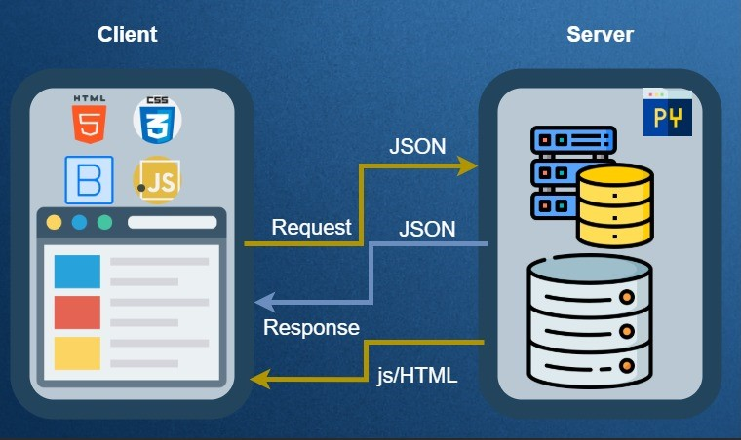

**Fig. ‎3‑1. SPA**

# UML Diagrams:

## Use-case Diagram

Use case diagram is a representation of our users interaction with the system in StoresHub.  
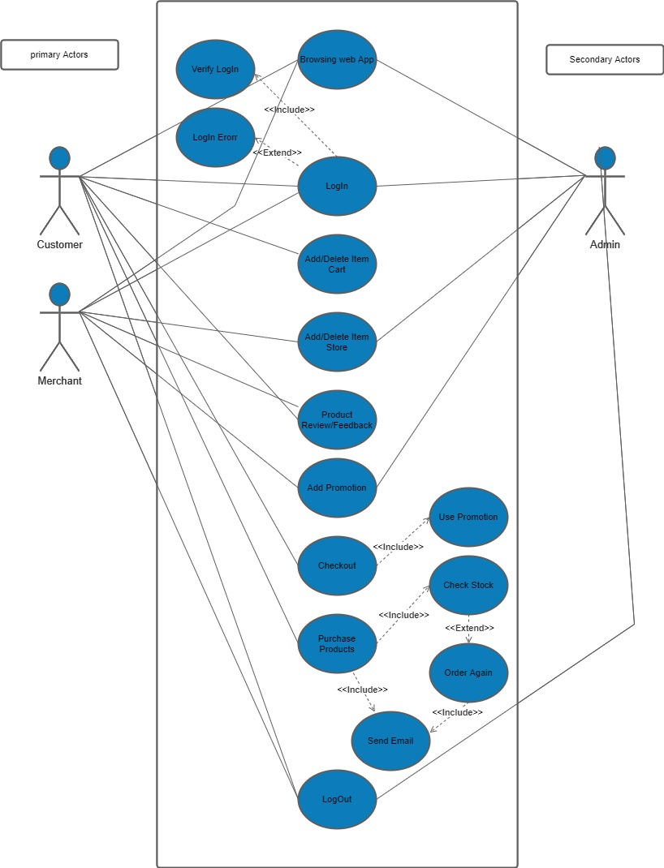

**Fig. ‎3‑1. 3.12.1 Use-case Diagram**

|  |  |  |
| --- | --- | --- |
| **Use Case UC-: 1** | | **Login** |
| **Actors:** | Admin, Customer, Merchant | |
| **Type:** | Primary and essential | |
| **Description:** | Start when a user attempts an action that is restricted. The user must to enter username and password in order to continue | |
| **Includes:** | Verify Login | |
| **Extends:** | Login Error | |
| **Cross Ref:** | None | |
| **Use-Cases:** | None | |

|  |  |  |
| --- | --- | --- |
| **Use Case UC-: 2** | | **Logout** |
| **Actors:** | Admin, Customer, Merchant, System | |
| **Type:** | Primary and essential | |
| **Description:** | The customer, admin or merchant will have the option to logout and if the user is idle for a specific time then the user will be logged out by the system automatically | |
| **Includes:** | None | |
| **Extends:** | None | |
| **Cross Ref:** | None | |
| **Use-Cases:** | User must Log In correctly use case | |

|  |  |  |
| --- | --- | --- |
| **Use Case UC-: 3** | | **Browse Web Application** |
| **Actors:** | Admin, Customer, Merchant | |
| **Type:** | Primary and Essential | |
| **Description:** | All Actors could browse the website | |
| **Includes:** | None | |
| **Extends:** | None | |
| **Cross Ref:** | None | |
| **Use-Cases:** | None | |

|  |  |  |
| --- | --- | --- |
| **Use Case UC-: 4** | | Add/ Delete Items to cart |
| **Actors:** | **Customer** | |
| **Type:** | Primary and Essential | |
| **Description:** | Allows the customer to add selected items in the shopping cart for later purchase | |
| **Includes:** | None | |
| **Extends:** | None | |
| **Cross Ref:** | None | |
| **Use-Cases:** | Customer must be Logged In use case | |

|  |  |  |
| --- | --- | --- |
| **Use Case UC-:5** | | Add/Delete item from store |
| **Actors:** | Merchant, Admin | |
| **Type:** | Primary and Essential | |
| **Description:** | Allows the Merchant and Admin to add products to their store | |
| **Includes:** | None | |
| **Extends:** | None | |
| **Cross Ref:** | None | |
| **Use-Cases:** | Merchant must be Logged In use case | |

|  |  |  |
| --- | --- | --- |
| **Use Case UC-:6** | | Add Promotion |
| **Actors:** | Merchant, Admin | |
| **Type:** | Primary | |
| **Description:** | This allows the Merchant and Admin to add a special promotion code. This will email all customers who are members to inform them of the new promotion | |
| **Includes:** | None | |
| **Extends:** | None | |
| **Cross Ref:** | None | |
| **Use-Cases:** | Admin and Merchant must be Logged In use case | |

|  |  |  |
| --- | --- | --- |
| **Use Case UC-:7** | | **Checkout** |
| **Actors:** | Customer | |
| **Type:** | Primary and Essential | |
| **Description:** | This takes the product from the customers shopping cart and processes them for a purchase | |
| **Includes:** | Use Promotion | |
| **Extends:** | None | |
| **Cross Ref:** | None | |
| **Use-Cases:** | Customer must be Logged In use case | |

|  |  |  |
| --- | --- | --- |
| **Use Case UC-:8** | | Use Promotion |
| **Actors:** | **Customer** | |
| **Type:** | Primary | |
| **Description:** | If the user is member then they have the option to enter a promotion code to take off a percentage from the total price | |
| **Includes:** | None | |
| **Extends:** | None | |
| **Cross Ref:** | None | |
| **Use-Cases:** | Checkout use cases, Customer must be Logged In use case and Add Promotion use case | |

|  |  |  |
| --- | --- | --- |
| **Use Case UC-:9** | | Purchase Product |
| **Actors:** | **Customer** | |
| **Type:** | Secondary | |
| **Description:** | happen when the customer clicks the order button in checkout. This decrements the inventory of all items, email the user and check stock to see if order again needs to take | |
| **Includes:** | Send Email, Check Stock | |
| **Extends:** | None | |
| **Cross Ref:** | None | |
| **Use-Cases:** | Customer must be Logged In use case and Checkout use cases | |

|  |  |  |
| --- | --- | --- |
| **Use Case UC-:10** | | Check Stock |
| **Actors:** | **System** | |
| **Type:** | Secondary | |
| **Description:** | Checks to see if stop-order is on for a particular item and if it is checks to see if the amount in stock is below the reorder amount. If it is then it will reorder | |
| **Includes:** | None | |
| **Extends:** | order again | |
| **Cross Ref:** |  | |
| **Use-Cases:** |  | |

|  |  |  |
| --- | --- | --- |
| **Use Case UC-:11** | | Order Again |
| **Actors:** | **System** | |
| **Type:** | Secondary | |
| **Description:** | Reorders a particular item and emails the Admin when product is out of stock | |
| **Includes:** | Send email | |
| **Extends:** | None | |
| **Cross Ref:** | None | |
| **Use-Cases:** | check stock use case | |

|  |  |  |
| --- | --- | --- |
| **Use Case UC-:12** | | Send Email |
| **Actors:** | **System** | |
| **Type:** | Secondary | |
| **Description:** | sends email to the customer if purchase occur correctly or need to order again | |
| **Includes:** | None | |
| **Extends:** | None | |
| **Cross Ref:** | None | |
| **Use-Cases:** | Purchase Product use case | |

|  |  |  |
| --- | --- | --- |
| **Use Case UC-:13** | | Product Review/Feedback |
| **Actors:** | **Customer, Merchant** | |
| **Type:** | Primary | |
| **Description:** | Give a review and feedback about particular product | |
| **Includes:** | None | |
| **Extends:** | None | |
| **Cross Ref:** | None | |
| **Use-Cases:** | Must login use case | |

## Activity Diagram

This is an activity diagram that explain the activities of the system.

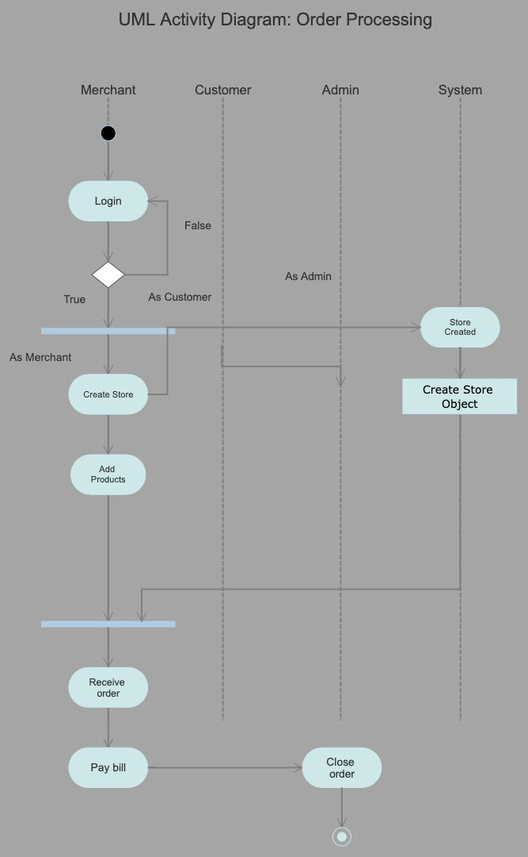

**Fig. ‎3‑1. 3.12.2 Activity Diagram of Order**

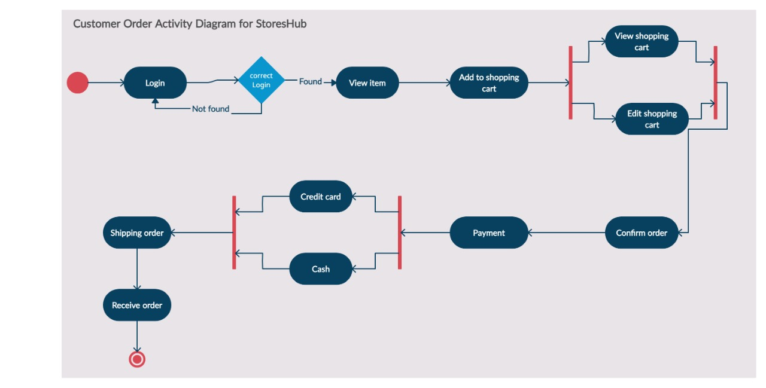

**Fig. ‎3‑2. 3.12.2 Activity Diagram of Customer Activities**

## Sequence diagram

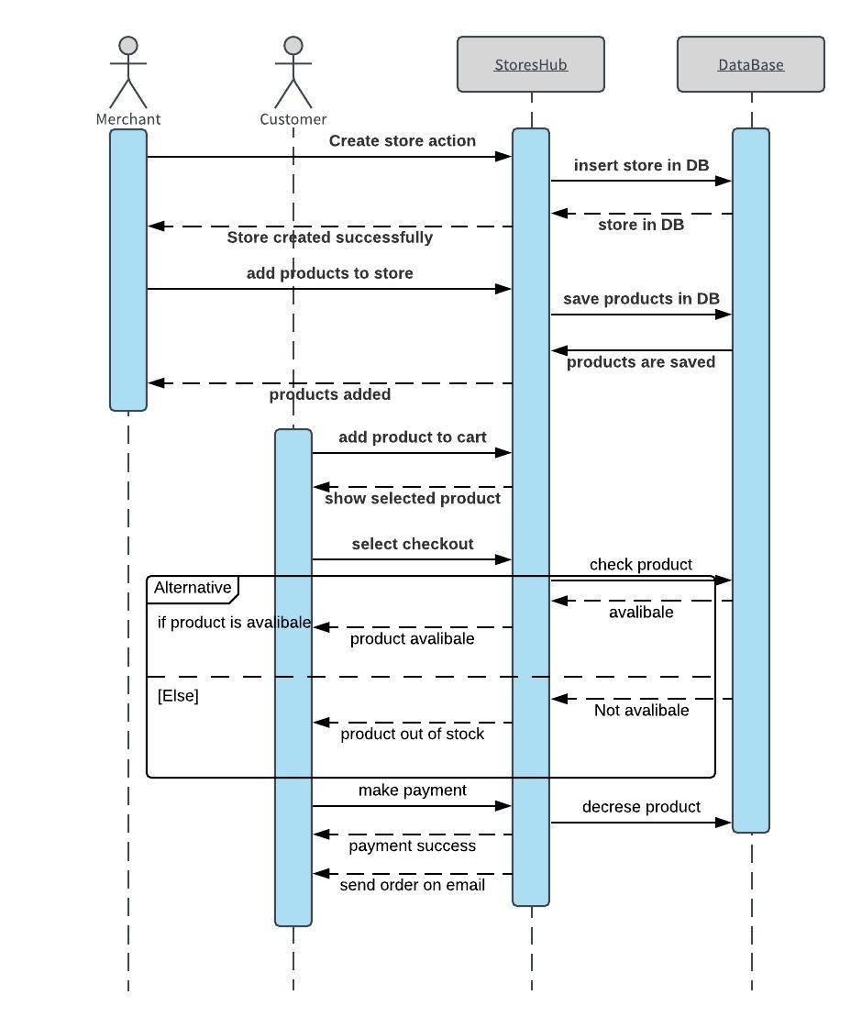

**Fig. ‎3‑1. 3.12.3 Sequence diagram**

## Class Diagram

**Fig. ‎3‑1. Class Diagram**

|  |  |  |
| --- | --- | --- |
| **Class** | | |
| ***This is a single product in which there are many in the system. They can also be a part of a customer.*** | | ***Product*** |
| ***Public: No*** | |
| Associations: **Merchant, OrderDetails** | ***Relationships*** |
| Aggregations: **Customer** |
| Generalization: None |
| ***Variables - id: int, name: string, price: double, quantity: int, description: string, feedBack: review, image: image***  ***Functions -None*** | |

|  |  |  |
| --- | --- | --- |
| **Class** | | |
| ***This is the base class where Customer, Merchant and Admin are extended and sharing the variables.*** | | ***user*** |
| ***Public: Yes*** | |
| Associations: None | ***Relationships*** |
| Aggregations: None |
| Generalization: Customer, Admin, Merchant |
| ***Variables -*** userID: int, userFirstName: string, userLastName: string, userName: string, userEmail: string, phoneNumber: int , password: string, loginStatus: string, registerDate: date  ***Functions - None*** | |

|  |  |  |
| --- | --- | --- |
| **Class** | | |
| ***This is a shopping cart class where customer could add products.*** | | **Shopping Cart** |
| ***Public: No*** | |
| Associations: Customer | ***Relationships*** |
| Aggregations: None |
| Generalization: None |
| ***Variables -*** cartId: int - productId: product - quantity: product - price: product - name: product  ***Functions -*** | |

|  |  |  |
| --- | --- | --- |
| **Class** | | |
| ***This is a class contains shipping information.*** | | **ShippingInfo** |
| ***Public: No*** | |
| Associations: None | ***Relationships*** |
| Aggregations: Order Generalization: |
| Generalization: |
| ***Variables -*** shippingId: int - shippingType: string - price: double - shippingCost: double  ***Functions - None*** | |

|  |  |  |
| --- | --- | --- |
| **Class** | | |
| ***Customer class inherited from user and have unique features for the customers*** | | **Customer** |
| ***Public: No*** | |
| Associations: Order | ***Relationships*** |
| Aggregations: **Payment**, **Address** |
| Generalization: None |
| ***Variables -*** Address: address - payment: payment - order: order - shippingInfo: order ***Functions - None*** | |

|  |  |  |
| --- | --- | --- |
| **Class** | | |
| ***Order class contains all order informations.*** | | **Order** |
| ***Public: No*** | |
| Associations: **OrderStatus, Customer** | ***Relationships*** |
| Aggregations: |
| Generalization: None |
| ***Variables -*** number: int - customerName: customer - ordered: date - price: double - shipped: date - shippedTo: customer - status: orderStatus - total; double - payment: customer  ***Functions -*** | |

|  |  |  |
| --- | --- | --- |
| **Class** | | |
| ***This class provide a details of product to used in order class*** | | **OrderDetails** |
| ***Public: No*** | |
| Associations: **OrderDetails** | ***Relationships*** |
| Aggregations: None |
| Generalization: Item |
| ***Variables -*** d: int - name: string - price: double - description: string - feedBack: review - image: image ***Functions - None*** | |

|  |  |  |
| --- | --- | --- |
| **Class** | | |
| ***Merchant class is the one who could add product to the store and create a store*** | | **Merchant** |
| ***Public: No*** | |
| Associations: Promotion | ***Relationships*** |
| Aggregations: None |
| Generalization: None |
| ***Variables -*** toreName: string - storeId: int ***Functions -*** creatSttore() + addProductToStore() | |

|  |  |  |
| --- | --- | --- |
| **Class** | | |
| ***This is a single item in which there are many in the system and they are all part of the inventory. They can also be a part of shopping carts and a transaction.*** | | **Payment** |
| ***Public: No*** | |
| Associations: None | ***Relationships*** |
| Aggregations: **Customer** |
| Generalization: **Card, Cash** |
| ***Variables*** d: int - paid: date - amount: double - cardInfo: card  ***Functions -*** | |

|  |  |  |
| --- | --- | --- |
| **Class** | | |
| ***This class express Order class status such as, new, shipped, closed and so on,*** | | **OrderStatus** |
| ***Public: No*** | |
| Associations: Order | ***Relationships*** |
| Aggregations: None |
| Generalization: None |
| ***Variables -*** status  ***Functions - None*** | |

|  |  |  |
| --- | --- | --- |
| **Class** | | |
| This Admin class has the additional ability of modifying items and creating promotion. | | **Admin** |
| ***Public: No*** | |
| Associations: **Promotion** | ***Relationships*** |
| Aggregations: None |
| Generalization: None |
| ***Variables –***  ***Functions -*** | |

|  |  |  |
| --- | --- | --- |
| **Class** | | |
| ***Address class that provides information about customer location for later shipping*** | | **Address** |
| ***Public: No*** | |
| Associations:None | ***Relationships*** |
| Aggregations: **Customer** |
| Generalization: None |
| ***Variables -*** treet1: string - street2: string - city: string - state: string -postalCode:string - country: string  ***Functions - CheckStock()*** | |

|  |  |  |
| --- | --- | --- |
| **Class** | | |
| ***Class that has information about the customer credit card.*** | | **Card** |
| ***Public: No*** | |
| Associations:None | ***Relationships*** |
| Aggregations: None |
| Generalization: |
| ***Variables - c***ardNumber: string - cardName: string - cvsCode: int - cardDate: date ***Functions - None*** | |

# Conclusion

In this chapter we did analyze the system and discussed the user characteristics and determine the types of users who we are targeting. Followed by product perspective and functions, then the system constrains and interfaces. Although extend the software requirements specification in both functional and non-functional described in details. At the end, we tried to give an overview of how our project works in high-level and low-level description represented in UML diagrams.

##### References:

[1] Kaura, A. (2020, October 15). *E-commerce Web Application: Why Your Business Needs One?* Seasia Infotech Blog. https://www.seasiainfotech.com/blog/e-commerce-web-application-business-needs-one/

[2] Editorial Team. (2021, January 14). *What Is An E-Commerce Website & How To Build One*. CyberChimps. <https://cyberchimps.com/e-commerce-websites/>

[3] "From History of Web Application Development", *Devsaran*, 2021. [Online]. Available: https://www.devsaran.com/blog/history-web-application-development. [Accessed: 11- Mar- 2021].

[4]"Web Application vs. Website", *Vibethink*, 2021. [Online]. Available: https://vibethink.com/web-application-vs-website/. [Accessed: 14- Mar- 2021].

[5] "Web App development for Data Scientists", *Medium*, 2021. [Online]. Available: https://towardsdatascience.com/web-app-development-for-data-scientists-48e445e54d7b. [Accessed: 15- Mar- 2021].

[6] "Medium", *Medium*, 2021. [Online]. Available: https://medium.com/@essentialdesign/website-vs-web-app-whats-the-difference-e499b18b60b4. [Accessed: 10- Mar- 2021].

[7] "Difference between Website and Web Application", *Guru99.com*, 2021. [Online]. Available: https://www.guru99.com/difference-web-application-website.html#:~:text=Summary%3A,you%20in%20branding%20your%20business. [Accessed: 11- Mar- 2021].

[8] IEEE Software Engineering Standards Committee, “IEEE Std 830-1998, IEEE Recommended Practice for Software Requirements Specifications”, October 20, 1998.

[9] J. Samuel, Z. Zheng and Y. Xie, "Value of Local Showrooms to Online Competitors", *MIS Quarterly*, vol. 44, no. 3, pp. 1073-1106, 2020. Available: 10.25300/misq/2020/15291.

[10] C. Lofi, W. Balke and U. Guntzer, "Eliciting Customer Wishes Using Example-Based Heuristics in E-Commerce Applications," 2011 IEEE 13th Conference on Commerce and Enterprise Computing, Luxembourg-Kirchberg, Luxembourg, 2011, pp. 74-81, doi: 10.1109/CEC.2011.26.

[11] Samuel, J., Zhiqiang (Eric) Zheng and Ying Xie (2020) ‘Value of Local Showrooms to Online Competitors’, MIS Quarterly, 44(3), pp. 1073–1106. Available at: http://search.ebscohost.com.sdl.idm.oclc.org/login.aspx?direct=true&db=bsu&AN=145446039&site=eds-live (Accessed: 11 April 2021)

[12] Wienclaw, R. A. (2020) ‘E-Commerce’, Research Starters: Business. Available at: http://search.ebscohost.com.sdl.idm.oclc.org/login.aspx?direct=true&db=ers&AN=89163657&site=eds-live (Accessed: 11 April 2021).

[13] Yadav, D. et al. (2018) ‘Vulnerabilities and Security of Web Applications’, 2018 4th International Conference on Computing Communication and Automation (ICCCA), Computing Communication and Automation (ICCCA), 2018 4th International Conference on, pp. 1–5. doi: 10.1109/CCAA.2018.8777558.

[14] Chatley, R. et al. (2003) ‘Visual methods for Web application design’, IEEE Symposium on Human Centric Computing Languages and Environments, 2003. Proceedings. 2003, Human Centric Computing Languages and Environments, 2003. Proceedings. 2003 IEEE Symposium on, Human centric computing languages and environments, pp. 242–244. doi: 10.1109/HCC.2003.1260236.

[15] Kiruthika, J. et al. (2016) ‘User Experience Design in Web Applications’, 2016 IEEE Intl Conference on Computational Science and Engineering (CSE) and IEEE Intl Conference on Embedded and Ubiquitous Computing (EUC) and 15th Intl Symposium on Distributed Computing and Applications for Business Engineering (DCABES), Computational Science and Engineering (CSE) and IEEE Intl Conference on Embedded and Ubiquitous Computing (EUC) and 15th Intl Symposium on Distributed Computing and Applications for Business Engineering (DCABES), 2016 IEEE Intl Conference on, CSE-EUC-DCABES, pp. 642–646. doi: 10.1109/CSE-EUC-DCABES.2016.253.