System Design
Document
Driving License Management Application

1 | System Overview
2 | Architecture
3 | UML Diagrams
4 | System Design
5 | Deployment Diagram
6 | Security Considerations
7 | API Design (Future Enhancement)
8 | Error Handling
9 | Reports

1. System Overview

The Driving & Vehicle License Department (DVLD) System is a desktop-based management system designed to automate and manage driving license services and operations within the DVLD department. The system provides efficient management of applicants, drivers, licenses, applications, driving tests, and user operations.
The system aims to improve operational efficiency, reduce manual paperwork, maintain accurate records, and support secure and reliable license processing operations.

Main Modules and Services
- User Management
- Person Management
- Driver Management
- License Application Management
- Test Type Management
- Test Management
- License Class Management
- Driving License Issuance
- License Renewal Services
- Lost and Damaged License Replacement Services
- International Driving License Services
- Driving License Detention and Release Management
- Audit and Activity Logging
- Search and Reporting Services

2. Architecture

2.1 Architectural Style
The DVLD System follows a 3-Tier Layered Architecture approach to separate system responsibilities and improve maintainability, scalability, and modularity.
The system architecture is divided into the following layers:

Presentation Layer

Business Layer

Data Access Layer

3-Tier Architecture Diagram
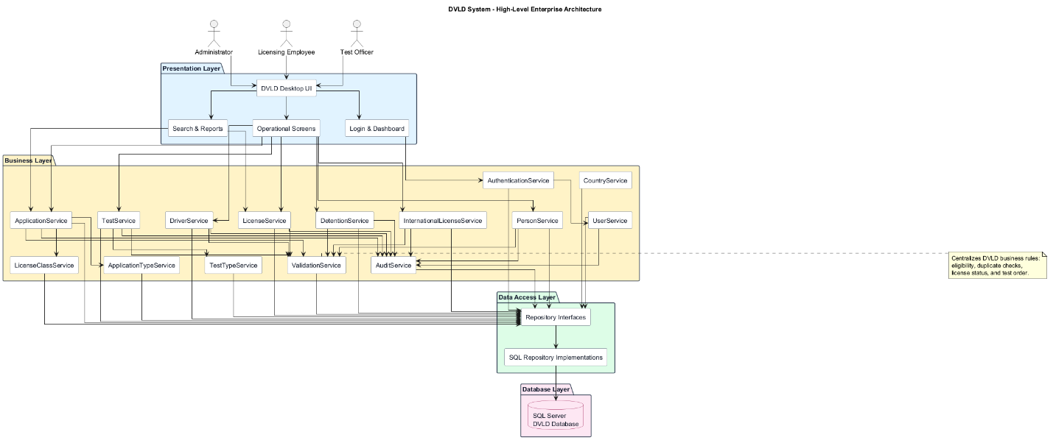

2.2 Architecture Flow
The DVLD System processes requests using a layered request-response workflow.
Presentation Layer → Business Layer → Data Access Layer → Database

Workflow Description
- The user interacts with the Presentation Layer through system forms and screens.
- Requests are forwarded to the Business Layer for validation and business logic processing.
- The Business Layer communicates with the Data Access Layer.
- The Data Access Layer performs database operations.
- Results are returned back to the Presentation Layer and displayed to the user.

2.3 Layers Description
Presentation Layer (GUI Layer)
The Presentation Layer is responsible for rendering the graphical user interface and handling user interactions. It forwards user requests to the Business Layer and displays processed results.
- Responsible for rendering the graphical user interface of the DVLD System.
- Handles forms, windows, dialogs, and user interactions.
- Receives user input and displays processed results.
- Contains no business logic.
- Communicates only with the Business Layer.

B. Business Layer (Service Layer)
The Business Layer contains services responsible for business rules and operational workflows, including application types, license classes, test types, and audit logging services.
- Contains the core business logic and validation rules of the system.
- Processes driving license applications, tests, renewals, and other services.
- Enforces business rules and workflow processing.
- Coordinates communication between the Presentation Layer and Data Access Layer.
- Independent from user interface and database implementation details.

C. Data Access Layer (Repository Layer)
The Data Access Layer uses repositories for each main entity and database table to isolate database operations from business logic.
- Responsible for database communication and data persistence.
- Performs Create, Read, Update, and Delete (CRUD) operations.
- Handles queries, transactions, and repository operations.
- Provides centralized access to database resources.
- Communicates directly with the Database Layer.

D. Database Layer
The Database Layer stores operational and reference data such as countries, application types, test types, and license classes.
- Stores all system data including users, persons, drivers, licenses, applications, and audit logs.
- Maintains relational database tables and constraints.
- Ensures data consistency and referential integrity.
- Supports secure and reliable data storage operations.

2.4 Service Layer Design
The Service Layer represents the core business logic of the DVLD System. It acts as an intermediary between the Presentation Layer and the Data Access Layer.
The Presentation Layer sends user requests to the appropriate service class. The service class validates the request, applies business rules, coordinates required operations, and communicates with the Data Access Layer when database access is needed.

Service | Responsibility
AuthenticationService | Handles user login, authentication, and account status validation.
UserService | Manages system users, permissions, activation, and user account operations.
PersonService | Manages person records, including adding, updating, deleting, viewing, and searching persons.
DriverService | Manages driver records and links drivers to issued licenses.
ApplicationService | Handles license applications, application status, and application tracking.
LicenseService | Handles license issuance, renewal, replacement, and license inquiry operations.
TestService | Handles test appointments, test results, retake tests, and test validation.
LicenseClassService | Manages license class settings such as minimum age, validity period, and fees.
TestTypeService | Manages test type settings and test fees.
DetentionService | Handles license detention and release operations.
InternationalLicenseService | Handles international driving license issuance and validation.
AuditService | Records important system operations, including the user who performed the operation and the operation date.
CountryService | Manages country and nationality reference data.
ApplicationTypeService | Manages application types and application fees.

Service Layer Rules
- The Presentation Layer shall not communicate directly with the database.
- All business rules shall be applied in the Service Layer.
- Services shall use the Data Access Layer for database operations.
- Each service shall focus on a specific business responsibility.
- Services shall support maintainability, testability, and separation of concerns.

2.5 SOLID Principles
Single Responsibility Principle (SRP) | Each class in the DVLD System is responsible for a single functionality or business responsibility only.

Open / Closed Principle (OCP) | System components are designed to allow extension without modifying existing source code.

Liskov Substitution Principle (LSP) | Derived classes can replace their base classes without affecting system correctness or functionality.

Interface Segregation Principle (ISP) | Clients should not be forced to depend on interfaces they do not use.

Dependency Inversion Principle (DIP) | High-level modules depend on abstractions rather than concrete implementations to reduce coupling and improve flexibility.

2.6 Design Patterns
The DVLD System applies selected design patterns to improve code organization, maintainability, reusability, and separation of concerns.
Pattern | Usage in the DVLD System
Singleton | Used for shared services or configuration objects that should have only one instance during application execution.
Factory Method | Used to create objects related to license services, test types, or application types without tightly coupling the code to concrete classes.
Repository Pattern | Used in the Data Access Layer to centralize database operations and isolate data access logic from the Business Layer.
Strategy Pattern | Used when different business rules or processing behaviors may vary, such as handling different license services or validation workflows.
Observer Pattern | Used only if the system needs event-based notifications or automatic updates between components.

3. UML Diagrams

3.1 Use Case Descriptions
Use Case Descriptions provide detailed explanations of the main system functionalities, including the primary actors and the purpose of each use case.

Use Case ID | Use Case Name | Actor | Preconditions | Main Flow | Postconditions
UC-01 | Manage Users | Administrator | Admin is logged in. | Admin adds, updates, deletes, deactivates users, or manages permissions. | User account information is updated.
UC-02 | Manage Persons | Licensing Employee | Employee is logged in. | Employee adds, views, updates, deletes, or searches person records. | Person information is saved or updated.
UC-03 | Manage Applications | Licensing Employee | Applicant exists in the system. | Employee creates, updates, views, searches, or filters applications. | Application record is created or updated.
UC-04 | Schedule Tests | Licensing Employee | Application exists and is valid. | Employee selects test type, sets appointment date, and saves appointment. | Test appointment is scheduled.
UC-05 | Record Test Results | Test Officer | Test appointment exists. | Test officer records Pass/Fail result and written test score if applicable. | Test result is saved.
UC-06 | Issue Driving License | Licensing Employee | Applicant passed all required tests and conditions. | Employee verifies eligibility and issues the license. | New driving license is generated.
UC-07 | Renew Driving License | Licensing Employee | License exists and is expired. | Employee verifies vision test and renewal requirements. | Renewed license is issued.
UC-08 | Replace Lost License | Licensing Employee | License exists and is not detained. | Employee verifies license status and issues replacement. | Lost license replacement is issued.
UC-09 | Replace Damaged License | Licensing Employee | Damaged license is surrendered. | Employee verifies license and issues replacement. | Damaged license replacement is issued.
UC-10 | Detain License | Licensing Employee | License exists. | Employee enters license number, fine amount, reason, and detention date. | License detention record is saved.
UC-11 | Release Detained License | Licensing Employee | License is detained and fine is paid. | Employee releases the license and records release date. | License is released.
UC-12 | Issue International License | Licensing Employee | Driver has valid non-detained Class 3 license. | Employee validates eligibility and issues international license. | International license is issued.
UC-13 | Search Records | Licensing Employee | User is logged in. | User searches persons, applications, drivers, licenses, or tests. | Matching records are displayed.
UC-14 | Manage License Classes | Administrator | Admin is logged in. | Admin updates license age, validity period, or fees. | License class settings are updated.
UC-15 | Manage Test Types | Administrator | Admin is logged in. | Admin updates test fees. | Test fee settings are updated.

3.2 Use Case Diagram

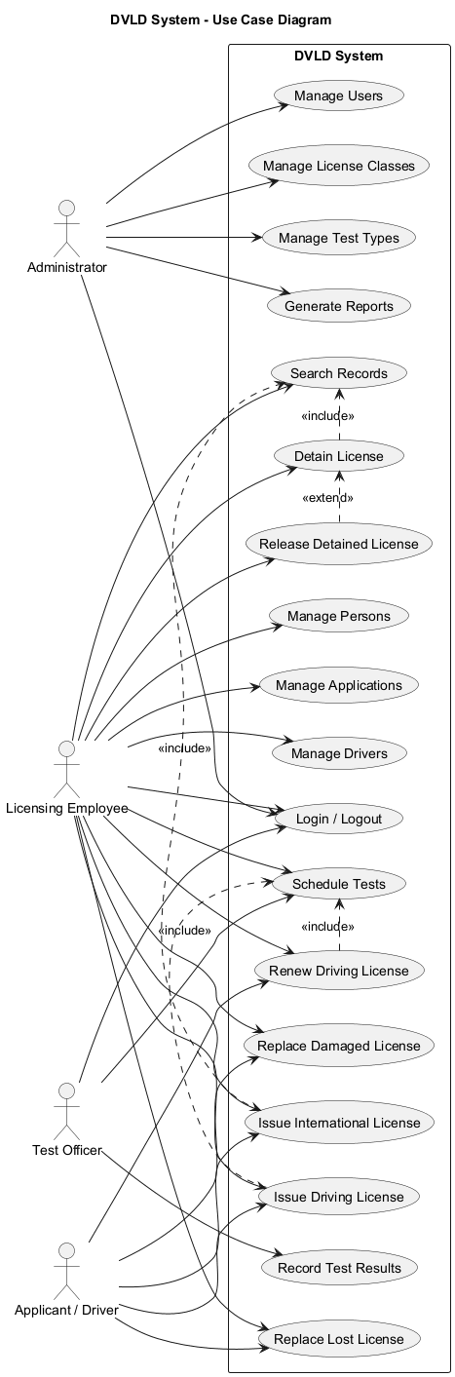

3.3 Conceptual Class Diagram
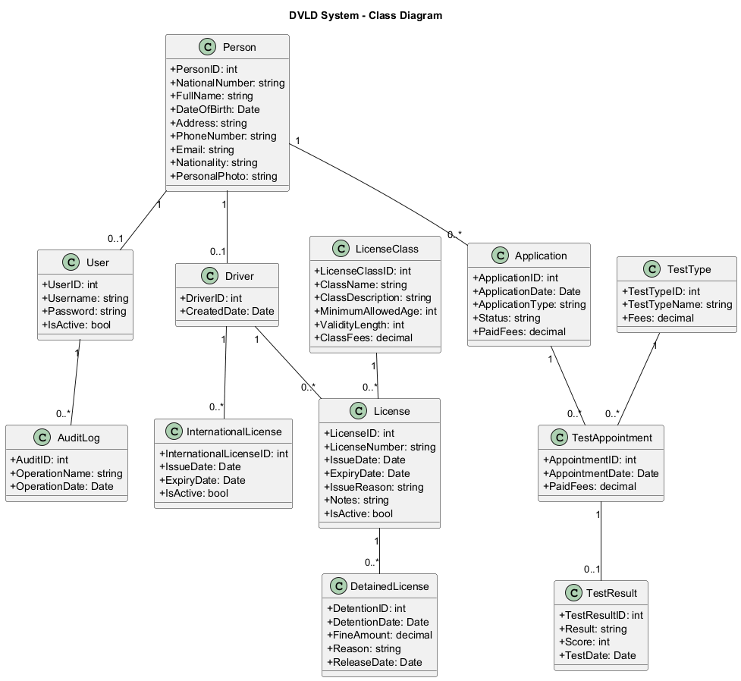

3.4 Sequence Diagrams
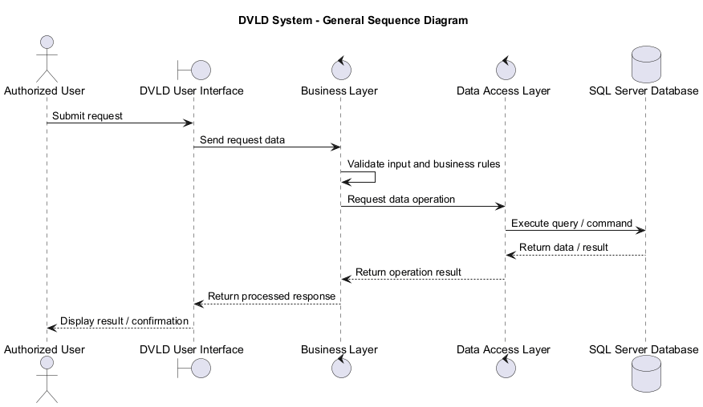

3.5 Activity Diagrams
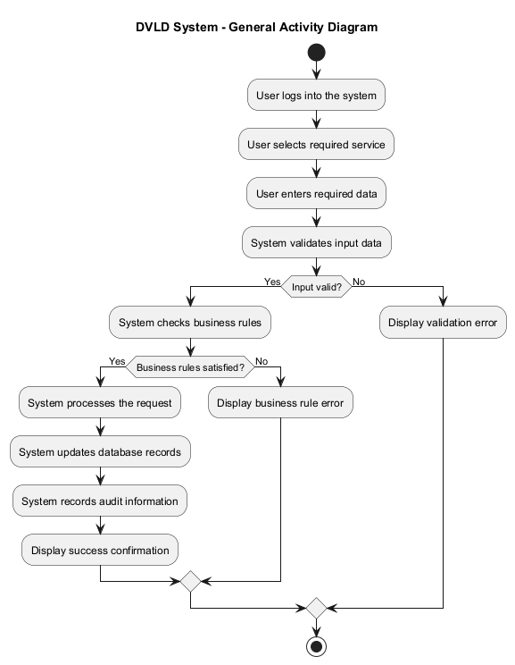

4. System Design

4.1 UI Flow / Navigation
The DVLD System provides a structured navigation flow that allows users to access system modules and services according to their permissions.
The navigation process starts from the Login Screen and provides access to the main system modules including User Management, License Services, Test Management, Driver Management, and Reporting Services.
The following diagram illustrates the main UI navigation flow of the system.

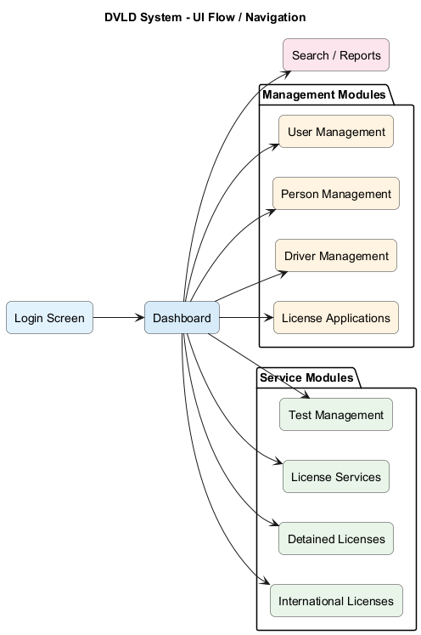

4.2 Module Interaction
The DVLD System modules communicate through the Business Layer to ensure workflow integration and data consistency across the system.
The following diagram illustrates the interaction between the main system modules.
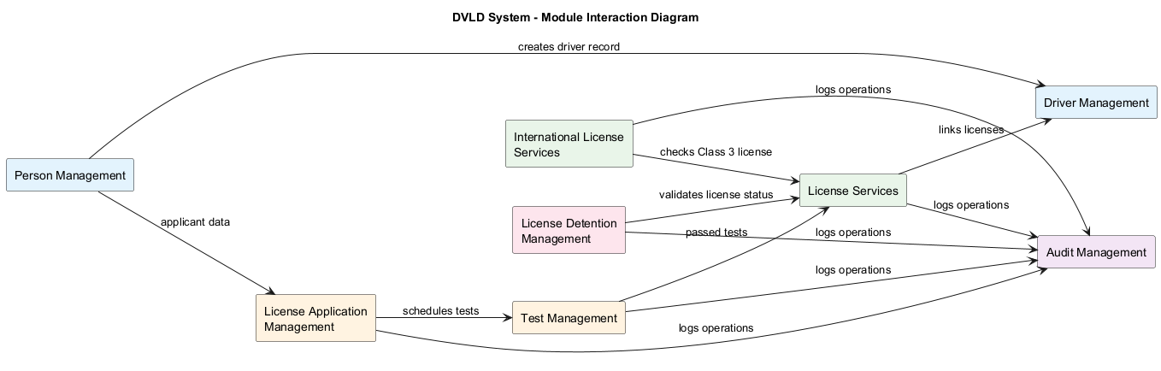

4.3 Screen Flow
The screen flow represents the movement between the main system screens during user operations and service processing.
The following diagram illustrates the general screen flow of the DVLD System.

5. Deployment Diagram

The Deployment Diagram illustrates the physical deployment structure of the DVLD System and shows how the application components are distributed across client machines and the database server.
The DVLD System is deployed as a desktop application installed on DVLD employee workstations. Each workstation runs the Presentation Layer and communicates with the Business Layer and Data Access Layer within the application. The Data Access Layer connects to a centralized SQL Server database that stores all system data.

Deployment Components
- Client Workstation: Runs the DVLD desktop application.
- DVLD Desktop Application: Contains the Presentation Layer, Business Layer, and Data Access Layer.
- SQL Server Database: Stores users, persons, drivers, licenses, applications, tests, and audit records.
- Local Network: Provides communication between client workstations and the database server.

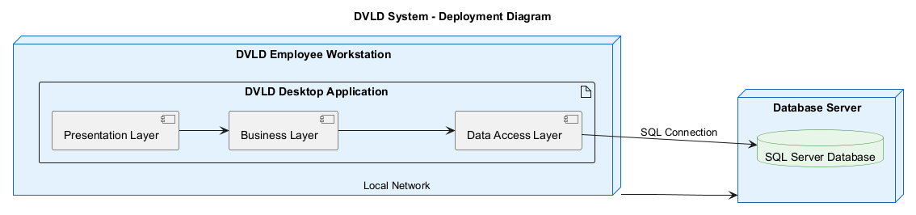

6. Security Considerations

The DVLD System applies security controls to protect user accounts, system data, and licensing operations.
Area | Security Consideration
Authentication | Users must log in using a valid username and password before accessing the system.
Authorization | System features shall be restricted based on assigned user roles and permissions.
Password Security | User passwords shall be securely hashed and shall not be stored in plain text.
Password Policy | Passwords should follow minimum length and complexity requirements.
Input Validation | All user inputs shall be validated before processing.
Data Access | Direct database access from the Presentation Layer shall not be allowed.
Audit Logging | Sensitive and important system operations shall be recorded with the user and operation date.
Account Status | Deactivated users shall not be allowed to access the system.
Session Management | User sessions shall expire automatically after inactivity.
Session Protection | Unauthorized session reuse shall be prevented.

7. API Design (Future Enhancement)

The current DVLD System is designed as a desktop application. However, a future version may expose RESTful APIs to support web applications, mobile applications, online services, and integration with external systems.
API Design Goals
- Support future web and mobile applications.
- Enable integration with national ID, payment, and traffic violation systems.
- Provide secure access to DVLD services.
- Allow external systems to query license and driver information.
- Maintain separation between client applications and business logic.

Suggested API Endpoints

Method | Endpoint | Description
POST | /api/auth/login | Authenticate system users.
GET | /api/persons/{nationalNumber} | Retrieve person information by national number.
POST | /api/persons | Create a new person record.
PUT | /api/persons/{personId} | Update person information.
GET | /api/drivers/{driverId} | Retrieve driver information.
GET | /api/applications/{applicationId} | Retrieve application details.
POST | /api/applications | Create a new license application.
PUT | /api/applications/{applicationId} | Update application information.
GET | /api/licenses/{licenseNumber} | Retrieve driving license information.
POST | /api/licenses/issue | Issue a new driving license.
POST | /api/licenses/renew | Renew a driving license.
POST | /api/licenses/replace-lost | Issue a replacement for a lost license.
POST | /api/licenses/replace-damaged | Issue a replacement for a damaged license.
POST | /api/licenses/detain | Detain a driving license.
POST | /api/licenses/release | Release a detained driving license.
POST | /api/international-licenses | Issue an international driving license.
POST | /api/tests/appointments | Schedule a test appointment.
PUT | /api/tests/results/{testId} | Record test results.
GET | /api/reports/audit-logs | Retrieve audit log records.

API Security Considerations
- APIs shall require authentication before access.
- Role-based authorization shall be applied to protected endpoints.
- Sensitive data shall be transmitted over secure channels.
- Input validation shall be applied to all API requests.
- API operations shall be recorded in audit logs.

8. Error Handling

The DVLD System shall handle errors in a clear and controlled manner to improve reliability and user experience.
Error Type | Handling Strategy
Validation Errors | Display clear messages when required fields are missing or invalid.
Authentication Errors | Display login failure messages without exposing sensitive information.
Authorization Errors | Prevent unauthorized access and display an access denied message.
Database Errors | Handle database connection or query failures and prevent application crashes.
Business Rule Errors | Display meaningful messages when license rules or eligibility conditions are violated.
Duplicate Data Errors | Prevent duplicate records such as repeated national numbers or duplicate active applications.
Unexpected Errors | Display a general error message and record the error for review.

Additional Error Handling Requirements
- The system shall display user-friendly error messages.
- The system shall log unexpected system exceptions.
- The system shall prevent application crashes caused by invalid operations or corrupted input.
- The system shall maintain data consistency during unexpected failures.
- The system shall allow safe recovery after system restart.

9. Reports

The DVLD System may provide reporting and inquiry features to support operational monitoring and decision-making.
Report / Inquiry | Description
Person Records Report | Displays stored person information and search results.
Driver Records Report | Displays driver information and linked licenses.
License History Report | Shows issued, renewed, replaced, and international licenses.
Application Status Report | Displays applications according to status such as New, Cancelled, or Completed.
Test Results Report | Shows vision, written, and practical test results.
Detained Licenses Report | Displays detained licenses, fine amounts, reasons, and release status.
License Expiration Report | Shows licenses near expiration
Audit Log Report | Displays user operations and operation dates.
Audit Activity Report | Shows system operations

10. Permission Matrix

Module | Admin | Employee | Test Officer
User Management | ✔ | ✖ | ✖
Test Management | ✖ | ✔ | ✔
License Services | ✖ | ✔ | ✖

Enterprise Security, Backup, And Recovery Addendum
This section defines concise operational controls for protecting DVLD data, recovering from failures, and preserving accountability in enterprise use.

Backup Strategy
- SQL Server database backups should be scheduled and monitored according to the approved operations calendar.
- Backup files should be stored in an approved secure location separate from the production database host where possible.
- Backup completion must be verified, and failed backups should be escalated to the responsible technical owner.
- Periodic restore tests should confirm that backups are usable, complete, and aligned with recovery expectations.

Recovery Strategy
- If the desktop application fails, users should restart the application and avoid repeating partially completed operations until record status is verified.
- Database recovery should follow the approved SQL Server restore process using the latest verified backup and any available recovery logs.
- After unexpected shutdown, critical records such as applications, tests, licenses, detention records, and payments should be checked for consistency.
- Recovery responsibility should be assigned to the system administrator or designated technical support owner.

Password Hashing
- User passwords must be stored as hashes, not plain text.
- Authentication should verify submitted credentials by comparing the computed password hash with the stored hash.
- Credentials, password hashes, and authentication secrets must not be exposed in logs, error messages, screenshots, or reports.

Session Timeout
- Authenticated sessions should expire after a defined period of inactivity.
- Inactive or deactivated users must not be allowed to continue using the system after account status changes are detected.
- Unauthorized session reuse should be prevented by clearing session state on logout, timeout, and failed authorization checks.

Audit Retention
- Important system operations should be logged, including login attempts, user management, application changes, test results, license issuance, detention, and release actions.
- Audit records should include the responsible user, operation name, date/time, affected entity, and outcome where practical.
- Audit records should be retained according to an approved organizational retention policy and protected from unauthorized modification.

