Database Design
Document
Driving License Management Application

1 | Database Overview
2 | ERD / EERD
3 | Database Schema
4 | Tables Description
5 | Relationships
6 | Primary Keys & Foreign Keys
7 | Constraints
8 | Data Dictionary

1. Database Overview

The DVLD database is designed to support the management of driving license operations, applications, drivers, tests, and licensing services within the Driving & Vehicle License Department.
The database structure follows a relational database design using SQL Server and ensures data consistency, integrity, and efficient transaction processing.
The database stores and manages:
- Person and driver information
- User accounts and permissions
- Driving license applications
- Driving tests and appointments
- License issuance and renewal operations
- International licenses
- Detained licenses and release operations
- Audit and tracking information
The database design is normalized to reduce redundancy and maintain reliable relationships between system entities.

2. ERD / EERD

The Entity Relationship Diagram (ERD) and Enhanced Entity Relationship Diagram (EERD) illustrate the logical structure of the DVLD database and the relationships between system entities.
The diagrams provide a visual representation of:
- Main database entities
- Relationships between entities
- Primary and foreign keys
- Business data dependencies
- Application and licensing workflows
The EERD extends the standard ERD by representing enhanced relationships and business structures used within the DVLD System.
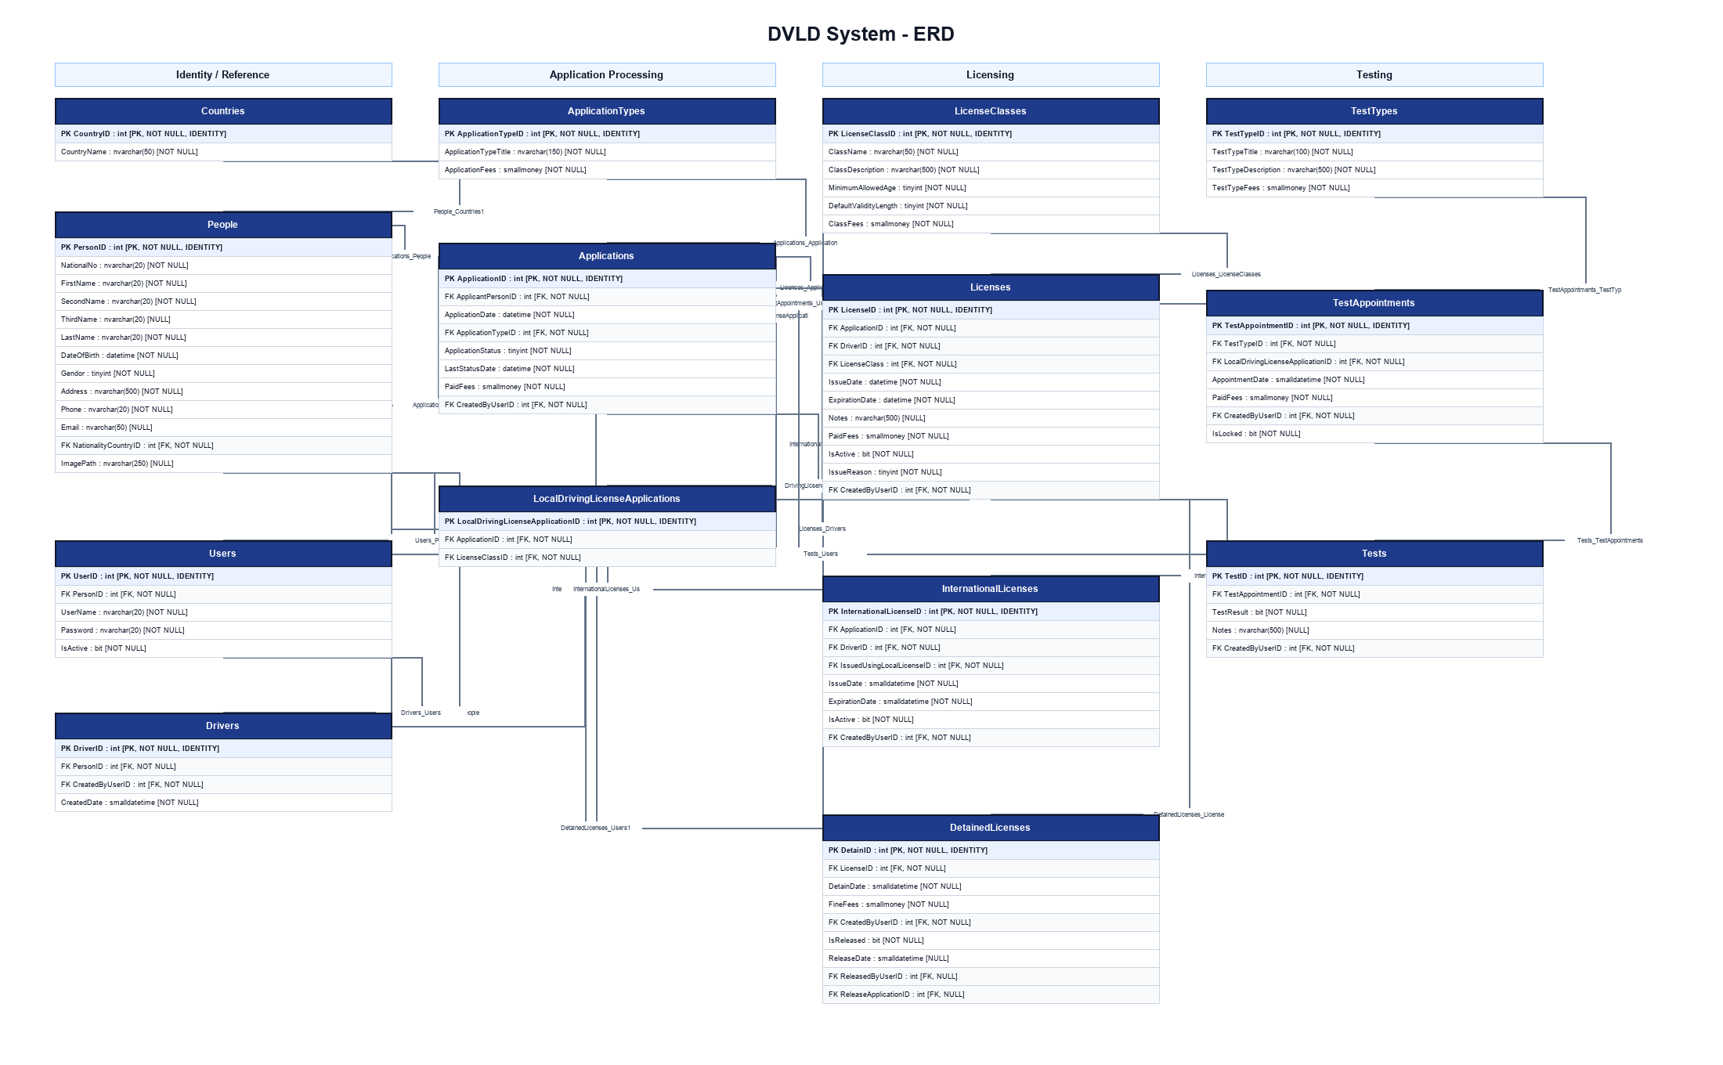
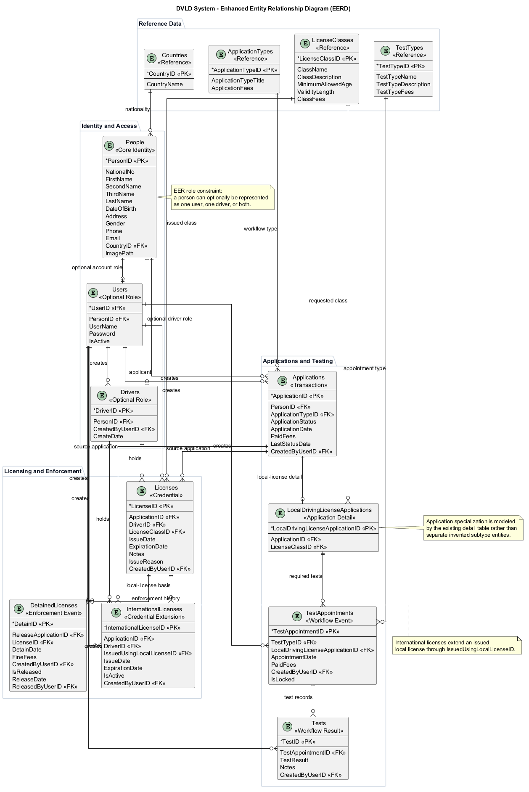

3. Database Schema

The database schema defines the physical structure of the DVLD database, including tables, columns, data types, constraints, and relational mappings.
The schema is implemented using SQL Server relational database principles and supports:
- Data consistency and integrity
- Efficient querying and indexing
- Transaction management
- Secure data storage
- Relationship enforcement through primary and foreign keys
The schema diagrams provide a detailed overview of the database tables and their structural relationships within the DVLD System.

3.1 Database Overview Diagram
This subsection references the high-level PlantUML database overview diagram for the DVLD database. The diagram is presentation-focused and groups the major entities by business domain rather than listing every column.
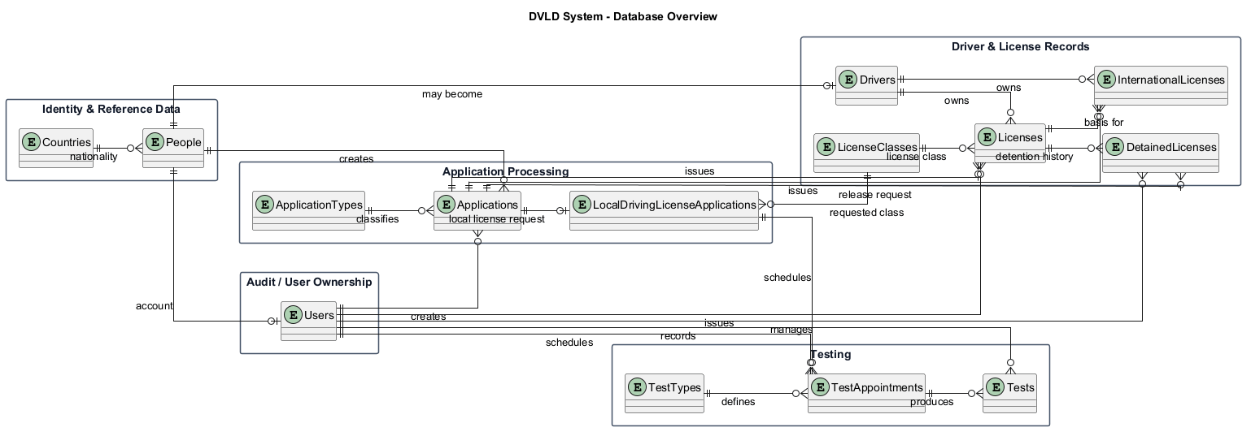

4. Tables Description
This section describes the main tables in the DVLD database model. The scope covers identity, application processing, licensing, detention, and testing entities represented in the latest ERD, EERD, and physical schema diagrams.
Entity Group | Table Name | Business Description
Identity & Reference Data | Countries | Reference table containing country records used to identify the nationality or country association of each person in the DVLD system.
Identity & Reference Data | People | Master person registry for applicants, drivers, employees, and users. Stores identity, contact, demographic, and nationality information used across licensing workflows.
Identity & Reference Data | Users | System account table linked to People. Stores login credentials, account activation status, and the employee identity used for audit ownership of DVLD transactions.
Driver Records | Drivers | Driver profile table created when a person becomes an approved driver. Connects the person registry to issued local and international license records.
Application Processing | ApplicationTypes | Lookup table defining DVLD service request categories such as new local license, renewal, replacement, release, retake test, and international license issuance.
Application Processing | Applications | Central application header table for all DVLD service requests. Stores applicant, application type, status, fees, dates, and user who created the transaction.
Application Processing | LocalDrivingLicenseApplications | Specialized extension for local driving license applications. Links a general application to the requested license class.
Licensing Reference Data | LicenseClasses | Reference table for driving license classes. Stores class name, description, minimum age, validity length, and class fees.
Licensing Records | Licenses | Core local driving license table. Stores issued license records linked to applications, drivers, license classes, issue and expiration dates, issue reason, and issuing user.
Licensing Records | InternationalLicenses | Stores international license records issued for eligible drivers. Each record depends on an approved local license and tracks active status and validity dates.
Licensing Records | DetainedLicenses | Stores detention and release history for licenses. Tracks fines, detention dates, release application, release date, and responsible users.
Testing | TestTypes | Lookup table for required driving tests, including vision, written, and practical test definitions and fees.
Testing | TestAppointments | Stores scheduled test appointments for local driving license applications by test type, date, fees, lock status, and creating user.
Testing | Tests | Stores actual test results recorded against appointments, including result value, notes, and the employee who recorded the test.

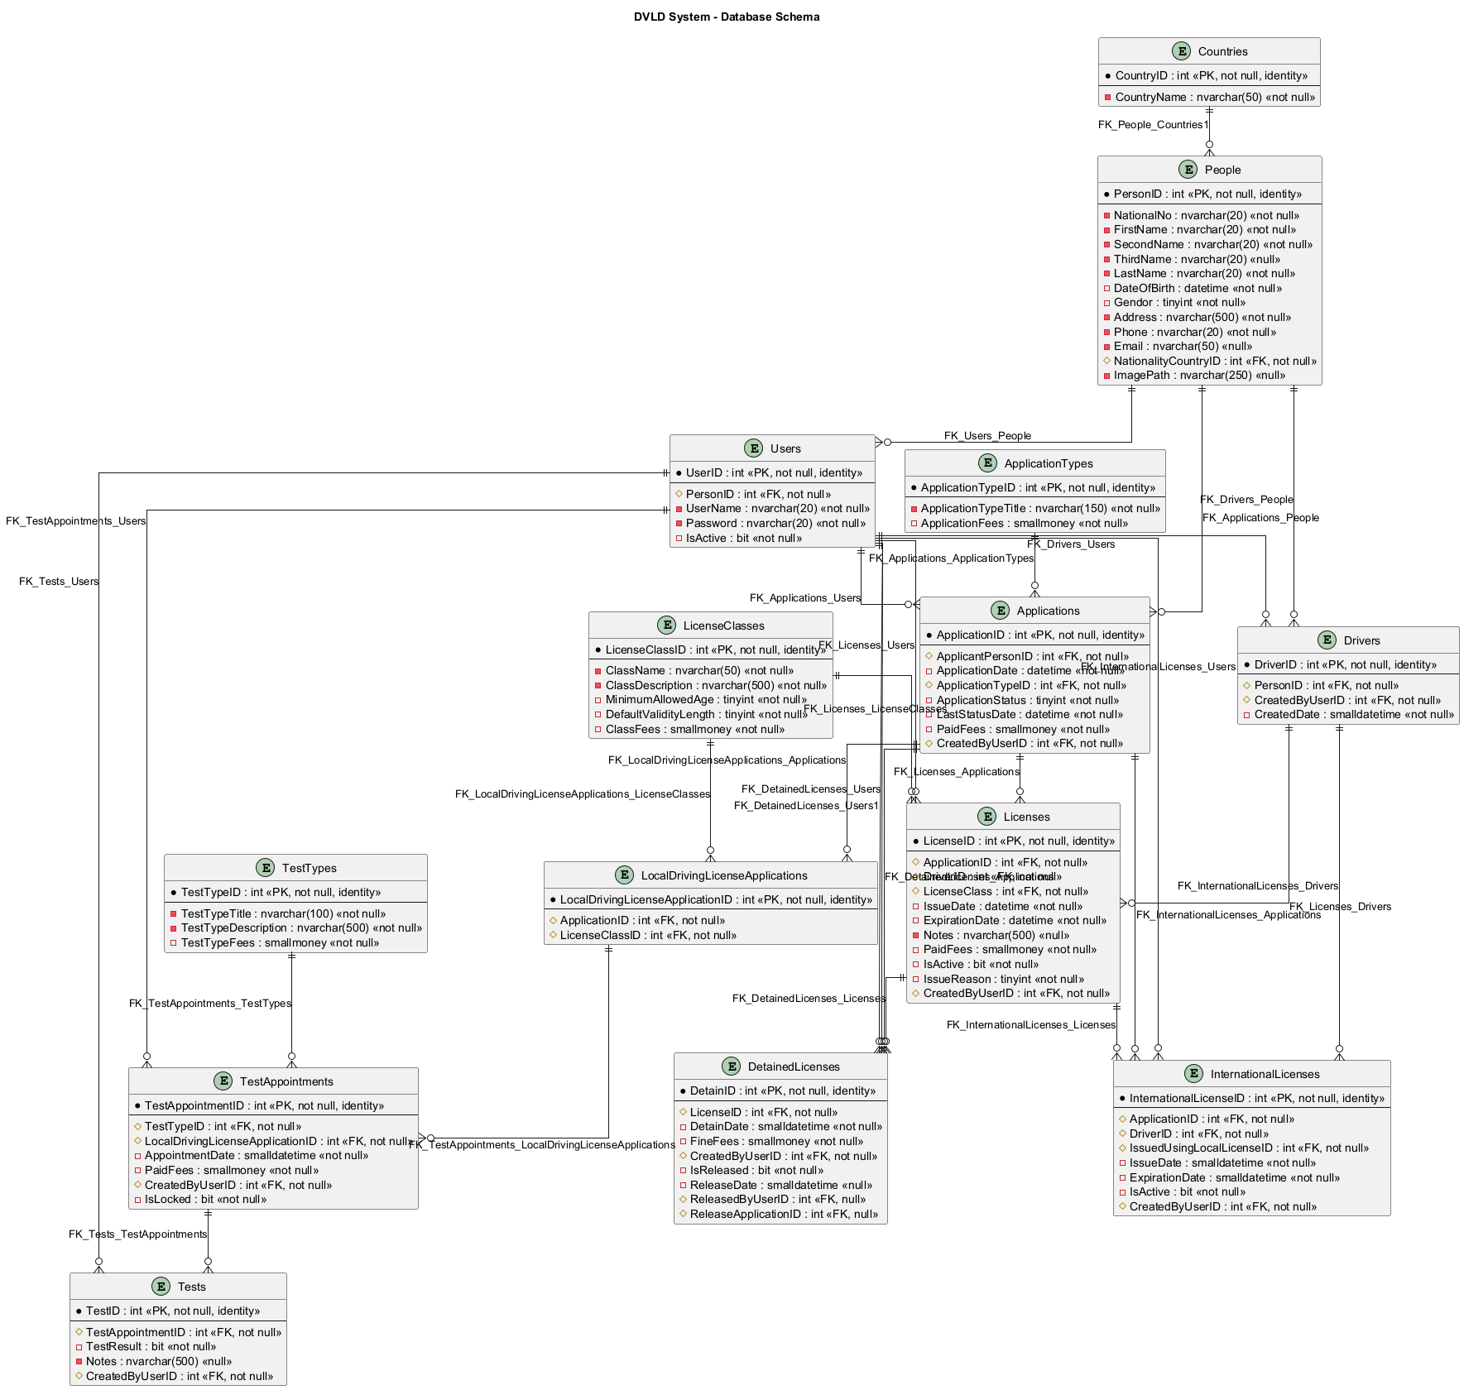

5. Relationships
Relationships in this section reflect SQL Server foreign key constraints from script.sql. Every FK is documented as Parent Table 1 to Child Table Many unless a SQL UNIQUE constraint exists on the FK column. script.sql currently defines 0 unique constraints.
Relationship | SQL Cardinality | FK Constraint | FK Mapping | Notes
ApplicationTypes -> Applications | One-to-Many | FK_Applications_ApplicationTypes | Applications.ApplicationTypeID -> ApplicationTypes.ApplicationTypeID | Applications.ApplicationTypeID references ApplicationTypes.ApplicationTypeID through FK_Applications_ApplicationTypes.
People -> Applications | One-to-Many | FK_Applications_People | Applications.ApplicantPersonID -> People.PersonID | Applications.ApplicantPersonID references People.PersonID through FK_Applications_People.
Users -> Applications | One-to-Many | FK_Applications_Users | Applications.CreatedByUserID -> Users.UserID | Applications.CreatedByUserID references Users.UserID through FK_Applications_Users.
Applications -> DetainedLicenses | One-to-Many | FK_DetainedLicenses_Applications | DetainedLicenses.ReleaseApplicationID -> Applications.ApplicationID | DetainedLicenses.ReleaseApplicationID references Applications.ApplicationID through FK_DetainedLicenses_Applications.
Licenses -> DetainedLicenses | One-to-Many | FK_DetainedLicenses_Licenses | DetainedLicenses.LicenseID -> Licenses.LicenseID | DetainedLicenses.LicenseID references Licenses.LicenseID through FK_DetainedLicenses_Licenses.
Users -> DetainedLicenses | One-to-Many | FK_DetainedLicenses_Users | DetainedLicenses.CreatedByUserID -> Users.UserID | DetainedLicenses.CreatedByUserID references Users.UserID through FK_DetainedLicenses_Users.
Users -> DetainedLicenses | One-to-Many | FK_DetainedLicenses_Users1 | DetainedLicenses.ReleasedByUserID -> Users.UserID | DetainedLicenses.ReleasedByUserID references Users.UserID through FK_DetainedLicenses_Users1.
People -> Drivers | One-to-Many | FK_Drivers_People | Drivers.PersonID -> People.PersonID | Drivers.PersonID references People.PersonID through FK_Drivers_People. Business rule may intend optional one-to-one, but SQL does not enforce uniqueness.
Users -> Drivers | One-to-Many | FK_Drivers_Users | Drivers.CreatedByUserID -> Users.UserID | Drivers.CreatedByUserID references Users.UserID through FK_Drivers_Users.
Applications -> InternationalLicenses | One-to-Many | FK_InternationalLicenses_Applications | InternationalLicenses.ApplicationID -> Applications.ApplicationID | InternationalLicenses.ApplicationID references Applications.ApplicationID through FK_InternationalLicenses_Applications.
Drivers -> InternationalLicenses | One-to-Many | FK_InternationalLicenses_Drivers | InternationalLicenses.DriverID -> Drivers.DriverID | InternationalLicenses.DriverID references Drivers.DriverID through FK_InternationalLicenses_Drivers.
Licenses -> InternationalLicenses | One-to-Many | FK_InternationalLicenses_Licenses | InternationalLicenses.IssuedUsingLocalLicenseID -> Licenses.LicenseID | InternationalLicenses.IssuedUsingLocalLicenseID references Licenses.LicenseID through FK_InternationalLicenses_Licenses.
Users -> InternationalLicenses | One-to-Many | FK_InternationalLicenses_Users | InternationalLicenses.CreatedByUserID -> Users.UserID | InternationalLicenses.CreatedByUserID references Users.UserID through FK_InternationalLicenses_Users.
Applications -> Licenses | One-to-Many | FK_Licenses_Applications | Licenses.ApplicationID -> Applications.ApplicationID | Licenses.ApplicationID references Applications.ApplicationID through FK_Licenses_Applications.
Drivers -> Licenses | One-to-Many | FK_Licenses_Drivers | Licenses.DriverID -> Drivers.DriverID | Licenses.DriverID references Drivers.DriverID through FK_Licenses_Drivers.
LicenseClasses -> Licenses | One-to-Many | FK_Licenses_LicenseClasses | Licenses.LicenseClass -> LicenseClasses.LicenseClassID | Licenses.LicenseClass references LicenseClasses.LicenseClassID through FK_Licenses_LicenseClasses.
Users -> Licenses | One-to-Many | FK_Licenses_Users | Licenses.CreatedByUserID -> Users.UserID | Licenses.CreatedByUserID references Users.UserID through FK_Licenses_Users.
Applications -> LocalDrivingLicenseApplications | One-to-Many | FK_DrivingLicsenseApplications_Applications | LocalDrivingLicenseApplications.ApplicationID -> Applications.ApplicationID | LocalDrivingLicenseApplications.ApplicationID references Applications.ApplicationID through FK_DrivingLicsenseApplications_Applications. Business rule may intend optional one-to-one, but SQL does not enforce uniqueness.
LicenseClasses -> LocalDrivingLicenseApplications | One-to-Many | FK_DrivingLicsenseApplications_LicenseClasses | LocalDrivingLicenseApplications.LicenseClassID -> LicenseClasses.LicenseClassID | LocalDrivingLicenseApplications.LicenseClassID references LicenseClasses.LicenseClassID through FK_DrivingLicsenseApplications_LicenseClasses.
Countries -> People | One-to-Many | FK_People_Countries1 | People.NationalityCountryID -> Countries.CountryID | People.NationalityCountryID references Countries.CountryID through FK_People_Countries1.
LocalDrivingLicenseApplications -> TestAppointments | One-to-Many | FK_TestAppointments_LocalDrivingLicenseApplications | TestAppointments.LocalDrivingLicenseApplicationID -> LocalDrivingLicenseApplications.LocalDrivingLicenseApplicationID | TestAppointments.LocalDrivingLicenseApplicationID references LocalDrivingLicenseApplications.LocalDrivingLicenseApplicationID through FK_TestAppointments_LocalDrivingLicenseApplications.
TestTypes -> TestAppointments | One-to-Many | FK_TestAppointments_TestTypes | TestAppointments.TestTypeID -> TestTypes.TestTypeID | TestAppointments.TestTypeID references TestTypes.TestTypeID through FK_TestAppointments_TestTypes.
Users -> TestAppointments | One-to-Many | FK_TestAppointments_Users | TestAppointments.CreatedByUserID -> Users.UserID | TestAppointments.CreatedByUserID references Users.UserID through FK_TestAppointments_Users.
TestAppointments -> Tests | One-to-Many | FK_Tests_TestAppointments | Tests.TestAppointmentID -> TestAppointments.TestAppointmentID | Tests.TestAppointmentID references TestAppointments.TestAppointmentID through FK_Tests_TestAppointments.
Users -> Tests | One-to-Many | FK_Tests_Users | Tests.CreatedByUserID -> Users.UserID | Tests.CreatedByUserID references Users.UserID through FK_Tests_Users.
People -> Users | One-to-Many | FK_Users_People | Users.PersonID -> People.PersonID | Users.PersonID references People.PersonID through FK_Users_People. Business rule may intend optional one-to-one, but SQL does not enforce uniqueness.

People -> Users: One-to-Many technically; Optional One-to-One as business rule.
People -> Drivers: One-to-Many technically; Optional One-to-One as business rule.
Applications -> LocalDrivingLicenseApplications: One-to-Many technically; Optional One-to-One as business rule if intended.

5.2 Audit Relationships
Users create, release, and manage operational records through CreatedByUserID and ReleasedByUserID relationships. These relationships support auditability and traceability across applications, drivers, licenses, international licenses, detained licenses, test appointments, and tests.

6. Primary Keys & Foreign Keys

Table Name | Primary Key | Foreign Key Columns | Referenced Table(s) / Constraint
Applications | ApplicationID | ApplicationTypeID; ApplicantPersonID; CreatedByUserID | ApplicationTypes.ApplicationTypeID (FK_Applications_ApplicationTypes); People.PersonID (FK_Applications_People); Users.UserID (FK_Applications_Users)
ApplicationTypes | ApplicationTypeID | None | None
Countries | CountryID | None | None
DetainedLicenses | DetainID | ReleaseApplicationID; LicenseID; CreatedByUserID; ReleasedByUserID | Applications.ApplicationID (FK_DetainedLicenses_Applications); Licenses.LicenseID (FK_DetainedLicenses_Licenses); Users.UserID (FK_DetainedLicenses_Users); Users.UserID (FK_DetainedLicenses_Users1)
Drivers | DriverID | PersonID; CreatedByUserID | People.PersonID (FK_Drivers_People); Users.UserID (FK_Drivers_Users)
InternationalLicenses | InternationalLicenseID | ApplicationID; DriverID; IssuedUsingLocalLicenseID; CreatedByUserID | Applications.ApplicationID (FK_InternationalLicenses_Applications); Drivers.DriverID (FK_InternationalLicenses_Drivers); Licenses.LicenseID (FK_InternationalLicenses_Licenses); Users.UserID (FK_InternationalLicenses_Users)
LicenseClasses | LicenseClassID | None | None
Licenses | LicenseID | ApplicationID; DriverID; LicenseClass; CreatedByUserID | Applications.ApplicationID (FK_Licenses_Applications); Drivers.DriverID (FK_Licenses_Drivers); LicenseClasses.LicenseClassID (FK_Licenses_LicenseClasses); Users.UserID (FK_Licenses_Users)
LocalDrivingLicenseApplications | LocalDrivingLicenseApplicationID | ApplicationID; LicenseClassID | Applications.ApplicationID (FK_DrivingLicsenseApplications_Applications); LicenseClasses.LicenseClassID (FK_DrivingLicsenseApplications_LicenseClasses)
People | PersonID | NationalityCountryID | Countries.CountryID (FK_People_Countries1)
TestAppointments | TestAppointmentID | LocalDrivingLicenseApplicationID; TestTypeID; CreatedByUserID | LocalDrivingLicenseApplications.LocalDrivingLicenseApplicationID (FK_TestAppointments_LocalDrivingLicenseApplications); TestTypes.TestTypeID (FK_TestAppointments_TestTypes); Users.UserID (FK_TestAppointments_Users)
Tests | TestID | TestAppointmentID; CreatedByUserID | TestAppointments.TestAppointmentID (FK_Tests_TestAppointments); Users.UserID (FK_Tests_Users)
TestTypes | TestTypeID | None | None
Users | UserID | PersonID | People.PersonID (FK_Users_People)

7. Constraints
Constraint Category | SQL Server Implementation
Primary Key Constraints | Every table has a single-column SQL primary key as defined in script.sql.
Foreign Key Constraints | script.sql defines 26 FK constraints connecting operational child records to parent reference or transaction records.
Nullability Constraints | NOT NULL and NULL settings are implemented at column level exactly as listed in the Data Dictionary.
Default Constraints | SQL default constraints exist for selected status, fee, age, validity, reason, gender code, and lock columns.
Unique Constraints | No SQL unique constraints are currently defined in script.sql. Business uniqueness rules such as unique NationalNo, unique UserName, one user per person, one driver per person, and one active international license should be enforced through application validation or future database unique/filtered indexes if required.

7.1 Recommended Future Constraints / Indexes
- Consider a unique index for People.NationalNo if national numbers must be SQL-enforced unique.
- Consider a unique index for Users.UserName if usernames must be SQL-enforced unique.
- Consider unique or filtered indexes for one user per person, one driver per person, and one active international license if those business rules must be enforced by SQL Server.
- Consider indexes on FK columns, status columns, date columns, and common search columns such as NationalNo and UserName.

8. Data Dictionary
The Data Dictionary reflects the current SQL Server implementation from script.sql. Some column names such as Gendor and LicenseClass are preserved exactly as implemented in the database, even if business documentation may use clearer wording such as Gender or LicenseClassID.

8.1 Applications
Stores service application headers, applicant references, application status, fees, dates, and creator user.
Column Name | Data Type | Key | Nullable | Default | Description
ApplicationID | int | PK | NOT NULL | IDENTITY(1,1) | Unique application identifier.
ApplicantPersonID | int | FK | NOT NULL | None | Applicant person reference.
ApplicationDate | datetime |  | NOT NULL | None | Date and time when the application was created.
ApplicationTypeID | int | FK | NOT NULL | None | Application type reference.
ApplicationStatus | tinyint |  | NOT NULL | ((1)) | Application workflow status.
LastStatusDate | datetime |  | NOT NULL | None | Date and time when status last changed.
PaidFees | smallmoney |  | NOT NULL | None | Fee amount paid for the record.
CreatedByUserID | int | FK | NOT NULL | None | User who created the record.

8.2 ApplicationTypes
Reference table for service request types and their configured fees.
Column Name | Data Type | Key | Nullable | Default | Description
ApplicationTypeID | int | PK | NOT NULL | IDENTITY(1,1) | Application type reference.
ApplicationTypeTitle | nvarchar(150) |  | NOT NULL | None | Business title of the application type.
ApplicationFees | smallmoney |  | NOT NULL | ((0)) | Configured application type fee.

8.3 Countries
Reference table for nationality and country lookup data.
Column Name | Data Type | Key | Nullable | Default | Description
CountryID | int | PK | NOT NULL | IDENTITY(1,1) | Unique country identifier.
CountryName | nvarchar(50) |  | NOT NULL | None | Country name.

8.4 DetainedLicenses
Stores license detention, release, fine, release application, and responsible-user audit references.
Column Name | Data Type | Key | Nullable | Default | Description
DetainID | int | PK | NOT NULL | IDENTITY(1,1) | Unique detention identifier.
LicenseID | int | FK | NOT NULL | None | License reference.
DetainDate | smalldatetime |  | NOT NULL | None | Date and time when the license was detained.
FineFees | smallmoney |  | NOT NULL | None | Fine fee amount.
CreatedByUserID | int | FK | NOT NULL | None | User who created the record.
IsReleased | bit |  | NOT NULL | ((0)) | Release status flag.
ReleaseDate | smalldatetime |  | NULL | None | Date and time when the detained license was released.
ReleasedByUserID | int | FK | NULL | None | User who released the detained license.
ReleaseApplicationID | int | FK | NULL | None | Application used to release the detained license.

8.5 Drivers
Stores driver identities linked to people and the user who created the driver record.
Column Name | Data Type | Key | Nullable | Default | Description
DriverID | int | PK | NOT NULL | IDENTITY(1,1) | Driver reference or unique driver identifier.
PersonID | int | FK | NOT NULL | None | Person reference or unique person identifier.
CreatedByUserID | int | FK | NOT NULL | None | User who created the record.
CreatedDate | smalldatetime |  | NOT NULL | None | Date and time when the driver record was created.

8.6 InternationalLicenses
Stores international license records linked to applications, drivers, local licenses, and creator users.
Column Name | Data Type | Key | Nullable | Default | Description
InternationalLicenseID | int | PK | NOT NULL | IDENTITY(1,1) | Unique international license identifier.
ApplicationID | int | FK | NOT NULL | None | Unique application identifier.
DriverID | int | FK | NOT NULL | None | Driver reference or unique driver identifier.
IssuedUsingLocalLicenseID | int | FK | NOT NULL | None | Local license used to issue the international license.
IssueDate | smalldatetime |  | NOT NULL | None | Date and time when the license was issued.
ExpirationDate | smalldatetime |  | NOT NULL | None | Date and time when the license expires.
IsActive | bit |  | NOT NULL | None | Active status flag.
CreatedByUserID | int | FK | NOT NULL | None | User who created the record.

8.7 LicenseClasses
Reference table for license classes, age requirements, validity length, and class fees.
Column Name | Data Type | Key | Nullable | Default | Description
LicenseClassID | int | PK | NOT NULL | IDENTITY(1,1) | Unique license class identifier or license class reference.
ClassName | nvarchar(50) |  | NOT NULL | None | License class name.
ClassDescription | nvarchar(500) |  | NOT NULL | None | License class description.
MinimumAllowedAge | tinyint |  | NOT NULL | ((18)) | Minimum allowed applicant age.
DefaultValidityLength | tinyint |  | NOT NULL | ((1)) | Default validity length for the license class.
ClassFees | smallmoney |  | NOT NULL | ((0)) | Configured fee for the license class.

8.8 Licenses
Stores issued local licenses, class, application, driver, dates, fees, status, reason, notes, and creator user.
Column Name | Data Type | Key | Nullable | Default | Description
LicenseID | int | PK | NOT NULL | IDENTITY(1,1) | License reference.
ApplicationID | int | FK | NOT NULL | None | Unique application identifier.
DriverID | int | FK | NOT NULL | None | Driver reference or unique driver identifier.
LicenseClass | int | FK | NOT NULL | None | License class foreign key column implemented in script.sql.
IssueDate | datetime |  | NOT NULL | None | Date and time when the license was issued.
ExpirationDate | datetime |  | NOT NULL | None | Date and time when the license expires.
Notes | nvarchar(500) |  | NULL | None | Optional notes.
PaidFees | smallmoney |  | NOT NULL | None | Fee amount paid for the record.
IsActive | bit |  | NOT NULL | ((1)) | Active status flag.
IssueReason | tinyint |  | NOT NULL | ((1)) | Numeric issue reason code.
CreatedByUserID | int | FK | NOT NULL | None | User who created the record.

8.9 LocalDrivingLicenseApplications
Specialized local driving license application table linked to general applications and license classes.
Column Name | Data Type | Key | Nullable | Default | Description
LocalDrivingLicenseApplicationID | int | PK | NOT NULL | IDENTITY(1,1) | Unique local driving license application identifier.
ApplicationID | int | FK | NOT NULL | None | Unique application identifier.
LicenseClassID | int | FK | NOT NULL | None | Unique license class identifier or license class reference.

8.10 People
Master person registry for applicants, users, drivers, and nationality references.
Column Name | Data Type | Key | Nullable | Default | Description
PersonID | int | PK | NOT NULL | IDENTITY(1,1) | Person reference or unique person identifier.
NationalNo | nvarchar(20) |  | NOT NULL | None | National number.
FirstName | nvarchar(20) |  | NOT NULL | None | First name.
SecondName | nvarchar(20) |  | NOT NULL | None | Second name.
ThirdName | nvarchar(20) |  | NULL | None | Third name.
LastName | nvarchar(20) |  | NOT NULL | None | Last name.
DateOfBirth | datetime |  | NOT NULL | None | Date and time of birth as implemented in SQL.
Gendor | tinyint |  | NOT NULL | ((0)) | Gender code column preserved exactly as implemented in script.sql.
Address | nvarchar(500) |  | NOT NULL | None | Address.
Phone | nvarchar(20) |  | NOT NULL | None | Phone number.
Email | nvarchar(50) |  | NULL | None | Email address.
NationalityCountryID | int | FK | NOT NULL | None | Nationality country reference.
ImagePath | nvarchar(250) |  | NULL | None | Optional person image path.

8.11 TestAppointments
Stores scheduled test appointments, test type, local application, fees, lock status, and creator user.
Column Name | Data Type | Key | Nullable | Default | Description
TestAppointmentID | int | PK | NOT NULL | IDENTITY(1,1) | Unique test appointment identifier or appointment reference.
TestTypeID | int | FK | NOT NULL | None | Test type reference or unique test type identifier.
LocalDrivingLicense  ApplicationID | int | FK | NOT NULL | None | Unique local driving license application identifier.
AppointmentDate | smalldatetime |  | NOT NULL | None | Date and time of the appointment.
PaidFees | smallmoney |  | NOT NULL | None | Fee amount paid for the record.
CreatedByUserID | int | FK | NOT NULL | None | User who created the record.
IsLocked | bit |  | NOT NULL | ((0)) | Appointment lock status flag.

8.12 Tests
Stores test results linked to appointments and creator users.
Column Name | Data Type | Key | Nullable | Default | Description
TestID | int | PK | NOT NULL | IDENTITY(1,1) | Unique test result identifier.
TestAppointmentID | int | FK | NOT NULL | None | Unique test appointment identifier or appointment reference.
TestResult | bit |  | NOT NULL | None | Pass/fail test result flag.
Notes | nvarchar(500) |  | NULL | None | Optional notes.
CreatedByUserID | int | FK | NOT NULL | None | User who created the record.

8.13 TestTypes
Reference table for configured test types, descriptions, and fees.
Column Name | Data Type | Key | Nullable | Default | Description
TestTypeID | int | PK | NOT NULL | IDENTITY(1,1) | Test type reference or unique test type identifier.
TestTypeTitle | nvarchar(100) |  | NOT NULL | None | Business title of the test type.
TestTypeDescription | nvarchar(500) |  | NOT NULL | None | Test type description.
TestTypeFees | smallmoney |  | NOT NULL | None | Configured fee for the test type.

8.14 Users
Stores system user accounts linked to people and active status.
Column Name | Data Type | Key | Nullable | Default | Description
UserID | int | PK | NOT NULL | IDENTITY(1,1) | Unique system user identifier.
PersonID | int | FK | NOT NULL | None | Person reference or unique person identifier.
UserName | nvarchar(20) |  | NOT NULL | None | System login username.
Password | nvarchar(20) |  | NOT NULL | None | Stored password field as currently implemented in script.sql.
IsActive | bit |  | NOT NULL | None | Active status flag.

