SCHOOL PROJECT REPORT
DEVELOPMENT OF A MACHINE LEARNING BASED SYSTEM FOR ORE GRADE AND MINERAL DISTRIBUTION PREDICTION IN DU, BUKURU, JOS SOUTH LGA, PLATEAU STATE, NIGERIA
ARUM ALPHA: AI-Powered Mineral Estimation System
Field | Details
Student | ARUM ALPHA AJIJI
Registration Number | UJ/2018/EN/0456
Department | Department of Mining Engineering, University of Jos
Supervisor | Mr. Joshua D. Joro
Study Area | Du/Bukuru, Jos South LGA, Plateau State, Nigeria
Production Link | https://plateau-mineral-estimation.vercel.app/
Project Type | Final year school project documentation
Prepared | June 24, 2026

This document was prepared from the local ARUM ALPHA proposal slides, README, source code, and Sheet 168 Naraguta metadata.

Table of Contents
The table below is generated from the report headings and updated in Microsoft Word.
Table of Contents 2
Abstract 3
1. Introduction 3
2. Problem Statement 3
3. Aim and Objectives 3
4. Project Scope and Requirements 4
Functional Requirements 4
Non-Functional Requirements 4
5. Significance of the Study 5
6. Literature Review and Research Gap 5
Research Gap 5
7. Study Area and Dataset 6
8. System Design and Technology Stack 6
System Workflow 7
9. Methodology 7
10. Implementation 7
11. Production Deployment and Screenshots 8
Desktop Dashboard Screenshot 9
Mobile Dashboard Screenshot 9
Deployment Discussion 10
12. Results and Discussion 10
13. Testing and Validation 11
14. Limitations 11
15. Conclusion and Recommendations 12
Recommendations for Further Work 12
References 12
Appendix A: Running the Project 12
Appendix B: Project Management Snapshot 13

Abstract
This project develops ARUM ALPHA, an AI-assisted web system for ore grade estimation and mineral distribution modelling in Du/Bukuru, Jos South LGA, Plateau State. The system focuses on cassiterite or tin mineralization within the Jos Plateau Younger Granite province, using radiometric potassium, thorium, and uranium grid data from Sheet 168 Naraguta as the principal local dataset.
The implemented prototype combines geospatial data processing, feature engineering, interactive mapping, AI-based geological interpretation, and dashboard visualization. It is built with Next.js, React, TypeScript, Leaflet, Recharts, Tailwind CSS, and a Groq Llama 3.3 70B integration with a rule-based fallback. The system lets a user select or search a location, retrieve nearby radiometric readings, estimate tin potential, inspect risk and confidence values, and export the result as JSON.
The repository represents a working prototype toward the broader machine learning objective proposed for the project. A fully validated final model would require labelled assay or production grade data, additional geochemical and geophysical layers, and formal comparison against Random Forest, XGBoost, ordinary kriging, inverse distance weighting, and other baseline approaches.

1. Introduction
Bukuru and neighbouring communities in Jos South occur within the Younger Granite province of the Jos Plateau, an area historically associated with cassiterite mineralization and tin mining. Traditional exploration workflows in such areas can be expensive because geological structures, hydrothermal alteration zones, and radiometric anomalies are spatially complex.
ARUM ALPHA addresses this challenge by presenting geological and radiometric information in an interactive web dashboard. The system is designed to help students, mining engineers, and exploration teams reason about likely ore grade potential before committing to detailed field verification.

2. Problem Statement
- Ore grade estimation in Bukuru is uncertain because the local geology is complex and mineralization may be controlled by multiple non-linear factors.
- Traditional interpolation methods such as ordinary kriging and inverse distance weighting can struggle when assumptions of stationarity or simple spatial continuity do not hold.
- Fragmented geochemical, geophysical, and spatial datasets make it difficult to form a single operational picture for exploration decisions.
- There is a need for a localized, data-driven dashboard tailored to tin mineralization in the Jos Plateau Younger Granite setting.

3. Aim and Objectives
The aim is to design and implement a machine learning based predictive system for ore grade estimation and mineral distribution modelling in Bukuru, Jos, Nigeria.
- Compile and preprocess multi-source datasets relevant to cassiterite exploration.
- Engineer useful geochemical and radiometric features from potassium, thorium, uranium, coordinates, and surrounding context.
- Develop predictive models that can estimate grade, confidence, and exploration risk for selected locations.
- Compare machine learning outputs with traditional geostatistical approaches when labelled validation data become available.
- Design a visualization dashboard that supports map-based exploration decisions and technical recommendations.

4. Project Scope and Requirements
The project scope covers the design, implementation, deployment, and documentation of a prototype mineral estimation platform for the Bukuru/Jos Plateau study area. The work is not presented as a certified reserve estimation system; rather, it is a decision-support prototype that combines radiometric data, geological reasoning, and dashboard visualization.
Scope Area | Description
In scope | Web dashboard, map visualization, coordinate-based estimation, K/Th/U feature extraction, AI/rule-based interpretation, production deployment, and report documentation.
Partly implemented | Supervised machine learning workflow is represented conceptually; final training requires labelled assay or production grade data.
Out of scope | Certified mineral reserve reporting, drilling design approval, laboratory assay generation, and legal mining lease evaluation.

Functional Requirements
- The system shall display the Sheet 168 Naraguta study area on an interactive map.
- The system shall allow users to enter latitude and longitude values or select a location on the map.
- The system shall retrieve radiometric context for the selected location when it lies inside the study bounds.
- The system shall return predicted tin potential, confidence, risk level, interpretation, and recommendations.
- The system shall allow exported estimation results in JSON format for later review.

Non-Functional Requirements
- The interface should be readable on desktop and mobile screen sizes.
- The dashboard should load quickly enough for classroom demonstration and project defence use.
- The API should return clear errors when coordinates or estimation requests are invalid.
- The project should be deployable to Vercel with environment variables separated from source code.
- The report should clearly separate prototype results from scientifically validated mineral reserve estimates.

5. Significance of the Study
The project contributes a localized digital approach to mineral prospectivity mapping for Bukuru and the Jos Plateau. It supports exploration efficiency by reducing blind sampling, providing early-stage target ranking, and presenting geoscience information in a form that is easier to interpret.
- Mining engineers can use the dashboard to compare potential targets and prioritize field verification.
- Exploration companies can reduce early-stage uncertainty before committing drilling or sampling budgets.
- Policymakers and researchers can use the prototype as a reference for sustainable, data-driven solid minerals development.
- The project demonstrates how modern web technologies and AI reasoning can be applied to Nigerian mining problems.

6. Literature Review and Research Gap
Geostatistical methods such as kriging remain important in mineral resource estimation because they model spatial continuity and can produce interpolated grade surfaces. However, their reliability depends on assumptions about the spatial structure of the data. In structurally complex terrains, machine learning models can capture nonlinear relationships among geochemical, geophysical, topographic, and spatial variables.
The project proposal identified Random Forest and XGBoost as appropriate supervised learning candidates because they handle nonlinear feature interactions, missing values, and feature importance analysis better than simple linear regression baselines. The present repository implements the dashboard, radiometric ingestion, geochemical indices, AI interpretation, and estimation workflow needed to support that later supervised modelling phase.

Research Gap
- Few student or local prototype systems focus specifically on tin mineralization in Bukuru and the Jos Plateau.
- Many mineral prospectivity examples are either generic or rely on single-source datasets rather than integrated geochemical, geophysical, and spatial evidence.
- The region needs a practical dashboard that turns technical radiometric data into location-specific exploration guidance.

7. Study Area and Dataset
The study area covers Sheet 168 Naraguta around Bukuru, Du, Naraguta, Jos, Rayfield, Gyel, Zawan, and nearby Jos South/Jos North communities. The software bounds the local radiometric study area between about 8.4999 and 8.9994 degrees east longitude, and 9.5001 and 9.9991 degrees north latitude.
Dataset Item | Description
Primary data layers | Potassium, thorium, and uranium radiometric grids
File format | Geosoft Grid with XML metadata
Grid sheet | Sheet168_Naraguta
Projection | WGS 84 / UTM Zone 32N, EPSG:32632
UTM extent | 445187.5E to 499937.5E; 1050187.5N to 1105312.5N
Geographic extent | 8.499873E to 8.999431E; 9.500149N to 9.999096N
Dataset date in metadata | April 16, 2021
Application sample limit | Up to 1,000 points returned for map visualization

The metadata confirms that the local grids were produced from Nigerian radiometric source grids using a Sheet 168 Naraguta mask. The current application parser contains a fallback for older Geosoft GRD formats, so raw grid value validation should be completed before the system is used for formal resource estimation.

8. System Design and Technology Stack
ARUM ALPHA is implemented as a Next.js web application with API routes for data retrieval and mineral estimation. The frontend presents a map, search tools, coordinate input, estimation results, radiometric values, risk assessment, model metrics, and JSON export.
Component | Technology or Role
Frontend framework | Next.js 16, React 19, TypeScript
Styling | Tailwind CSS 4
Mapping | Leaflet and React-Leaflet
AI service | Groq SDK using llama-3.3-70b-versatile
Charts and icons | Recharts and Lucide React
Core data code | GRD parser, UTM conversion, nearest point lookup, radius sampling
Deployment target | Vercel configuration included

System Workflow
Step | Process | Output
1 | Data load | Load K, Th, and U grids or fallback synthetic data
2 | Coordinate selection | User searches, enters coordinates, or clicks the map
3 | Spatial lookup | Find nearest point and optional surrounding points within radius
4 | Feature engineering | Calculate K/(Th+U), Th/U, and contextual averages
5 | Estimation | Generate grade, confidence, risk, analysis, and recommendations
6 | Visualization | Render markers, heatmap overlays, result cards, and export file

9. Methodology
The methodology follows the proposal workflow: data acquisition, preprocessing, feature engineering, model development, validation, spatial prediction, and dashboard deployment. The implemented prototype covers the ingestion, feature, AI interpretation, visualization, and deployment parts of this workflow.
Stage | Project Implementation
Data acquisition | Radiometric K, Th, and U grid files and XML metadata are stored in the repository data folder.
Preprocessing | The parser reads grid metadata, applies WGS84 UTM Zone 32N coordinate assumptions, and converts UTM coordinates to latitude/longitude for mapping.
Feature engineering | The system calculates K/(Th+U) and Th/U ratios, and optionally averages surrounding points within a user-selected search radius.
Prediction logic | The main estimator prompts an AI model with geophysical context and falls back to a rule-based estimator if the API fails.
Risk classification | Predicted grade thresholds are used to communicate low, medium, and high exploration risk in the dashboard.
Visualization | Leaflet renders the study area, data markers, prediction markers, base layers, and heatmap overlays.

10. Implementation
The main dashboard is implemented in components/Dashboard.tsx. It manages coordinate input, search results, selected point state, prediction state, loading states, map-layer toggles, and JSON result export. The map is loaded dynamically to avoid server-side rendering issues with Leaflet.
Endpoint | Purpose
GET /api/data | Loads radiometric data, bounds, sample points, and estimated grid dimensions for visualization.
POST /api/estimate | Accepts latitude/longitude, finds local radiometric context, and returns prediction, analysis, recommendations, and metrics.
GET /api/estimate | Simple health check that reports API status and loaded data point count.

A production build was executed successfully on June 23, 2026. The build compiled the app, checked TypeScript, generated static pages, and preserved dynamic server routes for /api/data and /api/estimate.

11. Production Deployment and Screenshots
The project has been deployed publicly on Vercel for demonstration and assessment. The production link is:
https://plateau-mineral-estimation.vercel.app/
The deployed system demonstrates that the application can be accessed outside the development machine, loads the study-area dashboard, and presents the Naraguta radiometric map interface through a public web address. This is important for project defence because supervisors and reviewers can inspect the implementation without running the source code locally.
Deployment Item | Evidence
Hosting platform | Vercel
Production URL | https://plateau-mineral-estimation.vercel.app/
Observed dashboard data count | 1,000 sampled visualization points
Visible study area | Bukuru, Jos Plateau
Primary interface elements | Location search, coordinate input, map layers, legend, and map-based radiometric point display

Desktop Dashboard Screenshot
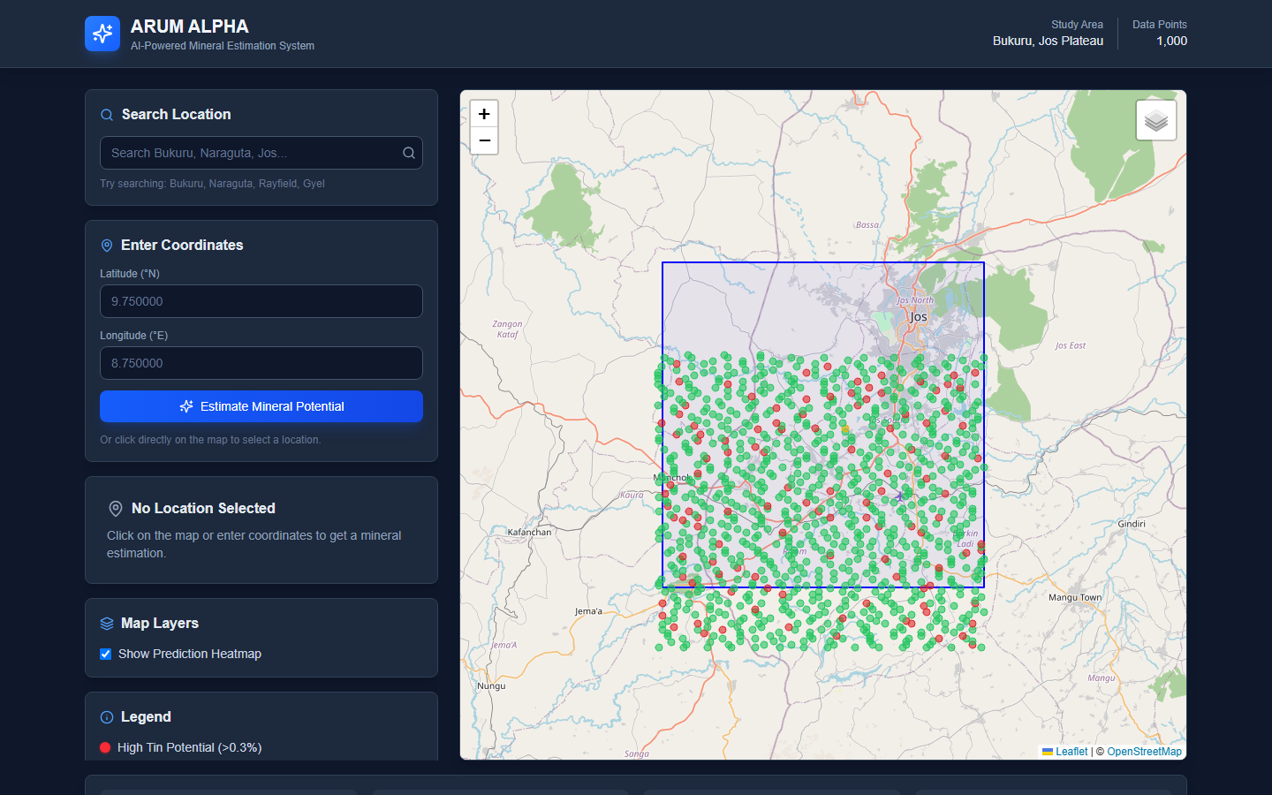
Figure 1: Desktop view of the deployed ARUM ALPHA dashboard showing the study-area map and radiometric data points.

Mobile Dashboard Screenshot
The mobile screenshot confirms that the dashboard layout remains usable on a narrow viewport. The interface stacks the search, coordinate input, and map sections vertically while preserving the study-area context.
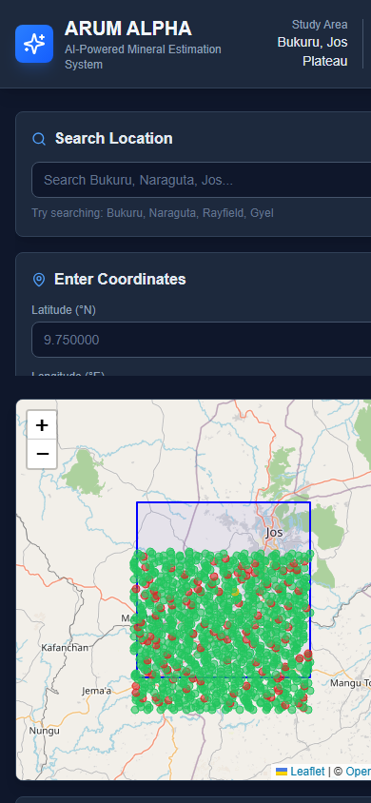
Figure 2: Mobile view of the deployed dashboard showing responsive layout and the mapped Naraguta data points.

Deployment Discussion
The deployed dashboard strengthens the project by showing that the prototype is not limited to local execution. It provides a visible product outcome: a web-based mineral estimation interface that can be reviewed, tested, and extended. In a final-year project setting, this supports both the technical implementation requirement and the presentation requirement because the application can be demonstrated live.

12. Results and Discussion
The resulting system is a working web dashboard that supports interactive mineral potential estimation. A user can search for Plateau locations such as Bukuru, Naraguta, Rayfield, Gyel, Du, Zawan, and Sabon Barki, or can click any coordinate on the map. For locations inside the Sheet 168 study area, the system uses local radiometric data. For locations outside the study area, it uses a broader geological context service and synthetic radiometric estimates.
The prediction panel communicates the estimated tin grade, confidence, risk level, potassium/thorium/uranium readings, K/(Th+U) ratio, AI analysis, field recommendations, and model performance metrics. The visualization gives students and technical reviewers a fast way to inspect how radiometric anomalies relate to predicted mineral potential.
Result Area | Observed Outcome
Dashboard | Implemented with controls, map, prediction card, legend, stats bar, and export.
Geospatial display | Study boundary, base map layers, sampled radiometric points, prediction markers, and heatmap layer.
Estimation output | Predicted grade, confidence, risk level, analysis, recommendations, and model metrics.
Build verification | npm.cmd run build completed successfully with Next.js 16.2.4.

13. Testing and Validation
Testing focused on confirming that the application builds, the deployed interface loads, the core routes are defined, and the generated report remains openable in Microsoft Word. Scientific validation of mineral grade prediction requires labelled field or assay data and is therefore listed as future work.
Validation Area | Result
Production build | npm.cmd run build completed successfully with Next.js 16.2.4.
Deployment inspection | The Vercel dashboard page loaded and screenshots were captured from the live URL.
Responsive interface | Desktop and mobile screenshots confirm the dashboard is usable across different viewport widths.
Document validation | The generated DOCX was opened through Microsoft Word automation and reported as a valid document.
Scientific validation status | Pending labelled assay or production-grade data for supervised ML training and test-set evaluation.

14. Limitations
- The repository does not yet include labelled assay or production grade data needed to train and validate Random Forest or XGBoost models.
- The reported model metrics in the current prototype are demonstration values from the estimator code, not final field-validated accuracy results.
- The Geosoft GRD binary parser should be independently validated against known grid values before scientific conclusions are drawn from raw values.
- Some outside-study-area geological and environmental values are simulated or rule-based, so they should be treated as exploratory context only.
- AI-generated geological interpretation should support, not replace, field mapping, sampling, laboratory assays, and professional resource estimation.

15. Conclusion and Recommendations
ARUM ALPHA demonstrates how mineral estimation for Bukuru and the Jos Plateau can be supported with a modern web dashboard, geospatial visualization, radiometric feature engineering, and AI-assisted interpretation. The project successfully converts the original proposal into a usable prototype that can guide exploratory analysis and communicate mineral potential to students, supervisors, and technical reviewers.

Recommendations for Further Work
- Acquire verified assay or production grade data for tin, then train Random Forest and XGBoost regression models.
- Compare supervised models against kriging, inverse distance weighting, and linear regression baselines using RMSE, MAE, R2, and MAPE.
- Validate the GRD parser with known Geosoft/Oasis Montaj exports and document the exact grid dimensions and null-value handling.
- Add geological layers such as faults, lithology, DEM, slope, aspect, and historical mine locations.
- Implement persistent storage for estimation history and field verification results.

References
- ARUM ALPHA project README and source code, local repository: arum-alpha/.
- ARUM ALPHA deployed production application: https://plateau-mineral-estimation.vercel.app/
- Sheet168_Naraguta_Potassium.grd.xml, Sheet168_Naraguta_Th.grd.xml, and Sheet168_Naraguta_U.grd.xml metadata files, dated April 16, 2021.
- Breiman, L. (2001). Random Forests. Machine Learning, 45, 5-32.
- Chen, T. and Guestrin, C. (2016). XGBoost: A scalable tree boosting system. Proceedings of KDD.
- Goovaerts, P. (1997). Geostatistics for Natural Resources Evaluation. Oxford University Press.
- Rodriguez-Galiano, V. F., Sanchez-Castillo, M., Chica-Olmo, M., and Chica-Rivas, M. (2015). Machine learning predictive models for mineral prospectivity. Ore Geology Reviews.

Appendix A: Running the Project
Prerequisites: Node.js 18 or newer and a Groq API key for live AI estimation.
Task | Command or Value
Install dependencies | npm install
Configure environment | copy env.example .env.local
Start development server | npm run dev
Open application | http://localhost:3000
Open deployed production site | https://plateau-mineral-estimation.vercel.app/
Build for production | npm run build

Appendix B: Project Management Snapshot
Budget Item | Estimated Cost (NGN)
Data acquisition | 50,000
Software and tools | 150,000
Research assistance | 100,000
Miscellaneous | 100,000
Total | 400,000

The proposal timeline covers topic approval, literature review, data collection, model development, dashboard implementation, validation, final report writing, and presentation preparation between January and June 2026.

