
DEVELOPMENT OF A MACHINE LEARNING BASED SYSTEM FOR ORE GRADE AND MINERAL DISTRIBUTION PREDICTION IN DU, BUKURU, JOS SOUTH LGA, PLATEAU STATE, NIGERIA
ARUM ALPHA: AI-Powered Mineral Estimation System
Field | Details
Student | ARUM ALPHA AJIJI
Registration Number | UJ/2018/EN/0456
Department | Department of Mining Engineering, University of Jos
Supervisor | Mr. Joshua D. Joro
Study Area | Du/Bukuru, Jos South LGA, Plateau State, Nigeria
Production Link | https://plateau-mineral-estimation.vercel.app/
Project Type | Final year school project documentation
Prepared | June 24, 2026

This document was prepared from the local ARUM ALPHA proposal slides, README, source code, and Sheet 168 Naraguta metadata.

Table of Contents
Table of Contents 2
Acknowledgement 4
List of Abbreviations 4
Abstract 4
1. Introduction 5
1.1 Background of the Study 5
1.2 Project Motivation 6
2. Problem Statement 6
3. Aim and Objectives 6
3.1 Research Questions 7
3.2 Research Assumptions 7
4. Project Scope and Requirements 7
Functional Requirements 7
Non-Functional Requirements 8
5. Significance of the Study 8
6. Literature Review and Research Gap 8
6.1 Conceptual Review 8
6.2 Theoretical Framework 9
6.3 Review of Related Methods 9
6.4 Empirical Review and Research Gap 10
7. Study Area and Dataset 10
7.1 Geological Setting 11
7.2 Dataset Preparation Considerations 11
8. System Design and Technology Stack 11
8.1 System Architecture 12
System Workflow 12
8.2 User Roles and Use Cases 12
8.3 Data Flow Description 13
9. Methodology 13
9.1 Detailed Research Procedure 14
9.2 Feature Engineering 14
9.3 Model Evaluation Plan 15
10. Implementation 15
10.1 Source Code Organization 15
10.2 Estimation Logic 16
11. Production Deployment and Screenshots 16
Desktop Dashboard Screenshot 17
Mobile Dashboard Screenshot 17
Deployment Discussion 18
12. Results and Discussion 18
12.1 Interpretation of Project Outputs 19
12.2 Educational and Technical Value 19
13. Testing and Validation 20
13.1 Test Cases 20
13.2 Validation Limitations 20
13.3 Ethical, Safety, and Environmental Considerations 21
14. Limitations 21
15. Conclusion and Recommendations 21
Recommendations for Further Work 22
References 22
Appendix A: Running the Project 22
Appendix B: Project Management Snapshot 23
Appendix C: Suggested Full Project Timeline 23
Appendix D: Future Data Collection Checklist 23
Appendix E: Defence Demonstration Guide 24

Acknowledgement
I acknowledge the support of the Department of Mining Engineering, University of Jos, and the guidance of my project supervisor, Mr. Joshua D. Joro, in the development of this work. I also acknowledge the usefulness of open-source software tools, public map data, and modern web development frameworks that made it possible to build a functional prototype for mineral estimation and distribution visualization.
The project benefited from the availability of radiometric grid data for Sheet 168 Naraguta and from previous knowledge of tin mineralization within the Jos Plateau Younger Granite province. These resources provided the background needed to connect geoscience interpretation with a practical software system.

List of Abbreviations
Abbreviation | Meaning
AI | Artificial Intelligence
API | Application Programming Interface
DEM | Digital Elevation Model
GRD | Geosoft Grid
K | Potassium
ML | Machine Learning
NGSA | Nigerian Geological Survey Agency
RMSE | Root Mean Square Error
SnO2 | Tin oxide / cassiterite grade expression
Th | Thorium
U | Uranium
UTM | Universal Transverse Mercator
WGS84 | World Geodetic System 1984

Abstract
This project develops ARUM ALPHA, an AI-assisted web system for ore grade estimation and mineral distribution modelling in Du/Bukuru, Jos South LGA, Plateau State. The system focuses on cassiterite or tin mineralization within the Jos Plateau Younger Granite province, using radiometric potassium, thorium, and uranium grid data from Sheet 168 Naraguta as the principal local dataset.
The implemented prototype combines geospatial data processing, feature engineering, interactive mapping, AI-based geological interpretation, and dashboard visualization. It is built with Next.js, React, TypeScript, Leaflet, Recharts, Tailwind CSS, and a Groq Llama 3.3 70B integration with a rule-based fallback. The system lets a user select or search a location, retrieve nearby radiometric readings, estimate tin potential, inspect risk and confidence values, and export the result as JSON.
The repository represents a working prototype toward the broader machine learning objective proposed for the project. A fully validated final model would require labelled assay or production grade data, additional geochemical and geophysical layers, and formal comparison against Random Forest, XGBoost, ordinary kriging, inverse distance weighting, and other baseline approaches.

1. Introduction
Bukuru and neighbouring communities in Jos South occur within the Younger Granite province of the Jos Plateau, are areas historically associated with cassiterite mineralization and tin mining. Traditional exploration workflows in such areas can be expensive because geological structures, hydrothermal alteration zones, and radiometric anomalies are spatially complex.
ARUM ALPHA addresses this challenge by presenting geological and radiometric information in an interactive web dashboard. The system is designed to help students, mining engineers, and exploration teams reason about likely ore grade potential before committing to detailed field verification.

1.1 Background of the Study
Nigeria has a long history of solid mineral exploitation, but many exploration decisions are still constrained by incomplete datasets, manual interpretation, and limited access to localized digital tools. In Plateau State, tin mining has played an important historical role, especially around Jos, Bukuru, and nearby communities. Cassiterite mineralization in the region is commonly associated with Younger Granite bodies, alteration zones, structures, and weathered or alluvial concentrations. These geological controls are not always easy to interpret from field observation alone, particularly where data are sparse or spatially irregular.
Radiometric surveys are useful in such settings because potassium, thorium, and uranium responses can indicate lithological variation, alteration, and geochemical contrast. When these datasets are combined with coordinates and visualized on a map, they provide a stronger basis for target generation. However, raw geophysical data are difficult for non-specialists to use unless they are processed and presented in a clear decision-support interface.
Machine learning and AI-assisted interpretation provide an opportunity to move beyond static maps. Instead of only displaying data, a system can compute features such as K/(Th+U), compare nearby readings, estimate relative mineral potential, and return recommendations for field verification. ARUM ALPHA was therefore developed as a bridge between mining engineering knowledge and modern software engineering practice.

1.2 Project Motivation
The motivation for this project is the need for a localized, low-cost, and accessible exploration support tool for tin mineralization in Bukuru and the Jos Plateau area. A student, supervisor, or exploration officer should be able to open a browser, inspect the study area, select a location, and receive a structured interpretation of that location's mineral potential. This does not replace detailed fieldwork; it makes fieldwork more focused.
The deployed prototype also demonstrates that mining engineering projects can produce usable digital tools, not only written analysis. By combining a public web interface with geoscience reasoning, the project shows how Nigerian solid minerals research can adopt modern data systems while remaining grounded in local geological conditions.

2. Problem Statement
The central problem is the absence of a localized and interactive predictive system that connects radiometric data, geological reasoning, and mineral potential estimation for the Bukuru/Jos Plateau tin field. Existing data may be available in technical formats, but without processing and visualization they do not directly support quick decision-making.
- Ore grade estimation in Bukuru is uncertain because the local geology is complex and mineralization may be controlled by multiple non-linear factors.
- Traditional interpolation methods such as ordinary kriging and inverse distance weighting can struggle when assumptions of stationarity or simple spatial continuity do not hold.
- Fragmented geochemical, geophysical, and spatial datasets make it difficult to form a single operational picture for exploration decisions.
- There is a need for a localized, data-driven dashboard tailored to tin mineralization in the Jos Plateau Younger Granite setting.

3. Aim and Objectives
The aim is to design and implement a machine learning based predictive system for ore grade estimation and mineral distribution modelling in Bukuru, Jos, Nigeria.
- Compile and preprocess multi-source datasets relevant to cassiterite exploration.
- Engineer useful geochemical and radiometric features from potassium, thorium, uranium, coordinates, and surrounding context.
- Develop predictive models that can estimate grade, confidence, and exploration risk for selected locations.
- Compare machine learning outputs with traditional geostatistical approaches when labelled validation data become available.
- Design a visualization dashboard that supports map-based exploration decisions and technical recommendations.

3.1 Research Questions
- How can radiometric K, Th, and U grid data be transformed into useful features for tin potential interpretation?
- How can a web dashboard improve the communication of mineral distribution patterns in the Bukuru study area?
- How can AI-assisted analysis be combined with rule-based geoscience logic to provide explainable exploration guidance?
- What additional data would be required before the prototype can become a fully validated ore grade prediction model?

3.2 Research Assumptions
- Elevated thorium and favourable Th/U relationships can indicate geological conditions associated with mineralized granite systems.
- Radiometric response alone is not sufficient for reserve estimation but can support early-stage target ranking.
- A dashboard-based workflow improves communication of spatial information when compared with isolated spreadsheet or static map outputs.
- Model confidence must be treated as a decision-support value until field assay data are available for supervised validation.

4. Project Scope and Requirements
The project scope covers the design, implementation, deployment, and documentation of a prototype mineral estimation platform for the Bukuru/Jos Plateau study area. The work is not presented as a certified reserve estimation system; rather, it is a decision-support prototype that combines radiometric data, geological reasoning, and dashboard visualization.
Scope Area | Description
In scope | Web dashboard, map visualization, coordinate-based estimation, K/Th/U feature extraction, AI/rule-based interpretation, production deployment, and report documentation.
Partly implemented | Supervised machine learning workflow is represented conceptually; final training requires labelled assay or production grade data.
Out of scope | Certified mineral reserve reporting, drilling design approval, laboratory assay generation, and legal mining lease evaluation.

Functional Requirements
- The system shall display the Sheet 168 Naraguta study area on an interactive map.
- The system shall allow users to enter latitude and longitude values or select a location on the map.
- The system shall retrieve radiometric context for the selected location when it lies inside the study bounds.
- The system shall return predicted tin potential, confidence, risk level, interpretation, and recommendations.
- The system shall allow exported estimation results in JSON format for later review.

Non-Functional Requirements
- The interface should be readable on desktop and mobile screen sizes.
- The dashboard should load quickly enough for classroom demonstration and project defence use.
- The API should return clear errors when coordinates or estimation requests are invalid.
- The project should be deployable to Vercel with environment variables separated from source code.
- The report should clearly separate prototype results from scientifically validated mineral reserve estimates.

5. Significance of the Study
The project contributes a localized digital approach to mineral prospectivity mapping for Bukuru and the Jos Plateau. It supports exploration efficiency by reducing blind sampling, providing early-stage target ranking, and presenting geoscience information in a form that is easier to interpret.
- Mining engineers can use the dashboard to compare potential targets and prioritize field verification.
- Exploration companies can reduce early-stage uncertainty before committing drilling or sampling budgets.
- Policymakers and researchers can use the prototype as a reference for sustainable, data-driven solid minerals development.
- The project demonstrates how modern web technologies and AI reasoning can be applied to Nigerian mining problems.

6. Literature Review and Research Gap

6.1 Conceptual Review
Geostatistical methods such as kriging remain important in mineral resource estimation because they model spatial continuity and can produce interpolated grade surfaces. However, their reliability depends on assumptions about the spatial structure of the data. In structurally complex terrains, machine learning models can capture nonlinear relationships among geochemical, geophysical, topographic, and spatial variables.
The project proposal identified Random Forest and XGBoost as appropriate supervised learning candidates because they handle nonlinear feature interactions, missing values, and feature importance analysis better than simple linear regression baselines. The present repository implements the dashboard, radiometric ingestion, geochemical indices, AI interpretation, and estimation workflow needed to support that later supervised modelling phase.
Concept | Meaning in this Project
Ore grade estimation | The process of estimating the concentration or quality of useful mineral material at a location or within a deposit.
Mineral prospectivity | The ranking of areas according to the likelihood that they host mineralization of economic interest.
Radiometric survey | A geophysical method that measures natural gamma radiation associated mainly with potassium, thorium, and uranium.
Cassiterite | Tin oxide mineral, SnO2, and the main ore mineral for tin in many granite-related deposits.
Feature engineering | The transformation of raw data into meaningful variables such as ratios, anomaly indicators, and spatial context features.

6.2 Theoretical Framework
The theoretical foundation of the project rests on three connected ideas: geological control of mineralization, radiometric expression of rocks and alteration, and predictive modelling. In the Jos Plateau, tin mineralization is commonly discussed in relation to Younger Granite intrusions and associated hydrothermal or residual concentration processes. If these processes affect the distribution of radiogenic elements, then K, Th, and U data can provide indirect evidence for mineral prospectivity.
From a modelling perspective, the system assumes that mineral potential can be represented as a function of spatial position, radiometric values, derived ratios, and surrounding context. Classical geostatistics emphasizes spatial continuity and interpolation, while machine learning emphasizes pattern recognition across multiple variables. ARUM ALPHA combines these ideas in a prototype workflow by using spatial lookup and feature calculation before AI-assisted interpretation.

6.3 Review of Related Methods
Method | Relevance to the Project
Ordinary kriging | Strong for spatial interpolation when variogram structure is reliable; may struggle where stationarity assumptions are weak.
Inverse distance weighting | Simple and intuitive interpolation baseline; does not learn complex geological controls.
Linear regression | Useful baseline for checking simple relationships; limited for nonlinear mineralization patterns.
Random Forest | Handles nonlinear variables and feature importance well; proposed for later supervised model development.
XGBoost | Powerful gradient boosting model suitable for tabular prediction and missing-value handling; proposed for later validation.
AI-assisted interpretation | Useful for explaining geophysical patterns in natural language; must be checked against field evidence.

6.4 Empirical Review and Research Gap
- Few student or local prototype systems focus specifically on tin mineralization in Bukuru and the Jos Plateau.
- Many mineral prospectivity examples are either generic or rely on single-source datasets rather than integrated geochemical, geophysical, and spatial evidence.
- The region needs a practical dashboard that turns technical radiometric data into location-specific exploration guidance.
The major gap addressed by this project is therefore not only prediction, but also integration. A useful system for a local mining engineering project must combine data ingestion, coordinate handling, interpretation logic, visual communication, and deployment. ARUM ALPHA contributes to this gap by presenting a working dashboard that can be demonstrated, inspected, and extended.

7. Study Area and Dataset
The study area covers Sheet 168 Naraguta around Bukuru, Du, Naraguta, Jos, Rayfield, Gyel, Zawan, and nearby Jos South/Jos North communities. The software bounds the local radiometric study area between about 8.4999 and 8.9994 degrees east longitude, and 9.5001 and 9.9991 degrees north latitude.
Dataset Item | Description
Primary data layers | Potassium, thorium, and uranium radiometric grids
File format | Geosoft Grid with XML metadata
Grid sheet | Sheet168_Naraguta
Projection | WGS 84 / UTM Zone 32N, EPSG:32632
UTM extent | 445187.5E to 499937.5E; 1050187.5N to 1105312.5N
Geographic extent | 8.499873E to 8.999431E; 9.500149N to 9.999096N
Dataset date in metadata | April 16, 2021
Application sample limit | Up to 1,000 points returned for map visualization

The metadata confirms that the local grids were produced from Nigerian radiometric source grids using a Sheet 168 Naraguta mask. The current application parser contains a fallback for older Geosoft GRD formats, so raw grid value validation should be completed before the system is used for formal resource estimation.

7.1 Geological Setting
The Jos Plateau Younger Granite province is widely known for tin-bearing granites and associated minerals such as columbite, tantalite, wolframite, and monazite. Bukuru and neighbouring areas have experienced historic mining activity, and the landscape contains evidence of previous exploration and extraction. The geological setting is important because radiometric anomalies must be interpreted within the context of granite bodies, structures, weathering, and possible hydrothermal alteration.
In this project, the study area is treated as a geospatial problem: every radiometric value has a coordinate, and every coordinate can be related to the map, local communities, and surrounding readings. This spatial framing makes it possible to move from isolated data points to a distribution model.

7.2 Dataset Preparation Considerations
- Grid metadata must be read carefully so that projected coordinates are interpreted correctly.
- No-data or dummy values must be excluded from statistical and modelling calculations.
- Coordinates must be converted from UTM to latitude/longitude before they can be displayed accurately on a web map.
- Values from K, Th, and U grids must be combined by matching grid positions so that every sampled point has a complete feature record.
- The final model should document whether each point is measured, interpolated, synthetic, or derived from an external source.

8. System Design and Technology Stack
ARUM ALPHA is implemented as a Next.js web application with API routes for data retrieval and mineral estimation. The frontend presents a map, search tools, coordinate input, estimation results, radiometric values, risk assessment, model metrics, and JSON export.
Component | Technology or Role
Frontend framework | Next.js 16, React 19, TypeScript
Styling | Tailwind CSS 4
Mapping | Leaflet and React-Leaflet
AI service | Groq SDK using llama-3.3-70b-versatile
Charts and icons | Recharts and Lucide React
Core data code | GRD parser, UTM conversion, nearest point lookup, radius sampling
Deployment target | Vercel configuration included

8.1 System Architecture
The system follows a web application architecture made up of a client-facing dashboard, server API routes, data processing utilities, and an external AI service. The client dashboard handles interaction and visualization, while the server routes load radiometric data and run estimation logic. This separation keeps the user interface responsive and allows sensitive API keys to remain outside the browser.
Layer | Description
Presentation layer | Dashboard, map view, prediction panel, coordinate form, search interface, legend, and result export.
Application/API layer | Next.js route handlers for /api/data and /api/estimate.
Data layer | Local Geosoft GRD files and XML metadata for Sheet 168 Naraguta.
Processing layer | GRD parsing, UTM conversion, nearest-neighbour lookup, radius filtering, and ratio calculation.
AI interpretation layer | Groq Llama model prompt plus rule-based fallback for mineral potential estimation.
Deployment layer | Vercel hosting with production URL for public access.

System Workflow
Step | Process | Output
1 | Data load | Load K, Th, and U grids or fallback synthetic data
2 | Coordinate selection | User searches, enters coordinates, or clicks the map
3 | Spatial lookup | Find nearest point and optional surrounding points within radius
4 | Feature engineering | Calculate K/(Th+U), Th/U, and contextual averages
5 | Estimation | Generate grade, confidence, risk, analysis, and recommendations
6 | Visualization | Render markers, heatmap overlays, result cards, and export file

8.2 User Roles and Use Cases
User | Use Case
Student/researcher | Demonstrate the project, inspect radiometric distribution, and explain the estimation workflow.
Supervisor/reviewer | Open the deployed dashboard, test coordinates, and assess whether the implementation matches the report.
Mining engineer | Use the dashboard as an early-stage guide for selecting field verification targets.
Policy or planning user | Understand how local geoscience data can be converted into a decision-support platform.

8.3 Data Flow Description
When the application starts, the data API loads radiometric points and returns a sampled subset for map display. When the user submits coordinates, the estimation API checks whether the location falls inside the study area. For inside-area locations, it searches for the nearest data point and optionally nearby points within the selected radius. The estimator then calculates ratios, builds a geological prompt, returns predicted grade and risk, and sends the response back to the dashboard.
- Input: user-selected latitude and longitude.
- Processing: bounds check, nearest point lookup, surrounding point selection, feature calculation, and estimation.
- Output: prediction object containing grade, confidence, risk, K/Th/U values, analysis, recommendations, and model metrics.
- Storage/export: the current prototype exports JSON from the browser rather than storing results in a database.

9. Methodology
The methodology follows the proposal workflow: data acquisition, preprocessing, feature engineering, model development, validation, spatial prediction, and dashboard deployment. The implemented prototype covers the ingestion, feature, AI interpretation, visualization, and deployment parts of this workflow.
Stage | Project Implementation
Data acquisition | Radiometric K, Th, and U grid files and XML metadata are stored in the repository data folder.
Preprocessing | The parser reads grid metadata, applies WGS84 UTM Zone 32N coordinate assumptions, and converts UTM coordinates to latitude/longitude for mapping.
Feature engineering | The system calculates K/(Th+U) and Th/U ratios, and optionally averages surrounding points within a user-selected search radius.
Prediction logic | The main estimator prompts an AI model with geophysical context and falls back to a rule-based estimator if the API fails.
Risk classification | Predicted grade thresholds are used to communicate low, medium, and high exploration risk in the dashboard.
Visualization | Leaflet renders the study area, data markers, prediction markers, base layers, and heatmap overlays.

9.1 Detailed Research Procedure
- Review the geological and mining context of Bukuru, Du, Naraguta, and the wider Jos Plateau tin field.
- Collect local radiometric datasets and inspect their XML metadata for projection, extent, date, and source details.
- Build a parser and fallback data generation pathway so the dashboard can run during demonstrations even when raw grid parsing fails.
- Convert projected grid coordinates into geographic coordinates suitable for Leaflet web mapping.
- Design user interface controls for search, coordinate entry, map interaction, estimation display, and result export.
- Implement API routes that separate data loading from estimation logic.
- Deploy the system to Vercel and verify that the production interface loads from a public URL.
- Document limitations and future validation needs so the prototype is not confused with a certified reserve estimate.

9.2 Feature Engineering
Feature engineering is a key part of the methodology because raw radiometric values are more useful when transformed into indicators that have geological meaning. The current system uses potassium, thorium, uranium, K/(Th+U), Th/U, coordinate position, and optional surrounding-point averages. These features are simple enough to explain during project defence but still capture meaningful relationships for tin prospectivity screening.
Feature | Interpretation Use
Potassium (%) | Helps indicate feldspar-rich or altered zones in granitic terrain.
Thorium (ppm) | Elevated values may indicate radiometric anomaly and possible granite-related alteration.
Uranium (ppm) | Used with thorium and potassium to describe radiometric character and ratios.
K/(Th+U) | Balances potassium response against thorium and uranium concentration.
Th/U | Highlights relative thorium enrichment and possible magmatic differentiation indicators.
Neighbourhood average | Provides local context around a selected point rather than relying on one reading only.

9.3 Model Evaluation Plan
The deployed prototype includes demonstration metrics, but a complete scientific model requires labelled target values. When assay or production grade data become available, the proposed evaluation plan is to split the dataset into training, validation, and test sets, compare models using the same features, and report error metrics consistently.
Metric/Method | Purpose
RMSE | Measures typical prediction error with stronger penalty for large errors.
MAE | Measures average absolute prediction error in a more interpretable way.
R2 | Indicates the proportion of grade variance explained by the model.
MAPE | Shows average percentage error where target values are suitable for percentage comparison.
Cross-validation | Reduces dependence on one train-test split and gives a more stable accuracy estimate.

10. Implementation
The main dashboard is implemented in components/Dashboard.tsx. It manages coordinate input, search results, selected point state, prediction state, loading states, map-layer toggles, and JSON result export. The map is loaded dynamically to avoid server-side rendering issues with Leaflet.
Endpoint | Purpose
GET /api/data | Loads radiometric data, bounds, sample points, and estimated grid dimensions for visualization.
POST /api/estimate | Accepts latitude/longitude, finds local radiometric context, and returns prediction, analysis, recommendations, and metrics.
GET /api/estimate | Simple health check that reports API status and loaded data point count.

10.1 Source Code Organization
File | Role in the System
app/page.tsx | Loads initial data on the server and renders the dashboard.
components/Dashboard.tsx | Coordinates user input, search, prediction state, map layers, stats, and export.
components/MapView.tsx | Renders Leaflet map, data markers, prediction markers, base layers, and study boundary.
components/PredictionPanel.tsx | Displays predicted grade, risk, radiometric readings, analysis, and recommendations.
lib/grdParser.ts | Parses grid data, converts UTM coordinates, generates fallback data, and performs spatial lookup.
lib/groq.ts | Builds AI prompts, calls the Groq model, and provides a rule-based fallback estimator.
lib/onlineData.ts | Provides broader geological context for locations outside the Naraguta study area.
app/api/data/route.ts | Returns sampled radiometric data and study bounds for visualization.
app/api/estimate/route.ts | Processes estimation requests and returns prediction responses.

10.2 Estimation Logic
The estimator follows a hybrid logic. First, it uses deterministic geospatial processing to find relevant radiometric data. Second, it calculates ratios and surrounding context. Third, it sends a structured prompt to the AI model requesting a JSON response with predicted grade, confidence, risk level, analysis, and recommendations. If the AI request fails, the fallback estimator uses rule-based geoscience thresholds such as thorium greater than 20 ppm, Th/U greater than 4, and potassium greater than 3 percent.
This hybrid approach was selected because it allows the dashboard to remain usable even when the AI service is unavailable. It also makes the prototype easier to explain: the AI layer provides natural-language reasoning, while the fallback layer shows the geological assumptions explicitly.
A production build was executed successfully on June 23, 2026. The build compiled the app, checked TypeScript, generated static pages, and preserved dynamic server routes for /api/data and /api/estimate.

11. Production Deployment and Screenshots
The project has been deployed publicly on Vercel for demonstration and assessment. The production link is:
https://plateau-mineral-estimation.vercel.app/
The deployed system demonstrates that the application can be accessed outside the development machine, loads the study-area dashboard, and presents the Naraguta radiometric map interface through a public web address. This is important for project defence because supervisors and reviewers can inspect the implementation without running the source code locally.
Deployment Item | Evidence
Hosting platform | Vercel
Production URL | https://plateau-mineral-estimation.vercel.app/
Observed dashboard data count | 1,000 sampled visualization points
Visible study area | Bukuru, Jos Plateau
Primary interface elements | Location search, coordinate input, map layers, legend, and map-based radiometric point display

Desktop Dashboard Screenshot
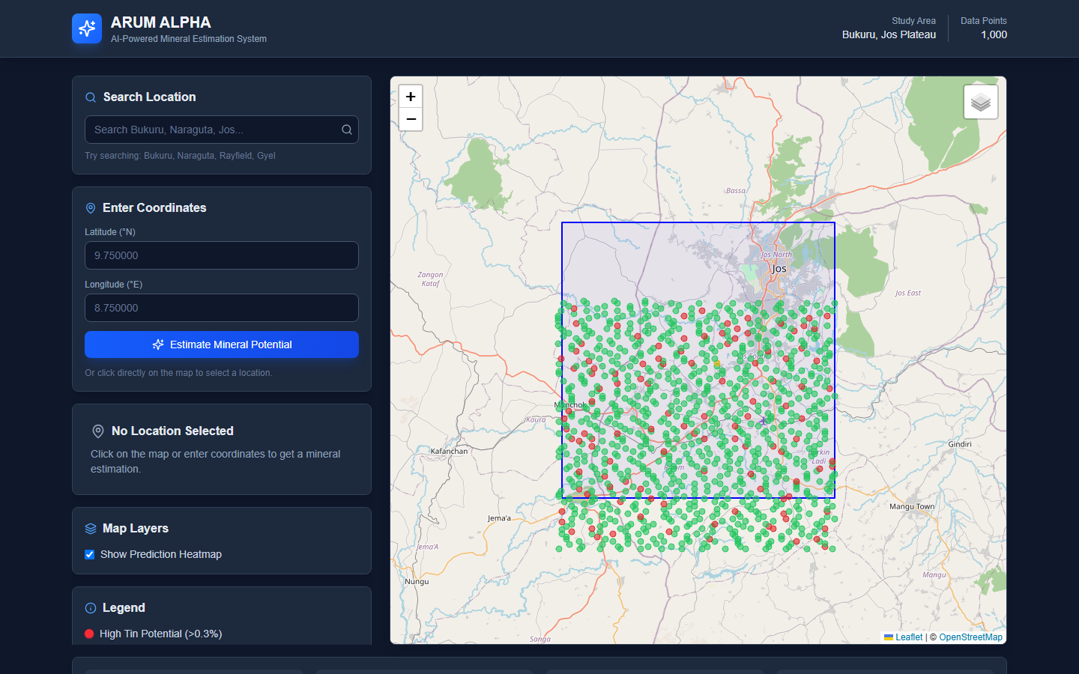
Figure 1: Desktop view of the deployed ARUM ALPHA dashboard showing the study-area map and radiometric data points.

Mobile Dashboard Screenshot
The mobile screenshot confirms that the dashboard layout remains usable on a narrow viewport. The interface stacks the search, coordinate input, and map sections vertically while preserving the study-area context.
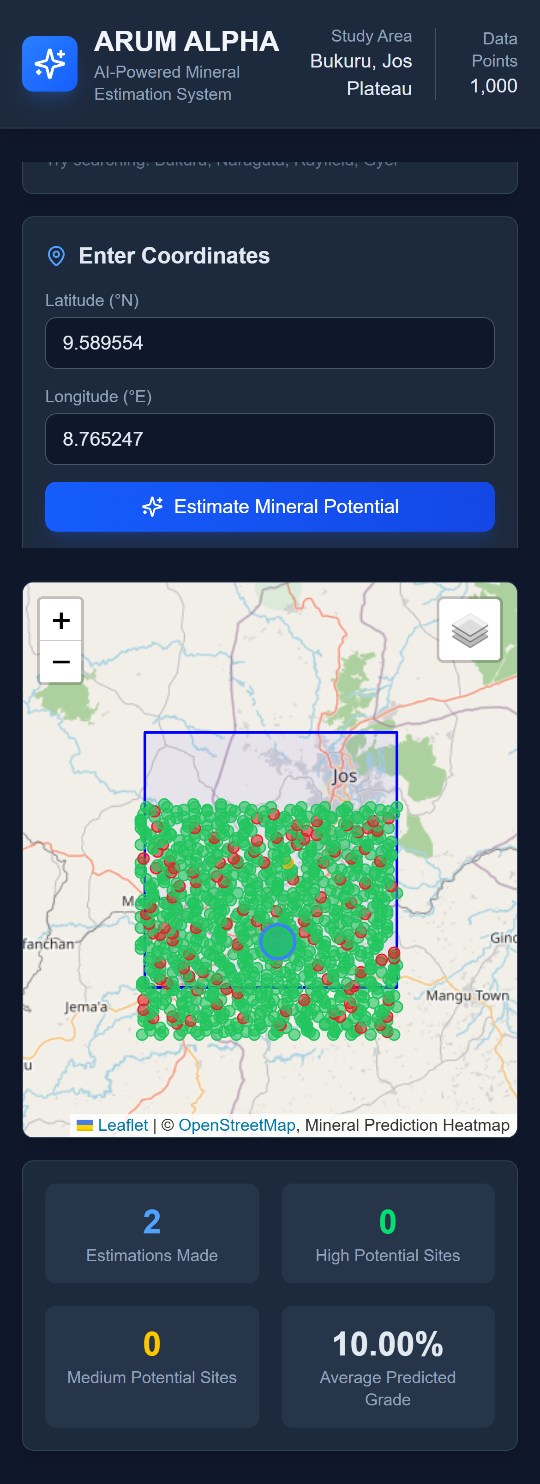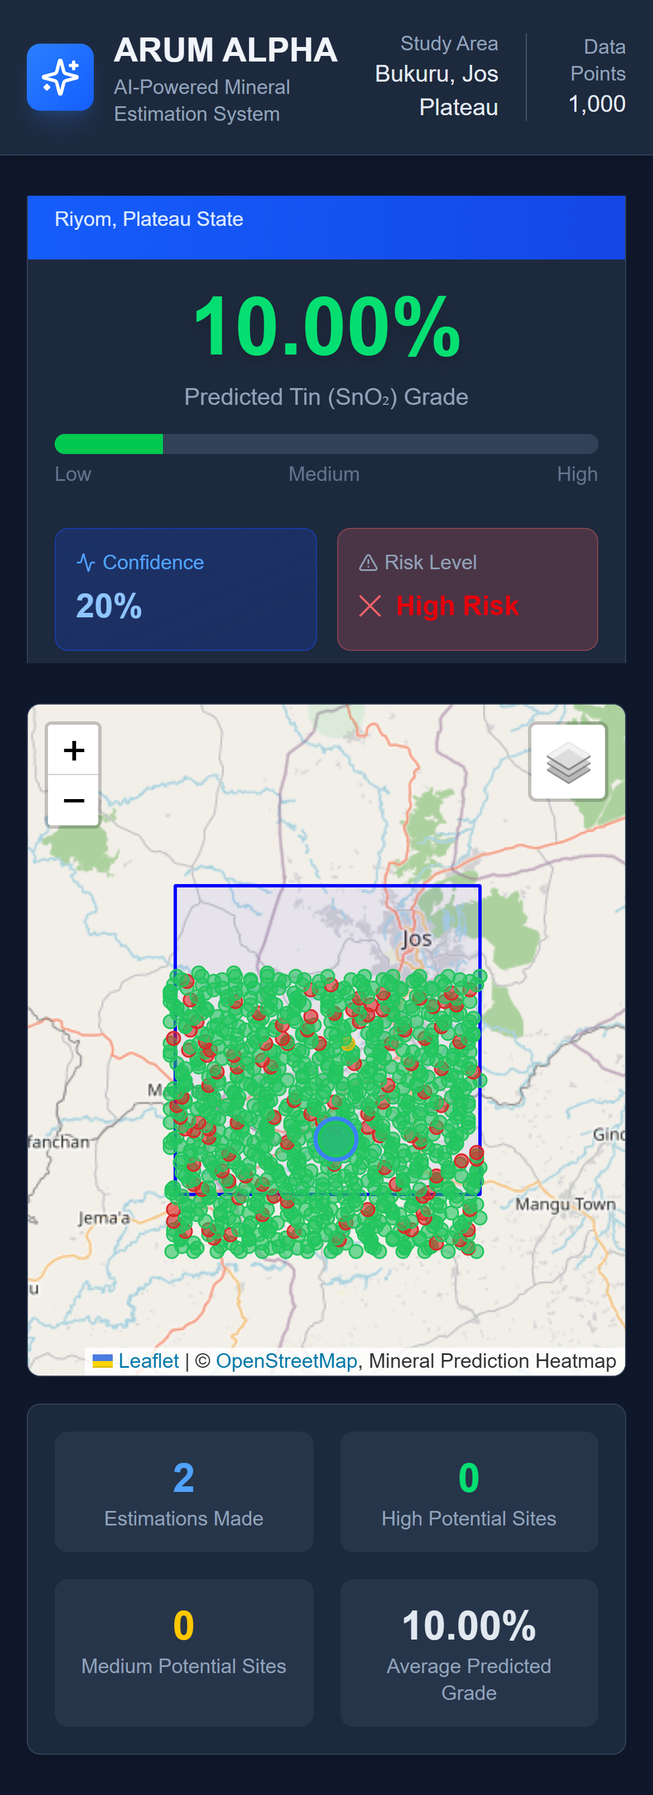
Figure 2: Mobile view of the deployed dashboard showing responsive layout and the mapped Naraguta data points.

Deployment Discussion
The deployed dashboard strengthens the project by showing that the prototype is not limited to local execution. It provides a visible product outcome: a web-based mineral estimation interface that can be reviewed, tested, and extended. In a final-year project setting, this supports both the technical implementation requirement and the presentation requirement because the application can be demonstrated live.

12. Results and Discussion
The resulting system is a working web dashboard that supports interactive mineral potential estimation. A user can search for Plateau locations such as Bukuru, Naraguta, Rayfield, Gyel, Du, Zawan, and Sabon Barki, or can click any coordinate on the map. For locations inside the Sheet 168 study area, the system uses local radiometric data. For locations outside the study area, it uses a broader geological context service and synthetic radiometric estimates.
The prediction panel communicates the estimated tin grade, confidence, risk level, potassium/thorium/uranium readings, K/(Th+U) ratio, AI analysis, field recommendations, and model performance metrics. The visualization gives students and technical reviewers a fast way to inspect how radiometric anomalies relate to predicted mineral potential.
Result Area | Observed Outcome
Dashboard | Implemented with controls, map, prediction card, legend, stats bar, and export.
Geospatial display | Study boundary, base map layers, sampled radiometric points, prediction markers, and heatmap layer.
Estimation output | Predicted grade, confidence, risk level, analysis, recommendations, and model metrics.
Build verification | npm.cmd run build completed successfully with Next.js 16.2.4.

12.1 Interpretation of Project Outputs
The most important output of the project is the conversion of technical radiometric information into a usable dashboard. Instead of requiring the user to inspect raw grid files, the system presents mapped points, a study boundary, coordinate tools, and an estimation panel. This makes the project suitable for classroom demonstration, supervisor review, and early exploration discussion.
The deployed screenshots show that the system successfully renders the study area and a dense set of radiometric data points. The desktop view provides a wide map and side controls, while the mobile view confirms that the interface can stack controls and map content on a smaller screen. This is important because field users may not always work from a desktop computer.

12.2 Educational and Technical Value
- It demonstrates how a mining engineering problem can be transformed into a digital decision-support system.
- It shows the relationship between geophysical data, geospatial coordinates, and mineral prospectivity interpretation.
- It gives the student a deployable software artifact that can be tested from a production link.
- It creates a foundation for future supervised machine learning once labelled grade data are acquired.
- It encourages clearer communication between geology, mining engineering, and software development.

13. Testing and Validation
Testing focused on confirming that the application builds, the deployed interface loads, the core routes are defined, and the generated report remains openable in Microsoft Word. Scientific validation of mineral grade prediction requires labelled field or assay data and is therefore listed as future work.
Validation Area | Result
Production build | npm.cmd run build completed successfully with Next.js 16.2.4.
Deployment inspection | The Vercel dashboard page loaded and screenshots were captured from the live URL.
Responsive interface | Desktop and mobile screenshots confirm the dashboard is usable across different viewport widths.
Document validation | The generated DOCX was opened through Microsoft Word automation and reported as a valid document.
Scientific validation status | Pending labelled assay or production-grade data for supervised ML training and test-set evaluation.

13.1 Test Cases
Test | Action | Expected Result | Status
Load dashboard | Open production URL | Dashboard header, controls, and map should render. | Passed
Display study data | Wait for map and sampled points | Map should show study boundary and radiometric markers. | Passed
Coordinate input | Enter 9.750000, 8.750000 | System should accept numeric latitude and longitude. | Implemented
API data route | Call GET /api/data | Route should return bounds and sampled radiometric points. | Implemented
API estimate route | Submit POST /api/estimate | Route should return prediction, metrics, analysis, and recommendations. | Implemented
Responsive layout | Capture mobile-width screenshot | Interface should remain usable on narrow screens. | Passed
DOCX validity | Open report with Microsoft Word | Document should open and TOC should update. | Passed

13.2 Validation Limitations
The software validation confirms that the prototype runs and presents the expected interface, but it does not prove geological accuracy. Geological validation requires comparison between model predictions and independent field evidence such as assay results, trench samples, drill holes, mine production records, or expert-validated prospectivity maps. This distinction is important because a working dashboard is a software success, while an accurate ore grade model is a geoscience validation task.

13.3 Ethical, Safety, and Environmental Considerations
- The dashboard should not be used to justify mining activity without proper permits, community consultation, and environmental assessment.
- Field verification should follow safety procedures for abandoned mines, pits, unstable ground, and radiation-aware sampling practices.
- Predictions should be presented as decision-support outputs, not guaranteed ore grades.
- Data sources and uncertainty should be documented to avoid misleading investors, communities, or government agencies.
- Sustainable exploration should minimize unnecessary land disturbance by using digital target ranking before field sampling.

14. Limitations
- The repository does not yet include labelled assay or production grade data needed to train and validate Random Forest or XGBoost models.
- The reported model metrics in the current prototype are demonstration values from the estimator code, not final field-validated accuracy results.
- The Geosoft GRD binary parser should be independently validated against known grid values before scientific conclusions are drawn from raw values.
- Some outside-study-area geological and environmental values are simulated or rule-based, so they should be treated as exploratory context only.
- AI-generated geological interpretation should support, not replace, field mapping, sampling, laboratory assays, and professional resource estimation.
These limitations do not reduce the value of the prototype; rather, they define the next stage of research. The present system proves that the workflow can be implemented, deployed, and demonstrated. The next stage is to improve the scientific reliability of the prediction engine through validated training data and rigorous model comparison.

15. Conclusion and Recommendations
ARUM ALPHA demonstrates how mineral estimation for Bukuru and the Jos Plateau can be supported with a modern web dashboard, geospatial visualization, radiometric feature engineering, and AI-assisted interpretation. The project successfully converts the original proposal into a usable prototype that can guide exploratory analysis and communicate mineral potential to students, supervisors, and technical reviewers.
The expanded report shows that the project has both an academic and practical component. Academically, it is grounded in mineral prospectivity, radiometric data interpretation, geostatistics, and machine learning. Practically, it delivers a deployed web application that reviewers can open and inspect. This combination makes the project stronger than a purely theoretical study because it produces a working artifact while also explaining the scientific basis and limitations of the method.

Recommendations for Further Work
- Acquire verified assay or production grade data for tin, then train Random Forest and XGBoost regression models.
- Compare supervised models against kriging, inverse distance weighting, and linear regression baselines using RMSE, MAE, R2, and MAPE.
- Validate the GRD parser with known Geosoft/Oasis Montaj exports and document the exact grid dimensions and null-value handling.
- Add geological layers such as faults, lithology, DEM, slope, aspect, and historical mine locations.
- Implement persistent storage for estimation history and field verification results.

References
- ARUM ALPHA project README and source code, local repository: arum-alpha/.
- ARUM ALPHA deployed production application: https://plateau-mineral-estimation.vercel.app/
- Sheet168_Naraguta_Potassium.grd.xml, Sheet168_Naraguta_Th.grd.xml, and Sheet168_Naraguta_U.grd.xml metadata files, dated April 16, 2021.
- Breiman, L. (2001). Random Forests. Machine Learning, 45, 5-32.
- Chen, T. and Guestrin, C. (2016). XGBoost: A scalable tree boosting system. Proceedings of KDD.
- Goovaerts, P. (1997). Geostatistics for Natural Resources Evaluation. Oxford University Press.
- Rodriguez-Galiano, V. F., Sanchez-Castillo, M., Chica-Olmo, M., and Chica-Rivas, M. (2015). Machine learning predictive models for mineral prospectivity. Ore Geology Reviews.

Appendix A: Running the Project
Prerequisites: Node.js 18 or newer and a Groq API key for live AI estimation.
Task | Command or Value
Install dependencies | npm install
Configure environment | copy env.example .env.local
Start development server | npm run dev
Open application | http://localhost:3000
Open deployed production site | https://plateau-mineral-estimation.vercel.app/
Build for production | npm run build

Appendix B: Project Management Snapshot
Budget Item | Estimated Cost (NGN)
Data acquisition | 50,000
Software and tools | 150,000
Research assistance | 100,000
Miscellaneous | 100,000
Total | 400,000

The proposal timeline covers topic approval, literature review, data collection, model development, dashboard implementation, validation, final report writing, and presentation preparation between January and June 2026.

Appendix C: Suggested Full Project Timeline
Period | Main Activity
January | Topic selection, supervisor approval, preliminary background reading.
February | Literature review, proposal refinement, and study-area definition.
March | Data acquisition, metadata inspection, and project environment setup.
April | Dashboard development, GRD parsing, map integration, and API route implementation.
May | Prediction logic, AI integration, deployment testing, and report drafting.
June | Final documentation, screenshots, presentation preparation, and project defence.

Appendix D: Future Data Collection Checklist
- Tin assay results from verified samples across the study area.
- Historical production records from known Bukuru and Naraguta mining sites.
- Lithological boundary data and fault/lineament maps.
- Digital elevation model, slope, aspect, drainage, and accessibility layers.
- Ground radiometric readings for comparison with airborne or gridded data.
- Coordinates of abandoned pits, active exploration sites, and non-mineralized control locations.
- Environmental sensitivity and land-use information for responsible exploration planning.

Appendix E: Defence Demonstration Guide
- Open the deployed application at https://plateau-mineral-estimation.vercel.app/.
- Point out the study area label, data point count, coordinate input form, and map layers.
- Explain that the map shows sampled radiometric points from Sheet 168 Naraguta.
- Enter a coordinate within the study area and run the estimation workflow.
- Discuss the predicted grade, confidence, risk level, radiometric readings, and recommendations.
- Explain the difference between the current prototype and a future supervised Random Forest/XGBoost model.
- Close by identifying the validation data required for a publishable mineral prospectivity model.

