

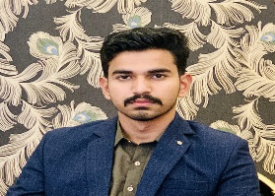
Contact Me
Nouman Pervaiz
.

 +923426984074



Johar Town Lahore
noumandhair@gmail.com

Skills
- Good Communication Skills.
- Team Work.
- Good leadership skills.
- Problem solving and strong work Ethics.
- Time Management and Teamwork.
- Management and event organization.

Digital Skills
- Affilate Marketing
- Keywords research
- M.S Office Professsincy
- Python
- Html
- Css
- Java(OOP)

Professional Summary
An enthusiastic Fresh Graduate ready to accept any Challenge for excelling in his career by using creative and Result oriented approaches.

Academic Record
- BS Artifical Intelligence 2026
University of Central Punjab . CGPA 2.8/4.0 (Continue 4th Semester)
- FSC 2024
BISE Gujrawala
- Matric 2022
BISE Gujrawala
Short Course
- OFFICE MANAGEMENT :FCA learner
- ILETS:

Languages
- English ▪ Urdu
- Punjabi

Reference
▪ Will be provided on demand.

