
High-Level Solution Design
PROTOTYPE PHASE HLSD

Solution Name:
Intelligent Invoice Management

Version:
0.3

Date:
14/09/2026

Document Information

Document Title | High-Level Solution Design (HLSD)
Solution Name | Intelligent Invoice Management
Version | 0.3
Date | 14/09/2026
Prepared By | ByteDance
Reviewed By | Central AI / Oversight Team
Approved By | AI Solutions Steering Group / Central AI Committee
Status | Draft
Phase | Prototype

Revision History

Version | Date | Author | Summary of Changes
0.1 | 24/08/2026 | ByteDance | Initial Draft Version
0.2 | 12/09/2026 | ByteDance | Update based on solution owner review 12/09/2026
0.3 | 14/09/2026 | ByteDance | Round-2 review: repositioned as revenue and receivables intelligence; corrected Sanad/Efaa/Makeen/Furas platform descriptions; added Sanad Enforcement-to-Invoice Mapping (WF-09); expanded KPI & Performance Intelligence and Dynamic Report Generation; added governed semantic/business metrics layer; removed remaining procurement/tax-compliance remnants from text and diagrams; strengthened data-authority matrix; aligned acceptance criteria and benefit statements with clarified scope

HLSD Review Checklist
Tick marks indicate which stakeholders should review each item.
✓ | Review Item | Sec. | OT | SO | AC | CAIT | SGG | SH | CAIC | ARB
Strategy & Business
□ | Business problem articulated with measurable impact | 2.1 | ✓ | ✓ | ✓ | ✓
□ | Strategic alignment to NHCI, MOMAH SSO, and AI strategy | 2.2 | ✓ | ✓ | ✓ | ✓
□ | Existing solution landscape documented | 2.5 | ✓ | ✓ | ✓ | ✓
□ | Key requirements identified | 4 | ✓ | ✓ | ✓ | ✓
□ | Success metrics (i.e., KPIs) with baseline and targets | 5 | ✓ | ✓ | ✓ | ✓
□ | Executive summary self-contained | Exec. | ✓ |  |  | ✓ | ✓ | ✓ | ✓
Solution Design
□ | Solution description accessible to non-technical audience | 3.1 | ✓ | ✓ | ✓ | ✓ |  | ✓
□ | Personas, and user journeys defined and linked | 3.2–3.3–3.4 | ✓ | ✓ |  | ✓
□ | High-level Roadmap | 6.1 | ✓ | ✓ | ✓ | ✓
□ | Stakeholders identified with responsibilities and contacts | 2.3 | ✓ | ✓ | ✓ | ✓

OT = Oversight Team | SO = Solution Owner | AC = Al Champion | CAIT = Central Al Team | SGG = Al Steering Group | SH = Sector Head | CAIC = Al Central Committee | ARB = NHCI ARB
Note: Other bodies might be involved during the development of the HLSD (e.g. DT, MOMAH EA). All sections listed above are mandatory for Prototype Phase approval.

Table of Contents

Document Information 1
Revision History 2
HLSD Review Checklist 3
Table of Contents 4
Executive Summary 5
1. Introduction 6
1.1 Purpose 6
1.2 Scope 6
In Scope 6
Out of Scope 6
1.3 Intended Audience 7
1.4 Definitions & Acronyms 8
2. Business Context 9
2.1 Business Problem 9
2.2 Strategic Alignment 10
2.3 Key Stakeholders 11
Omar Almhasen 11
2.4 Expected Business Outcomes 11
2.5 Current Solution Landscape 11
3. Solution Overview 12
3.1 Solution Description 12
3.2 User Personas 12
3.3 Process / Workflow 14
WF-01 — Intelligent Invoice Processing 15
WF-02 — Collection Forecast and Follow-up Prioritization 18
WF-03 — Operational Performance Analytics (KPI & Performance Intelligence) 20
WF-04 — Conversational Invoice Insight and Dynamic Report Generation 23
WF-05 — Financial Audit Review 26
WF-06 — Periodic Revenue Reporting 28
WF-07 — Financial Reconciliation 30
WF-08 — Violation Follow-up 32
WF-09 — Sanad Enforcement-to-Invoice Mapping 34
3.4 User Journey 37
4. Requirements Summary 39
4.1 Business Requirements 40
4.2 Non-Functional Requirements 41
5. Success Metrics 42
5.1 Strategic Metrics 42
5.2 Operational Metrics 43
5.3 Technical Metrics 44
6. Roadmap & Phasing 46
6.1 High-Level Delivery Roadmap 46
6.2 Capability Delivery Traceability 46
Additional resources 47
Appendix 48
A. References 48
B. Approval Sign-Off 48

Executive Summary

The proposed solution is a revenue and receivables intelligence platform that ingests invoice and receivables data from Tahseel, Makeen, Efaa, Sanad and other platforms, automatically classifies each item, and presents the results through a centralized AI-powered dashboard. The platform serves revenue and receivables management departments responsible for invoice, collection and enforcement oversight. It covers investment-revenue analysis, collection and enforcement monitoring, reconciliation, forecasting, KPI intelligence and conversational reporting; it is not a procurement, supplier-payment or tax-compliance solution. It provides real-time visibility into invoice and receivables status and classifications, accelerates processing, and supports decision-making through AI-powered insights and analytics. Core capabilities include automated invoice classification with confidence scores, detection of duplicates and abnormal charges, prediction of collection timelines, KPI and performance intelligence, and dynamic conversational report generation. It also provides customizable dashboards and reports, audit trails, the ability to align classifications with regulatory and institutional requirements, scalability, continuous learning, and secure data handling. Existing platforms remain the Systems of Record, with authoritative attribute ownership documented in a data-authority matrix and Tahseel serving as the authoritative source for official collection figures.

The Ministry of Municipalities and Housing faces a structural challenge in managing government invoices, as data is distributed across four separate platforms (Tahseel, Makeen, Efaa, and Sanad) without automated integration.
- Scope.In scope are multi-source invoice ingestion, OCR data extraction, duplicate detection, format standardization, automated cross-platform validation, financial anomaly detection, risk-based case routing, collection/delay/cancellation forecasting, KPI and performance intelligence, dynamic conversational report generation, and relevant municipal investment and lease-contract data originating from Furas for revenue and receivables analysis.
- Out of scope are direct payment processing, bank account reconciliation, tax/VAT compliance, replacement of Tahseel, Makeen, Efaa, or Sanad, procurement, supplier-payment processing, contract management and the full procurement lifecycle, the execution or administration of contract-award and amendment processes, entity relationship management, and issuance of legally approved official financial reports. The solution does not replace, overwrite, or assume transactional ownership from existing source systems.
- Expected impact and outcomes. Business impact is measured through productivity efficiency, expected collected revenue, employee hours saved and employee AI adoption, with phased targets defined in Section 5.
- Success metrics. Success metrics focus on productivity efficiency, expected collected revenue, employee hours saved, and employee AI adoption, with phased 6-month, Year 1 and Year 2 targets defined in Section 5.
- User journeys cover Intelligent Invoice Processing, Collection Forecast and Follow-up Prioritization, Operational Performance Analytics, Conversational Invoice Insight, Financial Audit Review, Periodic Revenue Reporting, Financial Reconciliation, Violation Follow-up, and Sanad Enforcement-to-Invoice Mapping.
- Human oversight. The solution applies mandatory Human-in-the-Loop for approval decisions and critical actions. AI agents provide recommendations, alerts, forecasts, explanations, and confidence scores, while final approval remains with the responsible human officer.
- High-level roadmap. Prototype completion is planned by 15 September 2026, followed by Alpha by 15 October 2026, Beta by 7 December 2026, and production Go-Live by 21 January 2027.

The solution is expected to improve collection performance, reduce invoice-processing time, release workforce capacity, reduce duplicate-payment and financial-anomaly risks, and strengthen financial transparency. Quantified business targets are defined in Section 5 using the current approved KPI baseline.

1. Introduction

1.1 Purpose
This Prototype Phase HLSD provides a high-level blueprint for Intelligent Invoice Management. It establishes the solution purpose, business context, scope, expected outcomes, personas, user journeys, requirements, success metrics, and delivery direction required to validate the solution during the Prototype phase and support progression to subsequent delivery phases.

1.2 Scope
The Prototype scope covers the capabilities below and explicitly preserves the existing source platforms rather than replacing them.

In Scope
- Ingest invoices from government ERP systems, and related platforms (Tahseel, Makeen, Efaa, Sanad) in a unified format.
- Extract invoice data using OCR: invoice number, ID number, registration number, SADAD number, Amanah, municipality, payment-order numbers, amounts, dates, and VAT.
- Detect duplicate invoices and automatically alert users.
- Automatically validate invoice matching between Sanad and Makeen and invoices collected through integration with government services.
- Check consistency of invoice records against payment-order data maintained by source systems, for monitoring and audit purposes (no approval action is performed by the platform).
- Detect financial anomalies and incorrect entries (mismatched or incomplete invoices, duplicate invoices, exaggerated items).
- Risk-based case routing and notification for review based on spending thresholds, entity type, and invoice data (no approval action performed by the platform).
- Predict the probability of invoice collection, delay, or cancellation based on historical data.
- Interactive dashboards, performance reports, KPI and performance intelligence, and dynamic conversational report generation.
- Relevant municipal investment and lease-contract data originating from Furas, in scope for revenue and receivables analysis, invoice matching, collection monitoring, forecasting and enforcement analysis.

Out of Scope
- Direct payment processing and bank account reconciliation.
- Modification or replacement of existing source systems (Tahseel, Makeen, Efaa, Sanad) - the system complements existing systems and does not replace them.
- Contract management or the full procurement lifecycle (procurement, tenders, negotiation), supplier-payment processing, and the execution or administration of contract-award and amendment processes. Relevant municipal investment and lease-contract data originating from Furas are in scope for revenue and receivables analysis; procurement, supplier-payment processing, and the execution or administration of contract-award and amendment processes remain outside this solution’s scope.
- Entity relationship management and their management processes.
- Production of legally approved official financial reports - the system supports reporting but does not issue reports in an official legal capacity.
- Tax/VAT compliance, tax assessment, tax-registration verification, and integration with tax-authority (ZATCA) systems; existing tax/VAT values may be retained only as source attributes for interpreting or reconciling invoice amounts.

1.3 Intended Audience
Audience | Purpose of Review
Central AI Committee | Strategic review of an executive version of the HLSD and final stage-gate approval
AI Solutions Steering Group | Strategic and technical review of an executive version of the HLSD, stage-gate endorsement for moonshot solutions and stage-gate approval for standalone solutions
Sector Head | Review for alignment with sector needs and priorities, provide final approval before submission to Steering Group / Central AI Committee
AI Champion | Review for sector alignment
NHCI ARB | Review for technical architecture (no approval at this stage)
NHCI Technical Lead(s) | Day-to-day delivery management and review
Oversight team | Governance review, standards compliance, and delivery assurance across the program
AI Solution Owner | Solution-level owner; provide input, review key requirements, business outcomes, and user journeys
Solution Vendor | Document owner - produced and maintained by vendor. Responsible for completeness and accuracy of all sections.
Note: For governing bodies’ review (i.e., Central AI Committee and AI Solutions Steering Group) an executive summary presentation needs to be developed covering all elements listed in the Executive Summary (at the beginning of this document)

1.4 Definitions & Acronyms
Term / Acronym | Definition
HLSD | High-Level Solution Design
NHCI | NHC Innovation
MOMAH | Ministry of Municipalities and Housing
ARB | Architecture Review Board
AI | Artificial Intelligence
Preparation phase | Define the vision, objectives, scope, requirements, and high-level solution approach
Prototype phase | Validate UX/UI, key features, and user journeys before full development
Alpha phase | Build and test core features in a sandbox environment to prove the technical approach
Beta phase | Complete feature development and validate the solution with integrations in a staging environment
Release & Stabilization phase | Deploy to production, release improvements, fix issues, and stabilize the solution
Operate phase | Hand over to operations/technical teams and drive adoption through change management and ongoing support
BRD | Business Requirements Document; defines the scope, business needs, functional requirements, and constraints for the Intelligent Invoice Management solution.
Human-in-the-Loop (HITL) | A governance model that requires mandatory human review and approval of AI outputs before official use or critical action.
Optical Character Recognition (OCR) | Technology that converts scanned or image-based documents into machine-readable text, enabling automated extraction and analysis of invoice data.
Personal Data Protection Law (PDPL) | Saudi Personal Data Protection Law issued by SDAIA; the primary data-protection regulation applicable to this solution.
Service Level Agreement (SLA) | A formal agreement defining guaranteed performance levels such as availability, response time, and service quality between the Ministry and the implementation partner.
Role-Based Access Control (RBAC) | An access-control model that restricts platform features and data according to user role and the need-to-know principle.
Tahseel Platform | Government payment platform of the Ministry of Municipalities and Housing for collecting revenue from municipal services and government payments.
Makeen Platform | Billing and invoice-record platform used at the Ministry of Municipalities and Housing, covering fee invoices, investment and lease-contract and license references (including Furas-originated contracts), and revenue-account mapping across Amanahs and sub-municipalities; description to be validated with the Makeen data owner.
Efaa Platform | Municipal violations and enforcement-referral platform recording violation cases that may result in invoiced penalties, matched with Mumtathil case-status data in WF-08 Violation Follow-up; description to be validated with the Efaa data owner.
Sanad Platform | Platform supporting municipalities in pursuing legal recovery of outstanding investment debts and other non-fine, non-violation municipal receivables through the Board of Grievances; distinct from the Efaa fines and violations workflow. Its enforcement/case reference and Board of Grievances reference are distinct from, and not always linked to, the underlying SADAD invoice number(s).
Furas Platform | Enables municipalities to offer municipal real estate to investors through competitive bidding, resulting primarily in investment and lease contracts that generate municipal receivables. Relevant contract data is in scope for revenue and receivables analysis, invoice matching, collection monitoring, forecasting and enforcement analysis; the required data feed and whether it is obtained directly or through an existing integration or approved dataset is to be confirmed with the Furas data owner.
Mumtathil Platform | Platform tracking municipal-violation judgment, appeal and enforcement case-status for violations referred from Efaa; used to update collection-probability scores and enforcement follow-up.
Confidence Score | A numeric value (0%-100%) produced by AI models for each decision or classification, indicating the degree of certainty in the output.
AI Agent | A specialized AI program that independently performs a specific task within defined boundaries, such as the Ingestion Agent or Validation Agent.
Financial Forecasting Model | A machine-learning model that analyzes historical invoice and collection data to predict the probability of collection, delay, or cancellation.
Financial Anomaly | Any invoice, item, or pattern that deviates materially from normal expectations based on historical behavior models.
Government ERP | Government Enterprise Resource Planning system; the integrated environment for managing financial, human, and operational resources in Saudi government entities.
Audit Trail | An immutable sequential record documenting every action in the system: who performed it, when, what changed, and for what reason.
National Cybersecurity Authority (NCA) | Government authority responsible for cybersecurity in the Kingdom; it issues controls and frameworks with which this solution must comply.

2. Business Context

2.1 Business Problem
Fragmentation of invoice data leads to slow processing, higher risks of duplication and misclassification, and limited transparency.
This document presents the Intelligent Invoice Management initiative, an AI-powered unified platform that ingests invoices from all sources and processes them automatically through five specialized AI agents: the Ingestion Agent, Validation and Compliance Agent, Financial Anomaly Detection Agent, Case Routing & Notification Agent, and Analytics and Forecasting Agent.

Current State

- Several separate systems (Tahseel, Makeen, Efaa, Sanad, and others) are used to manage invoices and collections.
- Data is distributed across platforms, resulting in classification differences, the need for manual reconciliation, and fragmented reporting.
- Stakeholders rely on manual data extraction, spreadsheets, and custom dashboards.
- Current processes lack unified analytics, AI-powered insights, and standardized governance.

Pain Point

# | Pain Point | Business Impact | Severity / Impact
1 | Invoice data is fragmented across multiple platforms (Tahseel, Makeen, Efaa, Sanad) | Data duplication and inconsistency and difficulty obtaining a unified view | High
2 | Reliance on manual invoice processing and reconciliation | Higher operating cost, slow processing cycle, and more human errors | High
3 | No automated validation of invoice matching across different platforms | Risk of uncollected or misapplied revenue due to unmatched or incorrect invoices | High
4 | Difficulty detecting duplicate invoices and potential manipulation | Loss of government funds and reduced confidence of oversight authorities | High
5 | Limited ability to predict collection or cancellation probability | Difficulty in financial planning and reduced accuracy of revenue forecasts | High
6 | Incoming invoice formats are not standardized across platforms | Intensive manual effort to standardize data before processing | High
7 | Current processes lack real-time, AI-powered analytics | Delayed decision-making and weak response to financial risks | High
8 | Difficulty routing invoices automatically to the responsible reviewing officer | Delayed case review and accumulation of unmonitored invoices | High
9 | Limited transparency in financial AI decisions | Difficulty in auditing and accountability in official financial reporting | High
10 | Difficulty connecting legacy financial systems with modern digital platforms | Technical barriers limiting integration and end-to-end automation | High

Opportunity Statement

Intelligent Invoice Management provides an opportunity to transform invoice processing at the Ministry of Municipalities and Housing from a fragmented manual model into a unified AI-powered platform. By automating invoice ingestion and validation and predicting collection probability, the solution is expected to achieve tangible operating savings, increase financial transparency, and reduce fraud and duplicate-payment risks. The indicative revenue-accuracy improvement range under evaluation during the Prototype phase is 15%-30%; the agreed measurement method, baseline, and the split between underlying revenue growth and solution-attributable benefit are defined in Section 5 and subject to business-owner approval before being treated as a committed target.

2.2 Strategic Alignment

Vision 2030 Objective | Improve government performance efficiency and enhance non-oil revenues; support the national financial planning ecosystem and transparency of government spending
NHCI Strategic Objective | Aligned with the core objectives of NHCI's AI innovation implementation and digital transformation of government services, aiming to develop a reusable benchmark solution for government AI agents.
MOMAH Sector Strategic Objectives (SSOs) | Achieve financial sustainability of 85% across the Ministry's first three revenue gates, reach SAR 25 billion in invoiced government revenue by 2025, and reduce the Ministry's dependence on oil revenues.
MOMAH AI Strategy Alignment | Delivers dynamic invoice capture, pattern analysis, and collection-probability forecasting under a mandatory human-in-the-loop model. Every AI recommendation and alert carries a confidence score and a clear rationale; final decision authority on every approval and critical action remains with the human official.

2.3 Key Stakeholders

Stakeholder | Role | Interests / Concerns | Responsibility | Name | Contact
AI Solution Owner | Solution-level owner | Requirements definition; ensure progress in line with business needs | Participate in vendor check-ins, Sprint Reviews, Steering Group, and design discussions | Tariq Aljarboa, Abdulaziz Alajlan | taljarboa@momah.gov.sa,  aa.alajlan@momah.gov.sa
AI Champion | Sector-level coordinator | Cross-solution coordination; surface risks, dependencies, and adoption needs within sector | Participate in Sprint Reviews and Bi-Weekly Sector meetings | Waleed Al-Askar | W.Alaskr@momah.gov.sa
Sector Head | Sector-level sponsor | Solution direction, progress alignment, escalation support | Participate in Bi-Weekly Sector meetings and Central AI Committee sessions | Omar Almhasen | Oalmhasen@momah.gov.sa

2.4 Expected Business Outcomes
- Improve revenue collection performance through automated tracking, matching, follow-up and anomaly detection.
- Accelerate the invoice processing cycle and reduce manual review time by up to 50%.
- Reduce errors and duplicate invoices through automated validation and financial reconciliation.
- Enhance financial transparency through real-time dashboards and AI-powered reports.
- Improve financial forecast accuracy through models that predict collection and cancellation probability.
- Provide a unified analytical view across Tahseel, Makeen, Efaa and Sanad while retaining the existing platforms as authoritative source systems
- Facilitate preparation of financial reports.

2.5 Current Solution Landscape

Solution Name | Owner / Provider | Dedicated Budget | Timeline / Status | Core features | Coverage of Problem (2.1) | Gaps / Limitations | Demo / Documentation
Tahseel / Makeen / Efaa / Sanad platforms (existing systems) |  |  | Fully operational since 2020+ | Invoice ingestion, issuance, collection, basic reporting - each platform is independent | Partial coverage by each platform independently - no unified integration, no AI, no forecasting | No unification across platforms; manual processing (3-5 days); no financial anomaly detection; no collection forecasting; | Official platform documentation at the Ministry

3. Solution Overview

This section provides a high-level description of the proposed solution, its capabilities, target users, workflows, and operating assumptions.

3.1 Solution Description
The Intelligent Invoice Management initiative is a unified AI-powered initiative managed by the Shared Services team at the Ministry of Municipalities and Housing.
The platform automatically ingests invoice data from Tahseel, Makeen, Efaa, and Sanad through integrated APIs and processes it in an automated sequence through five specialized AI agents:
1. Ingestion Agent - extracts data using OCR, standardizes formats, and detects duplicates.
2. Validation and Compliance Agent - matches the invoice against the system and the SADAD reference data recorded in source systems.
3. Anomaly Detection Agent – analyzes financial patterns to identify anomalies, mismatches and incorrect payments, and provides a risk score, explanation and supporting evidence for human review.
4. Case Routing & Notification Agent - identifies the responsible Revenue & Collection Officer/Manager for cases requiring review and routes case notifications; performs no approval or payment-authorization action.
5. Analytics and Forecasting Agent - generates collection forecast scores, updates dashboards, and answers user queries in Arabic.
Architectural Component: Semantic / Business Metrics Layer. A governed semantic layer sits between the integrated invoice/collection data and the KPI, forecasting and conversational-reporting capabilities. It defines reusable business entities, relationships, measures and calculation rules, including organizational and revenue-source classifications; investment-contract, invoice, collection and enforcement relationships; invoice-status and date definitions; approved KPI formulas, dimensions and aggregation rules; and source lineage, data-owner responsibility, access restrictions and definition versioning. The Ministry’s approved net-invoicing and collection-rate methodology is represented explicitly within this layer, including the applicable numerator, denominator, exclusions and time alignment; enforcement-to-invoice relationships are modeled to prevent double-counting. WF-03 KPI & Performance Intelligence and WF-04 Dynamic Report Generation query and analyze through these governed definitions rather than independently interpreting raw tables or inventing formulas; a new measure may be proposed but does not silently replace an approved measure.
Data Governance Principle: System-of-Record and Data Authority Boundary. Existing platforms remain the Systems of Record for their respective business domains. Tahseel is the authoritative source for official collection figures; this is not a blanket rule that Tahseel overrides every conflicting attribute from every other system. A data-authority matrix, agreed with the relevant Data Owners, will document the authoritative source for each material field or business domain (including payment status, collection dates, enforcement references and other source attributes). Where records conflict, the proposed platform will not overwrite either source record; it will retain the source lineage, classify the discrepancy per the authority matrix, and present it for authorized review. The platform may maintain its own traceable analytical mappings, review decisions and recommendations, but does not silently alter official source records; rejecting a proposed extraction, classification or mapping is distinct from rejecting or cancelling the underlying municipal receivable, which remains within the authorized source-system process.
The platform adopts a mandatory Human-in-the-Loop principle. Agents provide explainable recommendations and alerts with confidence scores, while the final decision remains with the human officer for all approval decisions and critical actions. The solution will follow the MOMAH program hosting baseline on OCI, with Saudi data-residency and applicable NCA/PDPL security controls.

3.2 User Personas

Persona | Description | Primary Need | Interaction with the solution | Frequency of use
Invoice and Collection Officer | Financial employee responsible for daily invoice ingestion and validation | Process invoices quickly and accurately and detect errors and duplicates | Uses the invoice and daily dashboard to review ingested invoices and alerts | Daily
Revenue and Collection Manager | Manager responsible for monitoring collection performance and making intervention decisions | Real-time view of collection performance, forecasts, and deviations from target | Reviews analytical dashboards and periodic reports and approves recommendations | Weekly / Monthly
Internal Financial Auditor | Auditor who reviews compliance with invoice, contract, and authority rules | Verify approval records, audit trails, and regulatory compliance | Reviews audit and validation records and approval paths | Periodic / As needed
Shared Services Leader | Executive leader responsible for performance of the invoice and revenue ecosystem | Comprehensive executive view of performance, risks, and financial impact | Reviews summary reports and strategic indicator dashboards | Monthly
Governance Officer | Governance role involved in financial delegation compliance, delegation-compliance oversight, exception escalation, and financial audit activities. | Verify compliance with financial delegation rules and review material delegation-compliance or governance exceptions. | Participates in financial audit and approval-path review; receives alerts for delegation-rule deviations, ambiguous authority classification, escalated rejected invoices, and high-risk cases requiring governance attention. | Periodic / As needed
Financial Reconciliation Officer | Financial officer responsible for reviewing billing differences between Makeen and Tahseel. | Identify, understand, and resolve cross-platform billing discrepancies using Tahseel as the official reference. | Reviews the Makeen–Tahseel reconciliation dashboard, examines differences by type and cause, reviews proposed corrective actions, exports reconciliation results, and may refer results to the Financial Auditor. | Weekly
Penalties and Fines Officer | Officer responsible for monitoring penalties and fines and their appeal and enforcement status across Efaa and Mumtathil. | Track violation status, enforcement progress, appeals, and their impact on collection probability. | Reviews matched Efaa/Mumtathil violation records, monitors appeal and enforcement status, receives material-change alerts, reviews updated collection probability, and follows up cases requiring enforcement or appeal action. | Daily / As needed
Field Collection Manager | Collection execution role responsible for acting on collection-priority recommendations generated from forecasting results. | Prioritize follow-up activities and focus collection effort on invoices requiring proactive intervention. | Uses collection-risk rankings, collection/delay/cancellation probabilities, and intervention recommendations to execute follow-up actions on prioritized invoices. | Daily
Amanah Leader | Amanah-level management role receiving revenue-performance information for oversight and performance review. | Review Amanah revenue performance against targets and understand operating-expense coverage and collection performance. | Reviews the periodic revenue report/dashboard, including collected-versus-target performance, revenue-source analysis, and operating-expense coverage at Amanah level. | Monthly

3.3 Process / Workflow

Step | Stage | Primary Actor | Activity | Output
1 | Invoice ingestion | Ingestion Agent | Receive invoice via email, ERP portal, Tahseel, or Sanad | Invoice ingested into the system with a unique identifier
2 | Data extraction (OCR) | Ingestion Agent | Extract key fields: ID number, Amanah, municipality, invoice number, date, amount, tax, payment-order number, SADAD number | Structured and standardized invoice record in the database
3 | Duplicate detection | Ingestion Agent | Check invoice against existing invoices to detect duplicates or similar entries | Duplicate alert or authorization to continue
4 | Validation and compliance | Validation Agent | Match the invoice in Makeen against the record in Tahseel and check invoice value consistency | Validation report with matching score and deviations
5 | Financial anomaly detection | Financial Anomaly Agent | Analyze invoice for unusual patterns, exaggerated items, or items required to be enforced against (excluded: deleted records - incomplete in Efaa - outside Efaa - under objection) | Anomaly alert with risk score or pass to the next step
6 | Case Routing & Notification | Case Routing & Notification Agent | Identify the responsible Revenue & Collection Officer/Manager based on amount, risk indication, and invoice data, and send a review notification (no approval action is performed) | Review notification sent to the relevant officer/manager
7 | Collection analysis and forecasting | Analytics Agent | Calculate probability of collection, delay, or cancellation and update dashboards | Collection-probability score and action recommendations
8 | Reporting and querying | Analytics Agent / User | Generate performance reports and answer user queries in natural language | Exportable reports, answers, and insights

Process / Workflow Summary
WORKFLOW ID | CORE WORKFLOW NAME | PRIMARY PERSONAS COVERED | RELATED UC
WF-01 | Intelligent Invoice Processing | Invoice & Collection Officer; Internal Financial Auditor | UC-01 / UC-02 / UC-03 / UC-04 / UC-08
WF-02 | Collection Forecast and Follow-up Prioritization | Revenue & Collection Manager; Field Collection Manager | UC-05
WF-03 | Operational Performance Analytics | Revenue & Collection Manager; Shared Services Leader | UC-06
WF-04 | Conversational Invoice Insight | Authorized Business Users; Revenue & Collection Manager; Shared Services Leader | UC-07
WF-05 | Financial Audit Review | Internal Financial Auditor; Governance Officer | UC-09
WF-06 | Periodic Revenue Reporting | Revenue & Collection Manager; Amanah Leader | UC-10
WF-07 | Financial Reconciliation | Financial Reconciliation Officer; Internal Financial Auditor | UC-11
WF-08 | Violation Follow-up | Penalties & Fines Officer; Internal Financial Auditor | UC-12
WF-09 | Sanad Enforcement-to-Invoice Mapping | Financial Reconciliation Officer; Internal Financial Auditor | UC-13

WF-01 — Intelligent Invoice Processing
As-Is Workflow (Before AI Solution Implementation)
Invoice processing is distributed across Tahseel, Makeen, Efaa and Sanad and relies on manual extraction, standardization, reconciliation and review coordination. Duplicate and anomaly controls are not available through a unified process.
To-Be Workflow (After AI Solution Implementation)

STEP ID | STEP DESC | RESPONSIBLE ROLE
WF01-01 | Receive a new invoice through manual upload or the configured supported-source intake. The workflow starts only for authenticated access and supported intake conditions. | Invoice & Collection Officer
WF01-02 | Create the unique invoice identifier, extract mandatory invoice fields using OCR where required, and standardize dates, amounts, units and field names into the unified invoice record. | Ingestion Agent
WF01-03 | Check file/record completeness and possible duplication. Unsupported format, missing mandatory information or a duplicate condition stops automated progression and creates a controlled review case. | Ingestion Agent
WF01-04 | Run invoice and SADAD reference validation using the configured reference data. Produce the matching report, confidence information, and deviations. This check runs in parallel with WF01-05. | Validation & Compliance Agent
WF01-05 | Run financial-anomaly analysis in parallel with validation. Compare the invoice with historical patterns and configured business rules, then produce the anomaly score, risk classification and explanation. | Financial Anomaly Detection Agent
WF01-06 | Wait for both validation/compliance and anomaly-analysis results. Continue only where both outcomes permit automatic or conditional progression; any mandatory-stop outcome is routed to human review. | Intelligent Invoice Platform
WF01-07 | Review deviations, high-risk anomalies or other mandatory-stop cases. The auditor may accept the case to continue, reject it, request clarification/additional investigation, or send it to pending-invoice resolution. | Internal Financial Auditor
WF01-08 | For invoices that pass validation and anomaly checks, identify the responsible Revenue & Collection Officer/Manager based on invoice value, entity type, and invoice data, and send a review notification containing the case summary. No approval or payment-authorization action is performed. | Case Routing & Notification Agent
WF01-09 | Review the notified case summary, validation results, and confidence information for awareness and ongoing monitoring. No approval, rejection, or payment action is taken at this step; the case continues to be tracked under WF-02 collection monitoring. | Revenue & Collection Officer / Revenue & Collection Manager
WF01-10 | Record the case notification event, timestamp, status and referral path in the audit trail. The invoice's collection status is updated for ongoing monitoring under WF-02; the Intelligent Invoice platform does not process, authorize, or execute any payment or disbursement action. | Intelligent Invoice Platform
WF01-11 | Manage invoices stopped or rejected at any stage through the pending-invoice process: review the stop reason and audit trail, correct and reprocess, re-fetch data, refer to a higher officer, request documents, or perform final rejection. Corrected invoices return to UC-01 from the beginning; final rejection requires Internal Financial Auditor confirmation and the entity is notified. | Invoice & Collection Officer / Internal Financial Auditor

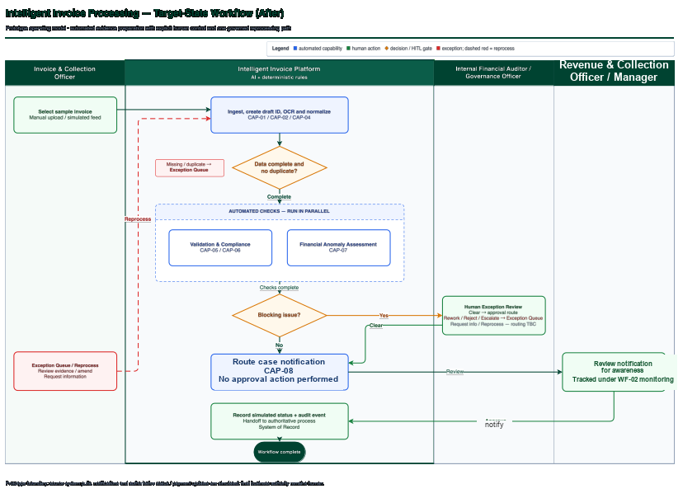
Figure 3.3-1 Intelligent Invoice Processing - Target-State Workflow (After)

WF-02 — Collection Forecast and Follow-up Prioritization
As-Is Workflow (Before AI Solution Implementation)
Collection follow-up relies on existing invoice status, reports and manual prioritization; predictive collection, delay and cancellation scoring is not available as a unified capability.

To-Be Workflow (After AI Solution Implementation)
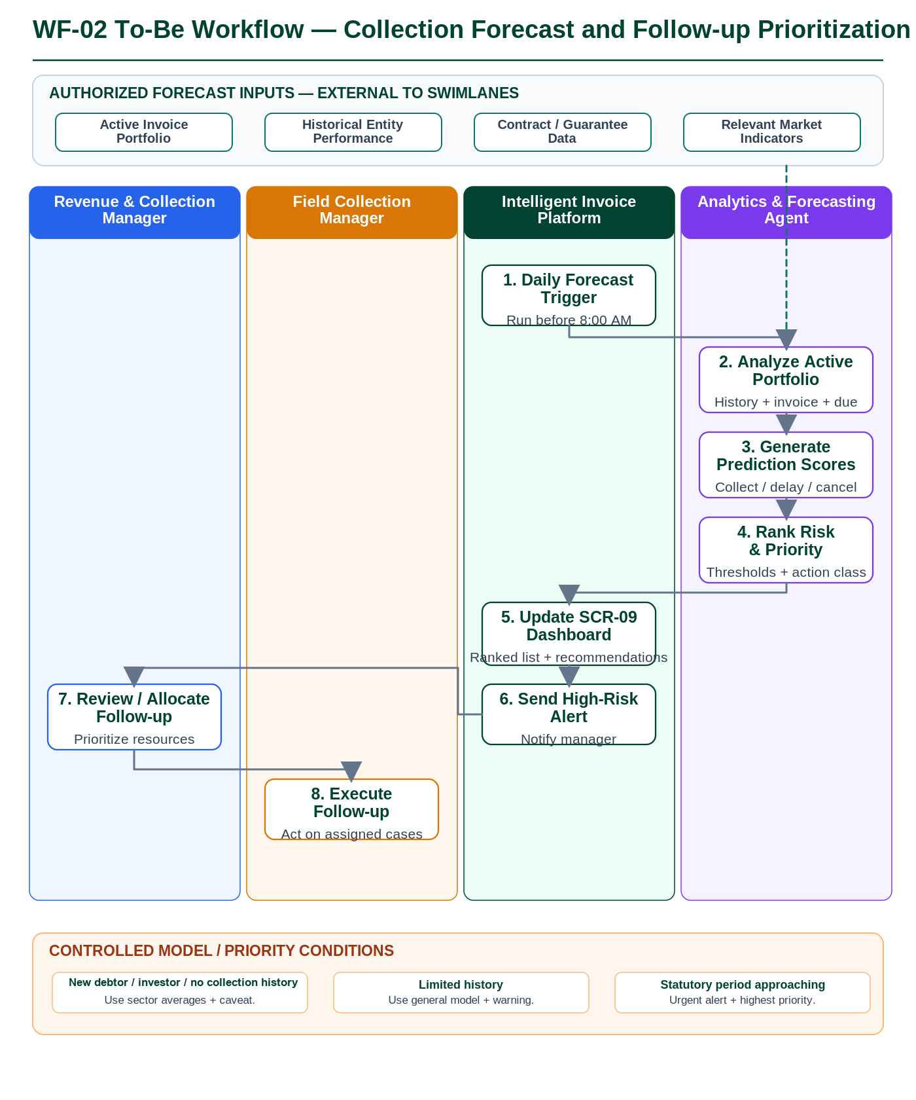

STEP ID | STEP DESC | RESPONSIBLE ROLE
WF02-01 | Start the daily collection-forecast cycle before 8:00 AM for the full active invoice portfolio (pending, in progress, overdue, or not fully paid). | Intelligent Invoice Platform
WF02-02 | Analyze each active invoice using the approved forecasting model and available inputs, including historical entity behavior, invoice data, due period, payment status, Furas investment/lease-contract and guarantee data, and relevant market indicators. | Analytics & Forecasting Agent
WF02-03 | Generate collection probability, delay probability, and cancellation probability for each active invoice. | Analytics & Forecasting Agent
WF02-04 | Apply the approved risk-classification thresholds, rank invoices by follow-up priority, and generate the corresponding action recommendation (urgent intervention / active follow-up / periodic follow-up). | Analytics & Forecasting Agent
WF02-05 | Update the Collection Forecast and Follow-Up Priority Dashboard (SCR-09) with the three scores, risk level, priority ranking, action recommendation, and performance views. | Intelligent Invoice Platform
WF02-06 | Issue the required automatic alert for invoices classified as high risk after forecast analysis is completed. | Intelligent Invoice Platform
WF02-07 | Review the ranked portfolio and intervention recommendations, then allocate follow-up attention and collection resources according to the approved priority list. | Revenue & Collection Manager
WF02-08 | Receive prioritized cases and execute the operational collection follow-up according to the assigned priority and established collection procedures. | Field Collection Manager

WF-03 — Operational Performance Analytics (KPI & Performance Intelligence)
As-Is Workflow (Before AI Solution Implementation)
Performance information is assembled from separate platforms, spreadsheets and custom dashboards, without a unified real-time AI analytics view.
To-Be Workflow (After AI Solution Implementation)
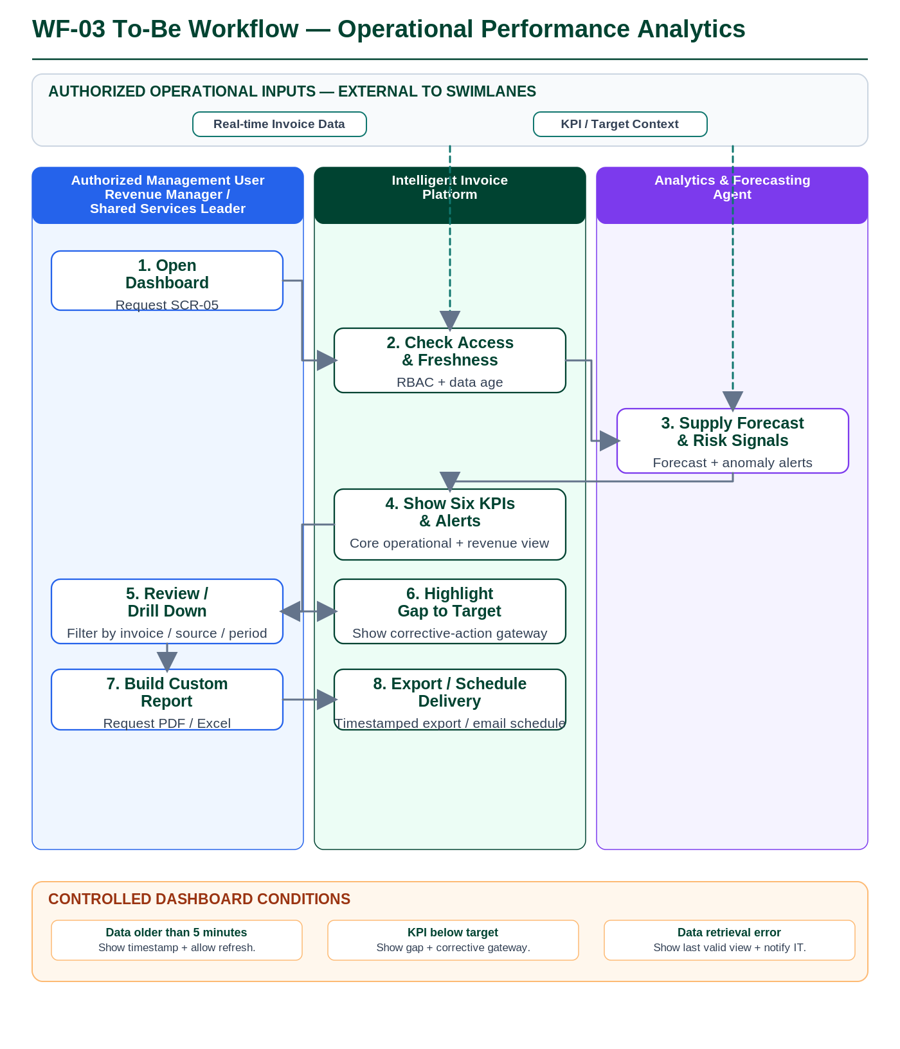

STEP ID | STEP DESC | RESPONSIBLE ROLE
WF03-01 | Open the Executive Performance and Revenue Dashboard (SCR-05) as an authenticated user with View Dashboards permission. | Revenue & Collection Manager / Shared Services Leader
WF03-02 | Validate the user RBAC scope and data freshness before loading the dashboard; operational dashboard data must be current within the defined five-minute freshness window. | Intelligent Invoice Platform
WF03-03 | Provide the current forecast results and financial-anomaly / detected-risk signals used by the management dashboard. | Analytics & Forecasting Agent
WF03-04 | Present the six required KPIs: actual collection rate, average invoice processing time, pending-invoice value, detected financial anomalies, invoices collected within the target timeframe, and invoices received today classified by sector / Amanah; show risk alerts in the side panel. | Intelligent Invoice Platform
WF03-05 | Review the KPIs and drill down into an indicator using the available filters for registration number, invoice data, source platform, and time period. | Revenue & Collection Manager / Shared Services Leader
WF03-06 | Where a KPI is below its specified target, highlight the gap-to-target and provide the configured gateway to corrective recommendations. | Intelligent Invoice Platform
WF03-07 | Generate a custom management report from the reviewed dashboard view and request export in Excel or PDF when required. | Revenue & Collection Manager / Shared Services Leader
WF03-08 | Create the timestamped export, retain the export action in the audit trail, and optionally schedule the report for automatic email delivery to specified recipients. | Intelligent Invoice Platform
WF03-09 | Analyze trend and material deviation for each KPI against its approved baseline and target, and identify evidence-supported contributing factors and recommended follow-up priorities or corrective actions. | Analytics & Forecasting Agent
WF03-10 | Propose additional KPIs where a meaningful gap is identified, with supporting rationale, formula, required data and decision-making value, for business-owner review; proposed KPIs do not take effect until approved. | Analytics & Forecasting Agent
WF03-11 | Apply analytical recalibration (updated forecasts, expectations and recommendations) as actual performance develops within approved rules. Any new official KPI or change to an approved definition, baseline, target or threshold requires business-owner approval, version control and an effective date; historical performance remains assessable against the baseline and target applicable at the time. | Revenue & Collection Manager / Analytics & Forecasting Agent

WF-04 — Conversational Invoice Insight and Dynamic Report Generation
As-Is Workflow (Before AI Solution Implementation)
Users currently rely on reports, dashboards and manual data lookup; a unified Arabic natural-language query interface is not available.
To-Be Workflow (After AI Solution Implementation)
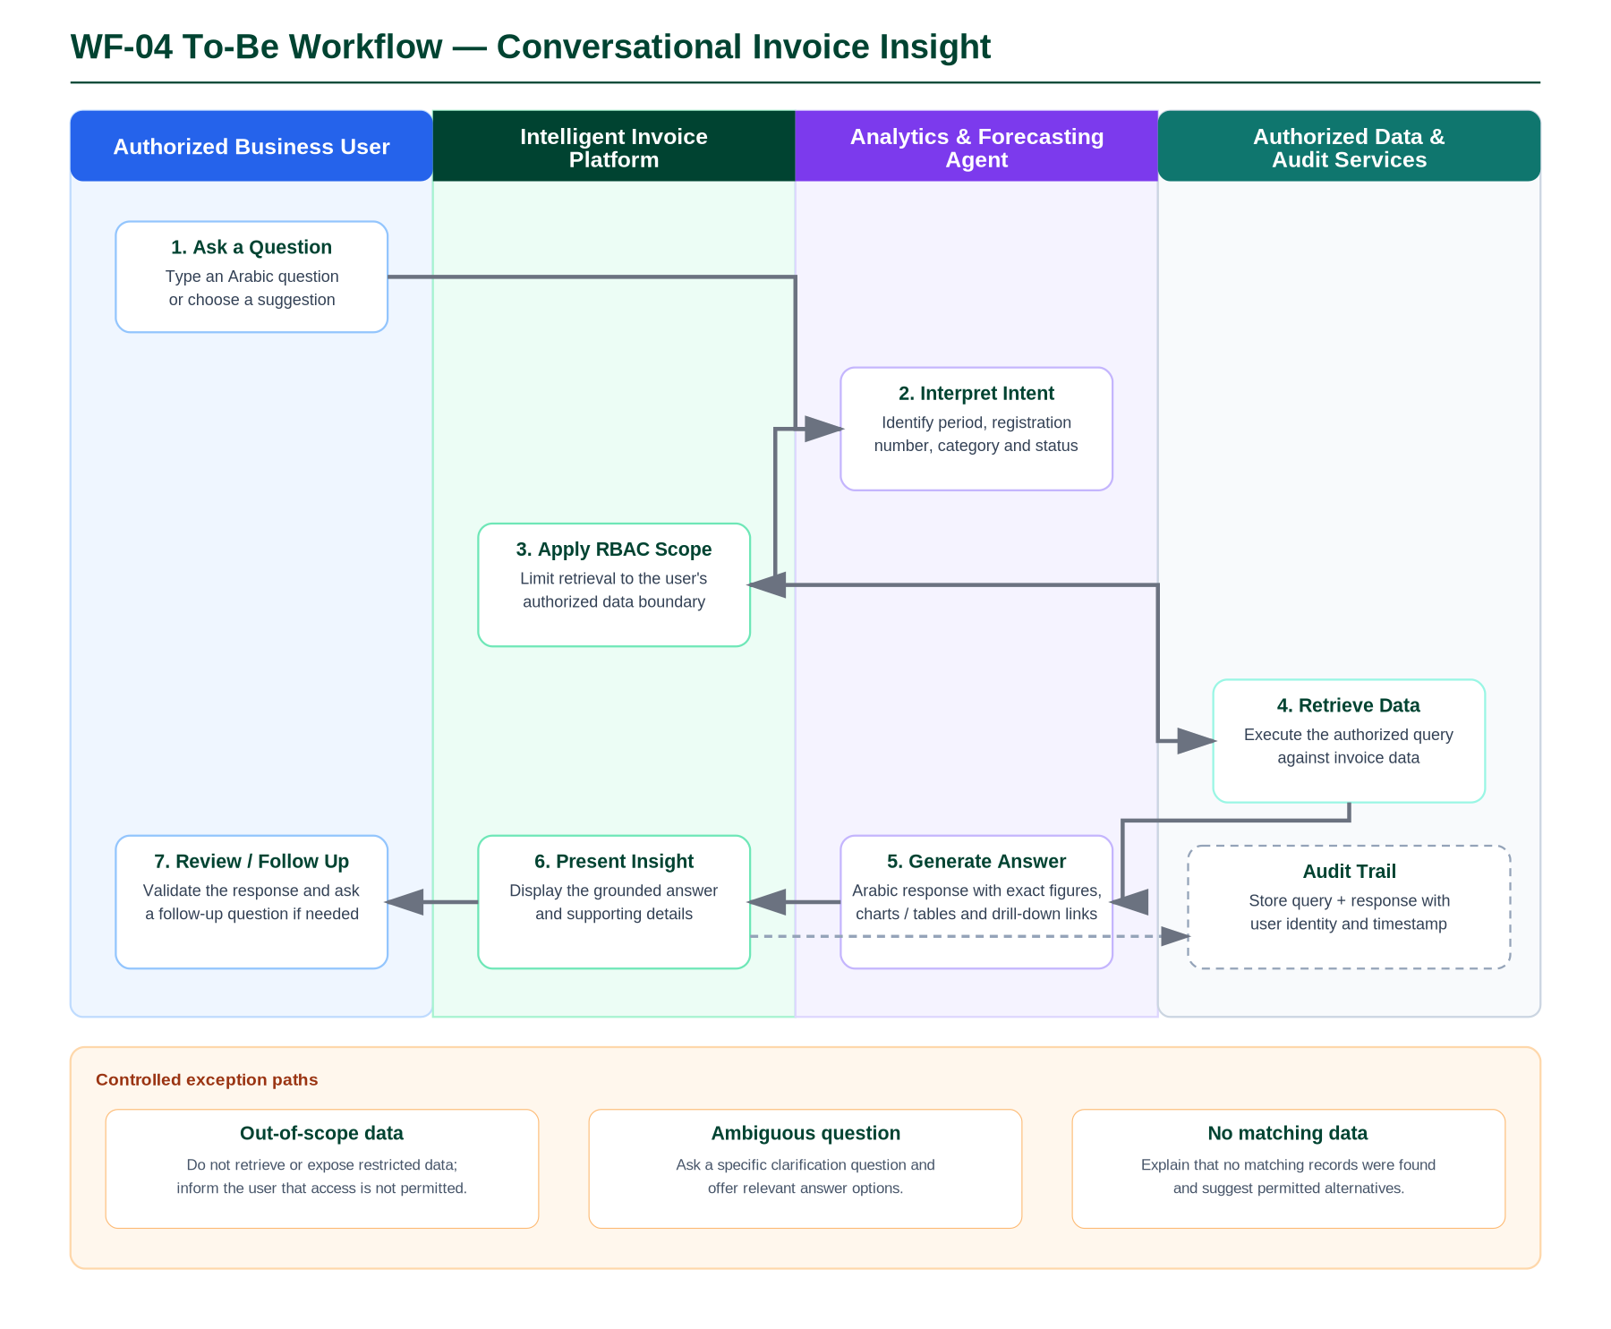

STEP ID | STEP DESC | RESPONSIBLE ROLE
WF04-01 | Authenticated user types an Arabic invoice / performance question or selects a suggested question in the conversational interface. | Authorized Business User
WF04-02 | Interpret the question and identify the business intent and required parameters, such as period, registration number, category and status. If the question is ambiguous, request a targeted clarification before retrieval. | Analytics & Forecasting Agent
WF04-03 | Apply the authenticated user identity and RBAC scope. Requests for data outside the user's authority are not executed and the user is informed that the information is outside the permitted access scope. | Intelligent Invoice Platform
WF04-04 | Execute the authorized query against the available invoice data and return only records within the permitted scope. If no matching data is found, return an empty result for controlled user guidance. | Authorized Data Service / Platform
WF04-05 | Generate an organized Arabic answer using the retrieved figures and provide suitable charts or tables and drill-down links where applicable. | Analytics & Forecasting Agent
WF04-06 | Display the answer to the user for review. The user may validate the result, open supporting details, or submit a follow-up question; each follow-up repeats the same authorization-constrained retrieval process. | Authorized Business User / Intelligent Invoice Platform
WF04-07 | Record the complete query-and-response interaction with user identity and timestamp in the audit trail for compliance and later review. | Intelligent Invoice Platform / Audit Service
WF04-08 | Where the user requests a report rather than a single answer, select the relevant approved measures, dimensions, period, filters, comparisons and visualization from the governed semantic layer, and produce an editable draft report with an accompanying explanation. | Analytics & Forecasting Agent
WF04-09 | Allow the user to refine the report conversationally — for example changing the period, adding an Amanah comparison, separating investment revenues, or distinguishing enforcement-referred receivables — without a separately developed dashboard for each request. If the request is ambiguous, request clarification; if required data is unavailable, identify the gap rather than estimate or invent a figure. | Authorized Business User / Analytics & Forecasting Agent
WF04-10 | Save the report definition (measures, dimensions, filters, period) for reuse and scheduled refresh, subject to the same RBAC scope, and support export and controlled distribution to authorized recipients; each report identifies its data sources, reporting period, filters, calculation definitions and data freshness. | Intelligent Invoice Platform

WF-05 — Financial Audit Review
As-Is Workflow (Before AI Solution Implementation)

Audit evidence is distributed across existing systems and requires manual review and consolidation; review-decision and anomaly evidence are not available in one unified audit view.
To-Be Workflow (After AI Solution Implementation)
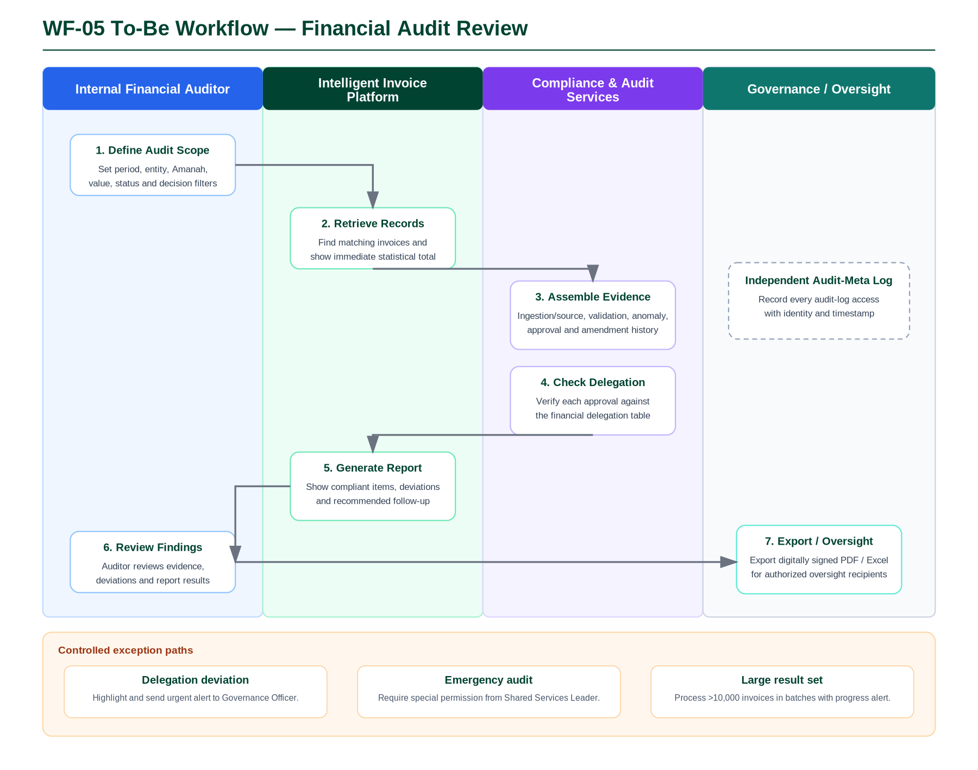

STEP ID | STEP DESC | RESPONSIBLE ROLE
WF05-01 | Authenticated Internal Financial Auditor opens the audit interface and defines the audit scope using approved search criteria such as period, registration number, entity, Amanah, municipality, sector, value range, invoice status and decision type. | Internal Financial Auditor
WF05-02 | Retrieve matching invoice records within the auditor's permitted scope and display the matching population with an immediate statistical total. | Intelligent Invoice Platform
WF05-03 | For the selected invoice population, assemble the complete immutable audit evidence: ingestion source, validation results and confidence score, financial anomaly report, review/escalation decision with employee identity and timestamp, and amendments with justification. | Compliance & Audit Services
WF05-04 | Run the automated delegation-table compliance check to verify whether each review or escalation decision was made by the competent employee within the applicable financial authority. | Compliance & Audit Services
WF05-05 | Generate a comprehensive compliance report showing compliant records, deviations and recommended follow-up. Any review or escalation action outside the delegation table is highlighted and an urgent alert is sent to the Governance Officer. | Intelligent Invoice Platform / Governance Officer
WF05-06 | Review the detailed evidence, review/escalation history, compliance findings and deviations to determine the required audit follow-up. | Internal Financial Auditor
WF05-07 | Export the audit report in PDF or Excel with digital signature confirming data validity for authorized oversight recipients. Every access to audit records remains recorded in the independent audit-meta log. | Internal Financial Auditor / Intelligent Invoice Platform

WF-06 — Periodic Revenue Reporting
As-Is Workflow (Before AI Solution Implementation)

Periodic revenue reporting requires aggregation and consolidation of data from existing sources before management review.

To-Be Workflow (After AI Solution Implementation)
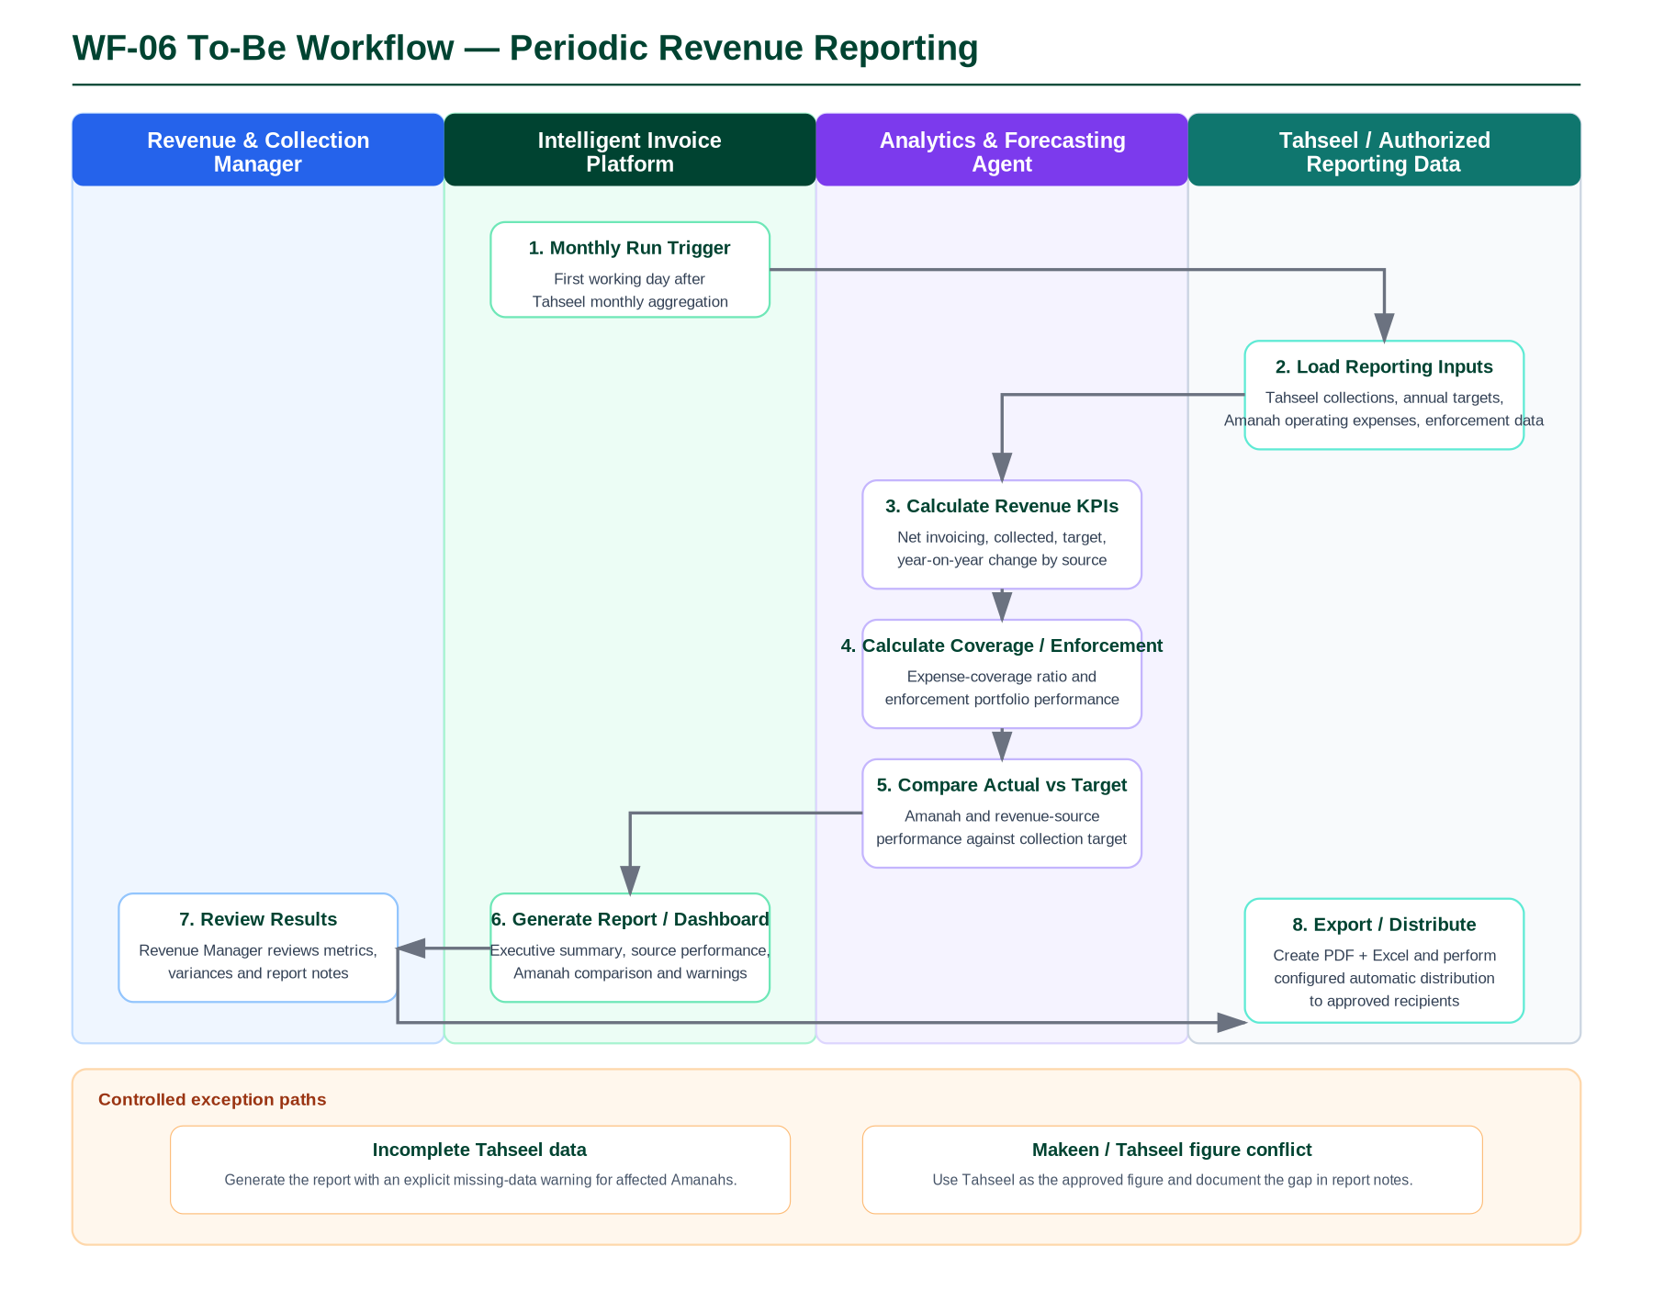

STEP ID | STEP DESC | RESPONSIBLE ROLE
WF06-01 | Start the monthly reporting run on the first working day after Tahseel monthly data aggregation is complete. | Intelligent Invoice Platform / Scheduler
WF06-02 | Load monthly Tahseel collection data classified by Municipal/Housing revenue source and Amanah, together with annual targets, Amanah operating-expense data and enforcement-portfolio data. | Analytics & Forecasting Agent / Authorized Reporting Data
WF06-03 | Calculate net invoicing, collected amount, target and year-on-year change for each revenue source. | Analytics & Forecasting Agent
WF06-04 | Calculate the operating-expense coverage ratio for the first three revenue chapters for each Amanah and the enforcement-performance measures: total revenue portfolio, enforceable, enforced-against and amount collected from enforcement. | Analytics & Forecasting Agent
WF06-05 | Compare actual collection performance with collection targets at Amanah and revenue-source level. If Makeen and Tahseel figures conflict, use Tahseel as the approved figure and document the gap in the report notes. | Analytics & Forecasting Agent
WF06-06 | Generate the monthly revenue report and update the reporting dashboard with executive summary, performance by revenue source, Amanah target comparison, expense-coverage ratio and enforcement performance. If Tahseel data is incomplete for an Amanah, clearly flag the missing-data warning. | Intelligent Invoice Platform / Analytics & Forecasting Agent
WF06-07 | Review the generated report, key metrics, variances and report notes in the Periodic Revenue Report Dashboard. | Revenue & Collection Manager
WF06-08 | Generate PDF and Excel outputs and perform configured automatic distribution to approved recipients, including Shared Services and Amanah stakeholders. Authorized users may request an ad hoc variation of this report conversationally through WF-04 Dynamic Report Generation instead of commissioning a new fixed report. | Intelligent Invoice Platform / Analytics & Forecasting Agent

WF-07 — Financial Reconciliation
As-Is Workflow (Before AI Solution Implementation)
Makeen–Tahseel billing differences require reconciliation and classification across the two systems; a unified automated reconciliation workflow is not currently available.
To-Be Workflow (After AI Solution Implementation)
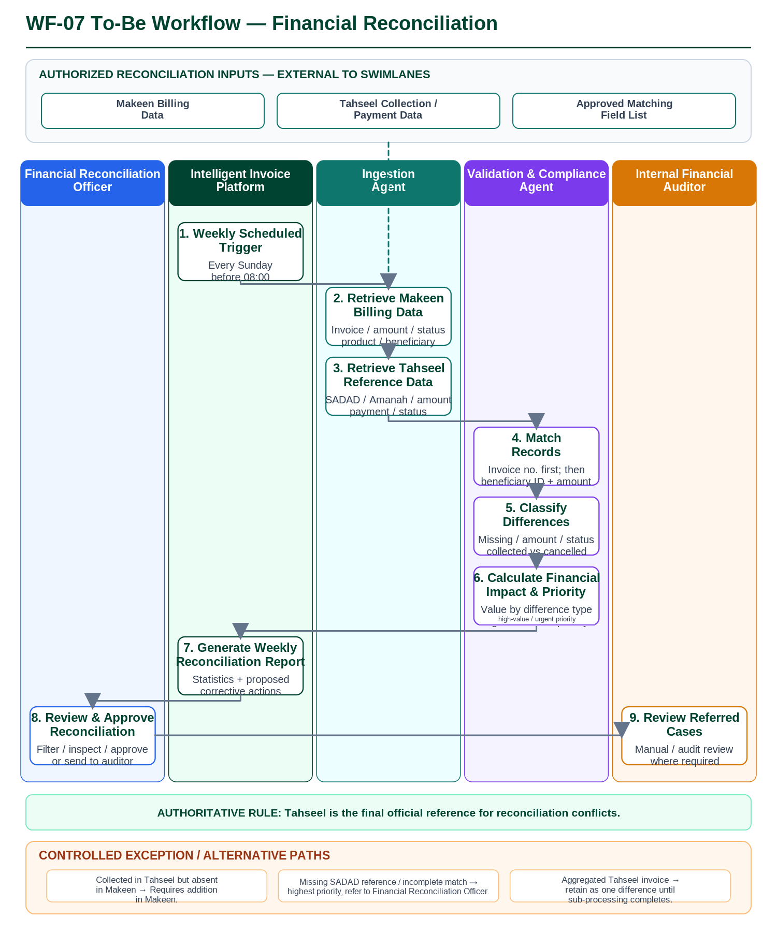

STEP ID | STEP DESC | RESPONSIBLE ROLE
WF07-01 | Start the scheduled weekly reconciliation when Makeen and Tahseel billing data are available; the run is scheduled every Sunday before 08:00. | Intelligent Invoice Platform
WF07-02 | Retrieve the Makeen billing dataset including invoice number, revenue amount, invoice amount, invoice status, product name, and beneficiary ID. | Ingestion Agent
WF07-03 | Retrieve the Tahseel reference dataset including SADAD invoice number, Amanah, municipality, invoice amount, payment date, invoice status, and payment status. | Ingestion Agent
WF07-04 | Match records first by invoice number and, where required, by beneficiary ID and amount using the approved matching-field list. | Validation & Compliance Agent
WF07-05 | Classify identified differences, including records missing in either platform, amount differences, status differences, and cases collected in Tahseel but cancelled in Makeen. | Validation & Compliance Agent
WF07-06 | Calculate the financial value of each difference type and prioritize cases requiring urgent treatment. Tahseel remains the final official reference for any conflict. | Validation & Compliance Agent
WF07-07 | Generate the weekly reconciliation report with classified differences, financial statistics, and a proposed corrective action for each difference type; high-value differences above SAR 50,000 are reviewed and reprioritized daily, with any correction to an authoritative source record made only by the responsible source-system owner. | Intelligent Invoice Platform
WF07-08 | Review the Difference Reconciliation Dashboard, inspect the proposed action, and approve the reconciliation or send selected cases to the auditor for further review. | Financial Reconciliation Officer
WF07-09 | Review referred reconciliation cases and supporting evidence when manual or audit review is required. | Internal Financial Auditor

WF-08 — Violation Follow-up
As-Is Workflow (Before AI Solution Implementation)
Violation, appeal, enforcement and collection information is reviewed across Efaa, Mumtathil and Tahseel with manual follow-up across status changes.

To-Be Workflow (After AI Solution Implementation)
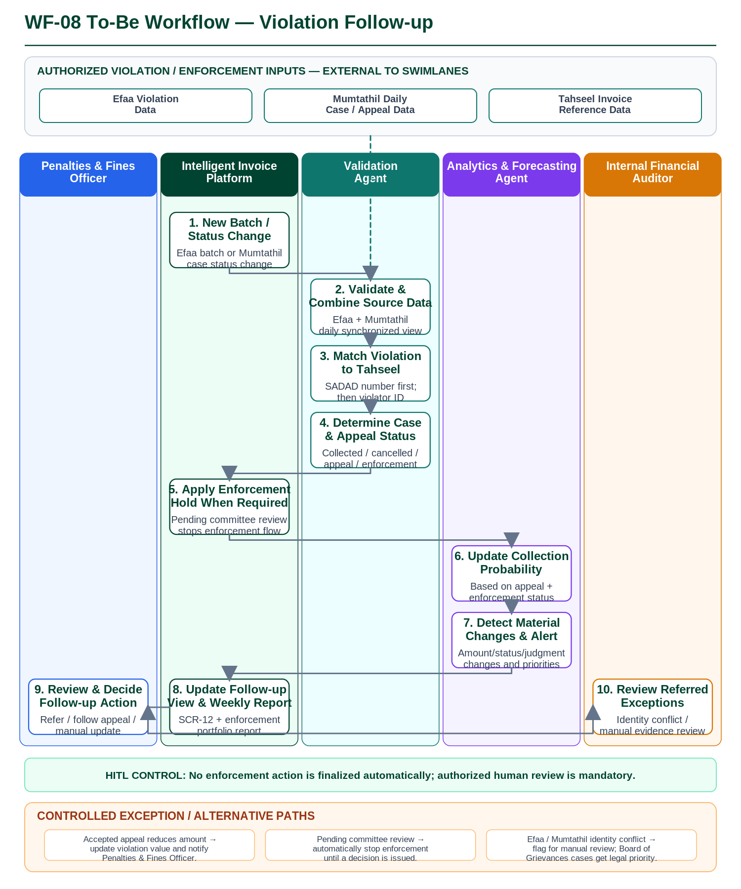

STEP ID | STEP DESC | RESPONSIBLE ROLE
WF08-01 | Start when a new Efaa violation batch arrives or Mumtathil reports a material case-status change, including judgment, appeal change, or enforcement referral. | Intelligent Invoice Platform
WF08-02 | Validate and combine complete Efaa violation data with the daily Mumtathil case data required for follow-up. | Validation Agent
WF08-03 | Match each violation to the related Tahseel invoice using SADAD number first and violator ID as the secondary key. | Validation Agent
WF08-04 | Determine the current violation, enforcement, and appeal status for the matched case. | Validation Agent
WF08-05 | If appeal status is Pending Committee Review, stop the enforcement workflow until a decision is issued. | Intelligent Invoice Platform
WF08-06 | Update the collection-probability score using the current enforcement and appeal status. | Analytics & Forecasting Agent
WF08-07 | Generate alerts for material judgment, amount, or status changes, including the BRD alert condition for cases below SAR 100,000. | Analytics & Forecasting Agent
WF08-08 | Refresh the Mumtathil and Violations Follow-Up view and prepare the weekly enforcement-portfolio report. | Intelligent Invoice Platform
WF08-09 | Review the case and choose the authorized action: Refer for Enforcement, Follow Up Appeal, or Manual Update. Enforcement is not finalized automatically. | Penalties & Fines Officer
WF08-10 | Review referred manual-review cases and supporting evidence, including cross-platform identity conflicts. | Internal Financial Auditor

WF-09 — Sanad Enforcement-to-Invoice Mapping
As-Is Workflow (Before AI Solution Implementation)
Sanad enforcement records are reviewed manually against SADAD invoice references; where a structured reference is missing, incomplete or ambiguous, association with the underlying invoice or invoices requires manual document lookup, with no standardized one-to-many allocation rule or evidence trail.

To-Be Workflow (After AI Solution Implementation)
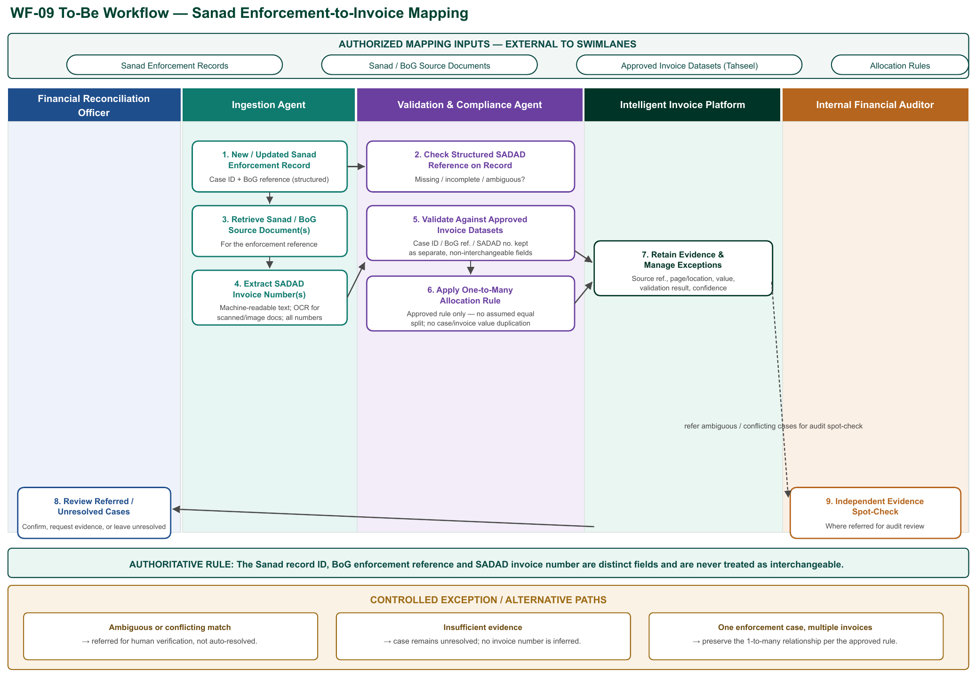

STEP ID | STEP DESC | RESPONSIBLE ROLE
WF09-01 | Start when Sanad provides a new or updated enforcement record containing a case ID and Board of Grievances reference. | Ingestion Agent
WF09-02 | Check the existing Sanad record for a structured SADAD invoice reference and determine whether it is missing, incomplete, or ambiguous. | Validation & Compliance Agent
WF09-03 | Where the reference is missing, incomplete or ambiguous, retrieve the source document(s) associated with that enforcement record. | Ingestion Agent
WF09-04 | Read machine-readable document text where available and apply OCR for scanned or image-based material; extract all relevant SADAD invoice numbers rather than assuming a single number per document. | Ingestion Agent
WF09-05 | Match extracted numbers against the approved invoice datasets, including Tahseel where applicable; maintain the Sanad record ID, Board of Grievances enforcement reference and SADAD invoice number as separate, non-interchangeable fields. | Validation & Compliance Agent
WF09-06 | Where one enforcement case covers several SADAD invoices, preserve the one-to-many relationship without duplicating the case value or invoice balances; allocate any aggregate enforcement amount across invoices only per an approved rule, not an assumed equal split. | Validation & Compliance Agent
WF09-07 | Store the source-document reference, page or location, extracted value, validation result and confidence assessment for every match attempt. | Intelligent Invoice Platform
WF09-08 | Review cases with an ambiguous or conflicting match and confirm the relationship, request further evidence, or leave the case unresolved; a case without sufficient evidence is not assigned an inferred invoice number. | Financial Reconciliation Officer
WF09-09 | Where a case is referred for audit review, independently inspect the retained evidence and validation result. | Internal Financial Auditor

3.4 User Journey
The prototype illustrates the planned user journeys using controlled sample data and simulated source-system responses. AI capabilities present draft extraction results, confidence or quality indicators, risk alerts, and routing recommendations. Authorized users verify the supporting evidence and retain responsibility for approval, rejection, escalation, and other critical decisions. The prototype does not execute production ingestion, payment, approval, notification, or authoritative status changes.

ID | User journey | Summary | Steps
J-01 | Intelligent Invoice Processing | The Invoice and Collection Officer initiates processing of a new invoice. The prototype demonstrates extraction, duplicate and compliance checks, anomaly review, and case routing and notification for officer review. AI outputs are recommendations and alerts; authorized officers retain monitoring and exception decisions. | 1. Submit or select an invoice  2. Extract and standardize invoice data  3. Check for duplicates  4. Validate invoice and compliance data  5. Assess financial-anomaly risk  6. Notify the responsible officer for review  7. Resolve and reprocess exceptions when required
J-02 | Collection Forecast and Follow-up Prioritization | The Field Collection Manager reviews AI-generated collection, delay, and cancellation probabilities for pending invoices and confirms which cases should receive follow-up priority. The recommendation does not change the official invoice status. | 1. Open the pending-invoice portfolio  2. Review probability scores and supporting factors  3. Filter and rank invoices by follow-up priority  4. Confirm the priority list  5. Continue follow-up through the existing collection process
J-03 | Operational Performance Analytics | The Revenue and Collection Manager reviews invoice-processing and collection performance, investigates deviations and risk indicators, and prepares an evidence-based management view. | 1. Select the reporting period and organizational scope  2. Review operational and collection KPIs  3. Drill down into a KPI or exception  4. Review anomaly and delay indicators  5. Export or share the reviewed view  6. Review trend and deviation evidence, follow-up recommendations, and any proposed new KPIs pending business-owner approval
J-04 | Conversational Invoice Insight | An authorized user asks an Arabic natural-language question about invoice status or performance. The prototype returns a permission-filtered answer with supporting data and a quality indicator for the user to verify before use. | 1. Enter an invoice or performance question  2. Interpret the question and apply the user's access scope  3. Retrieve the permitted invoice and KPI data  4. Generate an answer with supporting evidence  5. Verify, refine, or flag the answer  6. Optionally request a dynamic report, refine it conversationally, and save or export the definition
J-05 | Financial Audit Review | The Internal Financial Auditor searches invoice records, reviews the end-to-end decision trail and compliance evidence, validates identified deviations, and prepares an audit output. | 1. Define audit search criteria  2. Review matching invoice records  3. Inspect the complete processing and approval trail  4. Review delegation and compliance deviations  5. Validate and export the audit result
J-06 | Periodic Revenue Reporting | The Revenue and Collection Manager reviews a draft periodic revenue report assembled from approved source data, validates its figures and exceptions, and authorizes distribution to the intended management audience. | 1. Select the reporting period and recipients  2. Aggregate approved revenue and target data  3. Generate the draft report and exception notes  4. Validate figures and source-data gaps  5. Approve export and distribution, or request an ad hoc conversational variation
J-07 | Financial Reconciliation | The Financial Reconciliation Officer reviews Makeen-Tahseel billing differences, evaluates the proposed classification and corrective action, and confirms referral or export of the reconciliation result. Tahseel remains the official reference for identified conflicts. | 1. Open the reconciliation period  2. Match Makeen and Tahseel records  3. Classify differences and calculate their value  4. Review proposed corrective actions  5. Confirm referral, follow-up, or export
J-08 | Violation Follow-up | The Penalties and Fines Officer reviews matched violation, appeal, enforcement, and collection information, assesses material-change alerts and updated collection probability, and confirms the appropriate follow-up action. | 1. Review matched violation and invoice records  2. Check appeal and enforcement status  3. Review the updated collection-probability indication  4. Assess material-change alerts  5. Confirm follow-up through the existing process
J-09 | Sanad Enforcement-to-Invoice Mapping | The Financial Reconciliation Officer reviews Sanad enforcement cases whose SADAD invoice reference is missing, incomplete or ambiguous, validates the AI-extracted invoice number(s) against approved invoice datasets, and confirms the enforcement-to-invoice relationship or leaves it unresolved. The Sanad record ID, Board of Grievances reference and SADAD invoice number remain distinct fields. | 1. Review the enforcement record and existing SADAD reference  2. Retrieve source documents where the reference is missing or ambiguous  3. Review AI-extracted SADAD invoice number(s) and supporting evidence  4. Validate the match against approved invoice datasets  5. Confirm the one-to-many relationship, request further evidence, or leave the case unresolved

J-01 Intelligent Invoice Processing is expanded below. Each illustration combines the user action, the prototype response, AI involvement where applicable, and the required human oversight.
ID | User journey steps | Illustration
J-01.1 | Start invoice intake | The Invoice and Collection Officer selects a controlled sample invoice from manual upload or a simulated source-system feed. The prototype records the source and displays a draft unique invoice identifier. No production ingestion or source-system update is performed.
J-01.2 | Extract and standardize invoice data | The AI extraction capability identifies the core invoice fields, normalizes their format, and shows field-level confidence and missing-data indicators. The Invoice and Collection Officer reviews and corrects low-confidence or incomplete fields before the journey continues.
J-01.3 | Check for duplicate invoices | The prototype compares the sample invoice with controlled historical records using invoice number, entity, amount, and date. A potential-duplicate alert presents the matching evidence. The Invoice and Collection Officer decides whether to stop the case or allow it to continue.
J-01.4 | Validate invoice and compliance data | The validation capability compares the extracted invoice with simulated SADAD reference and delegation data. It presents a match result, deviations, supporting evidence, and confidence. The Invoice and Collection Officer or Internal Financial Auditor reviews deviations; the journey pauses until an authorized human decision is recorded.
J-01.5 | Assess financial-anomaly risk | The AI capability evaluates the invoice against controlled historical patterns and presents a risk indicator, reasons, and supporting comparisons. Flagged cases are referred to the Internal Financial Auditor for review; the prototype does not automatically reject an invoice.
J-01.6 | Notify responsible officer | A rules-based routing capability uses the sample financial delegation table to identify the responsible Revenue & Collection Officer/Manager and assembles a case notification containing the invoice summary, validation result, anomaly indication, and evidence. The Invoice and Collection Officer verifies the routing; the prototype only simulates notification delivery. No approval or payment action is proposed or taken.
J-01.7 | Resolve an exception and reprocess | For a potential duplicate, missing data, validation deviation, high-risk indication, or human rejection, the Invoice and Collection Officer or Internal Financial Auditor reviews the stop reason and evidence. The authorized user may record an amendment, reject with a reason, escalate, request more information, or restart processing. The original record and complete decision trail remain visible.

4. Requirements Summary

This section summarizes the key business and non-functional requirements for Intelligent Invoice Management. Detailed requirement descriptions, acceptance criteria, business rules, and traceability are maintained in DOC-01 Product Requirements in Additional resources.

4.1 Business Requirements
ID | Requirement | Priority | Source
FR-001 | Ingest invoices from multiple sources — accept PDF/DOCX/XML/Excel invoices through manual upload or automatic retrieval from Tahseel, Makeen, Efaa and Sanad (50 MB limit), create a unique INV-YYYY-NNNNN identifier, and trigger processing. | P0 | Invoice Officer / Ingestion Agent
FR-002 | Extract invoice data using OCR — extract key invoice fields including entity, invoice number, SADAD invoice number, date, amount, VAT and payment-order number, supporting Arabic, English and mixed-language invoices. | P0 | Invoice Officer / Ingestion Agent
FR-003 | Detect duplicate invoices and send alerts — compare each incoming invoice against existing records, stop suspected duplicates, and require officer review before processing continues. | P0 | Invoice Officer / Ingestion Agent
FR-004 | Standardize invoice data formats — normalize fields, units, dates and amounts from different sources into the Ministry unified data model and retain the transformation record. | P0 | Invoice Officer / Ingestion Agent
FR-005 | Automated validation of invoice and SADAD reference matching — match invoice data against SADAD and collection reference data, produce a matching report with confidence score, flag deviations, and route cases requiring review. | P0 | Validation Officer / Validation Agent
FR-006 | Validate invoice amount consistency — cross-check the extracted VAT and total amounts against the invoice record for arithmetic consistency and flag mismatches for review. No integration with external tax-authority (ZATCA) systems is required or performed. | P0 | Invoice Officer / Financial Auditor
FR-007 | Monitor invoice values against the financial delegation table for informational and audit visibility only — flag cases exceeding typical authority thresholds for officer awareness; the platform does not grant, block, or enforce any approval decision. | P0 | Invoice Officer / Governance Officer
FR-008 | Detect financial anomalies and incorrect entries — apply machine-learning analysis to identify exaggerated items, duplicate invoices and unusual patterns, and generate a risk report for each invoice. | P0 | Revenue Manager / Financial Auditor
FR-009 | Automatic case routing for review — determine the responsible Revenue & Collection Officer/Manager from invoice value, entity type, invoice data and the financial delegation table, and send a review notification containing summary, validation results and confidence score. No approval or payment-authorization action is performed. | P0 | Revenue & Collection Manager / Case Routing & Notification Agent
FR-010 | Analytics, collection forecasting and conversational querying — calculate collection, delay and cancellation probabilities, provide interactive dashboards and performance reports, and support Arabic natural-language queries on invoice status and indicators. | P0 | Revenue Manager / Shared Services Leader
FR-011 | Manage pending and rejected invoices — allow authorized officers and auditors to review stopped/rejected invoices, correct and reprocess, permanently reject the platform’s proposed extraction, classification or mapping with reason, refer to a higher officer, or re-fetch data while preserving the original record and complete audit trail. Rejection applies to the platform’s proposed output only; it does not cancel or amend the underlying municipal receivable, which remains within the authorized source-system process. | P0 | Invoice Officer / Internal Financial Auditor
FR-012 | Financial audit and delegation-compliance review — allow authorized auditors and governance users to search immutable invoice audit trails, verify delegation compliance, identify deviations, and export digitally signed audit reports. | P0 | Internal Financial Auditor / Governance Officer
FR-013 | Periodic revenue reporting — automatically generate monthly Municipal and Housing revenue-performance reports by revenue source and Amanah, including target comparison, expense-coverage and enforcement analysis, with PDF/Excel output and distribution to beneficiaries. | P0 | Revenue and Collection Manager
FR-014 | Makeen–Tahseel reconciliation — perform scheduled cross-platform reconciliation, classify billing differences, calculate their financial value, and produce a reconciliation report with proposed corrective actions using Tahseel as the official reference for conflicts. | P0 | Financial Reconciliation Officer
FR-015 | Violation, appeal and enforcement follow-up — ingest violation data from Efaa, match with Mumtathil/Tahseel data, track appeal and enforcement status, update collection-probability scores, and alert officers to material changes. | P0 | Penalties and Fines Officer
FR-016 | Sanad enforcement-to-invoice mapping — where a Sanad enforcement record lacks a clear structured SADAD invoice reference, retrieve the associated source document(s), extract candidate SADAD invoice number(s) using machine-readable text or OCR, validate against approved invoice datasets while keeping the Sanad record ID, Board of Grievances reference and SADAD invoice number as separate fields, and preserve one-to-many case-to-invoice relationships per an approved allocation rule. Ambiguous or unsupported matches are referred for human verification rather than resolved automatically. | P0 | Financial Reconciliation Officer / Internal Financial Auditor
FR-017 | KPI and Performance Intelligence — consume the Ministry’s approved KPI definitions, formulas, owners, baselines and targets; measure actual performance, identify trend and material deviation with evidence-supported contributing factors, and recommend follow-up priorities or corrective action; propose additional KPIs with rationale, formula, required data and decision value. New KPIs or changes to approved definitions, baselines, targets or thresholds require business-owner approval, version control and an effective date. | P0 | Revenue & Collection Manager / Analytics & Forecasting Agent
FR-018 | Dynamic conversational report generation — allow an authorized user to describe the analysis required through the conversational interface; select the relevant approved measures, dimensions, period, filters, comparisons and visualization from the governed semantic layer and produce an editable report with explanation; support conversational refinement, saving and scheduled refresh of report definitions, controlled export and distribution, and identification (rather than estimation) of unavailable data. | P0 | Authorized Business Users / Analytics & Forecasting Agent
FR-019 | Governed semantic / business metrics layer — define and maintain reusable business entities, relationships, measures and calculation rules (including the approved net-invoicing and collection-rate methodology, its numerator, denominator, exclusions and time alignment) between the integrated data and the KPI, forecasting and conversational-reporting capabilities; version definitions and enforce that new measures do not silently replace approved measures. | P0 | Shared Services Leader / Analytics & Forecasting Agent

Note: P0 Must have, P1 Should have, P2 Nice to have, P3 Backlog

4.2 Non-Functional Requirements
ID | Category | Requirement
NFR-001 | Performance | Response time — standard interactions (navigation, status check, reports and search) are targeted within 3 seconds for the 95th percentile under normal load of 50 concurrent sessions.
NFR-002 | Security | Role-Based Access Control (RBAC) — enforce role-based access, restrict data visibility to authorized scope, and record access attempts and changes in the immutable audit trail.
NFR-003 | Availability | Platform availability ≥ 99.5% during official working hours (07:00–22:00 on working days), with automatic failover and daily encrypted backup.
NFR-004 | Audit and Compliance | Complete and immutable audit trail — record invoice ingestion, validation results, review and escalation decisions, data changes and access attempts, with records retained for 7 years.
NFR-005 | Data Quality | Data accuracy, consistency and completeness — enforce mandatory-field completeness, format validity, currency/date consistency and duplicate prevention.
NFR-006 | Scalability | Horizontal scaling — support a threefold increase in processing volume and parallel processing of 500 invoices per minute at peak with automatic scaling and no performance degradation.
NFR-007 | Maintainability | Updates without service interruption — support zero-downtime updates and modification of business rules without code changes, with technical documentation updated for every release.
NFR-008 | Data Protection | Compliance with PDPL and Saudi regulations — host personal data inside the Kingdom, prevent transfer of sensitive data outside the government network, and use AES-256 encryption.
NFR-009 | AI Accuracy | Accuracy of classification, financial-anomaly detection and forecasting models — maintain accuracy of no less than 85% across AI tasks and perform documented quarterly model review and improvement.
NFR-010 | Systems Integration | Reliability of source-platform integrations — target API success rate of 99%, with retry and circuit-breaker handling for transient failures and source-system outages.
NFR-011 | Metrics Governance | Governed semantic-layer access and change control — restrict changes to approved measures, dimensions and calculation rules to authorized data owners, version every definition change with an effective date, and prevent the conversational-reporting and KPI capabilities from bypassing the governed layer to query raw source tables directly.

5. Success Metrics
The Ministry’s approved business KPIs (collection rate, processing time, and the other indicators managed through WF-03 KPI & Performance Intelligence) are distinct from the project-benefit and technical-success metrics defined below. The metrics in this section measure the delivery and performance of this solution; they do not themselves constitute, replace, or override the Ministry’s approved KPI definitions, baselines, or targets.

5.1 Strategic Metrics

Metric Type | Metric | Baseline | Target (6M / Y1 / Y2) | Measurement Method | Frequency | KPI Owner
Productivity Enhancement Value | Productivity Efficiency (SAR/year) | SAR 2.70M/year | SAR 1.08M / SAR 2.43M / SAR 4.05M | Value of released working-hour capacity; this is not a realized cash saving unless separately confirmed through workforce redeployment or cost reduction. Equivalent FTE capacity is calculated using 1,632 working hours/FTE/year, valued at SAR 270,000/FTE/year. The phased targets correspond to approximately 4, 9, and 15 FTEs of released capacity. | Yearly | Solution Owner
Revenue Generation | Expected Collected Revenue (SAR) | SAR 16.7B (2026) | – /  ≈ SAR 17.5B /  ≈ SAR 18.3B | Collected revenue is compared with the baseline projection based on expected annual GDP growth of 3.1%. The solution target assumes collection growth of approximately 4.65% annually, representing a 50% uplift over the underlying growth rate through improved matching, follow-up, and financial-anomaly detection. | Yearly | Solution Owner

5.2 Operational Metrics

Metric Type | Metric | Baseline | Target (6M / Y1 / Y2) | Measurement Method | Frequency | KPI Owner
Employee Time Saved |  | 0 hours | 6,528 / 14,688 / 24,480 hours | Annual working hours released through automation of invoice processing, reconciliation, and follow-up activities. Calculated using 1,632 working hours per equivalent FTE per year; the phased targets correspond to approximately 4, 9, and 15 FTEs respectively. | Yearly | Solution Owner
  Employee Hours Saved (hours/year)
Employee Adoption | Percentage of Employees Using AI | 0% | 50% / 80% / 100% | Number of approved target employees using the AI solution divided by the final approved target-user population. Adoption is measured progressively until full target-user coverage is reached in Year 2. | Yearly | Solution Owner

5.3 Technical Metrics
Metric Type | Metric | Baseline | Target (6M / Y1 / Y2) | Measurement Method | Frequency | KPI Owner
AI Model | OCR Accuracy | Accuracy of mandatory invoice-field extraction across Arabic, English and mixed-language invoices | N/A | ≥95% | Monthly random sample of OCR-extracted mandatory fields | Monthly | Invoice Officer / Ingestion Agent
AI Model | Anomaly Detection Accuracy | Accuracy of financial-anomaly detection | N/A | 6M: ≥85% / Y1: ≥95% / Y2: maintain validated Y1 threshold | Documented model evaluation against an approved labeled validation dataset | Quarterly | AI Manager
AI Model | Forecasting Accuracy | Collection / delay / cancellation forecasting accuracy measured by F1 Score | N/A | Y1: ≥85% F1; quarterly monitoring and maintenance thereafter | Documented F1-score evaluation against an approved validation dataset. | Quarterly | AI Manager
System | Availability | Platform availability during official working hours | N/A | ≥99.5% | Performance and load testing verifying peak throughput, 3× processing-volume support and automatic horizontal scaling at the defined capacity threshold. | Monthly | Ministry IT
System | Latency | P95 response time for standard system interactions under normal load | N/A | ≤3 seconds at P95 under 50 concurrent sessions | Load-testing tool at 50 concurrent sessions | Monthly | Ministry IT
System | Scalability / Throughput | Peak invoice-processing throughput and horizontal-scaling capability | N/A | 500 invoices/minute at peak; support 3× processing volume; automatic horizontal scaling at 80% capacity | TBC | Quarterly | Ministry IT
Data | Data Quality | Mandatory-field completeness, validity, consistency and duplicate prevention | N/A | ≥99% mandatory-field completeness; ≤0.1% invalid-data rate | Data-quality checks covering completeness, format validity, currency/date consistency and duplication; weekly quality report | Weekly | Invoice Officer / Data Team
Integration | Reliability | Reliability of integration interfaces with Tahseel, Makeen, Efaa, Sanad and Government ERP | N/A | ≥99% successful API transactions | API transaction monitoring; success rate calculated as successful API transactions divided by total attempted API transactions. | Quarterly | IT / Implementation Partner
Security | Access Control | RBAC coverage and unauthorized-access breaches | N/A | 100% RBAC coverage / zero unauthorized-rights breaches | Role-based access acceptance testing and audit-trail evidence | Quarterly | IT / Governance Officer
Audit | Logging Coverage | Coverage and retention of required auditable events | N/A | 100% logging of required auditable events | Audit-trail verification | Quarterly | Security Auditor / IT

6. Roadmap & Phasing

6.1 High-Level Delivery Roadmap

Key Milestones, Releases and Stabilization Plan
Phase | Key Milestone | Est. Start | Est. End
Prototype | Prototype solution scope, workflows, user journeys, PRD and service mapping completed and reviewed | 06/07/2026 | 15/09/2026
Alpha | Alpha Phase HLSD and technical approach completed and submitted | 16/09/2026 | 15/10/2026
Beta | Beta Phase HLSD, integrated solution validation and required Beta-stage delivery artifacts completed | 16/10/2026 | 07/12/2026
Release & Stabilization phase | Production release readiness, deployment, stabilization and final Go-Live preparation | 08/12/2026 | 21/01/2027
Operate phase | Operational handover, monitoring, KPI tracking and ongoing solution support | After Go-Live | Ongoing

6.2 Capability Delivery Traceability
The table below identifies the requirement, owner, priority, delivery phase and summary acceptance criteria for the capabilities clarified through the Round-1 review. It distinguishes what the Prototype will demonstrate using sample or simulated data from what depends on a production integration or business-owner confirmation still pending at the time of this revision.

Capability | Req. ID(s) | Owner | Priority | Phase | Acceptance Criteria (summary)
Sanad Enforcement-to-Invoice Mapping (WF-09) | FR-016 | Financial Reconciliation Officer | P0 | Prototype: sample data. Production: pending Sanad/Tahseel integration | Correct SADAD-number extraction on a representative document sample; validated enforcement-to-invoice matches reviewed against approved data; one-to-many cases preserved without value duplication; unresolved cases remain unresolved (none auto-inferred); every match carries a stored confidence and evidence reference.
KPI & Performance Intelligence (WF-03) | FR-017 | Revenue & Collection Manager | P0 | Prototype: sample KPIs. Production: full approved KPI catalog | Displayed KPIs match the Ministry’s approved definitions/baselines/targets; trend and deviation findings cite supporting evidence; a proposed KPI or definition change is not treated as adopted until business-owner approval with version and effective date is recorded.
Dynamic Report Generation (WF-04) | FR-018 | Shared Services Leader | P0 | Prototype: sample queries. Production: full semantic-layer coverage | Report-calculation results match the governed semantic-layer definitions on a test set; RBAC-scoped access enforced on saved/refreshed reports; unavailable data is flagged, not estimated; ambiguous requests trigger clarification rather than a guessed report.
Semantic / Business Metrics Layer | FR-019 / NFR-011 | Shared Services Leader | P0 | Prototype: core entities/measures. Production: full governed catalog | Net-invoicing and collection-rate figures reconcile to the documented numerator/denominator/exclusions on a test set; no double-counting between enforcement and invoice records; every definition change is versioned with an effective date and an authorized approver.
Investment / Lease-Contract Revenue Analysis (Furas) | In-scope bullet, Section 1.2; WF02-02 | Revenue & Collection Manager | P1 | Prototype: illustrative sample data. Production: pending Furas data-feed confirmation | Furas-originated investment/lease-contract data is distinguishable from procurement-contract data in the forecasting model; the data-feed mechanism (direct feed vs. existing integration vs. approved dataset) is confirmed with the Furas data owner before Alpha.

Additional resources

ID | Document type | Description | Link / Attachment Name
DOC-01 | Product requirements | Complete list of business and technical requirements for the solution. | 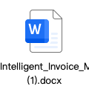
DOC-02 | Solution to services mapping | Solution mapping to the existing MOMAH services  Validate and update the mapping of this solution to the respective MOMAH services that the solution directly provides HERE | 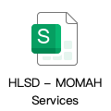

Appendix

A. References

B. Approval Sign-Off
Role | Name | Signature | Date | Supporting document
Solution Vendor  (Prepared By) | ByteDance |  | 24/08/2026 | HLSD Prototype
NHCI Oversight
(Reviewed By)
Solution Owner
(Reviewed By)
AI Champion
(Reviewed By)
Central AI
(Reviewed By)
Sector Head
(Approved By)
AI Solutions Steering Group
(Approved By)
Central AI Committee (Approved By)

Note: Supporting document, may include links to meeting minutes where approvals were recorded
HLSD — High-Level Solution Design | [Solution Name]

