**ANSWER ALL QUESTIONS**

1. Create the following tables with suitable constraints:
   1. 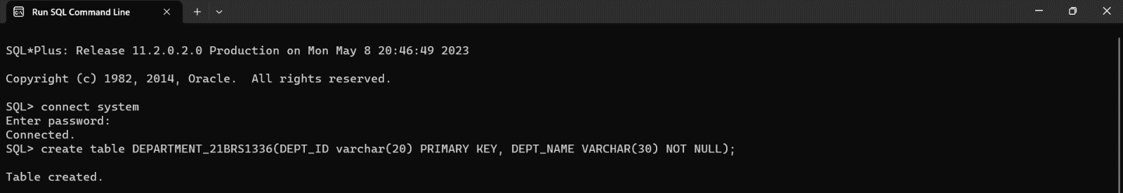DEPARTMENT (DEPT_ID, DEPT_NAME). Make DEPT_ID as the primary key and DEPT_NAME should not be null.
   2. PROJECT (PROJECT_ID, PROJECT_NAME, DID). Make PROJECT_ID as the primary key and PROJECT_NAME should not be null. DID will be the foreign keys for DEPARTMENT



* 1. EMPLOYEE(EMP_ID, NAME, GENDER, DID, PID, DOJ). Make EMP_ID as the primary key. DID and PID will be the foreign keys for DEPARTMENT and PROJECT tables respectively.



1. Insert 5 departments into DEPARTMENT table.

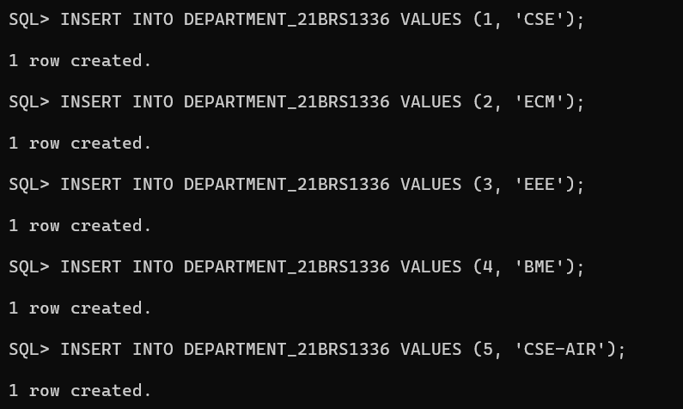

1. Insert 5 projects into PROJECT table.

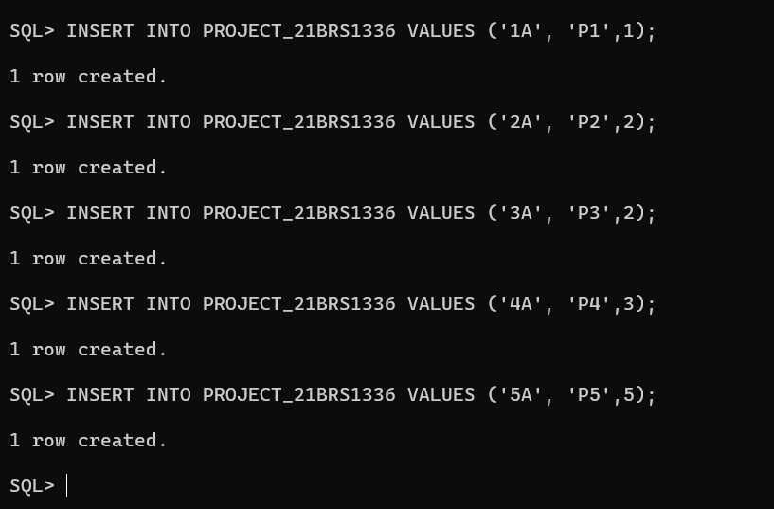

1. 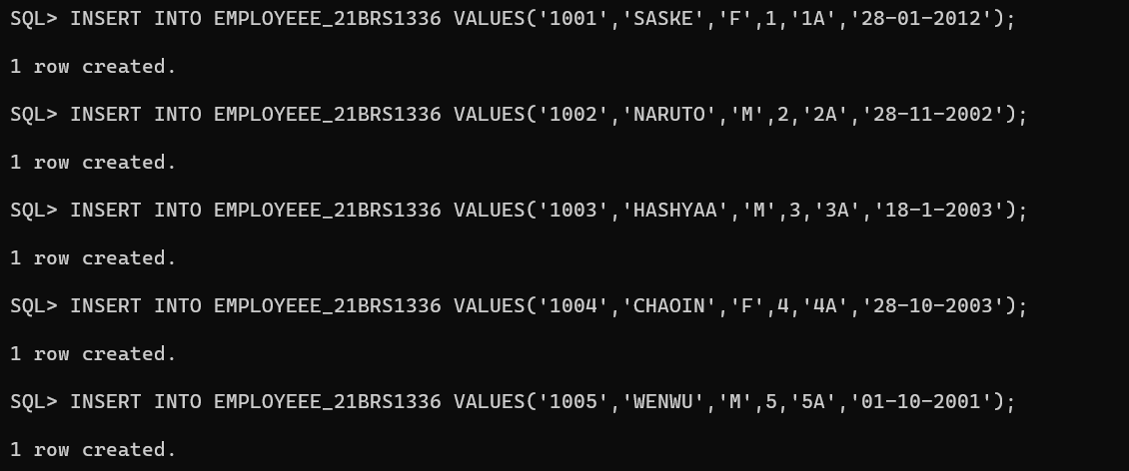Insert 5 Employees into EMPLOYEE table. Ensure that all the constraint criteria are met.
2. Update the employee PID from 1 to 2 for the employee whose employee id is ‘1001’.

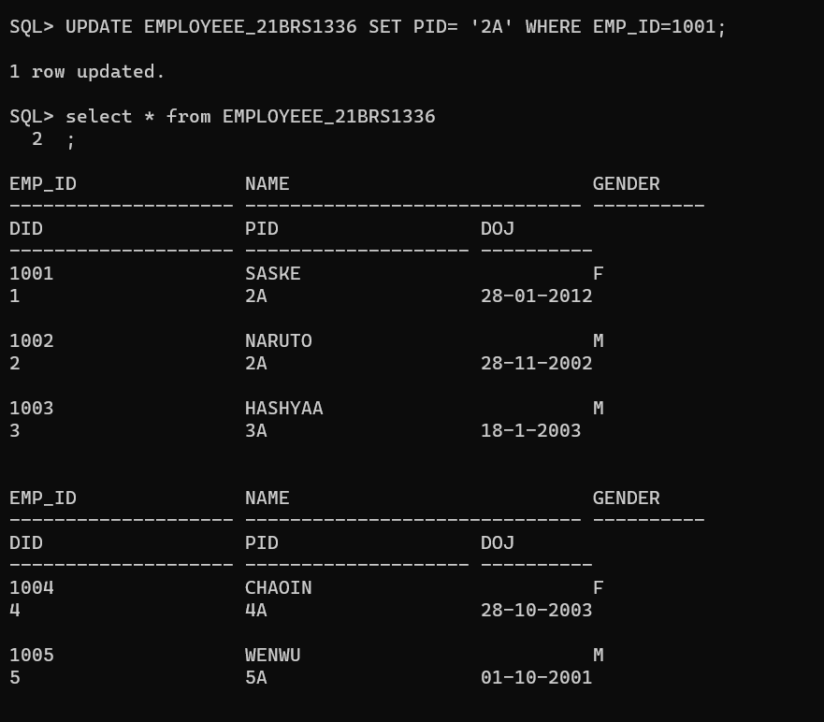

1. 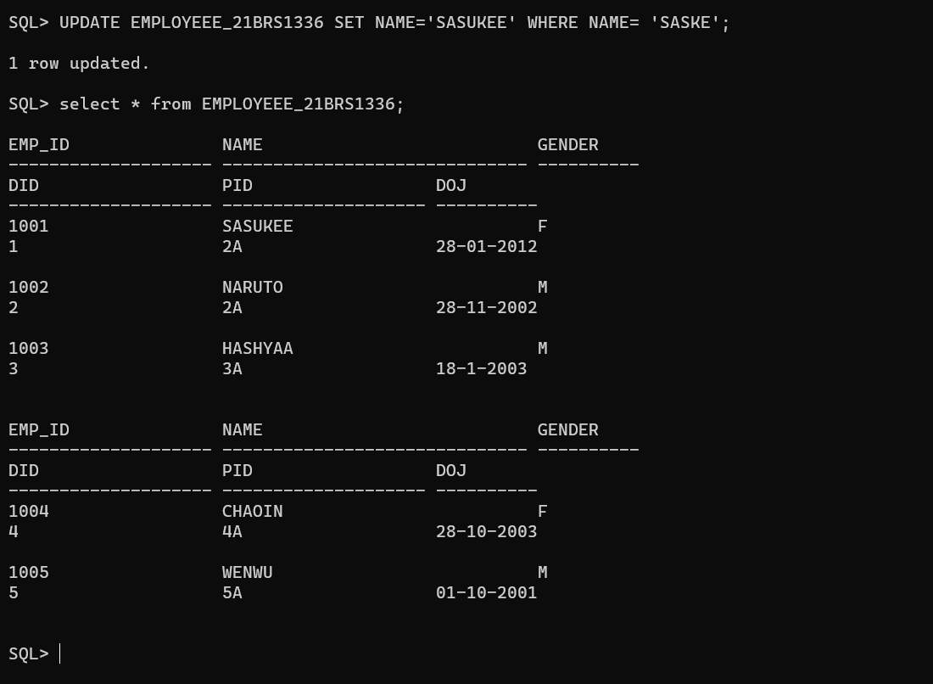Update the employee NAME from ‘SASKE’ to ‘SASUKEE’ for the employee whose name is ‘SASKE’.
2. 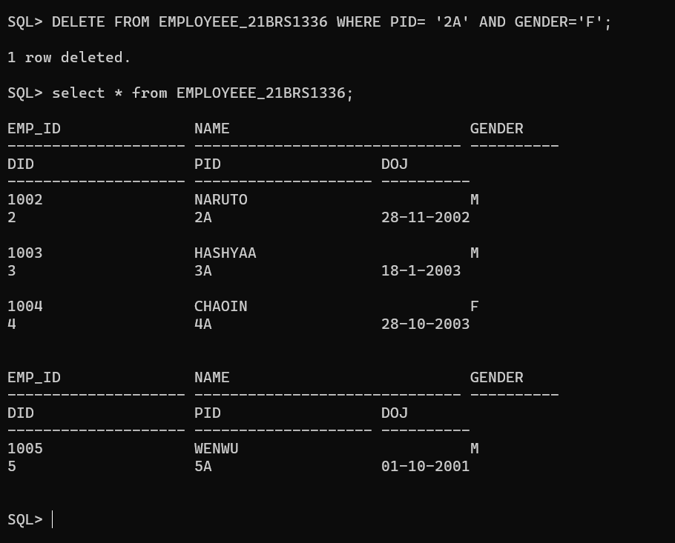Delete the list of female employees belonging to project 2.
3. Delete the list of male employees belonging to project 1.

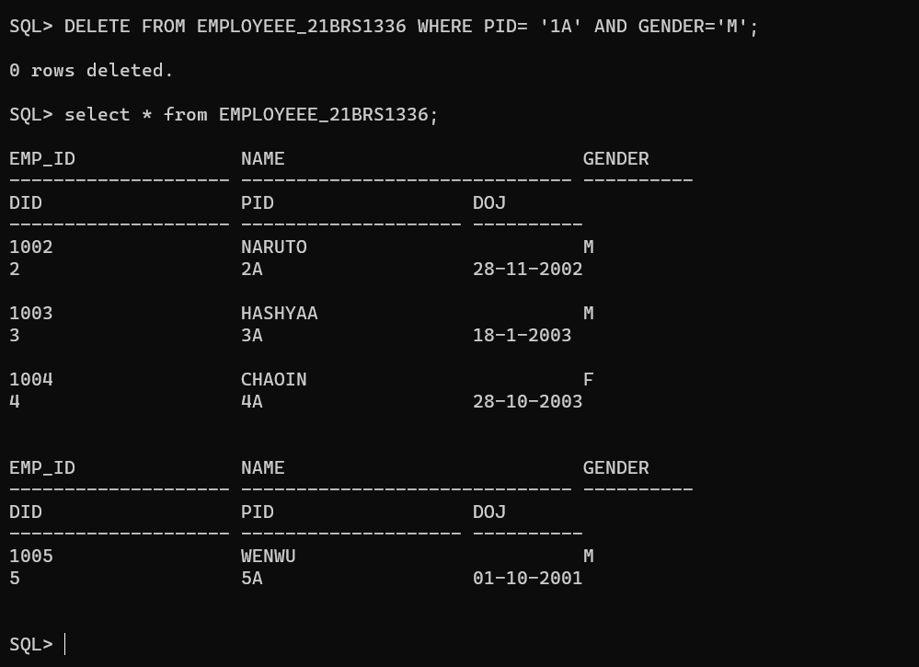

1. Delete the projects that are under department 1.

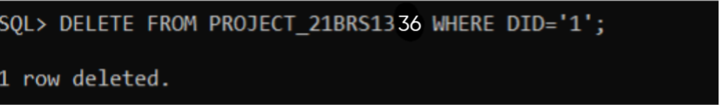

1. Drop all the three tables. Clearly indicate the order in which you will drop the three tables.

**NOTE:** While creating any new table suffix your registration number along with it.

**Eg:** EMPLOYEE_19MIS1234

