Playfair Cipher
The algorithm consists of 2 steps:
- Generate the key Square (5x5):
  - The key square is a 5×5 grid of alphabets that acts as the key for encrypting the plaintext. Each of the 25 alphabets must be unique and one letter of the alphabet (usually J) is omitted from the table (as the table can hold only 25 alphabets). If the plaintext contains J, then it is replaced by I.
  - The initial alphabets in the key square are the unique alphabets of the key in the order in which they appear followed by the remaining letters of the alphabet in order.
- Algorithm to encrypt the plain text: The plaintext is split into pairs of two letters (digraphs). If there is an odd number of letters, a Z is added to the last letter.
- Example:
- PlainText: "instruments"
After Split: 'in' 'st' 'ru' 'me' 'nt' 'sz'
Explanation: Pair cannot be made with same letter. Break the letter in single and add a fake letter to the previous letter. Here 'z' is the fake letter.
- Plain Text: "hello"
After Split: 'he' 'lx' 'lo'
Explanation: Here 'x' is the fake letter.
- Plain Text: "helloe"
After Split: 'he' 'lx' 'lo' 'ez'
Explanation: If the letter is standing alone in the process of pairing, then add an extra fake letter with the alone letter. Here 'x' and 'z' are the fake letters.

Rules for Encryption
If both the letters are in the same column: Take the letter below each one (going back to the top if at the bottom).
For example:
Diagraph: "me"
Encrypted Text: cl
Encryption: m -> c e -> l
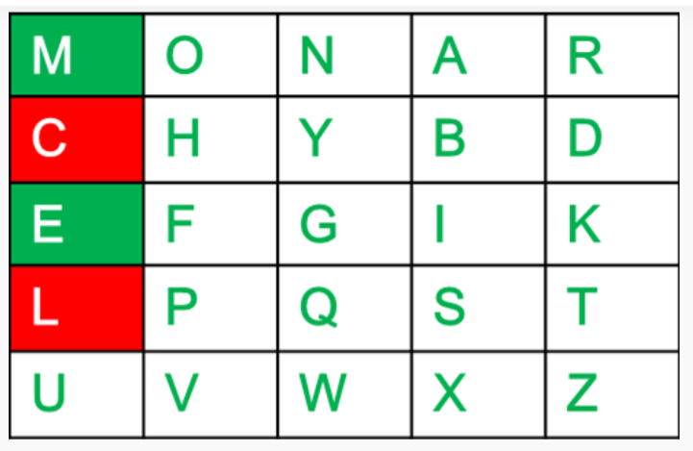

If both the letters are in the same row: Take the letter to the right of each one (going back to the leftmost if at the rightmost position).
For example:
Diagraph: "st"
Encrypted Text: tl
Encryption: s -> t t -> l
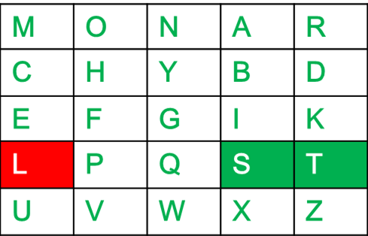
If neither of the above rules is true: Form a rectangle with the two letters and take the letters on the horizontal opposite corner of the rectangle.
For example:
Diagraph: "nt"
Encrypted Text: rq
Encryption: n -> r t -> q

For example:
Plain Text: "instrumentsz"
Encrypted Text: gatlmzclrqtx
Encryption:
i -> g
n -> a
s -> t
t -> l
r -> m
u -> z
m -> c
e -> l
n -> r
t -> q
s -> t
z -> x

Key text: Monarchy
Plain text: instruments

Digraph: in
st
re
me
nt
sz

Cipher text: gatlmzclrqtx
Decrypt:
Decrypting the Playfair cipher is as simple as doing the same process in reverse. The receiver has the same key and can create the same key table, and then decrypt any messages made using that key.
The Algorithm consists of 2 steps:
- Generate the key Square(5x5) at the receiver's end:
  - The key square is a 5×5 grid of alphabets that acts as the key for encrypting the plaintext. Each of the 25 alphabets must be unique and one letter of the alphabet (usually J) is omitted from the table (as the table can hold only 25 alphabets). If the plaintext contains J, then it is replaced by I.
  - The initial alphabets in the key square are the unique alphabets of the key in the order in which they appear followed by the remaining letters of the alphabet in order.
- Algorithm to decrypt the ciphertext: The ciphertext is split into pairs of two letters (digraphs).
Note: The ciphertext always have even number of characters.
If both the letters are in the same column: Take the letter above each one (going back to the bottom if at the top).

If both the letters are in the same row: Take the letter to the left of each one (going back to the rightmost if at the leftmost position).

If neither of the above rules is true: Form a rectangle with the two letters and take the letters on the horizontal opposite corner of the rectangle.
For example:
Plain Text: "gatlmzclrqtx"
Decrypted Text: instrumentsz
Decryption:
(red)-> (green)
ga -> in
tl -> st
mz -> ru
cl -> me
rq -> nt
tx -> sz
