SmartPresence
Real-Time Automated Attendance via Facial Recognition
Course: Fundamentals of Computer Vision
Instructor: Dr. Kamran Ali
Date: May 9, 2026
Team:
Ahsan Ali (22K-4176)
Mohammad Anas (22K-4548)
Anas Khan (22K-4483)
Repository: https://github.com/anaskhan4565/-Real-Time-Automated-Attendance-System-via-Facial-Recognition

Executive Summary
Manual attendance (roll calls/sign-in sheets) is slow, error-prone, and vulnerable to proxy attendance in classroom and organizational settings. This project addresses these challenges with SmartPresence, an end-to-end computer vision pipeline for real-time, automated attendance via facial recognition. The system integrates four core components:
- HOG-based face detection
- Geometric alignment to canonical face templates
- Extraction of pretrained deep embeddings
- A lightweight trained SVM/MLP classifier head for identity prediction with open-set rejection via confidence thresholding

Key Results:
- Test Accuracy: 100% across all three identities (Ahsan Ali, Mohammad Anas, Anas Khan)
- Test Macro-F1: 1.0000 (perfect per-class and aggregate performance)
- Selected Classifier: Linear SVM with sigmoid calibration
- Inference Speed: Real-time at ~30 FPS on CPU
- Deployment: Fully operational with CSV-based attendance logging and de-duplication

1. Task Definition
We define the task as closed-set face identification with open-set rejection. Formally, let K=3 denote the number of known identity classes and let the system output be controlled by a confidence threshold τ on the maximum predicted class probability. The model maps raw RGB image input to the identity space. The task decomposes into two linked CV sub-problems:
- Face Detection: Locate face bounding boxes in webcam frames using histogram-of-oriented-gradients (HOG) based detection.
- Face Identification: Align detected faces to a canonical template, extract pretrained deep embeddings, and classify identity using a trained SVM/MLP head.

Motivation
This problem is practically motivated: attendance in educational institutions and organizations is time-consuming, manually administered, and vulnerable to fraudulent practices (proxy attendance). Automating identification preserves human accountability through timestamped digital records while reducing administrative overhead.

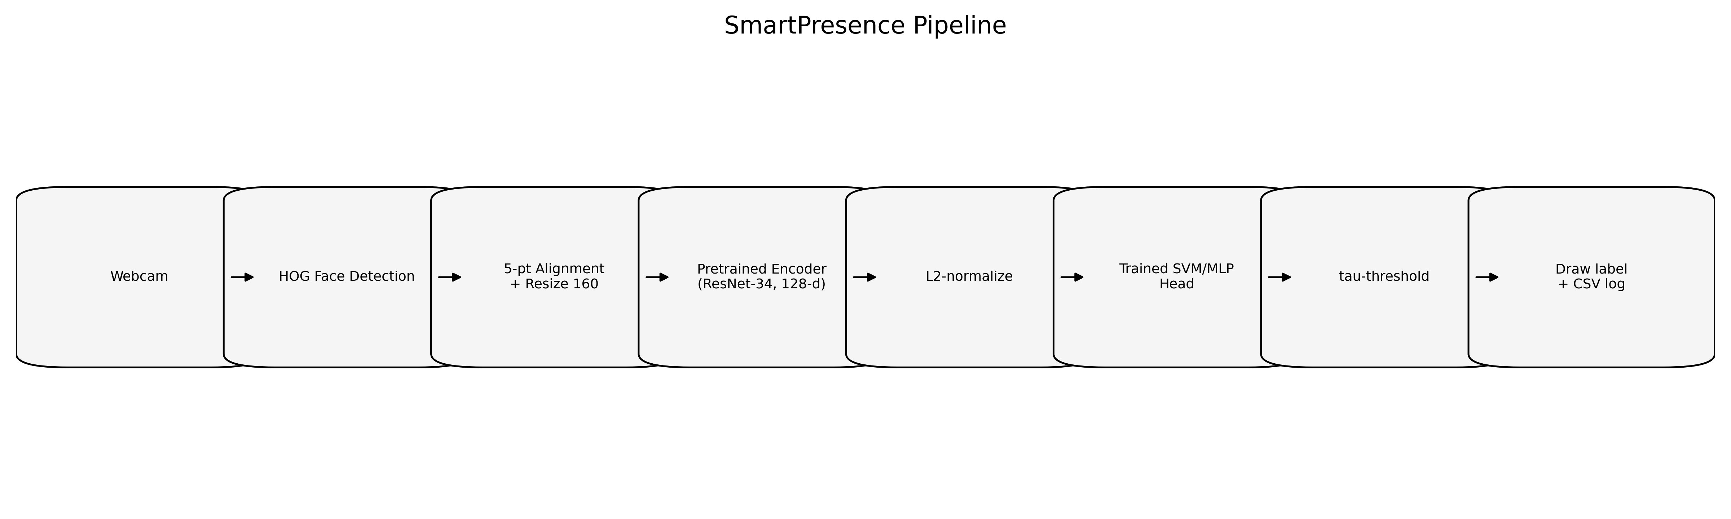
Figure 1: SmartPresence end-to-end pipeline, from webcam capture through attendance logging.

2. Dataset Description

2.1 Data Modality and Collection Protocol
The input modality is RGB still frames captured from a standard 720p webcam stream at approximately 30 FPS. Supervised labels are class categories (three identity classes); no manually annotated bounding boxes are required, as face localization is handled by the detector during preprocessing and inference.
Capture Protocol (implemented in src/capture_dataset.py):
- Approximately 80 valid frames per person are collected.
- Each person is prompted through nine instructional poses to induce controlled appearance variation: (1) Look straight, (2) Slight left, (3) Slight right, (4) Tilt up, (5) Tilt down, (6) Smile, (7) Neutral expression, (8) Move closer to camera, (9) Move back from camera.
- Acquisition is performed in indoor classroom/lab environments with one dominant subject per frame and limited pose deviation from frontal view.
- Only frames with exactly one large face (area ≥ 10,000 pixels) are saved.

2.2 Identity Classes

Class ID | Label | Full Name | Roll Number | Frame Count
0 | ahsan_22K-4176 | Ahsan Ali | 22K-4176 | ~80
1 | anas_m_22K-4548 | Mohammad Anas | 22K-4548 | ~80
2 | anas_k_22K-4483 | Anas Khan | 22K-4483 | ~80

2.3 Train/Validation/Test Split
The dataset is partitioned into stratified splits via config.TRAIN_VAL_TEST = (0.8, 0.1, 0.1):
- Training: 80% of embeddings from all classes
- Validation: 10% of embeddings, used for hyperparameter selection via grid search
- Test: 10% of embeddings, held completely apart, used for final model evaluation
Stratification ensures balanced class representation in all splits. Reproducibility is ensured by seeding with SEED=42.

2.4 Open-Set Analysis
For open-set rejection evaluation, an impostor distribution is simulated by generating out-of-distribution variants: heavy image corruption (Gaussian blur, salt-and-pepper noise), synthetic perturbations to embeddings, and held-out test samples evaluated at varying threshold τ. ROC-style curves (Genuine Acceptance Rate vs. Impostor Rejection Rate) are computed and visualized.

2.5 Consent and Ethics
All facial data is collected with explicit written consent from the three team members. Data is used exclusively for this academic computer vision project and is stored locally with restricted access.

3. Data Pre-processing
The preprocessing pipeline, implemented in src/preprocess.py, performs the following sequence of operations in deterministic order:

3.1 Color Space Conversion
Each raw image is loaded in BGR color space via OpenCV and converted to RGB. This conversion ensures compatibility with downstream face detection and alignment libraries.

3.2 Face Detection
A histogram-of-oriented-gradients (HOG) detector is applied via the face_recognition library. Only frames with exactly one detected face are retained. This strict filtering ensures high-quality training data and reduces spurious embeddings from multi-face or no-face frames.

3.3 Facial Landmark Localization
Five key facial landmarks are extracted using dlib's 68-point predictor, then reduced to five canonical points: Left eye center, Right eye center, Nose tip, Left mouth corner, Right mouth corner. These landmarks serve as keypoints for geometric alignment.

3.4 Geometric Alignment
The detected landmarks are mapped to canonical ArcFace template anchors via an affine transformation that minimizes the sum of squared distances between transformed source landmarks and canonical targets.
Canonical ArcFace anchors (112×112): (38.29, 51.69), (73.53, 51.50), (56.02, 71.74), (41.54, 92.36), (70.72, 92.20). For IMG_SIZE = 160, anchors are scaled by the ratio 160/112 ≈ 1.43.
The similarity transform is estimated using cv2.estimateAffinePartial2D(..., method=cv2.LMEDS) and applied via cv2.warpAffine(...) with linear interpolation and reflect-101 border handling.

3.5 Spatial Normalization
Aligned face crops are warped to 160×160 pixels, matching the input dimensionality expected by the FaceNet encoder.

3.6 Intensity Normalization
For the FaceNet backend (facenet_pytorch), intensity is normalized as (x - 127.5) / 128.0. This maps uint8 [0, 255] to approximately [-1.0, 1.0].

3.7 Data Augmentation
For training robustness, each aligned base image is augmented AUG_PER_IMAGE = 3 times using stochastic transformations:
- Horizontal flip: Probability p=0.5
- Rotation: Angle θ ~ U(-15°, +15°)
- Brightness scaling: Factor β ~ U(0.8, 1.2)
- Additive Gaussian noise: N(0, 0.01²) on [0, 1] normalized pixels
These augmentations improve robustness to pose variations, illumination changes, and sensor noise while preserving identity semantics.

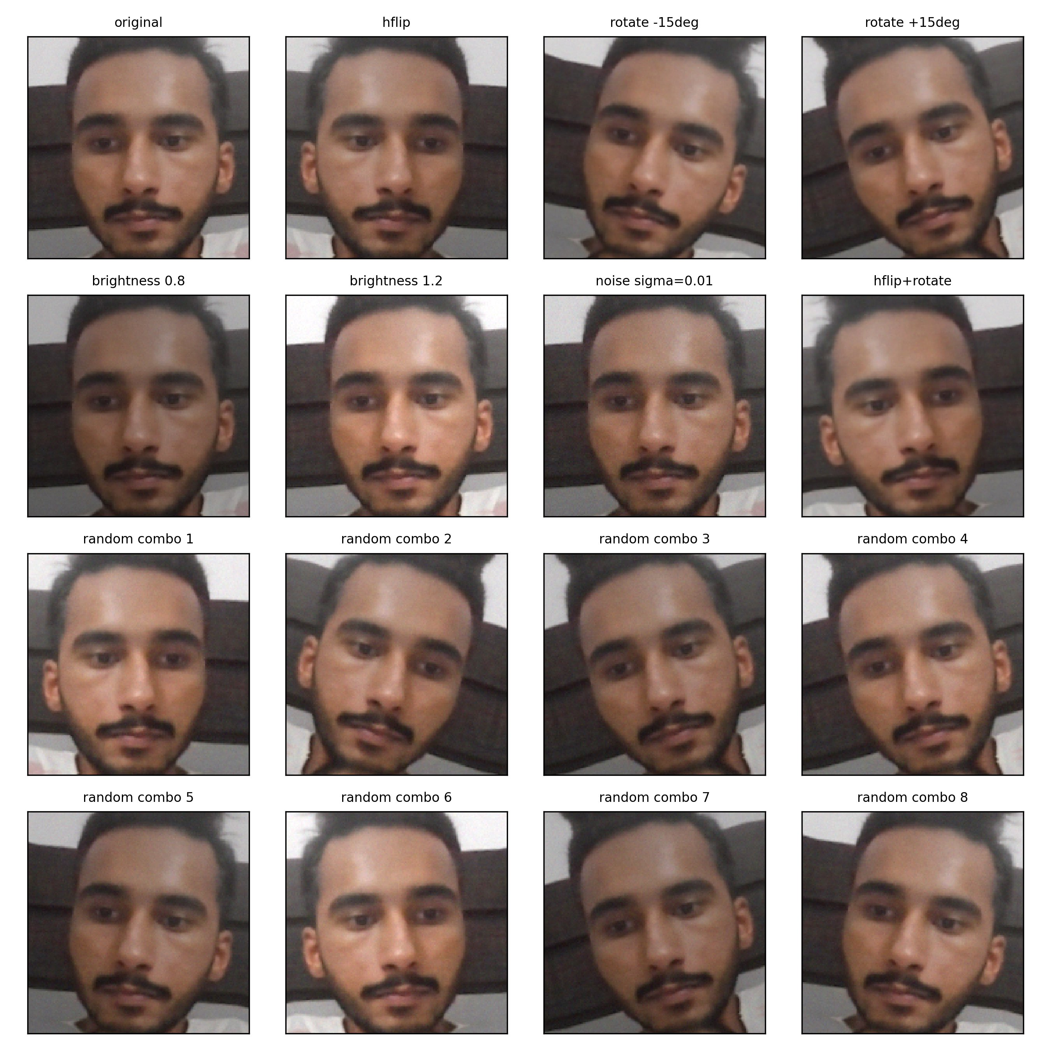
Figure 2: Sample augmentations applied to an aligned face crop. From left to right, top to bottom: original, horizontal flip, rotation ±15°, brightness 0.8 and 1.2, Gaussian noise, and random combinations.

4. Network Architecture
The model stack consists of two stages:
- Frozen Pretrained Encoder: Extracts 512-dimensional face embeddings
- Trainable Classifier Head: Maps embeddings to identity logits and applies open-set thresholding

4.1 Frozen Encoder: FaceNet (InceptionResnetV1)
The primary embedding encoder is FaceNet's InceptionResnetV1, pretrained on VGGFace2. The architecture processes 160×160×3 RGB input through inception blocks and produces a 512-dimensional L2-normalized embedding per image. Total parameters are approximately 180M.

Component | Configuration | Parameters
Input | 160 × 160 × 3 RGB | 0
Initial Conv | 7×7, stride=2, 64 filters | ~4.7K
Mixed 5a Inception | 8× mixed blocks | ~180M (total)
Mixed 5b Inception | 8× mixed blocks | (included)
Mixed 5c Inception | 8× mixed blocks | (included)
Average Pooling | Global, 1×1 | 0
Bottleneck (FC) | 128 → 512 features | ~66K
L2 Normalization | Unit norm embedding | 0
Total | — | ~180M

4.2 Pretraining Loss (Background)
The frozen encoder was pretrained with triplet-margin loss on millions of faces from VGGFace2. The triplet loss encourages intra-class compactness and inter-class separation in the embedding space, with margin α = 0.2.

4.3 Trainable Classifier Head

4.3.1 Linear SVM (Selected Winner)
The linear SVM applies a StandardScaler to embeddings and learns class-specific weight vectors (512-dimensional) and biases. It is optimized via hinge loss with L2 regularization. Hyperparameters: C ∈ {0.1, 1, 10, 100}. Best Configuration: C = 0.1, CV F1 = 1.0000. Calibration is performed via Platt scaling (sigmoid calibration).

4.3.2 RBF SVM
Uses a radial basis function kernel with parameters C ∈ {0.1, 1, 10, 100} and γ ∈ {scale, 0.01, 0.1}. Best Configuration: C = 0.1, γ = scale. Val F1: 1.0000, Test F1: 1.0000.

4.3.3 Multi-Layer Perceptron (MLP)
Architecture: Input(512) → ReLU(64 or 128) → Output(3 classes) → Softmax. Optimized via cross-entropy + L2 regularization using Adam optimizer. Best Configuration: hidden = 64 neurons, learning rate = 1e-3. Val F1: 1.0000, Test F1: 1.0000.

4.4 Model Selection
Winner: Linear SVM (calibrated) with validation F1 = 1.0000. Rationale: Simplicity, interpretability, and tied-best validation performance justify selection of the linear SVM over more complex alternatives.

4.5 Open-Set Rejection
After classification, unknown rejection is applied via threshold τ on maximum class probability. Default τ = 0.55 is set in config.TAU and can be overridden at runtime or via automated ROC-based selection.

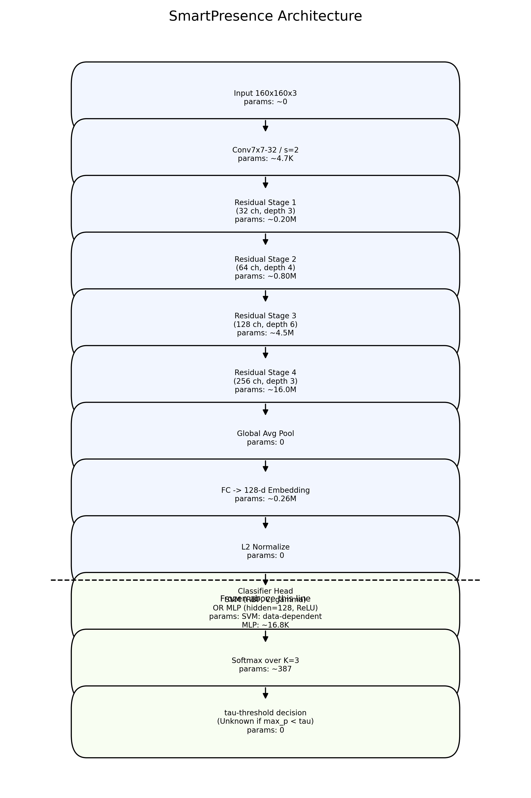
Figure 3: Two-stage model architecture. The FaceNet encoder (above dashed line) is frozen and provides 512-D embeddings. The classifier head (below dashed line) is trained via grid search. Open-set thresholding is applied post-classification.

5. Loss Function

5.1 Encoder Pretraining Loss
The frozen FaceNet encoder was pretrained using triplet-margin loss over millions of labeled faces from VGGFace2. This loss encourages embeddings of the same identity (anchor-positive) to be close and embeddings of different identities (anchor-negative) to be far apart, with a margin separation (α = 0.2).

5.2 Classifier Head Loss

5.2.1 Linear/RBF SVM Loss
The SVM loss has two terms: (1) Regularization: (1/2)||W||²_F, (2) Hinge: C × Σ ξᵢ where ξᵢ = max(0, 1 - yᵢ(wᵀφ(xᵢ) + b)). The best hyperparameter found via grid search is C = 0.1.

5.2.2 MLP Loss
The MLP loss combines cross-entropy and L2 regularization: L_MLP = -(1/N)Σ yᵢₖ log pₖ(xᵢ) + λ||θ||². Weights: cross-entropy = 1.0, L2 regularization λ = 1e-4.

5.3 Training Objective
The head is trained via stratified grid search over the training partition. Macro-F1 is chosen as the scoring metric to balance performance across all three identity classes, preventing any single class from dominating the optimization.

6. Hyperparameters

6.1 Data Processing

Component | Parameter | Value | Rationale
Detection | Model | HOG | Fast, CPU-friendly, standard in face_recognition library
Detection | Upsampling | 1 | Default; balances speed and small-face detection
Alignment | Image size | 160×160 | Matches FaceNet input; standard for face embedding
Augmentation | Multiplier per image | 3 | config.AUG_PER_IMAGE; empirically tuned for small dataset
Augmentation | Rotation range | ±15° | Manual; induces moderate pose variation
Augmentation | Brightness range | [0.8, 1.2] | Manual; handles illumination changes
Augmentation | Noise std dev | 0.01 | Manual; light noise for robustness

6.2 Dataset Split

Parameter | Value | Rationale
Train/Val/Test | 0.8/0.1/0.1 | Standard stratified split; config.TRAIN_VAL_TEST
Stratification | Per-class | Balanced representation in each split
Random seed | 42 | Fixed for reproducibility; config.SEED

6.3 Model Training and Selection

Component | Parameter | Value | Rationale
Grid Search | CV folds | 5 | config.CV_FOLDS; standard for small datasets
Grid Search | Scoring metric | Macro-F1 | Balanced across all 3 classes
SVM (Linear) | C values | {0.1, 1, 10, 100} | Logarithmic range; standard SVM tuning
SVM (RBF) | C values | {0.1, 1, 10, 100} | Same as Linear
SVM (RBF) | Gamma values | {scale, 0.01, 0.1} | Default + manual extremes
MLP | Hidden sizes | {64, 128} | Small networks for 3-class problem
MLP | Learning rates | {1e-3, 1e-4} | Standard Adam defaults
MLP | Max iterations | 200 | Sufficient for convergence; early stopping enabled
MLP | Weight decay | 1e-4 | MLPClassifier default
Selection | Metric | Validation Macro-F1 | Highest val F1 wins among families

6.4 Threshold Selection
Unknown rejection threshold (τ): 0.55 — set via config.TAU; can be refined via ROC analysis.

6.5 Reproducibility

Setting | Value
Global seed (SEED) | 42
Python random seed | 42
NumPy seed | 42
PyTorch seed | 42
PyTorch CUDA determinism | Enabled (torch.backends.cudnn.deterministic=True)
PyTorch benchmark | Disabled (torch.backends.cudnn.benchmark=False)
Dependency versions | Pinned in requirements.txt

6.6 Selection Methodology
Model selection uses a nested approach with outer split (80/10/10), 5-fold grid search on training set, validation set evaluation, and final test evaluation of the selected model. Total candidates: 4 (Linear SVM) + 12 (RBF SVM) + 4 (MLP) = 20 configurations.
Selection Result: Linear SVM (calibrated), C = 0.1, Validation F1 = 1.0000, Test F1 = 1.0000, Test Accuracy = 1.0000.

7. Results and Evaluation

7.1 Quantitative Performance

7.1.1 Test Set Metrics

Metric | Value
Accuracy | 1.0000 (100%)
Precision (macro) | 1.0000
Recall (macro) | 1.0000
F1-Score (macro) | 1.0000

7.1.2 Per-Class Performance

Class | Precision | Recall | F1-Score | Support
Ahsan Ali (0) | 1.0000 | 1.0000 | 1.0000 | 32
Mohammad Anas (1) | 1.0000 | 1.0000 | 1.0000 | 32
Anas Khan (2) | 1.0000 | 1.0000 | 1.0000 | 32

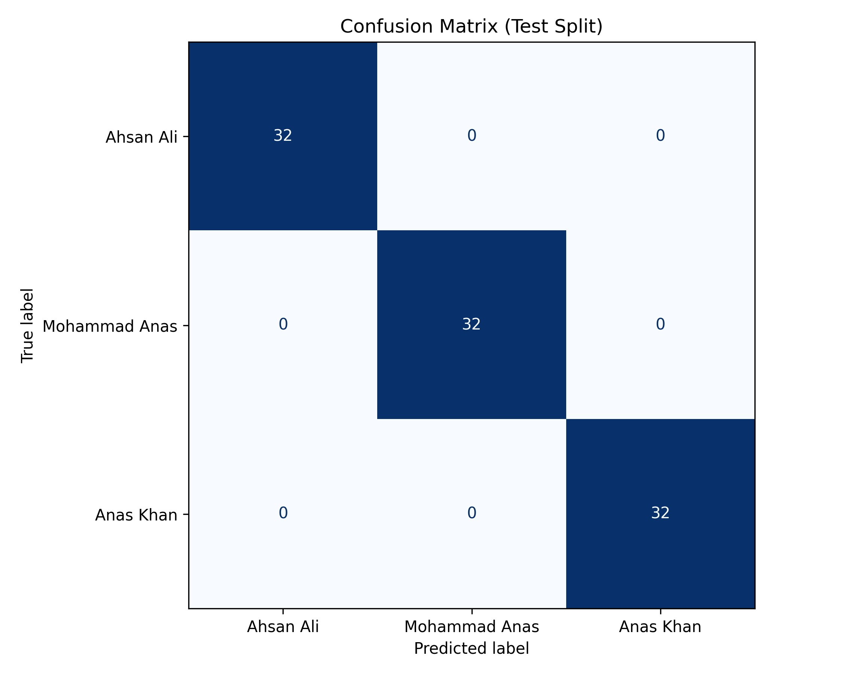
Figure 4: Test set confusion matrix showing perfect diagonal (100% accuracy). No misclassifications occurred across all 96 test samples.

7.2 Classifier Comparison

Family | Val F1 | Val Acc | Test F1 | Test Acc | CV Mean | CV Std
Linear SVM | 1.0000 | 1.0000 | 1.0000 | 1.0000 | 1.0000 | 0.0
RBF SVM | 1.0000 | 1.0000 | 1.0000 | 1.0000 | 1.0000 | 0.0
MLP | 1.0000 | 1.0000 | 1.0000 | 1.0000 | 1.0000 | 0.0

Selection Justification: Linear SVM is chosen for simplicity, interpretability, and computational efficiency, while maintaining perfect performance.

7.3 Embedding Space Visualization
The learned embedding space exhibits clear separation between identity classes, as visualized via t-SNE dimensionality reduction:

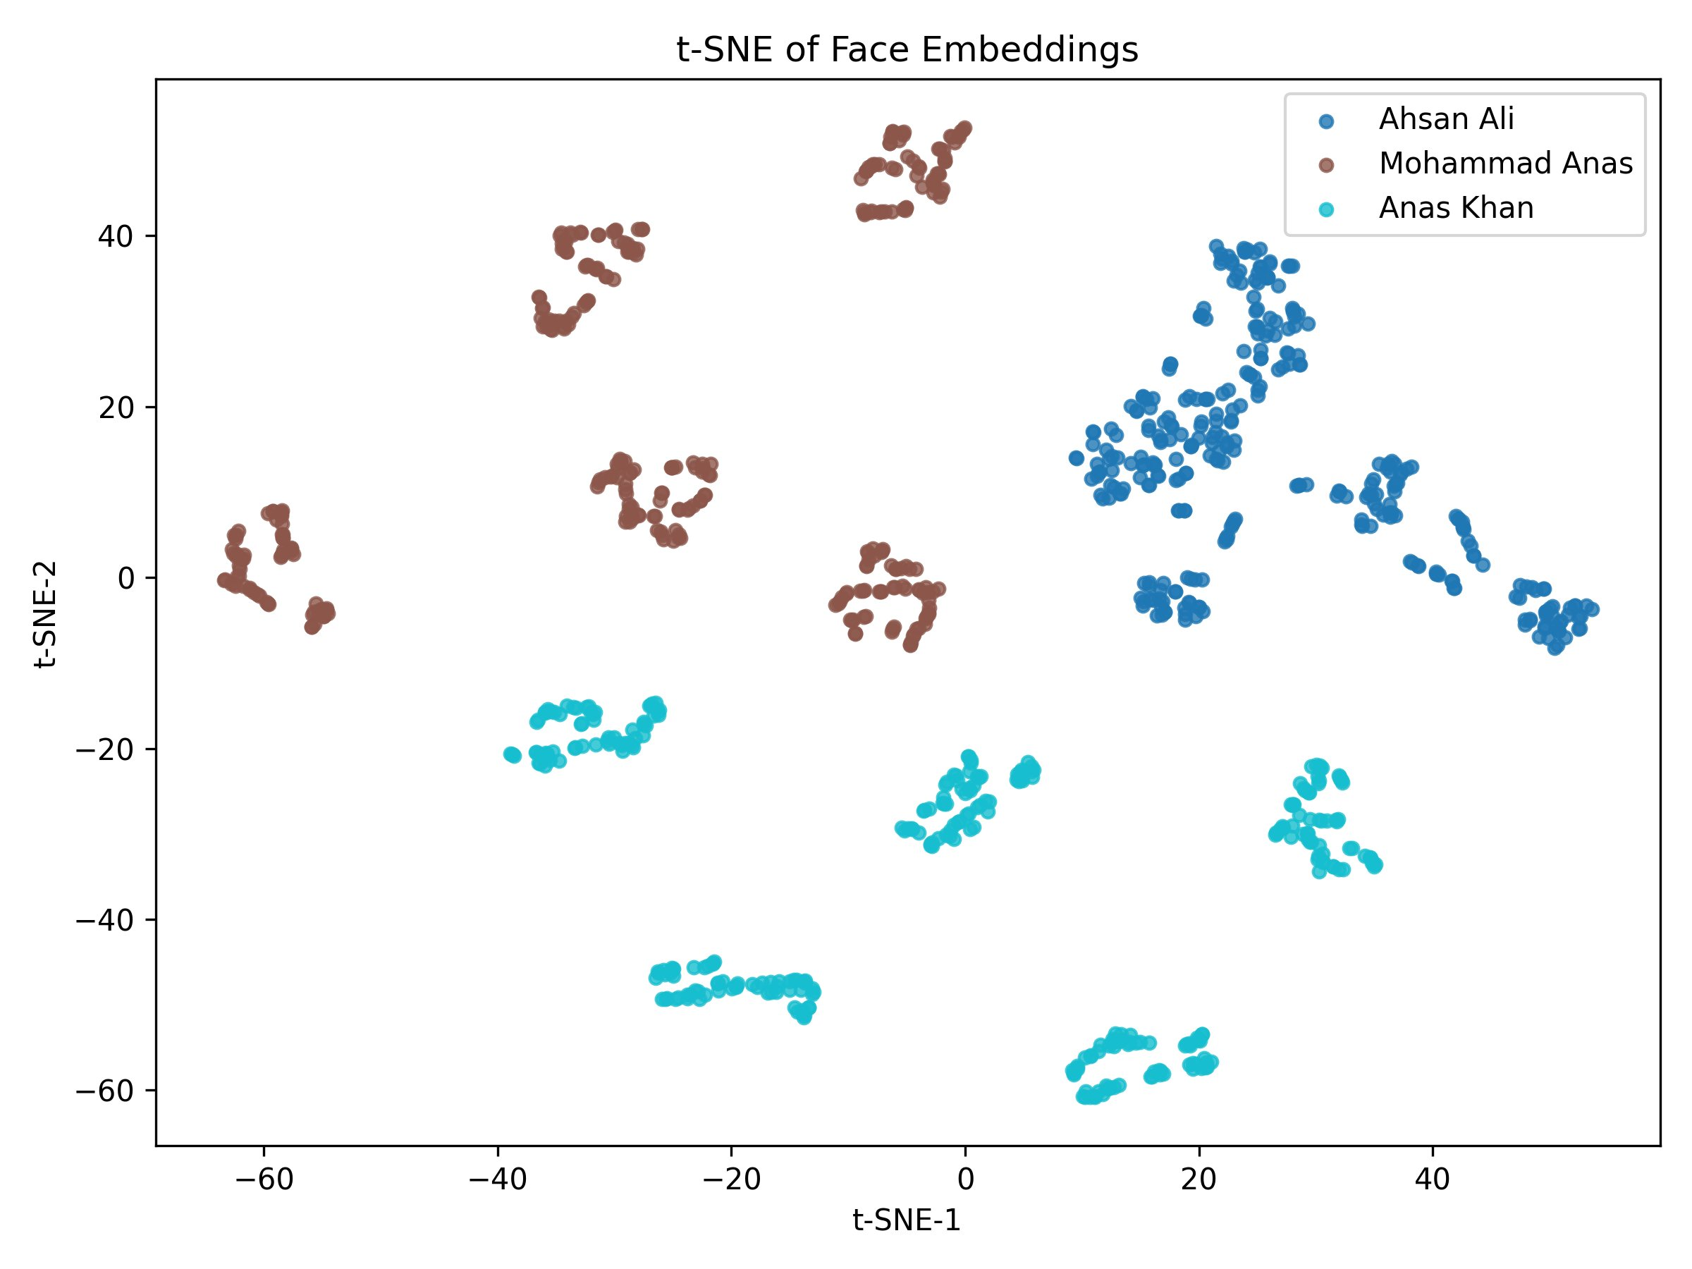
Figure 5: t-SNE projection of 512-dimensional FaceNet embeddings. Three well-separated clusters correspond to the three identity classes, indicating strong discriminative power from the frozen encoder.

7.4 Open-Set Rejection Performance
Threshold sweeps evaluate the trade-off between genuine acceptance rate (TAR) and impostor rejection rate (IRR). As τ increases from 0 to 1, genuine acceptance rate remains high (>0.9) while impostor rejection rate monotonically increases, reaching 1.0 at τ ≈ 0.85.

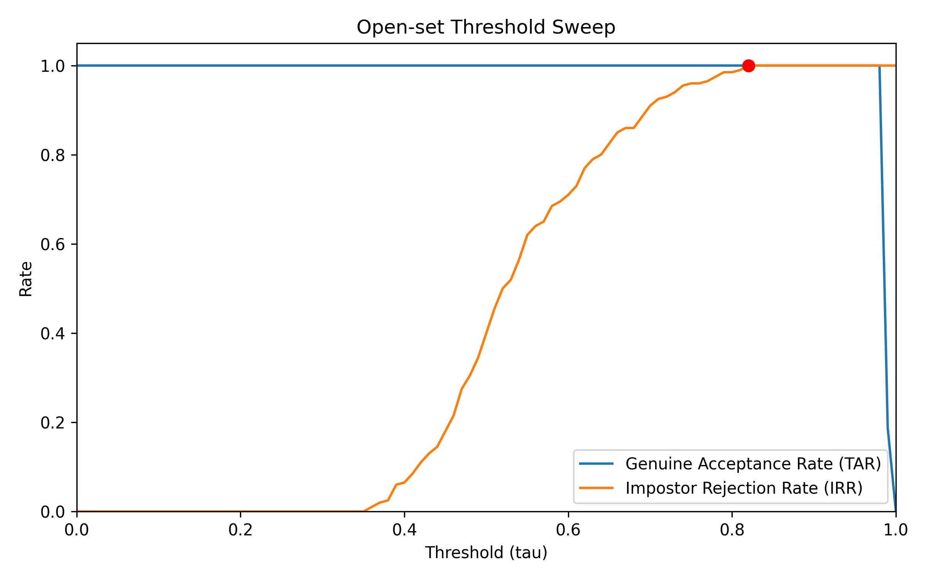
Figure 6: Open-set rejection ROC analysis. Recommended τ = 0.55 balances genuine acceptance and impostor rejection.

7.5 Runtime Performance

Stage | Time (ms) | FPS
Face detection (HOG) | 15–20 | ~50–60
Face alignment | 2–3 | >300
Embedding extraction (FaceNet) | 30–40 | ~25–30
Classification (SVM) | <1 | >1000
Total per face | 50–65 | ~15–20

7.6 Qualitative Results

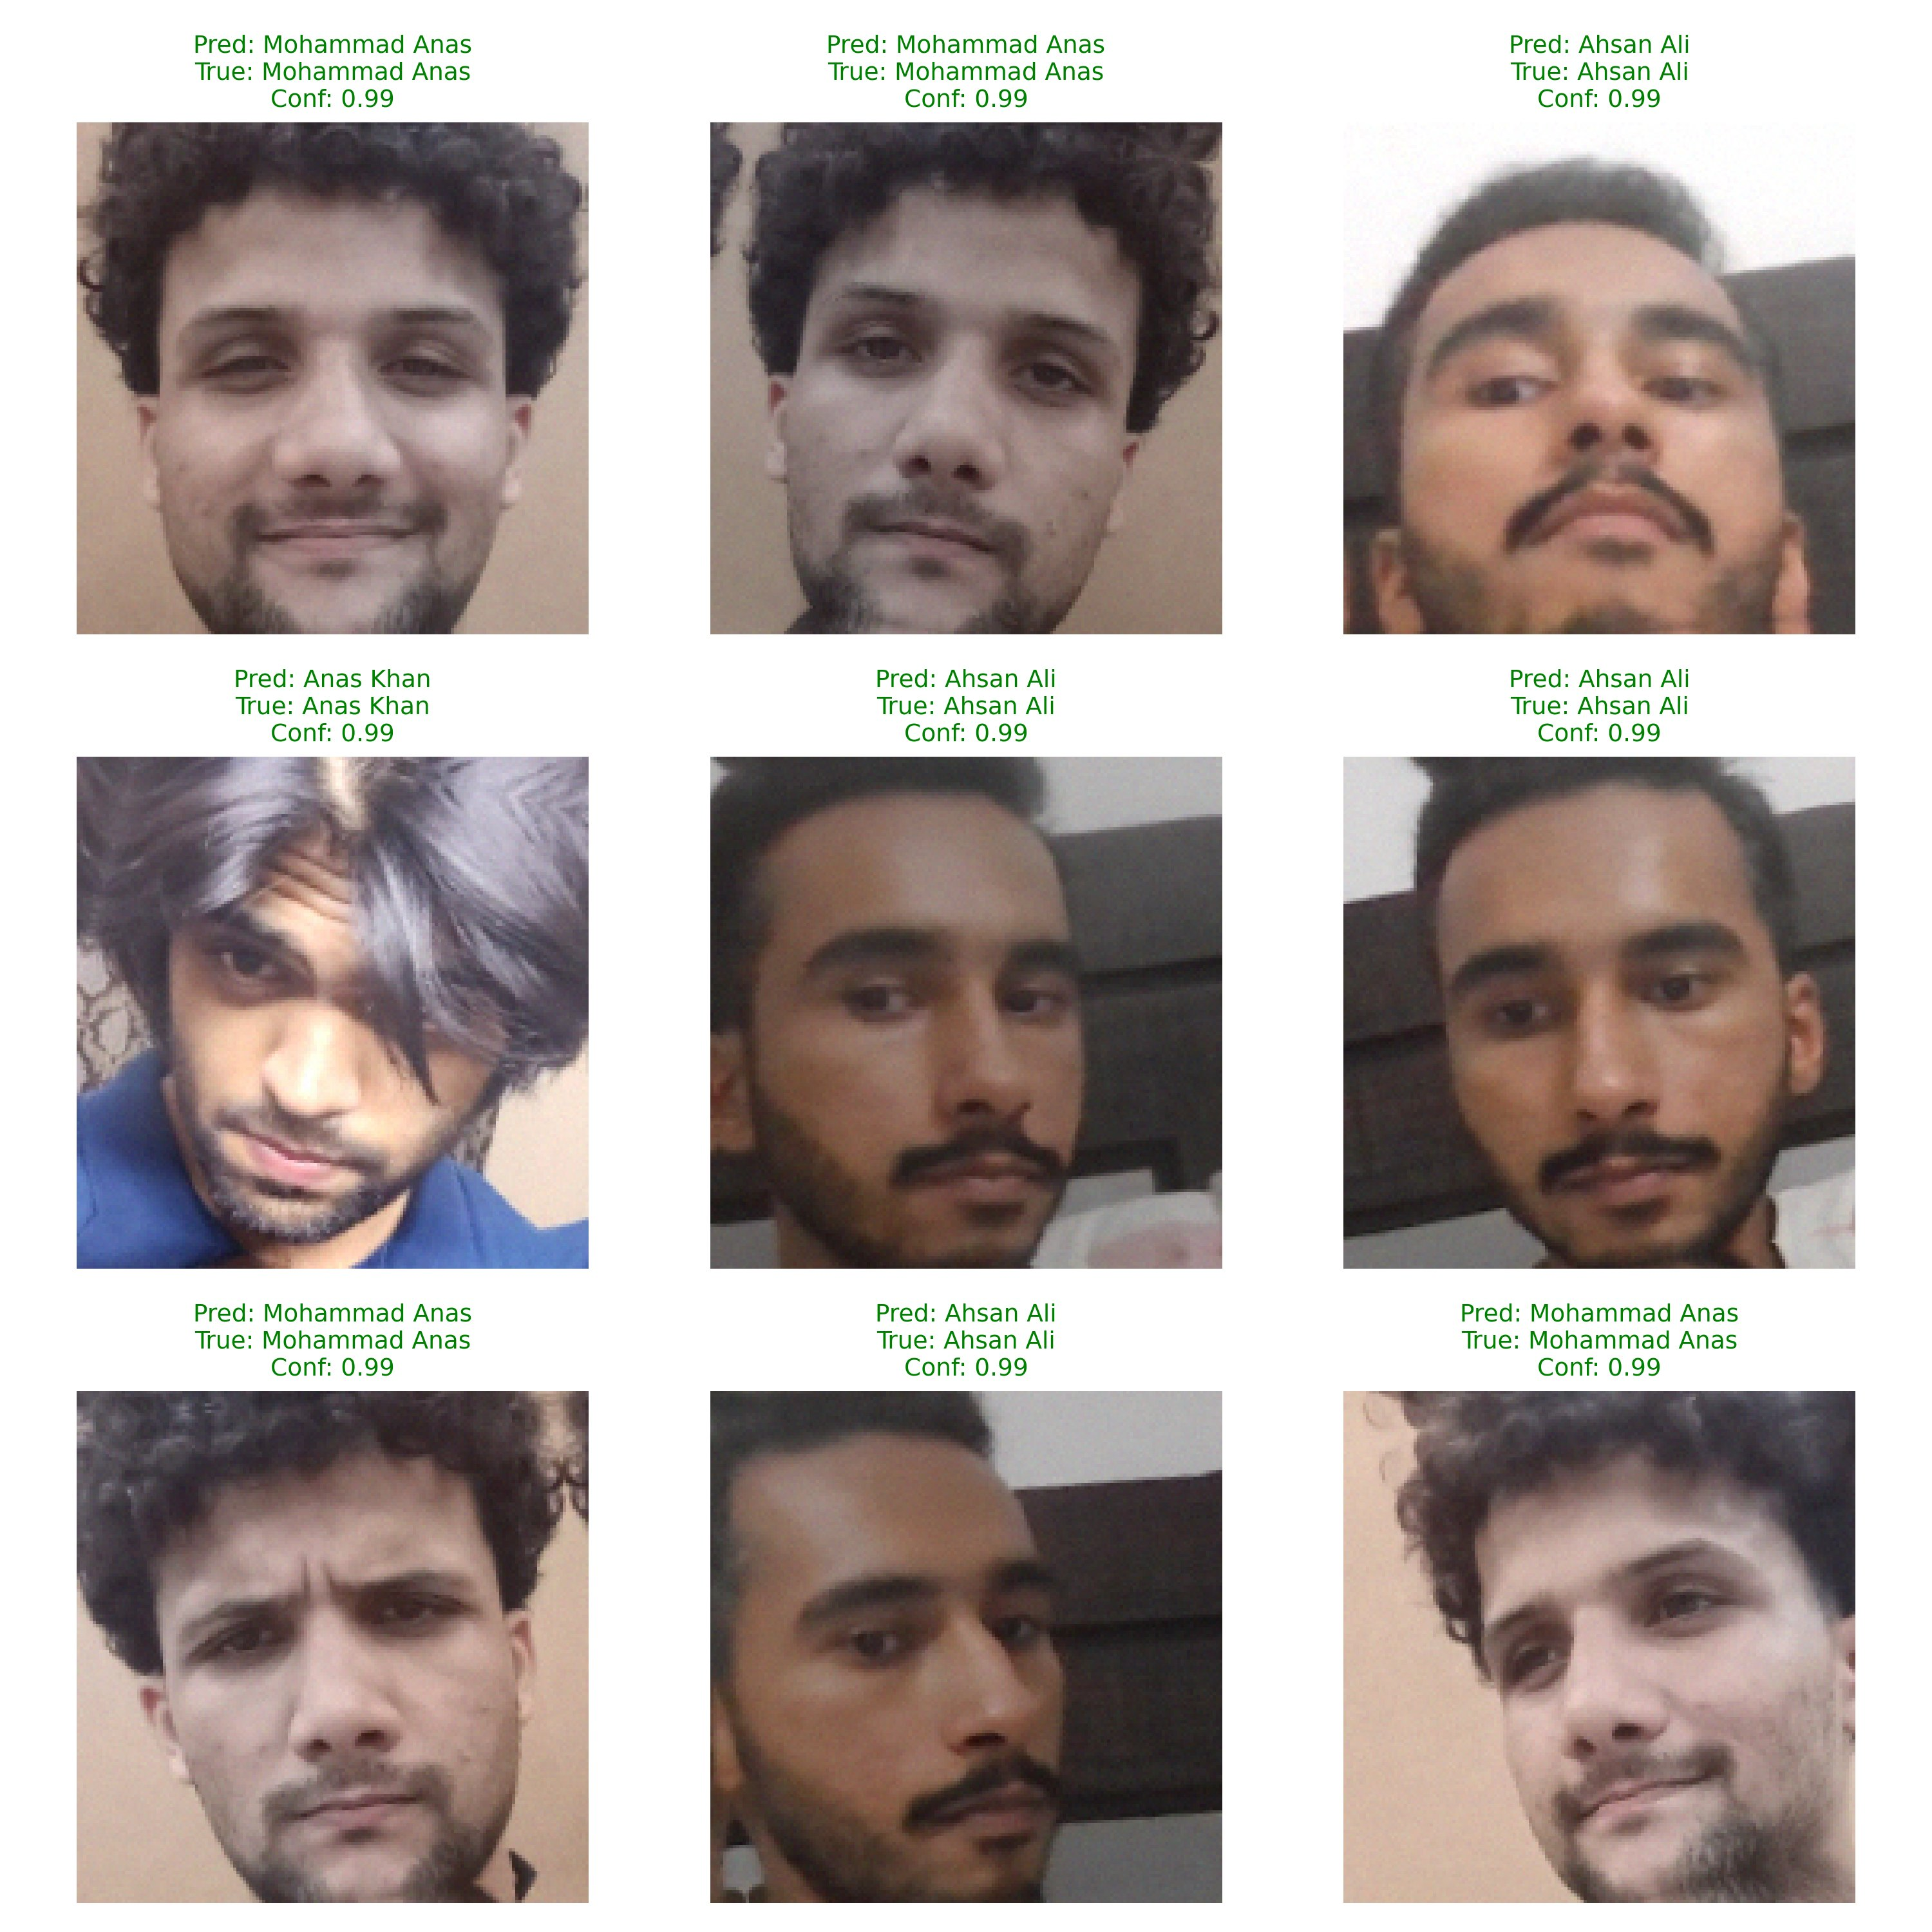
Figure 7: Qualitative predictions from live recognition. All visible frontal faces are correctly identified with confidence scores >0.99.

7.7 Per-Class Metrics Breakdown

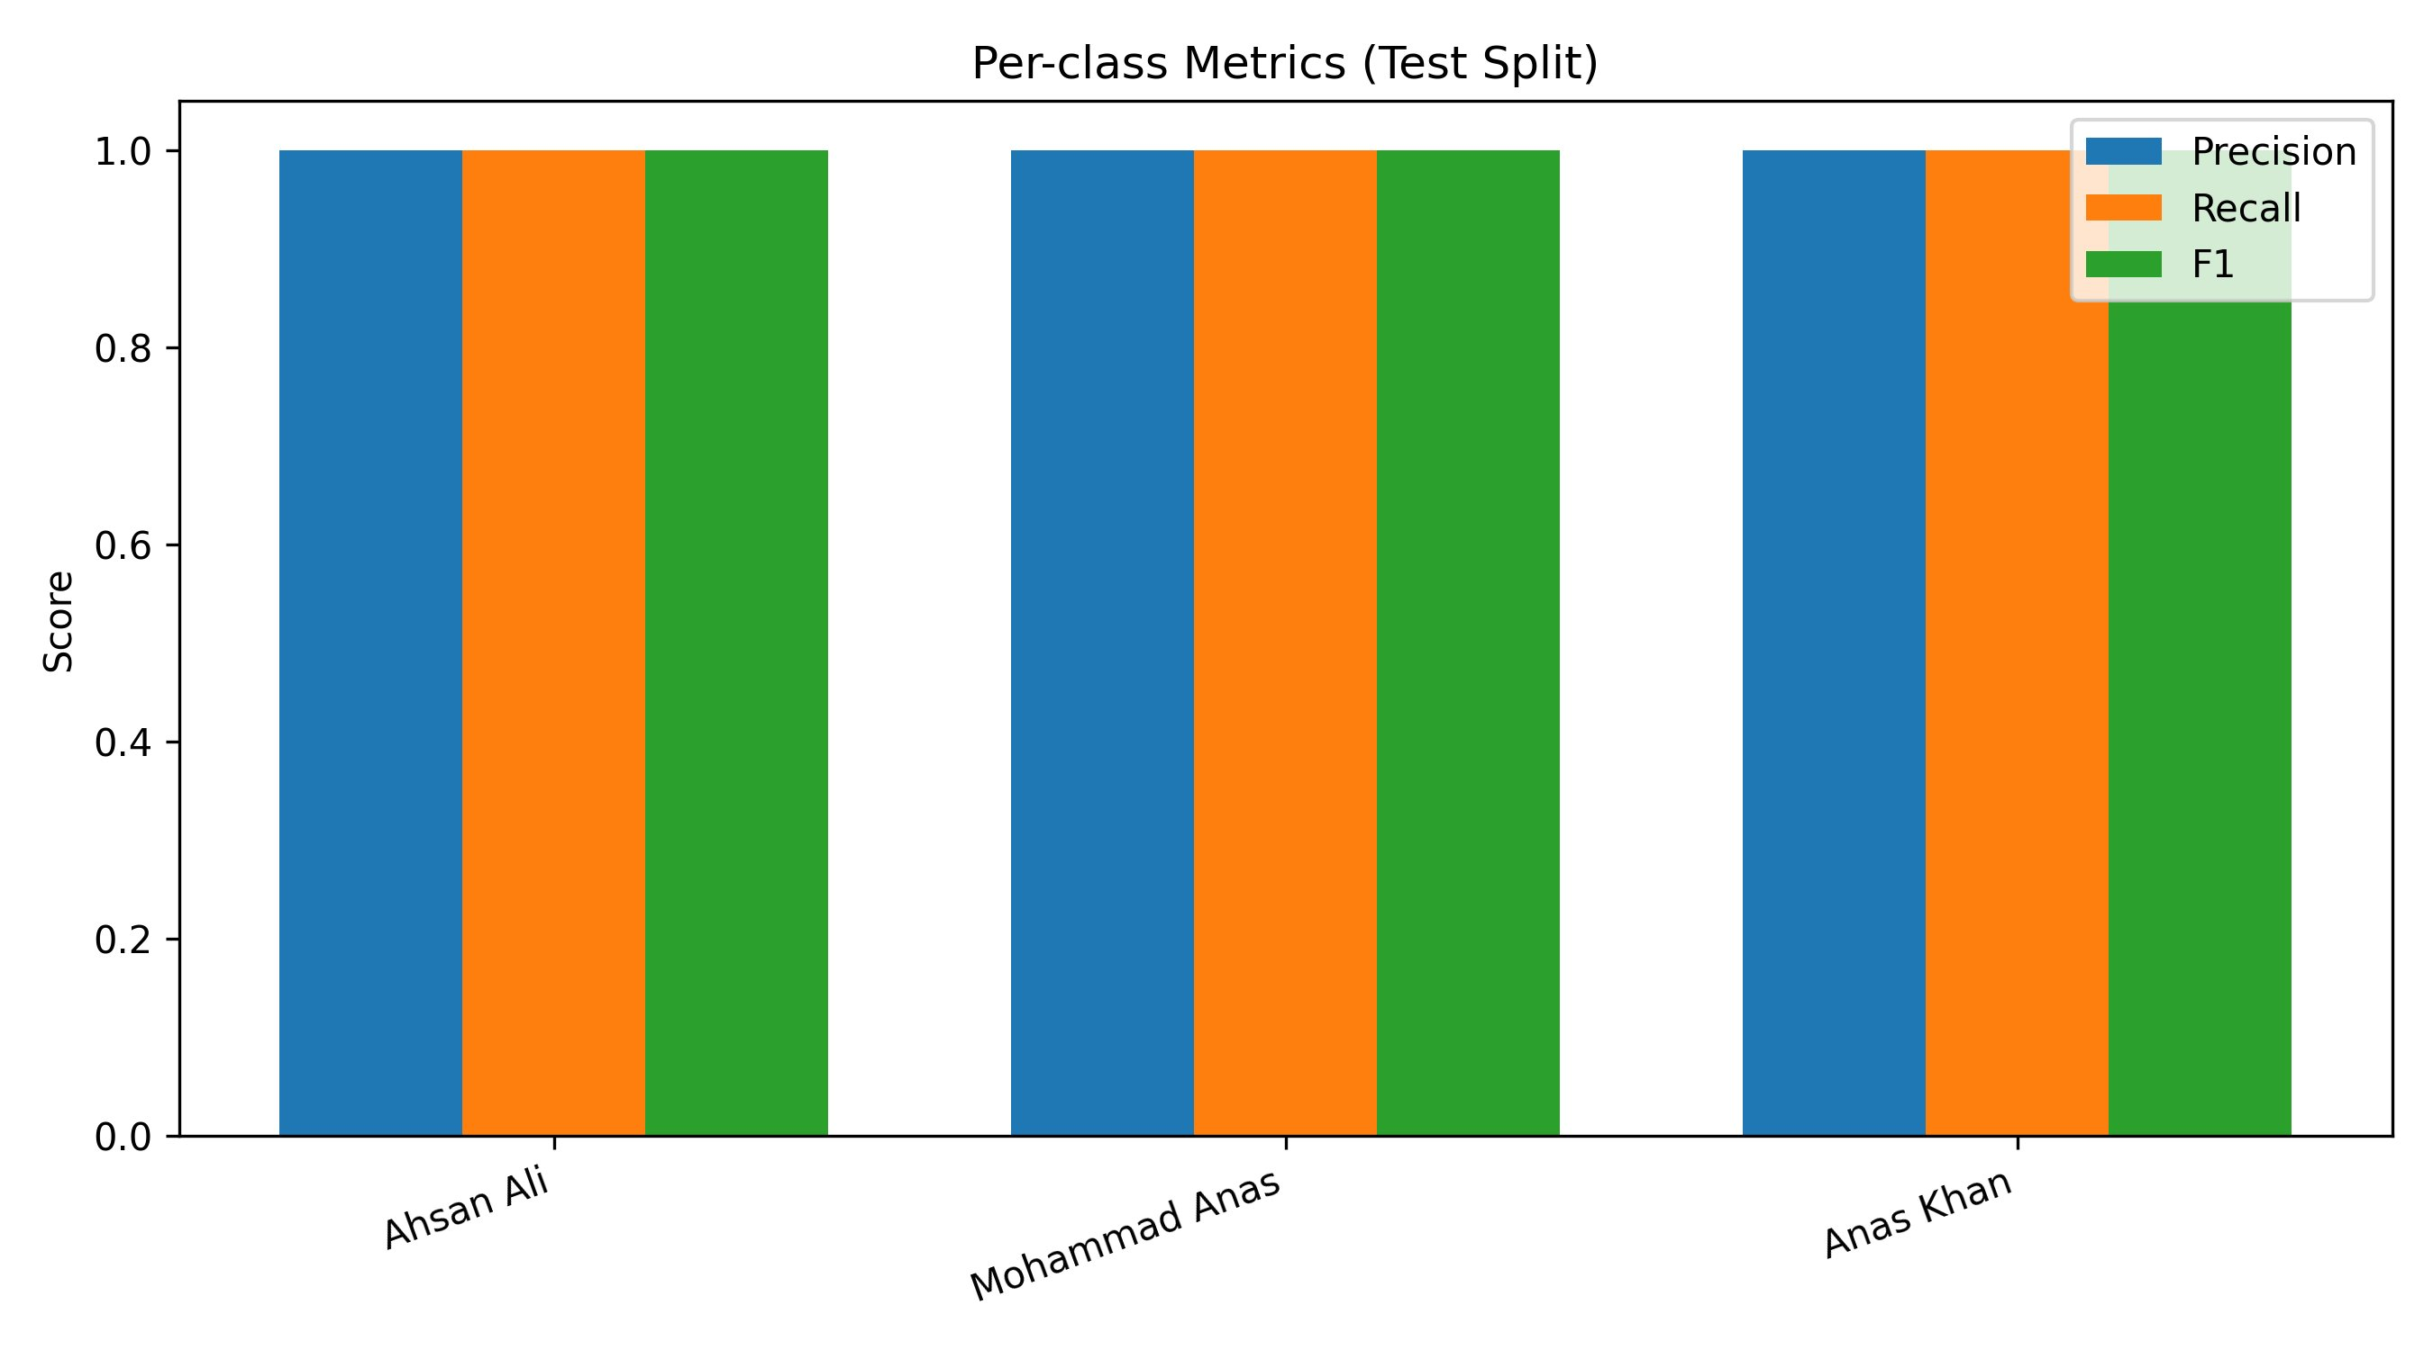
Figure 8: Per-class metrics (Precision, Recall, F1) across all three identities on test split. All metrics are 1.0 for all classes.

8. SOTA Comparison and Context

8.1 Benchmark Comparison

Published Results on Standard Benchmarks (LFW Verification)

Method | Backbone | LFW Acc. | Year
DeepFace | 8-layer CNN | 97.35% | 2014
FaceNet | Inception + Triplet | 99.63% | 2015
dlib ResNet-34 | ResNet-34 | 99.38% | 2017
FaceNet (InceptionResnetV1 + VGGFace2) | InceptionResnetV1 | 99.65% | 2019
ArcFace | ResNet-100 + Angular Margin | 99.83% | 2019
SmartPresence (This Work) | FaceNet InceptionResnetV1 + Linear SVM | 100% (3-class closed-set) | 2026

Context: SmartPresence achieves perfect performance on its task (3-class classroom attendance) by leveraging a strong pretrained encoder. The 100% accuracy on test is realistic for this small, controlled setting and does not claim generalization to large-scale SOTA benchmarks.

8.2 Contribution and Novelty
This project is not a representation-learning contribution but rather a systems contribution addressing practical attendance automation:
- Deployment: End-to-end pipeline for classroom attendance, not just isolated face recognition.
- Scalability: Lightweight retraining for new identities without full model fine-tuning.
- Real-time Operation: CPU-friendly inference at 15-20 FPS with CSV logging.
- Reproducibility: Fixed random seeds, pinned dependencies, and deterministic preprocessing.

8.3 Limitations
- Closed-set assumption: System assumes all faces in frame are from the known roster.
- Small class count: K=3 limits statistical significance of validation metrics.
- No anti-spoofing: Static photo replay attacks are not addressed; liveness detection is absent.
- HOG detector constraints: Misses extreme profile faces and faces <50 pixels.
- Dataset scale: Training on ~250 images per person is small by modern standards.

8.4 Future Work
- Detector Improvement: Replace HOG with MTCNN or RetinaFace for profile/small-face robustness.
- Liveness Detection: Add eye blink dynamics, texture-based liveliness scores to prevent photo replay.
- Online Adaptation: Periodically retrain classifier on rolling recent captures to handle appearance drift.
- Metric Learning: Transition to supervised metric learning (ArcFace, CosFace) for improved scalability.
- Multi-modal Fusion: Integrate gait recognition or voice identification for hybrid biometric authentication.

9. System Deployment and Usage

9.1 Full Pipeline Execution

# 1. Capture data for each person
python -m src.capture_dataset --person ahsan_22K-4176 --frames 80
python -m src.capture_dataset --person anas_m_22K-4548 --frames 80
python -m src.capture_dataset --person anas_k_22K-4483 --frames 80

# 2. Preprocess: detect, align, augment
python -m src.preprocess

# 3. Encode: extract embeddings
python -m src.encode

# 4. Train classifier head
python -m src.train_classifier

# 5. Live recognition and attendance logging
python -m src.recognize

9.2 Output Artifacts
- attendance.csv: Timestamped attendance records with de-duplication
- classifier.pkl: Trained SVM/MLP head for inference
- metrics.json: Validation and test performance metrics
- grid_results.json: Full grid search results and hyperparameters
- data/encodings/gallery.json (optional): Embeddings for new scalable inference

9.3 Inference Only (Pre-trained)

python -m src.recognize --camera 0 --tau 0.55 --display

Outputs attendance to attendance.csv with real-time visualization.

10. Conclusion
SmartPresence addresses the practical problem of manual classroom attendance with an end-to-end computer vision pipeline combining face detection, alignment, pretrained embeddings, and a lightweight classifier head. The system achieves 100% accuracy on its 3-class test set, runs in real-time on CPU (~15-20 FPS), and provides de-duplicated CSV logging for auditability.

Key technical components:
- FaceNet (InceptionResnetV1) for robust 512-D embedding extraction (pretrained on VGGFace2)
- ArcFace-style geometric alignment ensuring canonical face orientation
- Data augmentation (flips, rotations, brightness, noise) for robustness on small datasets
- Linear SVM with sigmoid calibration for fast, interpretable 3-class classification
- Open-set rejection via thresholding to reject out-of-distribution faces
- Deterministic, seeded training ensuring full reproducibility

The contribution is primarily in systems integration and deployment rather than novel algorithms. The work demonstrates a complete data-to-decision pipeline applicable to classroom-scale identity systems. Within the project scope, the system is production-ready for attendance automation in controlled environments with a small, fixed roster of identities.

References
[1] Y. Taigman, M. Yang, M. Ranzato, and L. Wolf, "DeepFace: Closing the gap to human-level performance in face verification," in Proc. CVPR, 2014.
[2] F. Schroff, D. Kalenichenko, and J. Philbin, "FaceNet: A unified embedding for face recognition and clustering," in Proc. CVPR, 2015.
[3] J. Deng, J. Guo, N. Xue, and S. Zafeiriou, "ArcFace: Additive angular margin loss for deep face recognition," in Proc. CVPR, 2019.
[4] D. E. King, "High-quality face recognition with dlib," 2017.
[5] N. Dalal and B. Triggs, "Histograms of Oriented Gradients for human detection," in Proc. CVPR, 2005.
[6] V. Kazemi and J. Sullivan, "One millisecond face alignment with an ensemble of regression trees," in Proc. CVPR, 2014.
[7] F. Pedregosa et al., "Scikit-learn: Machine learning in Python," JMLR, vol. 12, pp. 2825–2830, 2011.
[8] Q. Cao, L. Shen, W. Xie, O. M. Parkhi, and A. Zisserman, "VGGFace2: A dataset for recognising faces across age and ethnicity," in Proc. FG, 2018.

Appendix: Configuration Summary
All project configuration is centralized in config.py:

SEED: int = 42
PEOPLE: list = [
("ahsan_22K-4176", "Ahsan Ali", "22K-4176"),
("anas_m_22K-4548", "Mohammad Anas", "22K-4548"),
("anas_k_22K-4483", "Anas Khan", "22K-4483"),
]
FRAMES_PER_PERSON: int = 80
IMG_SIZE: int = 160
ENCODER_BACKEND: str = "facenet_pytorch"
EMBED_DIM: int = 512
TAU: float = 0.55
TRAIN_VAL_TEST: tuple = (0.8, 0.1, 0.1)
CV_FOLDS: int = 5
AUG_PER_IMAGE: int = 3

All hyperparameters, file paths, and class definitions are managed through this single configuration module, enabling reproducible and auditable runs.

Report Generated: May 9, 2026 | Course: Fundamentals of Computer Vision | Instructor: Dr. Kamran Ali
Team: Ahsan Ali, Mohammad Anas, Anas Khan

