*The code attached with the submission generates the MSF Image on the fly and does further operation on detection of letters using that MSF Image. Thus, the original image, template image and the ground truth file need to be passed along with the executable.*

* **Steps used to arrive at the Thinned Image:**

1. After detecting the letter e from the MSF image using the ground truth locations a binary image of size 9*15 was created.
2. This binary image was created by running a 9*15 window over the original image using the ground truth locations. In the binary image, a value of 0 was assigned to the pixels with value in the parent image above 128 and a value of 255 was assigned to the pixels having a value below 128.
3. An inflated binary image was then created which was padded with an extra row and extra column on both sides for edge handling. The deflated binary image is as shown below.

Figure 1 Binary image showing letter 'b'

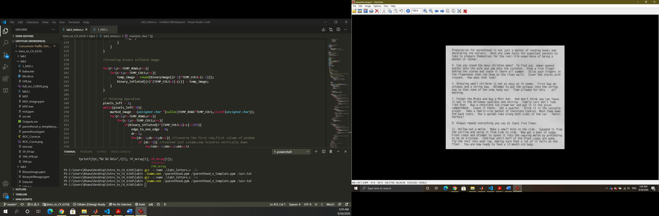

Figure 2 Parent Image

1. As can be seen above, the letter that gets identified at the threshold of 192 is ‘b’ whereas the template image is of the letter ‘e’. This is why a next set of operation was done which is called thinning to improve upon the initial results.
2. The first operation performed was a cyclic traversal around the image centered at the current row and column number. This was done to identify the number of edge to non edge transitions within that pixel.
3. The second operation was to check for total number edge neighbors around the pixel which had a value of 255.
4. The third operation was to check for the number of empty pixels that does not contain the outline of the letter in North or East or (South and West) directions.
5. If edge to non edge was equal to 1 and the edge neighbors lied between 2 and 6 and if there were empty pixels adjacent to the pixel, then the pixel is marked for erasure.
6. This operation was done until no more pixels were left for erasure. The thinned image of the letter ‘b’ looks like as shown below. It can be seen that some of the pixels get marked black or get erased after the operation.

Figure 3 Thinned Image

1. After thinning, we check for edge to non edge transitions again using clockwise traversal around the pixel. If there is exactly one edge to non edge transition the pixel is considered an endpoint. If there are more than two edge to non edge then the pixel is considered as a branchpoint.
2. This was done for all the letters and the number of true positive and false positive was counted. The letter was considered detected if it had exactly one endpoint and one branchpoint else it was undetected.

* **ROC Curve**

ROC curve is the plot of False Positive Rate vs True Positive Rate which is a measure of how well the algorithm detected a certain template (letter ‘e’) in the image.

The full 0-to-255 range of values was considered for the threshold to observe the evolution of the ROC curve as the threshold gets closer to 255. After obtaining the TP, FP, TN, and FN values the True Positive Rate and the False Positive Rate were calculated as:

The ideal point would be where the True Positive Rate is 1 and False Positive Rate is 0. This would indicate that the algorithm did not misclassify any detections.

However, that is only an ideal case. To obtain the point closest to FPR=0 and TPR=1 which is the “Knee of Curve”, the Euclidean distance was calculated as follows:

$$Distance=\sqrt{({\left(TPR-1\right)}^{2}}+\left(FPR-0\right)^2)$$

$$Best Distance=minargwhere distance$$

|  |  |  |  |  |  |
| --- | --- | --- | --- | --- | --- |
| *Threshold* | *Best Distance* | *Best TPR* | *Best FPR* | *TP Count* | *FP Count* |
| **200** | **0.0515** | **0.9536** | **0.0225** | **144** | **25** |

The results from last time are as follows:

|  |  |  |  |  |  |
| --- | --- | --- | --- | --- | --- |
| *Threshold* | *Best Distance* | *Best TPR* | *Best FPR* | *TP Count* | *FP Count* |
| **208** | **0.0707** | **0.9603** | **0.0585** | **145** | **65** |

The marked image is as shown below:

