**Designing view:**

The main idea of this page is to view the latest products and the release notes for the main changes / updates in products.

This page is containing two tabs, first one is for showing products and the other one is to show release notes.



The products tab designed to show products. In addition, it contains right side-bar to view the latest posts.

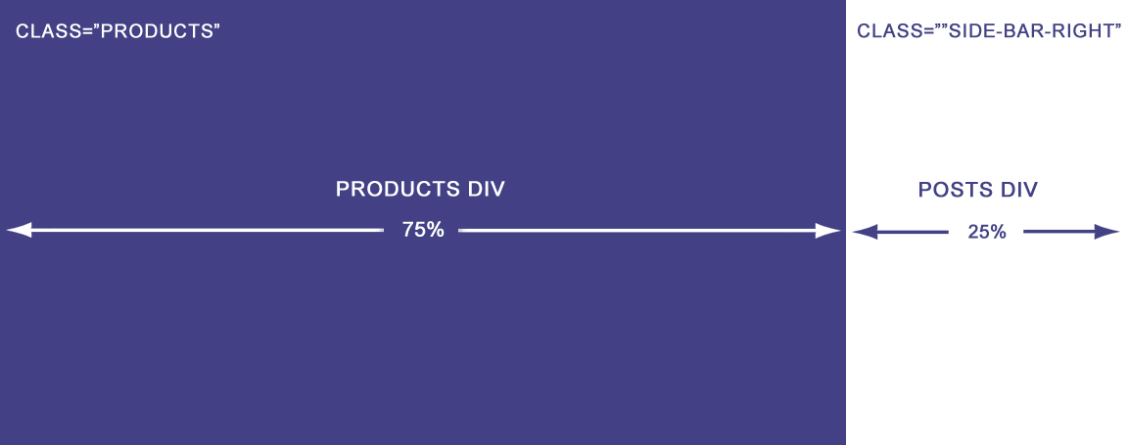

Every row of products div contains two products and every product have:

1- Image: (all products images should have the same dimensions).

2- Title

3- Review stars, and review text (number of reviews and if there is no reviews will show (new!)).

4- Two buttons:

4-1- try it for free :( to download the product for a trial period)

4-2- screenshots: (will open images modal to view images of the product)

P.S – products stars div contains four images of stars with these variants: (full – half – empty)

Every star image have width of 20%. Also the div contains title tooltip shows the stars as number (min=0, max=4)

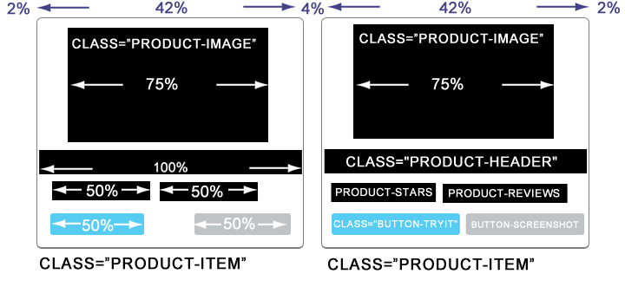

Posts div contains latest posts from the blog and every post have:

1- Background image: (featured image from the post) image size could be any size because I am cropping the image (recommended image larger than 400X400)

2- Title

3 – Read more button: to open the post full description page.

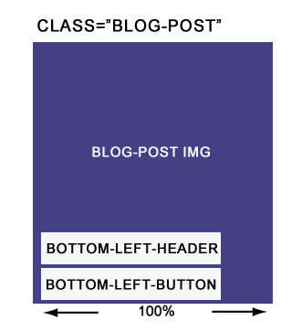

**Coding view:**

The main structure of this page is the tabs:

<label for="tab1">Products</label>

<label for="tab2">Changelog</label>

And the content is separated in two sections:

<section id="content1"></section> //content for products tab

<section id="content2"></section> // content for change-log tab

Products tab have two divs :

<div class="products"></div> //75% - float : left

<div class="side-bar-right"></div>//25% - float : right

Product item have this structure:

<div class="product-item" id="#">

<center><img src="product image url"/> </center>

<div class="product-description">

<span class="product-header">Product Title </span><br/>

<div class="product-stars" title="3 stars">

<img src="images/star.png" /> // four images (star , star-empty , star-half)

</div>

<a href="" class="product-reviews"> reviews</a>

<a href="" class="button-tryit">Try it for free</a>

<a href="" class="button-screenshot">ScreenShots</a>

</div>

</div>

Posts item have this structure:

<div class="blog-post">

<img src=" featured image URL from the post” />

<span class="bottom-left-header">post title </span><br/>

<a href="" class="bottom-left-button">Read more</a>

</div>

**Deploying notes:**

This page is available on ( Github pages) throw this link:

<https://anasmezher.github.io/spartez-assesment.io/>

In addition, you can download it from Google drive as .rar file from this link:

<https://drive.google.com/file/d/11W8nqQUBKBkg6rFJiBHTafPEIHsxiMvD/view?usp=sharing>

And you can view the repository from Github using this link :

<https://github.com/anasmezher/spartez-assesment.io>

To deploy this page you have to make sure to update the images and style.css url either by updating the URLs in the code or to put them in the same path (images/ , style/).

Then you have to add index.html file to you site using ftp or c-panel file-manager.

Alternatively, you can add this line to your page head:

<link rel="stylesheet" href="style/style.css">

Then you can add the codes.

P.S: Screenshots button could attached with link to open modal which viewing images as slider or we could make it opening other page as a normal link.

P.S: Change-log tab contains the main changes in every product and it could be as text or text and images/videos.

P.S: We can remove posts side bar by removing the div with class="side-bar-right” and change the width value for class="products" to be 100%.

P.S: We can change the number of products per row by changing the value of width of class="product-item" to be : 100/(number of products wanted).

P.S: We can change the paragraph : <p class="footer"><hr>powered by Spartez</p> with our desired footer.