Implementation and Evaluation of FastSpeech 2 Text-to-Speech Synthesis for English and Telugu
Technical report for the assignment "Implementation of FastSpeech 2-Based Text-to-Speech Synthesis"
Anasmita Bhattacharya, B.Tech Computer Science and Engineering (AI and ML), Vellore Institute of Technology
Application: Intern / Research Assistant (Voice AI), Speech Processing Lab, LTRC, IIIT Hyderabad. 6 November 2026
1. Summary
Two separate FastSpeech 2 models were trained, one for English on Svarah and one for Telugu on IndicTTS Telugu, each with about 5 hours of training audio and 1 hour of validation audio. Both models have 35.1 million parameters and were trained from scratch with the PyTorch implementation by ming024, adapted to current library versions, extended with a Telugu text front end, and run on a free Colab T4 GPU. Speech for the ten assigned test sentences was generated with the final checkpoint (step 15000) of each language, together with duration, pitch and energy plots from the variance adaptor.
The main results are the following.
- The Telugu model produces clearer and more natural speech than the English model. The English output follows the expected rhythm and sentence length, but individual words are hard to recognise and the pitch is almost flat.
- In both languages the validation loss reached its minimum very early (Telugu at step 1000, English at step 4000) and then rose, while training loss kept falling. The rise comes from the pitch and energy terms, which the model memorises. The checkpoint with the lowest validation loss was not the best sounding one, so checkpoints were saved every 1000 steps and compared with objective measurements on held-out sentences and by listening.
- A second training run with a shorter schedule and AdamW weight decay gave small improvements in validation loss at equal steps and half the training time, but did not remove the overfitting. The limit is mainly the amount and quality of data.
2. Implementation approach
2.1 Reference implementation and components used
The implementation starts from the PyTorch FastSpeech 2 repository by ming024 (MIT licence). The model, loss and dataset classes of that repository are used unchanged. The architecture is the standard one:
Component | Setting used
Encoder | 4 feed-forward Transformer blocks, 2 attention heads, hidden size 256, convolution filter 1024 (kernels 9 and 1), dropout 0.2
Speaker input | Learned speaker embedding added to the encoder output (multi-speaker model: 103 speaker groups for English, 2 speakers for Telugu)
Variance adaptor | Three predictors (duration, pitch, energy), each two 1-D convolutions (kernel 3, 256 filters) with layer norm and dropout 0.5. Pitch and energy are predicted per phone and quantised into 256 linear bins that are embedded and added. A length regulator expands every phone by its duration
Decoder | 6 feed-forward Transformer blocks, 2 heads, hidden size 256, dropout 0.2, linear layer to 80 mel bins, convolutional post-net
Loss | L1 on the mel-spectrogram before and after the post-net, MSE on pitch and energy, MSE on log-duration
Vocoder | Pretrained HiFi-GAN (universal), 22.05 kHz, from the reference repository (not retrained)
Audio features | 22.05 kHz, FFT 1024, hop 256 (11.6 ms), window 1024, 80 mel bins from 0 to 8 kHz

2.2 Changes to the reference code
The reference repository pins library versions from 2020 that no longer install, so the code was patched (every change is marked [PATCH] in the source and listed in the README):
- Audio code: keyword arguments for librosa 0.10 and later, removal of hard-coded .cuda() calls so that inference also runs on CPU.
- Float32 casts of pitch, energy and mel targets in the loss and in the batch tools, because the stored feature files are float64 and the loss failed with a dtype error.
- Preprocessor: an explicit train and validation split file, pitch and energy statistics computed on training files only, a fix for a stale-variable bug when an alignment file is missing, explicit sampling rate and utf-8 handling.
- The original train.py, synthesize.py, evaluate.py and prepare_align.py are replaced by shared code in common/: dataset-specific data selection, resumable training with CSV loss logs, a snapshot every 1000 steps, variance-adaptor plots, and a checkpoint evaluation script.
- Optimiser: AdamW (decoupled weight decay) instead of Adam in the final run (section 4).
2.3 Modifications for English
- Svarah has no speaker-ID column. Speakers are approximated by the unique combination of eight metadata columns (gender, age group, primary language, native state, native district, qualification, job category, occupation domain), which gave 103 speaker groups.
- Pronunciation: the LibriSpeech lexicon, with g2p_en for words that are not in it. At inference g2p_en is applied to the whole sentence so that part of speech can decide the stress of heteronyms such as "conduct" (section 6).
- A text normaliser expands times, years and numbers into words (for E4, "10:45 AM on 12 November 2026" becomes "ten forty five a m on twelve november twenty twenty six").
2.4 Modifications for Telugu
- New text front end common/telugu_frontend.py: Telugu spelling is close to phonetic, so a rule table converts script to 47 phones (inherent vowel, vowel signs, virama, geminates written as the phone twice, anusvara as "m"). The 47 phones were added to the symbol table and the Mandarin symbols were removed.
- Numbers, times and ordinals are expanded into Telugu words before conversion (in T4: 2026, 12వ and 10:45).
- A pronunciation lexicon is generated from the corpus text with the same rules, so that the aligner and the model use identical phone sequences.
- Separate Telugu/config.yaml (clips up to 15 s because Telugu utterances are long, two speakers).
Both languages use the same aligner recipe (Montreal Forced Aligner trained on the selected data), the same model and the same training settings, so that differences between the two models come from the data and the language, not from the setup.
3. Data, preprocessing and training configuration
3.1 Data selection and split
 | English (Svarah) | Telugu (IndicTTS Telugu)
Source | ai4bharat/Svarah (Hugging Face), about 9.6 h, 117 speakers, conversational and read speech | SPRINGLab/IndicTTS_Telugu (Hugging Face), studio recordings, 2 speakers
Length filter | 1 s to 12 s (1215 clips too short, 486 too long dropped) | 1 s to 15 s (12 clips too short, 3221 too long dropped)
Speaker filter | Speaker groups with less than 60 s of usable audio removed; 103 groups remain | None removed (2 speakers)
Subsampling | Same fraction of every speaker group's audio, fixed seed 1234 | Same fraction of each speaker's audio, fixed seed 1234
Train / validation selected | 4.99 h (3452 clips) / 1.11 h (748 clips) | 5.00 h (2245 clips) / 1.00 h (459 clips)
Used after alignment and silence trimming | 3.69 h (3437 clips) / 0.82 h (744 clips) | 3.57 h (2228 clips) / 0.72 h (455 clips)
Per speaker (train) | about 2 minutes on average per speaker group | speaker 1: 3.4 h, speaker 0: 1.6 h

The split is made by utterance with a fixed seed, and it is written to a file (split.json) that both the aligner and the feature extractor read, so no utterance appears in both sets. Speakers appear in both sets (the assignment asks for no overlap of data, not of speakers). Some selected hours are lost later because the aligner fails on a few utterances (21 in Telugu) and because leading and trailing silence is trimmed to the aligned phones.
3.2 Preprocessing
Audio is resampled to 22.05 kHz and transcripts are normalised. A lexicon is built for each language and the aligner is trained on the selected data to obtain phone-level alignments. From the alignments the preprocessor computes the duration of each phone, the mel-spectrogram, and phone-level pitch (WORLD/pyworld) and energy. Pitch and energy are normalised with the mean and standard deviation of the training files only. Because the feature files are shared between runs, both training runs described below use identical data.
3.3 Training configuration
Setting | Run 1 (baseline) | Run 2 (final)
Steps | 30000 (English); Telugu stopped at about 8700 by the GPU quota | 15000 (both)
Batch size / grad. clip | 16 / 1.0 | 16 / 1.0
Optimiser | Adam, betas (0.9, 0.98), no weight decay | AdamW, betas (0.9, 0.98), weight decay 0.01
Learning rate | Transformer schedule, 1500 warm-up steps, x0.3 at steps 20000, 25000, 28000 | Same schedule, x0.3 at steps 8000, 11000, 13000
Dropout (encoder, decoder / variance predictors) | 0.2 / 0.5 | 0.2 / 0.5
Validation | every 500 steps, full validation set | every 500 steps, full validation set
Checkpoints | best validation loss and last | best validation loss, last, and a snapshot every 1000 steps
Hardware, time | Colab T4 GPU | Colab T4 GPU; 2.0 h (English), 2.8 h (Telugu)

A third setting was tried first for Telugu (plain Adam with L2 weight decay 0.01 and dropout 0.3). The training loss rose after step 1500 (5.3 at step 5000, against 2.7 at step 2000 in the final run), because in Adam the L2 term is added to the gradient and then rescaled, which makes the pull towards zero very strong. The run was stopped after 5000 steps and restarted from scratch with AdamW and dropout 0.2. Only the restarted run is reported.
4. Training and validation loss analysis
Figures 1 to 4 are the loss plots of the final run (Results/<Language>/training_loss.png and validation_loss.png). Each shows the total loss and its five parts.
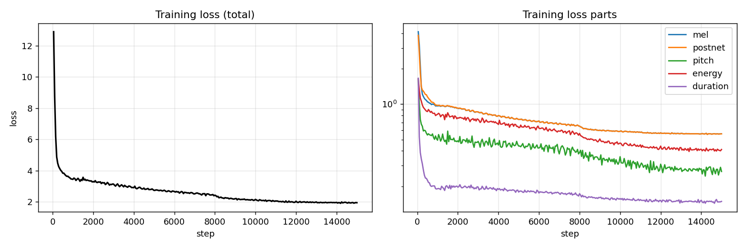
Figure 1. English, training loss (final run).
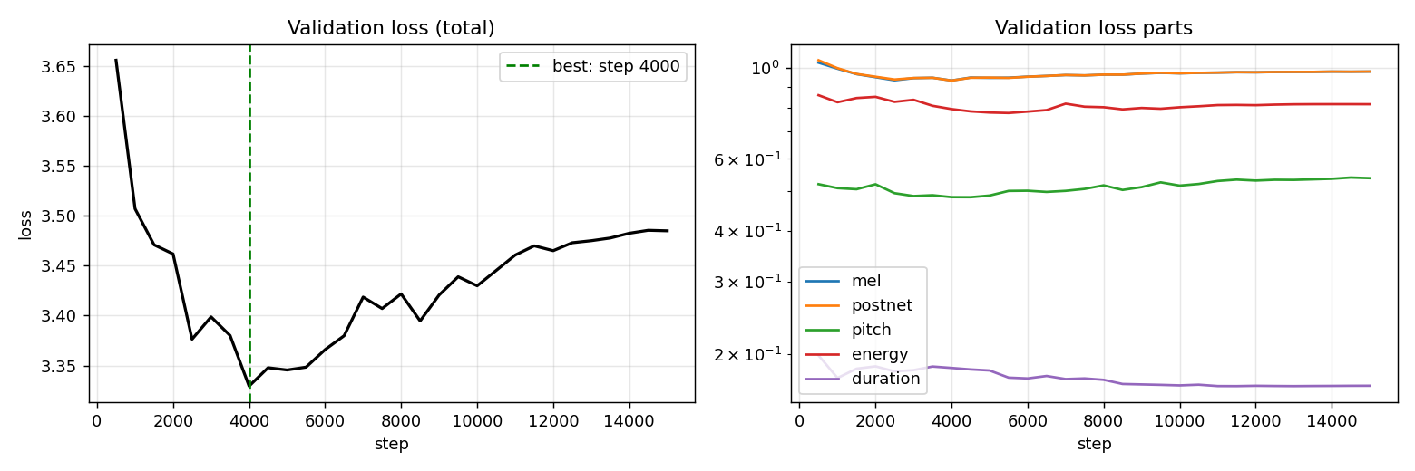
Figure 2. English, validation loss (final run). The dashed line marks the lowest validation loss.
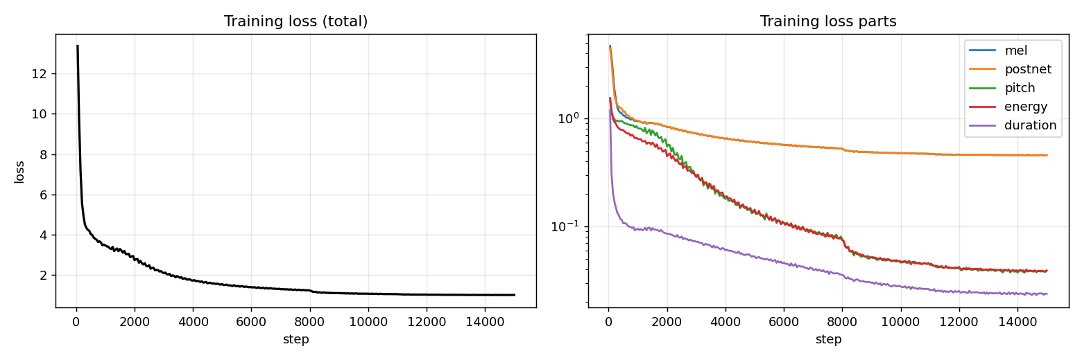
Figure 3. Telugu, training loss (final run).
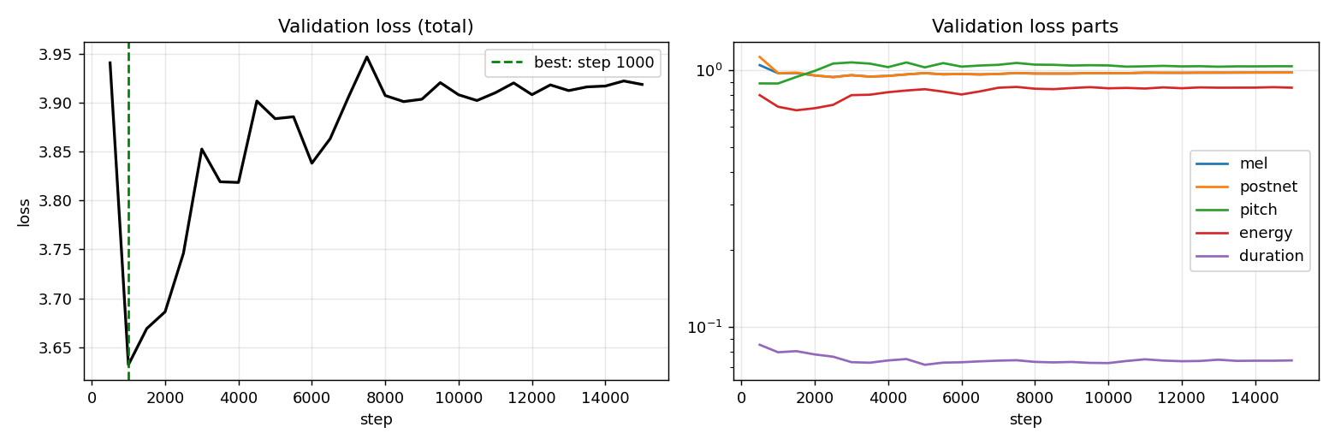
Figure 4. Telugu, validation loss (final run). The dashed line marks the lowest validation loss.
4.1 Convergence
Both models converge quickly and smoothly. The total training loss falls from about 13 to about 4 within the first 500 steps, then decreases steadily; there are no loss spikes in the final run. The steps in the curves at steps 8000 and 11000 are the learning-rate reductions. The duration loss is the smallest part and converges first. At the end of the final run the training loss is 1.95 (English) and 1.02 (Telugu).
4.2 Overfitting
Final run | English | Telugu
Lowest validation total loss (step) | 3.330 (4000) | 3.632 (1000)
Validation total loss at step 15000 | 3.485 | 3.919
Training / validation mel loss at step 15000 | 0.559 / 0.981 | 0.458 / 0.978
Training / validation pitch loss at step 15000 | 0.267 / 0.538 | 0.039 / 1.035
Training / validation energy loss at step 15000 | 0.412 / 0.817 | 0.039 / 0.854
Validation duration loss: lowest / at step 15000 | 0.167 / 0.167 | 0.074 / 0.074

The validation loss is lowest early and then rises in both languages, while the training loss keeps falling. The rise is caused by the pitch and energy terms. In Telugu the training pitch and energy losses go down to 0.04, but on validation sentences the pitch loss goes up to 1.04. Pitch and energy are normalised to unit variance, so a loss of about 1.0 is what a constant prediction would give; the predictor is then no better than the mean for unseen sentences. The mel loss on validation stays around 0.95 to 0.98 and does not improve after the first few thousand steps, while the training mel loss keeps decreasing. Only the duration prediction keeps improving on validation data (Telugu 0.080 at step 1000, 0.074 at step 15000).
With only 3.6 hours of Telugu audio from two speakers, and 3.7 hours of English audio shared among 103 speaker groups, the variance predictors can memorise the pitch and energy of the training utterances. English shows the same pattern with a smaller gap, because its pitch and energy targets are noisier and the model already fits them less closely.
4.3 Run 1 against run 2
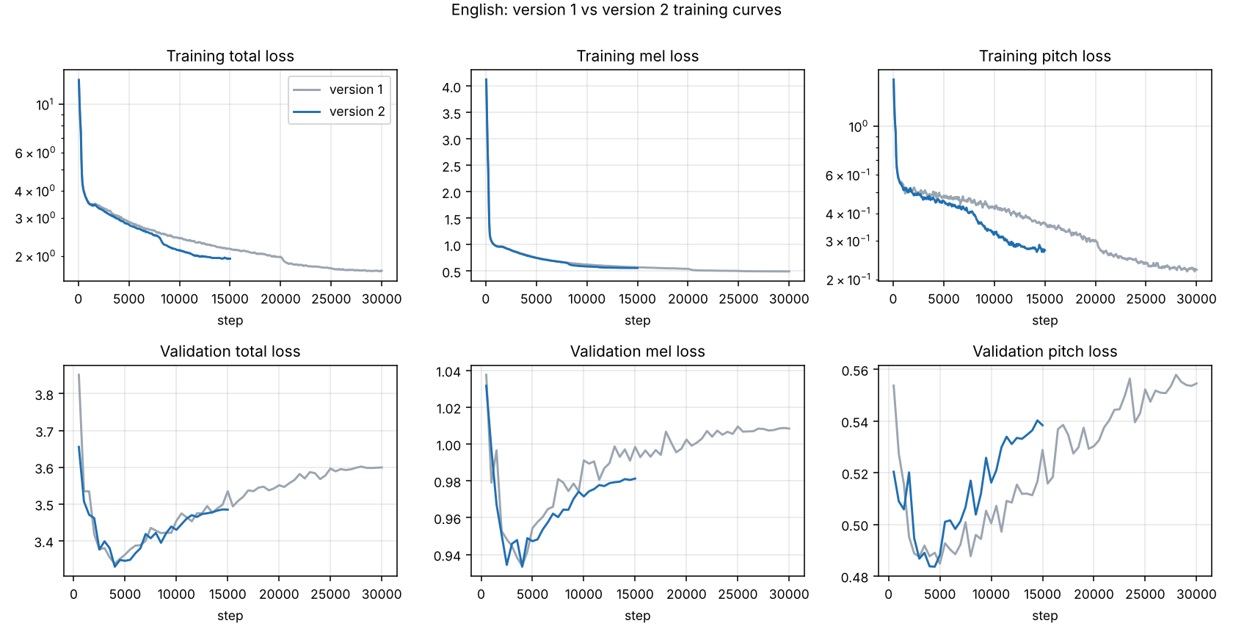
Figure 5. English, run 1 (grey, 30000 steps) and run 2 (blue, 15000 steps). Top row: training loss, bottom row: validation loss.
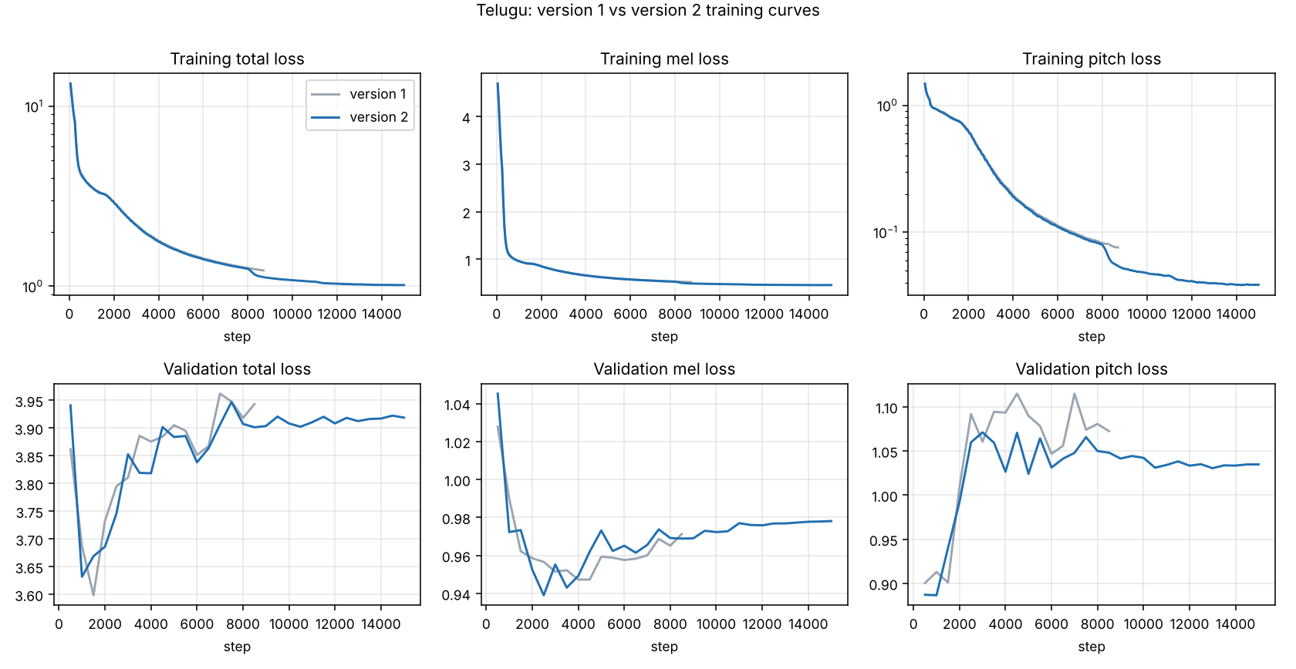
Figure 6. Telugu, run 1 (grey, stopped at about step 8700) and run 2 (blue, 15000 steps).
Validation total loss | English run 1 | English run 2 | Telugu run 1 | Telugu run 2
Lowest (step) | 3.338 (4000) | 3.330 (4000) | 3.599 (1500) | 3.632 (1000)
At step 8500 | 3.421 | 3.395 | 3.943 | 3.901
At step 15000 | 3.535 | 3.485 | not reached | 3.919
At last step | 3.600 (30000) | 3.485 (15000) | 3.943 (8500) | 3.919 (15000)

At equal steps run 2 has a slightly lower validation loss in most cases, and its final English validation loss (3.485) is lower than that of run 1 after 30000 steps (3.600), with half the training time. The differences are small, and the early minimum and the later rise are the same in both runs, so the regularisation did not remove the overfitting.
5. Checkpoint selection
Since the lowest validation loss comes from the early steps, it was checked whether that checkpoint is also the best sounding one. In run 1 it was not: for Telugu, the checkpoint at step 8000 sounded clearly better than the "best" one at step 1500, and for English the last checkpoint (step 30000) was better than the "best" one at step 4000. A spectrogram comparison of the two Telugu checkpoints shows why: the step 8000 spectrograms have sharper harmonic lines and clearer gaps between words, while step 1500 is smeared with horizontal noise bands.
In run 2 a snapshot was saved every 1000 steps, and each snapshot was scored on 160 held-out validation sentences with the full text-to-speech path (everything predicted from the text, no true durations). The scores are the distance between the generated and the real mel-spectrogram after dynamic time warping (lower is better), the mean duration error in frames (1 frame is 11.6 ms), the ratio of generated to real length, and the correlation of predicted pitch and energy with the real ones.
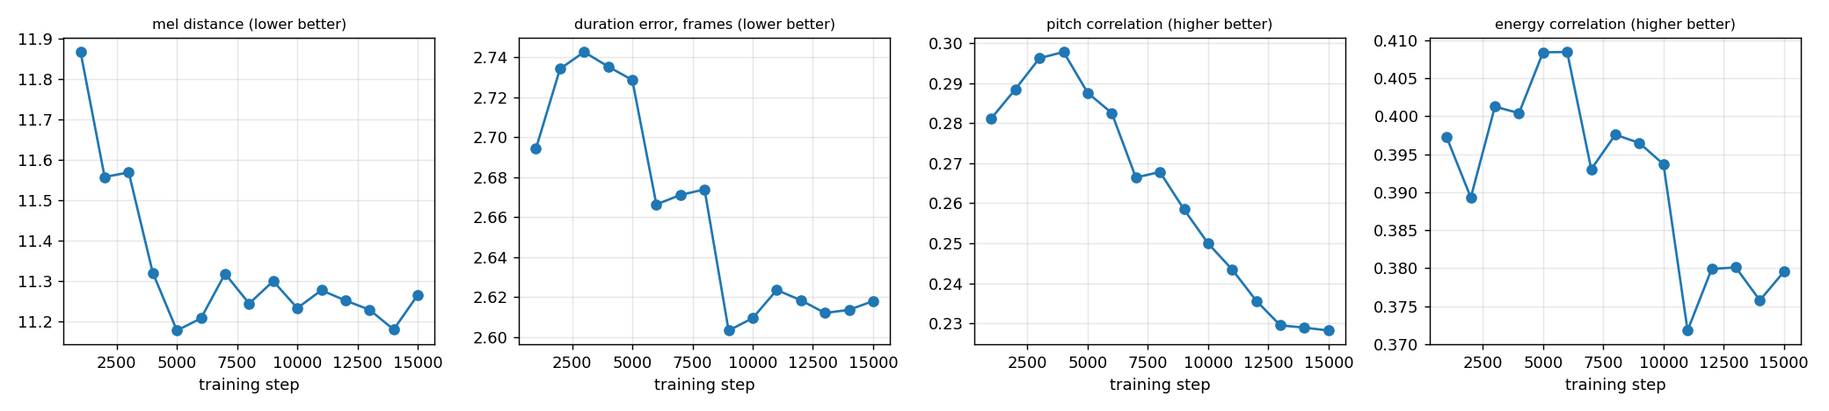
Figure 7. English, scores of every snapshot on held-out validation sentences.
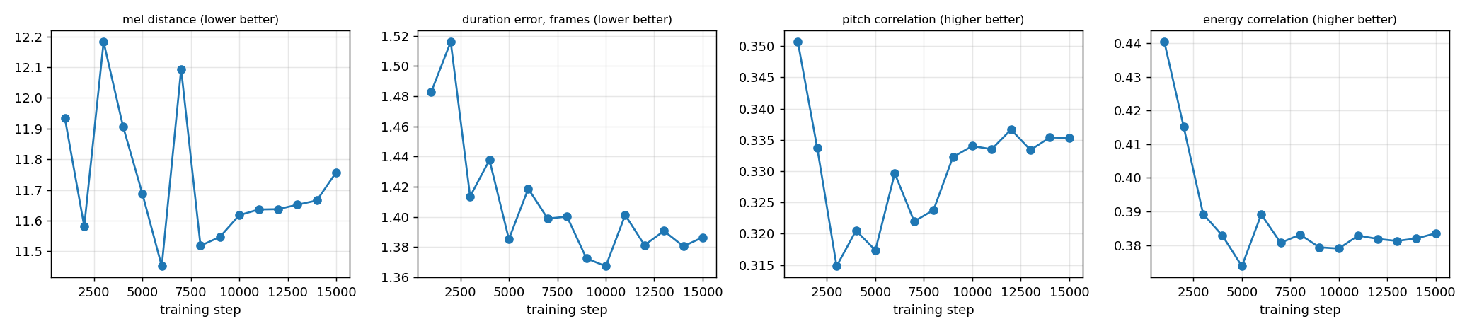
Figure 8. Telugu, scores of every snapshot on held-out validation sentences.
Snapshot | Mel distance | Duration error (frames) | Pitch corr. | Energy corr.
English step 1000 | 11.87 | 2.69 | 0.28 | 0.40
English step 5000 (best mel distance) | 11.18 | 2.73 | 0.29 | 0.41
English step 15000 (final) | 11.26 | 2.62 | 0.23 | 0.38
Telugu step 1000 | 11.94 | 1.48 | 0.35 | 0.44
Telugu step 6000 (best mel distance) | 11.45 | 1.42 | 0.33 | 0.39
Telugu step 15000 (final) | 11.76 | 1.39 | 0.34 | 0.38

Three things follow from these scores. First, the spread between snapshots is small (mel distance 11.2 to 11.9 in English, 11.5 to 12.2 in Telugu), so the score is a coarse tie-breaker and not a ranking of audio quality. Second, the duration predictor is good in both languages: the mean error is 1.4 frames (16 ms) in Telugu and 2.6 frames (30 ms) in English, and the generated length is within a few percent of the real length. Third, pitch and energy prediction is weak: the correlation with the real values is only 0.2 to 0.4, and the English pitch correlation drops from 0.30 at step 4000 to 0.23 at step 15000, which is the memorising seen in the loss curves.
The score preferred step 5000 for English and step 6000 for Telugu. The final checkpoint was chosen after listening to the candidates: step 15000 in both languages. For English, the generated test sentences from step 5000 had a flat, continuous voiced hum (voiced in 98 to 100% of frames, pitch standard deviation of 7 to 21 Hz); step 2000 had more pitch movement (22 to 29 Hz) but was less clear, and step 15000 was judged the clearest. For Telugu, step 15000 sounded like a slightly clearer version of step 6000 without the stretched vowels. The outputs of the checkpoint preferred by the score are kept in Results/<Language>/extra/.
6. Observations on the generated speech
Audio for the ten test sentences is in Results/<Language>/test_generated_audios/, generated with the speaker that has the most training data (English spk013, Telugu speaker 1). The sentences were used as printed in the assignment, except that the stray gaps in E3 ("rhyth m") and T3 (a gap inside అడవిలో) were removed. Measured values for each sentence are given in the table; they come from the predicted phone-level contour and from a pitch tracker run on the generated audio.
ID | Length (s) | Phones | Predicted F0 mean / sd (Hz) | Audio F0 sd (Hz) | Voiced frames
E1 | 5.5 | 87 | 131 / 8 | 18 | 92%
E2a | 3.6 | 51 | 132 / 7 | 15 | 99%
E2b | 3.8 | 56 | 135 / 9 | 20 | 96%
E3 | 2.6 | 37 | 134 / 11 | 28 | 100%
E4 | 5.9 | 81 | 139 / 7 | 12 | 99%
T1 | 4.6 | 66 | 193 / 33 | 38 | 100%
T2a | 2.3 | 31 | 194 / 21 | 27 | 97%
T2b | 2.3 | 37 | 186 / 27 | 33 | 98%
T3 | 2.0 | 31 | 196 / 32 | 37 | 97%
T4 | 7.2 | 120 | 188 / 24 | 30 | 100%

6.1 English
The English speech has the correct length and rhythm for every sentence, and the stress pattern of the phone sequences is carried by the duration predictor. Words are, however, not reliably recognisable. The speech sounds like muffled babble with little pitch movement: the audio is voiced in 92 to 100% of the frames and the standard deviation of the pitch is only 12 to 28 Hz, where the real recordings in the data vary by 24 to 68 Hz, and there are no clear pauses between words. An automatic speech recogniser (Whisper small) gave an error rate of 1.0 on generated validation sentences of the first run, even when the model was given the true durations, pitch and energy, while the real recordings passed through the same vocoder were recognised well, which shows that the vocoder and the feature pipeline are not the cause.
Sentence by sentence (front-end output and measured values):
- E1 (5.5 s). The very long word "antidisestablishmentarianism" is converted to 28 phones by the dictionary and g2p_en and is the sentence with the lowest voiced fraction (92%). The generated speech has the right overall length, but the word itself is not recognisable.
- E2a and E2b. These test the heteronym "conduct". With context-aware g2p_en the noun in E2a and the verb in E2b get different stress (noun K AA1 N D AH0 K T, verb K AA0 N D AH1 K T), and plain dictionary lookup gives both the noun form. The predicted durations follow the noun stress (stressed first vowel 93 ms, against 58 ms for the reduced first vowel in the verb), but the verb's stressed second vowel is short (46 ms), so the contrast is only partly realised.
- E3 (2.6 s). "rhythm" is converted correctly to R IH1 DH AH0 M, with a long final M (128 ms). Its audio has the largest pitch variation of the English sentences (F0 sd 28 Hz), and the predicted energy collapses for four phones near the end (section 7).
- E4 (5.9 s). The time and date are expanded to words ("ten forty five a m on twelve november twenty twenty six"). The unknown name "andaroo" is converted by letter-to-sound rules to AE0 N D AA1 R OW0 (final OW0 instead of a long u). A single 58 ms pause is inserted at the comma, and the numbers are the only part where the pitch is not clearly flat.
6.2 Telugu
The Telugu speech is clearer than the English one. It has more pitch movement (audio F0 sd 27 to 38 Hz, against 51 to 62 Hz for real recordings of the validation set), the sentence lengths are within about 3% of the real recordings of the validation set, and the spectrograms show clear harmonics and gaps between words. It is still muffled, and it is voiced in 97 to 100% of the frames where real speech is voiced in 74 to 82%, so short pauses and unvoiced consonants are not rendered cleanly. Earlier checkpoints stretched vowels; the final checkpoint does this less. The Telugu output has not been rated by a native speaker, so statements about pronunciation are limited to clarity, rhythm and the measured values.
- T1 (4.6 s). The long loanword న్యూరోఫార్మకోలాజికల్ is converted to 21 phones by rule; the predicted pitch rises from 157 Hz to a peak of 281 Hz on a long vowel, the highest of the Telugu set.
- T2a and T2b. The word పట్టు (grip in T2a, silk in T2b) has the same phones (p a tt tt u) in both sentences, and the predicted durations of the word are almost the same (35 and 70 ms for the geminate in both). The model, like any text-to-speech system without word-sense information, renders both senses with the same pronunciation, which is correct. The two sentences differ only through the surrounding words, with overall pitch means of 194 Hz (T2a) and 186 Hz (T2b).
- T3 (2.0 s). The pitch peaks at 269 Hz on a vowel of the first word పులి, which is also the longest phone (151 ms), and then falls to 128 Hz at the end.
- T4 (7.2 s). All three numbers are expanded to words: 2026, 12వ and 10:45 become 120 phones in total for the sentence. A 58 ms pause is inserted near the end of the sentence. Without the normaliser (section 6.3) the sentence has only 83 phones.
6.3 Normalisation and pronunciation experiments
Two small experiments were run with the checkpoint that the score preferred (English step 5000, Telugu step 6000). (1) For English, plain dictionary lookup instead of context-aware g2p_en gives the same pronunciation for the noun and the verb "conduct". (2) With number and time normalisation switched off, the numbers in English E4 are not expanded to words and the phone sequence changes from 81 to 79 phones. In Telugu, the same switch shrinks the T4 phone sequence from 120 to 83 phones, so the three numbers are not spoken as words. This is why a language-specific front end matters more for Telugu, where no existing converter handles digits. The outputs are in extra/no_normalisation and extra/plain_dictionary.
7. Variance adaptor analysis
For each test sentence the variance adaptor predicts a duration, a pitch value and an energy value for every phone. The plots are in Results/<Language>/variance_adaptor_plots/{duration,pitch,energy}/, one file per sentence, and the numbers are in variance_adaptor_values.json. Durations are multiples of the 11.6 ms frame, so the shortest phones are 23 ms (2 frames), and pauses appear only at punctuation. Pitch is shown in Hz after undoing the normalisation.
7.1 General patterns
- Duration. Vowels and fricatives are the longest phones (S, SH, CH, Z of 90 to 140 ms in English; long vowels of 150 to 185 ms in Telugu) and stops and short function-word vowels are the shortest (35 to 46 ms). The duration error against the real utterances is small (section 5), so this is the best predicted of the three variances.
- Pitch. English contours are almost flat: the sentence means are 131 to 139 Hz, the standard deviation is 7 to 11 Hz, and the range is about 120 to 170 Hz. They start slightly high and decline towards the end of the sentence (E3 falls from 157 Hz at the start to 127 Hz at the end). The Telugu contours are much wider (standard deviation 21 to 33 Hz, range 116 to 281 Hz), with peaks of 239 to 281 Hz and final values of 116 to 173 Hz.
- Energy. Predicted energy changes sharply between neighbouring phones and is the least stable of the three. In English it falls to below 10 for runs of several phones in the middle of words, which is probably where the audio becomes muffled or inaudible. In Telugu the energy stays higher and varies with the vowel and consonant type.
7.2 Per sentence
E1. 87 phones, 5.5 s. Pitch starts at 142 Hz, peaks at 160 Hz on phone 4 (N) and ends at 129 Hz (range 123 to 160 Hz). The longest phone is SH (number 17) at 128 ms. Predicted energy is below 10 for the runs M M UW1 (255 ms); IH1 D ER0 AH0 (221 ms).
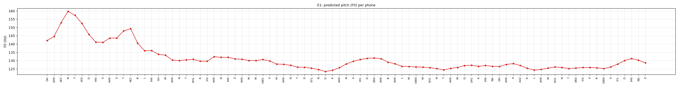
Figure 9. E1, predicted pitch (F0) per phone.
E2a. 51 phones, 3.6 s. Pitch starts at 134 Hz, peaks at 150 Hz on phone 10 (AH0) and ends at 120 Hz (range 120 to 150 Hz). The longest phone is S (number 51) at 151 ms. Predicted energy stays above 10 throughout. In the noun "conduct" the stressed first vowel AA1 lasts 93 ms with energy 81; the second vowel is AH0.
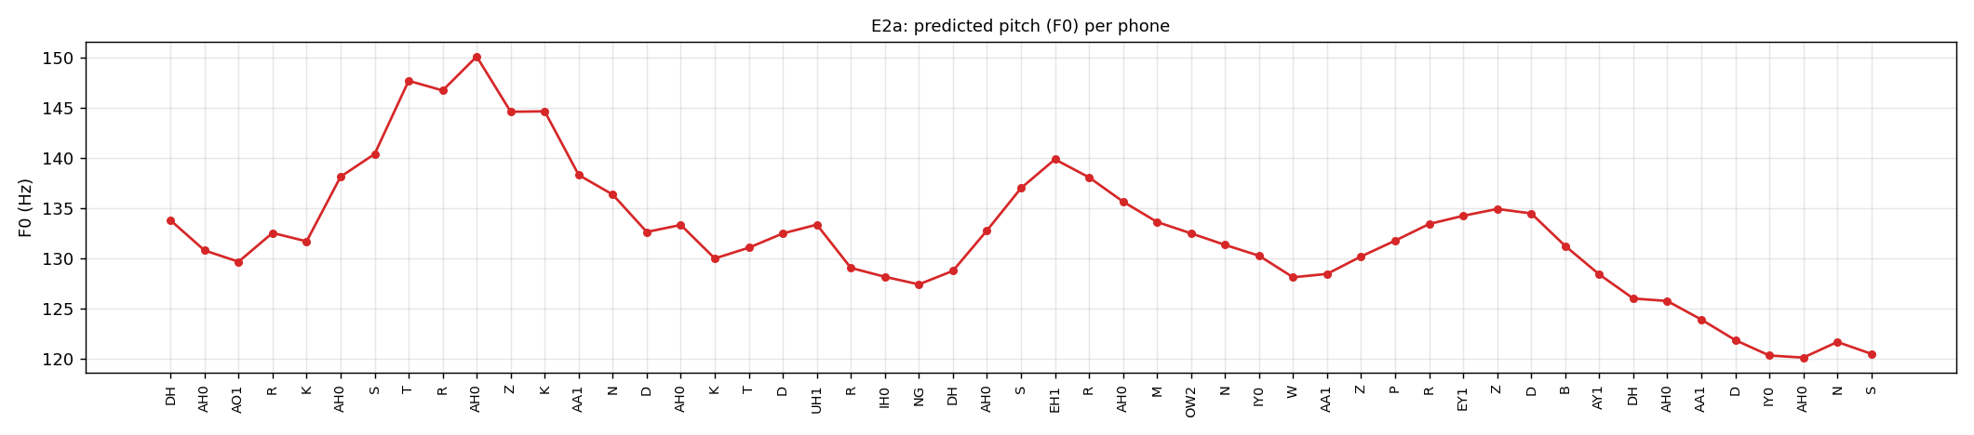
Figure 10. E2a, predicted pitch (F0) per phone.
E2b. 56 phones, 3.8 s. Pitch starts at 152 Hz, peaks at 170 Hz on phone 11 (IH1) and ends at 129 Hz (range 127 to 170 Hz). The longest phone is CH (number 7) at 116 ms. Predicted energy is below 10 for the runs L Y (128 ms); AH0 D (128 ms). In the verb "conduct" the first vowel is the reduced AA0 (58 ms, energy 45) and the stress falls on AH1, which lasts only 46 ms.
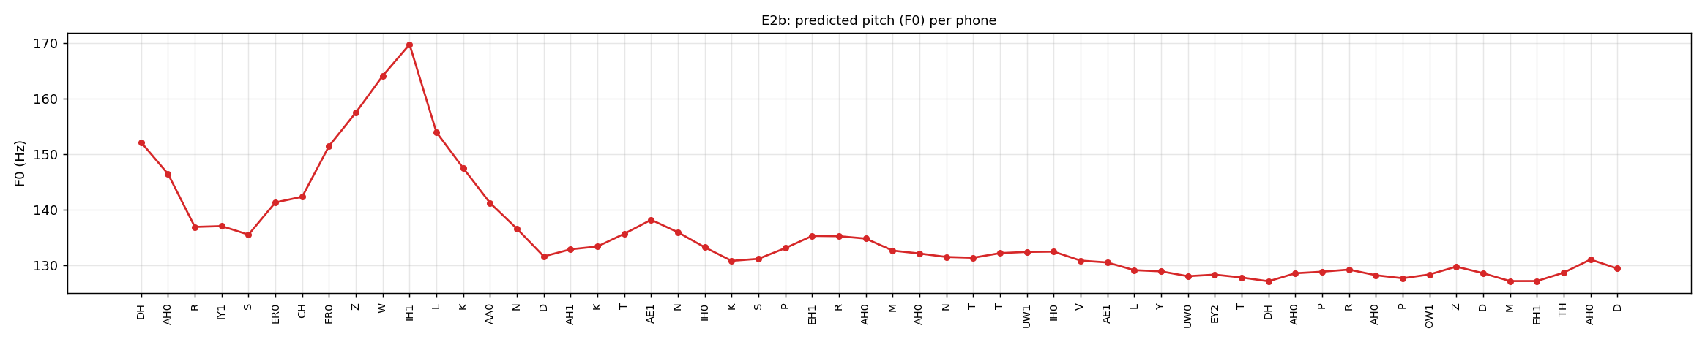
Figure 11. E2b, predicted pitch (F0) per phone.
E3. 37 phones, 2.6 s. Pitch starts at 157 Hz, peaks at 159 Hz on phone 4 (IH1) and ends at 127 Hz (range 123 to 159 Hz). The longest phone is M (number 7) at 128 ms. Predicted energy is below 10 for the runs EH1 K T IH0 (221 ms). The final M of "rhythm" is the longest phone, as expected for a syllabic nasal.
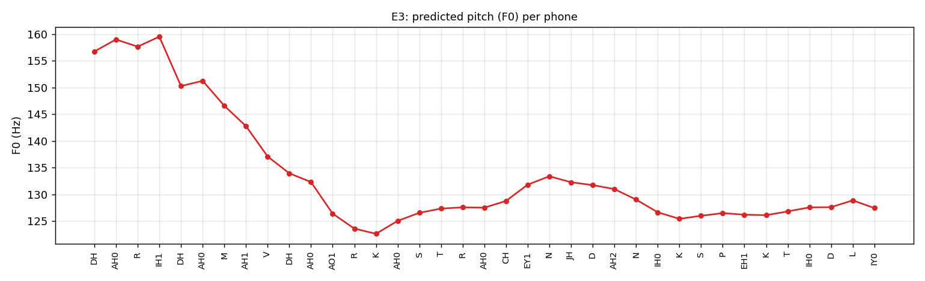
Figure 12. E3, predicted pitch (F0) per phone.
E4. 81 phones, 5.9 s. Pitch starts at 138 Hz, peaks at 169 Hz on phone 5 (T) and ends at 136 Hz (range 131 to 169 Hz). The longest phone is AY1 (number 27) at 139 ms. A pause of 58 ms is placed at the comma (phone 62). Predicted energy stays above 10 throughout.
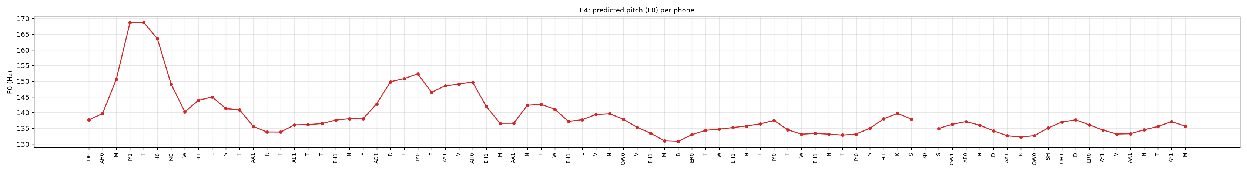
Figure 13. E4, predicted pitch (F0) per phone.
T1. 66 phones, 4.6 s. Pitch starts at 157 Hz, peaks at 281 Hz on phone 5 (oo) and ends at 125 Hz (range 125 to 281 Hz). The longest phone is uu (number 3) at 174 ms. Predicted energy stays above 10 throughout.
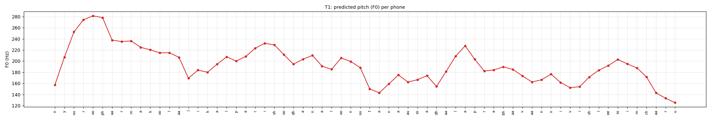
Figure 14. T1, predicted pitch (F0) per phone.
T2a. 31 phones, 2.3 s. Pitch starts at 164 Hz, peaks at 246 Hz on phone 17 (ch) and ends at 173 Hz (range 164 to 246 Hz). The longest phone is ai (number 6) at 174 ms. Predicted energy stays above 10 throughout. The word పట్టు is p a tt tt u with the geminate predicted as 35 ms plus 70 ms.
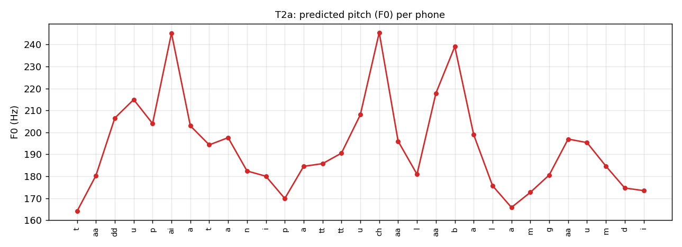
Figure 15. T2a, predicted pitch (F0) per phone.
T2b. 37 phones, 2.3 s. Pitch starts at 132 Hz, peaks at 239 Hz on phone 10 (ii) and ends at 116 Hz (range 116 to 239 Hz). The longest phone is aa (number 1) at 163 ms. Predicted energy stays above 10 throughout. The word పట్టు is p a tt tt u again, with 35 ms plus 70 ms, so its realisation does not depend on the sense (silk or grip).
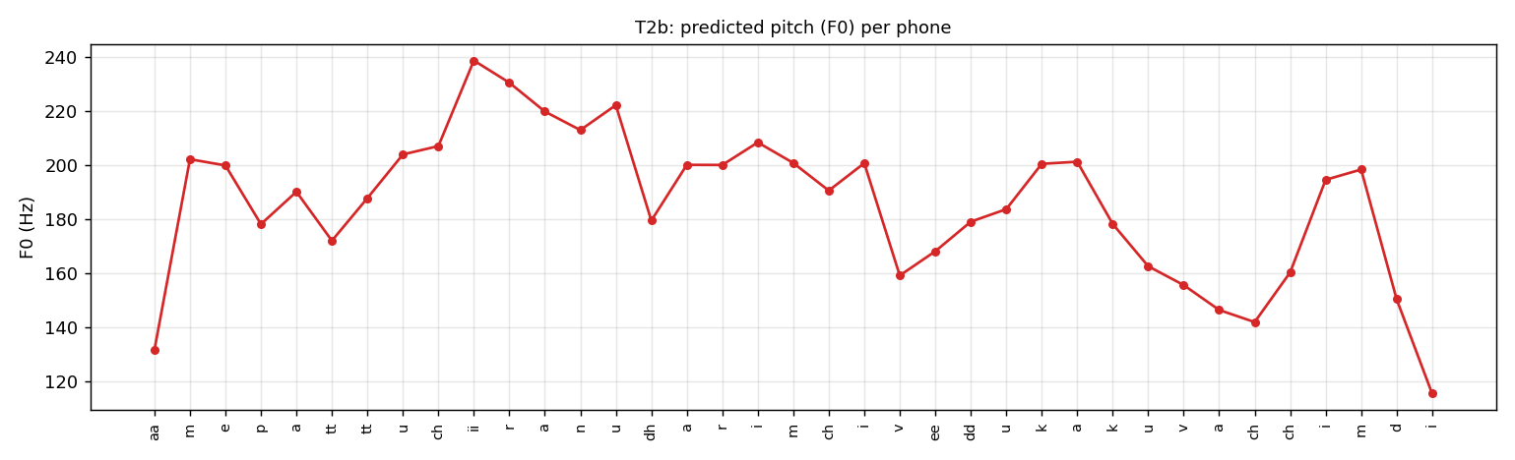
Figure 16. T2b, predicted pitch (F0) per phone.
T3. 31 phones, 2.0 s. Pitch starts at 194 Hz, peaks at 269 Hz on phone 4 (i) and ends at 128 Hz (range 128 to 269 Hz). The longest phone is i (number 4) at 151 ms. Predicted energy stays above 10 throughout.
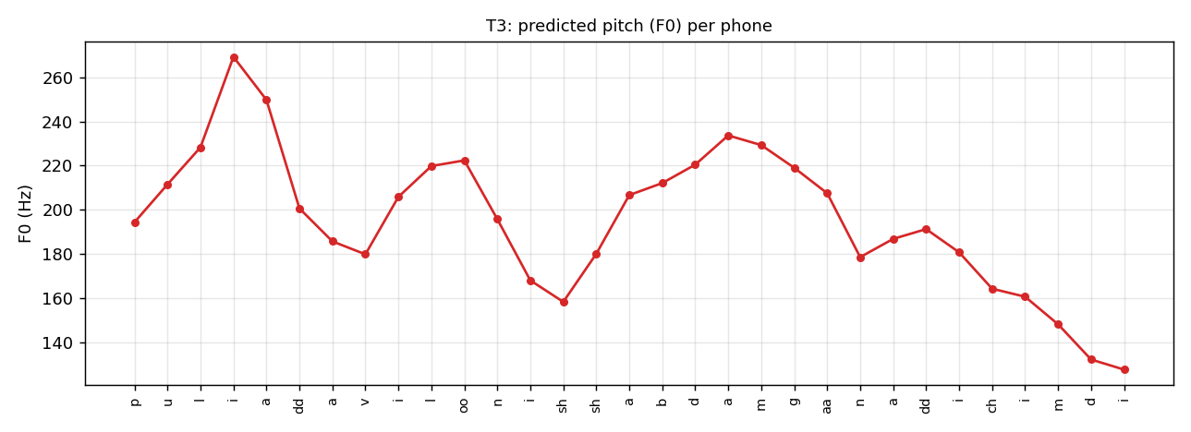
Figure 17. T3, predicted pitch (F0) per phone.
T4. 120 phones, 7.2 s. Pitch starts at 171 Hz, peaks at 255 Hz on phone 115 (m) and ends at 162 Hz (range 137 to 255 Hz). The longest phone is a (number 19) at 186 ms. A pause of 58 ms is placed at the comma (phone 95). Predicted energy stays above 10 throughout.
Figure 18. T4, predicted pitch (F0) per phone.
Duration and energy plots for one sentence of each language are shown below; all 30 plots are in the repository.
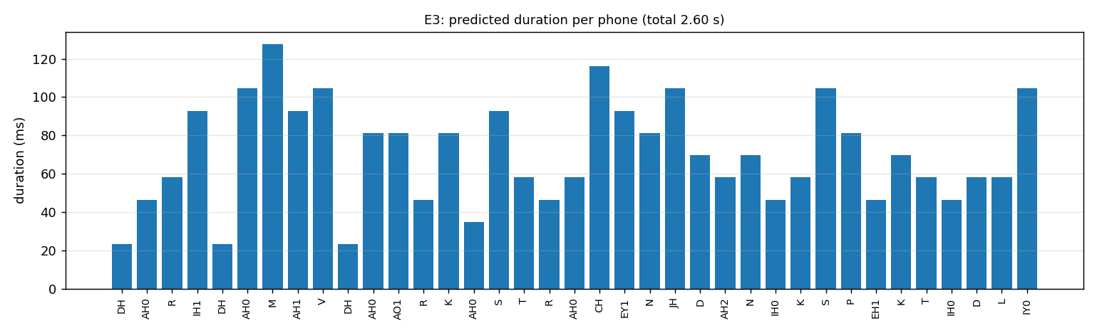
Figure 19. E3, predicted duration per phone.
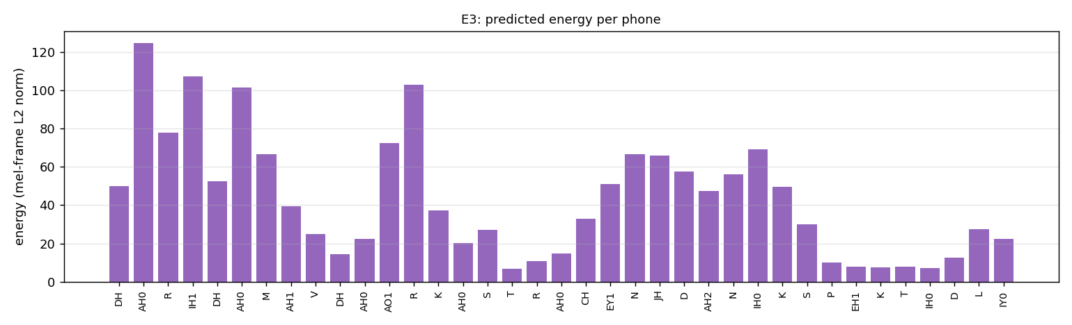
Figure 20. E3, predicted energy per phone. The near-zero values at the end belong to the last syllables of "unexpectedly".
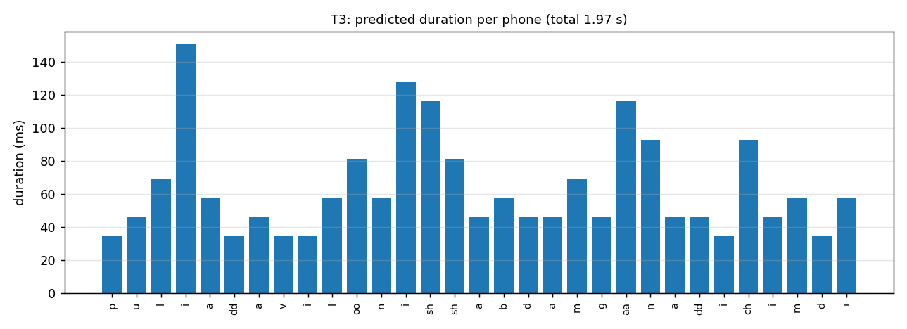
Figure 21. T3, predicted duration per phone.
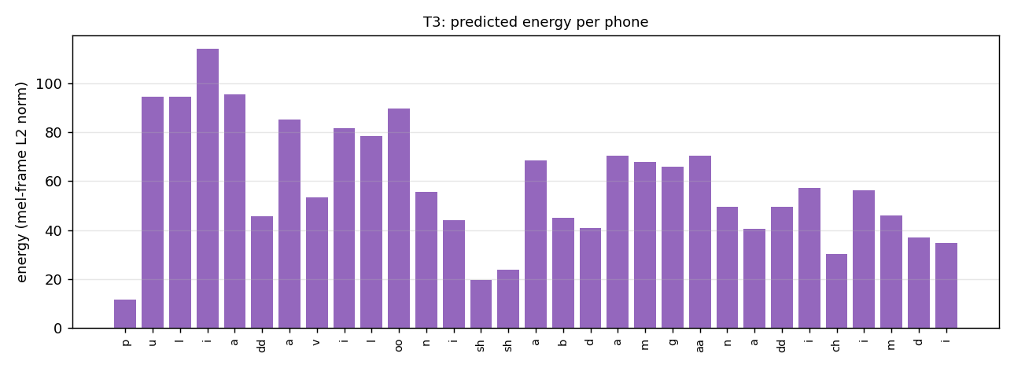
Figure 22. T3, predicted energy per phone.
8. English and Telugu compared: limitations, failures and improvements
 | English | Telugu
Training audio used | 3.7 h, 103 speaker groups (about 2 min each) | 3.6 h, 2 speakers (3.4 h and 1.6 h in the selection)
Recording conditions | Mixed, conversational and read speech, variable microphones and noise | Studio recordings
Text to phones | Dictionary plus neural g2p (ambiguous spelling) | Rules (spelling nearly phonetic)
Duration error | 2.6 frames (30 ms) | 1.4 frames (16 ms)
Pitch variation of the audio (F0 sd) | 12 to 28 Hz | 27 to 38 Hz
Pitch / energy correlation with real | 0.23 / 0.38 | 0.34 / 0.38
Overall quality | Flat, muffled, words not recognisable | Clearer and more natural, still muffled

Why English is worse. The English data is not text-to-speech data. Svarah was recorded to evaluate speech recognition, with many speakers, different microphones and spontaneous speech, and after the speaker split each speaker group has only about two minutes of audio, so the speaker embedding cannot be learned well and the acoustic model sees conflicting examples for the same phone. The Telugu data comes from two studio speakers with hours of audio each. The English model also has the harder text problem, since English spelling is not phonetic. The diagnostic of the first run shows that the English acoustic model itself does not generalise: it fails on validation sentences even with the true durations, pitch and energy.
Limitations and failures
- Overfitting of the pitch and energy predictors in both languages, with validation losses above the mean-prediction level for Telugu pitch.
- Flat pitch and continuous voicing in the English output, and energy that collapses on some words (E1, E3).
- The heteronym contrast in E2 is only partly realised, and rare names (andaroo in E4) rely on letter-to-sound guesses.
- The Telugu pronunciation rules and number words were written from standard usage and were not checked by a native speaker, and no automatic recogniser was available for Telugu (Whisper small could not transcribe even the real recordings), so the Telugu quality is judged by listening and signal measurements only.
- The pretrained universal HiFi-GAN vocoder was not adapted to either dataset; the scores are computed on the mel-spectrogram and the audio sample sizes are small (5 sentences per language).
Possible improvements
- Select the English data by quality as well as amount: remove noisy clips and speakers with too little audio, and use fewer speakers with more audio each.
- Regularise the variance predictors specifically: stop their training early, reduce their size, smooth the pitch and energy targets, or add noise to them, since the other parts of the model keep improving after they start to overfit.
- Pretrain the acoustic model on a larger corpus and fine-tune on the 5 hours (outside the scope of this assignment), or fine-tune the vocoder on the target speakers.
- Select checkpoints with listening tests or a recogniser-based score, and for Telugu ask a native speaker to rate each test sentence for intelligibility and naturalness.
- Extend the Telugu front end with a checked number lexicon and a pronunciation dictionary for loanwords.
9. Reproducibility
Software and hardware
Python 3.13 and PyTorch 2 on a Google Colab T4 GPU (16 GB). Packages (requirements.txt): torch, numpy, scipy, librosa 0.10 or later, soundfile, pyworld, tgt, g2p-en, nltk, inflect, scikit-learn, matplotlib, PyYAML, tqdm, unidecode, datasets, pandas. The Montreal Forced Aligner is installed separately (conda-forge). A Hugging Face read token is needed for the gated Svarah dataset. Data selection uses seed 1234; GPU training is not bit-exact, so repeated runs differ slightly.
Files
- English/config.yaml, Telugu/config.yaml: all settings of the final run (data selection, preprocessing, model, training). config_v1.yaml in each folder is the first run.
- English/ and Telugu/: preprocess.py, train.py, inference.py wrappers around common/pipeline.py; checkpoints/ holds the weights (fp16).
- notebooks/v2_final/ runs the whole pipeline in Colab and produced the files in Results/; notebooks/v1_baseline/ is the first run.
Commands
pip install -r requirements.txt
export HF_TOKEN=<token>
python English/preprocess.py --stage all # select, lexicon, align, features
python English/train.py # resumable
python English/inference.py --checkpoint English/checkpoints/selected_model_fp16.pth
python Telugu/preprocess.py --stage all
python Telugu/train.py
python Telugu/inference.py --checkpoint Telugu/checkpoints/selected_model_fp16.pth
python common/evaluate_snapshots.py --lang_dir English --ckpt_dir <work>/ckpt --out_dir Results/English/extra/checkpoint_selection

Inference runs on CPU in a minute or two per language. Options: --g2p_mode lexicon (English dictionary lookup), --no_normalize, --all_speakers. The final checkpoints are selected_model_fp16.pth (step 15000) in each checkpoints/ folder.
References
Y. Ren et al., "FastSpeech 2: Fast and High-Quality End-to-End Text to Speech", ICLR 2021. M. Chien, FastSpeech 2 PyTorch implementation (ming024/FastSpeech2). J. Kong, J. Kim, J. Bae, "HiFi-GAN: Generative Adversarial Networks for Efficient and High Fidelity Speech Synthesis", NeurIPS 2020. M. McAuliffe et al., "Montreal Forced Aligner", Interspeech 2017. Svarah: T. Javed et al., "Svarah: Evaluating English ASR Systems on Indian Accents", 2023. IndicTTS: A. Baby et al., "Resources for Indian languages", TSD 2016.

