

Company Profile · 2026
Your home knows when something changes.
A home that understands your health and knows when you need someone.

Connected Health and Wellness Technology
A SYLTRA ONE Company

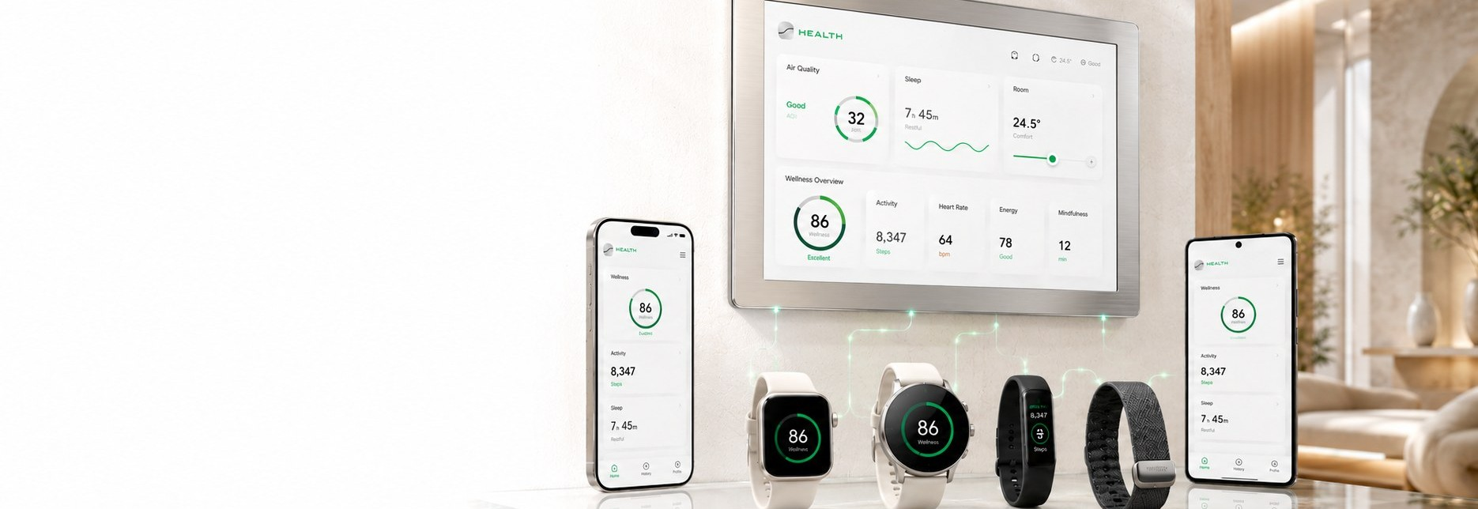
01 Definition
A health intelligence layer inside your home.
SYLTRA HEALTH is a health technology company within SYLTRA ONE. It connects what your body says with how your home moves, what its environment reads, and the people you trust, in one context. It learns your normal pattern, adapts your space, notices an unusual change, checks in with you, and reaches the most suitable person under a plan you approved in advance.
Most health apps show data after it is recorded. SYLTRA HEALTH turns data into an understanding of context, and then into a response in the real world.
It watches  It gathers your body and home signals quietly in the background, with your consent. | It understands  It learns your normal pattern, so it knows an ordinary day from one unlike you. | It responds  It adapts your space, checks in on a change, and reaches the right person if you need.

Who it is for
Individuals  A clearer view of sleep, activity and daily routines. | Older adults  Daily visibility that respects independence and reassures families, with the user's permission.
Chronic conditions  Readings and routines brought together to support follow-up. | Care providers  Organized summaries that users choose to share between visits.

02 The problem
One reading does not tell the whole story.
Health data is split between the watch, the phone and the measuring devices. Home and movement data sits apart from the state of the person living there. That separation produces three problems:
01 | Numbers without context  The user sees many readings and nothing that ties them to each other, or to the day.
02 | A home that ignores its resident  The home answers commands and routines. It knows nothing about how the person inside is doing.
03 | Alerts that do not know who can help  When something unusual happens, notifications scatter to everyone, and nobody knows who is closest or who can actually get there.

Your body. Your home. The people close to you. In one context.

03 Boundaries
What we do, and what we do not do.
SYLTRA HEALTH is a layer that understands the pattern, adapts the environment, and turns a meaningful change into verification and a personal response. The limits of that role are written before launch and reviewed with every health claim.
We detect change  We notice unusual changes in pattern, readings, movement and environment. | We check in first  We ask the user directly before any next step.
We alert the right person  We reach the most suitable trusted person under the user's plan, with the minimum information. | We adapt the space  We tie health to the home environment and apply settings the user approved in advance.

What we do not do
We do not diagnose, and we do not replace the doctor.
We are not an emergency service. We do not call an ambulance automatically, and we do not guarantee that help arrives.
We do not change a dose or a treatment plan. Those decisions stay between the user and the care team.
We do not collect data because it is available, and we never share more than the minimum necessary.

Technology designed to support understanding and follow-up. It does not replace medical evaluation or care. For an emergency or concerning symptoms, contact emergency services or a care provider directly.

04 How it works
From signals to response.
The journey has four steps: connect, learn your pattern, adapt your space, verify and respond.
Connect  Choose the compatible devices, apps and sensors. Connection does not begin without your permission, with specific consent for each data type. | Learn your pattern  The platform builds your baseline: sleep times, usual movement, and the home environment tied to your comfort.
Adapt your space  The home runs settings you approved in advance: temperature, better ventilation, suitable lighting, and reminders to move or measure. | Verify and respond  On a meaningful change, it checks in with you first, then reaches the most suitable trusted person under the response plan you chose.

The intelligent response path on an unusual change
01 | Collect signals  Health signals, movement, presence and home environment at the same moment.
02 | Compare to baseline  Comparing signals to your personal baseline and history to gauge the alert level.
03 | Check in with you  A direct check-in on your phone, watch or home screen: are you okay?
04 | Wait for a response  Waiting for the period you defined before any next step.
05 | Choose the right person  Selecting the most suitable trusted person by proximity, arrival time and acceptance.
06 | Approved escalation  Escalating under the plan you approved in advance, with minimal information.

Four response levels
Level | When | What happens
Everyday support | Every day | Reminders to move, measure or hydrate, and comfort-setting adjustments.
Check-in | A noticeable change | A direct question to you when a pattern or reading shifts.
Alert a trusted person | A request for help, or no response | Alerting the most suitable person when you ask for help, or do not respond while signals coincide.
Approved escalation | Within a documented plan | A further step once official integrations and approvals are in place.

05 The system
Five components, one outcome.
Intelligent response is not a feature added at the end. It is the outcome the four components before it work toward.
Component | Role
Connected Health | Connecting health and fitness data from approved, authorized sources.
Home Awareness | Understanding movement, presence and the home environment.
Personal Baseline | Learning each user's normal pattern over time.
Adaptive Environment | Adapting the home environment to health settings and routine.
Intelligent Response | Turning meaningful changes into verification, alerting and personal escalation.

The sources we read from
Phone  Movement, location and user-selected entries. | Wearables  Sleep, activity and supported signals from compatible devices.
Home health devices  Blood pressure, glucose and other readings from compatible devices. | Home sensors  Air quality, temperature, humidity, motion and presence. SYLTRA LIFE data appears inside your health experience with your consent.

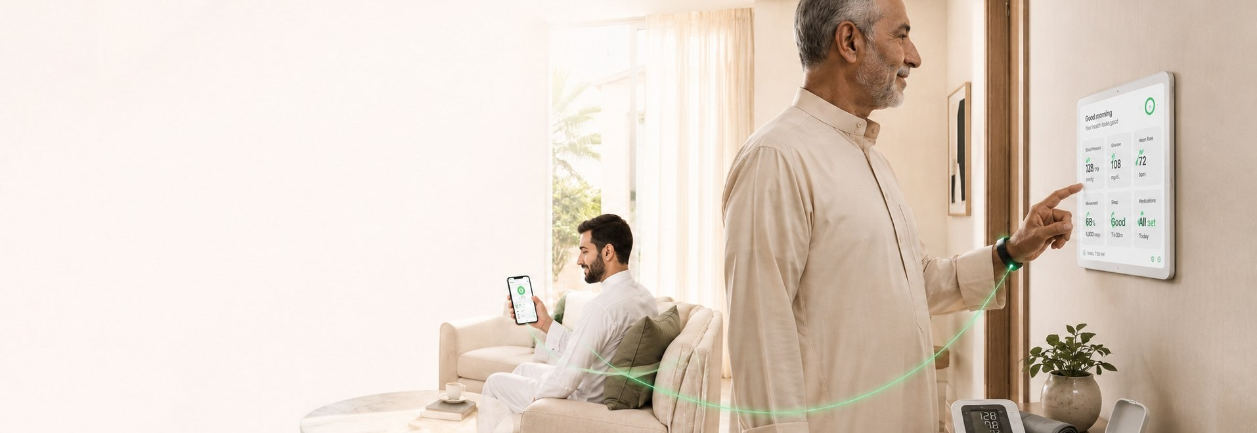
06 The trusted circle
If you do not answer, it knows who is closest.
The user builds a circle of people they trust and sets five things for each: the relationship, the priority, what they see, when they are available, and whether they can reach the home.
When needed, the system picks the most suitable person by arrival time, proximity and acceptance, and shares the minimum necessary information and location. One notification to the right person, instead of a broadcast to everyone.
Medication
A reminder at medication time with a clear confirm button on the preferred channel: phone, watch or home screen. A repeat alert if there is no confirmation, and a trusted person informed only on escalation and no response. The reminder supports adherence. It does not change the dose or the treatment plan.
01 | You add your medication  The name, units per pack, daily dose and dispense date. Once.
02 | The run-out date is computed  It is shown for you to confirm or adjust. Optional daily dose confirmation improves accuracy.
03 | An early alert arrives  A single alert before run-out within your chosen window, and a copy for your caregiver under your settings.
04 | You confirm, not the system  With an explicit confirmation from you or an authorized caregiver it becomes an order at a licensed partner pharmacy, with a cancel window. Nothing is dispensed without your permission.

07 The app
Few screens, each asking one simple question about your day.
Arabic first, calm and clear. Six screens, and the sentence comes before the number.
Today  How you are right now, within your usual pattern, in one line before any numbers. | Pattern  Your rhythm across days: sleep, movement and readings, and when they differ from normal.
Your home  Your room's temperature, humidity and air quality, with settings that adapt on your consent. | Your circle  The people you trust and who is closest, what they see, and when an alert reaches them.
Medications  Your medication schedule, timely reminders and a confirmation. | Settings  Your consents, response plan and test mode, always in your hands.

Test mode lets you run the whole response plan before you need it: you see how the system checks in, how long it waits, and who would be alerted at each level, while nothing leaves your screen.

08 People of Determination
More independence, not more supervision.
Access mode is an optional interface inside the app that adapts to how a person moves and communicates, while control and privacy stay with the user. Any setting that affects sharing, opening doors or making contact requires explicit consent and a clear log.
Six ready profiles
Motion  Large buttons, voice control, quick home commands and a longer press time. | Vision  Screen reader, voice commands, high contrast and a spoken description of the home. | Hearing  Visual and vibration alerts, live captions, and alarms mirrored to home screens.
Cognition  Short steps, clear visuals, steady routine and fewer choices per screen. | Sensory sensitivity  A quiet mode, reduced motion, and automatically lowered sound and light. | Custom  Set each option by hand, tied to no particular category.

Five quick scenes
Scene | What it does
I am home | Opens your path and sets lighting and temperature to your comfort.
Quiet mode | Lowers sound and light and pauses non-essential alerts.
Medication time | An alert on your preferred channel and a clear confirm button.
I need help | Finds the most suitable person in your circle and starts reaching them.
I am okay | Closes the check-in and records your response.

09 Two scenarios
What actually happens when something changes.
In both cases the platform does not describe a diagnosis. It describes what it observed: a reading, a movement, a response.
Diabetes  The glucose device records a low reading, and the home sensors notice an unusual stop in movement. The platform compares this to the baseline and checks in with the user. If there is no response within the set period, it reaches the most suitable person in their circle with one message: a low reading, an unusual stop in movement, and no response. | Older adults  No movement at a time they usually move, a change in heart rate, and no answer to the check-in. The platform reviews the full context, then runs the appropriate response level and reaches whoever is closest. One alert to one person, instead of a general alarm to the whole family.

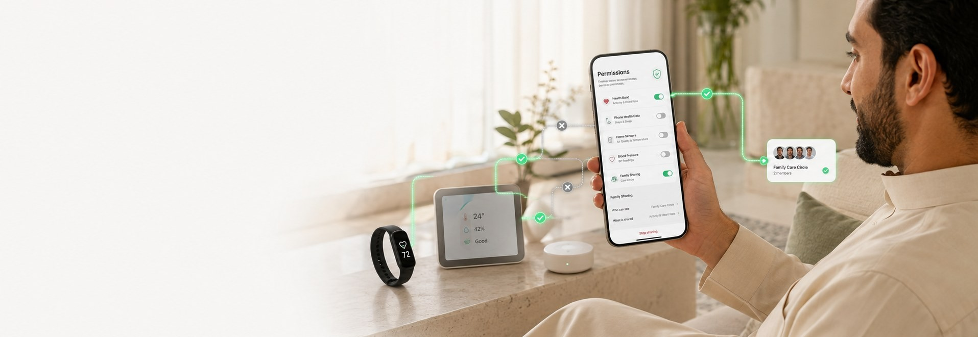
10 Integrations and privacy
Open to sources. Closed without your permission.
Ten target integrations: Apple Health, Google Health Connect, Samsung Health, WHOOP, Fitbit, HUAWEI Health, Nike Run Club, Apple Home, Google Home and Home Assistant. Plus compatible watches and bands, blood pressure and glucose devices, home sensors, and SYLTRA LIFE devices.
Integrations are under development and verification. The appearance of a name or logo does not mean a partnership or certification unless officially announced. An updated list of verified compatible devices and apps is published with each launch stage.
Six privacy principles
Consent  No source is connected and no information is shared without a clear choice, with specific consent for each data type. | Minimum necessary  Only information needed for the stated purpose is collected, and only the smallest amount required is shared. | Control  Connect or disconnect any source, decide who sees what, stop location sharing, withdraw consent, and delete data.
Transparency  The source and purpose of data use are explained. | Accountability  Access and sharing actions are logged, and the user can review the alert and sharing history. | Retention  Data is not kept longer than necessary for the stated purpose.

Privacy is part of the product experience and shows on every screen, not a legal paragraph at the end. Two internal references: the SDAIA Personal Data Protection controls for sensitive health data, and the SFDA controls for software as a medical device.

11 Roadmap
Three phases, and one status today.
We start with clear, testable rules, then personal learning to detect deviation from the pattern. Each phase unlocks new claims after its approval, never before.
01 | Wellness Safety  General integrations, movement and environment awareness, reminders and check-ins, a trusted circle and family escalation.
02 | Connected Care  Compatible medical devices, plans defined by a professional, programs for older adults and chronic conditions, and deeper analytics.
03 | Emergency Response  Official integrations with response agencies or care providers, after regulatory requirements, agreements and testing are complete.

Where we are now
The website  Live at health.syltraone.com: 15 pages in Arabic and English, and a journal of 11 articles. | The app  Screens on show: Today, Your home, Your circle, Medications, and Access mode. | Early access  The early testing program is open, and registrations run on the published infrastructure.

Join the early testing program.
We are looking for individuals, families and care providers who will try the platform in its first phase and tell us what works and what does not. Registration asks for contact details and areas of interest only. It never asks for health data.
health.syltraone.com
Riyadh, Kingdom of Saudi Arabia
instagram.com/syltrahealth
A SYLTRA ONE Company · syltraone.com


Technology designed to support understanding and follow-up. It does not replace medical evaluation or care.

